sum = sum + Integer.parseInt(String.valueOf(str2.charAt(i)));
works in three steps:
1. str2.charAt(i)
Gets the character at index i from the string str2.
EX- ch will be: 3
2. String.valueOf(...) -- Converts that character into a String.
String.valueOf('3') -"3"
3. Integer.parseInt(...) - Converts the String "3" into the integer 3.
Integer.parseInt("3") -3
4. Add it to sum - If sum is currently 5:
sum = 5 + 3; Result: sum = 8;
B]
Quick Memory Trick
- valueOf() → "Make it a String"
- parseInt() → "Make it an int"

Integer.parseInt() and String.valueOf() do different jobs:
String.valueOf() - Converts character a value into a String.
Examples: char ch = '5';
String s = String.valueOf(ch); // "5"

int num = 123;
String s2 = String.valueOf(num); // "123"

Input → any primitive/object
Output → String

Integer.parseInt() - Converts a numeric String into an int.

String s = "123";
int num = Integer.parseInt(s); // 123
Input → String Output → int
If the string is not a valid number:
Like - Integer.parseInt("ABC"); -> throws: NumberFormatException
Let's say:
str2 = "789"; i = 1;
Show more lines
- str2.charAt(1) → '8' (char)
- String.valueOf('8') → "8" (String)
- Integer.parseInt("8") → 8 (int)
So the whole expression becomes sum = sum + 8;
'7' --> String.valueOf() --> "7"
"7" --> Integer.parseInt() --> 7
So in your line:
sum = sum + Integer.parseInt(String.valueOf(str2.charAt(i)));

the character digit ('7', '8', etc.) is first converted to a String, then converted to an integer so it can be added to sum.

Yes, Integer.parseInt() only accepts a String (or a portion of a String) as input - Integer.parseInt("123"); // ✅ Valid
Integer.parseInt("-45"); // ✅ Valid

Invalid Inputs- Integer.parseInt(123); // ❌ Compile-time error
Integer.parseInt('5'); // ❌ Compile-time error
Because 123 is an int and '5' is a char, not a String.
How to Convert a char?- char ch = '5';
int num = Integer.parseInt(String.valueOf(ch));
Difference Between parseInt() and valueOf()
int a = Integer.parseInt("123"); // int
Integer b = Integer.valueOf("123"); // Integer
So:
- String.valueOf(x) → converts anything to String
- Integer.parseInt(str) → converts String to int
- Integer.valueOf(str) → converts String to Integer object

Constructor Rules in Java
Rule | Allowed? | Explanation
Constructor name must be same as class name | ✅ | Java identifies it as a constructor using the class name.
Constructor has no return type | ✅ | Not even void is allowed.
Constructor can have parameters | ✅ | Used to initialize objects with values.
Constructor can be overloaded | ✅ | Multiple constructors with different parameter lists.
Constructor can be overridden | ❌ | Constructors are not inherited.
Constructor can be inherited | ❌ | Child classes do not inherit parent constructors.
Constructor can call parent constructor using super() | ✅ | Used for constructor chaining.-
Constructor can call another constructor using this() | ✅ | Reuses constructor logic within the same class.
Constructor can be private | ✅ | Used in Singleton design pattern.
Constructor can be static | ❌ | Constructors belong to objects, not classes.
Constructor can be final | ❌ | Constructors cannot be overridden anyway.
Constructor can be abstract | ❌ | Constructors must have implementation.
Constructor can throw exceptions | ✅ | Uses throws keyword.

Most Important Interview Tricks
Question | Answer
Can constructor be overloaded? | ✅ Yes
Can constructor be overridden? | ❌ No
Can constructor be inherited? | ❌ No
Can constructor be private? | ✅ Yes
Can constructor be static? | ❌ No
Can constructor be final? | ❌ No
Can constructor have return type? | ❌ No
Can constructor call parent constructor? | ✅ Using super()
Can constructor call another constructor? | ✅ Using this()

Golden Interview Definition
A constructor is a special member of a class used to initialize objects. It has the same name as the class, does not have a return type, can be overloaded, cannot be inherited or overridden, and is automatically invoked when an object is created.

1-Overloading vs Overriding
Feature | Method Overloading | Method Overriding
Definition | Same method name, different parameters | Same method name, same parameters in child class
Class | Can be in same class | Requires parent-child relationship
Parameters | Must be different | Must be same
Return Type | Can be different (but params must differ) | Same or covariant return type
Polymorphism | Compile-time Polymorphism | Runtime Polymorphism
Binding | Early Binding | Late Binding
Inheritance Required? | ❌ No | ✅ Yes
Static Methods | Can be overloaded | Cannot be overridden
Private Methods | Can be overloaded | Cannot be overridden
Access Modifier | Any | Cannot be more restrictive
@Override Annotation | ❌ Not used | ✅ Used

Overloading vs Overriding Rules
Rule | Overloading | Overriding
Method Name | Must be same | Must be same
Parameters | Must be different | Must be same
Return Type | Can be different (if parameters differ) | Same or Covariant
Class Requirement | Same class or child class | Parent-Child class mandatory
Polymorphism Type | Compile Time | Runtime
Binding | Early Binding | Late Binding
Inheritance Required | ❌ No | ✅ Yes
Static Methods | ✅ Can be overloaded | ❌ Cannot be overridden(✅ Method Hiding)
Private Methods | ✅ Can be overloaded | ❌ Cannot be overridden
Final Methods | ✅ Can be overloaded | ❌ Cannot be overridden
Access Modifier | Any | Cannot reduce visibility
Exception Handling | No restriction | Child cannot throw broader checked exceptions
Constructor | ✅ Can be overloaded | ❌ Cannot be overridden
@Override Annotation | ❌ Not used | ✅ Used
Performance | Faster | Slightly slower due to runtime resolution

Overloading Rules
Rule | Valid?
Same method name | ✅
Different number of parameters | ✅
Different datatype of parameters | ✅
Different parameter order | ✅
Change only return type | ❌
Static method overloading | ✅
Constructor overloading | ✅

Overriding Rules
Rule | Valid?
Parent-child relationship required | ✅
Same method signature | ✅
Same return type | ✅
Covariant return type | ✅
Access modifier same or broader | ✅
Reduce access modifier | ❌
Override static method | ❌
Override private method | ❌
Override final method | ❌
Use @Override | ✅

2-Inheritance Rules
Rule | Allowed? | Explanation
Child can inherit public members | ✅ | Accessible everywhere
Child can inherit protected members | ✅ | Accessible in subclass
Child can inherit default members | ✅ (same package) | Only within same package
Child can inherit private members | ❌ | Private members belong only to parent class
Child can override inherited methods | ✅ | Runtime polymorphism
Child can inherit static methods | ✅ | But cannot override them
Child can override static methods | ❌ | Method hiding occurs
Child can inherit variables | ✅ | Except private variables directly
Child can inherit constructors | ❌ | Constructors are called using super()
Multiple inheritance using classes | ❌ | Java does not support it
Multiple inheritance using interfaces | ✅ | Supported
Final class can be inherited | ❌ | Not allowed
Final method can be overridden | ❌ | Not allowed
Abstract class can be inherited | ✅ | Common use case
Interface can be inherited/implemented | ✅ | Using implements
Every class inherits Object class | ✅ | Directly or indirectly

Types of Inheritance in Java
Type | Supported?
Single Inheritance | ✅
Multilevel Inheritance | ✅
Hierarchical Inheritance | ✅
Multiple Inheritance (Class) | ❌
Multiple Inheritance (Interface) | ✅
Hybrid Inheritance (Using Interfaces) | ✅

Access Modifier and Inheritance
Modifier | Inherited?
private | ❌
default | ✅ (same package only)
protected | ✅
public | ✅

Most Asked Interview Questions
Question | Answer
What is inheritance? | Mechanism by which one class acquires properties and behaviors of another class.
Why use inheritance? | Code reusability and maintainability.
Which keyword is used for inheritance? | extends
Can Java support multiple inheritance using classes? | ❌ No
Why doesn't Java support multiple inheritance? | To avoid Diamond Problem ambiguity.
How is multiple inheritance achieved in Java? | Using interfaces.
Can constructors be inherited? | ❌ No
Can private members be inherited? | ❌ No
Can static methods be inherited? | ✅ Yes
Can static methods be overridden? | ❌ No, only hidden.
Can final class be inherited? | ❌ No
Can final method be overridden? | ❌ No
Can abstract class be inherited? | ✅ Yes
Can interface extend another interface? | ✅ Yes
Which class is the parent of all classes? | java.lang.Object
Which methods come from Object class? | toString(), equals(), hashCode(), etc.
Which inheritance type is not supported by Java classes? | Multiple Inheritance
What is IS-A relationship? | Inheritance relationship (Dog IS-A Animal).
What is HAS-A relationship? | Composition/Aggregation relationship.

Interview Trick Questions
Question | Answer
Is constructor inherited? | ❌ No
Is parent constructor executed? | ✅ Yes, through super()
Can a child access parent's private variable directly? | ❌ No
Can child access private variable through getter method? | ✅ Yes
Does Object class have a parent class? | ❌ No
Can we inherit a final class? | ❌ No
Can we make a class both final and abstract? | ❌ No
Can private methods be overridden? | ❌ No
Can protected method be overridden as public? | ✅ Yes
Can public method be overridden as protected? | ❌ No

Diamond Problem (Very Common)
Why Java Doesn't Support Multiple Inheritance with Classes

class A {
void show() {}
}
class B extends A {
}
class C extends A {
}
class D extends B, C { // Not Allowed
}
Show more lines
Problem:
- If both B and C have show()
- Java won't know which one D should use
This is called the Diamond Problem.
Hence:
✅ Multiple Inheritance via Interfaces
❌ Multiple Inheritance via Classes

Quick Revision Sheet
Feature | Inheritance
Keyword | extends
Purpose | Reuse code
Parent Class | Superclass
Child Class | Subclass
Constructor Inherited | ❌
Private Members Inherited | ❌
Method Overriding Used? | ✅
Supports Runtime Polymorphism? | ✅
Multiple Class Inheritance | ❌
Multiple Interface Inheritance | ✅
Root Class | Object

Golden Interview Definition
Inheritance is an OOP concept in which a child class acquires the properties and behaviours of a parent class using the extends keyword. It promotes code reusability, supports method overriding and runtime polymorphism, but constructors and private members are not inherited.

3-What is Encapsulation?
Encapsulation = Wrapping data (variables) and methods into a single unit (class) and restricting direct access to data using access modifiers.

Encapsulation Rules
Rule | Allowed? | Explanation
Data members should be private | ✅ | Prevents direct access
Methods can be public | ✅ | Provide controlled access
Use getters to read data | ✅ | Data retrieval
Use setters to modify data | ✅ | Data update
Class can contain both data and methods | ✅ | Core principle of encapsulation
Direct access to private variables outside class | ❌ | Causes compile-time error
Validation can be added in setters | ✅ | Protects invalid data
Encapsulation improves security | ✅ | Data hiding

Why Make Variables Private?
Without encapsulation:
class Employee {
public int salary;
}

Employee e = new Employee();
e.salary = -10000;
❌ Invalid data accepted.

With encapsulation:
public void setSalary(int salary) {
if(salary > 0) {
this.salary = salary;
}
}
✅ Validation added.

Getter and Setter Rules
Method | Purpose
Getter | Read data
Setter | Modify data
Getter should return value | ✅
Setter usually returns void | ✅
Getter name starts with get | Convention
Setter name starts with set | Convention
Example:
private String name;
public String getName() {
return name;
}
public void setName(String name) {
this.name = name;
}

Advantages of Encapsulation
Advantage | Explanation
Data Hiding | Protects internal data
Security | Prevents unauthorized access
Flexibility | Internal implementation can change
Validation | Prevent invalid data
Maintainability | Easy to modify code
Reusability | Better class design

Interview Questions and Answers
Question | Answer
What is encapsulation? | Wrapping data and methods into a single unit and restricting direct access using private variables.
Which access modifier is mostly used in encapsulation? | private
How is encapsulation achieved? | Using private variables and public getter/setter methods.
Is encapsulation data hiding? | Encapsulation provides data hiding through access control.
What are getter methods? | Methods used to read private variables.
What are setter methods? | Methods used to update private variables.
Can we achieve encapsulation without getters/setters? | Yes, but getters/setters are the most common approach.
What is the benefit of encapsulation? | Security, maintainability, flexibility, validation.
Can private variables be accessed outside the class? | ❌ No
Can public methods access private variables? | ✅ Yes

Interview Trick Questions
Question | Answer
Does encapsulation mean all variables must be private? | ❌ No, but it is recommended.
Can a class be fully encapsulated? | ✅ Yes, all variables private and accessed via methods.
Is encapsulation an OOP pillar? | ✅ Yes
Which OOP pillar provides data security? | Encapsulation
Can private variables be accessed through getters/setters? | ✅ Yes
Is encapsulation possible without inheritance? | ✅ Yes
Does encapsulation increase code complexity? | Slightly, but improves maintainability and security.

Difference: Encapsulation vs Abstraction
Feature | Encapsulation | Abstraction
Focus | Data Hiding | Implementation Hiding
Achieved Using | Private variables + Getters/Setters | Abstract classes & Interfaces
Goal | Protect data | Hide complexity
Example | Bank account balance | ATM machine

Quick Revision Sheet
Feature | Encapsulation
OOP Pillar | ✅ Yes
Purpose | Data Hiding
Main Keyword | private
Access Through | Getters/Setters
Improves Security | ✅
Validation Possible | ✅
Hides Data | ✅
Hides Implementation | ❌ (That's Abstraction)
Golden Interview Definition
Encapsulation is the process of binding data and methods into a single unit (class) and restricting direct access to data by making variables private and providing controlled access through getter and setter methods.

4-What is Abstraction?
Abstraction means hiding implementation details and showing only essential functionality to the user.

Abstraction Rules
Rule | Allowed? | Explanation
Abstract class can have abstract methods | ✅ | Method without body
Abstract class can have normal methods | ✅ | Concrete methods allowed
Abstract class can have constructors | ✅ | Used during object creation
Abstract class can have variables | ✅ | Instance & static variables allowed
Abstract class can have static methods | ✅ | Allowed
Abstract class object creation | ❌ | Cannot instantiate directly
Abstract method can have body | ❌ | Must end with ;
Child class must implement abstract methods | ✅ | Unless child is also abstract
Abstract class can extend another abstract class | ✅ | Allowed
Abstract class can implement interfaces | ✅ | Allowed
Abstract method can be private | ❌ | Cannot be overridden
Abstract method can be static | ❌ | Static methods cannot be overridden
Abstract method can be final | ❌ | Final methods cannot be overridden
Abstract class can be final | ❌ | Contradictory concepts

Constructor in Abstract Class

abstract class Animal {
Animal() {
System.out.println("Animal Constructor"); }
}
✅ Allowed
Why? -When child object is created, parent constructor runs first.
Interview Questions & Answers
Question | Answer
What is abstraction? | Hiding implementation details and exposing only essential features.
Why use abstraction? | Reduce complexity and improve maintainability.
How is abstraction achieved in Java? | Abstract classes and interfaces.
Can we create object of abstract class? | ❌ No
Can abstract class have constructor? | ✅ Yes
Can abstract class have normal methods? | ✅ Yess
Can abstract class have variables? | s
Can abstract method have body? | ❌ No
Can abstract class contain only concrete methods? | ✅ Yes
Can abstract class contain no abstract methods? | ✅ Yes
Can abstract class be final? | ❌ No
Can abstract method be static? | ❌ No
Can abstract method be private? | ❌ No
Can abstract method be final? | ❌ No
Can child class avoid implementing abstract methods? | ✅ Only if child is also abstract
Which OOP pillar hides implementation? | Abstraction
What keyword is used for abstraction? | s

Interview Trick Questions
Question | Answer
Can abstract class have constructor? | ✅ Yes
Can we instantiate abstract class? | ❌ No
Can abstract class have static methods? | ✅ Yes
Can abstract class have final methods? | ✅ Yes
Can abstract method be final? | ❌ No
Can abstract method be private? | ❌ No
Can abstract class have all concrete methods? | ✅ Yes
Can abstract class have no abstract methods? | ✅ Yes
Can abstract class be declared final? | ❌ No
Can interface achieve abstraction? | ✅ Yes

Abstract Class vs Interface
Feature | Abstract Class | Interface
Keyword | abstract | interface
Multiple Inheritance | ❌ | ✅
Constructor | ✅ | ❌
Instance Variables | ✅ | ❌ (only public static final constants)
Abstract Methods | ✅ | ✅
Concrete Methods | ✅ | ✅ (default/static)
Object Creation | ❌ | ❌
Extends | One Class | Multiple Interfaces

Encapsulation vs Abstraction
Feature | Encapsulation | Abstraction
Purpose | Hide Data | Hide Implementation
Achieved By | Private variables + Getters/Setters | s
Focus | Security | Simplicity
Example | Bank Account Balance | ATM Machine

Quick Revision Sheet
Feature | Abstraction
OOP Pillar | ✅
Keyword | s
Hides | Implementation Details
Object Creation | ❌
Constructor Allowed | ✅
Normal Methods Allowed | ✅
Abstract Methods Allowed | ✅
Static Methods Allowed | ✅
Final Class Allowed | ❌
Achieved Through | Abstract Class & Interface
Golden Interview Definition
Abstraction is the process of hiding implementation details and exposing only the required functionality to the user. In Java, abstraction is achieved using abstract classes and interfaces. It helps reduce complexity and improves maintainability.
One-Line Interview Formula
Encapsulation = Hide Data
Abstraction = Hide Implementation
Inheritance = Reuse Code
Polymorphism = Many Forms

abstract class AbstractClass {
static int staticVar; //1.static_Var allowed
int instanceVar; //2.Instance Var also

AbstractClass() {System.out.println("IM Abstract Class Constructor");} //3. //Constructor allowed in AbstractClass

public void normalMethod() {System.out.println("In AbstractClass IM a Normal()/Concrete()"); } //4.Normal() also
abstract void abstractMethod();
static void staticMethod() {System.out.println("IM static() In Abstract Class");} //5. static() also
//default void defaultMethod(){} //Default methods are allowed only in interfaces. //6. default() aren't allowed
}
public class Abstract extends AbstractClass{
public void abstractMethod() {
System.out.println("IM abstract()"); }
public static void main(String[] args) {
//AbstractClass ab= new AbstractClass();
//7.Error-Cannot instantiate(Can't Create Object) the type AbstractClass
Abstract abstract1 = new Abstract();
abstract1.normalMethod(); //8.normal()/Concrete() called using Object
abstract1.abstractMethod();//9.abstract() created Object for normal class
AbstractClass.staticMethod(); //10.static() called using AbstrcatClass Name
Abstract.staticMethod(); //11.static() can be Inherited-✅ Yes, static methods are inherited by subclasses.
AbstractClass.staticVar=101; //11.staticVar also called using AbstrcatClass Name
System.out.println(staticVar);
System.out.println(abstract1.instanceVar=200); //12.instanceVar also called using Object } }

What is an Interface?
An Interface is a blueprint of a class that contains method declarations and constants. It is used to achieve 100% abstraction (before Java 8) and multiple inheritance.
Real-Time Example
Remote Control
Buttons:
✅ ON ✅ OFFss
How TV turns ON/OFF?
❌ Hidden
The remote defines what to do, not how to do it.
This is exactly what an Interface does.
Interface Rules
Rule | Allowed? | Explanation
Interface can have abstract methods | ✅ | Default behaviour before Java 8
Interface can have default methods | ✅ | Introduced in Java 8
Interface can have static methods | ✅ | Introduced in Java 8
Interface can have private methods | ✅ | Introduced in Java 9
Interface can have constructors | ❌ | No object creation
Interface object creation | ❌ | Cannot instantiate directly
Multiple interface inheritance | ✅ | Major advantage of interfaces
Interface can extend another interface | ✅ | Using extends
Class can implement multiple interfaces | ✅ | Using implements
Interface can implement another interface | ❌ | Only classes implement interfaces
Interface variables are automatically public static final | ✅ | Constants
Interface methods are automatically public abstract | ✅ | Unless default/static/private

Rule 1: Interface Cannot Be Instantiated
❌ Wrong
interface Animal {
}
Animal a = new Animal();
Compile Error.
Why? - Interface only provides a contract. It does not provide complete implementation.
Rule 3: Interface Methods Are Public Abstract By Default
Rule 4: Implemented Method Must Be Public
✅ Correct
class Demo implements Test {
public void show() { } }

❌ Wrong
class Demo implements Test {
void show() { // Error need Public access specifier } }

Rule 7: Interface Can Extend Another Interface
Rule 8: Interface Cannot Extend Class

Rule 9: Interface Can Have Default Methods (Java 8)
interface Vehicle {
default void start() {
System.out.println("Starting"); } }
Why? - ss

Rule 10: Interface Can Have Static Methods
interface Utility {
static void print() {
System.out.println("Hello"); } }
Call using:
Utility.print();
✅ Allowed
Rule 11: Interface Can Have Private Methods (Java 9)
interface Test {
private void helper() {
System.out.println("Helper"); } ss}
✅ Allowed
Why?
To reuse code among default methods.ss
Interface Variable Rules
Declaration | Compiler Converts To
int x = 100; | public static final int x = 100;
Interface Method Rules
Declaration | Compiler Converts To
void show(); | public abstract void show();
Interface vs Abstract Class
Feature | Interface | Abstract Class
Constructor | ❌ | ✅
Multiple Inheritance | ✅ | ❌
Variables | public static final only | Any type
Object Creation | ❌ | ❌
Abstract Methods | ✅ | ✅
Normal Methods | ✅ (default/static) | ✅
Keyword | interface | abstract
Common Interview Questions
Question | Answer
What is an interface? | ss
Why use interface? | To achieve abstraction and multiple inheritance.
Can we create object of interface? | ❌ No
Can interface have constructor? | ❌ No
Can interface have variables? | ✅ Yes, but public static final only
Can interface have static methods? | ✅ Yes
Can interface have default methods? | ✅ Yes
Can interface have private methods? | ✅ Yes (Java 9+)
Can interface extend another interface? | ✅ Yes
Can interface implement another interface? | ❌ No
Can class implement multiple interfaces? | ✅ Yes
Why multiple inheritance supported through interfaces? | No ambiguity because interfaces define contracts, not state.
Which keyword is used to inherit interface? | implements
Can interface be final? | ❌ No
Can methods in interface be final? | ❌ No
Tricky Interview Questions
Question | Answer
Can interface have all default methods? | ✅ Yes
Can interface have no methods? | ✅ Yes (Marker Interface)
Can interface extend multiple interfaces? | ✅ Yes
Can abstract class implement interface without implementing methods? | ✅ Yes, if abstract
Can a class extend a class and implement an interface simultaneously? | ✅ Yes
Can interface variable be changed? | ❌ No
Can we declare method as protected in interface? | ❌ No
Can interface contain main method? | ✅ Yes (static)
Marker Interface
Interface with no methods.
interface Serializable { }
Examples:
- Serializable
- Cloneable
Used to provide special information to JVM.

Quick Revision Sheet
Feature | Interface
Keyword | interface
Object Creation | ❌
Constructor | ❌
Multiple Inheritance | ✅
Variables | public static final
Methods | public abstract
Default Methods | ✅
Static Methods | ✅
Private Methods | ✅ (Java 9+)
Implement Keyword | implements

Golden Interview Definition
An Interface is a contract that defines what a class should do but not how it should do it. It is used to achieve abstraction and multiple inheritance in Java. A class implements an interface and provides the implementation for its methods. 🚀

Easy Formula for OOP
Inheritance = Reuse Code
Encapsulation = Hide Data
Abstraction = Hide Implementation
Polymorphism = Many Forms
Interface = Contract
This 5-line formula is excellent for Java interview revision. ✅

Remember
Interface Method Type | Inherited? | How to Call
Abstract Method | ✅ | Through object
Default Method | ✅ | Through object
Static Method | ❌ | InterfaceName.method()
Private Method | ❌ | Only inside interface

Quick formula:
Interface abstract method -> Inherited
Interface default method -> Inherited
Interface static method -> NOT inherited
Interface private method -> NOT accessible outside
interface Utility {
//1. Utility(){ } 1. Interface cannot have constructors
public static final int num = 2000;
int num2=10; //2. Variables are -by default public static final
//3-System.out.println(num2); not allowed in interface
static void print() { System.out.println("Hello"); }
//protected void myshow() {} //4-Error- Remove invalid Modifier(Protected)
public abstract void show();
// To call abstract() from Interface,have create Object for class,2] with @Oerride(Automatically comes)tag we have implement that(), 3]If i called abstract() using InterfaceName,will give error->
//with change method abstract to static & add implementation in the interface only
default void display() { System.out.println("Niceeeee"); }
}
public class InterfaceClass implements Utility{
@Override
public void show() { System.out.println("hiiiiiiiiiii"); }
public static void main(String[] args) {
Utility.print(); //print() is a static()& called by Interface Name also NOT inherited
InterfaceClass i= new InterfaceClass ();
i.show(); // abstract() called by Object also Inherited
i.display(); // default() called by Object also Inherited
System.out.println(num);
System.out.println(num2); }
} //O/P-Hell

Exception Handling
Throwable
│
├── Error
│ ├── OutOfMemoryError
│ ├── StackOverflowError
│ └── AssertionError
│
└── Exception
│
├── Checked Exception
│ ├── IOException
│ ├── SQLException
│ ├── ClassNotFoundException
│ └── InterruptedException
│
└── RuntimeException (Unchecked)
├── NullPointerException
├── ArithmeticException
├── NumberFormatException
├── IndexOutOfBoundsException
├── ClassCastException
└── IllegalArgumentException

Interview Question: Checked vs Unchecked Exception
Checked Exception | Unchecked Exception
Checked at compile time | Checked at runtime
Must be handled or declared using throws | No mandatory handling
Extends Exception (excluding RuntimeException) | Extends RuntimeException
Recoverable conditions | Programming errors/bugs
Example: IOException | Example: NullPointerException

Most Important Exceptions to Remember
Exception | Scenario
NullPointerException | Accessing null object
ArithmeticException | Divide by zero
NumberFormatException | Converting invalid String to number
ArrayIndexOutOfBoundsException | Invalid array index
ClassCastException | Invalid type casting
FileNotFoundException | File does not exist
IOException | File/Input-Output issues
SQLException | Database errors
InterruptedException | Thread interruption
IllegalArgumentException | Invalid method argument

Throwable
├── Error (JVM Problem)
└── Exception (Application Problem)
├── Checked (Compile Time)
└── Runtime (Run Time)

Interview One-Liners (Very Important)
Question | Quick Answer
Is Exception a class? | Yes
Is Throwable a class? | Yes, parent of Error and Exception
Is finally mandatory? | No
Can try have only finally? | Yes
Can we use catch without exception? | No
Can final, finally, finalize be used interchangeably? | No
Which executes first, constructor or exception handling? | Constructor
What is exception propagation? | Automatic forwarding of exception to caller method
Can abstract methods declare exceptions? | Yes
Can interface methods declare exceptions? | Yes
Which exception is thrown by divide by zero? | ArithmeticException
Which exception occurs for invalid array index? | ArrayIndexOutOfBoundsException
Which exception occurs when converting String to number fails? | NumberFormatException
Can we throw null? | Yes, but JVM throws NullPointerException

Frequently Asked Tricky Java Exception Interview Questions
Question | Answer
What is the difference between Error and Exception? | Exceptions can be handled; Errors are serious JVM issues and generally should not be handled.
What is the difference between Checked and Unchecked Exceptions? | Checked exceptions are checked at compile time; unchecked exceptions occur at runtime.
Can we have try without catch? | Yes, if try is followed by finally.
Can we have catch without try? | No.
Can we have multiple catch blocks? | Yes.
Can we have multiple finally blocks? | No.
Can finally exist without catch? | Yes. (try-finally)
Does finally always execute? | Mostly yes, except JVM shutdown, System.exit(), fatal crash, etc.
Can we write code after throw statement? | No, it causes unreachable code compilation error.
Can constructors throw exceptions? | Yes.
Can main method throw exception? | Yes, using throws Exception.
Can we overload methods based only on throws clause? | No.
Can we override method and throw broader checked exception? | No.
Can we catch RuntimeException? | Yes.
Is NullPointerException checked or unchecked? | Unchecked.
Can private methods throw exceptions? | Yes.
Can static methods throw exceptions? | Yes.
Can finally change the return value? | Yes, but it is not recommended.
Is Exception class checked or unchecked? | Checked.
Is RuntimeException checked or unchecked? | Unchecked.

Most Asked Tricky Questions with Detailed Answers
1. What will happen if an exception occurs in finally block?s
try {
System.out.println("Try");
} finally { throw new RuntimeException("Finally Exception"); }
Answer: The exception from the finally block overrides any previous exception or return statement.
Output- RuntimeException: Finally Exception

2. Which block executes first: Catch or Finally?
try { int a = 10/0; } catch(Exception e) {
System.out.println("Catch"); }
finally { System.out.println("Finally"); }
Output-Catch Finally `
Answer: Catch executes first, then finally.

3. Can Finally Block Run Without Exception?
try { System.out.println("No Exception"); }
finally { System.out.println("Finally"); }
Output
No Exception
Finally
Answer: Yes.

4. Return Statement in Try and Finally
public static int test() {
try { return 10; }
finally { return 20; } }
Output
20
Answer: The return from finally overrides the return from try.

5. Can We Catch Parent Exception Before Child Exception?
try { }
catch(Exception e) { }
catch(IOException e) { }
Answer: Compilation Error.
Reason: The child exception block becomes unreachable.

6. What Happens When Exception Is Not Handled?
public static void main(String[] args) {
int x = 10/0; }
Answer: Exception propagates to JVM. JVM terminates program and prints stack trace.

7. Difference Between throw and throws?
throw | throws
Used to explicitly throw exception | Declares exception handling responsibility
Used inside method | Used in method signature
Throws one exception object at a time | Can declare multiple exceptions
Keyword used with object | Keyword used with class names

throw new ArithmeticException("Error");
Example 1: throw
Here, the exception is created and thrown explicitly.
public class ThrowExample {
public static void validateAge(int age) {
if (age < 18) { throw new IllegalArgumentException("Age must be 18 or above"); }
System.out.println("Eligible for voting"); }
public static void main(String[] args) { validateAge(15); } }

Output
Exception in thread "main"
java.lang.IllegalArgumentException: Age must be 18 or above

Explanation
- The throw keyword is used to manually create an exception.
- An exception object is required after throw.
- Control immediately transfers to the nearest exception handler.

Example 2: throws
public void readFile() throws IOException
Here, the method declares that it may throw an exception.

import java.io.*;
public class ThrowsExample {
public static void readFile() throws IOException {
FileReader fr = new FileReader("abc.txt");
}
public static void main(String[] args) {
try { readFile(); }
catch (IOException e) {
System.out.println("File not found"); } } }
Explanation
- readFile() does not handle the exception.
- Using throws IOException, it informs the caller that an exception may occur.
- The caller (main) is responsible for handling it.
Example 3: throw and throws Together

public class ThrowThrowsExample {
static void checkMarks(int marks) throws Exception {
if (marks < 35) { throw new Exception("Failed in Exam"); }
System.out.println("Passed"); }

public static void main(String[] args) {
try { checkMarks(20); }
catch (Exception e) { System.out.println(e.getMessage()); } } }
Output
Failed in Exam
Explanation
- throws Exception declares the exception.
- throw new Exception(...) actually throws it.
- The caller handles the exception using try-catch.

8. Can We Catch Checked Exception Without Throwing It?
try { }
catch(IOException e) { }
Answer: Compilation Error because checked exception is never thrown in the try block.
IMP- One-line memory trick:
For checked exceptions, the compiler must "see a possibility" of that exception occurring in the try block; otherwise, it won't allow the catch block.
9. What Happens If Both Try and Catch Have Return Statements?
public static int test() {
try { return 10; }
catch(Exception e) { return 20; } }
Answer: If no exception occurs, returns 10. If exception occurs, returns 20.

10. Can an Overridden Method Throw Exception?
class Parent { void display() throws IOException {} }
class Child extends Parent { void display() throws FileNotFoundException {} }
Answer: Allowed because child exception is narrower than parent exception.
Easy Interview Memory Tip
throw = THROWING an exception
throws = DECLARING an exception

Example-
void m1() throws IOException { // declaration
throw new IOException(); // actual throwing
}
One-Line Interview Answer
throw is used to explicitly throw an exception object, whereas throws is used in a method declaration to indicate that the method may throw one or more exceptions and delegates handling responsibility to the caller.

JAVA Collection Programs
Pattern 1: Count Frequency Using HashMap
Trick - map.put(key,map.getOrDefault(key,0)+1);
Remember this line. Used for: 1] Character count 2] Word count 3] Duplicate count 4] Employee occurrences
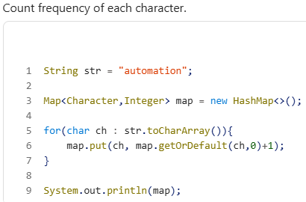
Pattern 2: Find Duplicate Characters
Question- String str = "programming";
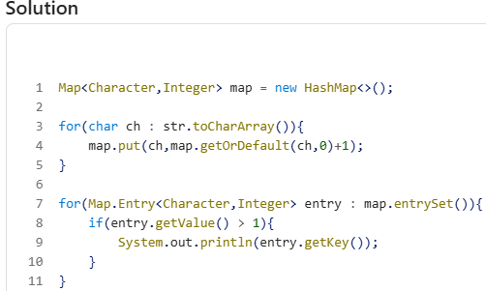
Pattern 3: First Non-Repeated Character
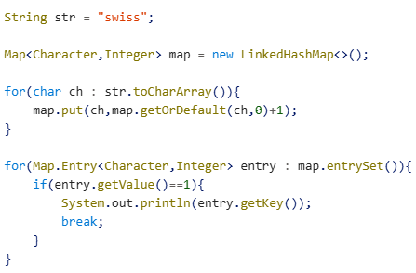
Trick -Use: LinkedHashMap - because insertion order is maintained.

Pattern 4: Duplicate Elements In Array
int[] arr = {1,2,3,2,4,1,5};
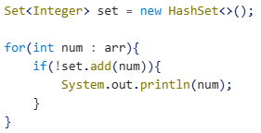
Trick-set.add()– returns=true & if element added returns=false(if duplicate)

Pattern 5: Remove Duplicates
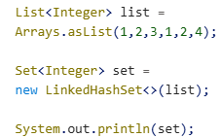
Output- [1, 2, 3, 4] =Trick- LinkedHashSet - Removes duplicates and preserves order.
Pattern 6: Find Highest Frequency Character
String str = "aaabbccccdd";
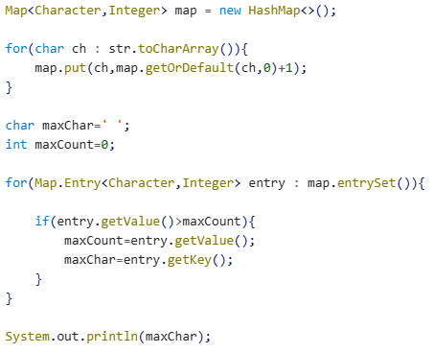
Trick – Remember = maxCount = 0 and compare while traversing.

Pattern 7: Sort List Descending
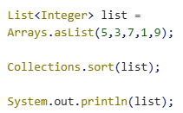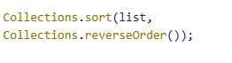

Pattern 8: Find Second Largest Number
Interview Trick - Maintain 2 variables: max, second - No sorting needed.
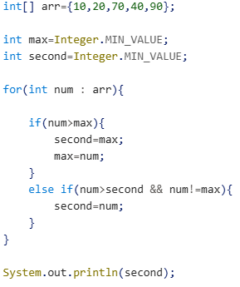
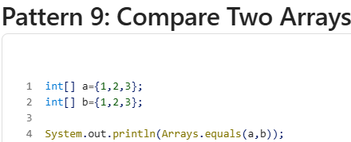
Trick -Never use – a==b Use -Arrays.equals()
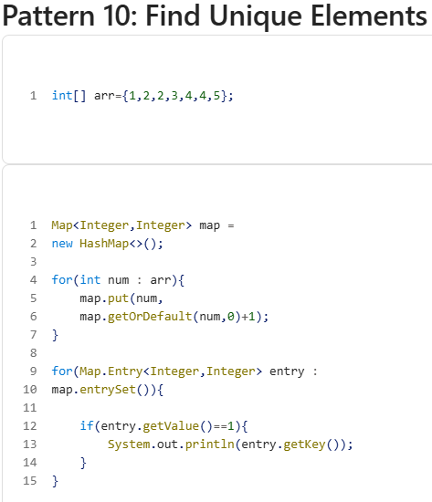
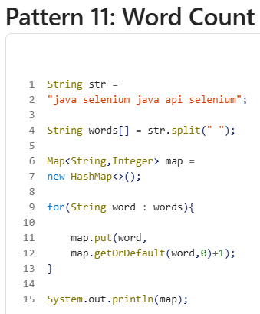
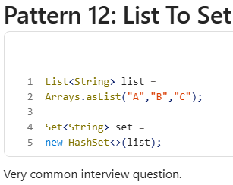
Pattern 13: Find Common Elements Between Lists
Output- [3,4] – Trick - retainAll() – Collect Common elements.
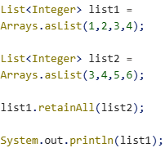

Pattern 14: HashMap Interview Questions
Iterate HashMap
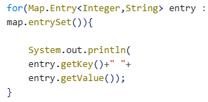
Check Key Exists- map.containsKey(101);
Check Value Exists-map.containsValue("Admin");
Remove Entry-map.remove(101);

Must-Practice Collection Programs For Automation Interviews
Practice these in order:
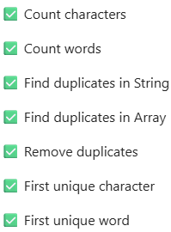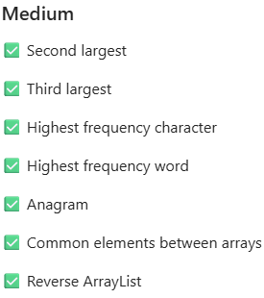

Golden Rule For Interviews
