Assignment 7 Report
Name: Prajapati Neel Hiteshbhai
Enrollment no: 202611022

1. Examination Registration Form
Code:
import tkinter as tk
from tkinter import messagebox
def register():
if not name_entry.get() or not roll_entry.get() or not course_entry.get() or not subject_entry.get() or not semester_entry.get() or not email_entry.get():
messagebox.showerror("Error", "All fields are required!")
else:
messagebox.showinfo("Success", "Registration Successful!")
def clear():
name_entry.delete(0, tk.END)
roll_entry.delete(0, tk.END)
course_entry.delete(0, tk.END)
subject_entry.delete(0, tk.END)
semester_entry.delete(0, tk.END)
email_entry.delete(0, tk.END)
root = tk.Tk()
root.title("Examination Registration Form")
tk.Label(root, text="Full Name:").grid(row=0, column=0, padx=10, pady=5)
name_entry = tk.Entry(root)
name_entry.grid(row=0, column=1, padx=10, pady=5)
tk.Label(root, text="Roll Number:").grid(row=1, column=0, padx=10, pady=5)
roll_entry = tk.Entry(root)
roll_entry.grid(row=1, column=1, padx=10, pady=5)
tk.Label(root, text="Course Name:").grid(row=2, column=0, padx=10, pady=5)
course_entry = tk.Entry(root)
course_entry.grid(row=2, column=1, padx=10, pady=5)
tk.Label(root, text="Subject:").grid(row=3, column=0, padx=10, pady=5)
subject_entry = tk.Entry(root)
subject_entry.grid(row=3, column=1, padx=10, pady=5)
tk.Label(root, text="Semester:").grid(row=4, column=0, padx=10, pady=5)
semester_entry = tk.Entry(root)
semester_entry.grid(row=4, column=1, padx=10, pady=5)
tk.Label(root, text="Email Address:").grid(row=5, column=0, padx=10, pady=5)
email_entry = tk.Entry(root)
email_entry.grid(row=5, column=1, padx=10, pady=5)
tk.Button(root, text="Register", command=register).grid(row=6, column=0, pady=10)
tk.Button(root, text="Clear", command=clear).grid(row=6, column=1, pady=10)
root.mainloop()

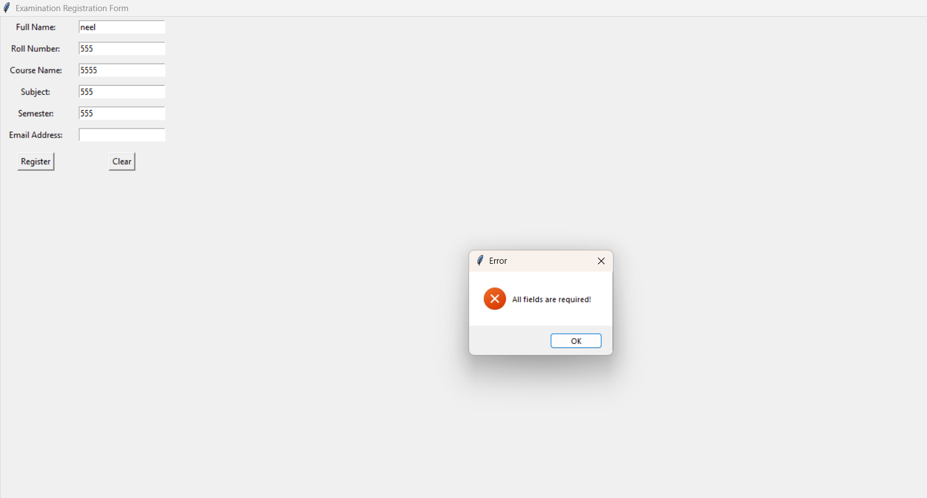

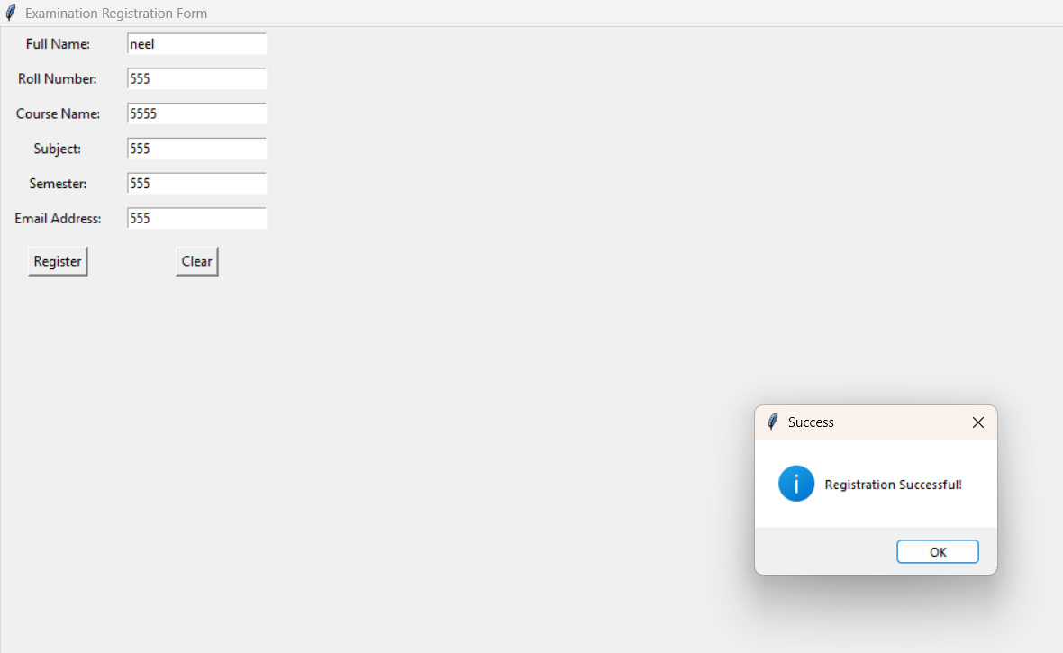

2. Student Record Management System
Code:
import tkinter as tk
from tkinter import messagebox
class Student:
def __init__(self, name, marks):
self.name = name
self.marks = marks
def display_result(self):
if self.marks > 40:
return "Pass"
else:
return "Fail"
def save_record():
name = name_entry.get()
marks_str = marks_entry.get()
try:
marks = float(marks_str)
student = Student(name, marks)
with open("students.txt", "a") as f:
f.write(f"Name: {student.name}, Marks: {student.marks}, Result: {student.display_result()}\n")
messagebox.showinfo("Success", "Record saved successfully!")
except ValueError:
messagebox.showerror("Error", "Invalid marks input (must be numeric)")
except Exception as e:
messagebox.showerror("Error", f"File error: {e}")
def show_result():
name = name_entry.get()
marks_str = marks_entry.get()
try:
marks = float(marks_str)
student = Student(name, marks)
result = student.display_result()
messagebox.showinfo("Result", f"{name} is {result}")
except ValueError:
messagebox.showerror("Error", "Invalid marks input (must be numeric)")
root = tk.Tk()
root.title("Student Record Management System")
tk.Label(root, text="Name").grid(row=0, column=0, padx=10, pady=5)
name_entry = tk.Entry(root)
name_entry.grid(row=0, column=1, padx=10, pady=5)
tk.Label(root, text="Marks").grid(row=1, column=0, padx=10, pady=5)
marks_entry = tk.Entry(root)
marks_entry.grid(row=1, column=1, padx=10, pady=5)
tk.Button(root, text="Save Record", command=save_record).grid(row=2, column=0, pady=10)
tk.Button(root, text="Show Result", command=show_result).grid(row=2, column=1, pady=10)
root.mainloop()

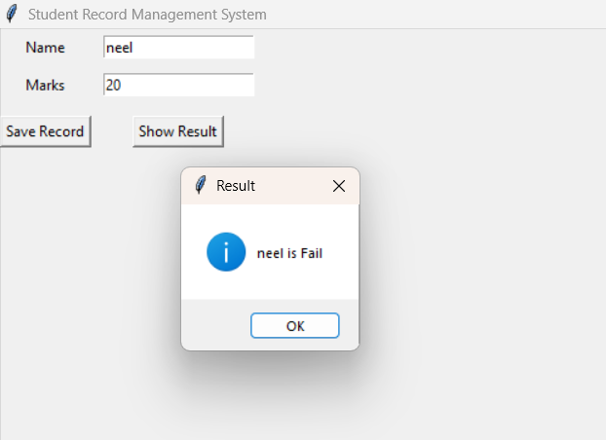

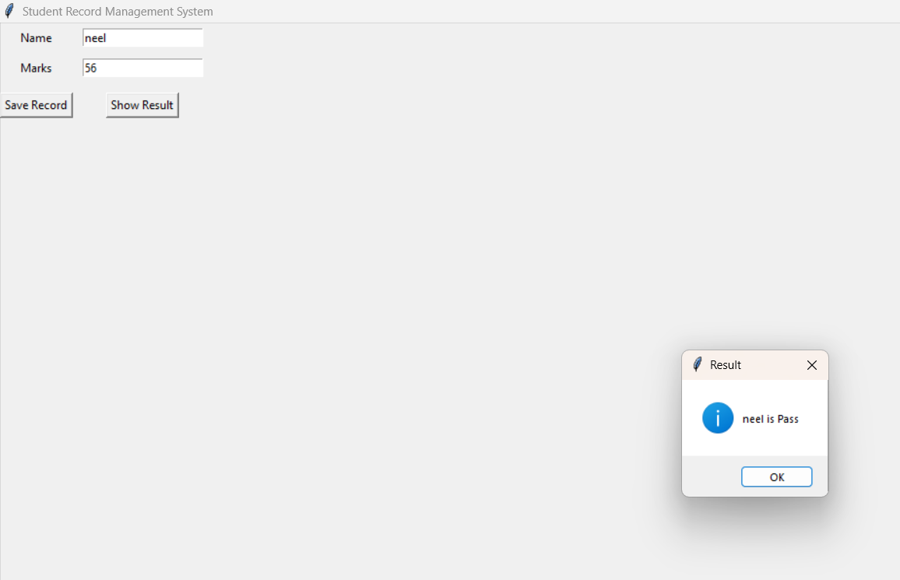

3. Student Information Form
Code:
import tkinter as tk
from tkinter import ttk, messagebox
import csv
def submit():
if not agree_var.get():
messagebox.showerror("Error", "You must agree to the terms and conditions")
return
data = {
"Name": name_entry.get(),
"Age": age_scale.get(),
"Gender": gender_var.get(),
"Course": course_var.get(),
"Programming": prog_var.get(),
"Maths": maths_var.get(),
"Communication": comm_var.get(),
"Hobbies": [hobbies_listbox.get(i) for i in hobbies_listbox.curselection()],
"Comments": comments_text.get("1.0", tk.END).strip()
}
with open("student_info.csv", "a", newline='') as f:
writer = csv.writer(f)
writer.writerow([data["Name"], data["Age"], data["Gender"], data["Course"],
data["Programming"], data["Maths"], data["Communication"],
", ".join(data["Hobbies"]), data["Comments"]])
messagebox.showinfo("Success", "Data saved successfully!")
root = tk.Tk()
root.title("Student Information Form")
root.geometry("400x650")
tk.Label(root, text="Student Information Form", font=("Arial", 14, "bold")).pack(pady=10)
tk.Label(root, text="Name").pack()
name_entry = tk.Entry(root)
name_entry.pack()
tk.Label(root, text="Age").pack()
age_scale = tk.Scale(root, from_=18, to=100, orient=tk.HORIZONTAL)
age_scale.pack()
tk.Label(root, text="Gender").pack()
gender_var = tk.StringVar(value="Male")
tk.Radiobutton(root, text="Male", variable=gender_var, value="Male").pack()
tk.Radiobutton(root, text="Female", variable=gender_var, value="Female").pack()
tk.Label(root, text="Select Course").pack()
course_var = tk.StringVar(value="Select Course")
course_dropdown = ttk.Combobox(root, textvariable=course_var, values=["BTech", "MTech", "PhD"])
course_dropdown.pack()
tk.Label(root, text="Select Subjects").pack()
prog_var = tk.BooleanVar()
maths_var = tk.BooleanVar()
comm_var = tk.BooleanVar()
tk.Checkbutton(root, text="Programming", variable=prog_var).pack()
tk.Checkbutton(root, text="Maths", variable=maths_var).pack()
tk.Checkbutton(root, text="Communication", variable=comm_var).pack()
tk.Label(root, text="Select Hobbies").pack()
hobbies_listbox = tk.Listbox(root, selectmode=tk.MULTIPLE, height=4)
for item in ["Reading", "Gaming", "Sports", "Music"]:
hobbies_listbox.insert(tk.END, item)
hobbies_listbox.pack()
tk.Label(root, text="comments").pack()
comments_text = tk.Text(root, height=4, width=30)
comments_text.pack()
agree_var = tk.BooleanVar()
tk.Checkbutton(root, text="I agree to the term and conditions", variable=agree_var).pack()
tk.Button(root, text="Submit", command=submit).pack(pady=10)
root.mainloop()

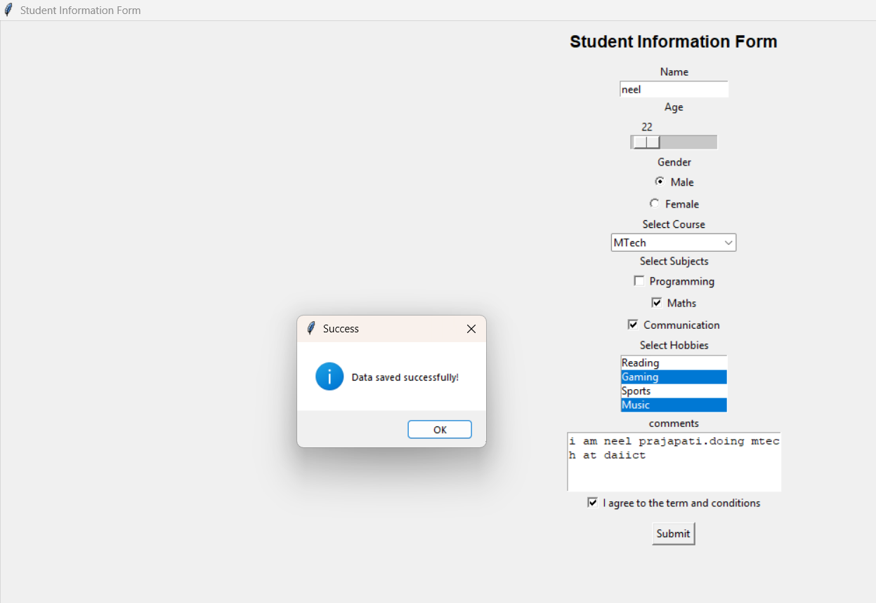

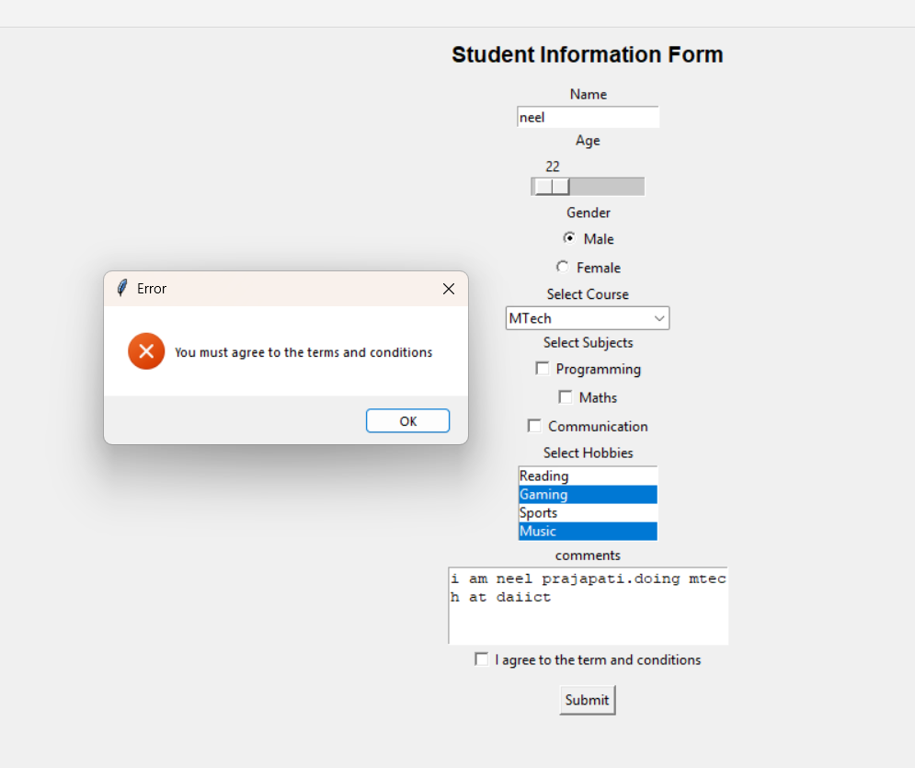

4. Simple Calculator
Code:
import tkinter as tk
from tkinter import messagebox
def calculate():
try:
num1 = float(entry1.get())
num2 = float(entry2.get())
result_label.config(text=f"Result is {num1 + num2}")
except ValueError:
messagebox.showerror("Error", "Please enter valid numbers")
root = tk.Tk()
root.title("Simple Calculator")
tk.Label(root, text="Simple Calculator", font=("Arial", 12)).grid(row=0, column=0, columnspan=2, pady=10)
tk.Label(root, text="Enter a number").grid(row=1, column=0, padx=5, pady=5)
entry1 = tk.Entry(root)
entry1.grid(row=1, column=1, padx=5, pady=5)
tk.Label(root, text="Enter another number").grid(row=2, column=0, padx=5, pady=5)
entry2 = tk.Entry(root)
entry2.grid(row=2, column=1, padx=5, pady=5)
tk.Button(root, text="Calculate", command=calculate).grid(row=3, column=0, pady=10)
result_label = tk.Label(root, text="")
result_label.grid(row=3, column=1, pady=10)
root.mainloop()

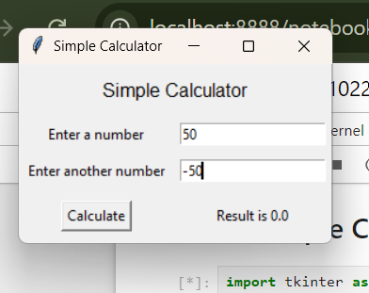

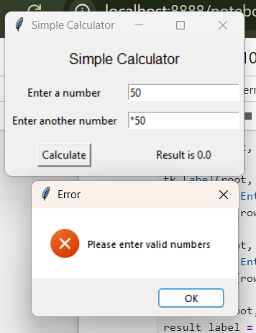

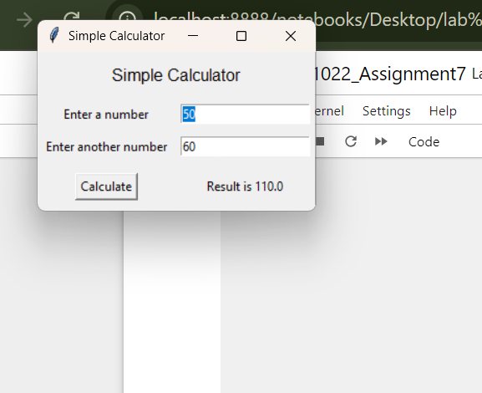

5. m to Km converter
Code:
import tkinter as tk
from tkinter import messagebox
def convert():
try:
meters = float(entry.get())
km = meters / 1000
result_label.config(text=f"{km} Km")
except ValueError:
messagebox.showerror("Error", "Please enter a valid number")
root = tk.Tk()
root.title("Demo App")
root.geometry("400x200")
tk.Label(root, text="m to Km converter", font=("Arial", 12)).pack(pady=10)
frame = tk.Frame(root)
frame.pack(pady=10)
tk.Label(frame, text="Enter the value in meter").grid(row=0, column=0, padx=5)
entry = tk.Entry(frame)
entry.grid(row=0, column=1, padx=5)
tk.Button(frame, text="Convert", command=convert).grid(row=0, column=2, padx=5)
result_label = tk.Label(root, text="Km")
result_label.pack(pady=10)
root.mainloop()

