HOW TO DO WORK:

Select a public repository. You can get it from github repository website

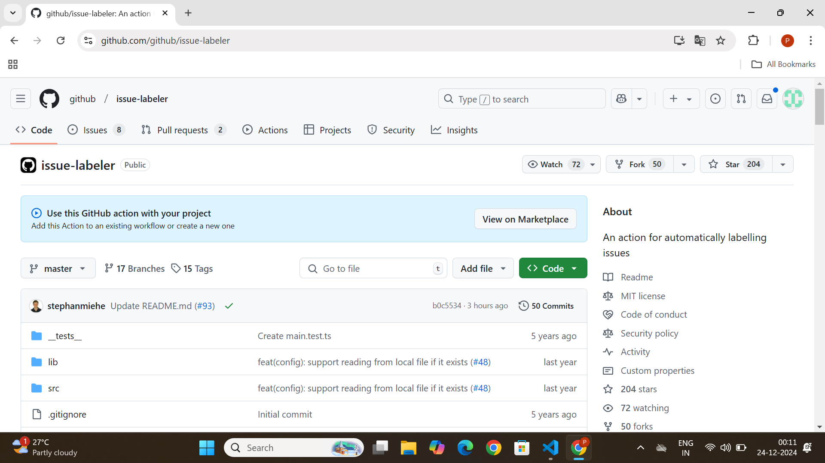

Inside that select fork

Click create fork

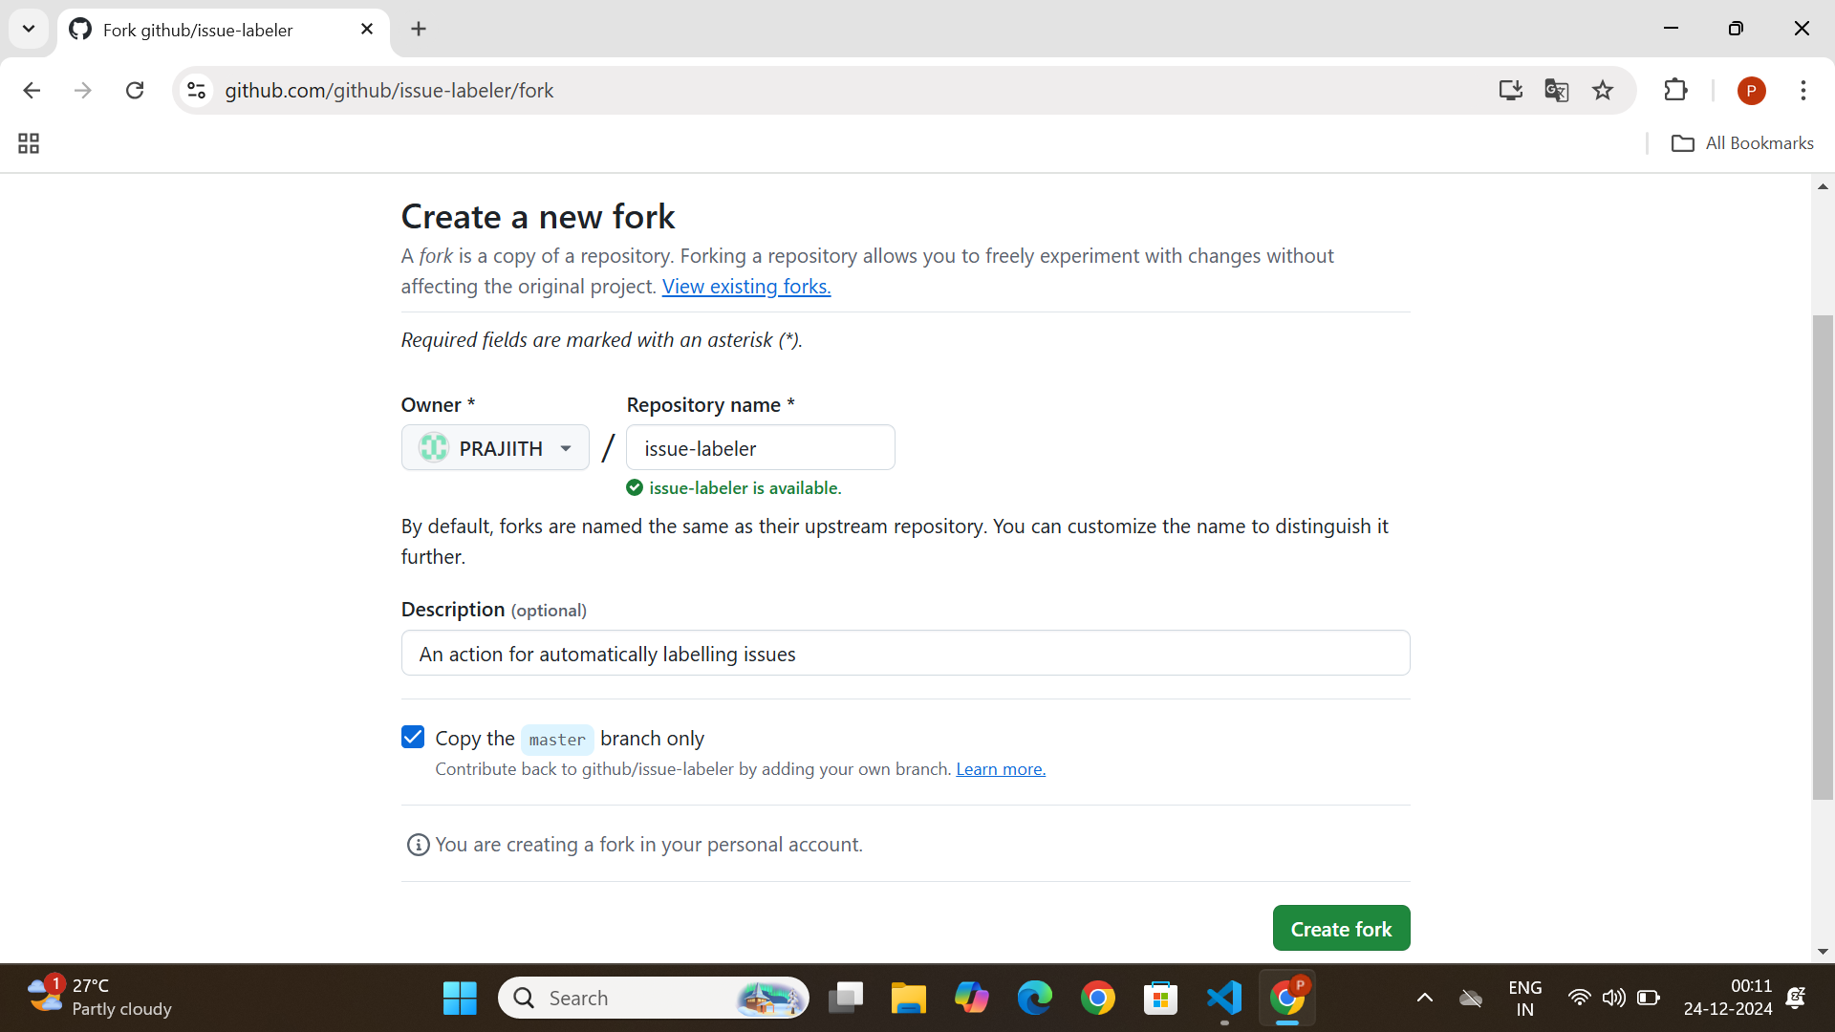

Now you will go to this screen

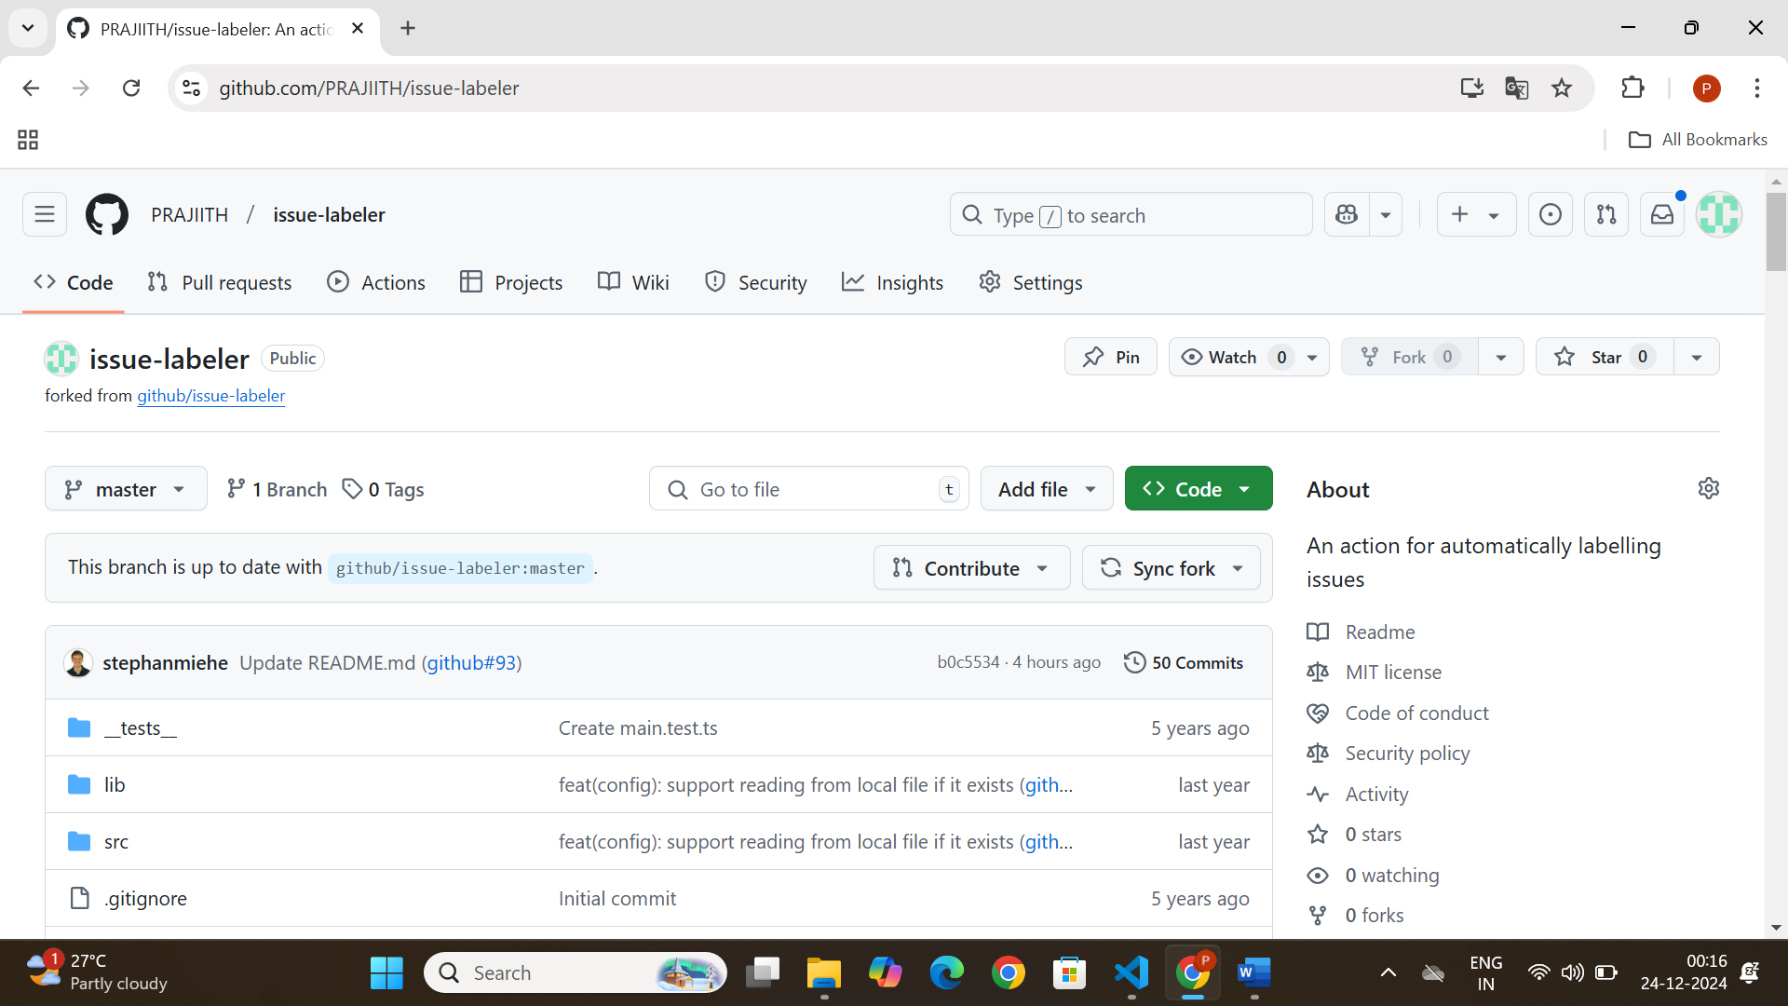

Copy the url

Step 2:

In vs code create a empty folder.

Open terminal

Commands:

git clone <https://github.com/PRAJIITH/issue-labeler>

Thus we have done forking and cloning the repository in our vs code

How to do modifications:

git clone <https://github.com/PRAJIITH/issue-labeler>

cd issue-labeler

git add prajiith

git commit -m "success changed"

git push origin

the red color words will change according to ur repository link and file name.

creating new branch

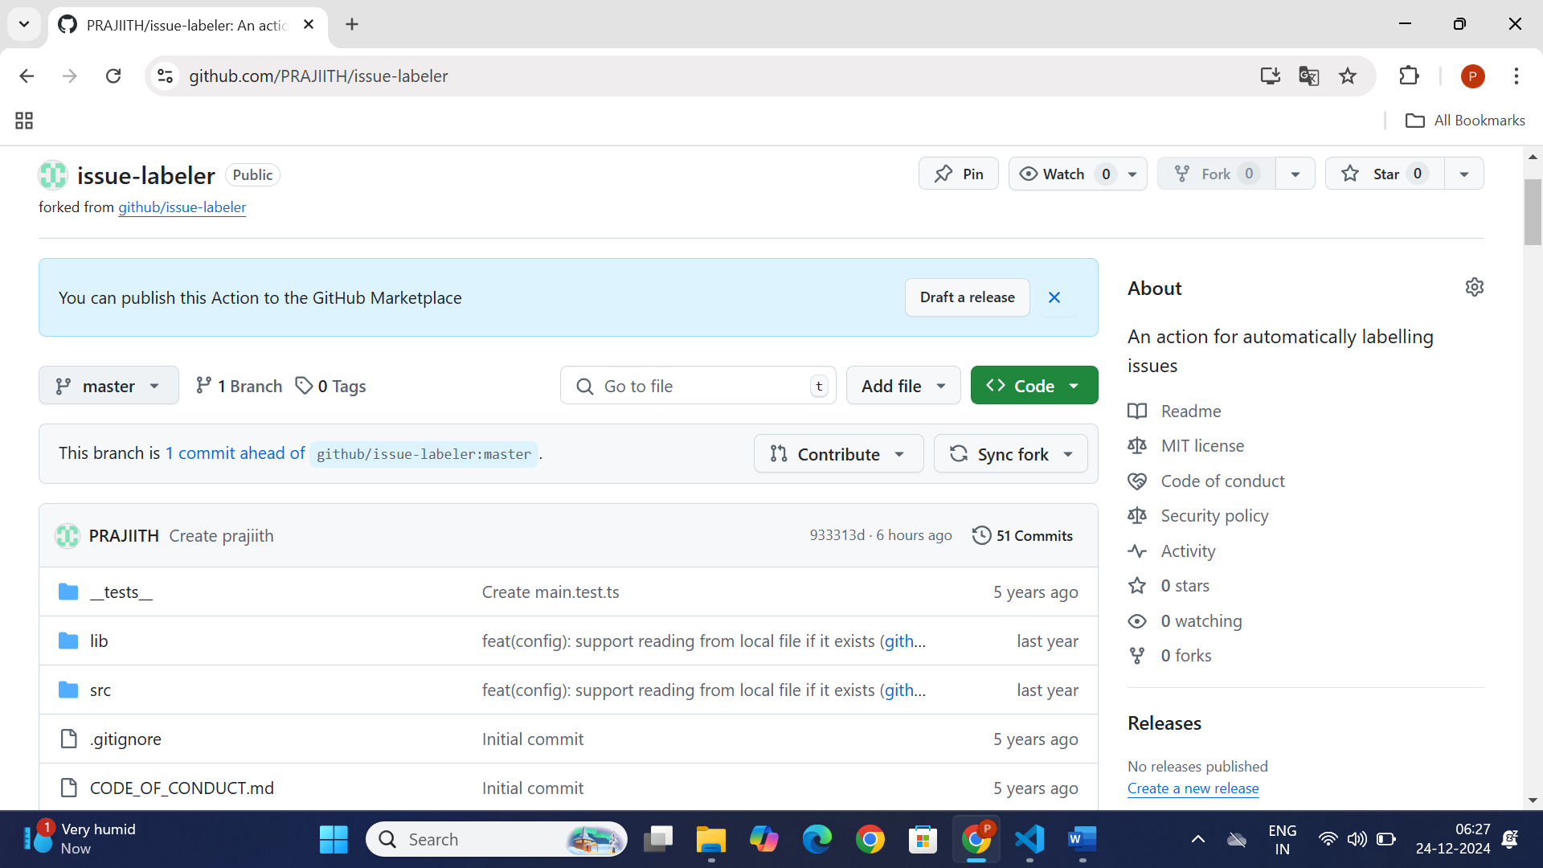

Click that master

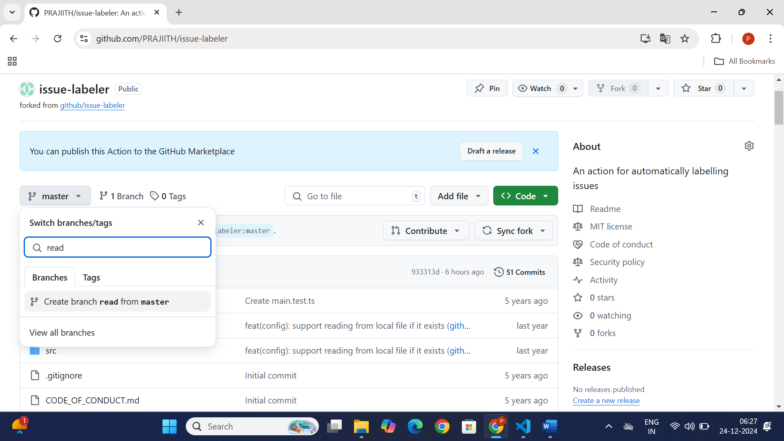

Give ur new branch name and click create branch read from main

Read will change accordind to ur branch name

How to switch to a new branch in vs code

git checkout -b read

how to get out from another branch and move to the main branch

git checkout

PULL REQUEST

Do some changes in ur file

git clone <https://github.com/PRAJIITH/issue-labeler>

cd issue-labeler

git add prajiith

git commit -m "success changed"

git push origin

the red color words will change according to ur repository link and file name.

go to github

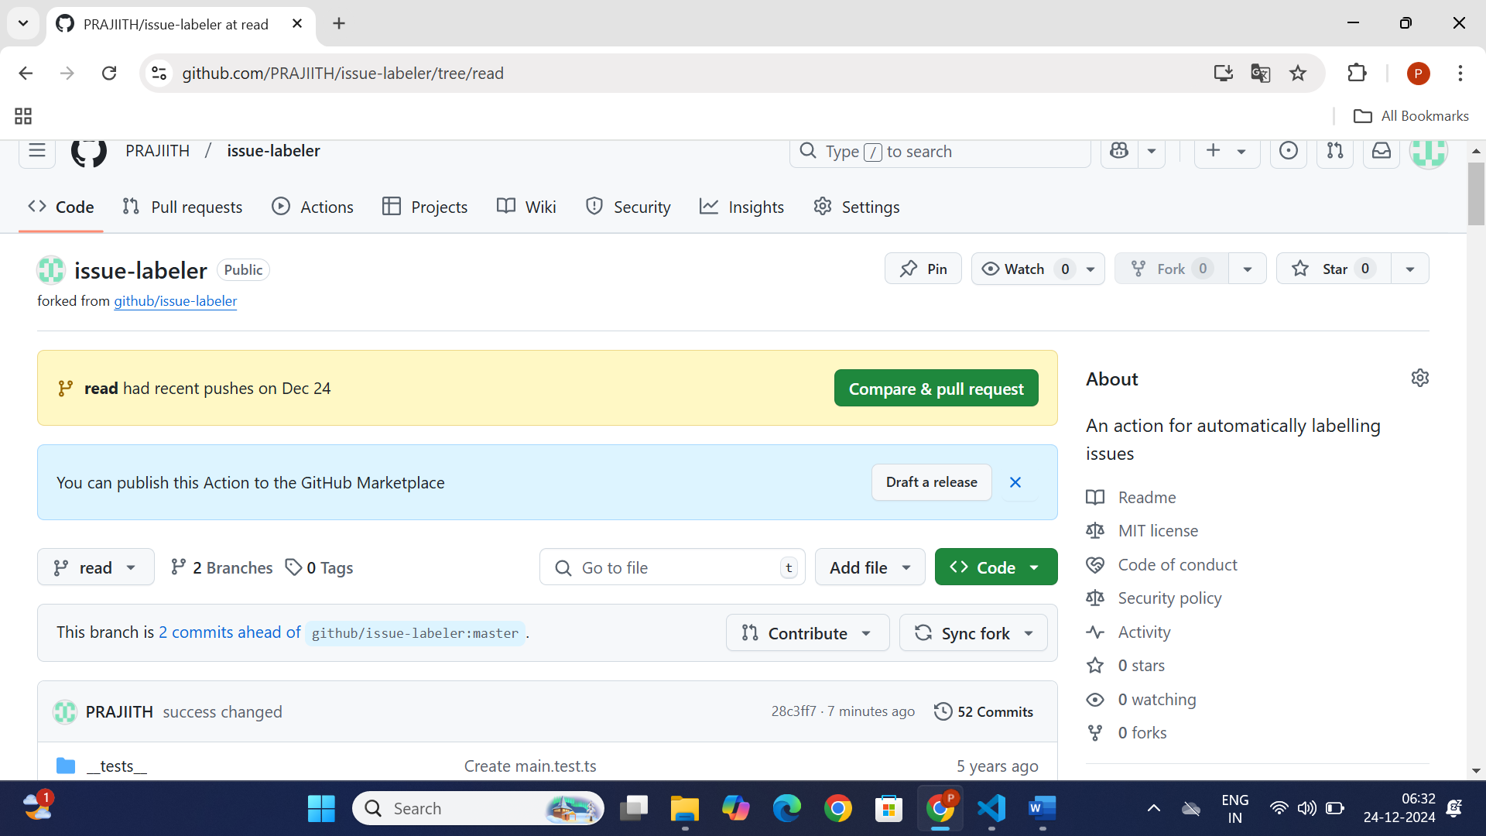

Compare and pull request

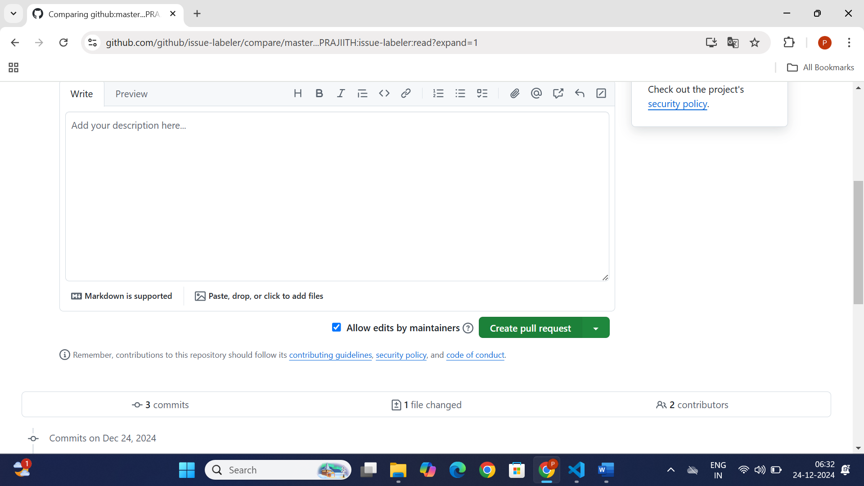

Create pull request