Step 1:

Create a nginx-deployment.yaml in a folder

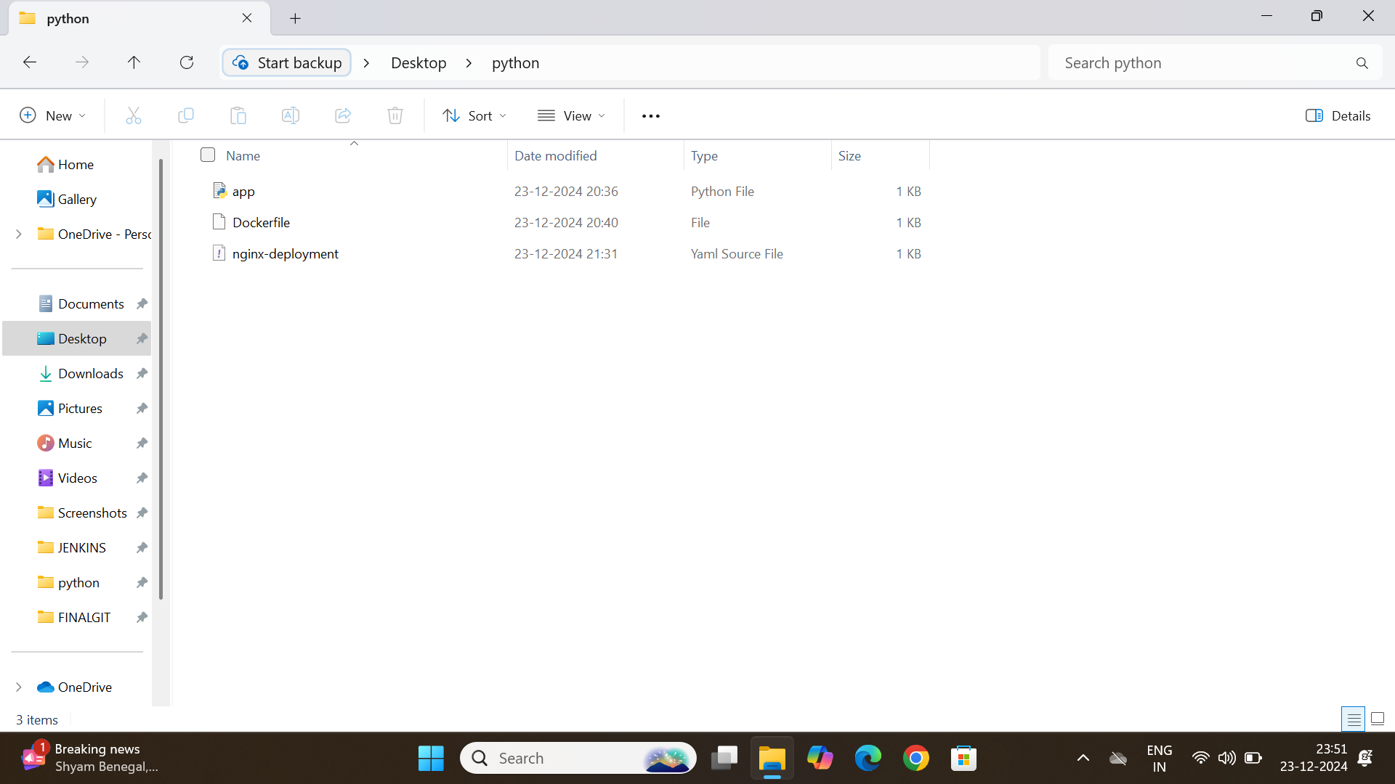

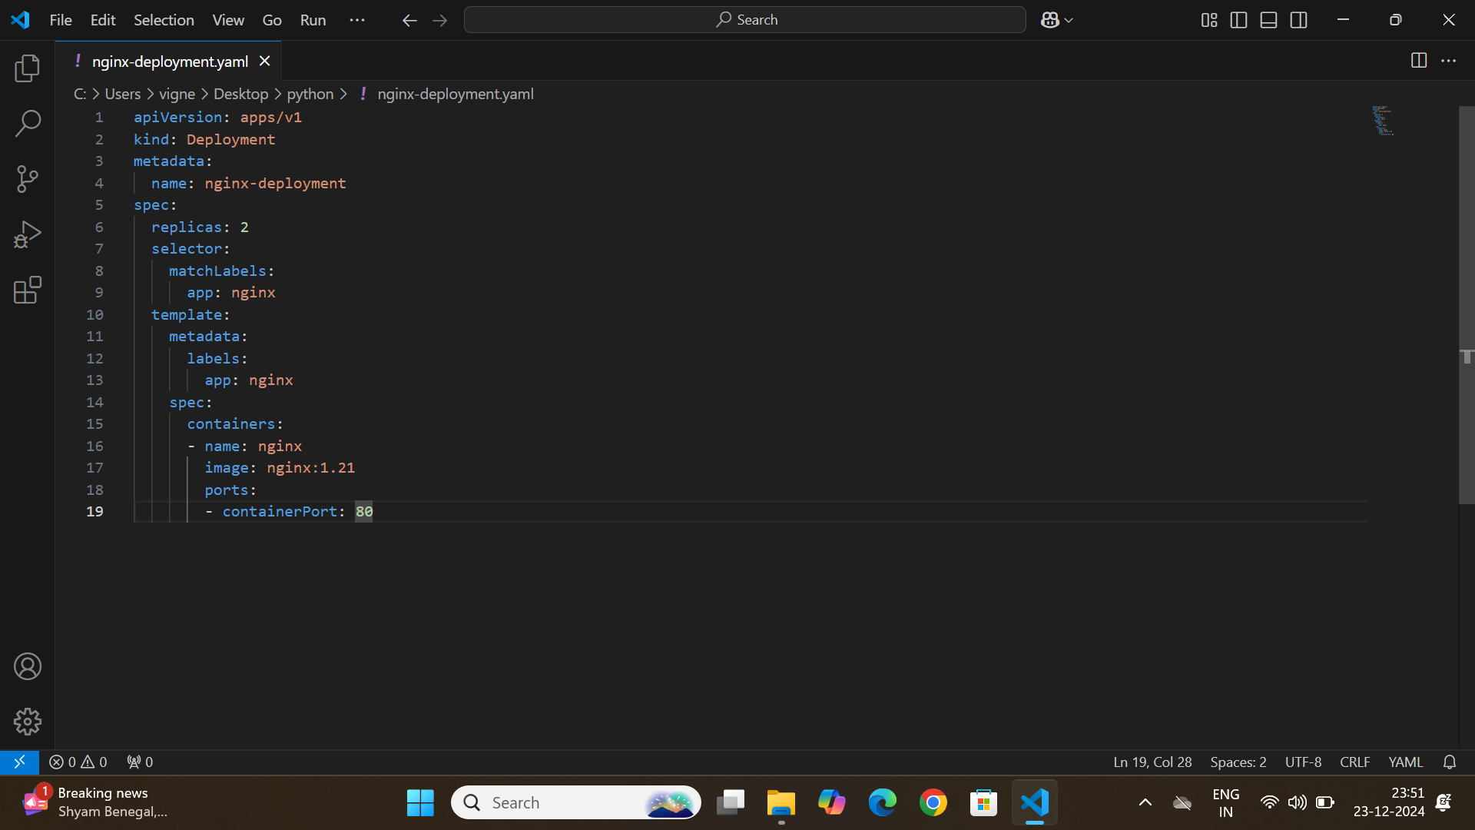

Code inside the ngnix-deployment

apiVersion: apps/v1

kind: Deployment

metadata:

name: nginx-deployment

spec:

replicas: 2

selector:

matchLabels:

app: nginx

template:

metadata:

labels:

app: nginx

spec:

containers:

- name: nginx

image: nginx:1.21

ports:

- containerPort: 80

Step 2:

Open the cmd in the same folder

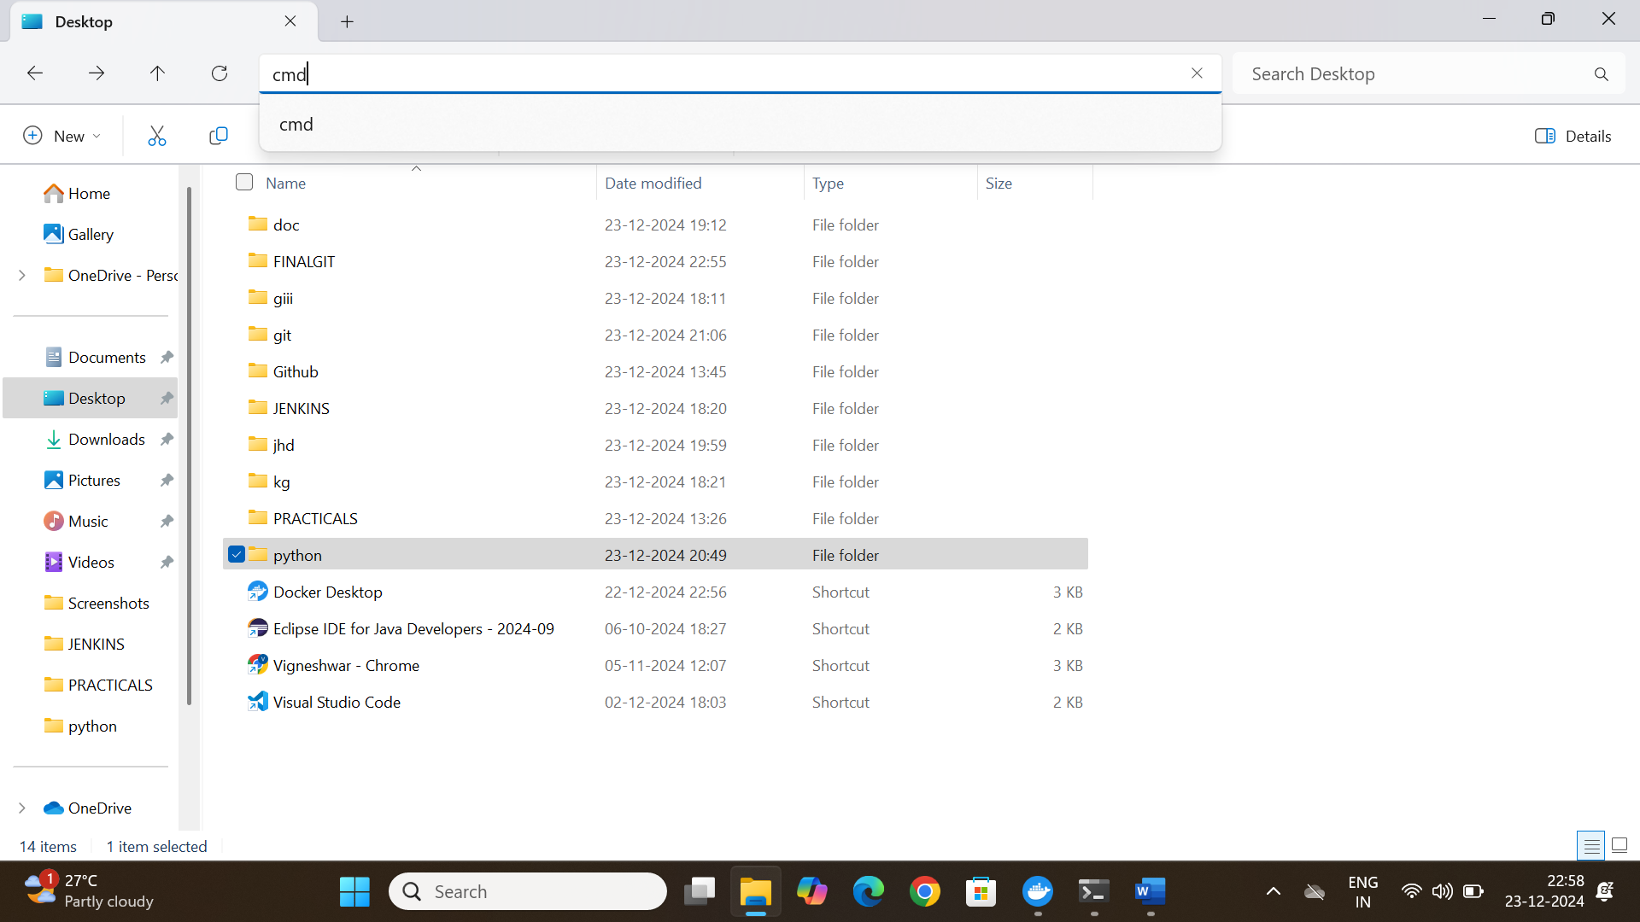

Step 3:

Type the following command in the command prompt:

kubectl apply -f nginx-deployment.yaml



kubectl expose deployment nginx-deployment --type=NodePort --name=nginx-service



kubectl get pods

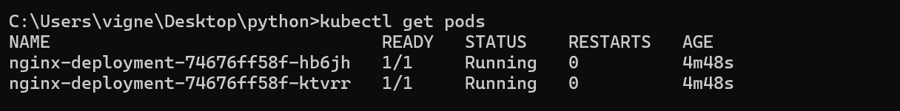

kubectl get svc

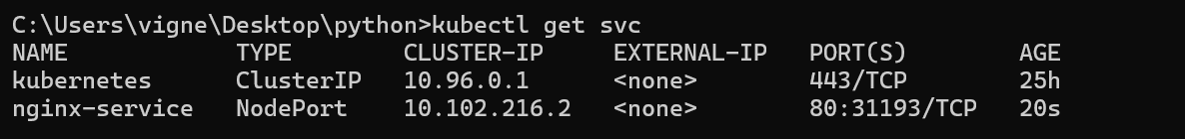

Step 4:

Type the nodeport address in your local browser like google or edge

<http://localhost:31193>

