Research Project Proposal
Fairness under Noisy Sensitive Labels: Asymmetric Corruption of Recorded Sensitive Attributes and a Noise-Aware Model-Selection Safeguard
Item | Details
Module | Interdisciplinary Elective: AI, Power & Responsibility: Governing Intelligence
Project | Project 22
Group number | 2
Team name | Rookies
Team members | Prajwal Dattatray Phalke; Naveenkumar Pugazhendhi
Document status | Initial proposal. All figures and tables in Section 8 contain dummy values that illustrate planned outputs. They are not experimental results.

1. Target journal and anchor paper
Item | Details
Target journal | Data Mining and Knowledge Discovery (Springer Nature; subscription or hybrid route). Impact factor 5.5 (2025 JIF, as recorded in the project catalogue, checked 26 October 2026).
Anchor paper | Small, E. A., Shao, W., Zhang, Z., Liu, P., Chan, J., Sokol, K., & Salim, F. D. (2025). How robust is your fair model? Exploring the robustness of prominent fairness strategies. Data Mining and Knowledge Discovery. DOI: 10.1007/s10618-025-01112-8 [1]
Fit with the journal | The anchor paper measures how fairness strategies behave when noise is injected into the data and proposes a robustness ratio [1]. Our project follows the same robust fair-data-mining theme and extends it to asymmetric, group-dependent corruption of the recorded sensitive attribute, applied separately to training and validation data, with a validation-based safeguard against models that look fair but are fragile.

2. Background and motivation
Group fairness metrics such as demographic parity and equalized odds compare outcomes across groups defined by a sensitive attribute, for example sex or gender. Computing them, and training models that satisfy them, requires that the attribute is recorded for each person. Recent surveys of bias mitigation and of fairness without demographics show how widely this assumption is built into practice [12, 13].
In real systems the recorded attribute is often imperfect. It may be self-reported inconsistently, inferred by a model, entered incorrectly, or missing. Empirical work shows that protected-label quality changes both the measured disparity and which mitigation method appears best [2, 4, 5]. For example, bias mitigation methods that use the sensitive attribute directly, such as threshold optimisation and resampling, were found to be the most sensitive to errors in an inferred sensitive attribute [4]. Work on AUC fairness also reports that standard methods become fragile when protected group labels are noisy [3].
Governance relevance. This matters for AI governance because fairness claims are increasingly used as evidence in audits and compliance processes. The EU AI Act (Regulation (EU) 2024/1689) allows providers of high-risk AI systems to process special categories of personal data under strict conditions when this is necessary for bias monitoring, detection and correction (Article 10(5)) [8, 11]. An auditor who relies on such data inherits its errors. If a model is selected because it looks fair on noisy group labels, a regulator, a company and the affected people may all receive false reassurance. The power to decide what counts as fair therefore depends on the quality of data that is rarely questioned.
Earlier theory showed that fair classification is possible under particular models of sensitive-feature noise [14], and that satisfying a fairness criterion on noisy groups can leave the true groups with a larger violation [15]. Empirical comparisons of attribute-unaware and noise-tolerant classifiers also exist [16]. Recent studies reuse the Folktables benchmark to study protected-label missingness in fairness audits and caution that apparent audit instability must be calibrated against ordinary seed variation [2]. Model selection itself can be unstable, because many near-equivalent models exist [6, 7]. Related noisy-label work in crowdsourcing also finds that label noise can distort fairness measures [9, 10].

3. Research problem and research gap
Research problem. When the recorded sensitive attribute is corrupted in a group-dependent way, how much do fairness-aware learning strategies degrade, and can practitioners be misled into choosing a model that appears fair but is not?
Identified gaps (based on the sources reviewed so far; to be confirmed by the Checkpoint 1 novelty search):
- Asymmetric corruption. Much robustness work injects symmetric or class-conditional noise. Group-dependent flips, where one group is mislabelled more than the other and in a chosen direction, are less systematically compared across several fairness strategies.
- Validation labels. Corruption is usually studied in training data. Fairness-aware model selection also uses validation sensitive labels, and corrupted validation labels may lead to the wrong model being chosen. This selection step is under-examined.
- Evaluation against a clean reference. Fairness is often reported on the same noisy labels used for training, which hides the gap between apparent and real fairness.
- Safeguards. Few practical, model-agnostic selection rules protect against false reassurance while respecting a utility requirement.
Contribution. We propose a controlled simulation study with asymmetric corruption applied separately to training and validation data, evaluated on clean test labels, and a noise-aware model-selection safeguard with a pre-specified utility floor.

4. Research questions and hypotheses
RQ | Research question | Working hypothesis
RQ1 | How does asymmetric corruption of sensitive-attribute labels affect the fairness-utility trade-off of different fairness-aware learning strategies across varying noise rates and group imbalances? | H1: Strategies that use the sensitive attribute more directly lose more of their fairness advantage as noise grows.
RQ2 | To what extent can corruption in validation-set sensitive labels cause fairness-aware model-selection procedures to select models that appear fair but exhibit substantial fairness disparities on clean reference labels? | H2: The false-reassurance rate rises with noise and is higher under asymmetric than symmetric corruption.
RQ3 | Can a noise-aware model-selection safeguard improve worst-case fairness under asymmetric sensitive-label corruption while maintaining a predefined predictive-utility threshold? | H3: The safeguard reduces worst-case clean fairness gaps relative to naive selection at a small, bounded utility cost.
RQ4 | How do the direction and severity of asymmetric label corruption interact with group prevalence and target-class imbalance to influence demographic parity, equal opportunity, and equalized odds? | H4: Harm is largest when the minority group is small, noise is high, and flips run from the minority to the majority group.
RQ5 | To what extent do the effects of asymmetric sensitive-label corruption and the effectiveness of noise-aware safeguards generalize between the Adult Income and Default of Credit Card Clients datasets? | H5: Strategy rankings are broadly preserved across datasets, with larger effects on the dataset with the larger base-rate gap (Adult).

5. Datasets, sources and accessibility
Both datasets are publicly available and downloadable. Reuse terms for both files will be confirmed and documented at Checkpoint 2.
 | Default of Credit Card Clients | Adult Income (Adult reconstruction)
Source / URL | UCI Machine Learning Repository | Folktables GitHub repository
Access and format | Direct download, Excel (.xls) | Direct download from GitHub, CSV
Size | 30,000 clients, 25 columns, no missing values | 49,531 rows, 14 attributes
Target | Default payment next month (about 22% positive) | Income above $50,000 (binarised from continuous income; about 24% above in our pilot sample)
Sensitive attribute | SEX (about 40% male); excluded from model features | Gender (about 67% male in our pilot sample); excluded from model features
Role in the study | Main dataset (finance, small base-rate gap between groups) | Second dataset (census, larger gap) for the RQ5 replication
Terms of use | To be confirmed from the dataset page at Checkpoint 2 | Repository is MIT-licensed; underlying data come from US Census sources. To be confirmed at Checkpoint 2
Change from the idea document: the catalogue proposed UCI credit card default plus bounded ACSIncome samples. We replaced ACSIncome with the Adult reconstruction from the same Folktables repository because it is the standard fairness benchmark with a binary income target and a gender attribute, which makes results comparable with earlier fairness work.

6. Methodology and experimental design

6.1 Data preparation and splits
- Targets: default next month (credit) and income above $50,000 (Adult). Sensitive attribute: recorded sex or gender, treated as binary and excluded from model features, but used for fairness training and evaluation.
- Stratified 60/20/20 train, validation and test splits, repeated over seeds. The original sensitive labels are kept as the clean reference.
- Corruption is injected into the training and validation sensitive labels only. The test set always uses clean labels.

6.2 Corruption model
- Group-dependent flip probabilities p0 = P(recorded = 1 | true = 0) and p1 = P(recorded = 0 | true = 1), at 0, 5, 10, 20 and 30%.
- Direction of asymmetry varied: symmetric, minority-to-majority only, majority-to-minority only, and class-dependent (flips depend on the target label).
- Further factors: group imbalance (for example 50/50, 70/30, 90/10 by resampling) and target-class imbalance.
- Training and validation corruption applied independently, so selection under corrupted validation labels can be isolated.

6.3 Strategies compared
- Unconstrained logistic regression (baseline).
- Group reweighting (Kamiran and Calders style) [20].
- Fairlearn exponentiated-gradient reductions for demographic parity and equalized odds [18].
- Extension: threshold post-processing [19], since post-processing methods were the most noise-sensitive family in the anchor paper and in related work [1, 4].

6.4 Noise-aware model-selection safeguard
- Candidate models come from a grid of strategy and hyper-parameter settings (for example constraint tolerance and regularisation strength).
- Naive selection picks the fairest model on the corrupted validation labels. The oracle picks the fairest model on clean validation labels (an upper bound, not deployable).
- Safeguard: for each candidate, compute a worst-case fairness estimate over a plausible range of flip rates (an uncertainty set around an assumed or estimated noise level), using noise-corrected group rates. Select the candidate with the smallest worst-case estimate among those meeting a pre-specified utility floor (for example at most 1.5 percentage points of balanced accuracy below the unconstrained baseline).
- Ablations: remove the correction, the worst-case step or the utility floor; mis-specify the assumed noise rate by ±50%; estimate the noise rate from a small clean audit sample.
The exact form of the correction will be finalised during implementation and checked against the theory of fairness under noisy groups [14, 15].

6.5 Evaluation metrics
- Utility: accuracy and balanced accuracy.
- Fairness: demographic parity difference, equal opportunity difference and equalized odds difference, all evaluated against the clean reference labels.
- Selection quality: false-reassurance rate (selected model passes a fairness threshold on corrupted validation labels but fails it on clean labels), selection disagreement with the oracle, and regret (clean fairness of the selected model minus that of the oracle choice).
- Robustness: a ratio of fairness under noise to fairness without noise, following the idea in the anchor paper [1]; the exact definition will be adopted from that paper.

6.6 Statistical analysis and reproducibility
- Pilot: 3 seeds on stratified subsamples (18,000 Adult and 12,000 credit rows). Final study: at least 20 seeds on the full data.
- Paired bootstrap 95% confidence intervals for selector comparisons; multiple-comparison control where several contrasts are tested; Pareto frontiers; failure detection (cases where fairness gains vanish or reverse).
- Sensitivity analysis of the fairness threshold (for example 0.03, 0.05, 0.08) and the utility floor (for example 1, 1.5, 3 percentage points).
- Python with scikit-learn, Fairlearn, pandas, NumPy and matplotlib; fixed seeds, pinned versions and a README with execution steps.

7. Expected results: how to read the figures
Section 8 shows 16 planned outputs (10 figures and 6 tables), grouped by research question. All values are synthetic placeholders created to show the planned format and the direction of the hypotheses. They are not measured results and must not be interpreted as findings. They will be replaced by real results from the executed study.

8. Planned results with dummy data

RQ1. Fairness-utility trade-off under asymmetric corruption
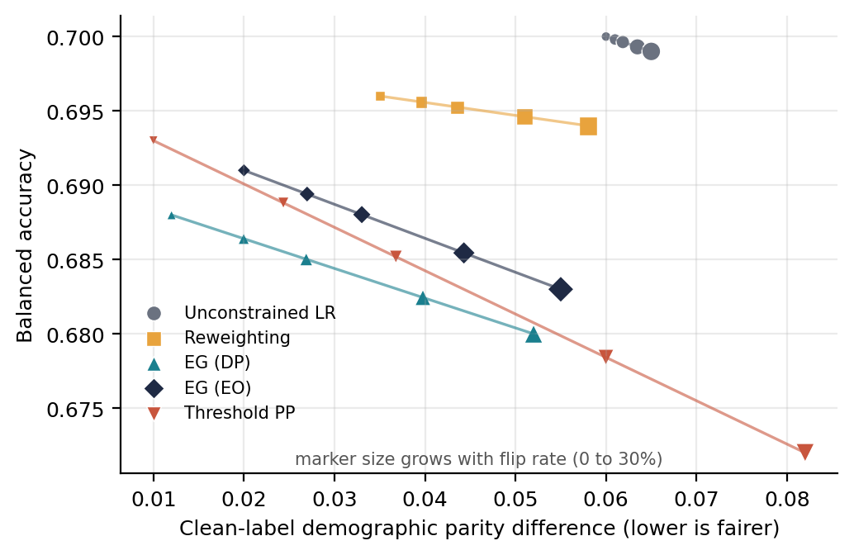
Figure 1. Fairness-utility Pareto plot for five strategies at flip rates from 0 to 30% (illustrative, dummy data)
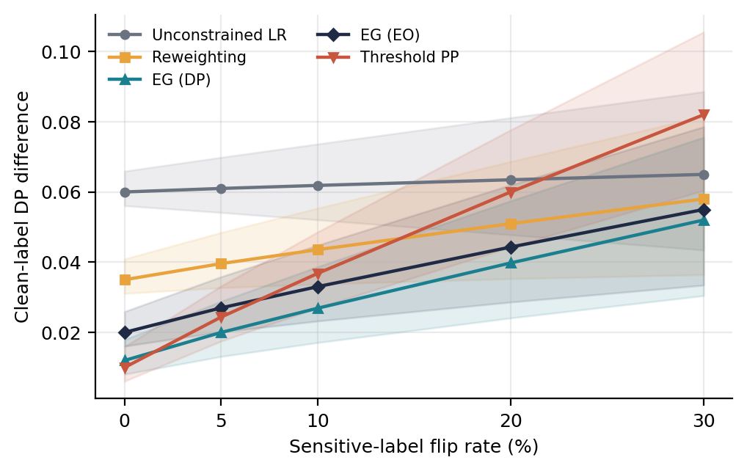
Figure 2. Clean-label demographic parity difference versus sensitive-label flip rate, with 95% bands (illustrative, dummy data)
Table 1. Utility and fairness summary at 20% flips (mean ± SD over seeds; dummy data)
Strategy | Accuracy | DP diff. | Equal opp. diff. | Eq. odds diff.
Unconstrained LR | 0.699 ± 0.004 | 0.063 ± 0.006 | 0.063 ± 0.007 | 0.073 ± 0.008
Reweighting | 0.695 ± 0.004 | 0.051 ± 0.006 | 0.054 ± 0.007 | 0.062 ± 0.008
EG (DP) | 0.682 ± 0.004 | 0.040 ± 0.006 | 0.054 ± 0.007 | 0.062 ± 0.008
EG (EO) | 0.685 ± 0.004 | 0.044 ± 0.006 | 0.038 ± 0.007 | 0.045 ± 0.008
Threshold PP | 0.678 ± 0.004 | 0.060 ± 0.006 | 0.059 ± 0.007 | 0.063 ± 0.008

Table 2. Strategy ranking by clean-reference demographic parity (1 = fairest; dummy data)
Strategy | 0% flips | 10% flips | 30% flips
Unconstrained LR | 5 | 5 | 4
Reweighting | 4 | 4 | 3
EG (DP) | 2 | 1 | 1
EG (EO) | 3 | 2 | 2
Threshold PP | 1 | 3 | 5
Reading: constrained methods rank best without noise, but the ranking changes as noise grows, and post-processing falls furthest (hypothesis H1).

RQ2. Selection under corrupted validation labels
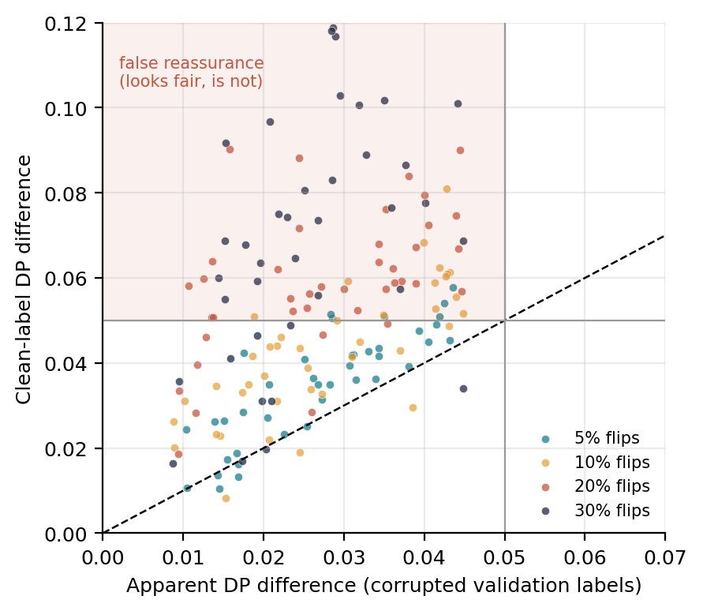
Figure 3. Apparent (noisy-label) versus clean-label fairness for naive-selected models (illustrative, dummy data)
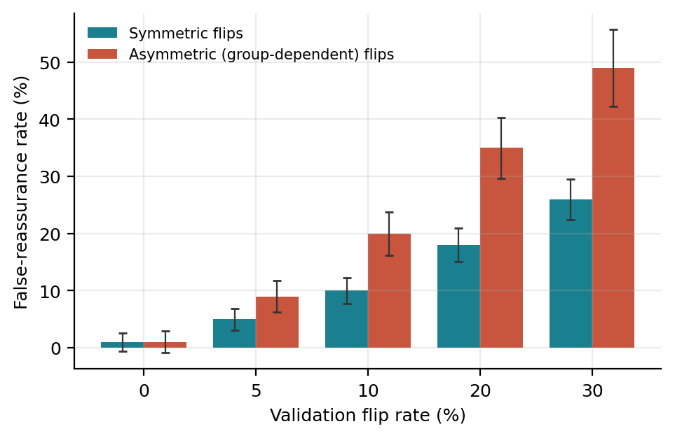
Figure 4. False-reassurance rate by validation flip rate, symmetric versus asymmetric corruption (illustrative, dummy data)
Table 3. Naive-selected versus clean-oracle model (dummy data)
Flip rate (%) | Naive choice | Oracle choice | Disagreement (%) | Regret (clean DP diff.)
10 | EG (DP) | EG (DP) | 22 | 0.006
20 | Threshold PP | EG (EO) | 41 | 0.019
30 | Threshold PP | EG (EO) | 58 | 0.034

RQ3. Noise-aware safeguard
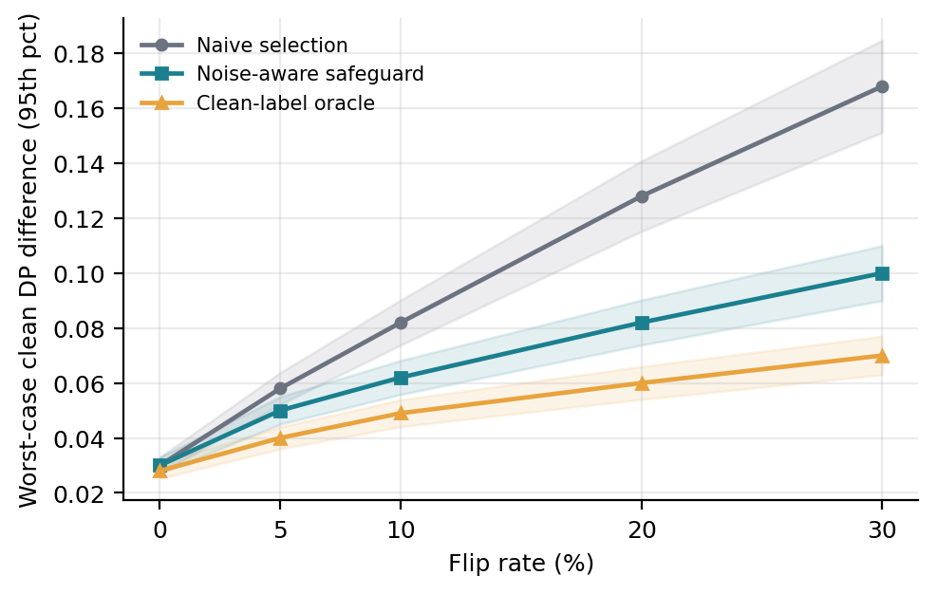
Figure 5. Worst-case clean demographic parity difference: naive selection, safeguard and oracle (illustrative, dummy data)
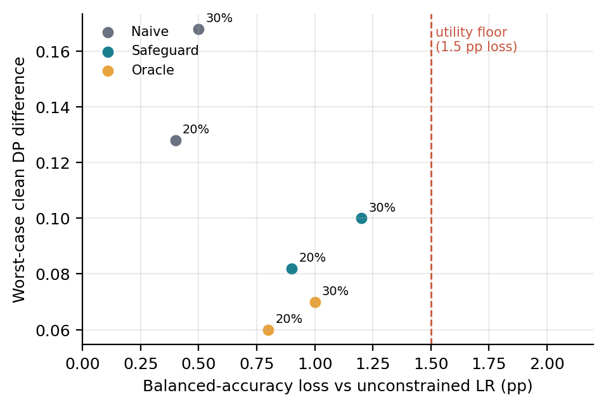
Figure 6. Utility-feasibility view: balanced-accuracy loss versus worst-case fairness, with the utility floor (illustrative, dummy data)
Table 4. Bootstrap uncertainty for selector comparisons (estimate [95% CI]; dummy data)
Outcome | Naive | Safeguard | Oracle | Safeguard − naive
Worst-case clean DP diff. (20%) | 0.128 [0.115, 0.142] | 0.082 [0.074, 0.091] | 0.060 [0.054, 0.067] | −0.046 [−0.058, −0.034]
Worst-case clean DP diff. (30%) | 0.168 [0.151, 0.186] | 0.100 [0.090, 0.111] | 0.070 [0.063, 0.078] | −0.068 [−0.083, −0.053]
Worst-case clean EO diff. (30%) | 0.172 [0.153, 0.192] | 0.108 [0.096, 0.121] | 0.081 [0.072, 0.090] | −0.064 [−0.080, −0.048]
Utility-floor feasibility (30%) | 100% [97, 100] | 96% [92, 99] | 98% [95, 100] | −4 pp [−8, 0]

RQ4. Direction, severity, group prevalence and class imbalance
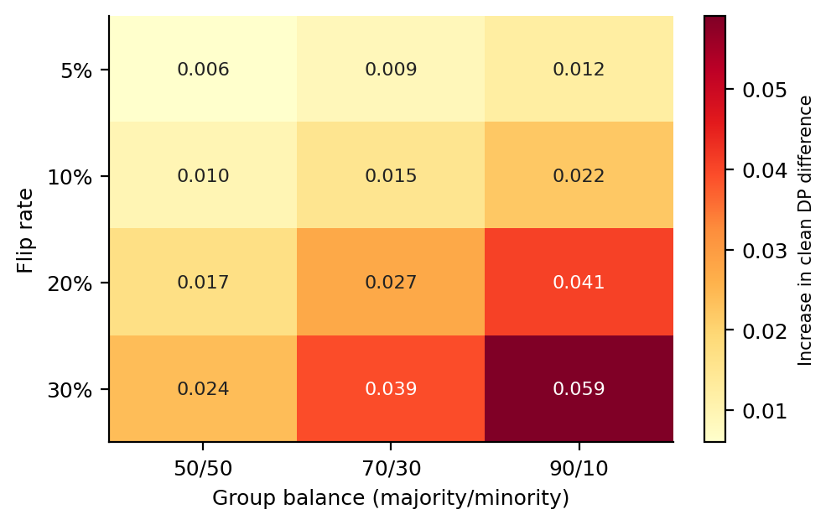
Figure 7. Flip rate by group-imbalance heatmap of the increase in clean demographic parity difference (illustrative, dummy data)
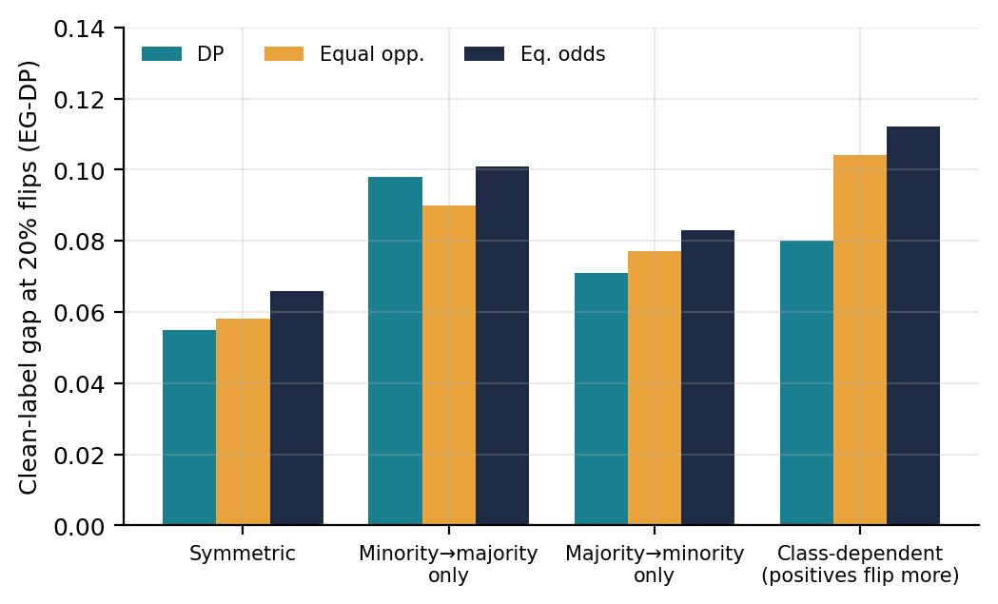
Figure 8. Comparison of corruption directions on three fairness gaps at 20% flips (illustrative, dummy data)
Table 5. Interaction effects on the clean demographic parity, equal opportunity and equalized odds gaps (coefficient [95% CI]; dummy data)
Factor | DP diff. | Equal opp. diff. | Eq. odds diff.
Flip rate (per +10 pp) | +0.021 [0.017, 0.025] | +0.024 [0.019, 0.029] | +0.027 [0.022, 0.032]
Minority share (per −20 pp) | +0.015 [0.011, 0.019] | +0.012 [0.008, 0.016] | +0.014 [0.010, 0.018]
Positive-class rate (per −10 pp) | +0.004 [0.000, 0.008] | +0.011 [0.006, 0.016] | +0.010 [0.005, 0.015]
Flip rate × minority share | +0.009 [0.005, 0.013] | +0.007 [0.003, 0.011] | +0.008 [0.004, 0.012]
Direction: minority→majority vs symmetric | +0.031 [0.024, 0.038] | +0.026 [0.019, 0.033] | +0.029 [0.022, 0.036]

RQ5. Generalisation across datasets
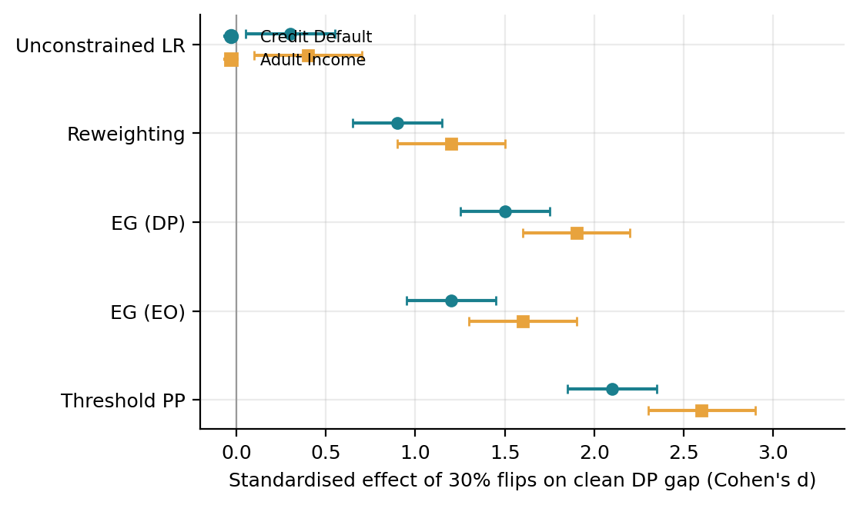
Figure 9. Cross-dataset effect sizes of 30% flips on the clean demographic parity gap (illustrative, dummy data)
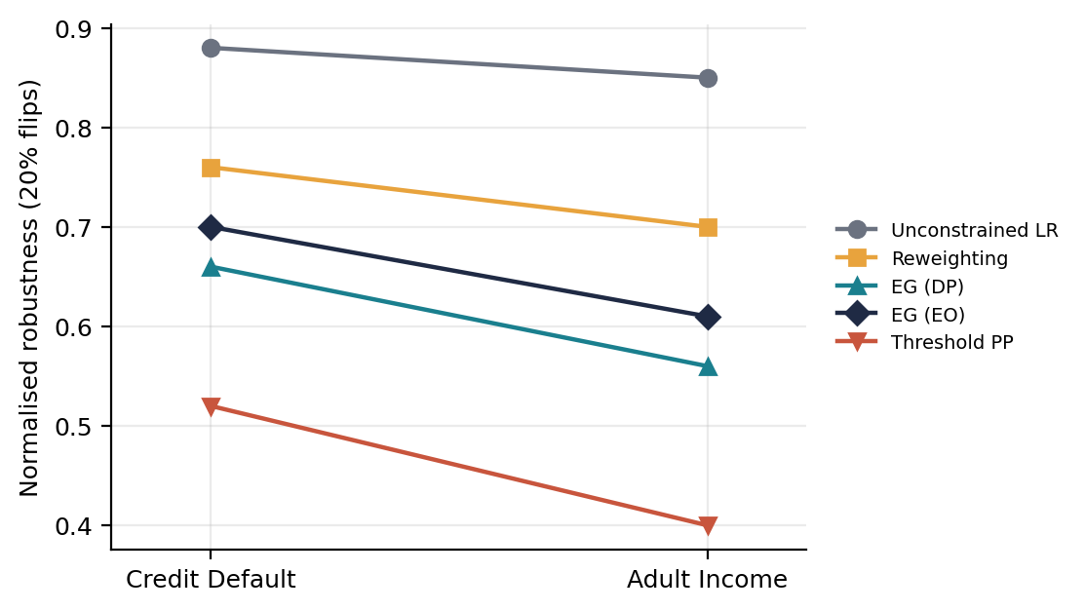
Figure 10. Dataset-by-strategy interaction in normalised robustness at 20% flips (illustrative, dummy data)
Table 6. Replication summary across Credit Default and Adult Income (dummy data)
Hypothesis | Credit Default | Adult Income | Verdict
H1: asymmetric noise erodes the fairness gain of constrained methods | Yes | Yes (larger) | Replicated
H2: naive validation selection gives false reassurance | 35% at 20% flips | 41% at 20% flips | Replicated
H3: safeguard lowers worst-case gap within utility floor | −0.046 | −0.052 | Replicated
H4: harm largest with small minority group and high noise | Yes | Yes | Replicated
H5: strategy ranking preserved across datasets | Spearman ρ = 0.90 (rank agreement) |  | Largely replicated

9. Feasibility, limitations and ethics
- Feasibility. Both datasets are small enough for at least 20 repeated seeds on standard hardware. All methods are available in scikit-learn and Fairlearn. A pilot with 3 seeds on subsamples will check run time before the full study.
- Simulation limits. Corruption is simulated. The study tests sensitivity to label error, not the real accuracy of any recorded attribute.
- Reference labels. The binary sex and gender categories have limited social meaning, and the clean labels are a reference, not objective ground truth.
- Novelty risk. The novelty claim depends on a well-justified safeguard and a rigorous comparison, so the pilot results are exploratory. Related work on fair classification with noisy protected attributes [14, 15, 16] will be reviewed in the Checkpoint 1 novelty search.
- Ethics and data. Only public, de-identified datasets are used. No attempt will be made to infer sensitive attributes of real individuals. Dataset reuse terms will be documented at Checkpoint 2.
- Responsible reporting. Findings will be reported with uncertainty and with the limits above, so that they are not used to justify or dismiss audits without context.

10. Work plan
Stage | Activity
Checkpoint 1 | Novelty search; finalise safeguard definition and corruption protocol
Checkpoint 2 | Confirm dataset reuse terms; complete pilot (3 seeds, subsamples)
Main study | At least 20 seeds on full data; ablations; sensitivity analysis
Reporting | Figures, tables and manuscript for the target journal

References
[1] Small, E. A., Shao, W., Zhang, Z., Liu, P., Chan, J., Sokol, K., & Salim, F. D. (2025). How robust is your fair model? Exploring the robustness of prominent fairness strategies. Data Mining and Knowledge Discovery. https://doi.org/10.1007/s10618-025-01112-8
[2] Tomar, Y. V. (2025). What must a fairness audit report when demographic data is incomplete? arXiv:2506.23033. (An earlier version is titled "How reliable are fairness audits with unreliable data?")
[3] Wu, M., Lin, L., Zhang, W., Wang, X., Yang, Z., & Hu, S. (2025). Preserving AUC fairness in learning with noisy protected groups. Proceedings of the 42nd International Conference on Machine Learning (ICML 2025). arXiv:2505.18532.
[4] Wang, Y., & Singh, L. (2025). Impact on bias mitigation algorithms to variations in inferred sensitive attribute uncertainty. Frontiers in Artificial Intelligence, 8, 1520330. https://doi.org/10.3389/frai.2025.1520330
[5] Min, S., Asif, H., & Vaidya, J. (2025). Exploring the inequitable impact of data missingness on fairness in machine learning. IEEE Intelligent Systems, 40(3), 28-38. https://doi.org/10.1109/MIS.2025.3549484
[6] Dai, G., Ravishankar, P., Yuan, R., Neill, D. B., & Black, E. (2025). Be intentional about fairness!: Fairness, size, and multiplicity in the Rashomon set. arXiv:2501.15634.
[7] Herasymuk, D., Poliakov, A., & Fedorchenko, V. (2025). Detecting trade-offs between fairness, stability, and accuracy for responsible machine learning model selection. Innovative Technologies and Scientific Solutions for Industries, 1(31), 5-19. https://doi.org/10.30837/2522-9818.2025.1.005
[8] Capellà i Ricart, A. (2026). Processing special categories of personal data for the purpose of ensuring bias detection and correction in relation to high-risk AI systems: an affirmative action measure? Derechos y Libertades. https://doi.org/10.20318/dyl.2026.9974
[9] Singer, G., Gruffaz, S., Vo Van, O., Vayatis, N., & Kalogeratos, A. (2026). Optimal fair aggregation of crowdsourced noisy labels using demographic parity constraints. Proceedings of the 43rd International Conference on Machine Learning (PMLR 306). arXiv:2601.23221.
[10] Ibrahim, S., Traganitis, P. A., Fu, X., & Giannakis, G. B. (2025). Learning from crowdsourced noisy labels: A signal processing perspective. IEEE Signal Processing Magazine, 42(3), 84-106.
[11] European Union (2024). Regulation (EU) 2024/1689 of the European Parliament and of the Council laying down harmonised rules on artificial intelligence (Artificial Intelligence Act).
[12] Kenfack, P. J., Ebrahimi Kahou, S., & Aivodji, U. (2024). A survey on fairness without demographics. Transactions on Machine Learning Research.
[13] Hort, M., Chen, Z., Zhang, J. M., Harman, M., & Sarro, F. (2024). Bias mitigation for machine learning classifiers: A comprehensive survey. ACM Journal on Responsible Computing, 1(2), 1-52.
[14] Lamy, A., Zhong, Z., Menon, A. K., & Verma, N. (2019). Noise-tolerant fair classification. Advances in Neural Information Processing Systems 32 (NeurIPS 2019).
[15] Wang, S., Guo, W., Narasimhan, H., Cotter, A., Gupta, M., & Jordan, M. I. (2020). Robust optimization for fairness with noisy protected groups. Advances in Neural Information Processing Systems 33 (NeurIPS 2020).
[16] Ghosh, A., Kvitca, P., & Wilson, C. (2023). When fair classification meets noisy protected attributes. Proceedings of the AAAI/ACM Conference on AI, Ethics, and Society (AIES 2023).
[17] Ding, F., Hardt, M., Miller, J., & Schmidt, L. (2021). Retiring Adult: New datasets for fair machine learning. Advances in Neural Information Processing Systems 34 (NeurIPS 2021).
[18] Agarwal, A., Beygelzimer, A., Dudik, M., Langford, J., & Wallach, H. (2018). A reductions approach to fair classification. Proceedings of the 35th International Conference on Machine Learning (ICML 2018).
[19] Hardt, M., Price, E., & Srebro, N. (2016). Equality of opportunity in supervised learning. Advances in Neural Information Processing Systems 29 (NeurIPS 2016).
[20] Kamiran, F., & Calders, T. (2012). Data preprocessing techniques for classification without discrimination. Knowledge and Information Systems, 33(1), 1-33.

