**MYSURU ROYAL INSTITUTE OF TECHNOLOGY**

Lakshmipura Road, Palahally Post, SR Patna, Mandya – 571606

**DEPARTMENT OF COMPUTER SCIENCE & ENGINEERING**

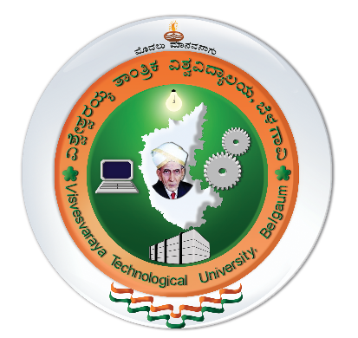

**CERTIFICATE**

This is to certify that the project work entitled **“A DATA ANALYTICS APPROACH TO THE CYBERCRIME UNDERGROUND ECONOMY”** is a bonafide work carried out by **Mahadevu M V [4MU16CS030] , Shiva Prasad N [4MU16CS058] , Yashas P [4MU16CS081] and Prajwal H S [4MU16CS088] ,** students of VIII Semester B.Eat, **Mysuru Royal Institute of Technology, Mandya,** in partial fulfillment of the requirement of project work of the **Visvesvaraya Technological University, Belagavi** during the academic year **2019–2020**. It is certified that all corrections/suggestions indicated during Internal Assessment have been incorporated in the report submitted to the department. The report has been approved as it satisfies the academic requirements in respect of the prescribed by the university.

|  |  |  |
| --- | --- | --- |
| ……………………………….  *Signature of the Guide*  **SOUMYA B,**  Asst. Professor &Head,  Department of  Computer Science & Engineering,  Mysuru Royal Institute of Technology, Mandya | ……………………………….  *Signature of the HOD*  **SOUMYA B,**  HOD,  Department of  Computer Science & Engineering,  Mysuru Royal Institute of Technology, Mandya | ……………………………….  *Signature of the Principal*  **Dr. H.S SURESH CHANDRA,**  Principal,  Mysuru Royal Institute of Technology, Mandya |

**External Viva-Voce**

**Name of the Examiner Signature with Date**

**1.**

**2.**