**CHAPTER 1**

**INTRODUCTION**

* 1. **History of Food-Ordering System**

The online food ordering system is one of the latest servicers most fast food restaurants in the western world are adopting. With this method, food is ordered online and delivered to the customer. This is made possible through the use of electronic payment system. Customers pay with their credit cards, although credit card customers can be served even before they makepayment either through cash or cheque. So, the system designed in this project will enable customers go online and place order for their food.

Due to the great increase in the awareness of internet and the technologies associated with it, several opportunities are coming up on the web. So many businesses and companies now venture into their business with ease because of the internet. One of such business that the internet introduced is an onlinefood ordering system. In today’s age of fast food and take out, many restaurants have chosen to focus on quick preparation and speedy delivery of orders rather than offering a rich dining experience. Until recently, most of this delivery orders were placed over the phone, but there are many disadvantages to this system.It is possible for anybody to order any goods via the internet and have the goods delivered at his/her doorsteps.

But while trying to discuss the transfer method of the goods and services, attention is focused on the payment mode. In other words, how possible is it to pay for goods and services via the internet? This then leads to the discussion of the economic consequences of digital cash. What are the implementations from the view point of economic? Since the world is fast becoming a global village, the necessary tool for this process is communication of which telecommunication is a key player. A major breakthrough is the wireless telephone system which comes in either fixed wireless telephone lines or the Global System of Mobile communication (GSM). What we propose is an online ordering system originally designed for use in college cafeterias, but just as applicable in any food delivery industry.

* 1. **Introduction**

Online Food ordering system is a process in which one can order various foods and beverages from some local restaurant and hotels through the use of internet, just by sitting at home or any place. And the order is delivered to the told location.

Nowadays everyone is having busy schedule whether it is urban area or rural. But talking specifically about the urban areas and deeply about the big cities, people out there are so busy in their life that they don’t get enough of time to have their meals properly. As these days women are no less than men, in any field. So in big cities even wives are working women, therefore mostly the small families manage to have their food ordered from somewhere, as they lack time. Not only this is the case, if we talk about the children in the modern era they like only fast food or something from the outside. But they ignore eating homemade meals. So food ordering system these days has one of the fastest growing market, though being a new idea.

In this project we have developed something like the same to earn from and serve the nation in a much better way possible. Nowadays, people are more regular to dine-in at restaurant for their meals. The online food ordering system provides convenience for the customers that are nothing special but the general busy people of the society. It overcomes the demerits of the manual hotel or mess system and the old fashioned queuing system. This system enhances the readymade of foods than people.

* 1. **Scope of Project**

In this project, a fast food company is designed and Food-pickup FAST FOOD, is taken as a case study to enable customers order for food and get it delivered accordingly and also to reduce the long queues of customers at the counter ordering for food and to reduce the work lord on the employees.

The following things are among other things that are discussed and what the software would handle:

❖ About the fast food company.

❖ The fast food and the services offered there.

❖ Online purchase.

❖ Type of food provided.

In view of the rapid development of computer technology in almost all the fields of operation and its use in relation to information management, it has become important to look into the development of online ordering system for firms to meet up with demands of the customers.

Therefore, the food ordering and delivery system will help customers and management to:

1. Advertise available foods in their company

2. Reduce the workload in the present system

3. Reduce time wasted in data processing

4. Create a platform for online purchase and delivery of fast food

5. Keep accurate record on purchased order and delivery.

**1.4 Definition**

**FOOD:** Any nutritious substance that people or animals eat or drink, or that plant absorbs, in order to maintain life and growth.

**MENU:** A list of dishes available in a restaurant or the food available or to be served in a restaurant or at a meal for example "a dinner-party menu”, “politics and sport are on the menu tonight".

**ONLINE FOOD ORDERING:** Online food ordering services are websites that feature interactive menus allowing customers to place orders with local restaurants and food cooperatives.

**CREDIT CARD:** A **credit card** is a payment card issued to users as a system of payment. It allows the cardholder to pay for goods and services based on the holder's promise to pay for them.

**ORDERING SYSTEM:** This is referred to as a set of detailed methods that is being used in handling the ordering process.

**RESTAURANT:** (eating place) is a place where meals and drinks are sold and served to customers.

**CUSTOMER:** Sometimes known as a client, buyer, or purchaser) is the recipient of goods, services, products or idea obtained from a seller, vendor, or supplier for a monetary or other valuable consideration.

**TECHNOLOGY:** It is the study of techniques or process of mobilizing resources (such as information) for accomplishing objectives that benefit man and his environment.

* + 1. **Existing Problem Statement**

The existing system happens to be a non computerized operating system were all operations are done manually by the waiter carrying paper and to take down the order of the customer or making an order over the counter. This leads to mistakes because the waiter might not understand what the customer had ordered therefore serving him/her a different menu. This could be so embarrassing because the customer might not take it lightly with the waiter which may lead to misunderstanding.

**PROBLEMS OF EXISTING SYSTEM**

Due to manual means being employed by the fast food restaurants, it is very

difficult to satisfy the wants and needs of the customers. Most of the problems

include:

1. Mistakes are made when taking the orders of the customers

2. The process of collecting customers’ purchases order is very tedious. This makes it impossible to deliver goods on time.

3. It leads to lack of understanding between the customers and the employees.

4. The record keeping system is poor. Losses of vital records have been reported in the past consequently. Besides, protecting the file system from unauthorized access is a problem that has defiled solution.

5. Unnecessary time is wasted conveying information through the ladder of authority. Management at times seeks to get a copy of the customer’s order form and this may take a lot of time to obtain it.

6. It causes reduction of production flow. These are the major problems facing the existing system and would be corrected with the help of the proposed system.

**1.4.2 THE PROPOSED SYSTEM**

The proposed system is developed to manage ordering activities in fast food restaurant. It helps to record customer submitted orders. The system should cover the following functions in order to support the restaurant’s business process for achieving the objectives:

1. To allow the customer to make order, view order and make changes before submitting their order and allow them make payment through prepayment card or credit card or debit card.

2. To provide interface that allows promotion and menu.

3. To prevent interface that shows customers’ orders detail to front-end and kitchen staffs for delivering customers’ orders

4. Tools that generate reports that can be used for decision making

5. A tool that allows the management to modify the food information such as price, add a new menu and many others as well as tools for managing user, system menu and promotion records.

**JUSTIFICATION FOR THE NEW SYSTEM**.

It is the purpose of the new system to address all the problems plaguing the present system. This system will do the analyzing and storing of information either automatically or interactively. It will make use of PhP-MYSQL. This will be like this: a report is generated conforming to particular information needed by the management via the monitor. This will require the input of necessary data and record of fast food ordering and delivery and then a report is generated.

The proposed system will also have some other features such as:

1. Accuracy in handling of data

2. The volume of paper work will be greatly reduced.

3. Fast rate of operation as in making the ordered food available and delivered on time.

4. Flexibility (i.e. it can be accessed at any time)

5. Easy way to back up or duplicating data in CD’s in case of data loss

6. Better storage and faster retrieval system

7. Errors in the reports will be greatly minimized.

**1.5.1 Limitations**

Due to time and financial constraints, the software that is developed covers only the aspect of food ordering and payments.

**1.5.2 Advantages**

* The main advantage of this system is that it greatly simplifies the ordering process for both the customer and the restaurant.
* The system also greatly lightens the load on the restaurants end, as the entire process of taking orders is automated.
* Once an order is placed on the webpage that will be designed, it is placed into the database and then retrieved, in pretty much real-time, by a desktop application on the restaurants end.
* Within this application, all items in the order are displayed, along with their corresponding options and delivery details, in a concise and easy to read manner.
* This allows the restaurant employees to quickly go through the orders as they are placed and produce the necessary items with minimal delay and confusion.
* The greatest advantage of this system is its FLEXIBILITY.

**CHAPTER 2**

**REQUIREMENTS AND SPECIFICATION**

Computer system is made up of units that are put together to work as one in order to achieve a common goal. The requirements for the implementation of the new system are:

* The Functional Requirements.
* The Non-Functional Requirements
* **FUNCTION REQUIREMENT**

**2.1 Purpose of the requirements document**

A requirements document is a [document](https://en.wikipedia.org/wiki/Document) containing all the requirements to a certain product. It is written to allow people to understand *what* a product should do. Purpose and [scope](https://en.wikipedia.org/wiki/Scope_(project_management)), from both a technical and business perspective.

* Product overview and [use cases](https://en.wikipedia.org/wiki/Use_case)
* [Requirements](https://en.wikipedia.org/wiki/Requirement), including[functional requirements](https://en.wikipedia.org/wiki/Functional_requirement) (e.g. what a product should do)
* [usability](https://en.wikipedia.org/wiki/Usability) requirements
* technical requirements (e.g. security, network, platform, integration, client)
* environmental requirements
* support requirements
* interaction requirements (e.g. how the product should work with other systems)
* Assumptions
* Constraints
* Dependencies.
* **Non-Functional Requirement**

**1. Practicality**

Project practicality is where you use only what is viewed as least needed to meet your goals.A communication system like tis needs hundreds of thousands of users to survive and thrive. Therefore, it should be designed to support large numbers of users, e.g., a substantial percent of a town or a campus.

**2. Efficiency**

Efficiency measures how well and productively a manger uses his resources to achieve goals. Project management places heavy focus on how to acquire the right project team to perform project tasks and to close project successfully within the agreed constraints.

**3. Cost**

Cost management is concerned with the process of planning and controlling the budget of a project or business. It includes activities such as planning, estimating, budgeting, financing, funding, managing, and controlling costs so that the project can be completed within the approved budget. Cost management covers the full life cycle of a project from the initial planning phase towards measuring the actual cost performance and project completion.

**4. Flexibility**

The need for flexibility is to deal with changed circumstances. Flexibility is used to scale back activities needing less effort while diverting resources to areas with unexpected problems.

**5. Modularity**

Modularity refers to the concept of making multiple [modules](http://www.defit.org/?p=74) first and then linking and combining them to form a complete system. Modularity enables re-usability and minimizes duplication. In addition to re-usability, modularity also makes it easierto fix problems as bugs can be traced to specific system modules, thus limiting the scope of detailed error searching.

**6. Extensibility**

Extensibility is a [software engineering](https://en.wikipedia.org/wiki/Software_engineering) and [systems design](https://en.wikipedia.org/wiki/Systems_design) principle where the implementation takes future growth into consideration. The term extensibility can also be seen as a systemic measure of the ability to extend a [system](https://en.wikipedia.org/wiki/System)and the level of effort required to implement the extension. Extensions can be through the addition of new functionality or through modification of existing functionality.

**7. Reliability**

Reliability refers to the probability and or the likelihood that a given product will perform in the way and or manner it was intended to perform in the efforts that have been deemed required of that given product within or under a specific period of time required.

**8. Maintainability**

It is the probability that a system or system element can be repaired in a defined environment within a specified period of time. Increased maintainability implies shorter repair times.

**9. Portability**

It is a measure of how easily an application can be transferred from one computer environment to another. A computer software application is considered portable to a new environment if the effort required to adapt it to the new environment is within reasonable limits.

**2.2 Software Requirements**

For the effective implementation of the new system, the following software has to be installed on the computer.

* Operating System : Windows 10,Linux
* Server Database : PhpMyadmin
* Database : MariaDB
* Server : Xampp server,Apache
* Editor : Brackets or Notepad++

**2.3 Hardware Requirements**

* RAM : 2GB RAM and above
* Memory : Min 500GB HD
* Components : Keyboard,Mouse
* Processor : Intel i3 7th Gen.

A **s**oftware **r**equirements **s**pecification(**SRS**) is a description of a [software system](https://en.wikipedia.org/wiki/Software_system) to be developed. The software requirements specification lays out [functional](https://en.wikipedia.org/wiki/Functional_requirement) and [non-functional](https://en.wikipedia.org/wiki/Non-functional_requirements) [requirements,](https://en.wikipedia.org/wiki/Non-functional_requirements) It should also provide a realistic basis for estimating product costs, risks, and schedules. Used appropriately, software requirements specifications can help prevent software project failure.

**CHAPTER 3**

**SYSTEM DESIGN**

**3.1 Architecture Diagram**

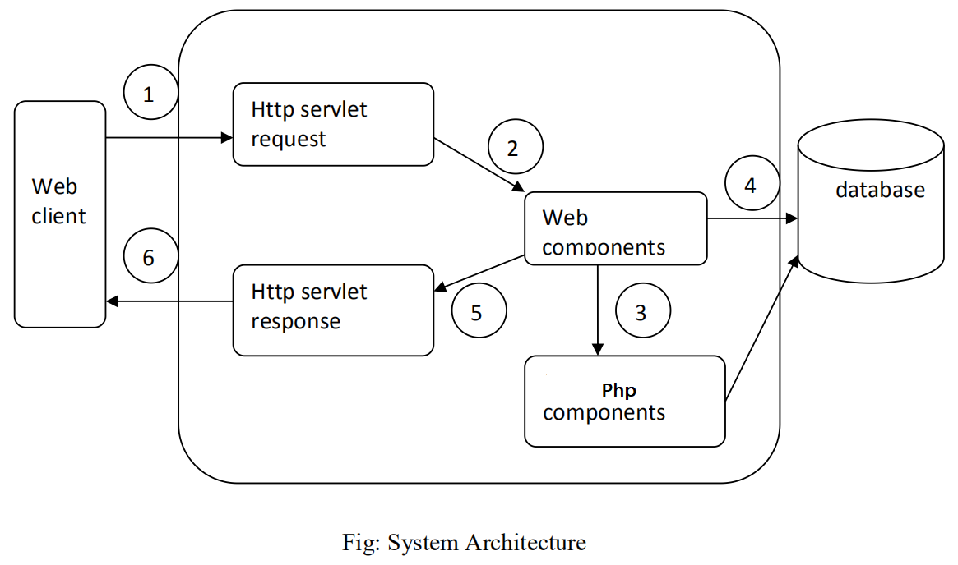

**1.Web Client:** The web client is a client-side component which asks for the request from server.

**2.Web Components:** They are the set of web platforms that allows to create custom,reusable,HTML tags to use in web pages and web apps.

**3.Php components:**  php programming and for creating web page.

**4.Database**: The collection of related data for the users application.

**5.Servlet response:**It defines an object assist a servlet in sending the response to the client.

**6.Web Client:** The web client is a client-side component here it receives the requested data from server.

**3.2 E-R Diagram**

Figure3.2 E-R Diagram

**3.3 System Design**

The system is designed with several interaction cues on each web page that makes up the web application (Food-Pickup). These cues are well-defined such as to make several functionality that the application exposes to collect, process and output data. Access to these functionalities is made possible by the well designed user interface which embodies several technologies such as AJAX (Asynchronous JavaScript and XML) to process data. The application is built in a modular form where these functionalities are built into modules.

**3.3.1 Class Diagram**

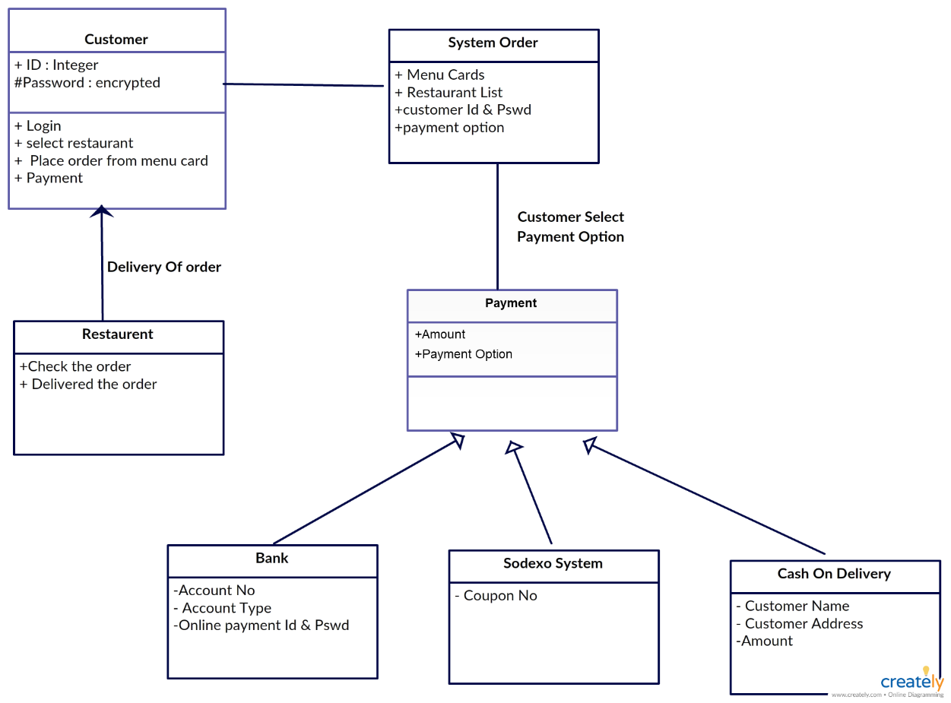

Figure 3.3.1 Class Diagram

A **class diagram** in the [Unified Modelling Language](https://en.wikipedia.org/wiki/Unified_Modeling_Language)(UML) is a type of static structure diagram that describes the structure of a system by showing the system's [classes](https://en.wikipedia.org/wiki/Class_(computer_science)), their attributes, operations (or methods), and the relationships among objects. The class diagram is the main building block of [object-oriented](https://en.wikipedia.org/wiki/Object-oriented_programming) modelling. It is used for general [conceptual modelling](https://en.wikipedia.org/wiki/Conceptual_model) of the structure of the application, and for detailed modelling translating the models into [programming code](https://en.wikipedia.org/wiki/Programming_code). Class diagrams can also be used for [data modelling](https://en.wikipedia.org/wiki/Data_modeling). The classes in a class diagram represent both the main elements, interactions in the application, and the classes to be programmed.

**3.2.2 Data-Flow Diagram**

Figure 3.3.2 Data-Flow Diagram

A **data-flow diagram** (DFD) is a way of representing a flow of a data of a [process](https://en.wikipedia.org/wiki/Process) or a system usually an [information system](https://en.wikipedia.org/wiki/Information_system). The DFD also provides information about the outputs and inputs of each entity and the process itself. A data-flow diagram has no control flow, there are no decision rules and no loops. Specific operations based on the data can be represented by a [flowchart](https://en.wikipedia.org/wiki/Flowchart).

**CHAPTER 4**

**IMPLEMENTATION**

**HTML**

Hypertext Mark-up Language is the standard mark-up language for creating web pages and web applications. With Cascading Style Sheets and JavaScript, it forms a triad of cornerstone technologies for the World Wide Web.

**CSS**

CSS is the latest evolution of the Cascading Style Sheets language and aims at extending CSS2.1. It brings a lot of long-awaited novelties, like rounded corners, shadows,gradients,transitions or animations, as well as new layouts like multi-columns, flexible box or grid layouts.

**PHP**

PHP is a server-side scripting language designed primarily for web development but also used as a general-purpose programming language.

**SQL**

SQL is a domain-specific language used in programming and designed for managing data held in a relational database management system, or for stream processing in a relational data stream management system. We Use MariaDb here.

**JavaScript**

JavaScript, often abbreviated as JS, is a high-level, dynamic, weakly typed, prototype based, multi-paradigm, and interpreted programming language.

**XAMPP server**

XAMPP is a free and open source cross-platform web server solution stack package developed by Apache Friends, consisting mainly of the Apache HTTP Server, MariaDB database, and interpreters for scripts.

**<script>**

The <script> tag is used to define a client-side script. The <script> either contains scripting statements, or it points to an external script file through the src attribute. Common uses for JavaScript are image manipulation, form validation, and dynamic changes of content.

**SRC**

This attribute specifies the URI of an external script; this can be used as an alternative to embedding a script directly within a document.

**Exporting and Importing modules in script:**

Export keyword labels variables and functions that should be accessible from outside the current module.

Import allows to import functionality from other modules.

• The object Import meta contains the information about the current module.

• Its content depends on the environment. In the browser, it contains the url of the script, or a current webpage url if inside HTML.

**Modules in html:**

Now that JavaScript modules are on the verge of widespread browser support, we should think about an HTML module system that plays well with it. ... The main points are that, using the JavaScript modules plumbing, you can import HTML.

**Class in html**:

The class is an attribute which specifies one or more class names for an HTML element. The class attribute can be used on any HTML element. The class name can be used by CSS and JavaScript to perform certain tasks for elements with the specified class name. The class selector selects elements with a specific class attribute. To select elements with a specific class, write a period (.) character, followed by the name of the class. You can also specify that only specific HTML elements should be affected by a class.

**CHAPTER 5:**

**TESTING**

**5.1 Testing Methodologies**

• **Black box Testing:** is the testing process in which tester can perform testing on an application without having any internal structural knowledge of application. Usually Test Engineers are involved in the black box testing.

• **White box Testing**: is the testing process in which tester can perform testing on an application with having internal structural knowledge. Usually The Developers are involved in white box testing.

• **Gray Box Testing:** is the process in which the combination of black box and white box techniques are used.

**1** **Unit Testing:**

Unit testing is essentially for the verification of the code produced during the coding phase and the goal is test the internal logic of the module/program. In the Generic code project, the unit testing is done during coding phase of data entry forms whether the functions are working properly or not. In this phase all the drivers are tested they are rightly connected or not.

1. **Integration Testing:**

All the tested modules are combined into sub systems, which are then tested. The goal is to see if the modules are properly integrated, and the emphasis being on the testing interfaces between the modules. In the generic code integration testing is done mainly on table creation module and insertion module.

1. **Validation testing:**

This testing concentrates on confirming that the software is error-free in all respects. All the specified validations are verified and the software is subjected to hard-core testing. It also aims at determining the degree of deviation that exists

in the software designed from the specification; they are listed out and are corrected.

**4 System testing:**

This testing is a series of different tests whose primary is to fully exercise the computer-based system. This involves Implementing the system in a simulated production environment and testing it.

* 1. **System Evolution:**

Our system should provide services to the users who are existing in this system. Users should have valid user id and password to enter the system. The administrator, agricultural students, general public, agricultural officer can use the benefits of the system who are having valid user id and password.

**System to be changed:**

In the existing system periodic generation of reports takes lot of time. It is time consuming and lot of complications will arise. So there is necessity to change the system and then the time taking will be very short.

**System understanding:**

Complete understanding of the system that is to be done i.e. brief study of the requirements and designing of the system is to be developed.

**Modified system:**

Modified system provides periodic generation of reports which is not available for the existing system such that reduce work being done manually and time consumption.

**5.2 Test case:**

Careful planning is required to the most of testing and controlled testing cost.

|  |  |  |  |  |  |
| --- | --- | --- | --- | --- | --- |
| **Test case ID** | **Description** | **Test steps** | **Expected value** | **Actual value** | **OK/Error** |
| 1. | Verify login page | Input username and password | Login page | Invalid data | error |
| 2 | Verify login page | Input username and password | Login page | Login page | ok |
| 3. | Verify registration page | Registration | User profile | Registration failed | error |
| 4. | Verify registration page | Registration | User profile | User profile | ok |
| 5. | Query is to be posted | Posting query | Query is posted | Unable to post the query | error |
| 6. | Query is to be posted | Posting query | Query is posted | Successfully posted | ok |
| 7. | Food name is to be entered | Enter food name | food name is entered | food is entered | ok |
| 8. | hotel name is to be entered | Enter hotel name | Hotel name is entered | Crop name is entered | ok |

**CHAPTER 6**

**SNAPSHOTS**

**6.1 Index page**

**6.2 MENU Page**

**6.3 Admin Page**

**

**6.5 User Login Page**

**6.6 Registration for New User Page**

**6.7 Admin Order Manage Page**

**6.8 Admin Restaurant Manage Page**

**6.9 Order Request Page for User**

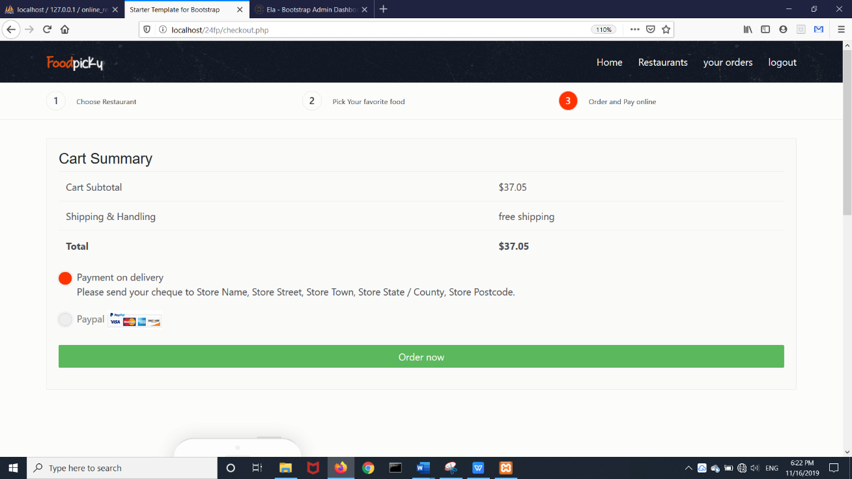

**6.10 Admin Confirmation Page**

**CONCLUSION**

The development of online food ordering system involved many phases. The approach used is a top-down one concentrating on *what* first, then *how* and moving to successive levels of details. The first phase started with a detailed study of the problems and prospects of ordering in Food pickup,In the course of this study, many problems were discovered to have hindered the effectiveness of the existing manual system. These problems, information needs and activities were documented and later used as the basis for system design, which immediately followed the first phase.

The design phase was concerned primarily with the specification of the system elements in manner that best met the organization’s business needs. During this phase, strict adherence was made on proven software engineering principles and practices. To implement this design, a computer program was then written and tested in phpMyadmin environment. It is hoped that effective implementation of this software product would liminate many problems discovered during systems investigation.

Proper training should be given to the data entry staff on how to handle the computer hardware especially during backup processes. In particular, electronic storage media are usually sensitive to change in temperature or pressure and as such, data can be lost very easily. The staff should also be highlighted on the need and advantage of the system and how it will equally assist them in their various field of work. They should also be informed of the cost of maintaining this new system so that they will handle it with all carefulness.

Training materials should not be presented in formal way but with procedures like policies and form etc, they should be circulated to the personnel. This will at the end generate appreciation and needed interest to operate the system.

**REFERENCES**

[1].Kirti Bhandge, Tejas Shinde, Dheeraj Ingale, Neeraj Solanki, Reshma Totare,”A Proposed System for Touchpad Based Food Ordering System Using Android Application”, International Journal of Advanced Research in Computer Science Technology (IJARCST 2015).

[2].Varsha Chavan, Priya Jadhav,Snehal Korade,Priyanka Teli, ”Implementing Customizable Online Food Ordering System Using Web Based Application”, International Journal of Innovative Science, Engineering Technology(IJISET) 2015.

[3].Resham Shinde, Priyanka Thakare, Neha Dhomne, Sushmita Sarkar, ”Design and Implementation of Digital dining in Restaurants using Android”, International Journal of Advance Research in Computer Science and Management Studies 2014.

[4].Ashutosh Bhargave, Niranjan Jadhav, Apurva Joshi, Prachi Oke, S. R Lahane,“Digital Ordering System for Restaurant Using Android”, International Journal of Scientific and Research Publications 2013.

[5].Patel Krishna, Patel Palak, Raj Nirali, Patel Lalit,” Automated Food Ordering System”, International Journal of Engineering Research and Development (IJERD) 2015.

[6].Mayur D. Jakhete, Piyush C. Mankar,” Implementation of Smart Restaurant with e-menu Card,” International Journal of Computer Applications 2015 of Smart Restaurant with e-menu Card,”International Journal of ComputerApplications 2015.