Date : 15/10/22 Name : Siva Prakash G
EX:10 Roll.No:19UITE006
Reg.No:920419205041

MapReduce (WordCount Program)

Step 1: Create a text file “D:/data.txt”

Step 2: Create a directory in HDFS, where to kept text file.
hdfs dfs -mkdir /user
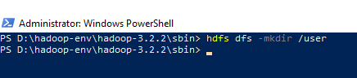

Step 3: Upload the data.txt file on HDFS in the specific directory
hdfs dfs -put D:/data.txt /user
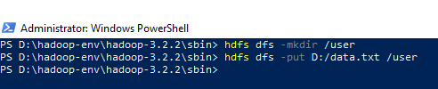

Step 4: List the files or directories in hdfs
hdfs dfs -ls /user/
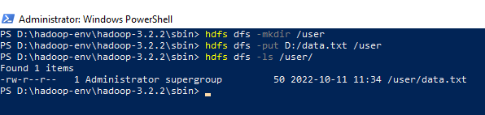

Step 5: To view the content of the file “/user/data.txt”
hdfs dfs -cat /user/data.txt
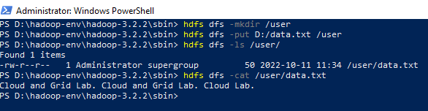

Step 6: Run the jar file
hadoop jar D:/hadoop-env/hadoop-3.2.2/share/hadoop/mapreduce/hadoop-mapreduce-examples-3.2.2.jar wordcount /user /out
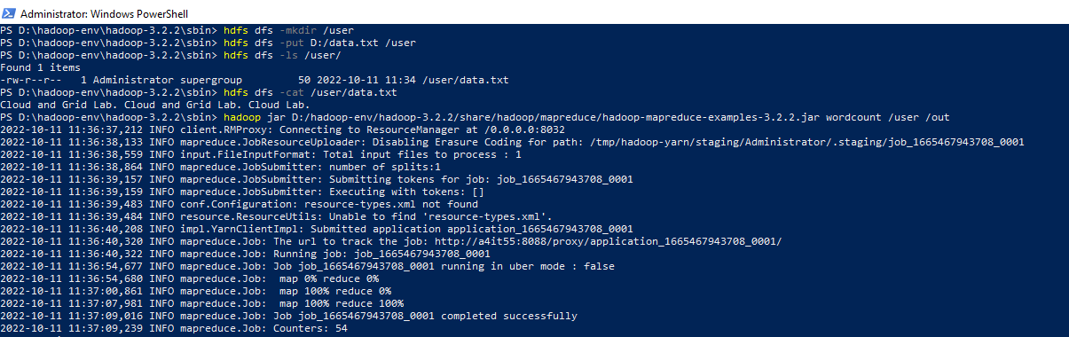
Step 7: To view the output in “/out/*”
hadoop fs -cat /out/*
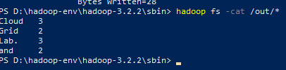
Output
