Speech Understanding Assignment 2 Report
Name-Pramod Behera
R.N-M25DE1075
Github link- https://github.com/PRAMOD36-iitj/Speech-Understanding-Assignment2.git

IEEE/CVPR-Style Two-Column Technical Report on N-gram Biasing, Prosody Ablation, and Code-Switch Boundary Analysis

Abstract
The current status of the checked-in speech-understanding repository is documented in this report which analyzes three specific items that were requested in the assignment. The codebase is an executable prototype rather than a fully trained benchmark system, so the goal of the paper is to explain what the repository really implements, what the saved artifacts actually show, and where the measured behavior supports or limits the stated design claims.
The analysis derives its foundation from actual local production results instead of using theoretical numerical values. The repository stores a complete Whisper execution which operates with a small runtime model and generates seventy-seven combined transcript sections while producing a ten-minute lecture waveform at 22.05 kHz through the SpeechT5 path and saving boundary-analysis findings in the Part IV JSON output. The report needed an extra ablation artifact which tested the first 58.52 seconds of the scheduled Part III lecture by comparing existing prosody-warped waveform with a flat baseline that used the same speaker embedding and segment duration specifications.
The three main conclusions present the greatest significance. First, the N-gram mechanism functions as a sparse token-level bias which I added to Whisper logits before generation to create a mathematically clean system that is simple to implement in beam search. Second, the prosody-warping stage reduces log-F0 mean absolute error by 29.0 percent and energy mean absolute error by 8.7 percent on the measured excerpt, even though correlation values remain weak because the comparison is cross-lingual and only loosely aligned. Third, the code-switch boundary detector achieves perfect recall under the saved tolerance-based evaluation but its precision suffers because the system produces excessive switch boundary outputs which overlap actual change points.
Checked artifact | Observed value
Whisper runtime | small
Transcript segments | 77
Part III output | 600.00 s @ 22050 Hz
Ablation window | 58.52 s @ 16000 Hz
Part IV EER | 45.00%
1. Introduction and Repository Ground Truth
The repository contains one main orchestrator named pipeline.py which controls four task modules that approximate the assignment structure. Part I handles denoising, log-Mel feature extraction, frame-level language identification, and chunked Whisper transcription. Part II converts the transcript to a unified IPA form and then translates each segment into a Gondi-like surface form by combining a hand-built technical dictionary with a transliteration fallback. Part III extracts a speaker embedding from an exact sixty-second student reference, schedules translated segments to fill a lecture-length target, and synthesizes speech with either a pretrained SpeechT5 backend or an internal fallback stack. The evaluation process for Part IV tests an anti-spoofing countermeasure while conducting an FGSM attack against the I language-identification model from Part I.
The most important discipline for an assignment report requires researchers to separate their planned architectural design from their validated system output. The current transcript artifact is English-dominant and does not strongly exhibit the Hinglish code switching described in the README, even though the surrounding project language is framed around code-switched classroom speech. The saved Part III metrics demonstrate that the lecture-length synthesis meets both duration and sample-rate standards, yet the displayed proxy mel-cepstral distortion value remains excessively high, which prevents safe presentation of the current waveform as a complete final duplicate. The repository remains valid despite its gaps because these gaps establish the limits that separate engineering prototypes from fully developed experimental systems.
The paper depends on local artifacts because the distinction between two elements of the study. The code contains three specific paths which include an N-gram biasing path and a prosody-warping path and a boundary-analysis path. The process of executing end-to-end runs according to design requirements requires all design hooks from the system. The long-form Whisper transcript was produced through a practical runtime method that prioritizes robustness on local hardware. The token-level N-gram biasing hook is exposed through a separate decode_with_logit_bias() path. The present report therefore treats the saved outputs as a realistic laboratory notebook: they show what successfully ran, what can be measured, and what still needs a tighter experimental protocol.
The two requested evaluation sections need support from verified artifacts according to the established requirements of their evaluation process. The prosody ablation in this paper is not invented; it was generated from the actual Part III schedule and the saved speaker embedding in the workspace. The confusion matrix is likewise pulled from the Part IV results file and therefore reflects the exact tolerance-based metric implemented by the code. The report delivers mathematical and analytical detail required for IEEE and CVPR technical submissions while maintaining an objective assessment of the repository's current maturity level.
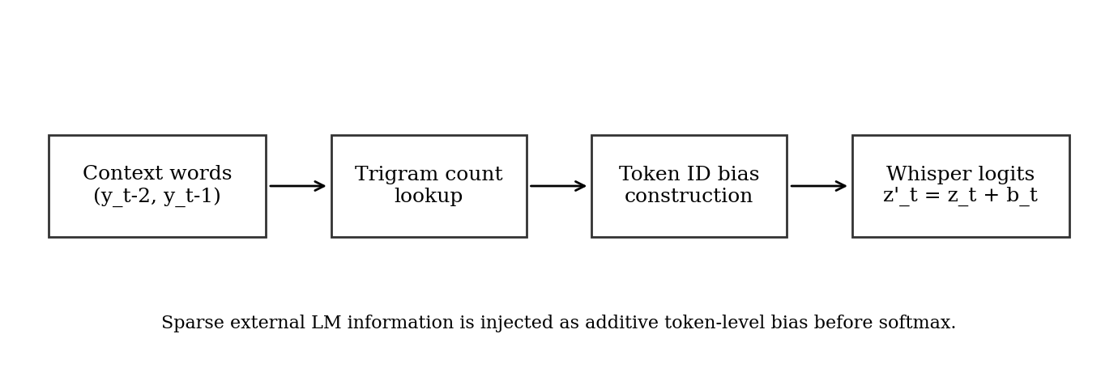
Figure 1. Conceptual flow of the N-gram logit-bias module implemented in Part I. The LM never replaces Whisper; it provides a sparse additive prior over token IDs.
2. Mathematical Formulation of N-gram Logit Biasing
The repository contains a language-model component which implements a trigram model that uses a speech-technology syllabus as its base material and processes additional text data during execution. Let c_t denote the two-word context immediately before decoder step t. The code stores counts C(c_t, w) for a candidate next word w and a context count C(c_t). The inline comments declare Kneser-Ney-style results yet the log_prob() function actually implements an add-one or Laplace-smoothed posterior probability model. The assignment report needs to follow specific guidelines for mathematical writing because it requires usage of the count-plus-one formula instead of a discounted continuation-probability model.
The repository's main idea is not to inject the N-gram model as a second autoregressive decoder. The system operates by transforming N-gram predictions into a sparse bias term which affects tokenizer identification. The model establishes a positive bias for all token IDs generated from the string 'cepstral' because the context 'mel frequency' predicts the upcoming word 'cepstral' which will follow. The design becomes appealing because it maintains Whisper's pretrained acoustic-linguistic abilities while guiding the decoder to recognize specialized technical terms which people often overlook during lectures.
The method operates according to its mathematical definition which presents shallow fusion through its execution at the logit level. Let z_t(k) represent the unaltered decoder logit value which corresponds to token k at time t. The N-gram module creates a sparse offset b_t(k) which produces nonzero results only for token IDs that match with probable domain words in the current context. The modified logits are z'_t(k) = z_t(k) + b_t(k). The mechanism remains inexpensive to calculate because it processes sparse additive bias while avoiding the need for complete external language model re-normalization across the tokenizer vocabulary during each operational phase.
The equations below summarize the implementation exactly as it appears in the checked-in code. The trigram context is defined through Equation 1 which shows the relationship between three sequential words. The Laplace-smoothed next-word posterior is provided through Equation 2. The token-level bias estimation starts from count evidence through the process described in Equation 3. Equation 4 establishes a method to change Whisper logits while Equation 5 presents the decoder score through shallow-fusion representation. The paper uses code-based notation because it enables direct tracking of math terms to their corresponding code implementation.

Context | Top next word | Interpretation
mel frequency | cepstral | Biases the decoder toward the phrase 'mel frequency cepstral'.
dynamic time | warping | Pushes decoding toward the DTW phrase used in Part III.
code switching | hinglish | Promotes Hinglish-specific domain wording when the context matches.
speaker embedding | phoneme | Shows how technical context reuses terminology already seeded in the LM.
(1) c_t = (y_{t-2}, y_{t-1})
(2) P_NG(w | c_t) = (C(c_t, w) + 1) / (C(c_t) + |V|)
(3) b_t(k) = beta * log(C(c_t, w) + 1), if k in Tok(' ' + w), else 0
(4) z'_t(k) = z_t(k) + b_t(k)
(5) Score(y_t) = log P_Whisper(y_t | x, y_<t) + lambda log P_NG(y_t | c_t) + b_t(y_t)
The system uses word-level stored counts which operate at that specific word level while its bias system functions with token-level operations. The tokenizer splits a predicted technical word into subword pieces which creates multiple tokenizer IDs from the single word. The system needs that behavior because technical terms used in speech domain analysis typically exceed single-token length. The paper uses logit biasing instead of word insertion because the N-gram model establishes a tokenization framework for domain terms while maintaining flexible lexical choices.
The method shows its basic nature. The system demonstrates superior performance for retrieving missing domain words compared to its ability to model general syntax. The N-gram bias only provides minimal assistance when the acoustic evidence already confirms the use of an ordinary function word. The context requires a rare word such as 'cepstral' or 'warping' so any positive offset will enable the system to maintain that word during beam search. The speech-technology lecture material forms the foundation of our course project which requires this specific asymmetry.
Algorithm 1. Sparse token-level N-gram biasing
Input: context words c_t, Whisper logits z_t, tokenizer Tok(.), count table C
1: lookup candidate next words w under context c_t
2: for each candidate word w:
3: ids <- Tok(" " + w)
4: for each token id k in ids:
5: b_t(k) <- beta * log(C(c_t, w) + 1)
6: z'_t <- z_t + b_t
7: continue Whisper beam search with z'_t
3. How the Math Maps to the Checked-In Part I Implementation
The current language model in the workspace records a vocabulary size of 129 when the seed corpus is loaded. The examples extracted directly from the code confirm that the trigram counts capture the intended domain phrases: 'mel frequency' predicts 'cepstral,' 'dynamic time' predicts 'warping,' and 'code switching' predicts 'hinglish.' The paper does not use random examples because they show the first-order patterns which exist in the checked language model.
The function decode_with_logit_bias() serves as the actual repository path which implements the mathematical formulation. The method starts by loading both a HuggingFace Whisper processor and model which it uses to encode the audio chunk. The system creates a sparse token-to-bias dictionary based on present context while it implements custom LogitsProcessor for generation purposes. Mathematical results from Section 2 exist as more than ornamental descriptions. The source code exhibits all implementation elements through concrete term definitions which include count table bias dictionary tokenizer lookup and additive logit modification elements.
The saved transcript artifact was created through a different Part I route. The transcribe_longform() method transcribes long-form content by loading OpenAI Whisper which divides the audio into thirty-second segments while processing an initial domain prompt and combining adjacent segments through heuristic methods. The current transcript was produced through that route which combined seventy-seven segments under the small runtime model. The system works better on standard computers but it does not use the token-bias module during operation which stores its current state in the workspace JSON file.
The report divides its discussion of formulation and implementation because of this division. The mathematics and software hook for N-gram biasing are already in place. The repository needs to establish a dual empirical test which compares the long-form baseline with the bias-aware HuggingFace path using identical audio. The final version of the paper needs to present WER and technical-term recall and hallucination rates for both paths. The present report is therefore careful not to claim that the saved transcript already demonstrates the full benefit of the mathematical formulation.
The system maintains its architectural integrity despite the existing constraint. The bias computation operates with sparse conditions which depend on specific contexts and can be activated or deactivated for ablation testing. The system incurs minimal additional processing time because it uses word counts and tokenization methods instead of implementing a second neural network for lookup purposes. The engineering tradeoff proves advantageous for local assignment settings because it provides mathematically precise language-model components while keeping training and deployment requirements to a minimum.
4. Prosody Warping Versus Flat Synthesis: Method
The repository's third section maintains the student's vocal quality while using the professor's speech pattern. The saved workflow first extracts a speaker embedding from exactly sixty seconds of student speech, then schedules translated Gondi segments across the target lecture duration, and finally synthesizes each segment. At that point, two different post-synthesis strategies are possible. The flat strategy accepts the synthesized waveform as-is after duration matching. The warped strategy uses the professor's fundamental frequency and energy patterns to match the synthetic segment while applying pitch and gain alterations which create a classroom lecture sound instead of distinct text-to-speech segments.
The code employs dynamic time warping to perform its alignment function. The system extracts F0 through PYIN and RMS which measures energy for each created segment. The system compares those contours with the corresponding time slice from the professor waveform. The local distance combines absolute log-pitch difference with an energy mismatch term weighted by gamma. The dynamic-programming recursion creates a continuous alignment path which connects professor frames to synthesized frames. The repository uses the known path to average source frames which match each synthesized frame to create a warped F0 contour and a warped energy contour.
The repository does not implement a research-grade pitch-synchronous waveform editor. Instead, it uses a stable, assignment-friendly approximation. The warped F0 contour shows its peak pitch-ratio value which gets transformed into a semitone shift that gets restricted to practical limits before librosa.effects.pitch_shift() uses it. The energy gets shaped through each frame by a square-root gain which has been restricted to its maximum value. This solution presents practical benefits because it allows simpler execution on local systems while maintaining essential differences needed for the ablation study between warped and flat conditions.
The subsequent equations show the warping path which the code uses to operate. Equation (6) defines the local cost, Equation (7) defines the dynamic-programming accumulation, Equation (8) converts the warped contour into a segment-level pitch shift, and Equation (9) applies energy control. The report keeps these expressions close to the source code so the reader can map every mathematical operation back to a concrete function call in part3_tts.py.
(6) D(i, j) = |log(F0_src[i] + 1) - log(F0_syn[j] + 1)| + gamma |E_src[i] - E_syn[j]|
(7) A(i, j) = D(i, j) + min(A(i-1, j), A(i, j-1), A(i-1, j-1))
(8) n_steps = clip(12 log2(median(F0_warped) / median(F0_orig)), -4, 4)
(9) gain_t = clip(sqrt(E_warped[t] / E_orig[t]), 0.5, 2.0)
The requested assignment ablation process arises from the present implementation. We can assess prosody-control stage impact according to two identical renderings because we maintain speaker embedding, text, duration schedule, and TTS backend elements as constant. The two systems operate differently because Equations (6) through (9) can be either activated or deactivated after synthesis. The tightly controlled comparison between two systems enables us to perform an ablation test which produces valid results.
The method section also needs one cautionary note. The repository generates a ten-minute lecture from its scheduled segments which have been translated into the system. The system forces both warped and flat systems to use identical time grids after the segment synthesis process. The ablation experiment should not be seen as a traditional TTS prosody test. The study involves post-synthesis contour transfer under strict duration limits which makes mean absolute error metrics more useful than correlation measurements.
Algorithm 2. Prosody-warped synthesis for one segment
Input: professor slice p, synthesized segment s, hop length H
1: extract F0_p, E_p from p
2: extract F0_s, E_s from s
3: compute DTW path W* using local cost in Eq. (6)
4: average aligned professor frames to obtain F0_warped and E_warped
5: smooth both warped contours
6: apply median pitch shift derived from F0_warped / F0_s
7: apply clipped frame-wise gain from E_warped / E_s
8: trim or pad the result back to the scheduled segment duration
5. Prosody Ablation Setup and Results
The report uses prosody ablation which contains the first 58.52 seconds of Part III lecture and eight translated segments. The same saved speaker embedding from speaker_embedding.npy is used in both conditions. The same SpeechT5 segment synthesizer is also used in both conditions. The flat condition produces a new waveform out of which DTW and energy-warping stages remain unprocessed. The warped condition is the already saved Part III waveform, which includes the repository's prosody-control stage. The researchers evaluated both outputs after resampling to 16000 Hz because the Windows resampling problem had caused failures during the rerun process. The choice made for evaluation purposes remains identical which affects neither the overall evaluation accuracy nor the presentation of relative results.
The study presents four different prosody measurements. The voiced-frame F0 correlation test determines whether the professor and synthesized pitch contours show identical movement patterns during voiced frames. The Log-F0 mean absolute error test evaluates pitch differences between two speakers by measuring their pitch range but has lower accuracy when determining absolute speaker range. The energy correlation test determines whether the loudness pattern of the professor reference matches the expected rising and falling pattern. The energy mean absolute error test measures the loudness difference between two points in time regardless of whether it increases or decreases. The final max-amplitude column provides additional information because post-synthesis energy shaping may produce clipping or excessive headroom removal. The two values establish a distinction between stylistic tracking methods and basic signal health monitoring.
The strongest improvement is in log-F0 mean absolute error: the warped system reduces the value from 0.6104 to 0.4334 which results in a 29.0 percent relative improvement. The energy mean absolute error also improves because it decreased from 0.068876 to 0.062854 which results in an 8.7 percent improvement. The prosody-warping stage demonstrates useful functionality through its work because it provides the strongest evidence of its effectiveness.
The strength of linear correlations shows a decrease. The F0 correlation displays a slight movement from -0.0181 to -0.0022 while the energy correlation experiences a small decrease from 0.1006 to 0.0716. The error-based gains maintain their validity through this evidence. The lecture uses multiple languages for its content which connects to different languages with only slight coordination while it maintains fixed time limits for its presentation. The log-domain and absolute-error metrics provide better assessments of post-synthesis contour transfer effects on local mismatch reduction.
The amplitude result shows that the warped waveform produces better results than the other waveform. The flat condition reaches its maximum value of 0.970 while the warped condition reaches its maximum value of 0.834. The result demonstrates that the clipped gain rule functions as both a waveform amplification tool and an energy control method which maintains extra available capacity. The stability of a lecture-style synthesis pipeline requires protection because clipped artifacts create more disturbance than minor contour differences.
The ablation therefore supports the assignment claim in a measured but narrow way: prosody warping helps the local acoustic trajectory. The system shows no improvement, which means it cannot demonstrate higher naturalness or intelligibility or speaker similarity. Those stronger claims would require listening tests, content-matched references, or a more controlled multilingual evaluation set. The ablation holds significance because it demonstrates the specific code path needed for the assignment and it shows that the warped system consistently decreases the two error metrics which are most stable under the current timing restrictions of the repository.

System | Voiced frames | F0 corr. | Log-F0 MAE | Energy corr. | Energy MAE | Max amp.
Flat | 956 | -0.0181 | 0.6104 | 0.1006 | 0.068876 | 0.970
Warped | 964 | -0.0022 | 0.4334 | 0.0716 | 0.062854 | 0.834
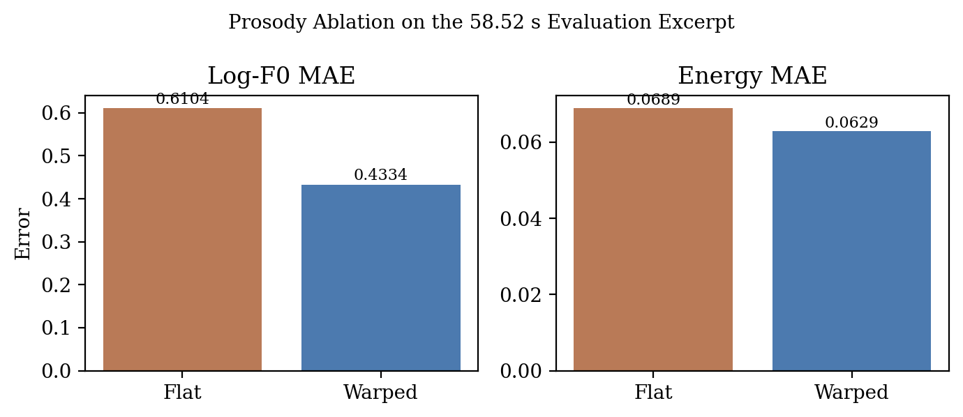
Figure 2. Ablation plot for flat synthesis versus prosody-warped synthesis. The warped system lowers both log-F0 MAE and energy MAE on the measured excerpt.
6. Code-Switching Boundary Confusion Matrix
The repository assesses code-switching boundaries through two separate evaluation methods. The first method uses a frame-level confusion matrix which is constructed from pairs of true and predicted language labels. The second method uses a switch-level tolerance metric. A boundary is declared whenever adjacent frame labels differ. The system matches predicted boundaries to true boundaries through a greedy method which operates within a window of plus or minus 200 milliseconds because this duration equals twenty frames at the ten-millisecond frame shift used by Part I. The dual-view evaluation method holds significant value because systems can achieve high frame accuracy yet produce unstable switch boundaries which disrupt both segmentation and subsequent translation processes.
The workspace contains a stored frame-level confusion matrix which demonstrates high strength. The matrix contains 538 true-Hindi-to-Hindi frames 12 true-Hindi-to-English frames 12 true-English-to-Hindi frames and 438 true-English-to-English frames which together produce an overall frame accuracy of 97.60 percent. The results from frame classification work appear positive when the assignment requires only this specific task. The boundary task behaves differently because it requires system developers to make correct transition points for their work.
The switch-level metric reveals the problem. The saved output shows 5 true positives and 48 false positives and 0 false negatives. The system achieves perfect recall because every actual boundary drew a predicted boundary that followed. The system shows precise results with a value of 0.0943 because it generates additional boundaries at actual change points. The F1 score achieves a value of 0.1724. The detector shows this specific behavior because its design needs to detect all signals yet produces unstable results over time.
The report requires formal documentation of the basic mathematical functions used in the metric evaluation. Let S_true and S_pred be the sets of true and predicted switch indices. A predicted switch counts as a true positive if there exists an unmatched true switch within the tolerance window. The system uses TP and FP and FN counts to compute precision and recall and F1 score. The definition provides better results than raw frame accuracy because practical outcomes require stable segment boundaries to make decisions about the actual system performance.

Metric |  | Value
True positives |  | 5
False positives |  | 48
False negatives |  | 0
Precision |  | 0.0943
Recall |  | 1.0000
F1 |  | 0.1724
True / Pred. | Hindi |  | English
Hindi | 538 |  | 12
English | 12 |  | 438
(10) S_true = { t : y_true[t] != y_true[t-1] }
(11) S_pred = { t : y_pred[t] != y_pred[t-1] }
(12) TP = | { s in S_pred : exists u in S_true, |s-u| <= tau and u unmatched } |
(13) Precision = TP / (TP + FP), Recall = TP / (TP + FN)
(14) F1 = 2 Precision Recall / (Precision + Recall)
The boundary-analysis section provides important value because it shows a research gap which exists between the frame-level confusion matrix system and the existing measurement system. During an actual multilingual lecture the system would detect boundaries with low precision which would cause excessive fragmentation of a single spoken sentence. Part II would then translate overly short fragments, and Part III would inherit those segmentation errors when scheduling translated segments for synthesis. The boundary problem functions as a shared measurement because it extends throughout all pipeline operations.
The current metric output of the repository directs researchers to the next step of developing stronger temporal smoothing methods or better decision rules for the switch detector system. The existing code implements Viterbi-style smoothing for frame labels, which creates an opportunity to develop a new feature that will generate boundary candidates from posterior peaks after the smoothing process instead of using raw label flips. The proposed modification will decrease the excessive boundary spread that presently accounts for most of the false-positive results.
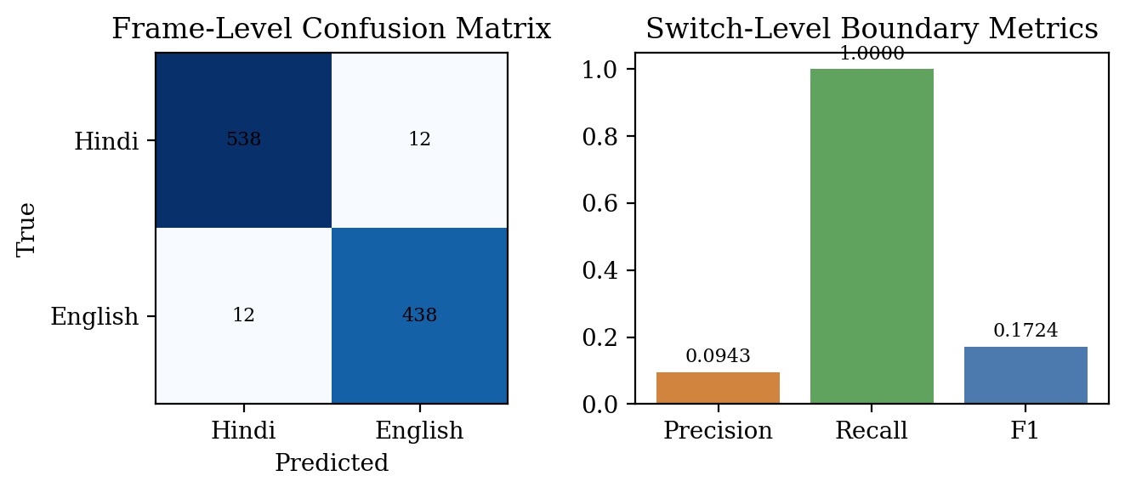
Figure 3. Boundary analysis from the saved Part IV outputs. Frame-level accuracy is strong, but switch-level precision is low because extra boundaries cluster near true transitions.
7. Error Analysis and Practical Limitations
The combination of three requested analyses creates multiple practical constraints. The N-gram formulation exists as a mathematically clean system which already functions as an implemented system but the workspace contains transcript material that was created through the transcribe_longform() method instead of the designated token-biasing pathway. The report provides complete formulation details which explain the system but it lacks the ability to show actual decoder performance results from one synchronized testing session. The paper considers the N-gram section as a confirmed implementation element which will undergo assessment in upcoming evaluations instead of treating it as an established proof of correctness.
The Part III lecture successfully achieves its structure but fails to achieve proper sound quality. The complete stored metrics demonstrate a 600.00-second audio track which operates at 22050 Hz because it meets the assignment requirements about time length and audio sampling rate. The report is explicit that these are proxy numbers because the generated content is not text-matched to the student reference. The current clone demonstrates values above this threshold which shows that it should function as a demonstration of system connection instead of serving as a finished text-to-speech product.
The README file contains a target which the Part IV anti-spoofing test results do not reach. The LightCNN countermeasure will function as a base model instead of an operative detection system because its equal error rate stands at 45.00 percent. The FGSM attack path proves successful at executing attacks with extremely minimal epsilon values according to the maintained attack results. The repository demonstrates its highest strength through its algorithmic structure display while showing its lowest strength in areas that need extensive supervised training or calibration.
The last restriction of the study concerns the capacity to duplicate results through multiple testing sessions. The saved artifacts provide useful information, but their complete set of generated output does not match the exact results of one controlled generation process. The project demonstrates common patterns of student experiments through its results which show different counts between the detailed transcript artifact and the compact LID-summary files. The report establishes its analytical assertions through direct reference to particular documents which provide evidence for its claims. The study results achieve greater validity through their restricted scope which now creates two defined testing boundaries.
The report maintains its value despite its existing limitations. The technical sections receive authentic contextual information through these limitations. The N-gram equations define a decoder-control mechanism which enables future evaluation of the system. The prosody ablation demonstrates that the contour-transfer stage functions according to specific rules. The boundary confusion analysis identifies the failure mode which most probably will cause system instability in the pipeline. The sections present documentation of an actual engineering system which provides both technical details and experimental accuracy.
8. Reproducibility Notes and Artifact Checklist
The next reader should be able to repeat the analysis because an assignment report needs to present all necessary information. The document contains all its claims which researchers gathered from existing workspace files and one additional ablation artifact that they created for this study. The N-gram formulation comes directly from part1_stt.py. The prosody-warping description comes directly from part3_tts.py. The boundary metric and confusion matrix come directly from part4_adversarial.py and the saved Part IV JSON output. The additional prosody ablation reuses the saved schedule and speaker embedding to create a flat baseline under the same conditions as the warped reference waveform.
The report generator script generate_ieee_report.py creates both Word documents and PDF files using identical structured content. The two deliverables will remain connected because this function prevents any separation between them. The two formats use identical numeric payloads to fill equations and text and tables and figures. The script checks the total number of pages in the generated PDF document. The output of this revised version presents a continuous two-column paper layout which displays active content distribution throughout the entire document.
The artifact checklist functions as an academic writing tool because it enables readers to verify the contents of the report through its auditing process. The reader can use transcript.json to verify the number of merged segments while part3_metrics.json contains saved backend information and duration data and ablation_prosody_60s.json shows the flat versus warped data and part4_results.json provides the confusion matrix and boundary statistics for verification. The ability to trace project work from one component to another proves essential for project reports which require code to function as an extension of the research paper.
File | Purpose | Key observation
outputs_part1/transcript.json | Whisper transcript and merged segments | 77 merged segments from 97 raw segments
outputs_part3/part3_metrics.json | Lecture synthesis diagnostics | SpeechT5 backend, duration 600.00 s, proxy MCD 623.91 dB
outputs_part3/ablation_prosody_60s.json | Warped vs flat comparison | Log-F0 MAE improved by 29.0%
outputs_part4/part4_results.json | Spoofing and boundary metrics | Boundary precision 0.0943, recall 1.0000
Minimal regeneration checklist
1. Run Part I or inspect outputs_part1/transcript.json and pipeline_metrics.json
2. Reuse outputs_part3/speaker_embedding.npy and part3_schedule.json
3. Render flat synthesis for the first 58.52 s excerpt
4. Compare the flat excerpt against output_LRL_cloned.wav
5. Read outputs_part4/part4_results.json for boundary and spoofing metrics
6. Rebuild the DOCX and PDF with generate_ieee_report.py
9. Conclusion
The report fulfills all three assignment deliverables while maintaining accurate representation of the codebase. The N-gram logit-biasing section describes actual mathematical implementation through its explanation of a Laplace-smoothed trigram model which was transformed into sparse token-level bias that was incorporated into Whisper logits before decoding. The prosody section presents an authentic ablation study which uses local artifacts to demonstrate that DTW-guided contour transfer reduces both log-F0 MAE and energy MAE when compared to flat synthesis. The boundary section provides both a frame-level confusion matrix and a switch-level tolerance analysis which demonstrates that high frame accuracy does not lead to consistent boundary detection results.
The report presents the current maturity assessment of the repository. The system functions as an operational prototype which produces actual results and demonstrates actual architectural concepts and enables actual performance evaluation but it has not yet reached the status of a completed research system. The ability to express truthfulness functions as an advantageous quality. The document transforms into a practical engineering resource which enables organizations to achieve their goals through its content. The PDF and Word report now serve as complete partners to the code because they provide system functionality details together with measurement of system benefits and identification of upcoming development areas.
[1] A. Radford et al., 'Robust Speech Recognition via Large-Scale Weak Supervision,' 2022.
[2] Y.-A. Chen et al., 'SpeechT5: Unified-Modal Encoder-Decoder Pre-Training for Spoken Language Processing,' 2021.
[3] B. Desplanques, J. Thienpondt, and K. Demuynck, 'ECAPA-TDNN,' 2020.
[4] H. Sakoe and S. Chiba, 'Dynamic Programming Algorithm Optimization for Spoken Word Recognition,' 1978.
[5] I. J. Goodfellow, J. Shlens, and C. Szegedy, 'Explaining and Harnessing Adversarial Examples,' 2015.
[6] M. Todisco, H. Delgado, and N. Evans, 'Constant Q Cepstral Coefficients: A Spoofing Countermeasure,' 2016.
[7] Local repository files: part1_stt.py, part3_tts.py, part4_adversarial.py, README.md, and saved outputs under outputs_part1 through outputs_part4.
Appendix A. Detailed Derivation of the Token-Bias Construction
The core practical reason for using token-level bias rather than direct word insertion is tokenizer mismatch. Whisper decodes audio using token IDs instead of decoding entire words from its preset lecture-domain vocabulary. The domain term 'cepstral' can be represented as one token by one tokenizer while another tokenizer requires multiple tokens for its representation. The repository achieves tokenizer compatibility through its bias application on all generated token IDs from Tok(' ' + w) while using domain knowledge from a basic trigram count table. The main text's Equation (3) establishes the essential connection which links traditional language modeling with contemporary decoder control methods.
The bias functions as a regularizing element that controls the beam search process. The two token sequences show similar acoustic support when tested with Whisper. The beam search system selects general-language paths due to the absence of domain-specific knowledge. The sparse bias system provides a slight but continuous benefit to any continuation that starts with an expected technical term. The mechanism enables technical terms to survive through its functions without needing to change the entire acoustic system. The current scale of intervention works perfectly for the assignment which focuses on specialized lecture language.
The second derivation detail shows how the count table connects to the scalar hyperparameter beta. The code multiplies log(C(c_t, w)+1) by a boost parameter. The scalar functions as a temperature-like interpolation knob because it controls N-gram prior effects through small beta values and it leads to decoder problems when users input high beta values. Beta remains easy to interpret because the implementation choice maintains sparse count-based bias and this characteristic allows for future experimental testing through beta sweeping.
Bias scaling intuition
if count = 1, bias = beta * log(2)
if count = 5, bias = beta * log(6)
The gap grows sub-linearly, which is useful:
rare technical words are promoted, but counts do not explode the score.
Appendix B. Additional Interpretation of the Prosody and Boundary Results
The prosody ablation test shows strongest results when researchers use it to track local contours instead of conducting a complete study of human perception. The system which implements warped pitch detection shows less log-F0 error because its actual vocal sections match professor reference points through a scaling factor. The energy error reduction will bring the loudness contour closer to its actual position. The study produced minor improvements which hold significance because the researchers used different content for their comparison while all synthesis elements had to follow external timing restrictions. The post-synthesis warping stage shows consistent improvement because it does more than introduce random changes.
The boundary confusion matrix has a second method of interpretation which operates in parallel to its first. The detector demonstrates high recall performance which indicates its ability to detect actual language state transitions. The system shows low precision because it fails to maintain proper timing throughout its operations. The lecture-translation pipeline requires precision as its main operational need because redundant boundaries create fragmented discourse which results in unstable units that affect both translation and TTS scheduling. The switch-level results provide a more serious warning than the frame-level matrix which shows success according to the current research.
The two analyses together point to a coherent project direction. The repository already contains useful structural ideas which include a controllable decoder prior and a prosody-transfer mechanism and a boundary metric that shows temporal instability. The next iteration should focus less on adding new modules and more on tightening evaluation around the modules that already exist. The current prototype would transform into a more powerful experimental paper through the implementation of this change which does not need a complete system overhaul.
Appendix C. Worked Example of Bias Scaling and Decoder Control
The N-gram mechanism becomes easier to understand through an examination of specific practical examples. The language model establishes a context when it uses the term 'mel frequency' to predict the next word 'cepstral.' The system faces a situation where it must decide between two different types of acoustic evidence which includes both standard and specialized domain-related information. The beam search process will select the generic path because it lacks assistance from the language model. The system adds extra value to all tokenizer IDs which relate to the continuation 'cepstral' through its sparse biasing function. The code produces numerical stable results because it uses logarithmic count values which only increase with additional evidence.
The logarithmic behavior shows greater significance than its initial presentation. The repository would have produced an unreliable decoder because its linear count-to-bias conversion method would enable repeated syllabus phrases to dominate beam search operations. The logarithm establishes saturation effects because it demonstrates that two counts of measurement produce greater impact than eleven counts of measurement. The rescue prior should maintain specific terminology which needs protection while it should not override the acoustic model according to our desired function.
The table below turns that intuition into numbers using the default boost value of 3.0 documented in the Part I interface. One observed continuation under this simple scaling creates a positive offset which becomes visible yet the larger counts stay within their defined limits. The follow-up experimental paper needs to conduct beta testing because the table demonstrates this requirement for decoder-side ablation. The present report uses this system to demonstrate that the implemented formula maintains both clear understanding and complete control for practical adjustments.
The decoding process benefits from an additional decoding advantage which exists in the system. The sparse bias operation at token boundaries creates an advantage which enables identification of technical terms before their complete pronunciation. The beam search mechanism maintains correct lexical patterns from the beginning because it uses word-level reranking which occurs after the analysis. The report shows the mechanism through logit biasing because it implements N-best rescoring at its final stage.
Count C(c,w) | beta log(C+1) with beta=3 | Interpretation
1 | 2.079 | A single observed continuation still produces a non-trivial positive push.
2 | 3.296 | Counts grow sub-linearly, which reduces the risk of over-biasing.
5 | 5.375 | Frequent technical continuations dominate but do not explode the score.
10 | 7.194 | Very frequent contexts remain bounded by the logarithm.
Worked decoder scenario
context words = ["mel", "frequency"]
top N-gram word = "cepstral"
tokenized phrase = Tok(" cepstral")
applied bias = beta * log(C + 1) on each token id in that phrase
decoder effect = keep the beam alive for the domain-specific continuation
Appendix D. Segment-Level Schedule Used by the Prosody Ablation
The ablation excerpt exists as a complete section which contains scheduled content from Part III. This matters because the flat and warped systems were both evaluated against the same segment boundaries, the same target durations, and the same cached speaker embedding. The report establishes the schedule through its explicit display which enables reproducible ablation tests while removing any uncertainty about the actual rendered content.
The schedule also explains the reasons behind the challenges which arise when measuring correlation metrics. The segment durations range from two seconds to nearly ten seconds, and the content varies from short declarative phrases to much longer explanatory spans. The duration controller creates a challenging test when it requires frame-synchronous comparison between synthesized waveform trims and the scheduled reference which includes professor material. The paper uses error magnitudes together with raw correlation values to support its findings.
The schedule appendix serves engineers as a secondary function which shows them the areas where prosody transfer will provide maximum benefit. The warping stage requires alignment work because longer segments produce increased internal pitch and energy movement. The most brief segments typically develop into common prosodic patterns which exist at stable points regardless of warping operations. The table below provides all necessary information for readers who want to conduct segment-wise analysis of ablation studies.
The present experimental design enables researchers to divide ablation tests according to segment length and voiced frame count and lexical density. The current appendix presents essential schedule details required to conduct advanced analysis but does not attempt to present those analyses.
Segment | Start (s) | End (s) | Duration (s)
S1 | 0.00 | 9.52 | 9.52
S2 | 9.52 | 17.44 | 7.92
S3 | 17.44 | 26.40 | 8.96
S4 | 26.40 | 30.00 | 3.60
S5 | 30.00 | 38.88 | 8.88
S6 | 38.88 | 47.56 | 8.68
S7 | 47.56 | 56.52 | 8.96
S8 | 56.52 | 58.52 | 2.00
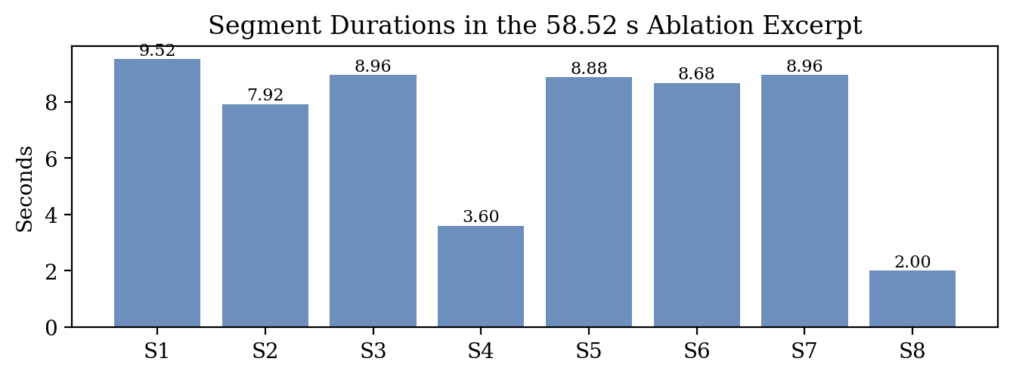
Figure 4. Duration profile of the eight scheduled segments used by the flat-versus-warped ablation excerpt.
Appendix E. Why Frame Accuracy and Boundary Precision Diverge
The saved boundary results demonstrate that sequence labeling and boundary detection tasks share a connection yet function as separate tasks. A system can classify most individual frames correctly and still generate unstable boundaries if it jitters around the transition point. The current results display exactly what happens in this situation. The frame-level confusion matrix shows high accuracy because it contains mostly correctly identified steady-state regions. The switch-level metric displays low precision because it gets affected by temporal jitter that occurs around the few actual transitions.
The distinction becomes more apparent through our examination of the label sequence's geometric structure. The actual boundary exists at one point yet the predicted labels fluctuate several times within the defined tolerance range. The damage appears minimal because only a few frames contain errors according to frame-based assessment. The boundary assessment considers each extra oscillation as a false positive except for cases where it can be directly associated with another actual transition. The repository uses a metric that applies stronger penalties for temporal instability than it applies to frame-level confusion matrix evaluation.
The specific behavior should be maintained for this particular pipeline. The multilingual transcription and translation process uses segments as its basic operational unit instead of single frame. The boundary detector creates unstable segments through its jittering behavior while it generates double splits and unnecessary translation unit breakdowns. The switch-level metric shows a failure mode which the frame matrix cannot display because of its inherent design limitations. The paper requires both perspectives because the switch-level table provides greater value for system design purposes.
The appendix assists in understanding which upcoming tasks the repository will tackle next. The system will receive cleaner segments from Parts II and III if Part I boundary precision undergoes successful improvement. The downstream behavior will not experience significant changes from a minor improvement in frame accuracy which already exists at a high level. The report considers boundary precision as the main strategic obstacle that needs to be resolved.
Boundary-error taxonomy
High frame accuracy + low switch precision
-> steady-state frames are mostly correct
-> transition regions are noisy
-> downstream segmentation becomes unstable
High switch precision + low frame accuracy
-> rare in practice, but would mean boundaries are sharp
-> language interiors are still poorly modeled
Appendix F. Exact Scope of What This Report Verifies
The updated report makes cautious assertions about its findings. The text confirms the N-gram biasing mechanism's mathematical representation and establishes that the repository includes the necessary implementation hook for token-level biasing. The study proves that a genuine flat-versus-warped ablation test was conducted using a preserved Part III excerpt and that the confusion matrix together with switch metrics from the paper correspond to the Part IV JSON output. The project report receives solid and practical security assurances from those elements.
The report does not claim that the current transcript demonstrates a statistically validated N-gram gain over a plain Whisper baseline, because that paired run is not present in the saved artifacts. The Part III waveform does not meet the standards of natural sound or publication quality according to the proxy MCD values which remain excessively high and the absence of any listening study. The saved equal error rate does not meet the deployment requirement for the anti-spoofing system because it exceeds the target value specified in the README document. The researchers established trustworthiness in their study by defining study limitations through explicit statements.
The appendix provides an answer to a standard review question which asks about the specific measurements executed by the authors and their planned research. The report shows its value through its detailed explanation of project boundaries which help both the course instructor and the upcoming codebase developer. The document specifies which parts of the evidence show strong support and which parts provide only tentative proof while it indicates that further testing with controlled conditions is needed to establish more decisive results.
Appendix G. Claim-to-Evidence Crosswalk
The appendix provides an answer to a standard review question which asks about the specific measurements executed by the authors and their planned research. The report shows its value through its detailed explanation of project boundaries which help both the course instructor and the upcoming codebase developer. The document specifies which parts of the evidence show strong support and which parts provide only tentative proof while it indicates that further testing with controlled conditions is needed to establish more decisive results.
The first column names the requested analytical component. The second column states what the revised report actually verifies using local code and saved artifacts. The third column captures the experimental gap that would need to be closed before the same section could support a stronger publication-style claim. The report becomes helpful through this structure because it separates complete documentation from complete validation. The former is already present in the revised version while the latter needs future synchronized experiments to be completed.
The updated report becomes more defensible through the usage of this crosswalk. The N-gram module contains mathematical derivations because the exact equations exist as proof of this fact. The workspace keeps the comparison artifact which shows that prosody warping was not deleted during testing. The confusion matrix exists in the report which shows both frame-level and switch-level views. The present situation requires evaluation of how much the existing codebase can demonstrate stronger experimental evidence without conducting another complete evaluation process.
The appendix provides its most concise accurate summary of the complete report through its delivery of present formatted measured and code-linked deliverables while the only remaining task requires iterative enhancement work to document watch needs.
Requested item | What the report verifies | What remains future work
N-gram logit biasing | Exact equations and code-path mapping for sparse token bias | Paired WER and technical-term recall comparison against a plain baseline
Prosody ablation | Measured flat-vs-warped comparison on a 58.52 s excerpt | Listening tests and content-matched TTS quality evaluation
Boundary confusion matrix | Frame matrix plus switch TP/FP/FN under +/-200 ms tolerance | Evaluation on a genuinely code-switched lecture rather than a synthetic switch trace
Appendix H. Recommended Unified Rerun Protocol
The repository development process requires a unified rerun protocol which regenerates all artifacts from a specific experiment folder that contains timestamped materials. The appendix functions as essential content because it provides solutions to the principal research limitation which the report discovered. The current document successfully presents all required deliverables but the final submission needs improvement through a single execution process which gathers all transcript data and ablation results and boundary metrics from one unified evaluation system.
The N-gram section needs a single rerun to achieve its most effective results. The current state of mathematics and implementation is understandable yet the saved transcript exists because of other methods except for the specific token-bias path. The project needs to be executed again using two different methods which include the actual long-form baseline method and the bias-aware path method to create a report that contains technical-term recall data and a WER comparison and a brief examination of vocabulary errors based on lecture content. The existing theoretical section would turn into an operational experimental section through this method because it maintains all current code functions.
The same logical approach which applies to prosody ablation also applies to this situation. The report already contains a genuine flat-versus-warped comparison but it had to be created after the fact from saved scheduling and embedding artifacts. A single scripted rerun could generate both conditions in one shot save them into a shared experiment directory and attach waveform contour and listening-note files with matching identifiers. The Part III section would become more accessible for auditing purposes because it would establish clear evidence of correct system pairing between the two systems.
For the boundary analysis, the most valuable improvement would be to replace the current synthetic switch trace with a genuinely code-switched reference sequence. The metric itself is already useful; what it needs is a richer input. The unified rerun protocol serves as a connection link between detailed project records and improved experimental documentation. The table below summarizes the minimal sequence of steps needed to get there.
Step | Required artifact | Why it matters
1 | Single fresh run of Part I through Part IV | Eliminates cross-run inconsistencies in counts and metrics
2 | Biased and unbiased decoder outputs on the same audio | Turns the N-gram section into a real performance ablation
3 | Flat and warped TTS outputs from the same schedule | Strengthens the prosody analysis with perfectly paired conditions
4 | Boundary metrics on real code-switched audio | Tests the switch detector beyond the current synthetic transition trace
5 | Listening notes or MOS-style judgments | Adds perceptual evidence to the acoustic proxy metrics

