**A**

**MINI PROJECT REPORT**

**ON**

**“Android** **Attendance System”**

**BY**

**Walunj Pranav Namdev**

**SAVITRIBAI PHULE PUNE UNIVERSITY**

**MASTERS OF COMPUTER APPLICATION**



**Akole Taluka Education Society’s**

**TECHNICAL CAMPUS AKOLE 2021-2022**

CERTIFICATE

This is to certify that, the **Mini Project Report** entitled **“Android** **Attendance System ”**, which is being submitted herewith for the award of the Degree of **Master In Computer Application** semester I under the faculty **Commerce and Management** of **Savitribai Phule Pune University, Pune** is the result of original research work completed by **Mr. Walunj Pranav Namdev,** under my supervision and guidance. To the best of my knowledge and belief the work embodied in this Mini Project Report has not submitted earlier for the award of any Degree, Diploma, Associateship, Fellowship or similar title in this or any other University or any other Examining Body.

I give an undertaking that the material included in the Mini Project Report from other sources are duly acknowledged.

**Pranav Walunj Prof.Kiran A.Shejul**

I have verified that, the research student has incorporated all the changes as suggested by Pre-submission Presentation Committee, if any.

**Place :Akole Dr. Prashant Radhakrishna Tambe**

**Date : 26/2/2022 Director**

DECLARATION

I, hereby declare that, the research work presented in the **Mini Project Report** entitled **“Android** **Attendance System”** submitted for the award of the Degree of **Master In Computer Application** semester I under the faculty **Commerce and Management** of **Savitribai Phule Pune University, Pune** is an outcome of my own efforts and a genuine research work done under the guidance of **Prof.Kiran A.Shejul**. I also declare that, this mini–Project

Report or any part therein has not been previously submitted by me for the award of any Degree, Diploma, Associateship, Fellowship or Titles in this or any other University or any other Institution of Higher Learning.

I, further declare that the material obtained from other sources has been duly acknowledged.

**Place :Akole**

**Date : 26/2 / 2022 Walunj Pranav Namdev**

ACKNOWLEDGEMENT

*This Mini project report is a fruitful outcome of experiences, challenges, and relationships involving many great people to whom I am more indebted than I can possibly acknowledge. Some of them, however, deserve special thanks. I take this opportunity with much pleasure to thank all, who directly and indirectly contributed, helped me for this mini-Project.*

*I, take this opportunity to express my deep sense of gratitude and indebtedness to my research guide* ***Prof. Kiran A.Shejul*** *for his keen interest, dynamic guidance and constant encouragement. I, express deep sense of gratitude* ***to Dr. Prashant Radhakrishna Tambe, Director - ATES’s Technical Campus, Akole*** *for his continuous encouragement and support to complete this mini–Project Report.*

*I, owe sincere thanks to* ***Mr. Prof. Kiran A.Shejul , Mr.Prof Amol Nawale, Mr. Prof Vaibhav B.Dongare*** *for their stimulating support to*

*complete this Project Report.*

**Place :Akole**

**Date : 26/ 2/2022 Pranav Namdev Walunj**

**INDEX**

|  |  |
| --- | --- |
| Sr.no | Topic |
| 1 | Introduction |
| 2 | System Requirements |
| 3 | Diagrams |
| 4 | Input Design |
| 5 | Future Scope |
| 6 | Conclusion |
| 7 | References |

**Introduction**

Attendance Management System is a software developed for daily student attendance in schools, collages and institutes.

If facilitates to access the attendance information of a particular student in a particular class.

The information is sorted by the operators, which will be provided by the teacher for a particular class.

This system will also help in evaluating attendance eligibility criteria of a student.

Attendance is a vital part of daily routine in educational institutes, offices and many other organizations.

The mobile attendance system has been built to eliminate the time and effort wasted in taking attendances in school and collages.

It also greatly reduces the amount of paper resources needed in attendance data management. This is an android mobile app.

* 1. **Existing System**

In existing system when teacher write the all information in on paper means designing the theoretically .

then it write the information on student spellings are mistake in the data that’s why it is very difficult to handle this system.

* Time consuming
* Difficult to report generating.
* Difficult to handle the all student data.
  1. **Proposed System**

In proposed system the attendance are design in practical format.

Teacher can collect information in this system. Then overcome this problem in existing system this attendance system are developing.

* This system saves the time.
* Easily install.
* Easy to transfer from mobile to computer.
* It gives the overall performance of class in attendance.

Over the years the manual attendance management report in java has been carried across most of educational institutions. To overcome the problems of manual attendance, I have developed “web based attendance Management System”.

Attendance Management System is based on web server, which can be implemented on any computer. In This application, java is server side language, MySQL/SQLITE and java is used as back-end design and HTML, CSS and JavaScript are used as front-end tools.

**System Requirements:**

* **Hardware Requirements:**

**Processor** :- Intel I 5

**RAM :**-512 MB

**Hard disk** :-512 MB

* **Software Requirements:**

**Platform**:- Windows, Android Operating System

**Language**:- Java, XML

**External Source**:- Android Studio

* **Backend**: SQLITE.
* **Frontend**: JAVA.
* **Entity relationship diagram (ERD)**

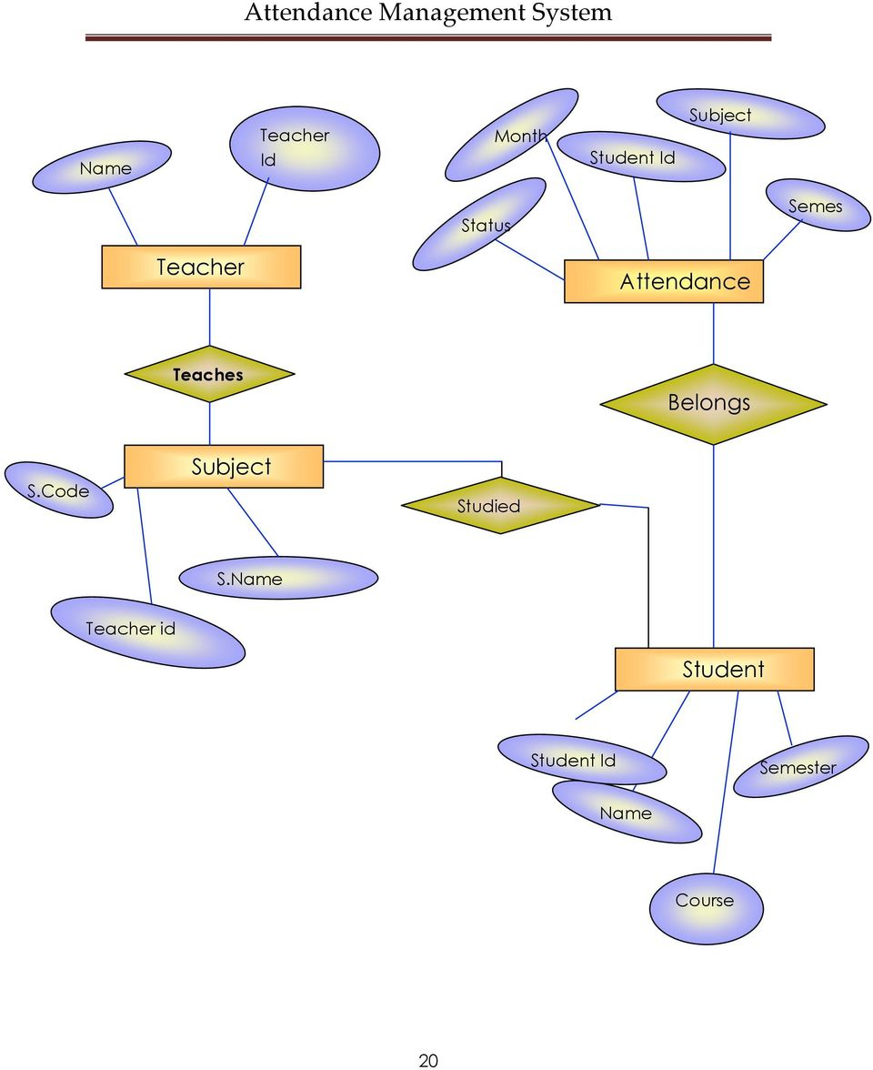

* **Data Flow Diagram (DFD)**
* **0 Level DFD**

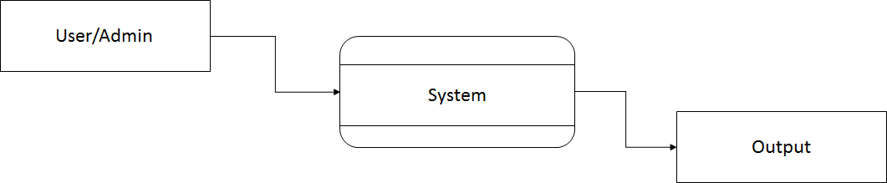

* Fig: 0 level DFD

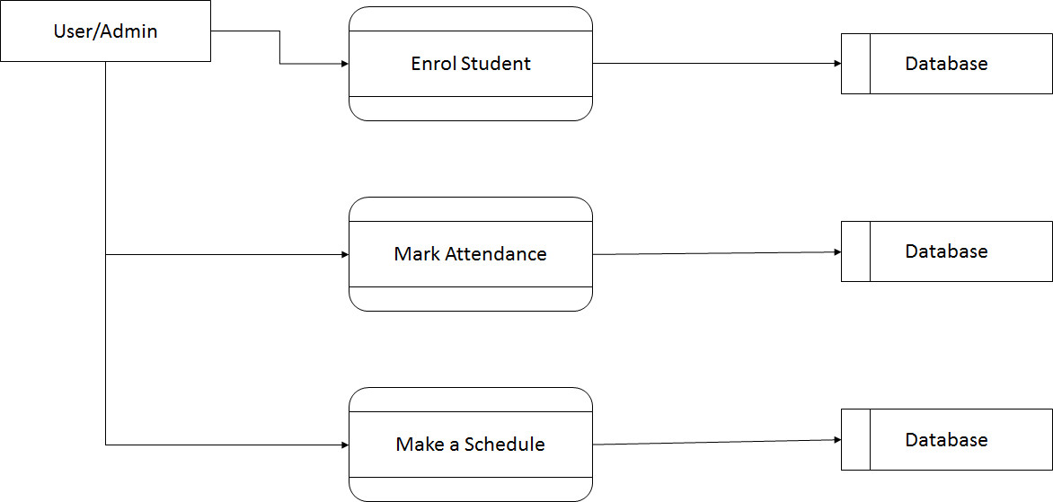

**1 Level DFD**



* Fig: 1 Level DFD

**Use Case**

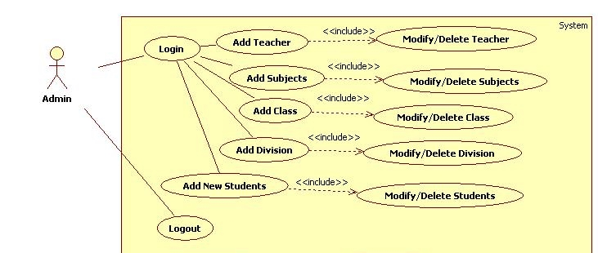

**Input Design**



**Home Page**

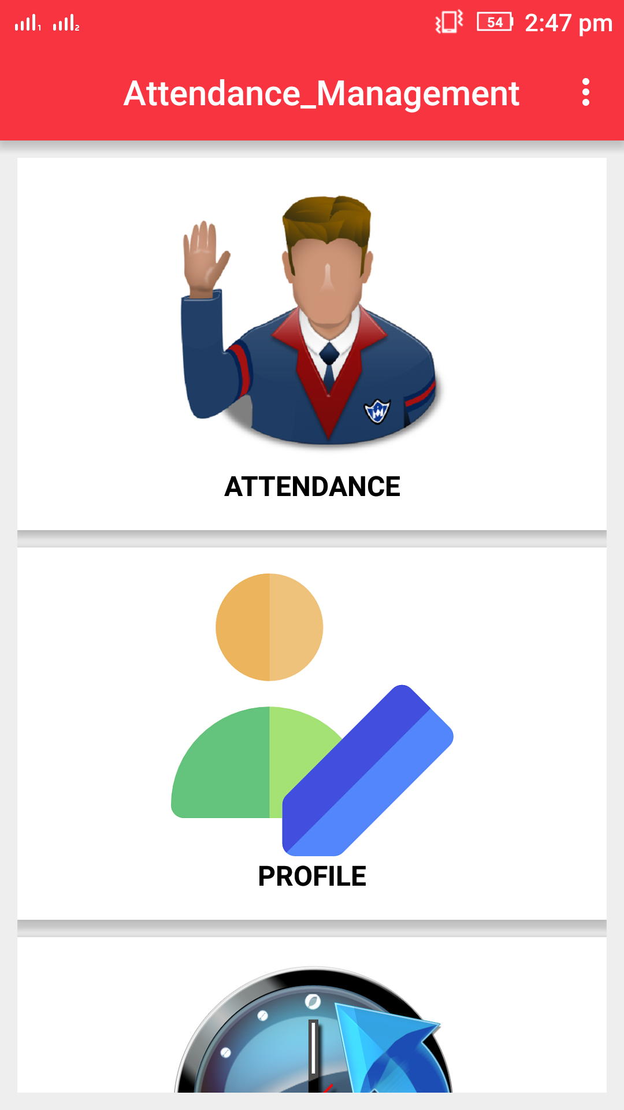

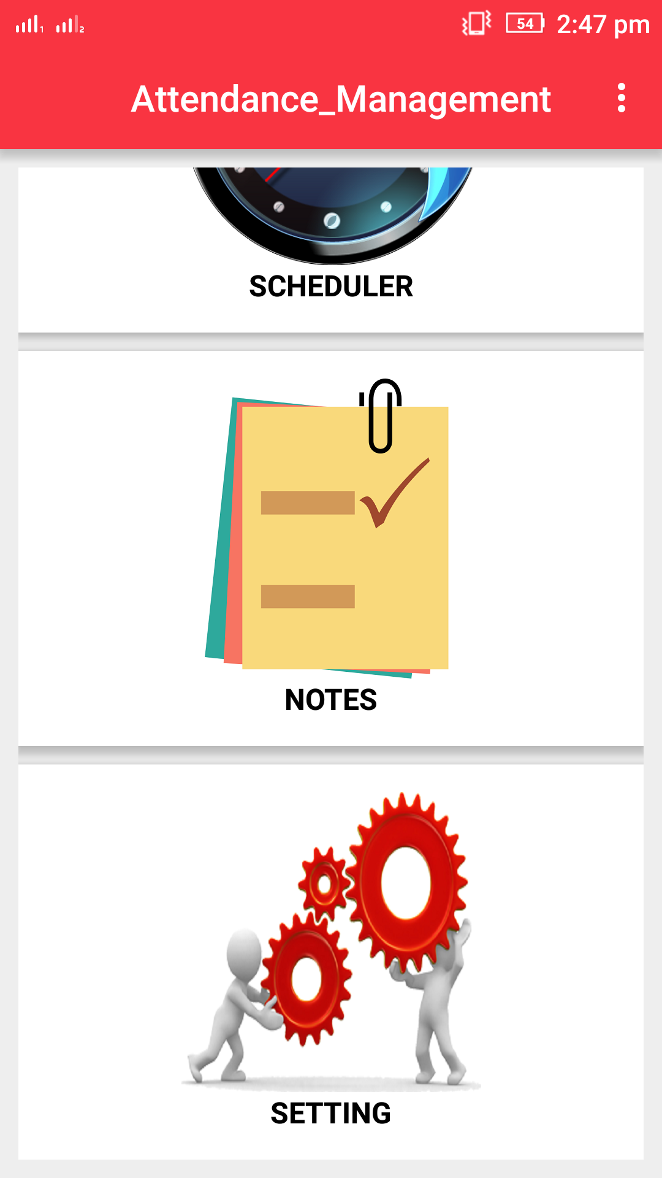

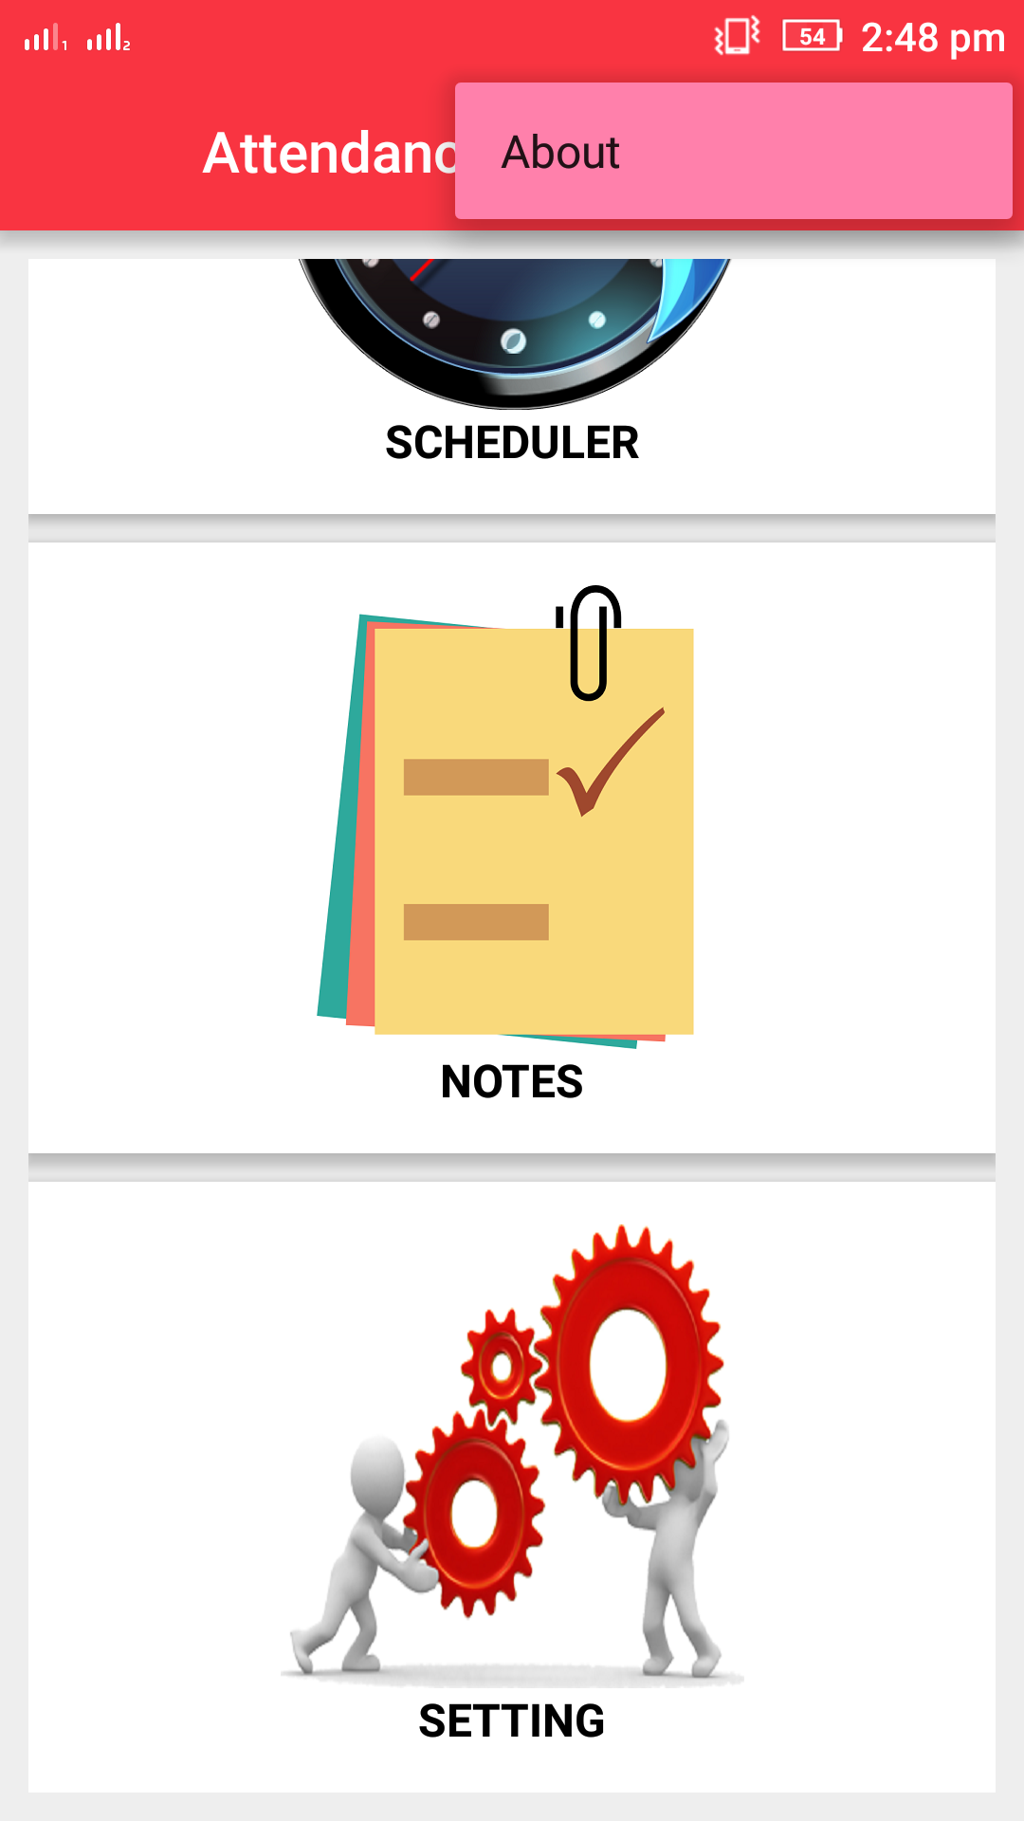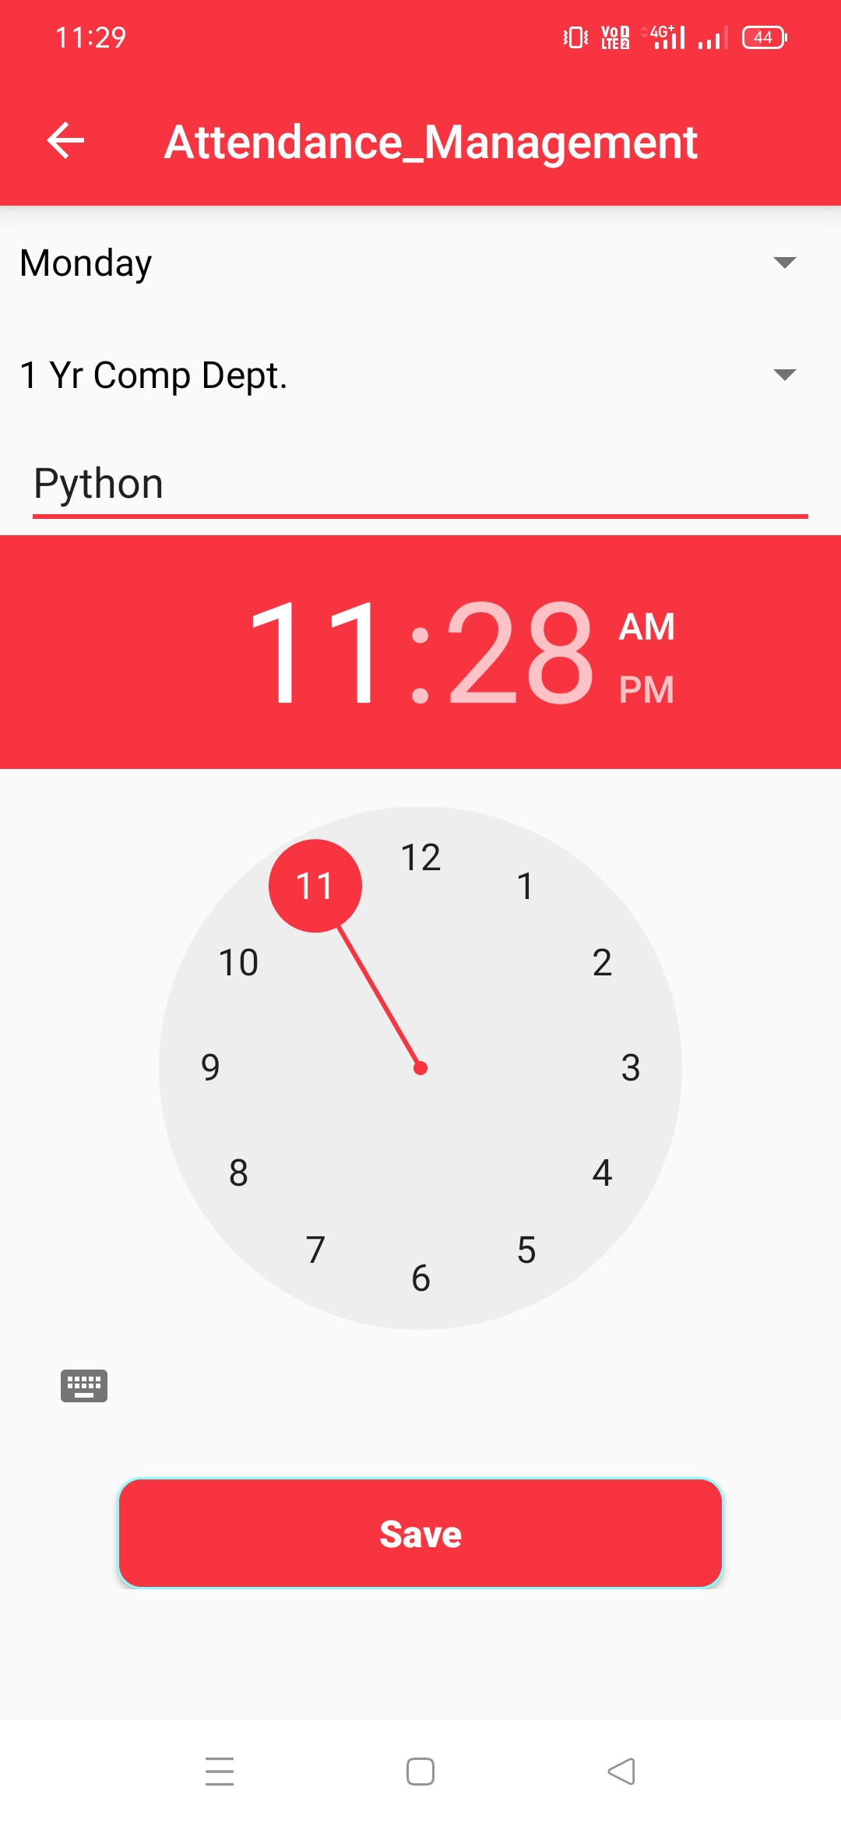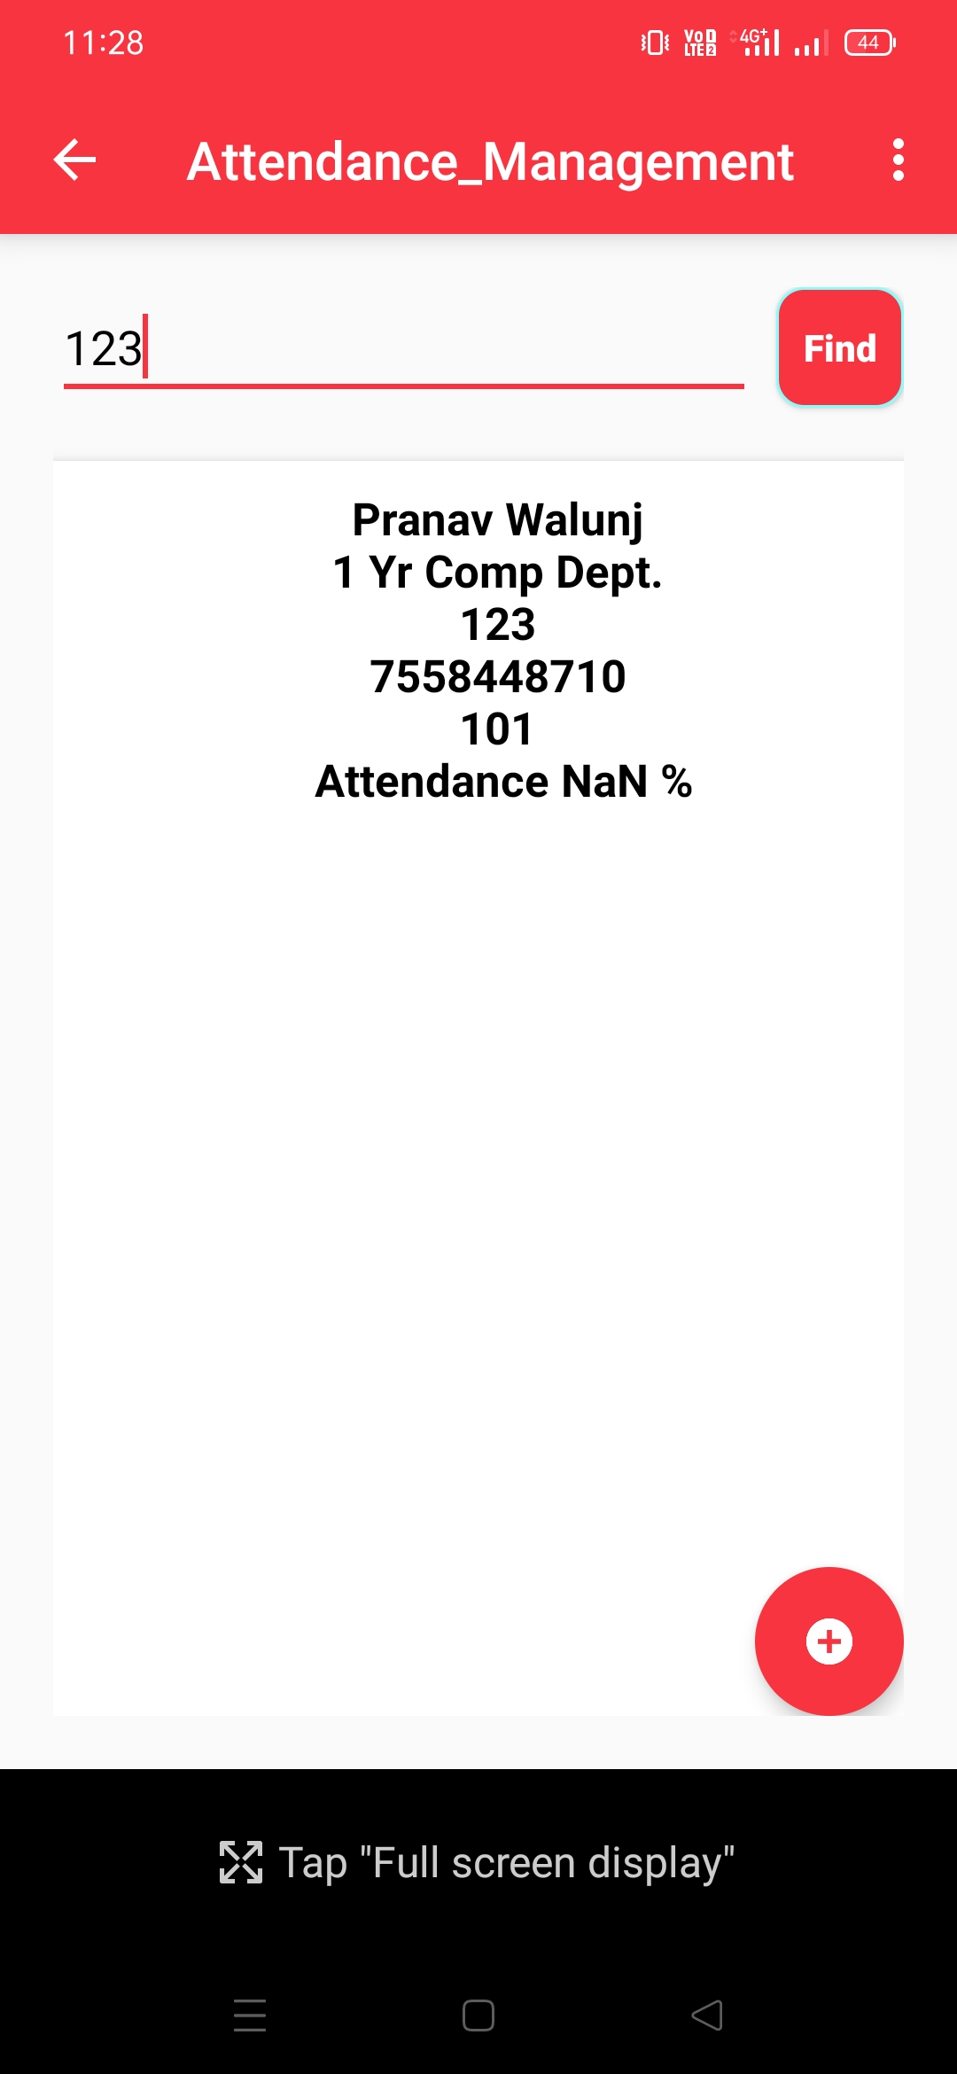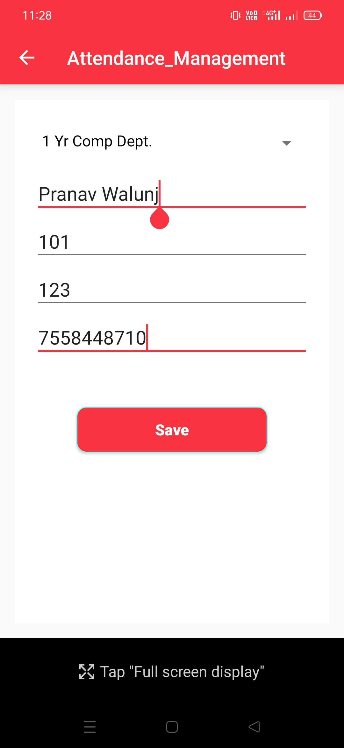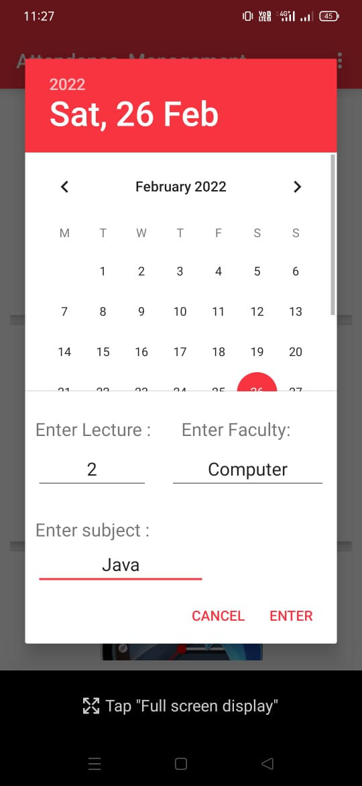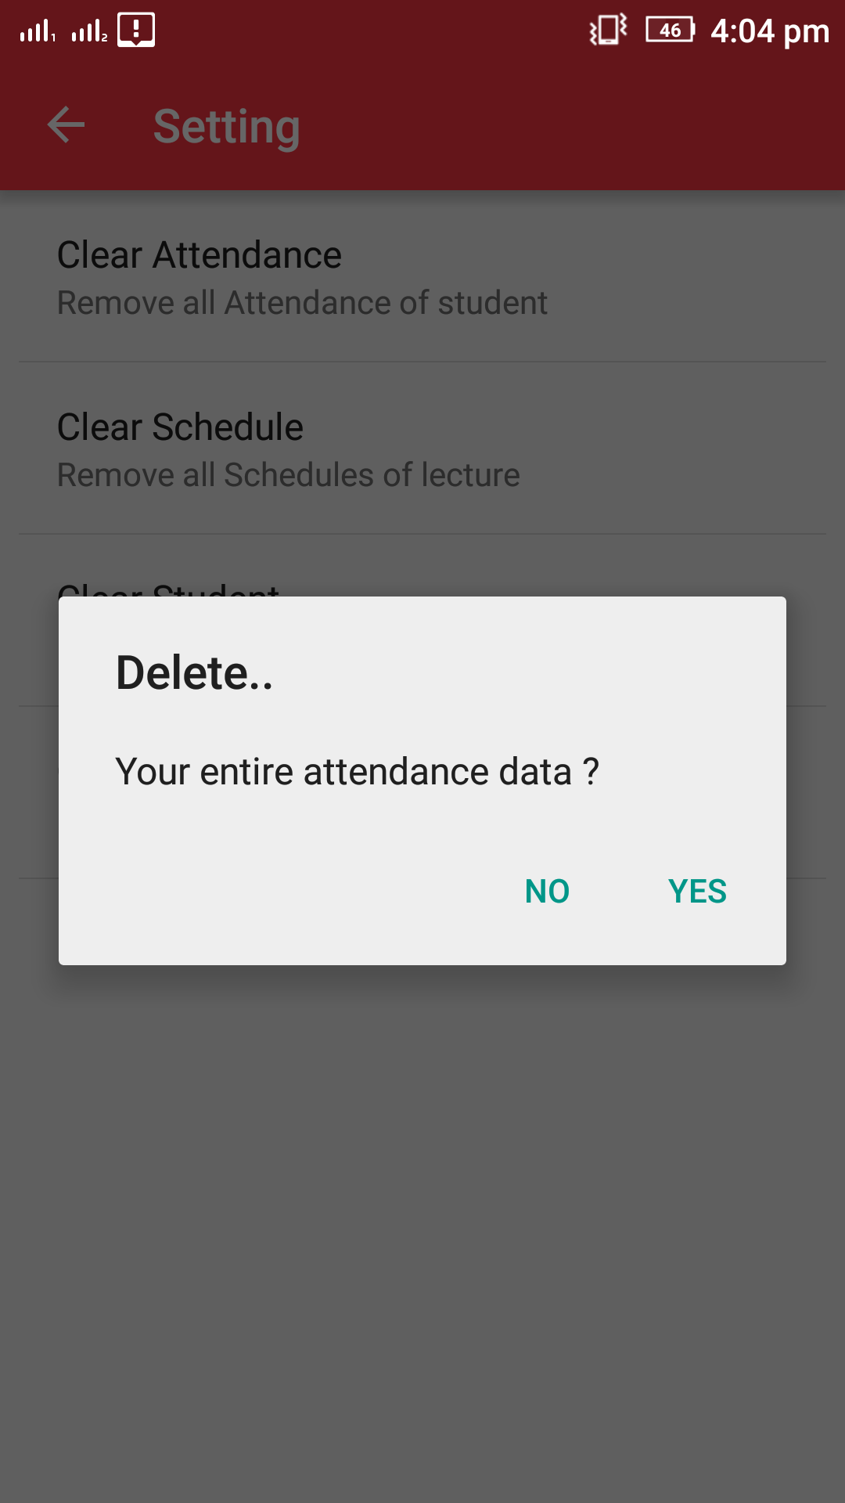

**Future Enhancement**

**Future Enhancement**

Introduction of messaging and emailing can be added, which may send the attendance details to the students, or more probably their parents.

This feature may help in maintaining a good attendance of any institute.

It is not possible to develop a system that makes all the requirement of the user. User requirements keep changing as the system is being used. Some of the future enhancements that can be done to this system are :

1. As the technology emerges, it is possible to upgrade the system and can be adaptable to desired environment.

2. Based on the future security issues, security can be improved using emerging technologies.

**Conclusion:**

The Attendance Management System is developed using Java and Android fully meets the objectives of the system which it has been developed.

The system has reached a steady state where all bugs have been eliminated.

The system is operated at a high level of efficiency and all the teachers and user associated with the system understands its advantage.

The system solves the problem. It was intended to solve as requirement specification

**References:**

[www.wikipedia.org](http://www.wikipedia.org)

[www.issuu.com](http://www.issuu.com)

[www.scribd.com](http://www.scribd.com)

<http://www.dropbox.com>

<http://www.slideshare.com>