**A**

**MINI PROJECT REPORT**

**ON**

**“Lost Adventurer game”**

**BY**

**Walunj Pranav Namdev**

**SAVITRIBAI PHULE PUNE UNIVERSITY**

**MASTERS OF COMPUTER APPLICATION**



**Akole Taluka Education Society’s**

**TECHNICAL CAMPUS AKOLE 2021-2022**

CERTIFICATE

This is to certify that, the **Mini Project Report** entitled **“Lost Adventurer game”**, which is being submitted herewith for the award of the Degree of **Master In Computer Application** semester I under the faculty **Commerce and Management** of **Savitribai Phule Pune University, Pune** is the result of original research work completed by **Mr. Walunj Pranav Namdev,** under my supervision and guidance. To the best of my knowledge and belief the work embodied in this Mini Project Report has not submitted earlier for the award of any Degree, Diploma, Associateship, Fellowship or similar title in this or any other University or any other Examining Body.

I give an undertaking that the material included in the Mini Project Report from other sources are duly acknowledged.

**Pranav Walunj Prof.Kiran A.Shejul**

I have verified that, the research student has incorporated all the changes as suggested by Pre-submission Presentation Committee, if any.

**Place :Akole Dr. Prashant Radhakrishna Tambe**

**Date : 26/2/2022 Director**

DECLARATION

I, hereby declare that, the research work presented in the **Mini Project Report** entitled **“Lost Adventurer game”** submitted for the award of the Degree of **Master In Computer Application** semester I under the faculty **Commerce and Management** of **Savitribai Phule Pune University, Pune** is an outcome of my own efforts and a genuine research work done under the guidance of **Prof.Kiran A.Shejul**. I also declare that, this mini–Project

Report or any part therein has not been previously submitted by me for the award of any Degree, Diploma, Associateship, Fellowship or Titles in this or any other University or any other Institution of Higher Learning.

I, further declare that the material obtained from other sources has been duly acknowledged.

**Place :Akole**

**Date : 26/2 / 2022 Walunj Pranav Namdev**

ACKNOWLEDGEMENT

*This Mini project report is a fruitful outcome of experiences, challenges, and relationships involving many great people to whom I am more indebted than I can possibly acknowledge. Some of them, however, deserve special thanks. I take this opportunity with much pleasure to thank all, who directly and indirectly contributed, helped me for this mini-Project.*

*I, take this opportunity to express my deep sense of gratitude and indebtedness to my research guide* ***Prof. Kiran A.Shejul*** *for his keen interest, dynamic guidance and constant encouragement. I, express deep sense of gratitude* ***to Dr. Prashant Radhakrishna Tambe, Director - ATES’s Technical Campus, Akole*** *for his continuous encouragement and support to complete this mini–Project Report.*

*I, owe sincere thanks to* ***Mr. Prof. Kiran A.Shejul , Mr.Prof Amol Nawale, Mr. Prof Vaibhav B.Dongare*** *for their stimulating support to*

*complete this Project Report.*

**Place :Akole**

**Date : 26/ 2/2022 Pranav Namdev Walunj**

**INDEX**

|  |  |  |  |
| --- | --- | --- | --- |
|  | **Topic Name** |  | |
| **1** | Introduction   * 1. Overview   2. Purposes   3. Objective   4. Existing System   5. Scope | **4** | |
| **2** | System Design   * 1. Design   2. Sequence Diagram   3. Activity Diagram   4. Use Case Diagram | **3** | |
| **3** | Hardware and Software Requirement   * 1. Hardware Required   2. Software Required | **2** | |
| **4** | Implementing Tools for the Project   * 1. Tools   2. JAVA | **1** | |
| **5** | Project View Structure   * 1. Design   2. Home Page   3. Start Page   4. End Page | **3** | |
| **6** | Conclusion  6.Conclusion | | **1** |

Introduction:

The lost adventurer game is an adventure game. This whole game or the project uses java and some swing component to make it look astonishing. You have to make the game protagonist reach this home.

Purpose System:

Aim of the project is to develop a Lost Adventurer game using the technology Java. It is a classic video game . A boy is walking on a site. By pressing arrow keys he will move left and right and by pressing space he will jump to avoid obstruction in site. When we press control boy will shoot the bullet which help him to kill eagle and save himself. When boy is fall in valley while walking on site game will end there.

The home page of the game is consist of multiple point like Play, Intro, Guide, Credits and Exit.

Play – User can start play the game by using play tab button.

Intro – Hunger, wind, pain, loss. The light of down. The sense of loss. You wake up in the mountains. You have lost something. Something important. You have lost everything. Your way, your memories, everything.

All you know that IT is here. Somewhere here, And you have to find it…And you don’t even remember what or where it is.

**Guide** – Move character with the arrow keys. Pressing space makes the character jump. Control key shoots bullets. Contact with an enemy or falling into an abyss or ground results in death.

**Credits** – This tab holds all about the credit or score of the game.

**Exit** – User can exit the game by using Exit tab.

The objective of the system:

The main purpose of LOST Adventure game is user can play a game individual with a system.

Existing system:

Adventure Game Studio (AGS) is an open source development tool that is primarily used to create graphic adventure games. It is aimed at intermediatelevel game designers, and combines an Integrated development environment (IDE) for setting up most aspects of the game with a scripting language based on the java programming language to process the game logic.

Scope:

Anyone can play this game from the age of teen to adult .

Windows:

This project can easily be configured on the Windows operating system. For running this project on the Windows system all we need is to install JDK and IDE(Eclipse).

System Design:

The system is divided into some parts these are StartGame, Playing Game,  End Game as well as High Score. The flow of game is designed by using a  diagram illustrated in below figure-

**​**

**1.Sequence Diagram​**

**2.Activity Diagram​**

**3.Use Case Diagram​**

1.Sequence Diagram:

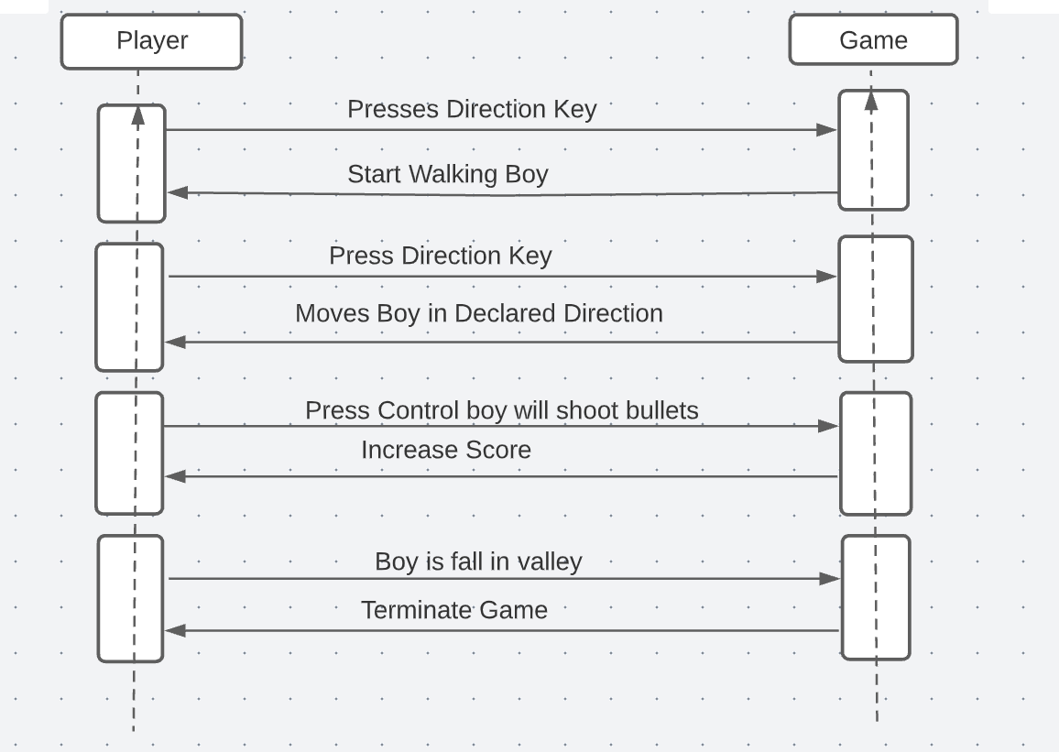

2.Activity Diagram:

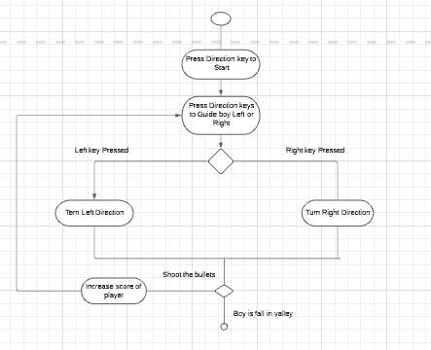

3. USE CASE-

### 

Hardware And Software Requirements:

**Hardware Requirements:**

* + Processor: Intel i5 10th gen/Ryzen 5
  + Memory: Min 4GB Disk
  + RAM: 2GB or Above
  + Input Devices: Keyboard, Mouse
  + Disk Space: Min 1GB

**Software Requirement:**

* + Windows 7/8/10
  + Java Virtual Machine

Project Model View:

Home Page:

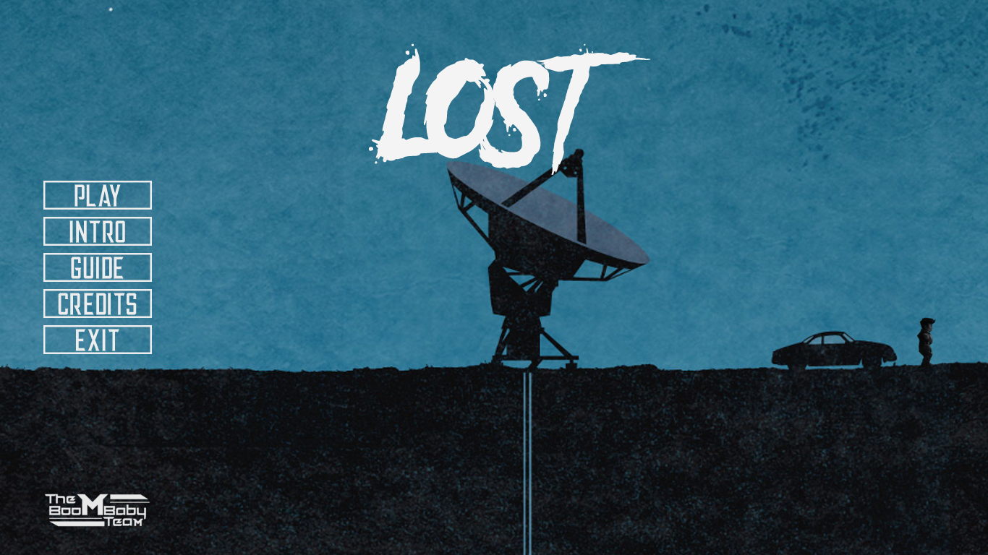

##### Starting Page:

##### 

**End Page:**

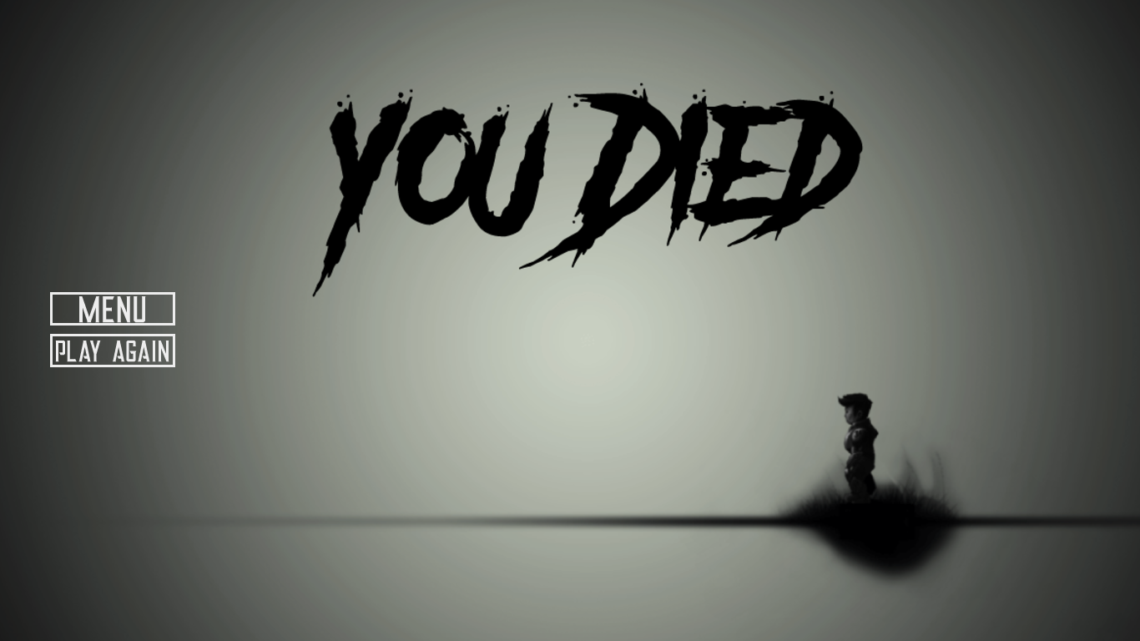

**Guid page**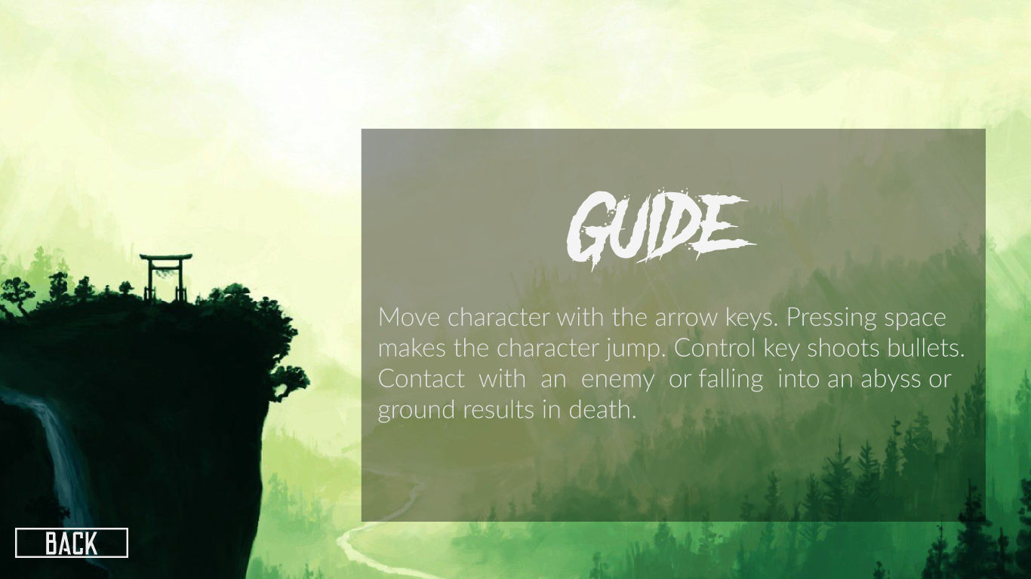

Conclusion:

Video games are a form of media that is often associated with negative health consequences. However, when games are played in moderation and with mindfulness, they are a viable source of stress relief as well as a catalyst for mental health improvement and development of social skills.