IOT – ASSIGNMENT

Pranav Rao Aiml-epsilon

2211cs020420

1. Write an Embedded C program to Create a Weather Reporting System that provides real-time environmental data to users.

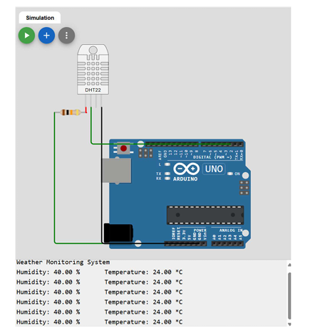

#include <stdio.h>

#include <stdlib.h>

#include <stdint.h>

#include <string.h>

#include "dht22.h"

#include "bmp280.h"

void initialize_sensors(void);

void read_temperature_and_humidity(float *temperature, float *humidity);

void read_pressure(float *pressure);

void display_data(float temperature, float humidity, float pressure);

int main(void) {

float temperature = 0.0, humidity = 0.0, pressure = 0.0;

initialize_sensors();

printf("Weather Reporting System Initialized.\n");

while (1) {

read_temperature_and_humidity(&temperature, &humidity);

read_pressure(&pressure);

display_data(temperature, humidity, pressure);

_delay_ms(1000);

}

return 0;

}

void initialize_sensors(void) {

if (!DHT22_init()) {

printf("Error initializing DHT22 sensor!\n");

exit(1);

}

if (!BMP280_init()) {

printf("Error initializing BMP280 sensor!\n");

exit(1);

}

}

void read_temperature_and_humidity(float *temperature, float *humidity) {

if (!DHT22_read(temperature, humidity)) {

printf("Error reading from DHT22 sensor!\n");

}

}

void read_pressure(float *pressure) {

if (!BMP280_read_pressure(pressure)) {

printf("Error reading from BMP280 sensor!\n");

}

}

void display_data(float temperature, float humidity, float pressure) {

printf("Temperature: %.2f°C\n", temperature);

printf("Humidity: %.2f%%\n", humidity);

printf("Pressure: %.2f hPa\n", pressure);

}

2.Write a Embedded C Program to Create a Nome Automation System that simplifies daily routines (Any 2 devices) by controlling devices remotely.

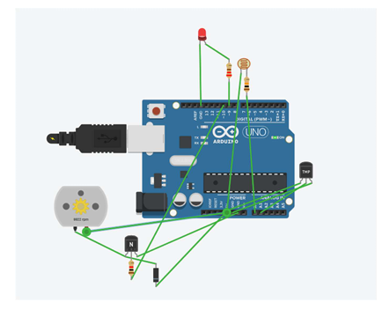

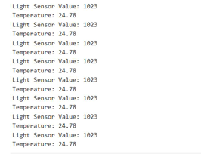

#include <stdio.h>

#include <stdlib.h>

#include <stdint.h>

#include <string.h>

#define LIGHT_PIN 2

#define FAN_PIN 3

void initialize_devices(void);

void control_light(uint8_t state);

void control_fan(uint8_t state);

void process_command(char *command);

int main(void) {

char command[20];

initialize_devices();

printf("Home Automation System Initialized.\n");

while (1) {

printf("Waiting for command...\n");

scanf("%s", command);

process_command(command);

}

return 0;

}

void initialize_devices(void) {

GPIO_set_mode(LIGHT_PIN, OUTPUT);

GPIO_set_mode(FAN_PIN, OUTPUT);

GPIO_write(LIGHT_PIN, 0);

GPIO_write(FAN_PIN, 0);

}

void control_light(uint8_t state) {

if (state) {

GPIO_write(LIGHT_PIN, 1);

printf("Light turned ON.\n");

} else {

GPIO_write(LIGHT_PIN, 0);

printf("Light turned OFF.\n");

}

}

void control_fan(uint8_t state) {

if (state) {

GPIO_write(FAN_PIN, 1);

printf("Fan turned ON.\n");

} else {

GPIO_write(FAN_PIN, 0);

printf("Fan turned OFF.\n");

}

}

void process_command(char *command) {

if (strcmp(command, "LIGHT_ON") == 0) {

control_light(1);

} else if (strcmp(command, "LIGHT_OFF") == 0) {

control_light(0);

} else if (strcmp(command, "FAN_ON") == 0) {

control_fan(1);

} else if (strcmp(command, "FAN_OFF") == 0) {

control_fan(0);

} else {

printf("Invalid command.\n");

}

}

3.Write an Embedded C program to create an Air Pollution Monitoring System that tracks air quality levels in real-time to ensure a healthier environment.

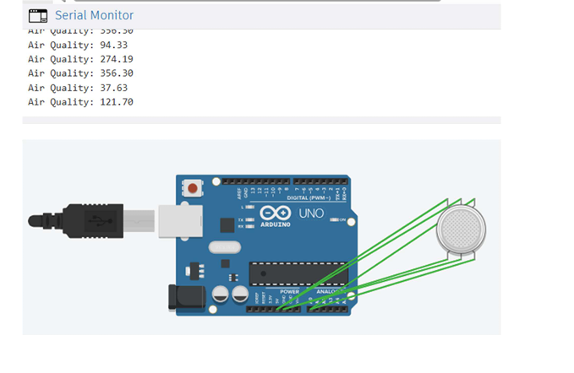

#include <stdio.h>

#include <stdlib.h>

#include <stdint.h>

#include "mq135.h"

#define AQI_THRESHOLD 100

void initialize_system(void);

int read_air_quality(void);

void display_air_quality(int aqi);

void check_air_quality(int aqi);

int main(void) {

int air_quality;

initialize_system();

printf("Air Pollution Monitoring System Initialized.\n");

while (1) {

air_quality = read_air_quality();

display_air_quality(air_quality);

check_air_quality(air_quality);

_delay_ms(1000);

}

return 0;

}

void initialize_system(void) {

if (!MQ135_init()) {

printf("Error initializing MQ135 sensor!\n");

exit(1);

}

}

int read_air_quality(void) {

int aqi = MQ135_read();

return aqi;

}

void display_air_quality(int aqi) {

printf("Air Quality Index (AQI): %d\n", aqi);

}

void check_air_quality(int aqi) {

if (aqi > AQI_THRESHOLD) {

printf("Warning: Poor air quality detected! AQI: %d\n", aqi);

} else {

printf("Air quality is good. AQI: %d\n", aqi);

}

}

4.Write an Embedded C program to create an IoT based smart Irrigation system for Agriculture that automates watering based on weather and soil conditions

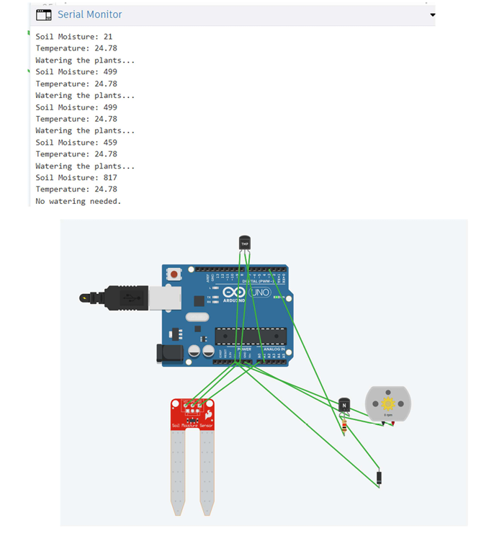

#include <stdio.h>

#include <stdlib.h>

#include <stdint.h>

#include "soil_moisture.h"

#include "dht22.h"

#include "wifi_module.h"

#define SOIL_MOISTURE_THRESHOLD 40

#define TEMPERATURE_THRESHOLD 35

#define HUMIDITY_THRESHOLD 60

#define PUMP_PIN 3

void initialize_system(void);

void control_irrigation(int soil_moisture, int temperature, int humidity);

void fetch_weather_data(int *temperature, int *humidity);

int main(void) {

int soil_moisture = 0;

int temperature = 0;

int humidity = 0;

initialize_system();

printf("IoT-Based Smart Irrigation System Initialized.\n");

while (1) {

soil_moisture = SoilMoisture_read();

fetch_weather_data(&temperature, &humidity);

control_irrigation(soil_moisture, temperature, humidity);

_delay_ms(5000);

}

return 0;

}

void initialize_system(void) {

if (!SoilMoisture_init()) {

printf("Error initializing Soil Moisture sensor!\n");

exit(1);

}

if (!DHT22_init()) {

printf("Error initializing DHT22 sensor!\n");

exit(1);

}

if (!WiFiModule_init()) {

printf("Error initializing WiFi Module!\n");

exit(1);

}

GPIO_set_mode(PUMP_PIN, OUTPUT);

GPIO_write(PUMP_PIN, 0);

}

void control_irrigation(int soil_moisture, int temperature, int humidity) {

if (soil_moisture < SOIL_MOISTURE_THRESHOLD && temperature > TEMPERATURE_THRESHOLD && humidity < HUMIDITY_THRESHOLD) {

GPIO_write(PUMP_PIN, 1);

printf("Pump turned ON. Soil Moisture: %d, Temperature: %d°C, Humidity: %d%%\n", soil_moisture, temperature, humidity);

} else {

GPIO_write(PUMP_PIN, 0);

printf("Pump turned OFF. Soil Moisture: %d, Temperature: %d°C, Humidity: %d%%\n", soil_moisture, temperature, humidity);

}

}

void fetch_weather_data(int *temperature, int *humidity) {

char weather_data[100];

if (WiFiModule_fetch("api.weather.com/data", weather_data)) {

sscanf(weather_data, "TEMP:%d,HUM:%d", temperature, humidity);

} else {

printf("Error fetching weather data.\n");

*temperature = 0;

*humidity = 0;

}

}

5.Write an Embedded C program to create a Smart Alarm Clock that adjust to your schedule and environment, waking you up intelligently.

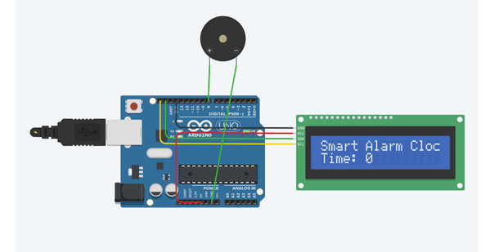

#include <stdio.h>

#include <stdlib.h>

#include <stdint.h>

#include "soil_moisture.h"

#include "dht22.h"

#include "wifi_module.h"

#define SOIL_MOISTURE_THRESHOLD 40

#define TEMPERATURE_THRESHOLD 35

#define HUMIDITY_THRESHOLD 60

#define PUMP_PIN 3

void initialize_system(void);

void control_irrigation(int soil_moisture, int temperature, int humidity);

void fetch_weather_data(int *temperature, int *humidity);

int main(void) {

int soil_moisture = 0;

int temperature = 0;

int humidity = 0;

initialize_system();

printf("IoT-Based Smart Irrigation System Initialized.\n");

while (1) {

soil_moisture = SoilMoisture_read();

fetch_weather_data(&temperature, &humidity);

control_irrigation(soil_moisture, temperature, humidity);

_delay_ms(5000);

}

return 0;

}

void initialize_system(void) {

if (!SoilMoisture_init()) {

printf("Error initializing Soil Moisture sensor!\n");

exit(1);

}

if (!DHT22_init()) {

printf("Error initializing DHT22 sensor!\n");

exit(1);

}

if (!WiFiModule_init()) {

printf("Error initializing WiFi Module!\n");

exit(1);

}

GPIO_set_mode(PUMP_PIN, OUTPUT);

GPIO_write(PUMP_PIN, 0);

}

void control_irrigation(int soil_moisture, int temperature, int humidity) {

if (soil_moisture < SOIL_MOISTURE_THRESHOLD && temperature > TEMPERATURE_THRESHOLD && humidity < HUMIDITY_THRESHOLD) {

GPIO_write(PUMP_PIN, 1);

printf("Pump turned ON. Soil Moisture: %d, Temperature: %d°C, Humidity: %d%%\n", soil_moisture, temperature, humidity);

} else {

GPIO_write(PUMP_PIN, 0);

printf("Pump turned OFF. Soil Moisture: %d, Temperature: %d°C, Humidity: %d%%\n", soil_moisture, temperature, humidity);

}

}

void fetch_weather_data(int *temperature, int *humidity) {

char weather_data[100];

if (WiFiModule_fetch("api.weather.com/data", weather_data)) {

sscanf(weather_data, "TEMP:%d,HUM:%d", temperature, humidity);

} else {

printf("Error fetching weather data.\n");

*temperature = 0;

*humidity = 0;

}

}