Subject: No Objection for Registration of Copyright for the Work titled “Reelbite: Cinematic Cravings”

Dear Sir/Madam,

We, the undersigned authors of the work titled “Reelbite: Cinematic Cravings”, do hereby solemnly affirm and declare as follows:

Author 1:
I, Pranav Gupta, son of Sh. Bimal Kumar, residing at HOUSE NO.:433, BADALCOLONY,ZIRAKPURPUNJAB,DISTRICT:SASNAGAR,PINCODE:140603-140603, holding Indian nationality:
- I am one of the original authors and contributors of the above-mentioned work.
- I am authorized by all co-authors to communicate and coordinate with the Copyright Office.
- I have no objection to the registration of copyright jointly.

Author 2 :
I, Dr. Rajat Takkar, son of Mr. Pawan Takkar, residing at House no-205/B Vivek Vihar,Near Dr. Kapil Vohra opposite Govt. Rest House, Ambala City 140401, holding Indian nationality:
1. I am one of the original authors and the corresponding author of the work.
2. I am authorized by all co-authors to communicate and coordinate with the Copyright Office.
3. I have no objection to the registration of copyright jointly.

Joint Declaration:
1. The work is original and jointly created by all authors.
2. All authors agree to joint ownership.
3. No author will raise any objection in future.
4. This NOC is issued voluntarily.

Signatures:
Pranav Gupta 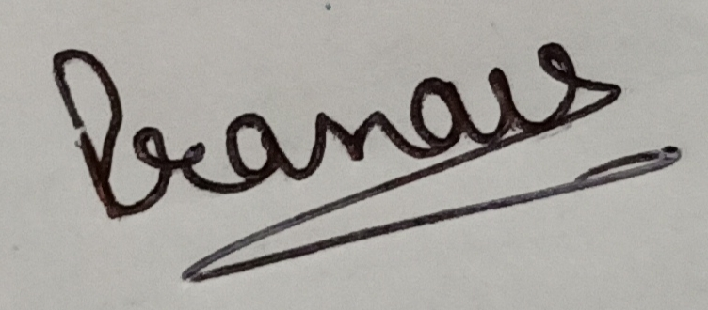
Dr. Rajat Takkar

Contact :
Pranav Gupta
Phone: 6280047400
Email: pranav666.be22@chitkara.edu.in
Rajat Takkar
Phone: 9467026112
Email: rajat.takkar@chitkara.edu.in

