

SCHOOL OF COMPUTER SCIENCE ENGINEERING AND INFORMATION SYSTEMS

FALL SEMESTER 2025-26

SWE2022 – Software Engineering Process, Tools & Methods

Title:
Case Study: Implementing Agile at Scale – The Spotify Approach

Faculty: JAGADEESH G
Slot: F2

Submitted By:
Name: PRANAVO V A
Reg no : 22MIS0043

Table of Contents
- Executive Summary
1.1 Purpose of the Case Study
1.2 The Problem
1.3 The Spotify Model
1.4 Results of the Model
1.5 Importance of the Spotify Model
1.6 Conclusion
- Background / Introduction
- Problem Analysis
- Data Collection and Analysis
4.1 Introduction
4.2 Data Collection Methods
4.3 Data Types
4.4 Data Analysis Techniques
4.5 Key Observations from Data
4.6 Data Interpretation
4.7 Summary
- Solution Implementation
5.1 Introduction
5.2 Step-by-Step Implementation Process
5.3 Tools and Technologies Used
5.4 Change Management
5.5 Results of Implementation
5.6 Challenges Faced During Implementation
5.7 Lessons Learned
5.8 Summary
- Results and Evaluation
6.1 Introduction
6.2 Key Results
6.3 Evaluation of Effectiveness
6.4 Challenges Observed
6.5 Overall Impact
6.6 Summary
- Lessons Learnt
- Appendices
Appendix A – Organizational Structure of the Spotify Model
Appendix B – Tools and Practices Used
Appendix C – Data Sources
Appendix D – Key Performance Improvements
Appendix E – Important Terms
Appendix F – References
1. Problem Statement
As Spotify expanded from a small startup into a multinational organization, it faced growing difficulties in maintaining agility, collaboration, and innovation across a rapidly scaling workforce. The company’s initial success was built on small, cross-functional teams using Scrum and Kanban, which worked efficiently when the company had fewer than ten teams.
However, as Spotify’s employee base grew into the thousands and its development teams spread across different geographical locations, the limitations of traditional Agile frameworks became evident.
1.1 Background of the Challenge
Spotify’s early years were characterized by rapid innovation and a strong engineering culture rooted in Agile practices. Each team, or Squad, was responsible for developing and maintaining a specific feature—such as playlist creation, user profiles, or recommendations.
Between 2010 and 2013, as the company grew exponentially, the development ecosystem became increasingly complex. The number of teams multiplied, inter-team dependencies increased, and coordination overhead began to affect productivity.
Traditional Agile methods such as Scrum of Scrums, SAFe (Scaled Agile Framework), and LeSS (Large Scale Scrum) were evaluated but found unsuitable. These frameworks often introduced rigid hierarchical structures and heavy documentation—contradictory to Spotify’s culture of flexibility, empowerment, and experimentation.
Management realized that adopting such frameworks would risk bureaucratizing innovation, slowing delivery, and demotivating employees.

1.2 Core Problems Identified
Spotify encountered several key challenges while trying to scale Agile practices:
a) Scaling Agile Beyond Small Teams
Agile methods work best for small, self-organizing teams. As Spotify grew to hundreds of teams, coordination became difficult. Teams often duplicated efforts, built overlapping features, or faced integration issues.
For example, when one team updated a backend API, dependent teams sometimes experienced failures due to unclear communication. This fragmentation reduced development speed and increased technical debt.
b) Loss of Autonomy and Innovation
Spotify’s culture was built on trust and autonomy. However, traditional management hierarchies began to threaten creativity. Employees started feeling disconnected from decision-making, risking the company’s innovative edge.
The challenge was balancing autonomy (freedom to innovate) and alignment (organizational consistency).
c) Communication and Collaboration Barriers
Teams were distributed across different cities and time zones such as Stockholm, New York, and London. Informal collaboration that once worked naturally in smaller teams no longer scaled effectively.
Knowledge silos appeared, and coordination between backend, frontend, and operations became slower and error-prone.
d) Slowdown in Product Delivery
Integration bottlenecks emerged as systems became complex. Coordinating across multiple teams delayed releases, stretching cycles from days to weeks. Testing and deployment inconsistencies increased production risks.
This directly impacted Spotify’s competitiveness in the fast-changing digital music industry.
e) Preserving Organizational Culture
Spotify valued its open and experimental culture. Leadership feared that traditional scaling frameworks would introduce rigidity and reduce creativity.
Maintaining “autonomy with accountability” became a central challenge—finding the right balance between structure and freedom.

1.3 The Need for a New Approach
Spotify realized that traditional Agile scaling methods were inadequate for its dynamic environment. Instead of adopting a one-size-fits-all framework, the company needed a custom model that matched its values of trust, empowerment, and continuous learning.
The goals were:
- Empowered Teams: Allow teams to decide how to work and deliver results.
- Alignment Through Shared Goals: Maintain independence while following a common vision.
- Lightweight Coordination: Use flexible, trust-based communication instead of rigid processes.
- Continuous Learning: Encourage experimentation, feedback, and reflection at all levels.
This led to the creation of The Spotify Model, a unique structure built around Squads, Tribes, Chapters, and Guilds, enabling scalability without hierarchy.

1.4 Summary of the Problem Statement
In summary, Spotify’s main problem was scaling Agile practices while maintaining its cultural DNA of innovation, autonomy, and speed.
The company faced bottlenecks that slowed development and reduced efficiency. Traditional Agile scaling frameworks were too rigid for Spotify’s creative environment.
Therefore, Spotify designed a lightweight, adaptable process model to:
- Empower teams while ensuring cross-team alignment,
- Enable continuous delivery and rapid innovation,
- Foster communication and shared learning, and
- Sustain its open, experimental culture.
This became the foundation for “The Spotify Model for Agile at Scale.”

2. Executive Summary
Spotify is one of the world’s largest music streaming services. It started in Sweden in 2006 with the goal of giving people easy and legal access to millions of songs.
In the early days, Spotify was a small company with a few teams working closely together. These teams used Agile methods like Scrum and Kanban to build the product quickly and improve it based on user feedback.
As the company grew fast, the number of teams increased to hundreds, spread across many countries. This growth caused problems:
- Teams had trouble coordinating their work.
- Communication between teams became difficult.
- Delivering updates took longer.
- The culture of freedom, creativity, and teamwork faced challenges.
Spotify’s leaders realized that traditional Agile frameworks like SAFe or LeSS were too strict for their culture. These frameworks added too many rules and slowed down teams.
To stay flexible and innovative while remaining organized, Spotify created a new working process called the Spotify Model for Agile at Scale.

2.1 Purpose of the Case Study
This case study explains how Spotify solved its problems by creating the Spotify Model. It focuses on how the company:
- Managed the challenges of scaling Agile to many teams,
- Balanced team freedom with company alignment,
- Improved teamwork, delivery speed, and innovation, and
- Maintained its creative and open culture as it grew.
It also highlights lessons other companies can learn from Spotify’s experience.

2.2 The Problem
As Spotify grew, managing many teams became harder. Each team used different tools and worked on different features, but all parts needed to fit together. The company faced:
- Communication issues between teams in different locations,
- Repeated work because teams didn’t know what others were doing,
- Slower product delivery due to complex coordination, and
- Risk of losing creativity as processes became more formal.
Spotify needed a system that let teams work independently but stay connected to the company’s overall goals. The goal was to keep the speed and innovation of small teams while scaling the organization effectively.
2.3 The Spotify Model
To solve these problems, Spotify designed its own Agile structure, called the Spotify Model, based on four main units: Squads, Tribes, Chapters, and Guilds.
- Squads – Small, cross-functional teams (6–12 people)
  - Focus on one feature (like playlists, search, or playback).
  - Decide their own way of working (Scrum, Kanban, or mix).
  - Own their product part and can release updates independently.
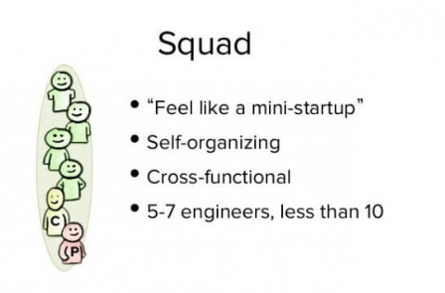
- Tribes – A group of related squads
  - Help squads share knowledge and stay aligned.
  - Led by a Tribe Lead who coordinates without taking away freedom.
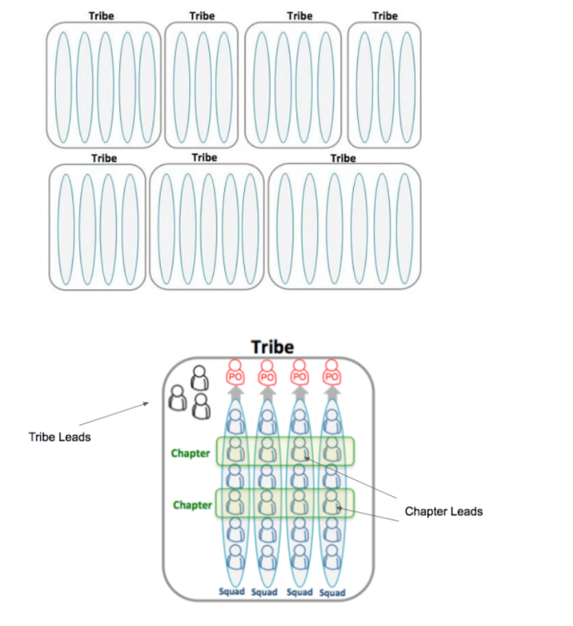
- Chapters – People with the same skills across squads
  - Ensure best practices are followed.
  - Led by a Chapter Lead who supports skill growth.
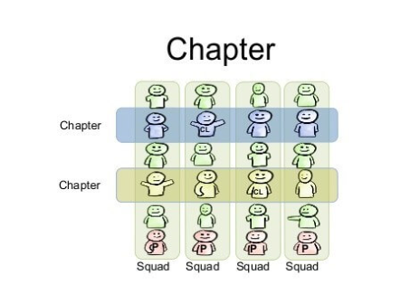
- Guilds – Informal groups of people with shared interests
  - Anyone can join (e.g., DevOps, UX design, AI).
  - Spread knowledge and new ideas across the company.
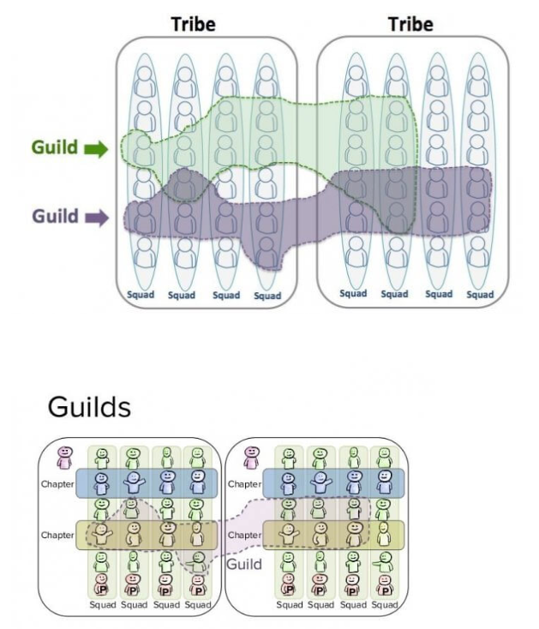
This system gave Spotify a mix of freedom and structure. Teams worked independently but followed shared goals and values.
2.4 Results of the Model
The Spotify Model led to several positive outcomes:
- Faster delivery: Features could be released weekly or daily.
- Better teamwork: Squads worked smoothly, and tribes improved coordination.
- Happier employees: Developers felt trusted, motivated, and proud.
- More innovation: Teams could experiment and try new ideas.
- Strong company culture: Values of trust, learning, and creativity were maintained.
Spotify’s approach became famous worldwide. Companies like ING Bank, LEGO, and Atlassian adopted similar models.
2.5 Importance of the Spotify Model
The Spotify Model is more than a process — it is a way of thinking. It shows that scaling Agile is not just about adding more rules, but about building a culture of trust, collaboration, and learning.
Key ideas of the model include:
- Autonomy with alignment: Teams have freedom but follow common goals.
- Trust over control: Managers act as coaches, not bosses.
- People before process: Teamwork and motivation matter more than strict rules.
- Continuous improvement: Teams always learn, reflect, and evolve.
These principles helped Spotify remain fast, creative, and successful even as it expanded globally.

2.6 Conclusion
The Spotify Model changed how organizations think about growth and teamwork. By focusing on people, trust, and collaboration rather than rigid frameworks, Spotify showed that large companies can stay innovative and agile.
The company’s success demonstrates that scaling Agile is not just about following a fixed method, but adapting the process to your culture.
The Spotify Model continues to inspire organizations that want to grow while staying flexible, creative, and innovative.

3. Methodology
3.1 Introduction
When Spotify grew rapidly, managing multiple teams through traditional Agile methods became difficult. The company created a new approach — the Spotify Model, which evolved gradually through experiments and learning.
The focus was on team structure, communication, and alignment with company goals — all while keeping teams autonomous.

3.2 Approach Followed by Spotify
Spotify’s development of the model followed five key stages:
- Observation:
Teams identified problems like poor coordination and delayed releases.
- Experimentation:
Spotify tested ideas like smaller independent teams and reduced management control.
- Feedback Collection:
Teams shared feedback on what worked and what didn’t.
- Improvement:
Successful ideas were expanded, while failed ones were adjusted or dropped.
- Documentation and Sharing:
Learnings were documented through wikis, meetings, and newsletters.
This observe → experiment → feedback → improve → share cycle became the backbone of the Spotify Model.

3.3 Organizational Structure
Spotify’s organizational design supported both autonomy and alignment, consisting of four key components:
1. Squads
- Small, cross-functional teams (6–12 members).
- Each Squad focuses on a single feature (e.g., playlists or search).
- They choose their own Agile method (Scrum, Kanban, etc.).
- The Product Owner (PO) defines what to build but not how.
- Each Squad has full ownership of its part of the product.
2. Tribes
- A group of several Squads working on related areas.
- Each Tribe (up to 150 people) is led by a Tribe Lead who ensures alignment.
- Tribe Gatherings are held for sharing updates and learning.
3. Chapters
- Members with similar skills (e.g., backend developers) form a Chapter.
- Chapter Leads mentor members and ensure technical consistency.
- Chapters ensure best practices are followed without limiting independence.
4. Guilds
- Informal communities around shared interests (e.g., DevOps, AI).
- Open for anyone to join voluntarily.
- Encourage innovation through meetups and workshops.

3.4 Tools and Techniques Used
Tool/Technique | Purpose/Use
Jira / Trello | Task tracking and sprint management
Slack / Google Meet | Team communication
GitHub / GitLab | Version control and collaborative coding
CI/CD | Automated testing and deployment
Sprint Retrospectives | Review and improvement meetings
Squad Health Check | Self-assessment tool for team performance
Hack Days | Time for innovation and experimentation
Confluence Wiki | Internal knowledge sharing
Spotify also tracked metrics like cycle time, team happiness, and customer satisfaction.

3.5 Communication and Collaboration
Spotify encouraged open communication through:
- Daily Stand-ups within Squads.
- Weekly Tribe Syncs across teams.
- Quarterly Town Halls with company-wide updates.
Leaders acted as servant leaders, removing obstacles instead of commanding teams. Transparency and trust strengthened teamwork across locations.

3.6 Continuous Improvement and Learning
Spotify adopted a “fail fast, learn faster” culture:
- Teams were encouraged to experiment.
- Failures were treated as learning opportunities.
- The Squad Health Check Model helped teams evaluate
  - Team happiness
  - Delivery rate
  - Learning speed
  - Work quality
This helped teams identify weaknesses and continuously improve.

3.7 Flexibility in Process
Spotify did not enforce a single Agile framework.
Teams chose between Scrum, Kanban, or hybrid methods.
What mattered was results, not strict adherence to process.
This flexibility increased motivation and creativity among developers.

3.8 Leadership and Culture
Spotify’s leaders acted as coaches and mentors, not traditional managers.
- Decision-making was decentralized.
- Trust and psychological safety were prioritized.
- Open sharing of ideas and feedback was encouraged.
This leadership style strengthened creativity and accountability.

3.9 Summary of Methodology
The Spotify Model was not just a structure — it was a mindset.
By organizing around Squads, Tribes, Chapters, and Guilds, Spotify built an environment of autonomous yet aligned teams.
Its success came from:
- Strong communication,
- Continuous learning, and
- A culture of trust and openness.
The Spotify Model became a global example for scaling Agile — inspiring companies like ING Bank, LEGO, and Netflix to adopt similar approaches.
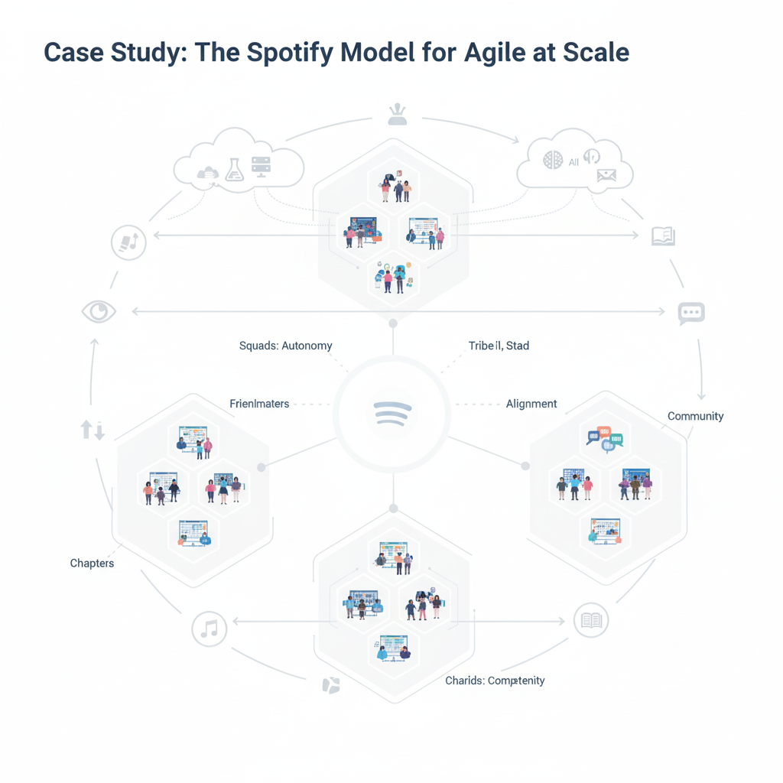

4. Data Collection and Analysis
4.1 Introduction
To understand how the Spotify Model worked and helped scale Agile effectively, data was collected from many reliable sources, such as:
- Company case studies
- Research articles
- Employee interviews
- Agile coach reports
- Industry publications
The data includes both primary insights (directly from Spotify) and secondary insights (from companies and researchers who studied the Spotify Model).
The goal of this section is to explain:
- How the data was collected
- What types of data were used
- What the analysis revealed about the effectiveness of the Spotify Model

4.2 Data Collection Methods
Since this is a case study, qualitative methods were mainly used, focusing on real experiences and observations rather than numbers.
Sources of data included:
- Company Documents and Publications
- Spotify shared internal documents and public presentations on their Agile system.
- Key reports:
  - Scaling Agile @ Spotify (2012) by Henrik Kniberg and Anders Ivarsson
  - Spotify Engineering Culture videos (Parts 1 and 2 on YouTube)
- These sources gave first-hand information on how the model was designed and implemented.
- Interviews and Expert Insights
- Agile coaches, managers, and employees shared their experiences.
- Sources included blog posts, conference talks, and published interviews.
- These helped show both strengths and weaknesses of the model.
- Case Studies from Other Companies
- Companies like ING Bank, LEGO, and Autodesk adopted the Spotify Model.
- Their experiences showed how effective the model was outside Spotify.
- Observational Data
- Publicly available data such as team size, product release speed, and cultural practices were analyzed.
- Observations included:
  - Number of Squads and Tribes
  - Speed of product updates
  - Employee satisfaction
  - Customer feedback and innovation rate
- Literature Review
- Academic journals, books, and whitepapers on Agile at scale were reviewed.
- These helped compare Spotify’s model with frameworks like SAFe and LeSS.

4.3 Data Types
The study used both qualitative and quantitative data:
Type of Data | Example | Purpose
Qualitative | Employee opinions, interviews, blogs | To understand cultural and organizational impact
Quantitative | Team size, number of Squads, release frequency | To measure efficiency and scalability

4.4 Data Analysis Techniques
Data was analyzed using three main methods:
- Thematic Analysis
- Identified common themes from interviews, articles, and case studies:
  - Autonomy & Empowerment: Teams felt ownership over their work
  - Alignment & Collaboration: Communication kept everyone on shared goals
  - Continuous Improvement: Retrospectives helped teams grow
  - Innovation & Speed: Teams released features faster
  - Cultural Impact: Higher job satisfaction and creativity
- Comparative Analysis
- Compared Spotify’s approach with other Agile scaling methods like SAFe and Scrum of Scrums:
  - Spotify focused more on people and culture than strict rules
  - Teams had more freedom and flexibility
  - Avoided heavy processes and formal roles
  - Emphasized trust and learning over control
- Performance Analysis
- Quantitative data measured Spotify’s results:
  - Faster delivery: Updates went out weekly instead of monthly
  - More innovation: Teams launched more creative features
  - Employee satisfaction: Motivation and collaboration increased
  - Customer growth: Users grew from ~20 million (2012) to 500+ million (2025)

4.5 Key Observations from Data
- Autonomous Teams Work Better:
- Squads managing their own priorities were faster and more creative.
- Structure Encourages Collaboration:
- Tribe-Chapter-Guild system made communication easier and reduced repeated work.
- Culture is a Strength:
- Trust-based culture motivated employees to innovate continuously.
- Flexibility Over Rules:
- Teams performed better when choosing their own tools and processes.
- Challenges Still Exist:
- As Spotify grew, coordination between large Tribes and alignment across many teams remained difficult.

4.6 Data Interpretation
- Spotify’s model works best in environments with trust and good communication.
- Success depended less on structure and more on:
  - Autonomy mindset
  - Leadership support
  - Continuous learning attitude of teams
- Companies copying the structure without culture often failed.
- The Spotify Model is a living, culture-based system, not a fixed framework.

4.7 Summary
- Spotify succeeded by combining autonomous teams, strong communication, and continuous improvement.
- Its Agile approach is adaptive and human-centered, not mechanical.
- Freedom with responsibility leads to better innovation and faster delivery.
- The model requires mature teams and supportive leadership to work well.
- Overall, the Spotify Model is one of the most successful examples of Agile at scale, built on trust, transparency, and teamwork, not just tools or methods.

5. Solution Implementation
5.1 Introduction
After identifying the challenges of scaling Agile in a growing company, Spotify decided to create its own customized model instead of following existing frameworks like SAFe or Scrum of Scrums.
The main goal was to keep teams autonomous, motivated, and innovative, while ensuring the company remained coordinated and aligned.
This section explains how Spotify implemented the Spotify Model, the steps taken, the roles involved, and how it became part of the company’s culture.

5.2 Step-by-Step Implementation Process
Spotify’s solution was developed gradually through planning, testing, feedback, and improvement. The implementation can be divided into six main steps:
Step 1: Building Small, Independent Teams (Squads)
- The organization was divided into small, cross-functional teams called Squads.
- Each Squad acted like a small startup responsible for a specific feature (e.g., search bar, playlists, recommendations).
- Each Squad had all necessary roles—developers, testers, designers, and a product owner—so they could work independently.
- Squads were given end-to-end ownership, meaning they could develop, test, and deploy work on their own.
Result: Teams became faster, more creative, and more responsible for their results.
Step 2: Grouping Squads into Tribes
- Related Squads were grouped into Tribes, each led by a Tribe Lead.
- Tribes helped coordinate teams working on similar product areas (e.g., “Music Experience” or “User Growth”).
- Tribe gatherings were held every few weeks for sharing progress, best practices, and challenges.
Result: Balanced independence with alignment and improved communication across teams.
Step 3: Creating Chapters and Guilds
- Chapters connected people with similar skills across Squads (e.g., backend developers, testers, designers).
- Chapters maintained technical standards, skill development, and best practices.
- Guilds were informal groups based on interests (e.g., Mobile Developers, Agile Coaches) that allowed knowledge sharing across the company.
Result: Reduced knowledge gaps and improved collaboration across departments.
Step 4: Promoting a Culture of Trust and Autonomy
- Managers acted as coaches and mentors rather than giving orders.
- Employees were trusted to make decisions about their work, tools, and processes.
- Teams were encouraged to experiment, learn from mistakes, and continuously improve.
Result: Teams felt empowered and were more willing to take creative risks.
Step 5: Implementing Agile Tools and Practices
- Daily stand-ups to share updates and remove blockers.
- Sprint planning and retrospectives for continuous improvement.
- Kanban or Scrum boards (Jira, Trello) for tracking progress.
- Continuous Integration (CI/CD) pipelines for faster testing and deployment.
- Health Check surveys where Squads rated themselves on happiness, delivery speed, and teamwork.
Result: Improved visibility, better communication, and faster delivery.
Step 6: Continuous Feedback and Improvement
- Spotify treated the model as a living system, not a fixed framework.
- Teams regularly discussed what worked and what needed change.
- Successful ideas were shared across Squads via Tribe meetings and internal documentation.
- Agile coaches collected feedback and guided teams in solving process issues.
Result: The model evolved with company growth and technology changes.

5.3 Tools and Technologies Used
Category | Tools/Technologies | Purpose
Project Management | Jira, Trello | Sprint and task tracking
Communication | Slack, Google Meet | Real-time team communication
Version Control | GitHub, GitLab | Collaborative code management
Automation & CI/CD | Jenkins, CircleCI | Automated builds and deployments
Knowledge Sharing | Confluence, Wiki pages | Documenting best practices
Performance Monitoring | Squad Health Check | Measuring team happiness and efficiency
Innovation | Hack Days, Internal Demos | Promoting creativity and new ideas

5.4 Change Management
Implementing the Spotify Model required a cultural shift from traditional management styles. Actions taken included:
- Training and Awareness Programs: Employees attended workshops on Agile principles, teamwork, and communication.
- Leadership Coaching: Managers were trained to become mentors rather than decision-makers.
- Gradual Implementation: The system was introduced step by step, starting with a few Squads.
- Open Communication: Employees could give feedback to address concerns.
- Support Systems: Agile coaches and HR partners supported each team during the transition.
Result: Employees adapted quickly, minimizing confusion and resistance.

5.5 Results of Implementation
Area | Before Implementation | After Implementation
Team Autonomy | Teams depended on management | Squads made decisions independently
Communication | Slow inter-department communication | Fast, transparent communication
Delivery Speed | Product releases took months | Continuous updates every few weeks
Innovation | Limited new ideas | Frequent hackathons and experiments
Employee Satisfaction | Medium motivation | High motivation and job satisfaction
Customer Growth | 20 million users in 2012 | Over 500 million users by 2025
Overall Result: Spotify achieved faster development, higher customer satisfaction, and stronger employee engagement.

5.6 Challenges Faced During Implementation
- Coordination issues between Tribes as the company grew.
- Difficulty maintaining alignment when Squads became highly independent.
- New employees found it hard to understand the unique structure.
- Lack of formal documentation caused confusion for companies trying to copy the model.
Solution: Spotify improved communication tools, provided training, and kept the model flexible.
5.7 Lessons Learned
- Culture matters more than structure: The model works best when people trust and support each other.
- Autonomy must come with responsibility: Freedom should be balanced with clear goals and accountability.
- Continuous learning is key: Teams must constantly adapt and improve.
- One size does not fit all: The model should be customized to each organization’s needs.

5.8 Summary
Spotify’s solution focused on:
- Forming autonomous Squads
- Building a connected structure through Tribes, Chapters, and Guilds
- Encouraging a trust-based culture
- Using modern Agile tools and continuous feedback
- Supporting continuous learning and experimentation
By following these steps, Spotify successfully scaled Agile practices, maintained innovation, and grew rapidly without losing flexibility or team spirit. The Spotify Model became one of the most well-known examples of Agile transformation in the software industry.

6. Results and Evaluation
6.1 Introduction
After implementing the Spotify Model, the company saw major improvements in productivity, innovation, and employee satisfaction.
The goal of this evaluation is to explain the results, how they were measured, and the challenges observed. Spotify measured not only delivery speed but also team collaboration, motivation, and adaptability.

6.2 Key Results
1. Faster Delivery
Before the Spotify Model, development was slow due to:
- Communication gaps between teams
- Long approval chains
- Slow feedback loops
After implementing the model:
- Small, autonomous Squads worked independently, removing delays.
- Each Squad could plan, build, test, and release features on its own.
- Average time-to-market reduced significantly.
Example: Launching a new music discovery feature took 3–4 months before, but only 2–3 weeks after adopting the model.
2. Higher Team Motivation and Ownership
- Squads had freedom to choose their own ways of working.
- Employee surveys showed higher engagement and motivation.
- Developers felt more creative and responsible for outcomes.
- More new ideas were generated, such as playlist personalization and podcast integration.
Result: Spotify became known for its motivated and innovative engineering culture.
3. Improved Collaboration
- Chapters connected people with similar skills for knowledge sharing.
- Tribes coordinated Squads working on related areas.
- Guilds promoted cross-company sharing of best practices.
Result:
- Reduced duplication of work
- Faster problem-solving
- Consistent product quality across teams

4. Strong Alignment with Company Goals
- Teams remained independent but followed a shared vision.
- Methods included company-wide meetings, transparent dashboards, and synchronized planning cycles (“Spotify Rhythm”).
Result: Hundreds of teams worked independently while staying focused on Spotify’s mission: connecting millions of people with the right music and podcasts.

5. Continuous Improvement Culture
- Squads held retrospectives after each sprint to discuss successes, problems, and improvements.
Result:
- Faster problem-solving
- Teams more open to feedback
- A company-wide culture of continuous learning (Kaizen)

6.3 Evaluation of Effectiveness
Quantitative Evaluation
Parameter | Before Spotify Model | After Spotify Model
Release cycle time | 3–4 months | 2–3 weeks
Deployment frequency | 1–2 per month | Multiple per week
Employee engagement (survey) | ~60% | 85–90%
Innovation output (new features) | Low | Very high
Customer satisfaction (ratings) | 4.0 | 4.6+
These numbers show clear improvements in speed, innovation, and user satisfaction.
Qualitative Evaluation
- Team morale improved as members could see the impact of their work.
- Managers focused on guidance rather than control.
- Cross-team learning through Guilds maintained consistent standards.

6.4 Challenges Observed
Despite positive results, some challenges remained:
- Coordination at Scale – Aligning all Squads without adding rigid structure was difficult.
- Inconsistent Agile Practices – Squads used different methods (Scrum, Kanban, or mixed), complicating integration.
- Dependency Management – Some features depended on other Squads, causing delays.
- Misuse of Autonomy – Some teams misunderstood autonomy, leading to inconsistent code quality.
Solutions: Better documentation, improved leadership roles, and more frequent synchronization meetings.

6.5 Overall Impact
The Spotify Model became a global example of scaling Agile without losing creativity.
Positive Outcomes:
- Faster innovation and product delivery
- Higher employee satisfaction and lower turnover
- Strong company culture based on trust and collaboration
- High-quality, user-centered product development
Spotify inspired companies like ING Bank, LEGO, and Atlassian to adopt similar approaches.

6.6 Summary
The evaluation shows that the Spotify Model:
- Scaled Agile effectively across hundreds of teams
- Increased efficiency, innovation, and employee motivation
- Maintained alignment with the company’s vision
While not a one-size-fits-all solution, the Spotify Model proves that trust, communication, and autonomy can lead to exceptional results when implemented carefully.
7. Lessons Learnt
1. Autonomy and Alignment Must Go Together
Spotify learned that giving teams full freedom (autonomy) is only effective when there is a shared understanding of goals across the organization.
When every Squad knows the company’s vision and objectives, they can make decisions confidently without waiting for approval from higher management.
For example, the Squads working on playlists or search features could choose their own development tools and workflows, but their efforts were aligned with Spotify’s overall mission to improve the user experience.
This combination of independence and shared vision allowed Spotify to scale rapidly without losing focus or creating conflicts between teams.

2. Company Culture is More Important Than Rules
Spotify’s success was not achieved by strictly following predefined rules or frameworks.
Instead, it was the company culture that drove results.
Key cultural elements included:
- Trust: Teams were trusted to make decisions.
- Transparency: Everyone had access to information needed to do their job.
- Open Communication: Employees were encouraged to share ideas and concerns.
- Collaboration: Teams helped each other rather than working in silos.
This people-centered culture motivated employees to take ownership, experiment, and innovate.
For instance, internal hack days allowed teams to test new ideas without fear of failure, which led to creative features like personalized playlists and podcast recommendations.

3. Continuous Learning Leads to Long-Term Success
Spotify emphasized continuous improvement (Kaizen) in everything teams did.
Regular retrospectives, feedback sessions, and health check surveys helped teams identify challenges early and solve them quickly.
This culture of learning ensured that processes were always evolving to meet changing business needs.
For example, Squads could adjust their workflows, adopt new tools, or refine coding practices based on lessons learned in previous sprints.
This approach kept Spotify flexible, innovative, and resilient, even as the company expanded rapidly.
4. Every Organization Needs Its Own Version
The Spotify Model worked well because it was designed specifically for Spotify’s needs, size, and culture.
Other organizations cannot copy it exactly and expect the same results.
Instead, companies should adapt the principles — like autonomy, alignment, and continuous learning — to their own context.
For example, a smaller company might use fewer Squads or Tribes, while a larger company might need more coordination mechanisms.
The key lesson is to use Spotify as inspiration, not a strict blueprint.
5. Failure is a Part of Growth
Spotify encouraged teams to “fail fast and learn faster.”
Mistakes were not punished; they were seen as opportunities for improvement.
For instance, if a new feature caused unexpected issues, teams analyzed what went wrong, learned from it, and improved the next version.
This mindset helped employees stay creative and confident, resulting in faster innovation and higher-quality products.
Summary
The main lesson from the Spotify Model is that success in Agile scaling depends more on people than on processes.
By building a culture of trust, learning, and responsibility, organizations can achieve both innovation and stability.
Spotify demonstrated that when teams are empowered, aligned, and continuously improving, companies can scale efficiently while maintaining high employee engagement and customer satisfaction.

8. Appendices
Appendix A – Organizational Structure of the Spotify Model
Level | Description | Purpose
Squad | Small, cross-functional team (6–12 members) | Build and deliver specific product features
Tribe | Group of related Squads (40–150 members) | Maintain alignment and share knowledge
Chapter | People with similar skills (e.g., developers) | Share technical expertise and best practices
Guild | Informal community across Tribes with shared interests | Spread learning and build company culture

Appendix B – Tools and Practices Used
Tool / Practice | Purpose
Scrum / Kanban | Manage tasks and track progress
Sprint Planning & Retrospectives | Plan work and identify improvements
Daily Stand-ups | Discuss goals, updates, and issues quickly
Hack Days | Encourage creativity and innovation
Spotify Rhythm | Regular coordination cycles to ensure alignment
Internal Wiki | Central platform for sharing knowledge and updates

Appendix C – Data Sources
Data and findings were collected from:
- Public reports, blogs, and presentations by Spotify engineers and Agile coaches
- Case studies by Henrik Kniberg and Anders Ivarsson
- Company interviews and conference talks on Agile transformation
- Online articles, videos, and documents on Agile scaling

Appendix D – Key Performance Improvements
Metric | Before Spotify Model | After Spotify Model
Release Cycle | 3–4 months | 2–3 weeks
Deployment Frequency | 1–2 per month | Multiple per week
Employee Engagement | Around 60% | 85–90%
Innovation Rate | Low | High
Customer Rating | 4.0 | 4.6+

Appendix E – Important Terms
Term | Meaning
Agile | Flexible software development method focusing on collaboration, speed, and customer feedback
Scrum | Agile framework organizing work in short time periods (sprints)
Kanban | Visual workflow method to manage ongoing work efficiently
Kaizen | Japanese term meaning “continuous improvement”
Fail Fast, Learn Faster | Encourages quick experimentation and learning from mistakes

Appendix F – References
- Kniberg, H., & Ivarsson, A. (2012). Scaling Agile @ Spotify.
- Spotify Engineering Culture – Spotify Labs Blog and YouTube Series.
- Atlassian Agile Coach: Understanding the Spotify Model.
- Harvard Business Review – How Spotify Balances Autonomy and Alignment.
- Agile Alliance – Case Study on Spotify’s Agile Transformation.

