

**SCHOOL OF COMPUTER SCIENCE ENGINEERING AND INFORMATION SYSTEMS**

**FALL SEMESTER 2025-26**

**Digital Assignment – II**

**Subject :** CSE3501 - Information Security Analysis and Audit Lab

**Lab Slot :** L23 + L24

**Faculty :** Dr. A. Anbarasa Kumar

**Name:** PRANAVO V A

**Reg no :** 22MIS0043

**1. Using Cisco Packet Tracer Wireless Router Configuration, Configure a wireless network.**

**Set up a wireless router (WRT 300N) with five PCs. ensure the router connect the PCs**

**wirelessly to the router, Connect PCs wirelessly to the router and verify connectivity. What**

**steps would you take to configure on the wireless router? How do you verify that the PCs has**

**connected successfully to the network?**

1)Wireless Router Coniguration:

**Procedure:**

Step 1: Search for the WRT300N router and drag and drop it.

Step 2: drag and drop 5 pc’s.

Step 3: Click the pc: Physical> in Physical Device View, turn off the device, and scroll down and

Remove the port and drag the WMP300N and put it in the removed place.

Step 4:click router >config>wireless, then in authentication select WEP and set the key

(0123456789)

step 5:click pc>desktop>pc wireless> connect .

Step 6: wait for a while, en the default connection appeared in the column, then select it and

connect, now enter the key and connect.

Step 7: do similarly for the other two PC’s

Step 8: Secure the wireless configuration established.

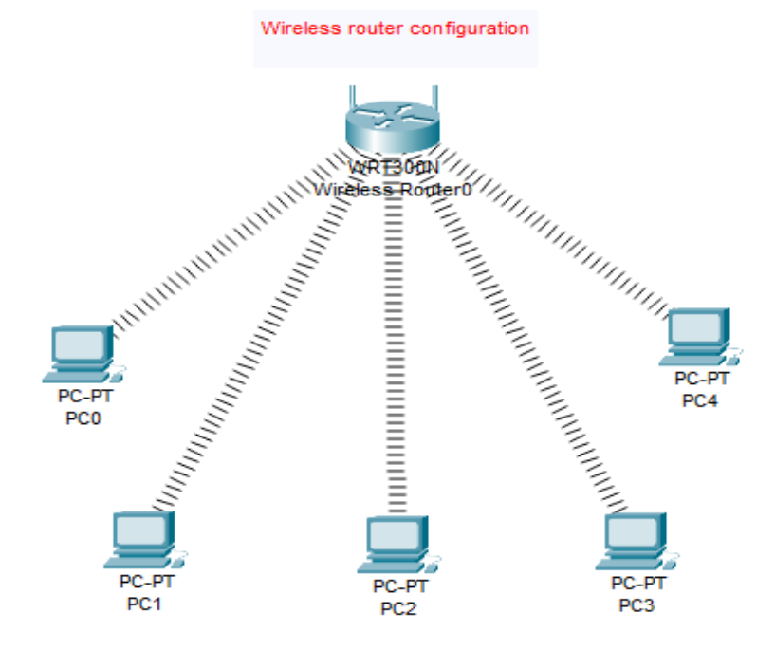

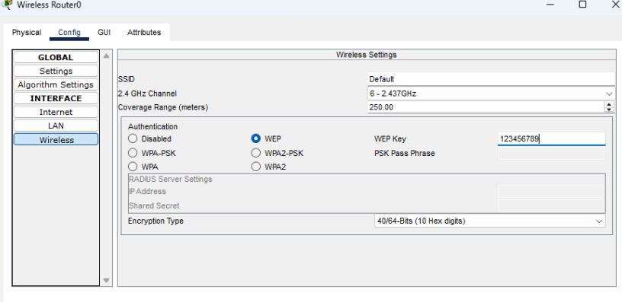

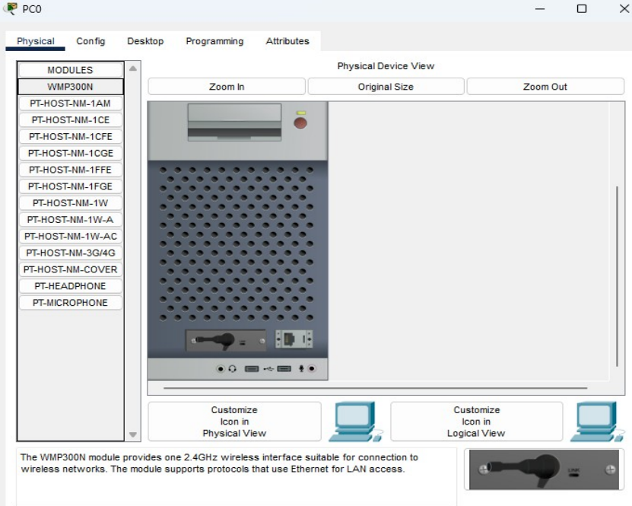

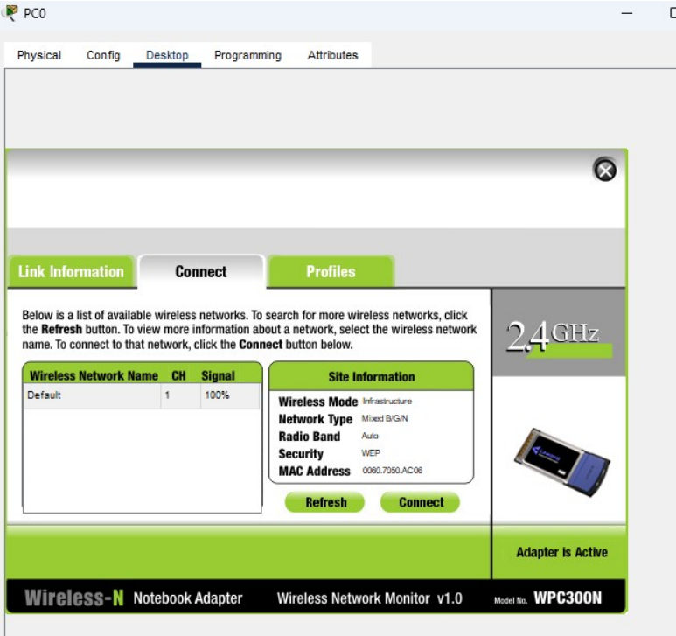

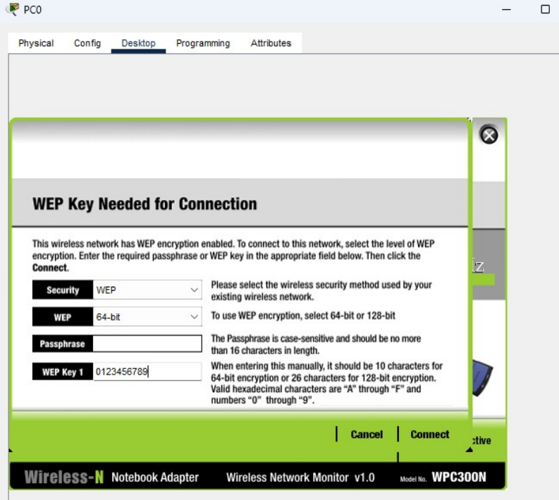

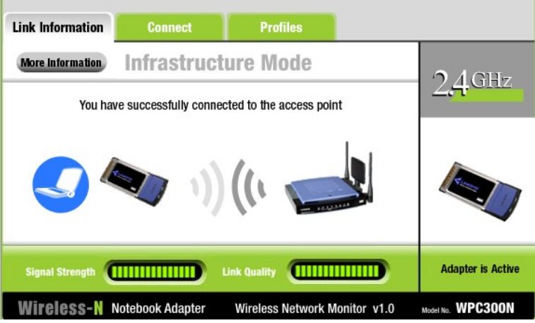

**2) Use the Real-Time Packet Capture and Analysis Using Wireshark tool to monitor real-time network traffic and analyze captured frames. Extract and examine the following key details from the frame headers:**

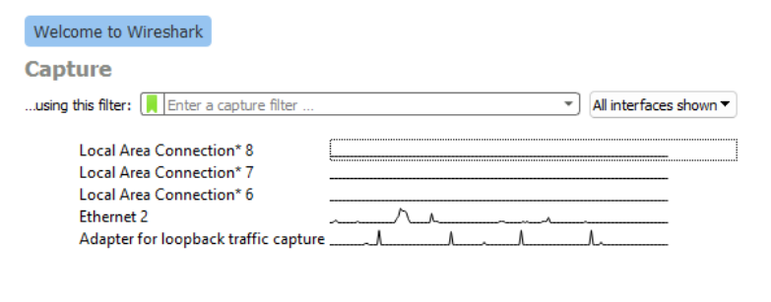

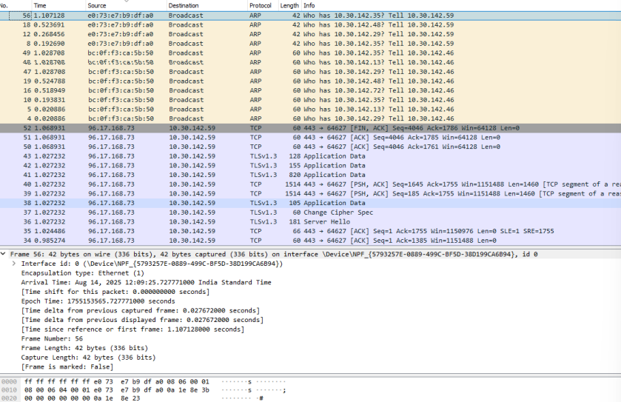

1. **Source Address**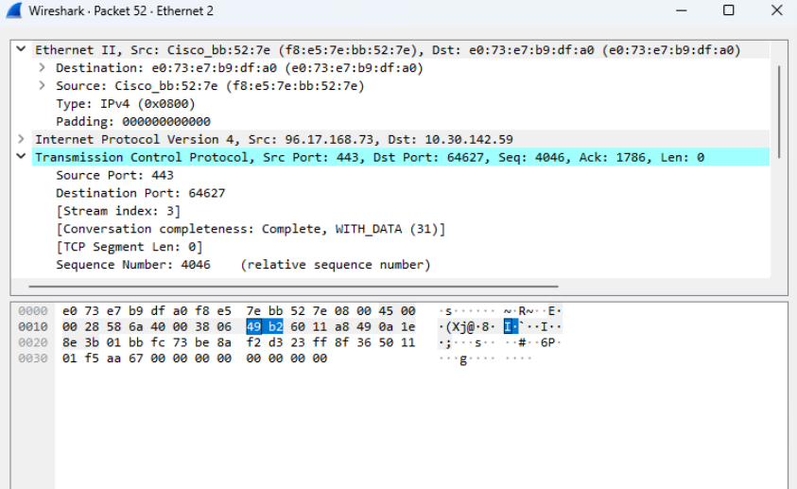
2. **Destination Address:**

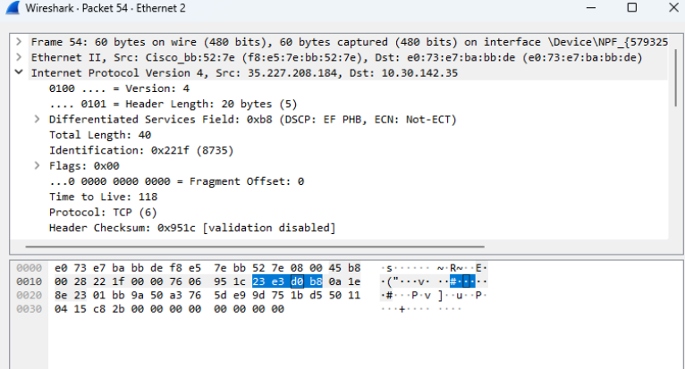

1. **Timestamp**

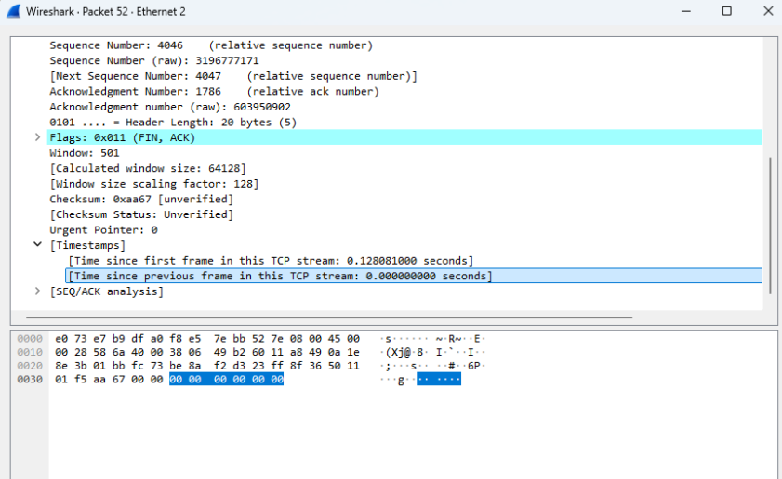

1. **Protocol Type**

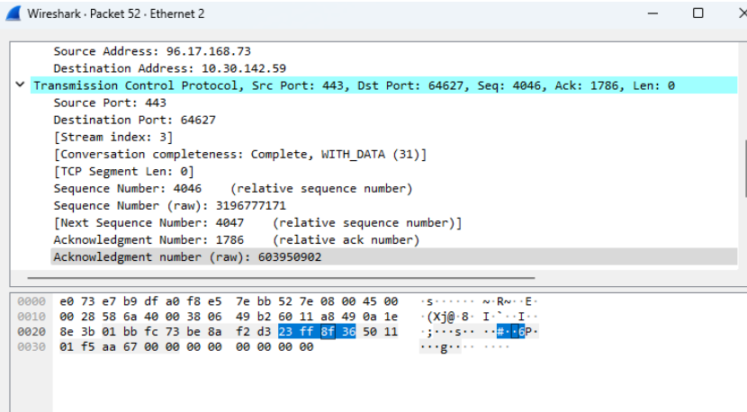

1. **Frame Size**

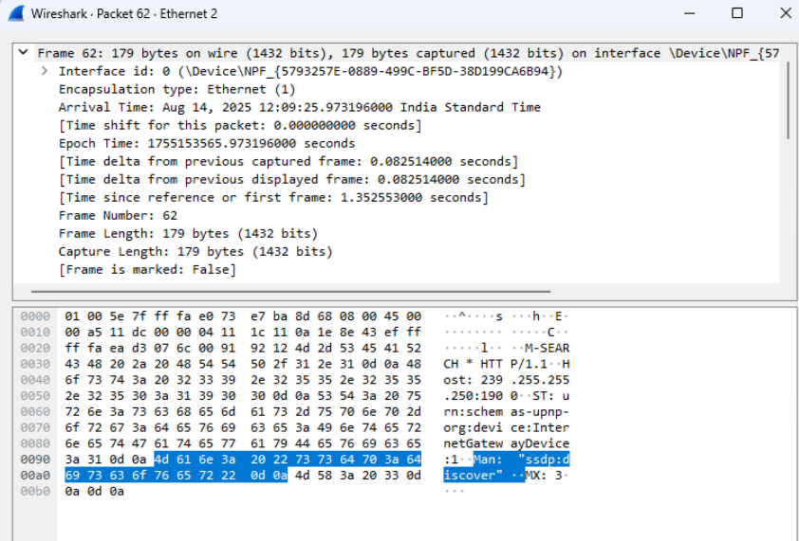

1. **Additional Packet Information**