

**SCHOOL OF COMPUTER SCIENCE ENGINEERING AND INFORMATION SYSTEMS**

**FALL SEMESTER 2025-26**

**Digital Assignment – III**

**Subject :** CSE3501 - Information Security Analysis and Audit Lab

**Lab Slot :** L23 + L24

**Faculty :** Dr. A. Anbarasa Kumar

**Name:** PRANAVO V A

**Reg no :** 22MIS0043

**1. Virus tool is a free service that scans submitted files and URLs.**

**VirusTotal – Home**

**a) Your task is upload a file and check the hashes and study the detection of**

**malware, metadata, history and relations of the file content.**

**Result Screenshot:**

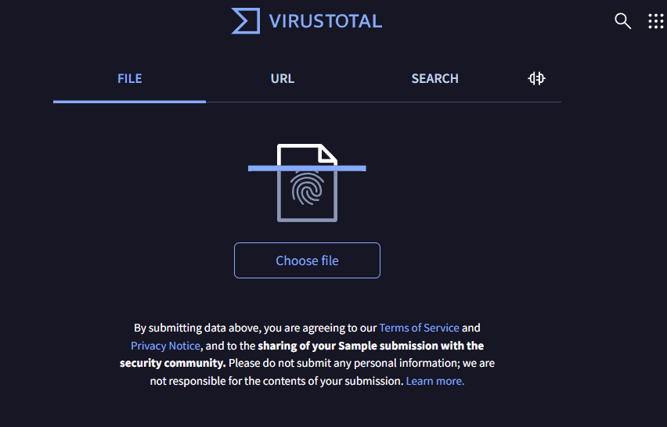

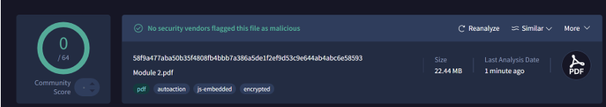

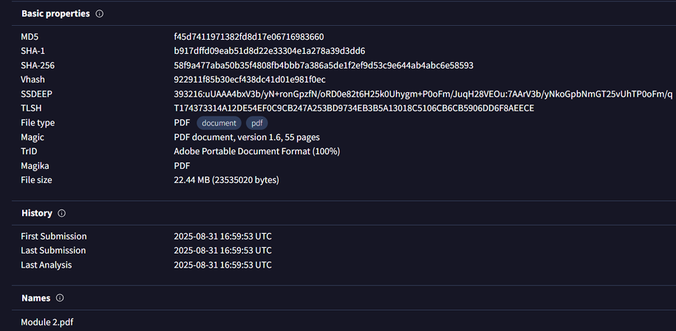

**b) Type your preferred URL and read the IP address, headers, metatags,**

**links & also identify the https certificate, relations and subdomains.**

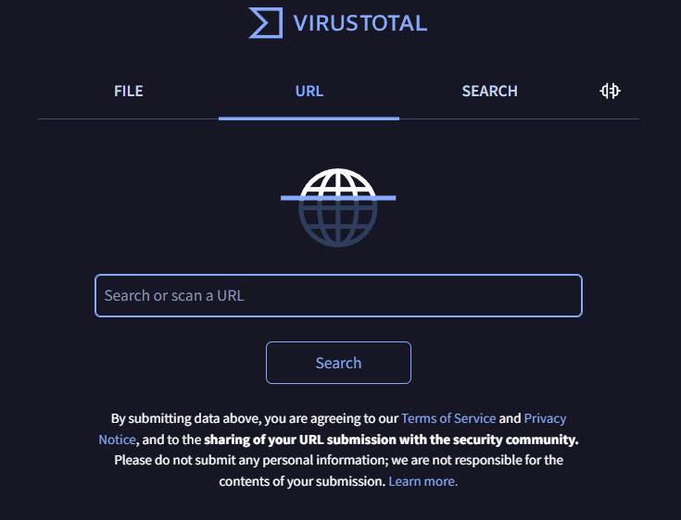

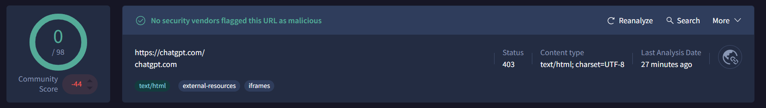

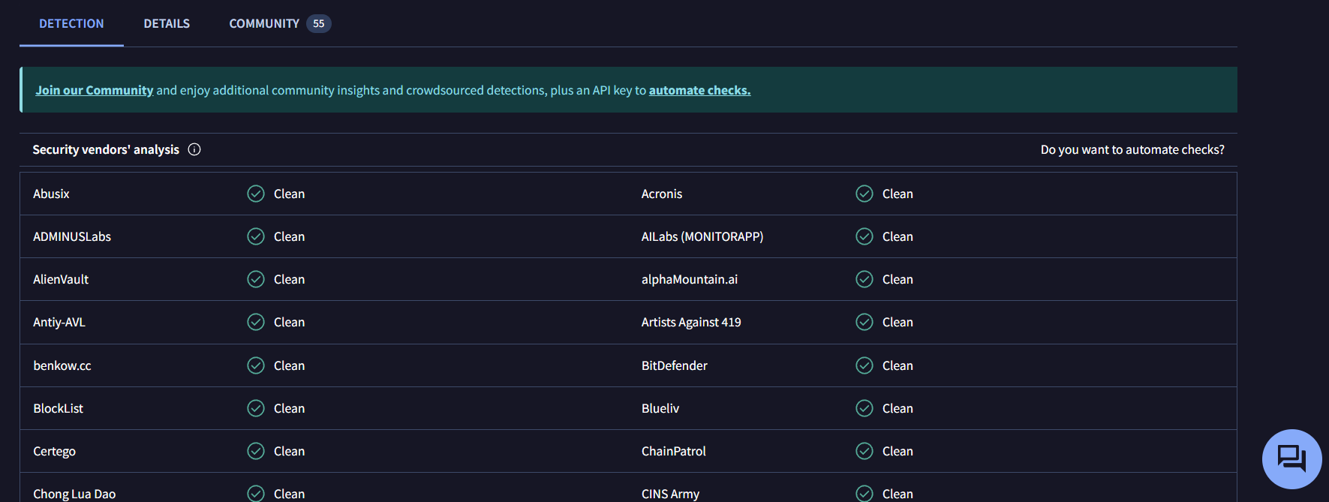

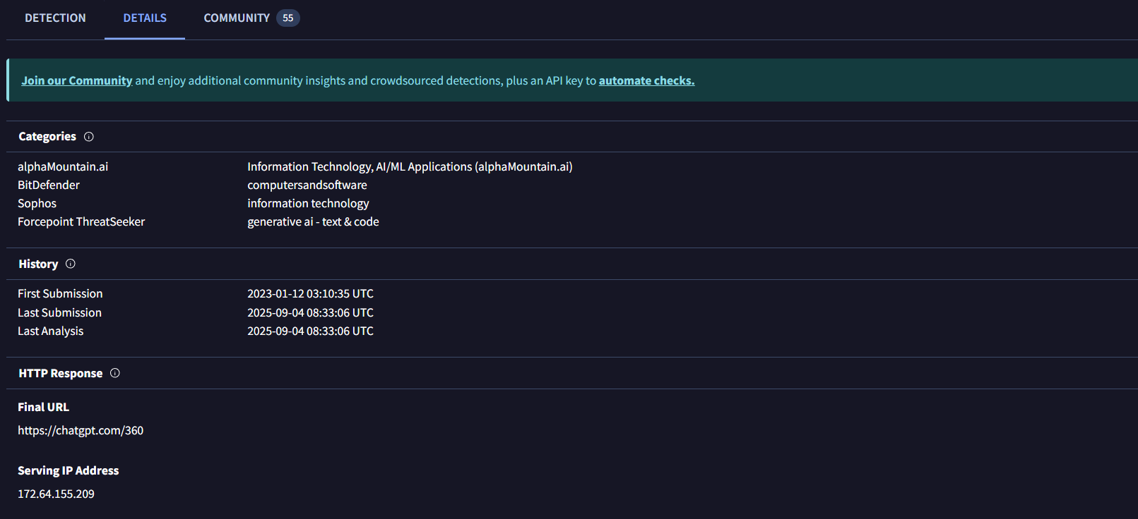

**2. Demonstrate how you can configure Telnet authentication to securely manage network devices in Cisco Packet Tracer. Telnet is a protocol by which you can remotely login into remote devices tomafke changes in the configuration of that device. The aim of this article is to give you a quick guideabout how you can enable telnet on a switch.**

**Procedure:**

**Step 1:** Drag and drop the PC and switch (2950-24).

**Step 2:** Connect them with a wire.

**Step 3:** Open PC and assign IP address (10.0.0.1).

**Step 4:** Open the switch, go to CLI, and write the given commands:

en

cong t

int vlan 1

no shut

ip add 10.0.0.0 255.0.0.0

exit

line vty 0 4

password cisco

login

exit

enable secret cisco12

**Step 5:** After writing the commands, open the terminal in PC and enter: telnet 10.0.0.10 to connect to Telnet.

**Step 6:** Once it opens, enter the password and secret password to log in.

**Step 7:** User Access Verification is completed.

