Real-Time Industrial Air Quality and Gas Monitoring System
Ms Avantika K. Yerawar  Department of Electronics & Telecommunication Engineering, Jawaharlal Darda Institute of Engineering & Technology, Yavatmal, Maharashtra, India  Avantikayerawar517@gmail.com | Mr Pranay V. Jadhao  Department of Electronics & Telecommunication Engineering, Jawaharlal Darda Institute of Engineering & Technology, Yavatmal, Maharashtra, India  pranayvjadhao@gmail.com

Abstract: In infrastructure and industrial plants, the rapid growth is creating environmental issues like pollution, climate change and malfunctioning. It has significant consequences for the requirement of an operationally adaptable, efficient, cost-effective, and intelligent monitoring system. For this purpose, we came up with idea to use this kind of technology, i.e., the Internet of Things (IoT), in the form of a solution. In this paper, we suggest wireless data gathering frameworks that enable each detector node to track the changes in the behavioural pattern of gases and to identify their role in the gas leakage problem, whilst at the same time trying to minimise power consumption. In the proposed device, the temperature detector (DHT 11), the gas detector (MQ2, MQ7 and MQ135) and also humidity sensors are used to determine the environment and the undesirable gas within the manufacturing plant. The gauged details can be connected to the web. In addition, our research findings demonstrated substantial energy efficiency and high-precision data analysis relative to conventional protection device strategies. For monitoring the fluctuation of parameters like air pollution levels from their normal levels, in this case, the sensing devices are connected to the embedded computing system.
Keywords: Environmental monitoring, Arduino Uno, temperature and humidity sensor, CO₂ sensor, air quality, embedded systems
- Introduction
Safety at the workplace and in the industry is always a priority. In this regard, the less costly options for accident and mishap prevention in the oil and gas industries are commonly adopted, yet these measures ought to be effective. Security is the level of protection against danger and loss. The help of technology is needed to provide early warning alerts in order to ensure that enough time is available to prevent potential dangers. In this study, gas leakage detection systems have been highlighted along with troubleshooting directives. Even though building a system with a gas sensor is not as easy as it may seem, a warning system has been developed based on an ESP (WiFi) network. The system detects the presence of natural gases such as Methane and LPG. Whenever a gas leakage occurs, the sensors used in the circuit will detect it, the ESP modem will be activated, and a notification alert to the user will be transmitted by a customised dashboard. The system provides a real-time notification, allowing immediate implementation of health and safety measures and increasing the available time span to overcome the situation. The same system can be utilised in several other places, such as kitchens, oil and gas pipelines, gas storage facilities, etc.
With the increasing population and increase in vehicles, industries and factories, Air pollution is a matter of concern that we have to deal with every day. Air pollution affects society at large. The population most affected by air pollution is the elderly, kids with asthma and people living in poverty. WHO estimates that 7M people die every year from exposure to polluted air. At least 140 million people in India breathe air that is 10 times or more over the WHO safe limit. IOT Based Air Pollution Monitoring System is used to monitor the Air Quality over a web server using the Internet. It will trigger an alarm when the air quality goes down beyond a certain level, meaning when there are sufficient amounts of harmful gases present in the air like CO2, smoke, alcohol, benzene, NH3 and NOx.It will show the air quality in PPM on the LCD as well as on the BLYNK App, so that the air pollution level can be monitored very easily.

- Discussion
This paper aims to design and implement an ESP32-based industrial indoor air quality monitoring system capable of detecting environmental parameters such as temperature, humidity, carbon monoxide (CO), carbon dioxide (CO₂), and dust concentration in real time. The proposed system continuously monitors these parameters and displays the readings on a local display unit inside the room, while simultaneously transmitting the same information to an external display placed outside the room for safe and convenient monitoring. In addition, the system supports Wi-Fi-based communication, enabling faster data transmission and real-time visualisation through a dashboard for operators. Unlike conventional systems that rely on GSM-based communication, which is slower and dependent on mobile devices, the proposed system provides continuous monitoring suitable for industrial environments. The availability of real-time data allows operators to take immediate corrective actions in case of unsafe conditions. The system is designed to improve safety, accessibility, and monitoring efficiency and can be effectively deployed in industrial rooms, laboratories, server rooms, oil and gas facilities, as well as residential environments.
- System Design
The figure illustrates the hardware architecture of a real-time industrial air quality and gas monitoring system developed using an ESP32 development board as the central processing unit. The system is designed to continuously monitor critical environmental parameters such as temperature, humidity, carbon monoxide (CO) concentration, and airborne dust particles, which are essential for maintaining safety in industrial environments.
A DHT22 sensor is interfaced with the ESP32 to measure ambient temperature and relative humidity. Carbon monoxide levels are detected using an MQ-7 gas sensor, which is commonly used for industrial gas leakage and safety monitoring applications. In addition, a dust sensor capable of measuring fine particulate matter (PM2.5) is employed to monitor air quality and particulate pollution levels in the surrounding environment.
The measured sensor data is processed in real time by the ESP32 and displayed on a four-digit seven-segment display, allowing operators to observe environmental conditions instantly. For safety alerts, a buzzer is connected to the system, which is activated automatically whenever any parameter exceeds predefined safe threshold values. This immediate alert mechanism enables quick response to hazardous conditions.
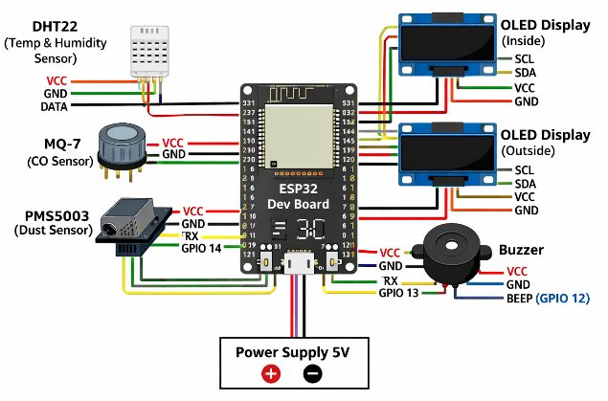The ESP32’s built-in Wi-Fi capability allows the system to support continuous monitoring and future integration with industrial dashboards or Distributed Control System (DCS) rooms. Overall, the proposed system provides a compact, low-cost, and efficient solution for real-time air quality monitoring and gas leakage detection in industrial settings, as well as in confined domestic environments.

- Component Descriptions
- ESP32
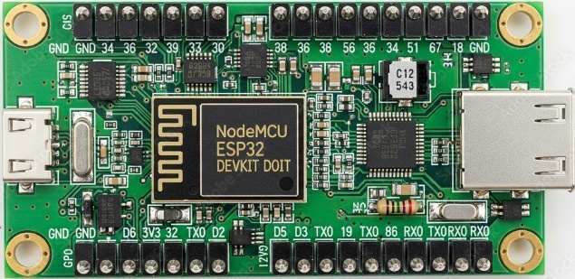
Fig. Esp-32
The ESP32 is a low-cost, high-performance microcontroller unit widely used in industrial Internet of Things (IoT) and embedded system applications. It is developed by Espressif Systems and integrates a dual-core 32-bit processor along with built-in Wi-Fi and Bluetooth capabilities on a single chip. This high level of integration makes the ESP32 suitable for real-time monitoring and control systems that require reliable communication and data processing.
In the proposed air quality and gas monitoring system, the ESP32 functions as the central controller responsible for acquiring sensor data, processing the measurements, and controlling output devices such as the display unit and buzzer. The microcontroller reads data from temperature, humidity, carbon monoxide, and dust sensors through its digital and analog input pins. Based on predefined threshold values, the ESP32 triggers alert mechanisms when unsafe environmental conditions are detected.
One of the major advantages of the ESP32 is its built-in Wi-Fi module, which enables real-time data transmission to external displays or monitoring dashboards without the need for additional communication hardware. This feature makes the system suitable for continuous industrial monitoring and remote supervision from control rooms. Furthermore, the ESP32 supports low-power operation, multiple communication protocols, and a wide range of peripheral interfaces, enhancing system scalability and reliability.
Overall, the ESP32 provides a compact, efficient, and cost-effective solution for implementing real-time industrial monitoring systems with local and remote data visualisation capabilities.
- Temperature Sensor (DHT11 / DHT22)
DHT 11: The DHT11 is a commonly used Temperature and humidity sensor. The sensor comes with a dedicated NTC to measure temperature and an 8-bit microcontroller to output the values of temperature and humidity as serial data. The sensor is also factory calibrated and hence easy to interface with other microcontrollers. The sensor can measure temperature from 0°C to 50°C and humidity from 20% to 90% with an accuracy of ±1°C and ±1%. So if you are looking to measure in this range, then this sensor might be the right choice for you.
- Humidity Sensor (DHT11 / DHT22 combined with temperature)
Humidity sensors generally measure the relative humidity (RH), i.e., the ratio of water vapor present in air compared to the maximum it can hold. • Capacitive humidity sensors measure changes in capacitance due to moisture content in the surrounding air.
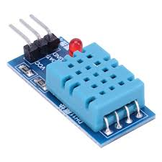
Fig. Temperature and humidity Sensor
- CO₂ Sensor (MQ-135 or equivalent gas sensor)
The MQ-135 gas sensor is commonly used for monitoring air quality and detecting the presence of carbon dioxide (CO₂) along with other harmful gases in indoor and industrial environments. The sensor operates based on a metal oxide semiconductor (MOS) sensing principle, where the electrical resistance of the sensing element changes in the presence of target gases. This change in resistance is converted into an analog voltage signal that can be processed by a microcontroller.
In the proposed system, the MQ-135 sensor is interfaced with the ESP32 microcontroller to measure variations in CO₂ concentration and overall air quality. The sensor continuously samples the surrounding air and provides real-time data, which is analyzed by the ESP32 to determine whether the gas concentration exceeds safe threshold levels. When abnormal levels are detected, the system can activate alert mechanisms such as a buzzer and display the readings on a local display unit.
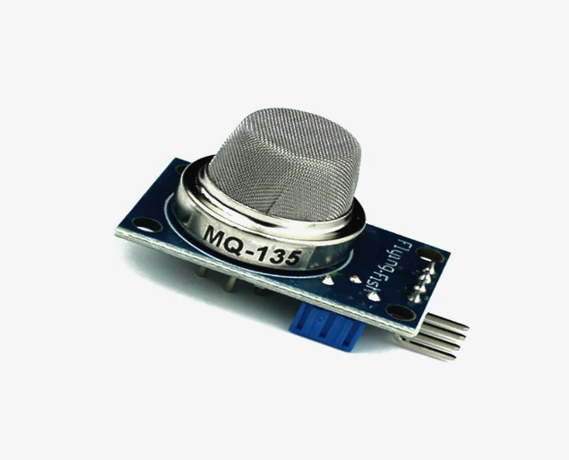
The MQ-135 sensor is suitable for industrial and indoor monitoring applications due to its sensitivity to CO₂ and other air pollutants, ease of interfacing, and cost-effectiveness. Its application in the proposed system enhances workplace safety by enabling early detection of poor air quality conditions and supporting timely corrective actions.

- Dust Particle Sensor (e.g., GP2Y1010AU0F or SDS011)
The dust particle sensor, such as the GP2Y1010AU0F or SDS011, is used to measure the concentration of particulate matter present in the surrounding air. These sensors operate based on the light scattering principle, where an internal infrared light source emits a beam across a sensing chamber. When airborne dust particles pass through this chamber, the light is scattered in different directions. A photodiode positioned inside the sensor detects the scattered light, and the intensity of this detected signal is converted into an electrical output that corresponds to the density of dust particles in the air.
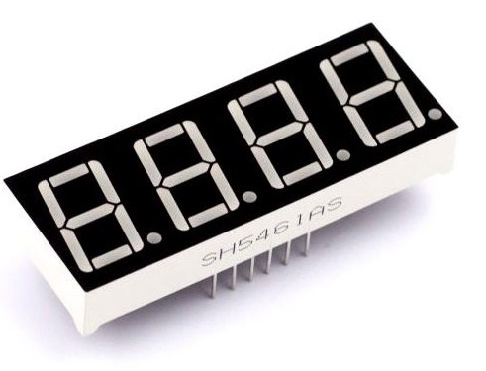
Dust particle sensors are widely applied in electronic systems such as air purifiers and smart air-conditioning units to monitor air cleanliness. They are also used in industrial environments where excessive dust can pose health and safety risks, as well as in public air-quality monitoring systems for pollution assessment and control. In the proposed project, the dust sensor measures particulate matter levels, typically PM2.5 and PM10, to evaluate air quality conditions. The sensor data is processed by the microcontroller and displayed in real time, allowing the system to assess environmental health and support applications in urban areas, industrial workplaces, and indoor air-quality monitoring.
- Buzzer
A buzzer is used in the proposed system as an audible alert device to warn users when environmental parameters exceed safe limits. It converts electrical energy into sound signals, providing immediate audio feedback during hazardous conditions such as high gas concentration or poor air quality. The buzzer plays a crucial role in safety-critical monitoring systems by ensuring that alerts are noticed even when visual displays are not actively observed.

In this project, the buzzer is controlled by the ESP32 microcontroller and is activated whenever sensor readings cross predefined threshold values. This enables real-time warning and prompts users or operators to take immediate corrective action. The buzzer enhances system reliability by acting as a secondary alert mechanism alongside visual displays and dashboard monitoring.

- Applications:
Harmful Gas Detection
The sensing of toxic gases such as H2S, Methane, and CO is of great importance in any industry to avoid unwanted leakage and consequences like poisoning or explosions. The presence of these gases can be easily detected in industrial facilities and commercial buildings with the help of an IoT-powered gas monitoring solution. Moreover, a gas detector or sensor device is a crucial part to carry out safe industrial operations. The sensor-enabled solution helps prevent the high risk of gas explosions and affecting any casualties within and outside the premises.
Fire Hazard Prevention
The gas sensors help detect the concentration of the gases present in the atmosphere to avoid hazardous consequences like fire breakouts. Also, it is an imperative solution to keep the plant workers and equipment safe from fire hazards. It effectively detects the presence of hazardous gases like propane and methane and alerts the plant authorities, preventing the premises from unexpected ignition. Moreover, a gas monitoring solution uses gas analysers to generate alerts regarding the temperature increase. This allows the management to take immediate actions to curb harmful fire explosions.
Oxygen Level Measurement
Sensing the presence of gases is a necessity to conduct industrial operations, as several miners have lost their lives due to a lack of oxygen in the process of mining explorations. A sudden decrease in the oxygen levels can result in dizziness, brain damage, or even death among workers working in mines or close-packed industrial premises. A gas monitoring system significantly benefits the industries by maintaining proper oxygen levels that reflect the optimal performance of your workers. This system also creates alerts in real-time about the decreasing oxygen levels, which gives enough time to take necessary measures to evacuate the facilities much before the health gets affected.
- Conclusion
This project successfully presents a real-time industrial air quality and gas monitoring system using an ESP32 microcontroller. The system continuously monitors key environmental parameters such as temperature, humidity, carbon monoxide, carbon dioxide, and dust particle concentration. By integrating multiple sensors with a local display and an audible alert mechanism, the system ensures immediate awareness of unsafe conditions.
The use of ESP32 enables reliable data processing and wireless communication, making the system suitable for both indoor and industrial environments. The external display and buzzer enhance safety by allowing quick identification of hazardous situations without the need for constant manual inspection. Overall, the proposed system offers a cost-effective, scalable, and efficient solution for improving environmental monitoring and safety in industries, workplaces, and residential areas.

- References
- https://timesofindia.indiatimes.com/home/environment/pollution/7-of-the-top-10-most-polluted-cities-in-the-world-are-in-india-study/articleshow/
- https://www.bloomberg.com/news/articles/2020-02-25/china-clears-air-to-leave-indian-cities-unrivaled-smog-centers
- https://www.statista.cohttps://www.statista.com/chart/19835/where-air-pollution-cuts-life-expectancy-the-most/m/chart/19835/where-air-pollution-cuts-life-expectancy-the-most/
- G. Parmar, S. Lakhani and M. K. Chattopadhyay, “An IoT-based low-cost air pollution monitoring system,” 2017 International Conference on Recent
- Innovations in Signal Processing and Embedded Systems (RISE), Bhopal, 2017, pp. 524-528, doi: 10.1109/RISE.2017.8378212.
- Poonam Pal, Ritik Gupta, Sanjana Tiwari, Ashutosh Sharma (2017) “IoT-Based Air Pollution Monitoring System Using Arduino”, International Research Journal of Engineering and Technology (IRJET), Volume: 04 Issue: 10.
- Harsh N. Shah, Zishan Khan, Abbas Ali Merchant, Moin Moghal, Aamir Shaikh, Priti Rane, “IOT Based Air Pollution Monitoring System”, International Journal of Scientific & Engineering Research, Vol. 9, Issue 2, Feb.2018, pp. 62-66.
- C. Xiaojun, L. Xianpeng and X. Peng, “IOT-based air pollution monitoring and forecasting system,” 2015 International Conference on Computer and Computational Sciences (ICCCS), Noida, 2015, pp. 257-260, doi: 10.1109/ICCACS.2015.7361361.

