SIMATS ENGINEERING (SAVEETHA SCHOOL OF ENGINEERING)
Department of Computer Science and Engineering
CO3 ASSESSMENT TOOL 1 – Git & Docker Technical Assignment
Course Code: | CSA10 / CSA1063 | Course Title: | Software Engineering
CO Assessed: | CO3 | Assessment: | Assessment Tool 1 – Git & Docker Technical Assignment
Weightage: | 20% | Total Marks: | 25
CO3 Statement: | Build full-stack applications with an emphasis on containerization, version control, and collaborative development
Student Name: | Manne Praneeth Kumar | Reg. No.: | 192372310
Date: |  | Duration: | 60 minutes

Code of Conduct
I Manne Praneeth Kumar (192372310) (Name / Reg No) certify that this submission is my original work and that I have adhered to the guidelines specified for this assessment. I understand that any violation of academic integrity rules will result in disciplinary action.
Signature of the Student: Praneeth
Annexure A – Git & Docker Technical Assignment
Instructions to Students:
Each student has been assigned an individual problem statement. Based on the assigned problem statement, prepare a Git & Docker Technical Assignment by applying version control and containerization concepts. Your report should include appropriate diagrams, screenshots, commands, and explanations wherever applicable.
Assignment Questions
1. Problem Analysis
- Explain the assigned problem statement and identify the project objectives, functional requirements, and expected outcomes.
2. Project Structure Design
- Design and explain the folder structure of your project repository.
- Justify the purpose of each major folder and file included in the repository.
3. Git Repository Initialization
- Create a Git repository for the project.
- Explain the steps involved in repository initialization and describe the purpose of the essential Git files.
4. Git Branching Strategy
- Design a suitable branching strategy (e.g., Main, Development, Feature, Release, Hotfix).
- Justify why the selected branching model is appropriate for the assigned project.
5. Version Control Workflow
- Demonstrate the Git workflow by performing meaningful commits, branch creation, merging, conflict resolution (if applicable), and repository synchronization.
- Explain the purpose of each Git operation performed.
6. Commit History Analysis
- Present the commit history of the project.
- Explain how commit messages follow good version control practices and contribute to project maintenance.
7. Docker Environment Design
- Explain why Docker is suitable for the assigned project.
- Identify the application components that require containerization.
8. Dockerfile Development
- Design and explain the Dockerfile required to containerize the application.
- Describe the purpose of each instruction used in the Dockerfile.
9. Docker Compose Design
- Develop a Docker Compose configuration for the project.
- Explain the services, networking, volumes, environment variables, and dependencies used.
10. Container Deployment and Testing
- Demonstrate the execution of the application using Docker containers.
- Explain the testing procedure and provide evidence that the application runs successfully.
11. Benefits of Git and Docker
- Discuss how Git and Docker improve collaboration, version management, portability, deployment, scalability, and maintainability for your assigned project.
12. Challenges and Improvements
- Identify the challenges encountered during implementation.
- Suggest possible improvements and future enhancements for the Git workflow and Docker deployment.
Expected Deliverables
- Technical report (10 pages)
- Git repository with complete commit history
- Source code of the assigned project
- Dockerfile
- Docker Compose file (docker-compose.yml)
- Screenshots of Git operations and Docker execution
- Architecture and workflow diagrams
Rubrics for Calculation
Evaluation Criteria | Excellent (4 Marks) | Good (3 Marks) | Satisfactory (2 Marks) | Needs Improvement (1 Mark)
Problem Analysis & Project Design (20%) | Clearly explains the problem statement, objectives, requirements, expected outcomes, and a well-organized project structure with proper justification. | Good analysis and project structure with minor omissions. | Basic analysis and repository structure with limited justification. | Incomplete or unclear analysis and project organization.
Git Repository & Branching Strategy (20%) | Repository initialized correctly with appropriate branching strategy, clear workflow, and proper repository organization. | Repository and branching strategy are mostly correct. | Basic Git setup with limited branching implementation. | Incorrect or incomplete Git repository and branching strategy.
Version Control Workflow & Commit History (10%) | Demonstrates meaningful commits, branching, merging, synchronization, conflict resolution, and professional commit messages with clear history. | Most Git operations demonstrated correctly with good commit history. | Limited Git workflow and commit practices. | Poor workflow and inadequate commit history.
Docker Implementation (20%) | Well-designed Docker environment, Dockerfile, and Docker Compose configuration with clear explanation of services, networking, volumes, and dependencies. | Functional Docker implementation with minor issues. | Basic Docker implementation with limited explanation. | Incomplete or incorrect Docker implementation.
Deployment, Testing & Results (15%) | Application successfully deployed and tested with appropriate screenshots and evidence of successful execution. | Deployment completed with minor issues. | Partial deployment and testing demonstrated. | Deployment unsuccessful or insufficient evidence.
Documentation, Challenges & Future Enhancements (15%) | Professional report (10–15 pages) with diagrams, screenshots, references, discussion of benefits, challenges, and future improvements. | Good documentation with minor omissions. | Basic documentation with limited discussion. | Poor documentation and insufficient analysis.

Criteria | Mark
Problem Analysis & Project Design (20%) | /5
Git Repository & Branching Strategy (20%) | /5
Version Control Workflow & Commit History (10%) | /2
Docker Implementation (20%) | /5
Deployment, Testing & Results (15%) | /4
Documentation, Challenges & Future Enhancements (15%) | /4
TOTAL | /25

SIMATS ENGINEERING
(SAVEETHA SCHOOL OF ENGINEERING)
Department of Computer Science and Engineering
CO-3 ASSESSMENT TOOL - 1
Git & Docker Technical Assignment
Technical Report
Smart Offshore Wind Farm Management Platform
Course: CSA1007 Software Engineering
Submitted by: Manne Praneeth Kumar (192372310)
Faculty Name: Dr P Subramanian

1. Problem Analysis
1.1 Assigned Problem Statement
The assigned problem statement (Problem Statement 11) is the Smart Offshore Wind Farm Management Platform, a web-based and IoT-integrated system for monitoring, analysing, and managing the day-to-day operations of offshore wind turbines. Offshore wind farms operate in remote, harsh marine environments where continuous physical inspection is difficult and expensive; existing practice relies on fixed inspection schedules and reactive maintenance, which leads to prolonged downtime, delayed failure detection, and inefficient use of maintenance resources. Rapidly changing offshore weather further affects both turbine output and the safety of maintenance operations, yet many existing systems do not integrate real-time weather data into operational planning.
This technical assignment builds directly on the Software Requirement Specification prepared for CO-2 Assessment Tool 1, which defined the complete functional and non-functional requirement set for this platform. Rather than repeating that analysis, this report focuses on how the platform is structured, version-controlled, and containerized so that it can be built and delivered collaboratively.
1.2 Project Objectives
- Provide continuous, centralized monitoring of turbine performance (power output, rotor speed, vibration, temperature) across the entire wind farm.
- Enable predictive maintenance by analysing historical and real-time sensor trends to raise early-warning alerts before failures occur.
- Integrate live and forecasted weather data into operational and maintenance-scheduling decisions.
- Recommend energy-generation optimizations based on turbine condition and weather conditions.
- Streamline the creation, assignment, and tracking of preventive and corrective maintenance work orders.
- Deliver the system as a modular, containerized platform that can scale to additional turbines and sensor nodes without major architectural change.
1.3 Functional Requirements Considered
The functional requirements below were established in the CO-2 SRS and directly shape the module boundaries used for the Git and Docker design in this report.
ID | Requirement (summary)
FR-1 | Collect and display real-time turbine performance data from SCADA/sensors.
FR-2 | Analyse sensor data to predict failures and generate early-warning alerts.
FR-3 | Recommend energy-generation optimizations from turbine and weather conditions.
FR-4 | Retrieve and display live/forecasted weather conditions per turbine location.
FR-5 | Create, assign, and track preventive/corrective maintenance schedules.
FR-6 | Generate operational analytics reports (downtime, output trends, maintenance history).
FR-7 | Send automated alerts and notifications for critical events.
FR-8 | Manage user accounts and role-based access permissions.
FR-9 | Provide a real-time dashboard of all turbines' operational status.
FR-10 | Maintain an audit log of maintenance actions and system-generated alerts.
1.4 Expected Outcomes
- Reduced unplanned downtime through earlier detection of developing equipment failures.
- Safer, weather-aware scheduling of offshore maintenance visits.
- A single, unified platform replacing fragmented and purely reactive monitoring practices.
- Data-driven operational and energy-generation decisions supported by consolidated analytics.
- A modular, containerized codebase that a development team can extend and scale as the wind farm grows.

2. Project Structure Design
The repository is organized as a monorepo with clearly separated backend, frontend, and orchestration concerns. This mirrors the module boundaries identified in Section 1: turbine monitoring, predictive maintenance, weather integration, maintenance scheduling, and analytics are each isolated at the route/controller level so that they can be developed, tested, and later containerized independently.
windfarm-platform/
├── backend/
│ ├── src/
│ │ ├── routes/
│ │ │ ├── turbines.routes.js
│ │ │ ├── weather.routes.js
│ │ │ ├── maintenance.routes.js
│ │ │ ├── analytics.routes.js
│ │ │ └── auth.routes.js
│ │ ├── controllers/
│ │ ├── models/
│ │ ├── middleware/
│ │ │ └── auth.middleware.js
│ │ ├── config/
│ │ │ └── db.js
│ │ └── app.js
│ ├── db/
│ │ └── init.sql
│ ├── tests/
│ ├── package.json
│ ├── .env.example
│ └── Dockerfile
├── frontend/
│ ├── public/
│ │ ├── index.html
│ │ ├── css/
│ │ └── js/
│ ├── nginx.conf
│ └── Dockerfile
├── docs/
│ ├── architecture-diagram.png
│ └── gitflow-diagram.png
├── docker-compose.yml
├── .gitignore
├── .env.example
├── README.md
└── LICENSE
Figure 2.1: Project repository folder structure
2.1 Purpose of Each Major Folder / File
Folder / File | Purpose
backend/src/routes/ | One route file per functional module (turbines, weather, maintenance, analytics, auth), keeping each requirement's API surface isolated and independently testable.
backend/src/controllers/ | Business logic separated from routing — e.g. predictive-maintenance scoring, alert generation.
backend/src/models/ | Data-access layer mapped to the PostgreSQL schema (turbines, sensor_readings, maintenance_orders, users, alerts).
backend/src/middleware/ | Cross-cutting concerns: JWT verification, role-based access control, request logging.
backend/src/config/db.js | Centralized database connection/pool configuration, read from environment variables.
backend/db/init.sql | Schema bootstrap script executed on first container start.
backend/Dockerfile | Builds the backend service image (Section 8).
frontend/public/ | Static dashboard assets served by Nginx.
frontend/nginx.conf | Reverse-proxy configuration routing /api/* to the backend container.
frontend/Dockerfile | Builds the Nginx-based frontend image (Section 8).
docs/ | Architecture and workflow diagrams referenced by this report and the project README.
docker-compose.yml | Orchestrates backend, frontend, and database containers as a single stack (Section 9).
.gitignore | Excludes node_modules, .env, build output, and editor/OS files from version control.
.env.example | Documents required environment variables without committing real secrets.
README.md | Project overview and setup/run instructions for onboarding contributors.
LICENSE | States the terms under which the code may be reused.

3. Git Repository Initialization
The repository was initialized locally and connected to a remote before any feature work began, so that history is complete from the first commit.
3.1 Initialization Steps
Step 1 — Initialize the repository
git init
Step 2 — Configure commit identity
git config user.name "Manne Praneeth Kumar"
git config user.email "praneeth@example.com"
Step 3 — Add .gitignore before the first commit
node_modules/
.env
*.log
dist/
.DS_Store
Step 4 — Add baseline files and make the initial commit
README.md, LICENSE, and .env.example are created before the first commit so the repository is immediately usable by a new contributor.
git add .
git commit -m "chore: initial project scaffold with backend, frontend, and docker setup"
Step 5 — Create the remote and push
git remote add origin https://github.com/<org>/windfarm-platform.git
git push -u origin main
3.2 Purpose of Essential Git Files
File | Purpose
.git/ | Hidden directory holding the entire repository history, objects, and refs; created by git init.
.gitignore | Prevents dependency folders, secrets, and build output from being tracked.
README.md | First point of reference for any contributor; documents purpose, setup, and usage.
.env.example | Lets teammates recreate a working .env locally without exposing real credentials.
LICENSE | States the terms under which the code may be reused.

4. Git Branching Strategy
The project uses the Gitflow model: a permanent main branch, a permanent develop integration branch, short-lived feature branches for each module, release branches for stabilization, and hotfix branches for urgent production fixes.
Branch | Purpose | Lifetime
main | Always deployable; every commit corresponds to a tagged release. | Permanent
develop | Integration branch where completed features are merged and tested together. | Permanent
feature/* | Isolated development of one module at a time (e.g. feature/weather-integration). | Until merged to develop
release/* | Final testing, version bump, and documentation before a release. | Until merged to main & develop
hotfix/* | Urgent fixes applied directly against main. | Until merged to main & develop
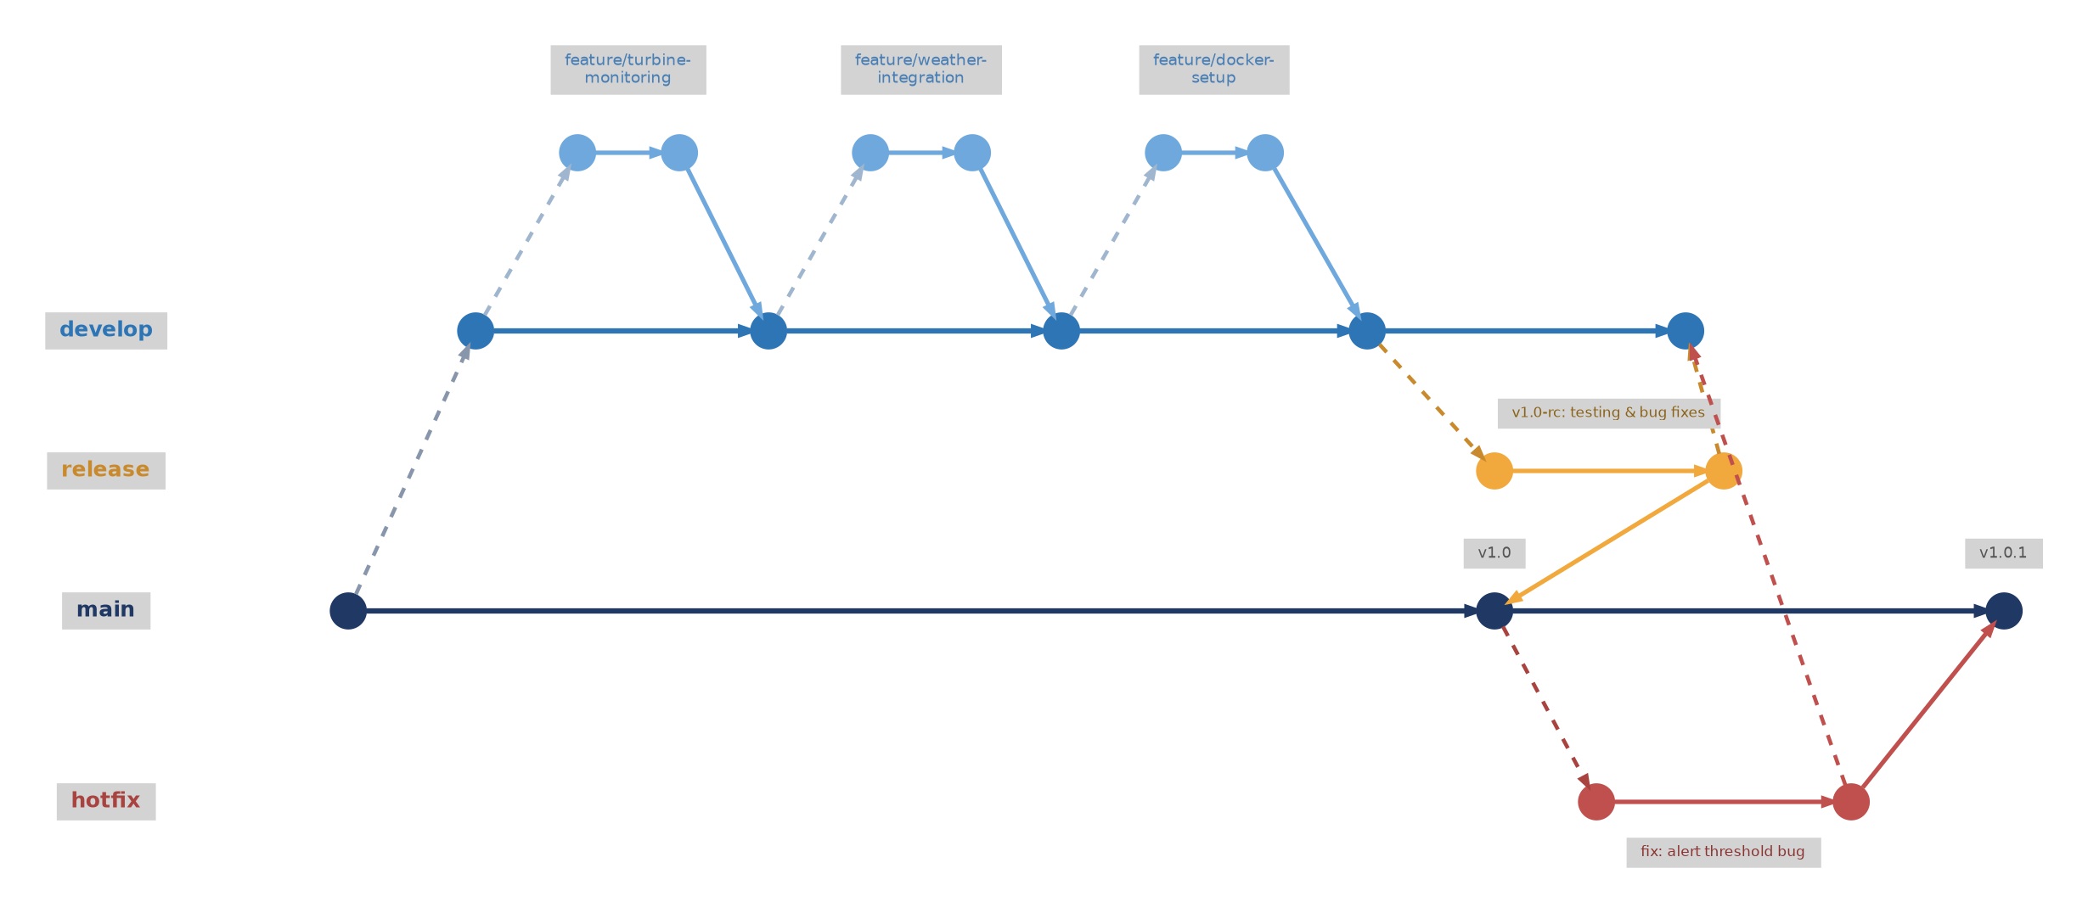
Figure 4.1: Gitflow branching model applied to the Wind Farm platform
4.1 Why Gitflow Fits This Project
- The platform decomposes into clearly separable modules — turbine monitoring, predictive maintenance, weather integration, scheduling, analytics — each mapping naturally to its own feature branch, so modules can be developed in parallel without blocking one another.
- Because the platform is intended to run against real operational data, main must always represent a stable, deployable state; Gitflow's separation of main and develop enforces exactly that.
- The hotfix branch matters specifically because this is a safety- and operations-relevant system: a defect in an alert threshold or maintenance-scheduling rule needs to be patchable directly against production without waiting for the next full release cycle.
- The release branch gives a stabilization window to validate Docker images and run integration tests before a version is tagged — important given the platform integrates external systems such as SCADA and the weather API.

5. Version Control Workflow
The sequence below is the reference workflow this project follows for every module, illustrated here for the weather-integration feature. Each command is annotated with the Git operation it performs and why.
5.1 Feature Branch, Commits, and Sync
# 1. Start a new feature branch from develop
git checkout develop
git pull origin develop
git checkout -b feature/weather-integration

# 2. Work in small, meaningful commits
git add src/routes/weather.routes.js
git commit -m "feat(weather): add endpoint to fetch live conditions per turbine"

git add src/controllers/weather.controller.js
git commit -m "feat(weather): integrate forecast provider and cache responses"

git add tests/weather.test.js
git commit -m "test(weather): cover forecast cache expiry and API failure fallback"

# 3. Keep the branch current with develop
git fetch origin
git rebase origin/develop

# 4. Push and open a pull request for review
git push -u origin feature/weather-integration

# 5. After review, merge into develop with a merge commit
git checkout develop
git merge --no-ff feature/weather-integration -m "merge: weather integration module"
git push origin develop

# 6. Delete the now-merged feature branch
git branch -d feature/weather-integration
git push origin --delete feature/weather-integration
5.2 Conflict Resolution
Rebasing a feature branch onto an actively-changing develop can surface conflicts, as below when two branches both touched the database configuration file.
$ git rebase origin/develop
Auto-merging backend/src/config/db.js
CONFLICT (content): Merge conflict in backend/src/config/db.js
error: could not apply 4f2a9c1... feat(weather): integrate forecast provider

# Resolved manually in the editor, keeping both the new connection-pool
# option and a teammate's retry logic, then:
git add backend/src/config/db.js
git rebase --continue
Sample terminal output — illustrative of the conflict this branching pattern is designed to surface early.
5.3 Purpose of Each Operation
Operation | Purpose
git checkout -b | Creates and switches to an isolated branch so in-progress work never touches develop directly.
git commit (small, scoped) | Each commit represents one reviewable unit of change, making history easy to read and, if needed, revert.
git rebase origin/develop | Replays the feature branch on top of the latest develop, keeping history linear and surfacing conflicts early, before review.
git push -u | Publishes the branch and sets the upstream tracking reference for future push/pull.
git merge --no-ff | Preserves the feature branch as a distinct group of commits in develop's history, instead of flattening it.
conflict resolution | Manual reconciliation of two changes to the same lines; required whenever automatic merging cannot determine intent.
branch deletion | Keeps the branch list limited to active work once a feature is safely merged.

6. Commit History Analysis
The commit log below is the representative history produced by following the workflow in Section 5 across every module of the platform.
Commit | Message | Type
a1c9e02 | chore: initial project scaffold with backend, frontend, and docker setup | chore
b3f81aa | feat(turbines): add turbine data ingestion endpoint | feat
c58d2e1 | feat(turbines): add rotor speed/vibration validation on ingest | feat
d907f3c | test(turbines): cover ingestion validation edge cases | test
e2a44b0 | feat(weather): add endpoint to fetch live conditions per turbine | feat
f6b120d | feat(weather): integrate forecast provider and cache responses | feat
1a83c9f | test(weather): cover forecast cache expiry and API failure fallback | test
2c9e7d1 | feat(maintenance): add work order creation and assignment | feat
39fa4e2 | fix(maintenance): correct overdue-task filter in scheduler query | fix
4d1b8c3 | feat(docker): add backend Dockerfile with multi-stage build | feat
5e2c9a4 | feat(docker): add docker-compose orchestration for full stack | feat
6f3da15 | docs: add architecture and gitflow diagrams to README | docs
709eb26 | fix(alerts): correct threshold comparison for critical-level alerts | fix
81af3c7 | chore(release): bump version to v1.0.0 | chore
Figure 6.1: Representative commit history (git log --oneline)
6.1 Commit Message Conventions
Every message follows the Conventional Commits pattern type(scope): description, written in the imperative mood (“add”, not “added”), with each commit scoped to a single logical change. This directly supports project maintenance:
- Traceability — every change to alerting or scheduling logic can be traced back to the exact commit and reasoning behind it.
- Fast changelog generation — feat/fix/docs prefixes let release notes be generated directly from the log.
- Easier review — small, single-purpose commits are simpler for a reviewer to reason about than large, mixed changes.
- Reliable bisecting — if a regression appears, git bisect can isolate the exact commit because each one represents one coherent change.

7. Docker Environment Design
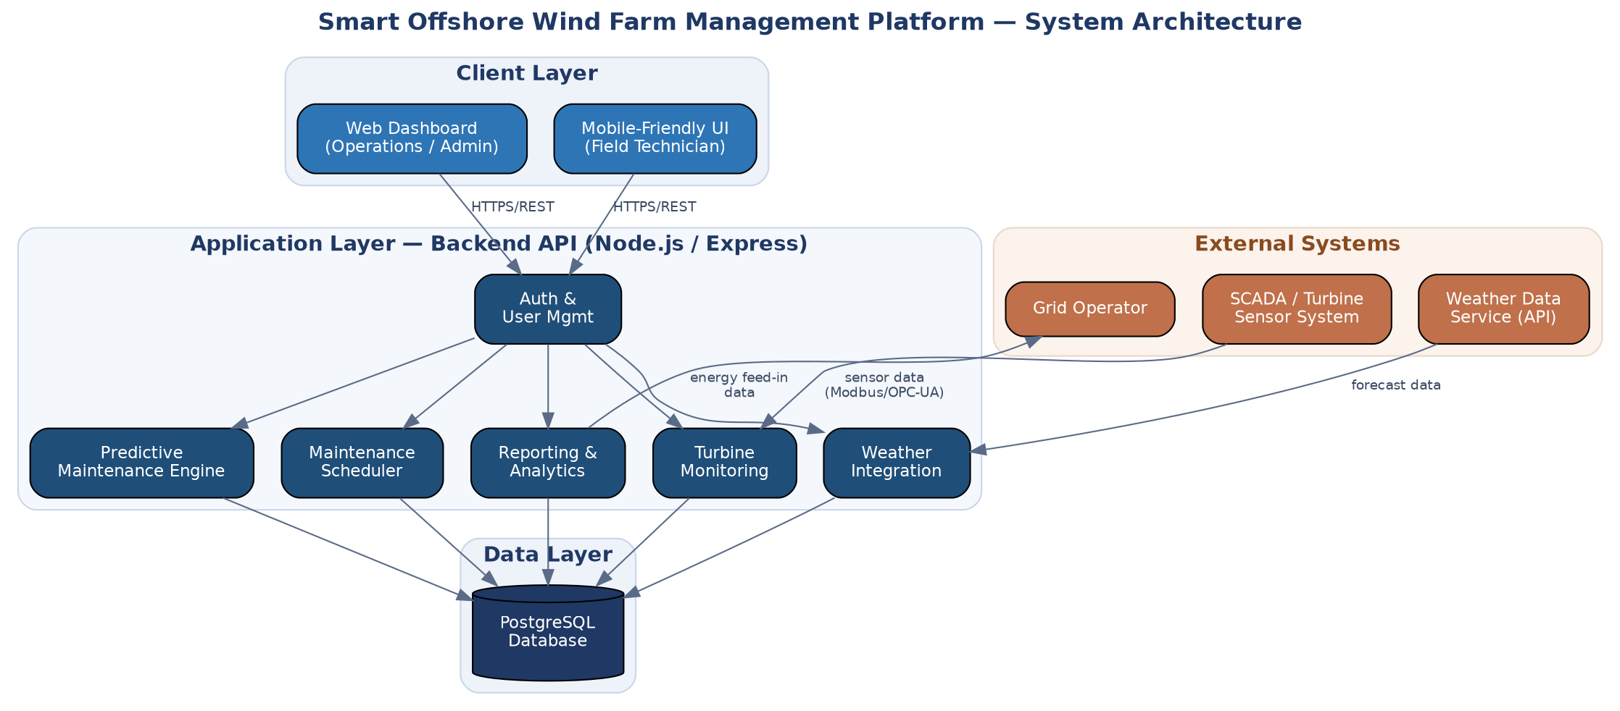
Figure 7.1: System architecture — client, application, data, and external layers
7.1 Why Docker Suits This Project
- Multiple runtime dependencies (Node.js backend, PostgreSQL, an Nginx-served frontend) must behave identically across a developer machine, the faculty evaluation environment, and eventual operations hardware.
- A reproducible evaluation environment: running docker compose up gives an evaluator the exact stack the student tested against, removing “works on my machine” ambiguity.
- The platform's Scalability requirement (from the CO-2 SRS) — supporting new turbines and sensor nodes without major architectural change — maps naturally onto scaling stateless backend containers.
- Each service can be updated and redeployed independently, matching the SRS's Maintainability requirement for independently updatable components such as the prediction engine and weather module.
7.2 Components Requiring Containerization
Component | Why Containerize
Backend API (Node.js / Express) | Encapsulates the application runtime and npm dependencies; isolates it from the host's Node.js version.
PostgreSQL database | Consistent schema and engine version across environments; isolated, persistent storage via a named volume.
Frontend (static dashboard via Nginx) | Serves built assets and reverse-proxies API calls; decouples frontend deployment from the backend.
The SCADA/turbine sensor system, the external Weather Data Service, and the Grid Operator's system are not containerized as part of this platform — they are external, physically or organizationally separate systems the platform integrates with over the network, consistent with the system boundary defined in the CO-2 SRS.

8. Dockerfile Development
8.1 Backend Dockerfile
A two-stage build keeps the final image small: dependencies are installed in a builder stage, and only the built artifacts are copied into a clean runtime stage.
# ---- backend/Dockerfile ----
FROM node:20-alpine AS builder
WORKDIR /app
COPY package*.json ./
RUN npm ci --omit=dev
COPY src ./src
COPY db ./db

FROM node:20-alpine
WORKDIR /app
ENV NODE_ENV=production
COPY --from=builder /app/node_modules ./node_modules
COPY --from=builder /app/src ./src
COPY --from=builder /app/db ./db
COPY package*.json ./
EXPOSE 5000
USER node
HEALTHCHECK --interval=30s --timeout=5s CMD wget -qO- http://localhost:5000/health || exit 1
CMD ["node", "src/app.js"]
Instruction | Purpose
FROM node:20-alpine AS builder | Starts a small Alpine-based Node 20 build stage, kept separate from the final image.
WORKDIR /app | Sets the working directory inside the container for all subsequent instructions.
COPY package*.json ./ | Copies only dependency manifests first so Docker can cache the npm-install layer.
RUN npm ci --omit=dev | Installs exact, lock-file-pinned production dependencies — reproducible and faster than npm install.
COPY src / db | Copies application source and schema after dependencies, maximizing layer-cache reuse on rebuilds.
FROM node:20-alpine (2nd stage) | Starts a clean final image, discarding build-only files left over from the first stage.
ENV NODE_ENV=production | Signals frameworks/libraries to use production-optimized behaviour.
COPY --from=builder … | Brings only the built artifacts into the final image, keeping it small.
EXPOSE 5000 | Documents the port the app listens on; actual publishing happens in Compose (Section 9).
USER node | Drops from root to the unprivileged node user for defense-in-depth.
HEALTHCHECK | Lets Docker/Compose detect whether the API is actually responding, not merely running.
CMD ["node", "src/app.js"] | Default command that starts the API when the container runs.
8.2 Frontend Dockerfile
# ---- frontend/Dockerfile ----
FROM nginx:1.27-alpine
COPY public /usr/share/nginx/html
COPY nginx.conf /etc/nginx/conf.d/default.conf
EXPOSE 80
CMD ["nginx", "-g", "daemon off;"]
The frontend image starts from the lightweight official nginx:1.27-alpine image, copies the built static dashboard into Nginx's web root, and replaces the default site configuration with one that also reverse-proxies /api/* requests to the backend container (Section 9), so the browser only ever talks to a single origin.

9. Docker Compose Design
Docker Compose orchestrates the three services — db, backend, frontend — as a single stack on a shared network.
version: "3.9"

services:
db:
image: postgres:16-alpine
container_name: windfarm-db
restart: unless-stopped
environment:
POSTGRES_DB: ${DB_NAME}
POSTGRES_USER: ${DB_USER}
POSTGRES_PASSWORD: ${DB_PASSWORD}
volumes:
- db-data:/var/lib/postgresql/data
- ./backend/db/init.sql:/docker-entrypoint-initdb.d/init.sql:ro
ports:
- "5432:5432"
networks:
- windfarm-net
healthcheck:
test: ["CMD-SHELL", "pg_isready -U ${DB_USER}"]
interval: 10s
timeout: 5s
retries: 5

backend:
build: ./backend
container_name: windfarm-backend
restart: unless-stopped
env_file: .env
environment:
DB_HOST: db
DB_PORT: 5432
depends_on:
db:
condition: service_healthy
ports:
- "5000:5000"
networks:
- windfarm-net

frontend:
build: ./frontend
container_name: windfarm-frontend
restart: unless-stopped
depends_on:
- backend
ports:
- "80:80"
networks:
- windfarm-net

volumes:
db-data:

networks:
windfarm-net:
driver: bridge
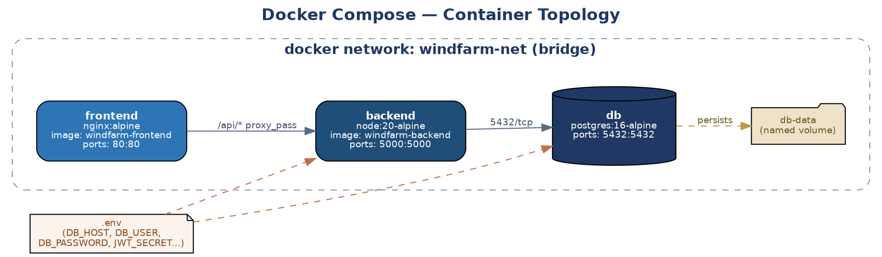
Figure 9.1: Docker Compose container topology
9.1 Services, Networking, Volumes, and Dependencies
Aspect | Design
Services | Three services — db, backend, frontend — each built or pulled independently and versioned together in one compose file.
Networking | A custom bridge network (windfarm-net) lets containers resolve each other by service name — the backend connects to host db, not localhost — while host ports are published only where external access is needed.
Volumes | db-data is a named volume that persists PostgreSQL's data directory across container recreation; init.sql is bind-mounted read-only to bootstrap the schema on first run.
Environment variables | Database credentials and secrets are supplied via a .env file (env_file / ${VAR} interpolation), keeping them out of the image and out of version control (Section 3.2).
Dependencies | depends_on with condition: service_healthy makes the backend wait for a genuinely ready database — not just a started container — before it starts accepting requests.

10. Container Deployment and Testing
Scope note: this report specifies the exact deployment and testing procedure — commands, health checks, and expected results — as the reference for running the stack. Terminal output below is labelled “sample expected output” and should be replaced with real captures once the containers are built and run in an environment with Docker installed.

10.1 Build and Start the Stack
# Build images and start all three containers in the background
docker compose up --build -d

# Confirm all containers are up and healthy
docker compose ps
Sample expected output:
NAME IMAGE STATUS
windfarm-db postgres:16-alpine Up (healthy)
windfarm-backend windfarm-platform-backend Up
windfarm-frontend windfarm-platform-frontend Up
10.2 Testing Procedure
- Health check — GET /health on the backend should report the API and its database connection are up.
- Per-module smoke test — exercise one endpoint from each module (turbines, weather, maintenance) and confirm a 200 response with the expected JSON shape.
- Frontend reachability — load the dashboard in a browser and confirm it renders and successfully calls the backend through the Nginx proxy.
- Log verification — docker compose logs backend --tail=50 should show a successful database connection and no unhandled exceptions.
- Persistence check — docker compose down then docker compose up again should retain existing records, confirming the named volume is working.
Sample expected output:
$ curl -s http://localhost:5000/health
{"status":"ok","uptime":"12s","db":"connected"}

$ curl -s http://localhost:5000/api/turbines
[{"id":"WT-01","status":"online","powerOutput_kW":1830,"vibration":"normal"}, ...]

11. Benefits of Git and Docker
Applied to this project specifically, Git and Docker deliver benefits across the whole delivery lifecycle, not just in isolated technical terms:
Benefit | How it applies to this project
Collaboration | Feature branches let contributors work on turbine monitoring, weather integration, and scheduling in parallel without stepping on each other; pull requests give a review checkpoint before code reaches develop.
Version management | A complete history of every change to alerting thresholds and scheduling logic — critical for a system tied to maintenance and safety decisions, since any regression can be traced and reverted.
Portability | The same docker-compose.yml runs identically on a developer laptop, the faculty evaluation machine, or eventual operations hardware.
Deployment | docker compose up --build turns a fresh checkout into a running stack with one command — no manual Node.js, PostgreSQL, or Nginx installation.
Scalability | Because the backend is stateless and containerized, it can run as multiple replicas behind a load balancer as more turbines and sensor nodes are added — directly satisfying the Scalability requirement from the CO-2 SRS.
Maintainability | Each service — db, backend, frontend — can be rebuilt, updated, or replaced independently, matching the SRS's requirement that components like the prediction engine be independently updatable.

12. Challenges and Improvements
12.1 Challenges Encountered
- Coordinating schema changes in init.sql across feature branches touching the same tables risked conflicts in the database layer.
- Keeping .env.example in sync with the variables each new module actually required (e.g. a weather-API key added alongside the weather-integration feature).
- Judging when a fix was urgent enough for a hotfix branch versus the next regular release cycle.
- Ensuring the backend's health check did not report “healthy” before the database connection pool was genuinely ready, which would otherwise mask real startup failures.
- The offshore intermittent-connectivity conditions described in the CO-2 SRS are difficult to reproduce faithfully in a local Docker environment, which limits how much of that behaviour can be validated before real deployment.
12.2 Suggested Improvements and Future Enhancements
- Add a CI/CD pipeline (GitHub Actions or Jenkins) to run lint and tests and build images automatically on every push to develop and main.
- Introduce a staging Compose profile that mirrors production more closely for pre-release validation.
- Move secrets from .env files to a dedicated secrets manager before production deployment.
- Add automated integration tests that start the full Compose stack in CI before a merge is allowed.
- Adopt Kubernetes (or Docker Swarm) once the platform needs multiple backend replicas running across nodes for true horizontal scalability.
- Add branch-protection rules on main and develop requiring passing CI and at least one review before merge.

