SIMATS ENGINEERING
(SAVEETHA SCHOOL OF ENGINEERING)
Department of Computer Science and Engineering

COA-4 ASSESSMENT -2
CI/CD Pipeline Design Exercise

“Smart Offshore Wind Farm Management Platform”

Submitted by
MANNE PRANEETH KUMAR
Register Number: 192372310
Course Code: CSA-1007
Course Name: SOFTWARE ENGINEERING
Faculty In-Charge: Dr. P. Subramanian

Department of Computer Science and Engineering
SIMATS Engineering (Saveetha School of Engineering)
Chennai – 602105, Tamil Nadu
2026

SIMATS ENGINEERING (SAVEETHA SCHOOL OF ENGINEERING)
Department of Computer Science and Engineering
CO4 ASSESSMENT TOOL 2 – CI/CD Pipeline Design Exercise

Course Code: | CSA-1007 | Course Title: | Software Engineering
CO Assessed: | CO4 | Assessment: | Assessment Tool 2 – CI/CD Pipeline Design Exercise
Weightage: | 20% | Total Marks: | 25
CO4 Statement: | Implement robust testing, quality assurance, and DevOps practices, emphasizing security, reliability, and ethics.
Student Name: | Manne Praneeth Kumar | Reg. No.: | 192372310
Faculty In-Charge: | Dr. P. Subramanian | Duration: | 60 minutes

Code of Conduct
I, Manne Praneeth Kumar (Reg. No. 192372310), certify that this submission is my original work and that I have adhered to the guidelines specified for this assessment. I understand that any violation of academic integrity rules will result in disciplinary action.
Signature of the Student: ____________________________

1. Problem Overview and CI/CD Requirement Analysis
This report presents the CI/CD (Continuous Integration and Continuous Deployment) pipeline design for Problem Statement 11 — the Smart Offshore Wind Farm Management Platform. The platform brings turbine telemetry, predictive-failure indicators, weather data, and maintenance workflows into a single operational dashboard, organized around modules for turbine performance monitoring, predictive maintenance, energy-generation optimization, weather tracking, maintenance scheduling, and operational analytics. Because the system is safety- and revenue-critical — it directly informs decisions about turbine shutdowns, maintenance dispatch, and energy trading — changes to it cannot be released the way an ordinary internal tool would be: every change needs to be integrated, verified, and rolled out in a controlled, auditable, and reversible way.
Analyzing the assigned problem against this backdrop surfaces four concrete CI/CD needs. First, frequent integration: with distinct modules being developed in parallel across the front end, back end, and predictive-maintenance logic, code from multiple contributors must be merged and validated continuously rather than in large, infrequent batches, so integration conflicts and regressions surface early. Second, automated verification: because a false negative in the failure-prediction module or an incorrect turbine command could have real operational consequences, every change needs automated unit, integration, and end-to-end tests before it can be merged, not just manual review. Third, environment consistency: turbine telemetry ingestion, the analytics dashboard, and the API layer must behave identically in development, staging, and production, which requires containerization rather than manual server configuration. Fourth, controlled, reversible releases: because the platform is expected to run continuously against live turbine data, deployments must support staged rollout, health monitoring, and an immediate rollback path if a release misbehaves in production.
These four needs — continuous integration, automated quality gates, environment consistency through containerization, and safe, reversible deployment — map directly onto the CI/CD pipeline architecture designed in the sections that follow.

2. CI/CD Pipeline Architecture and Workflow
The pipeline is organized as nine sequential stages, triggered automatically on every commit and pull request against the repository, and gated by a manual approval step before production release. Table 2.1 summarizes the stages; the full pipeline diagram and the commit-to-deployment walkthrough are provided in Section 7.
Table 2.1: CI/CD Pipeline Stage Overview
Stage | Purpose
1. Source Code Management | Developers push feature branches and raise pull requests; this is the trigger point for the entire pipeline.
2. CI Trigger & Build | The pipeline is triggered automatically; dependencies are installed and the client and server applications are compiled/built.
3. Code Quality & Security Analysis | Static analysis, linting, and dependency/vulnerability scanning run against the freshly built code.
4. Automated Testing | Unit, integration, and end-to-end tests validate functional correctness across the affected modules.
5. Packaging (Containerization) | Verified builds are packaged into versioned Docker images and pushed to a container registry.
6. Deployment to Staging | The new image is deployed to a staging environment that mirrors production.
7. Approval & QA Validation | A manual sign-off, combined with staging smoke tests, confirms the release is fit for production.
8. Deployment to Production | The approved image is rolled out to production using a controlled release strategy.
9. Monitoring & Rollback | Post-deployment health is monitored continuously, with automatic rollback on failure.

This structure keeps the pipeline linear and easy to reason about: nothing reaches staging without passing quality and test gates, and nothing reaches production without passing an explicit approval gate on top of that. The workflow is triggered on every push to a feature branch (running stages 1–4 for fast feedback) and on every merge to the protected main branch (running the full pipeline through to deployment), which keeps day-to-day development friction low while still enforcing the full gate before a release goes live.

3. Tools and Technology Selection
The table below sets out the tool selected for each pipeline stage and the justification for that choice, based on the platform's React/Node/Docker technology stack established in the earlier repository design.
Table 3.1: Tools and Technology Justification by Stage
Stage | Tool(s) | Justification
Source Control | Git + GitHub | Industry-standard distributed version control with built-in pull-request review and branch-protection rules, already used for the project repository.
CI/CD Orchestration | GitHub Actions | Native integration with the GitHub repository removes the need for a separate CI server, and workflow files are version-controlled alongside the code.
Build | Node.js / npm, Docker | npm builds the React client and Node/Express server; Docker produces a reproducible, portable build artifact for every environment.
Code Quality | ESLint, Prettier, SonarQube | ESLint and Prettier enforce a consistent style automatically; SonarQube adds deeper static analysis for maintainability and code-smell detection.
Security Scanning | npm audit, Trivy | npm audit flags vulnerable dependencies; Trivy scans the built Docker image for OS- and library-level vulnerabilities before it is deployed.
Automated Testing | Jest, Supertest, Cypress | Jest covers unit tests for both client and server logic; Supertest validates API endpoints; Cypress runs end-to-end tests against key workflows such as maintenance scheduling.
Packaging & Registry | Docker, Docker Hub / GitHub Container Registry | Versioned, immutable images guarantee the same artifact is promoted from staging to production, eliminating environment drift.
Deployment | Docker Compose (staging), Kubernetes (production) | Docker Compose is sufficient for a single-host staging environment; Kubernetes gives production the rolling updates, self-healing, and scaling the live platform needs.
Notifications | Slack / email webhook integration | Immediate pipeline-status alerts to the development team on build failure, test failure, or a completed deployment.
Monitoring & Rollback | Health-check endpoints, Prometheus/Grafana | Continuous health monitoring detects a failing release quickly and triggers the automatic rollback described in Section 6.

4. Automated Testing Strategy
Testing is integrated into the pipeline as a mandatory gate rather than a manual, post-hoc step, combining three layers so that each core feature is validated from more than one angle before a change is merged:
- Unit testing (Jest): individual functions are tested in isolation — for example, confirming that the failure-prediction check correctly flags a turbine when a sensor reading crosses its defined threshold, or that the energy-optimization calculation returns the expected output for a given weather input.
- Integration testing (Supertest): API endpoints are tested against a test database to confirm the front end and back end interact correctly — for example, that a maintenance-scheduling request persists correctly and returns the expected response.
- End-to-end testing (Cypress): complete user workflows are exercised in a browser against a running build, such as logging in, viewing the turbine dashboard, and generating an operational analytics report for a selected date range.
Unit and integration tests run on every push (stage 4) and must pass before packaging; the slower end-to-end suite runs against the deployed staging environment (as part of stage 7) before the manual approval gate, so that a genuinely broken workflow is caught before production without slowing down every individual commit. A minimum coverage threshold is also enforced in the code-quality stage, so a pull request that reduces test coverage below the agreed baseline fails the build automatically.

5. Deployment Strategy
Three environments are used, each with a distinct purpose and level of stability:
- Development environment: runs locally via Docker Compose for each developer, using the same container images and configuration as the shared environments so that “works on my machine” issues are minimized.
- Staging/testing environment: an exact mirror of production, deployed automatically after every successful build on the main branch. This is where end-to-end tests, manual QA, and the approval sign-off take place before anything reaches real users.
- Production environment: the live platform serving real turbine telemetry and operator dashboards, deployed only after staging validation and explicit approval, using a rolling or blue-green deployment strategy so the previous version keeps serving traffic until the new version is confirmed healthy.
The rolling/blue-green approach means production never runs a single, unverified version for all users at once: the new release is brought up alongside the old one, traffic is shifted once health checks pass, and the old version is only decommissioned after the new one is confirmed stable — which is also what makes the rollback mechanism in Section 6 immediate rather than a fresh redeploy.

6. Security, Quality Checks, Notifications, and Rollback Mechanisms
Security
- Dependency scanning (npm audit) and container image scanning (Trivy) run automatically before packaging, blocking the build if a high-severity vulnerability is found.
- Secrets (API keys, database credentials) are stored in the CI/CD platform's encrypted secrets store, never committed to the repository.
- Branch protection on main requires a passing pipeline and at least one reviewed pull-request approval before merge, preventing unreviewed or unverified code from reaching the deployable branch.
Quality Checks
- ESLint/Prettier and SonarQube gate the build on style violations and code-quality issues before tests even run, giving fast feedback on avoidable problems.
- A minimum automated-test coverage threshold is enforced as part of the quality gate, described in Section 4.
Notifications
- The pipeline posts status updates to a Slack channel (and email, for production releases) on build failure, test failure, a completed staging deployment, and a completed production deployment, so the team is informed at every meaningful transition without needing to watch the pipeline manually.
Rollback Mechanism
- Every production deployment is tied to a specific, versioned Docker image, so rolling back means redirecting traffic to the last known-good image rather than rebuilding from source.
- Automated health checks (API responsiveness, database connectivity, key dashboard endpoints) run continuously after a production release; if a check fails within the post-deployment monitoring window, the pipeline automatically redirects traffic back to the previous stable image and alerts the team, as shown by the feedback path in Figure 7.1.
- A manual rollback command is also available for issues that surface after the automated monitoring window closes.

7. Pipeline Diagram and Workflow Explanation
Figure 7.1 shows the complete CI/CD pipeline for the Smart Offshore Wind Farm Management Platform, from an initial code commit through to a monitored production release.
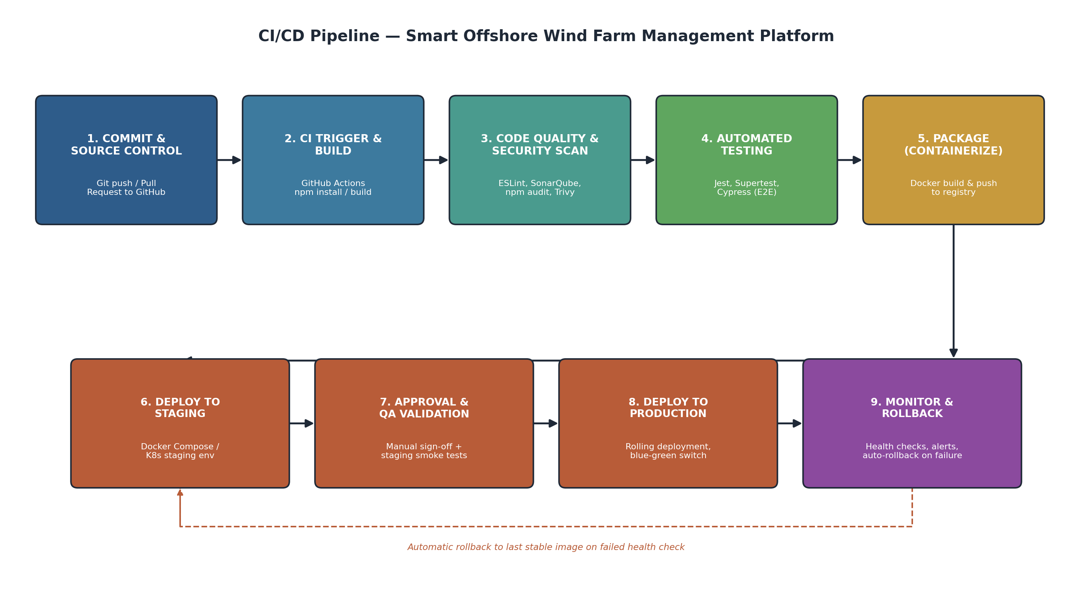
Figure 7.1: CI/CD Pipeline — Smart Offshore Wind Farm Management Platform

The workflow proceeds as follows. A developer commits code to a feature branch and opens a pull request against the protected main branch (Stage 1). This automatically triggers GitHub Actions, which installs dependencies and builds the client and server applications (Stage 2). The freshly built code is then run through linting, static analysis, and dependency/image vulnerability scanning (Stage 3), followed by the full automated test suite — unit, integration, and, once deployed to staging, end-to-end tests (Stage 4). Only a build that passes every quality and test gate is packaged into a versioned Docker image and pushed to the container registry (Stage 5).
The image is then deployed automatically to the staging environment (Stage 6), where QA validation and a manual approval sign-off confirm the release behaves correctly against realistic conditions before anything reaches real turbine operators (Stage 7). Once approved, the same versioned image is rolled out to production using a rolling/blue-green strategy so the previous version keeps serving traffic until the new one is confirmed healthy (Stage 8). From that point on, health checks and monitoring run continuously (Stage 9); if a post-deployment check fails, the pipeline automatically rolls traffic back to the last stable image and notifies the team, closing the loop shown by the dashed feedback path in Figure 7.1.
Together, this gives the platform exactly the properties identified as necessary in Section 1: frequent, automatically verified integration; environment consistency through containerization from development through to production; and a deployment process that is both controlled — gated by automated tests and a manual approval — and safely reversible if a production release misbehaves.

References
1. GitHub, Inc. (2024). GitHub Actions Documentation. https://docs.github.com/actions
2. Docker, Inc. (2024). Docker Documentation. https://docs.docker.com
3. Humble, J., & Farley, D. (2010). Continuous Delivery: Reliable Software Releases through Build, Test, and Deployment Automation. Addison-Wesley.
4. Kim, G., Debois, P., Willis, J., & Humble, J. (2016). The DevOps Handbook. IT Revolution Press.
5. Sommerville, I. (2015). Software Engineering (10th ed.). Pearson Education.

