**Create a Spring Web Project using Maven**

1.Go to https://start.spring.io/

2.Fill in:

* Group: com.cognizant
* Artifact: spring-learn

3.Add dependencies:

* Spring Boot DevTools
* Spring Web

4.Click Generate, then extract the downloaded ZIP to your Eclipse workspace folder.

5. Move the extracted folder (spring-learn) into Eclipse Workspace.

6. Open Command Prompt or Terminal and navigate to the project folder and run following command:

mvn clean package -Dhttp.proxyHost=proxy.cognizant.com -Dhttp.proxyPort=6050 -Dhttps.proxyHost=proxy.cognizant.com -Dhttps.proxyPort=6050 -Dhttp.proxyUser=123456

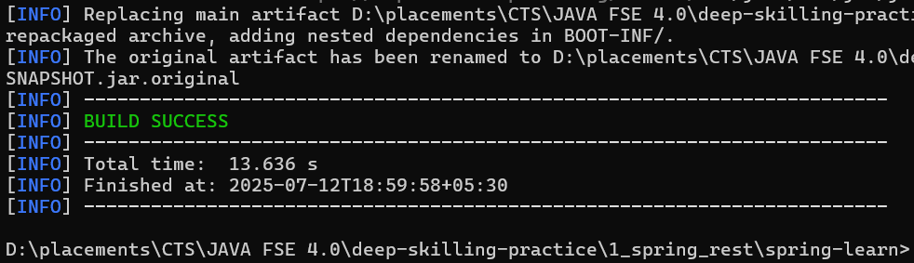

7. In Eclipse: File > Import > Maven > Existing Maven Projects,Select the extracted orm-learn folder.

Click Finish.

**pom.xml:**

<?xml version="1.0" encoding="UTF-8"?>

<project xmlns="http://maven.apache.org/POM/4.0.0" xmlns:xsi="http://www.w3.org/2001/XMLSchema-instance"

xsi:schemaLocation="http://maven.apache.org/POM/4.0.0 https://maven.apache.org/xsd/maven-4.0.0.xsd">

<modelVersion>4.0.0</modelVersion>

<parent>

<groupId>org.springframework.boot</groupId>

<artifactId>spring-boot-starter-parent</artifactId>

<version>3.5.3</version>

<relativePath/> <!-- lookup parent from repository -->

</parent>

<groupId>com.cognizant</groupId>

<artifactId>spring-learn</artifactId>

<version>0.0.1-SNAPSHOT</version>

<name>spring-learn</name>

<description>Demo project for Spring Boot</description>

<url/>

<licenses>

<license/>

</licenses>

<developers>

<developer/>

</developers>

<scm>

<connection/>

<developerConnection/>

<tag/>

<url/>

</scm>

<properties>

<java.version>17</java.version>

</properties>

<dependencies>

<dependency>

<groupId>org.springframework.boot</groupId>

<artifactId>spring-boot-starter-web</artifactId>

</dependency>

<dependency>

<groupId>org.springframework.boot</groupId>

<artifactId>spring-boot-devtools</artifactId>

<scope>runtime</scope>

<optional>true</optional>

</dependency>

<dependency>

<groupId>org.springframework.boot</groupId>

<artifactId>spring-boot-starter-test</artifactId>

<scope>test</scope>

</dependency>

</dependencies>

<build>

<plugins>

<plugin>

<groupId>org.springframework.boot</groupId>

<artifactId>spring-boot-maven-plugin</artifactId>

</plugin>

</plugins>

</build>

</project>

**SpringLearnApplication.java:**

package com.cognizant.spring_learn;

import org.slf4j.Logger;

import org.slf4j.LoggerFactory;

import org.springframework.boot.SpringApplication;

import org.springframework.boot.autoconfigure.SpringBootApplication;

@SpringBootApplication

public class SpringLearnApplication {

private static final Logger *LOGGER* = LoggerFactory.*getLogger*(SpringLearnApplication.class);

public static void main(String[] args) {

*LOGGER*.info("SpringLearnApplication Starting...");

SpringApplication.*run*(SpringLearnApplication.class, args);

*LOGGER*.info("SpringLearnApplication Started Successfully.");

}

}

**Output:**

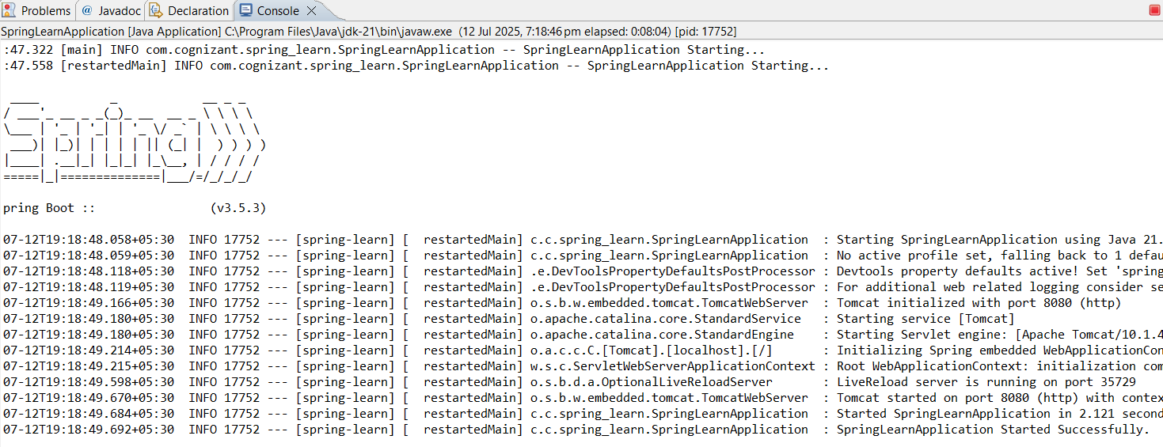

**Spring Core – Load Country from Spring Configuration XML**

**Create Country.java in package com.cognizant.spring_learn;**

**Country.java:**

package com.cognizant.spring_learn;

import org.slf4j.Logger;

import org.slf4j.LoggerFactory;

public class Country {

private static final Logger *LOGGER* = LoggerFactory.*getLogger*(Country.class);

private String code;

private String name;

public Country() {

*LOGGER*.debug("Inside Country Constructor.");

}

public String getCode() {

*LOGGER*.debug("Getting country code: {}", code);

return code;

}

public void setCode(String code) {

*LOGGER*.debug("Setting country code to: {}", code);

this.code = code;

}

public String getName() {

*LOGGER*.debug("Getting country name: {}", name);

return name;

}

public void setName(String name) {

*LOGGER*.debug("Setting country name to: {}", name);

this.name = name;

}

@Override

public String toString() {

return "Country{" + "code='" + code + '\'' + ", name='" + name + '\'' +'}';

}

}

**country.xml: (in src/main/resources)**

<?xml version="1.0" encoding="UTF-8"?>

<beans xmlns="http://www.springframework.org/schema/beans"

xmlns:xsi="http://www.w3.org/2001/XMLSchema-instance"

xsi:schemaLocation="http://www.springframework.org/schema/beans

https://www.springframework.org/schema/beans/spring-beans.xsd">

<bean id="country" class="com.cognizant.spring_learn.Country">

<property name="code" value="IN"/>

<property name="name" value="India"/>

</bean>

</beans>

**application.properties:**

spring.application.name=spring-learn

logging.level.com.cognizant.spring_learn=DEBUG

logging.level.root=DEBUG

**SpringLearnApplication.java:**

package com.cognizant.spring_learn;

import org.slf4j.Logger;

import org.slf4j.LoggerFactory;

import org.springframework.boot.SpringApplication;

import org.springframework.boot.autoconfigure.SpringBootApplication;

import org.springframework.context.ApplicationContext;

import org.springframework.context.support.ClassPathXmlApplicationContext;

@SpringBootApplication

public class SpringLearnApplication {

private static final Logger *LOGGER* = LoggerFactory.*getLogger*(SpringLearnApplication.class);

public static void displayCountry() {

ApplicationContext context = new ClassPathXmlApplicationContext("country.xml");

Country country = (Country) context.getBean("country", Country.class);

*LOGGER*.debug("Country : {}", country.toString());

}

public static void main(String[] args) {

*LOGGER*.info("SpringLearnApplication Starting...");

SpringApplication.*run*(SpringLearnApplication.class, args);

*displayCountry*();

*LOGGER*.info("SpringLearnApplication Started Successfully.");

}

}

**Output:**

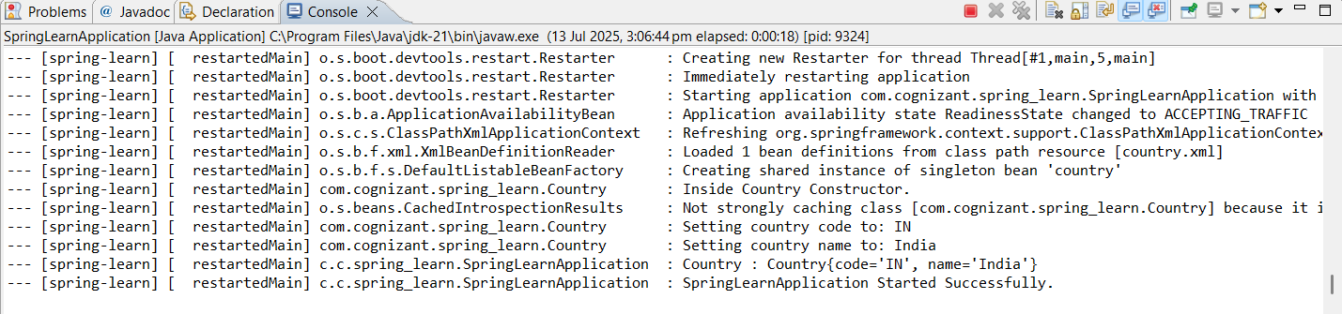

**Hello World RESTful Web Service**

Created HelloController.java in com.cognizant.spring_learn.controller package.

**HelloController.java:**

package com.cognizant.spring_learn.controller;

import org.slf4j.Logger;

import org.slf4j.LoggerFactory;

import org.springframework.web.bind.annotation.GetMapping;

import org.springframework.web.bind.annotation.RestController;

@RestController

public class HelloController {

private static final Logger *LOGGER* = LoggerFactory.*getLogger*(HelloController.class);

@GetMapping("/hello")

public String sayHello() {

*LOGGER*.info("START: sayHello()");

String response = "Hello World!!";

*LOGGER*.info("END: sayHello()");

return response;

}

}

**application.properties:**

spring.application.name=spring-learn

logging.level.com.cognizant.spring_learn=DEBUG

logging.level.root=DEBUG

server.port=8083

**SpringLearnApplication.java:**

package com.cognizant.spring_learn;

import org.slf4j.Logger;

import org.slf4j.LoggerFactory;

import org.springframework.boot.SpringApplication;

import org.springframework.boot.autoconfigure.SpringBootApplication;

@SpringBootApplication

public class SpringLearnApplication {

private static final Logger *LOGGER* = LoggerFactory.*getLogger*(SpringLearnApplication.class);

public static void main(String[] args) {

*LOGGER*.info("SpringLearnApplication Starting...");

SpringApplication.*run*(SpringLearnApplication.class, args);

*LOGGER*.info("SpringLearnApplication Started Successfully.");

}

}

**Output:**

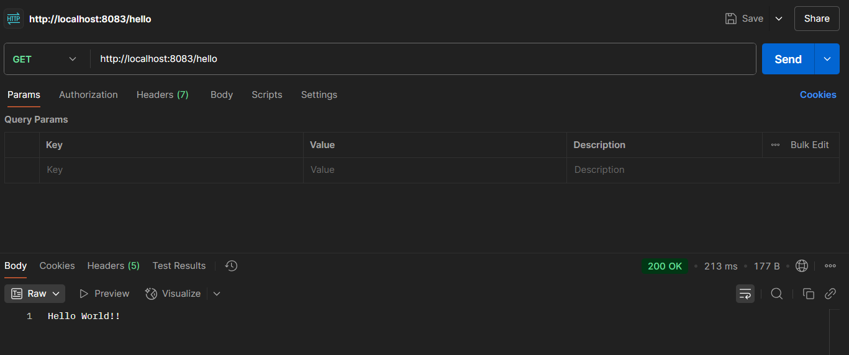

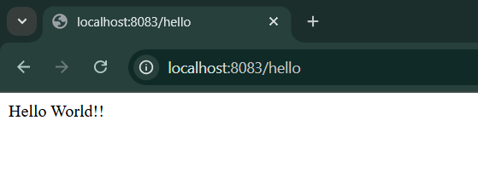

**REST - Country Web Service**

Create CountryController.java in in com.cognizant.spring_learn.controller package.

**CountryController.java:**

package com.cognizant.spring_learn.controller;

import com.cognizant.spring_learn.Country;

import org.slf4j.Logger;

import org.slf4j.LoggerFactory;

import org.springframework.web.bind.annotation.RequestMapping;

import org.springframework.web.bind.annotation.RestController;

import org.springframework.context.support.ClassPathXmlApplicationContext;

@RestController

public class CountryController {

private static final Logger *LOGGER* = LoggerFactory.*getLogger*(CountryController.class);

@RequestMapping("/country")

public Country getCountryIndia() {

*LOGGER*.info("START: getCountryIndia()");

// Load country bean from XML

ClassPathXmlApplicationContext context = new ClassPathXmlApplicationContext("country.xml");

Country country = context.getBean("country", Country.class);

context.close();

*LOGGER*.info("END: getCountryIndia()");

return country;

}

}

**Output:**

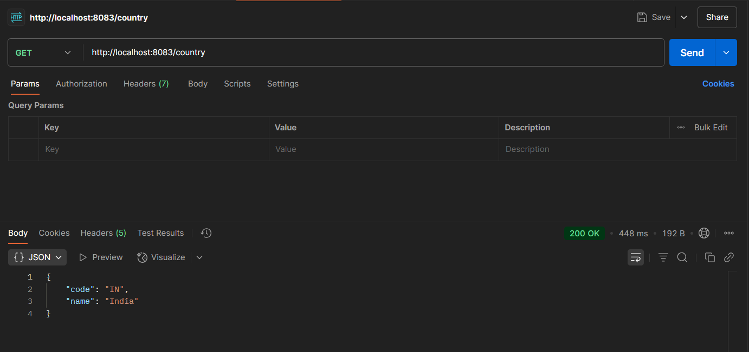

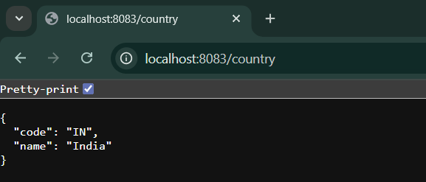

**REST - Get country based on country code**

**country.xml:**

<?xml version="1.0" encoding="UTF-8"?>

<beans xmlns="http://www.springframework.org/schema/beans"

xmlns:xsi="http://www.w3.org/2001/XMLSchema-instance"

xsi:schemaLocation="http://www.springframework.org/schema/beans

https://www.springframework.org/schema/beans/spring-beans.xsd">

<bean id="country" class="com.cognizant.spring_learn.Country">

<property name="code" value="IN"/>

<property name="name" value="India"/>

</bean>

<bean id="in" class="com.cognizant.spring_learn.Country">

<property name="code" value="IN"/>

<property name="name" value="India"/>

</bean>

<bean id="us" class="com.cognizant.spring_learn.Country">

<property name="code" value="US"/>

<property name="name" value="United States"/>

</bean>

<bean id="jp" class="com.cognizant.spring_learn.Country">

<property name="code" value="JP"/>

<property name="name" value="Japan"/>

</bean>

<bean id="countryList" class="java.util.ArrayList">

<constructor-arg>

<list>

<ref bean="in"/>

<ref bean="us"/>

<ref bean="jp"/>

</list>

</constructor-arg>

</bean>

</beans>

Create CountryService.java in in com.cognizant.spring_learn.service package.

**CountryService.java:**

package com.cognizant.spring_learn.service;

import com.cognizant.spring_learn.Country;

import org.springframework.context.ApplicationContext;

import org.springframework.context.support.ClassPathXmlApplicationContext;

import org.springframework.stereotype.Service;

import java.util.List;

@Service

public class CountryService {

public Country getCountry(String code) {

ApplicationContext context = new ClassPathXmlApplicationContext("country.xml");

List<Country> countries = context.getBean("countryList", List.class);

return countries.stream()

.filter(c -> c.getCode().equalsIgnoreCase(code))

.findFirst()

.orElse(null);

}

}

**CountryController.java:**

package com.cognizant.spring_learn.controller;

import com.cognizant.spring_learn.Country;

import com.cognizant.spring_learn.service.CountryService;

import org.slf4j.Logger;

import org.slf4j.LoggerFactory;

import org.springframework.context.ApplicationContext;

import org.springframework.context.support.ClassPathXmlApplicationContext;

import org.springframework.web.bind.annotation.*;

@RestController

public class CountryController {

private static final Logger *LOGGER* = LoggerFactory.*getLogger*(CountryController.class);

private final ApplicationContext context;

private final CountryService countryService;

public CountryController(CountryService countryService) {

this.context = new ClassPathXmlApplicationContext("country.xml");

this.countryService = countryService;

}

@RequestMapping("/country")

public Country getCountryIndia() {

*LOGGER*.info("START: getCountryIndia()");

Country country = context.getBean("country", Country.class);

*LOGGER*.info("END: getCountryIndia()");

return country;

}

@GetMapping("/countries/{code}")

public Country getCountry(@PathVariable String code) {

*LOGGER*.info("START: getCountry() with code: {}", code);

Country country = countryService.getCountry(code);

*LOGGER*.info("END: getCountry()");

return country;

}

}

**SpringLearnApplication.java:**

package com.cognizant.spring_learn;

import org.springframework.boot.SpringApplication;

import org.springframework.boot.autoconfigure.SpringBootApplication;

import org.springframework.context.annotation.ComponentScan;

@SpringBootApplication

@ComponentScan("com.cognizant.spring_learn")

public class SpringLearnApplication {

public static void main(String[] args) {

SpringApplication.*run*(SpringLearnApplication.class, args);

}

}

**Output:**

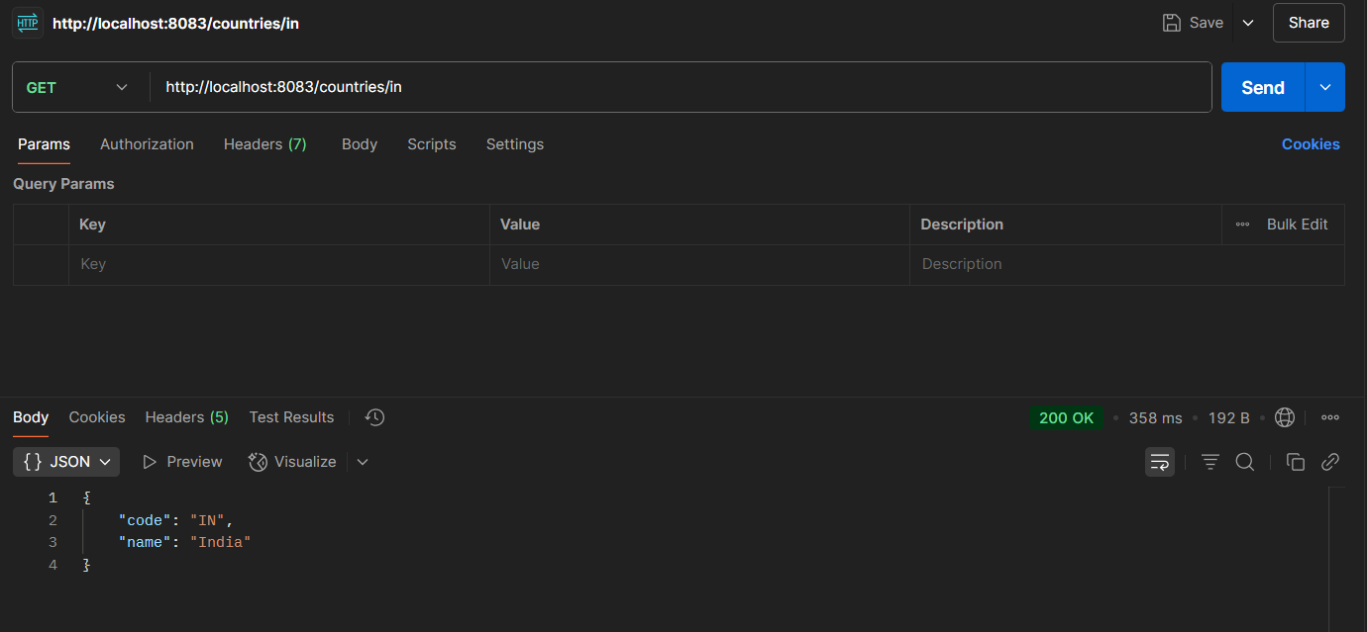

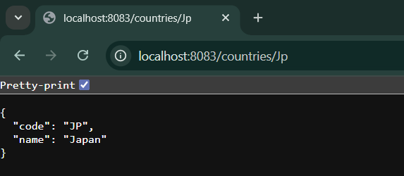

**Create authentication service that returns JWT**

**pom.xml:**

<?xml version="1.0" encoding="UTF-8"?>

<project xmlns="http://maven.apache.org/POM/4.0.0" xmlns:xsi="http://www.w3.org/2001/XMLSchema-instance"

xsi:schemaLocation="http://maven.apache.org/POM/4.0.0 https://maven.apache.org/xsd/maven-4.0.0.xsd">

<modelVersion>4.0.0</modelVersion>

<parent>

<groupId>org.springframework.boot</groupId>

<artifactId>spring-boot-starter-parent</artifactId>

<version>3.5.3</version>

<relativePath/> <!-- lookup parent from repository -->

</parent>

<groupId>com.cognizant</groupId>

<artifactId>spring-learn</artifactId>

<version>0.0.1-SNAPSHOT</version>

<name>spring-learn</name>

<description>Demo project for Spring Boot</description>

<url/>

<licenses>

<license/>

</licenses>

<developers>

<developer/>

</developers>

<scm>

<connection/>

<developerConnection/>

<tag/>

<url/>

</scm>

<properties>

<java.version>17</java.version>

</properties>

<dependencies>

<dependency>

<groupId>org.springframework.boot</groupId>

<artifactId>spring-boot-starter-web</artifactId>

</dependency>

<dependency>

<groupId>org.springframework.boot</groupId>

<artifactId>spring-boot-devtools</artifactId>

<scope>runtime</scope>

<optional>true</optional>

</dependency>

<dependency>

<groupId>org.springframework.boot</groupId>

<artifactId>spring-boot-starter-test</artifactId>

<scope>test</scope>

</dependency>

<dependency>

<groupId>org.springframework.boot</groupId>

<artifactId>spring-boot-starter-security</artifactId>

</dependency>

<dependency>

<groupId>io.jsonwebtoken</groupId>

<artifactId>jjwt-api</artifactId>

<version>0.11.5</version>

</dependency>

<dependency>

<groupId>io.jsonwebtoken</groupId>

<artifactId>jjwt-impl</artifactId>

<version>0.11.5</version>

<scope>runtime</scope>

</dependency>

<dependency>

<groupId>io.jsonwebtoken</groupId>

<artifactId>jjwt-jackson</artifactId>

<version>0.11.5</version>

<scope>runtime</scope>

</dependency>

</dependencies>

<build>

<plugins>

<plugin>

<groupId>org.springframework.boot</groupId>

<artifactId>spring-boot-maven-plugin</artifactId>

</plugin>

</plugins>

</build>

</project>

Create AuthController.java incom.cognizant.spring_learn.controller package

**AuthController.java:**

package com.cognizant.spring_learn.controller;

import io.jsonwebtoken.Jwts;

import io.jsonwebtoken.SignatureAlgorithm;

import io.jsonwebtoken.security.Keys;

import org.slf4j.Logger;

import org.slf4j.LoggerFactory;

import org.springframework.web.bind.annotation.*;

import java.util.Base64;

import java.util.Date;

import java.util.HashMap;

import java.util.Map;

@RestController

public class AuthController {

private static final Logger *LOGGER* = LoggerFactory.*getLogger*(AuthController.class);

private static final String *SECRET_KEY* = "mysecretkeymysecretkeymysecretkey!";

@GetMapping("/authenticate")

public Map<String, String> authenticate(@RequestHeader("Authorization") String authHeader) {

*LOGGER*.info("START: authenticate()");

String username = extractUsername(authHeader);

String token = generateJwt(username);

Map<String, String> response = new HashMap<>();

response.put("token", token);

*LOGGER*.info("END: authenticate()");

return response;

}

private String extractUsername(String authHeader) {

String base64 = authHeader.substring("Basic".length()).trim();

String decoded = new String(Base64.*getDecoder*().decode(base64));

return decoded.split(":")[0];

}

private String generateJwt(String user) {

return Jwts.*builder*()

.setSubject(user)

.setIssuedAt(new Date())

.setExpiration(new Date(System.*currentTimeMillis*() + 20 * 60 * 1000))

.signWith(Keys.*hmacShaKeyFor*(*SECRET_KEY*.getBytes()), SignatureAlgorithm.*HS256*)

.compact();

}

}

Create SecurityConfig.java incom.cognizant.spring_learn.config package

**SecurityConfig.java:**

package com.cognizant.spring_learn.config;

import org.springframework.context.annotation.Bean;

import org.springframework.context.annotation.Configuration;

import org.springframework.security.config.annotation.web.builders.HttpSecurity;

import org.springframework.security.config.Customizer;

import org.springframework.security.core.userdetails.User;

import org.springframework.security.core.userdetails.UserDetailsService;

import org.springframework.security.provisioning.InMemoryUserDetailsManager;

import org.springframework.security.web.SecurityFilterChain;

@Configuration

public class SecurityConfig {

@Bean

public UserDetailsService userDetailsService() {

return new InMemoryUserDetailsManager(

User.*withUsername*("user")

.password("{noop}pwd")

.roles("USER")

.build(),

User.*withUsername*("admin")

.password("{noop}adminpwd")

.roles("ADMIN")

.build()

);

}

@Bean

public SecurityFilterChain filterChain(HttpSecurity http) throws Exception {

http.csrf(csrf -> csrf.disable())

.authorizeHttpRequests(auth -> auth

.requestMatchers("/authenticate").hasAnyRole("USER", "ADMIN")

.requestMatchers("/countries").hasRole("USER")

.anyRequest().authenticated()

)

.httpBasic(Customizer.*withDefaults*());

return http.build();

}

}

**Output:**

