**Creating Microservices for account and loan**

**Account Microservice:**

1.Go to <https://start.spring.io/>

2.Fill in:

* Group: com.cognizant
* Artifact: account

3.Add dependencies:

* Spring Boot DevTools
* Spring Web

4.Click Generate, then extract the downloaded ZIP to your Eclipse workspace folder.

5. Move the extracted folder (spring-learn) into ‘microservices’ folder in D drive.

6. Open Command Prompt or Terminal and navigate to the project folder and run following command:

mvn clean package

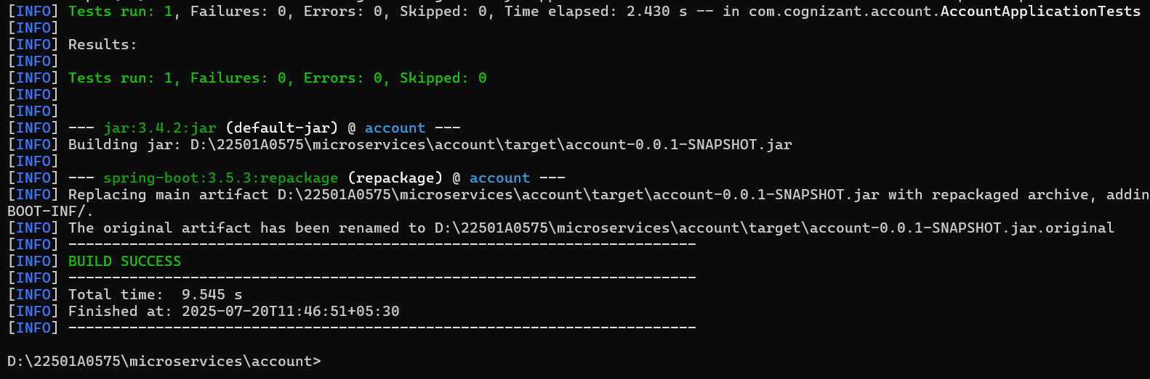

7. In Eclipse: File > Import > Maven > Existing Maven Projects,Select the extracted account folder.

Click Finish.

**AccountApplication.java:**

package com.cognizant.account;

import org.springframework.boot.SpringApplication;

import org.springframework.boot.autoconfigure.SpringBootApplication;

@SpringBootApplication

public class AccountApplication {

public static void main(String[] args) {

SpringApplication.*run*(AccountApplication.class, args);

}

}

**AccountController.java:**

package com.cognizant.account;

import org.springframework.web.bind.annotation.*;

import java.util.HashMap;

import java.util.Map;

@RestController

@RequestMapping("/accounts")

public class AccountController {

@GetMapping("/{number}")

public Map<String, Object> getAccountDetails(@PathVariable String number) {

Map<String, Object> response = new HashMap<>();

response.put("number", number);

response.put("type", "savings");

response.put("balance", 234343);

return response;

}

}

**Output:**

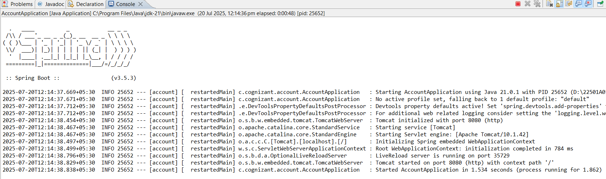

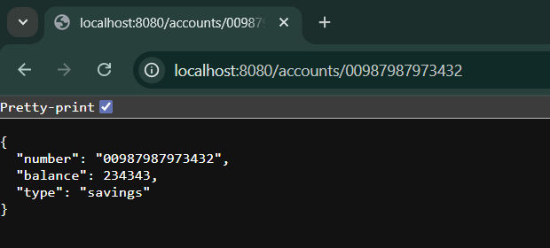

**Loan Microservice:**

1.Go to <https://start.spring.io/>

2.Fill in:

* + Group: com.cognizant
  + Artifact: loan

3.Add dependencies:

* + Spring Boot DevTools
  + Spring Web

4.Click Generate, then extract the downloaded ZIP to your Eclipse workspace folder.

5. Move the extracted folder (spring-learn) into ‘microservices’ folder in D drive.

6. Open Command Prompt or Terminal and navigate to the project folder and run following command:

mvn clean package

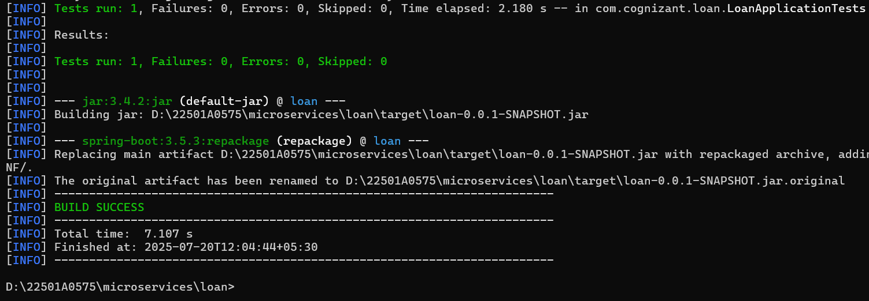

7. In Eclipse: File > Import > Maven > Existing Maven Projects,Select the extracted loan folder.

Click Finish.

**LoanApplication.java:**

package com.cognizant.loan;

import org.springframework.boot.SpringApplication;

import org.springframework.boot.autoconfigure.SpringBootApplication;

@SpringBootApplication

public class LoanApplication {

public static void main(String[] args) {

SpringApplication.*run*(LoanApplication.class, args);

}

}

**LoanController.java:**

package com.cognizant.loan;

import org.springframework.web.bind.annotation.*;

import java.util.HashMap;

import java.util.Map;

@RestController

@RequestMapping("/loans")

public class LoanController {

@GetMapping("/{number}")

public Map<String, Object> getLoanDetails(@PathVariable String number) {

Map<String, Object> response = new HashMap<>();

response.put("number", number);

response.put("type", "car");

response.put("loan", 400000);

response.put("emi", 3258);

response.put("tenure", 18);

return response;

}

}

**application.properties:**

spring.application.name=loan

server.port=8081

**Output:**

