**Exercise-1: “myfirstreact” App**

1. Install Nodejs and Npm.

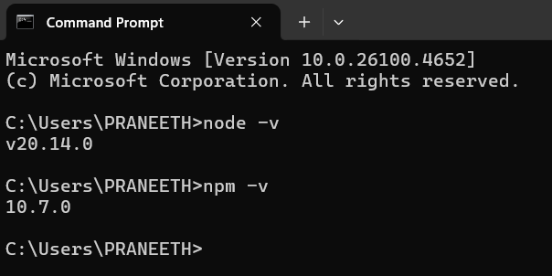

2. Install Create-react-app.

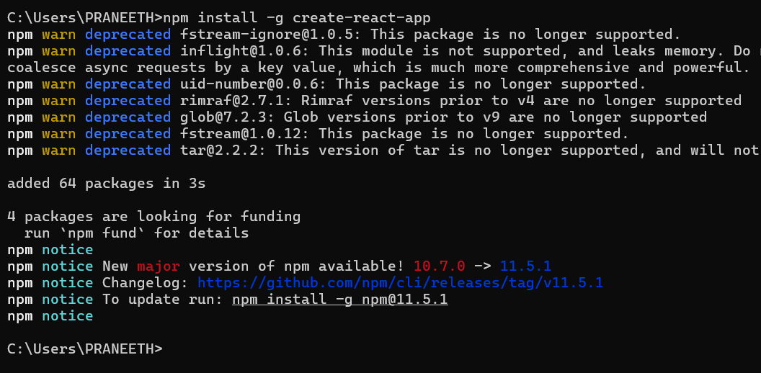

3. Create a React Application with the name of “myfirstreact”.

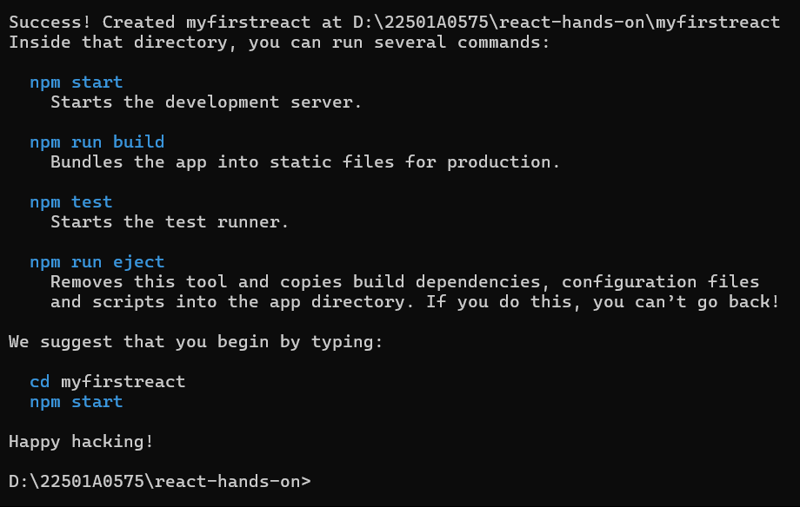

4. Open the folder of myfirstreact in Visual Studio Code

**App.js:**

import React from 'react';

function App() {

  return (

    <div>

      <h1>Welcome to the first session of React</h1>

    </div>

  );

}

export default App;

5. Run the application using “npm start” command.

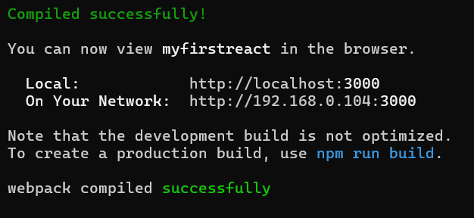

**Output:**

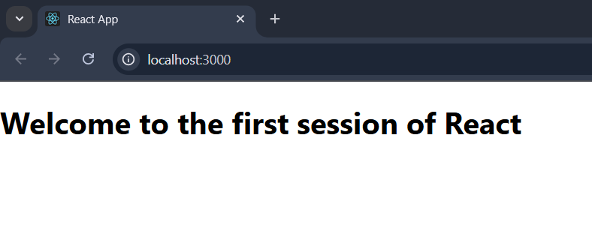

**Exercise-2: “StudentApp” App**

1. Create a React project named “studentapp”

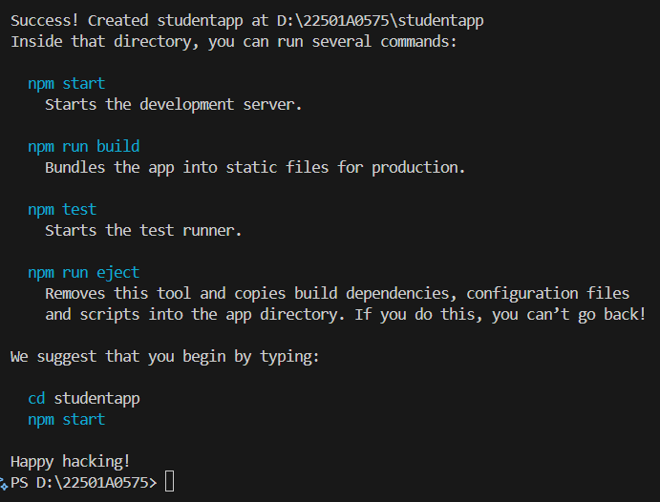

2. Create a new folder under src folder with the name “Components”. Add new files named “Home.js”, “About.js” and “Contact.js”.

**Home.js:**

import React, { Component } from 'react';

export class Home extends Component {

    render() {

        return (

            <div>

                <h3>Welcome to Home Page of Student Management Portal</h3>

            </div>

        );

    }

}

**About.js:**

import React, { Component } from 'react';

export class About extends Component {

  render() {

    return (

      <div>

        <h3>Welcome to the About page of the Student Management Portal</h3>

      </div>

    );

  }

}

**Contact.js:**

import React, { Component } from 'react';

export class Contact extends Component {

  render() {

    return (

      <div>

        <h3>Welcome to the Contact page of the Student Management Portal</h3>

      </div>

    );

  }

}

3. App.js:

import './App.css';

import {Home} from './Components/Home';

import {About} from './Components/About';

import {Contact} from './Components/Contact';

function App() {

  return (

    <div>

      <Home />

      <About />

      <Contact />

    </div>

  );

}

export default App;

4. Run the application using “npm start” command.

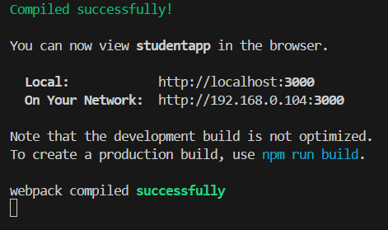

**Output:**

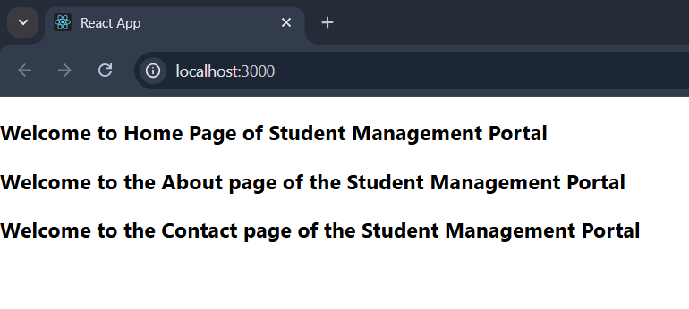

**Exercise-3: “scorecalculatorapp” App**

1. Create a React project named “scorecalculatorapp”.

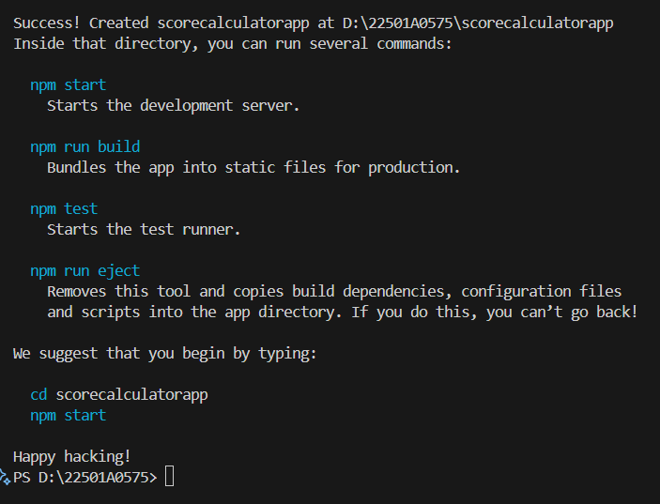

2. Create a new folder under src folder with the name “Components”. Add a new file named “CalculateScore.js”

**CalculateScore.js:**

import './Stylesheets/mystyle.css';

const percentToDecimal = (decimal) => {

  return (decimal.toFixed(2) + '%');

}

const calcScore = (total, goal) => {

  return percentToDecimal(total / goal);

}

export const CalculateScore = ({ Name, School, total, goal }) => (

  <div className="formatstyle">

    <h1><font color="Brown">Student Details:</font></h1>

    <div className="Name">

      <b><span>Name:</span></b>

      <span>{Name}</span>

    </div>

    <div className="School">

      <b><span>School:</span></b>

      <span>{School}</span>

    </div>

    <div className="Total">

      <b><span>Total:</span></b>

      <span>{total}</span>

      <span>Marks</span>

    </div>

    <div className="Score">

      <b>Score:</b>

      <span>{calcScore(total, goal)}</span>

    </div>

  </div>

);

3. Create a Folder named Stylesheets and add a file named “mystyle.css”

**mystyle.css:**

.Name {

    font-weight: 300;

    color: blue;

}

.School {

    color: crimson;

}

.Total {

    color: darkmagenta;

}

.formatstyle {

    text-align: center;

    font-size: large;

}

.Score {

    color: forestgreen;

}

**4. App.js:**

import { CalculateScore } from './src/components/CalculateScore';

function App() {

  return (

    <div>

      <CalculateScore

        Name={"Steeve"}

        School={"DNV Public School"}

        total={284}

        goal={3}

      />

    </div>

  );

}

export default App;

5. Run the application using “npm start” command.

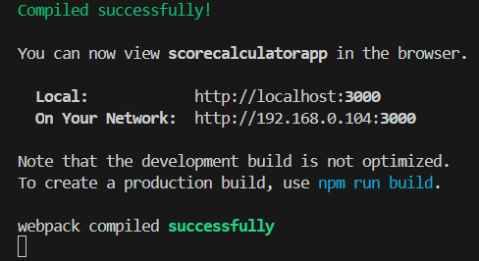

**Output:**

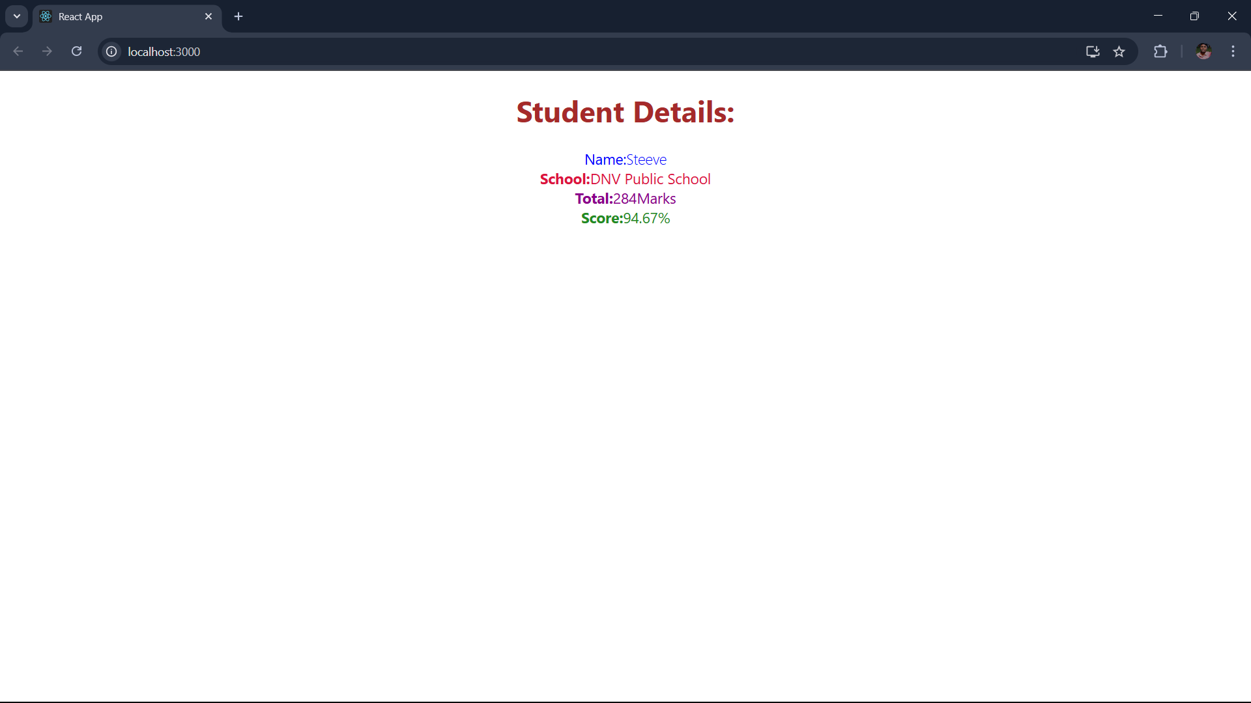

**Exercise-4: “blogapp” app**

1. Create a React project named “blogapp”.

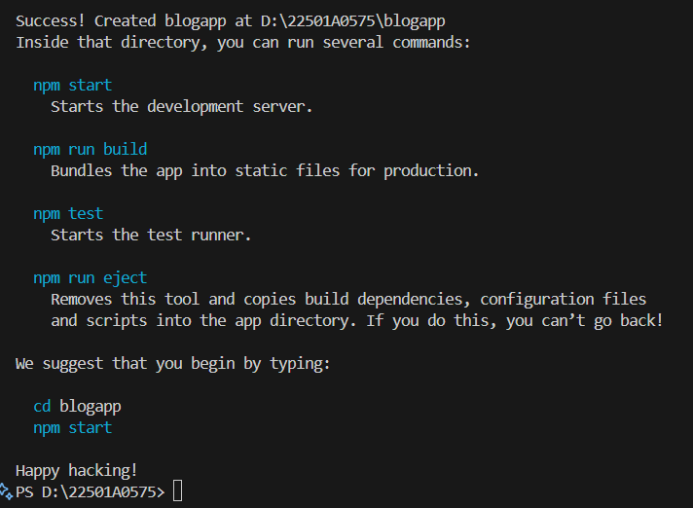

2. Create a new file named as Post.js in src folder

**Post.js:**

class Post {

  constructor(id, title, body) {

    this.id = id;

    this.title = title;

    this.body = body;

  }

}

export default Post;

3. Create a new file named as Posts.js in src folder

**Posts.js:**

import React from 'react';

import Post from './Post';

class Posts extends React.Component {

  constructor(props) {

    super(props);

    this.state = {

      posts: [],

      error: null

    };

  }

  loadPosts = () => {

    fetch('https://jsonplaceholder.typicode.com/posts')

      .then((response) => {

        if (!response.ok) {

          throw new Error('Failed to fetch posts');

        }

        return response.json();

      })

      .then((data) => {

        const posts = data.map(p => new Post(p.id, p.title, p.body));

        this.setState({ posts });

      })

      .catch((error) => {

        this.setState({ error });

      });

  };

  componentDidMount() {

    this.loadPosts();

  }

  componentDidCatch(error, info) {

    alert(`An error occurred: ${error.message}`);

    console.error('Caught error:', error, info);

  }

  render() {

    const { posts, error } = this.state;

    if (error) {

      return <p style={{ color: 'red' }}>Error loading posts: {error.message}</p>;

    }

    return (

      <div>

        <h2>Blog Posts</h2>

        {posts.map(post => (

          <div key={post.id} >

            <h3>{post.title}</h3>

            <p>{post.body}</p>

          </div>

        ))}

      </div>

    );

  }

}

export default Posts;

**4. App.js:**

import React from 'react';

import './App.css';

import Posts from './Posts';

function App() {

  return (

    <div className="App">

      <Posts />

    </div>

  );

}

export default App;

5. Run the application using “npm start” command.

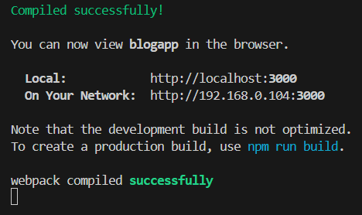

**Output:**

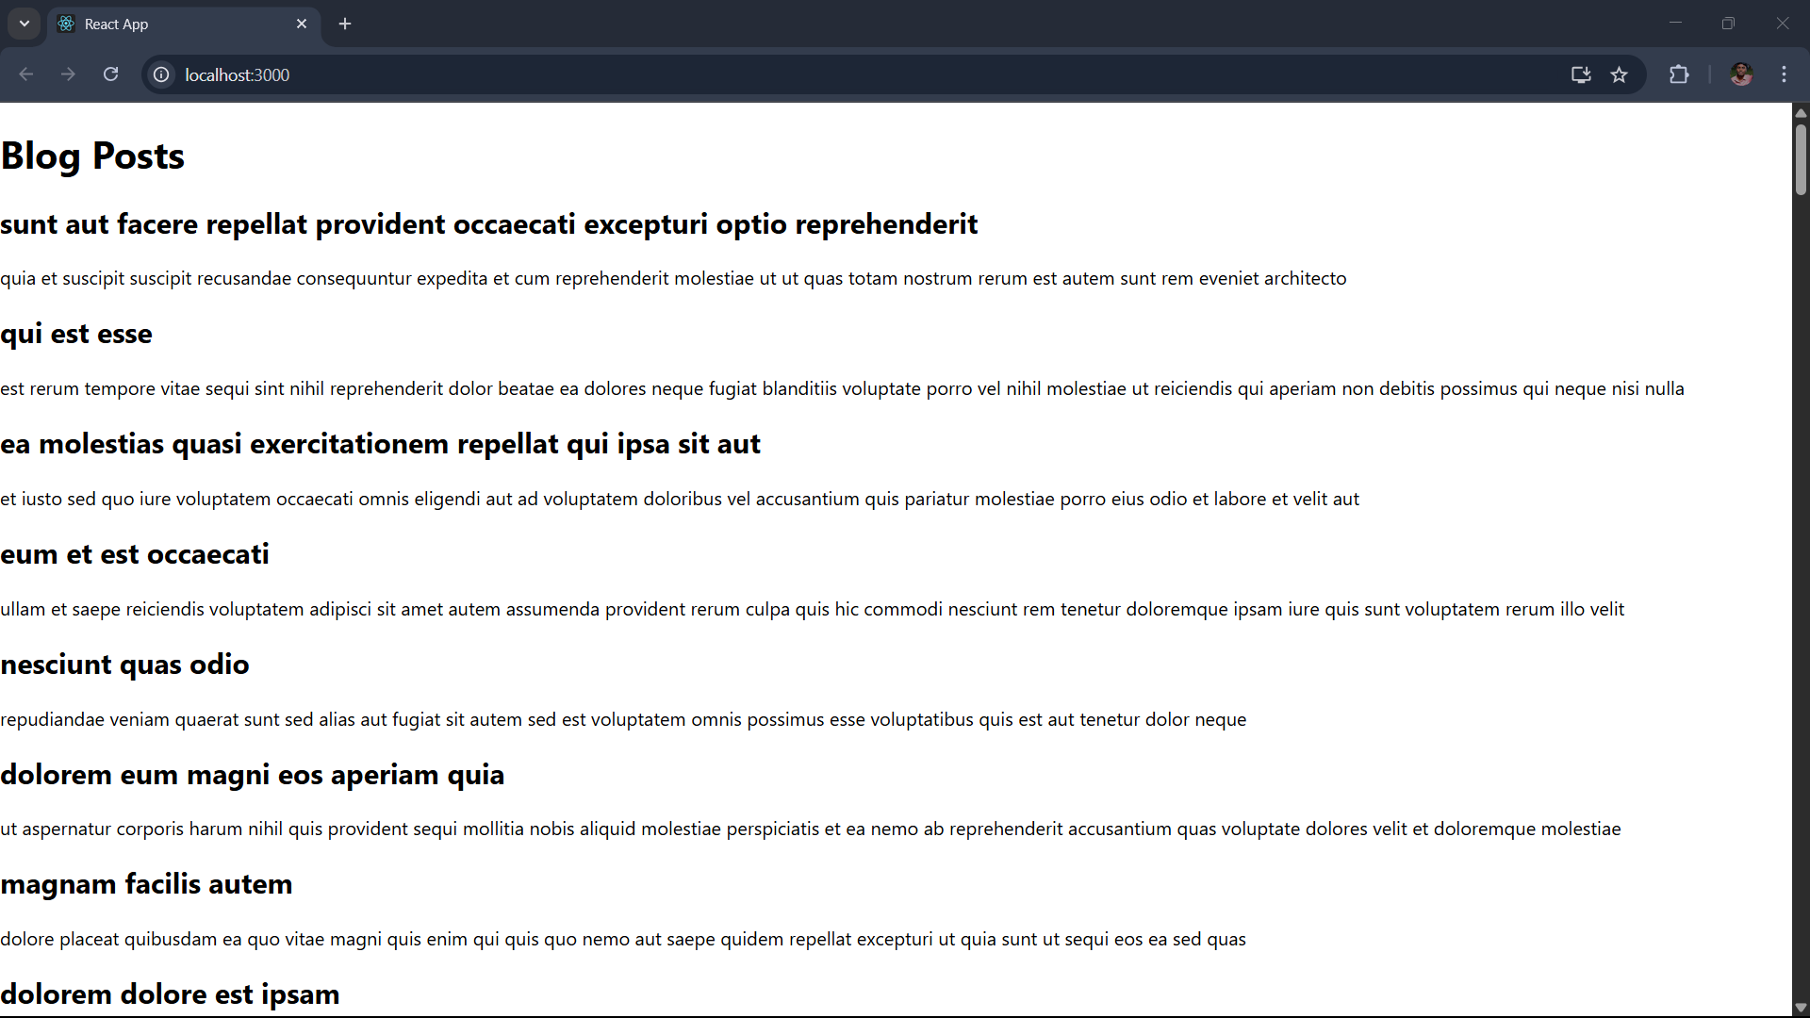

**Exercise-5: “cohorttracker” App**

1. Open Coharttracker App in VS Code and restore the node packages using “npm install”.

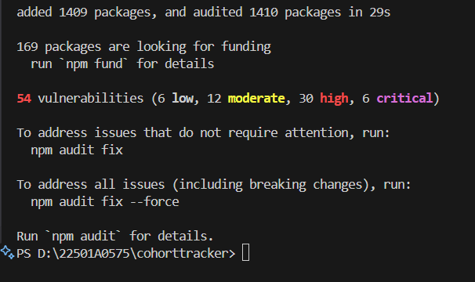

2. Create a new file called “CohortDetails.module.css” in src.

**CohortDetails.module.css:**

.box {

  width: 300px;

  display: inline-block;

  margin: 10px;

  padding: 10px 20px;

  border: 1px solid black;

  border-radius: 10px;

}

dt {

  font-weight: 500;

}

**3. CohartDetails.js:**

import styles from './CohortDetails.module.css';

function CohortDetails(props) {

    return (

        <div className={styles.box}>

            <h3 style={{ color: props.cohort.currentStatus === 'Ongoing' ? 'green' : 'blue' }}>

                {props.cohort.cohortCode} -

                <span>{props.cohort.technology}</span>

            </h3>

            <dl>

                <dt>Started On</dt>

                <dd>{props.cohort.startDate}</dd>

                <dt>Current Status</dt>

                <dd>{props.cohort.currentStatus}</dd>

                <dt>Coach</dt>

                <dd>{props.cohort.coachName}</dd>

                <dt>Trainer</dt>

                <dd>{props.cohort.trainerName}</dd>

            </dl>

        </div>

    );

}

export default CohortDetails;

4. Run the application using “npm start” command.

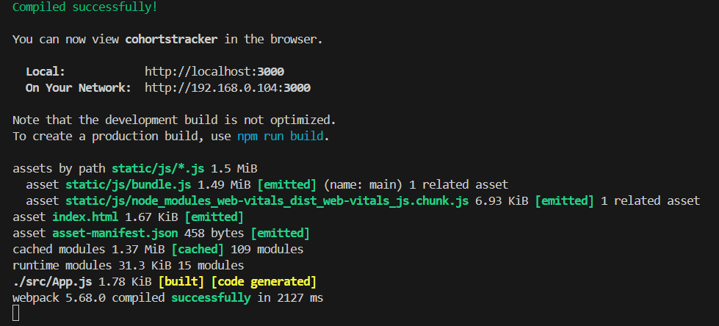

**Output:**

