**Exercise-9: “cricketapp”**

1. Create a React Application with the name of “cricketapp”.

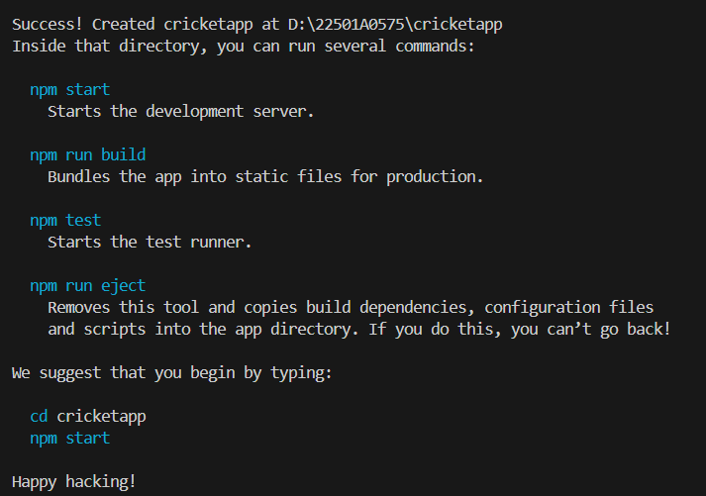

2. Create a new file under src folder named “ListofPlayers.js”.

**ListofPlayers.js:**

import React from "react";

const ListofPlayers = ({ players }) => (

  <ul>

    {players.map(player => (

      <li key={player.name}>

        {player.name} {player.score}

      </li>

    ))}

  </ul>

);

export default ListofPlayers;

3. Create a new file under src folder named “Scorebelow70.js” .

**Scorebelow70.js:**

import React from "react";

const Scorebelow70 = ({ players }) => {

  const filtered = players.filter(player => player.score < 70);

  return (

    <ul>

      {filtered.map(player => (

        <li key={player.name}>

          {player.name} {player.score}

        </li>

      ))}

    </ul>

  );

};

export default Scorebelow70;

4. Create a new file under src folder named “IndianPlayers.js”.

**IndianPlayers.js:**

import React from "react";

export function OddPlayers(IndianTeam) {

  const [first, second, third, fourth, fifth, sixth] = IndianTeam;

  return (

    <ul>

      <li>First: {first}</li>

      <li>Third: {third}</li>

      <li>Fifth: {fifth}</li>

    </ul>

  );

}

export function EvenPlayers(IndianTeam) {

  const [first, second, third, fourth, fifth, sixth] = IndianTeam;

  return (

    <ul>

      <li>Second: {second}</li>

      <li>Fourth: {fourth}</li>

      <li>Sixth: {sixth}</li>

    </ul>

  );

}

export function ListofIndianPlayers({ IndianPlayers }) {

  return (

    <ul>

      {IndianPlayers.map((player, idx) => (

        <li key={idx}>{player}</li>

      ))}

    </ul>

  );

}

5. In the src folder change the following file:

**App.js:**

import React from "react";

import ListofPlayers from "./ListofPlayers";

import Scorebelow70 from "./Scorebelow70";

import { OddPlayers, EvenPlayers, ListofIndianPlayers } from "./IndianPlayers";

function App() {

  var flag = true;

  const players = [

    { name: "Mr. Jack", score: 50 },

    { name: "Mr. Michael", score: 70 },

    { name: "Mr. John", score: 40 },

    { name: "Mr. Ann", score: 61 },

    { name: "Mr. Elisabeth", score: 61 },

    { name: "Mr. Sachin", score: 95 },

    { name: "Mr. Dhoni", score: 100 },

    { name: "Mr. Virat", score: 84 },

    { name: "Mr. Jadeja", score: 64 },

    { name: "Mr. Raina", score: 75 },

    { name: "Mr. Rohit", score: 80 },

  ];

  const IndianTeam = ["Sachin1","Dhoni2","Virat3","Rohit4","Yuvaraj5", "Raina6",];

  const T20players = ["Mr. First Player","Mr. Second Player","Mr. Third Player",];

  const RanjiTrophyPlayers = ["Mr. Fourth Player","Mr. Fifth Player","Mr. Sixth Player",];

  const IndianPlayers = [...T20players, ...RanjiTrophyPlayers];

  if (flag === true) {

    return (

      <div>

        <h1>List of Players</h1>

        <ListofPlayers players={players} />

        <h1>List of Players having Scores Less than 70</h1>

        <Scorebelow70 players={players} />

      </div>

    );

  } else {

    return (

      <div>

        <h1>Indian Team</h1>

        <h1>Odd Players</h1>

        {OddPlayers(IndianTeam)}

        <h1>Even Players</h1>

        {EvenPlayers(IndianTeam)}

        <h1>List of Indian Players Merged:</h1>

        <ListofIndianPlayers IndianPlayers={IndianPlayers} />

      </div>

    );

  }

}

export default App;

6. Run the application using “npm start” command.

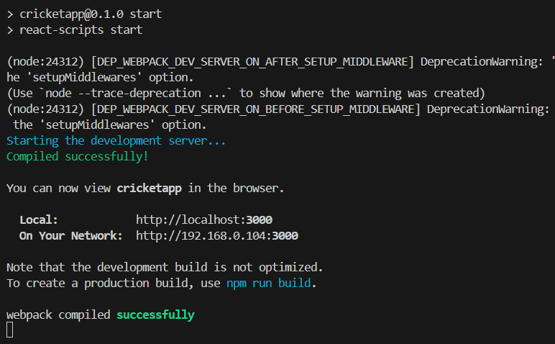

**Output:**

When flag=true

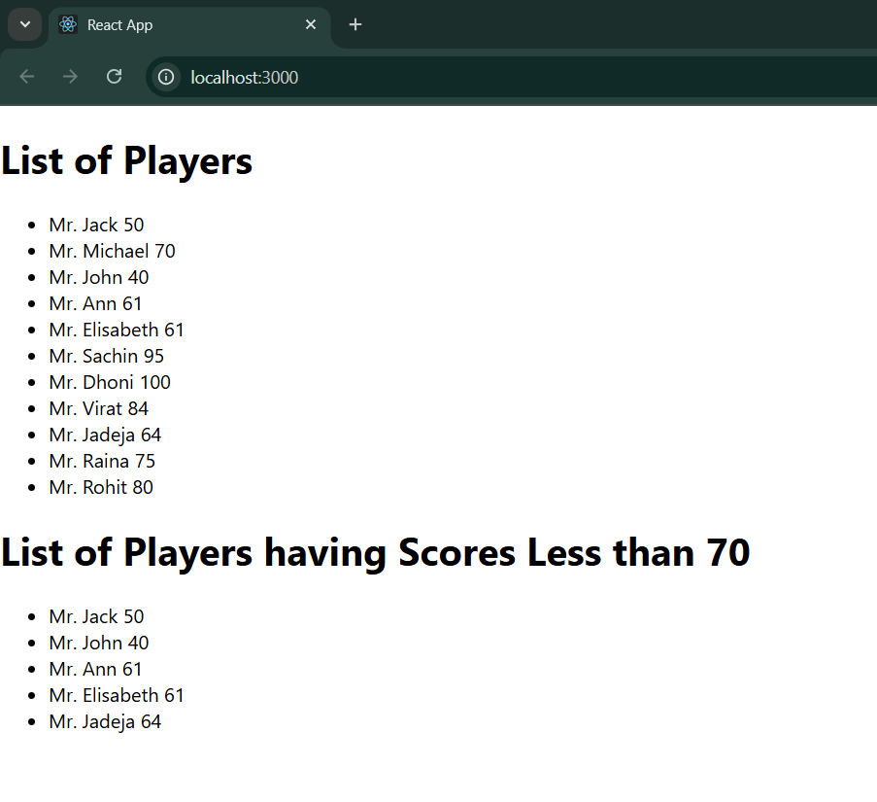

When flag=false

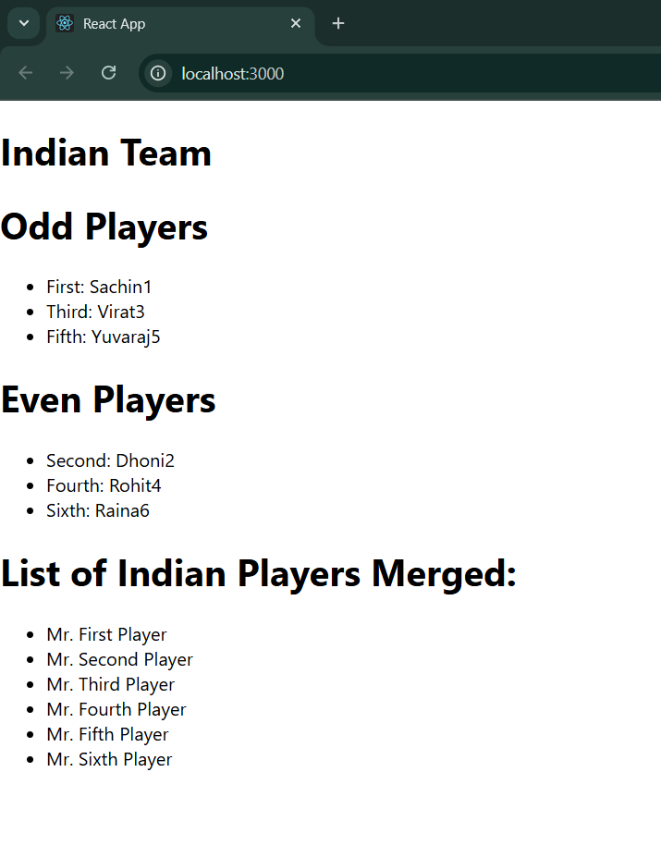

**Exercise-10: “officespacerentalapp”**

1. Create a React Application with the name of “cricketapp”.

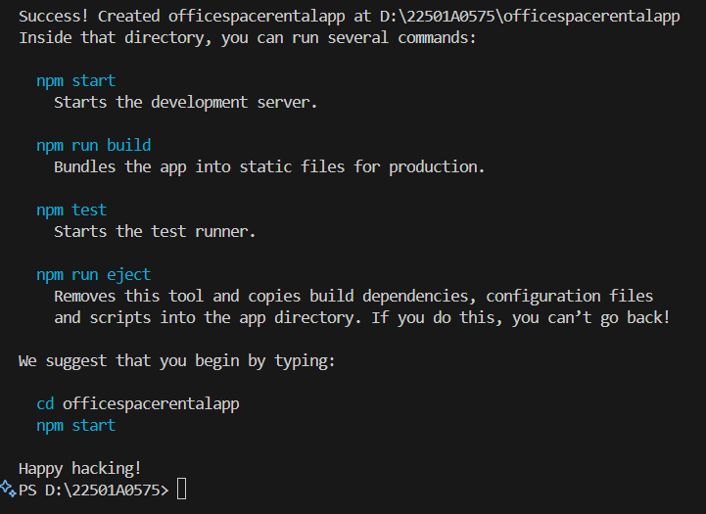

2. In the src folder change the following files:

**App.js:**

import React from "react";

import "./App.css";

import sr from "./office.jpg";

function App() {

  const element = "Office Space";

  const jsxatt = (

    <img src={sr} width="25%" height="25%" alt="Office Space" />

  );

  const ItemName = { Name: "DBS", Rent: 50000, Address: "Chennai" };

  let colors = [];

  if (ItemName.Rent <= 60000) {

    colors.push("textRed");

  } else {

    colors.push("textGreen");

  }

  const officeSpaces = [

    { Name: "DBS", Rent: 50000, Address: "Chennai" },

    { Name: "Hive", Rent: 65000, Address: "Bangalore" },

  ];

  function getRentClass(rent) {

    return rent <= 60000 ? "textRed" : "textGreen";

  }

  return (

    <div className="App">

      <h2>{element}, at Affordable Range</h2>

      {jsxatt}

      {officeSpaces.map((office, idx) => (

        <div key={idx}>

          <h2>Name: {office.Name}</h2>

          <h4 className={getRentClass(office.Rent)}>

            Rent: Rs. {office.Rent}

          </h4>

          <h4>Address: {office.Address}</h4>

        </div>

      ))}

    </div>

  );

}

export default App;

**App.css:**

.App{

  padding: 20px;

  margin-left: 40px;

}

.textRed {

  color: red;

}

.textGreen {

  color: green;

}

3. Run the application using “npm start” command.

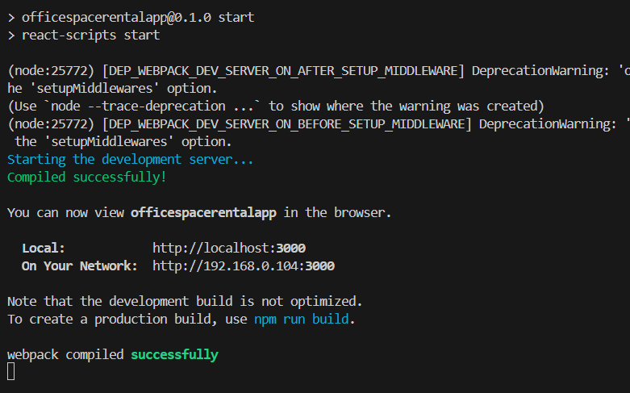

**Output:**

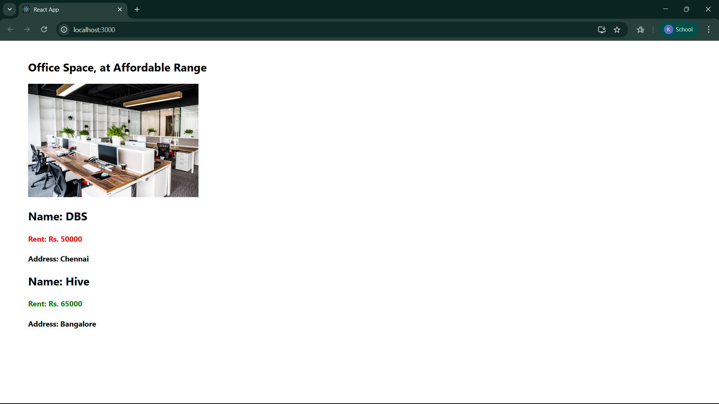

**Exercise-11: “eventexamplesapp”**

1. Create a React Application with the name of “eventexamplesapp”.

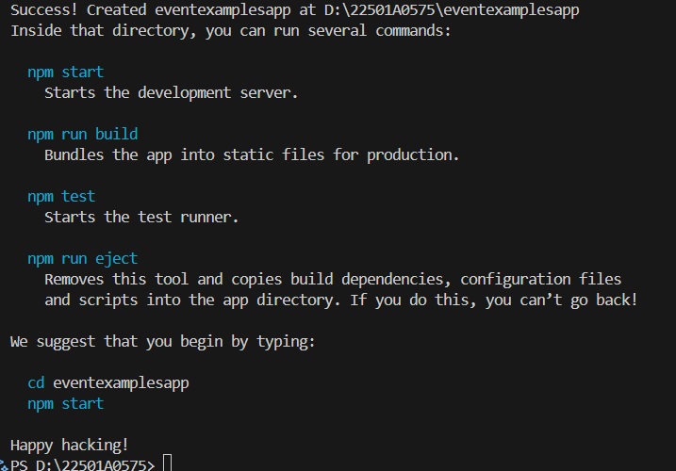

2. In the src folder change the following files:

**App.js:**

import React, { Component } from "react";

class App extends Component {

  constructor(props) {

    super(props);

    this.state = {

      count: 0,

      amount: "",

      currency: "",

      result: null,

    };

    this.handleIncrement = this.handleIncrement.bind(this);

    this.handleDecrement = this.handleDecrement.bind(this);

    this.sayWelcome = this.sayWelcome.bind(this);

    this.handleClickMe = this.handleClickMe.bind(this);

    this.handleAmountChange = this.handleAmountChange.bind(this);

    this.handleCurrencyChange = this.handleCurrencyChange.bind(this);

    this.handleSubmit = this.handleSubmit.bind(this);

  }

  handleIncrement() {

    this.setState(

      (prevState) => ({ count: prevState.count + 1 }),

      () => {

        alert("Hello Member");

      }

    );

  }

  handleDecrement() {

    this.setState((prevState) => ({ count: prevState.count - 1 }));

  }

  sayWelcome(msg) {

    alert(msg);

  }

  handleClickMe() {

    alert("I was clicked");

  }

  handleAmountChange(e) {

    this.setState({ amount: e.target.value });

  }

  handleCurrencyChange(e) {

    this.setState({ currency: e.target.value });

  }

  handleSubmit(e) {

    e.preventDefault();

    const { amount, currency } = this.state;

    if (currency.trim().toLowerCase() === "euro") {

      if (amount.trim() !== "" && !isNaN(amount)) {

        const euro = Number(amount) / 80;

        alert(`Converting to Euro amount: ${Math.round(euro)}`);

        this.setState({ result: Math.round(euro) });

      } else {

        alert("Please enter a valid amount");

      }

    } else {

      alert("Currency not supported");

    }

  }

  render() {

    const { count, amount, currency, result } = this.state;

    return (

      <div className="App" style={{ marginLeft: "40px", marginTop: "20px" }}>

        <p>{count}</p>

        <button onClick={this.handleIncrement}>Increment</button>

        <br />

        <button onClick={this.handleDecrement}>Decrement</button>

        <br />

        <button onClick={() => this.sayWelcome("welcome")}>Say welcome</button>

        <br />

        <button onClick={this.handleClickMe}>Click on me</button>

        <br />

        <br />

        <div>

          <h1 style={{ color: "green" }}>Currency Convertor!!!</h1>

          <form onSubmit={this.handleSubmit}>

            <label>Amount: </label>

            <input

              type="text"

              value={amount}

              onChange={this.handleAmountChange}

            />

            <br />

            <label>Currency: </label>

            <input

              type="text"

              value={currency}

              onChange={this.handleCurrencyChange}

            />

            <br />

            <input type="submit" value="Submit" />

          </form>

          {result !== null && <h4>Result: {result} Euro</h4>}

        </div>

      </div>

    );

  }

}

export default App;

3. Run the application using “npm start” command.

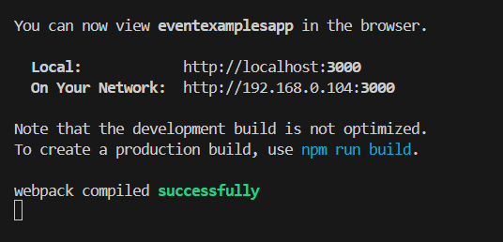

**Output:**

Increment:

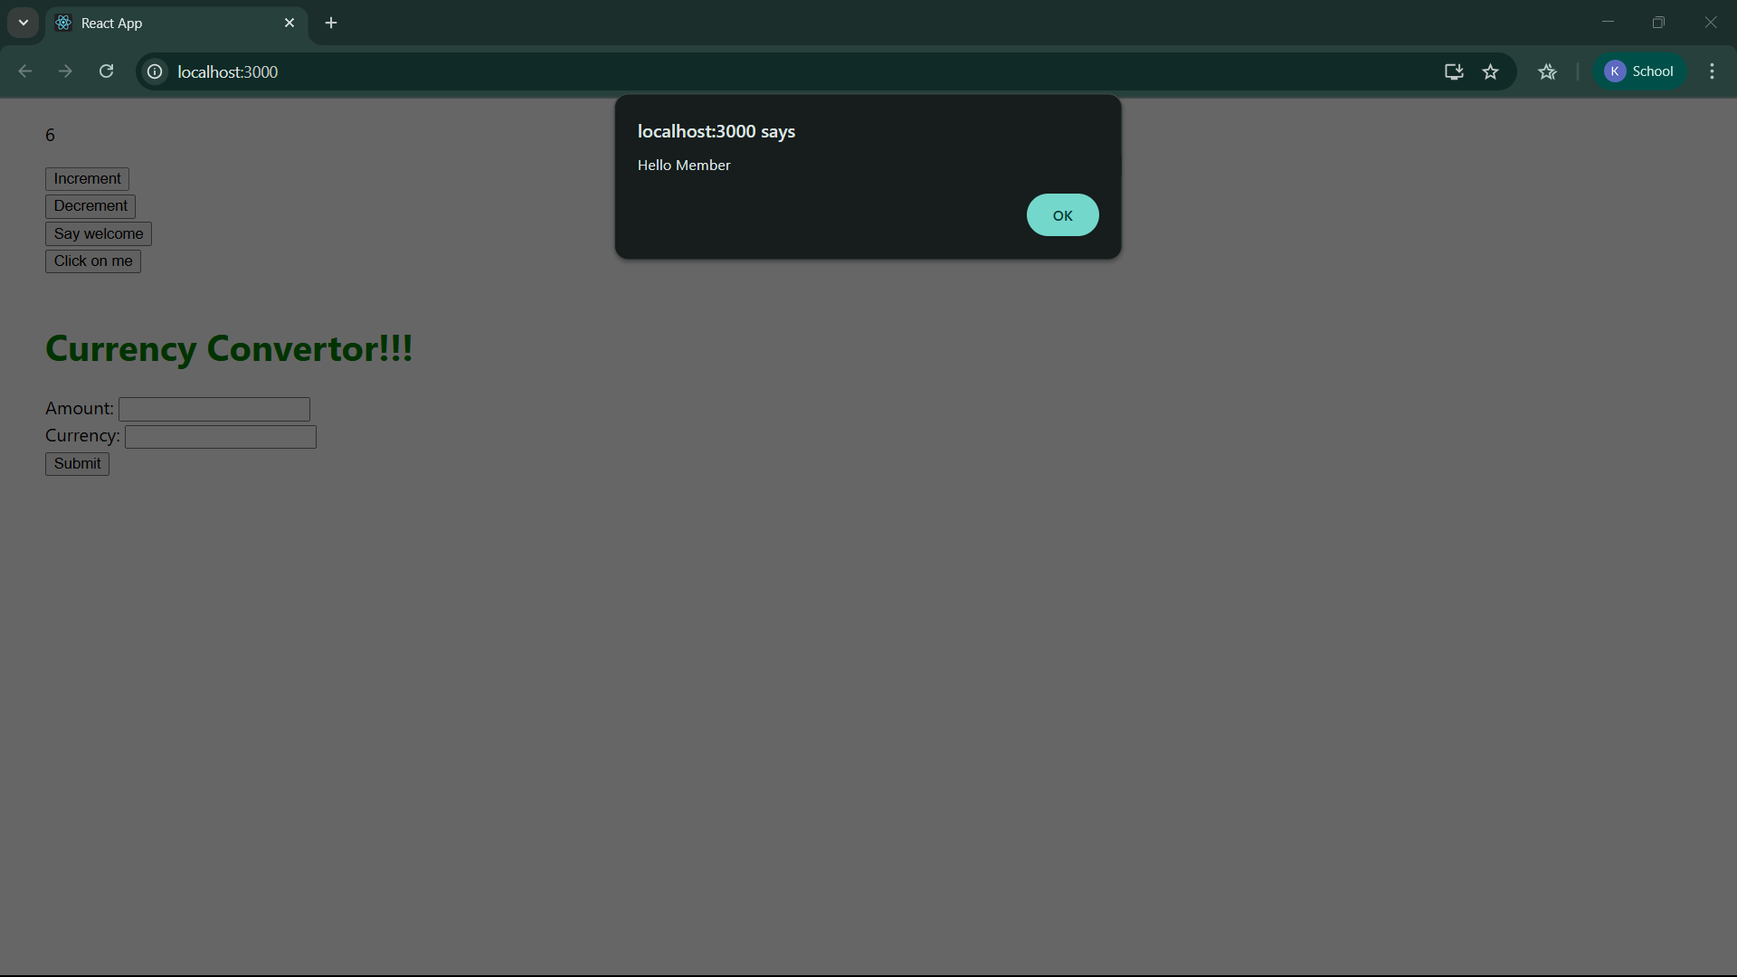

Decrement:

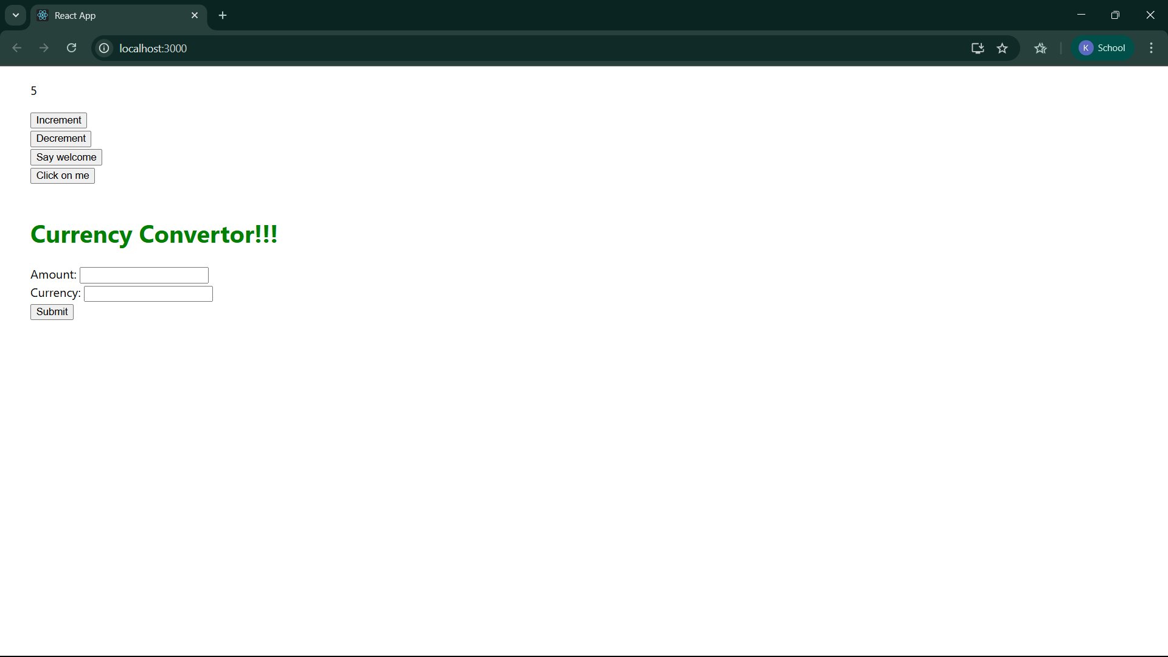

Say Welcome:

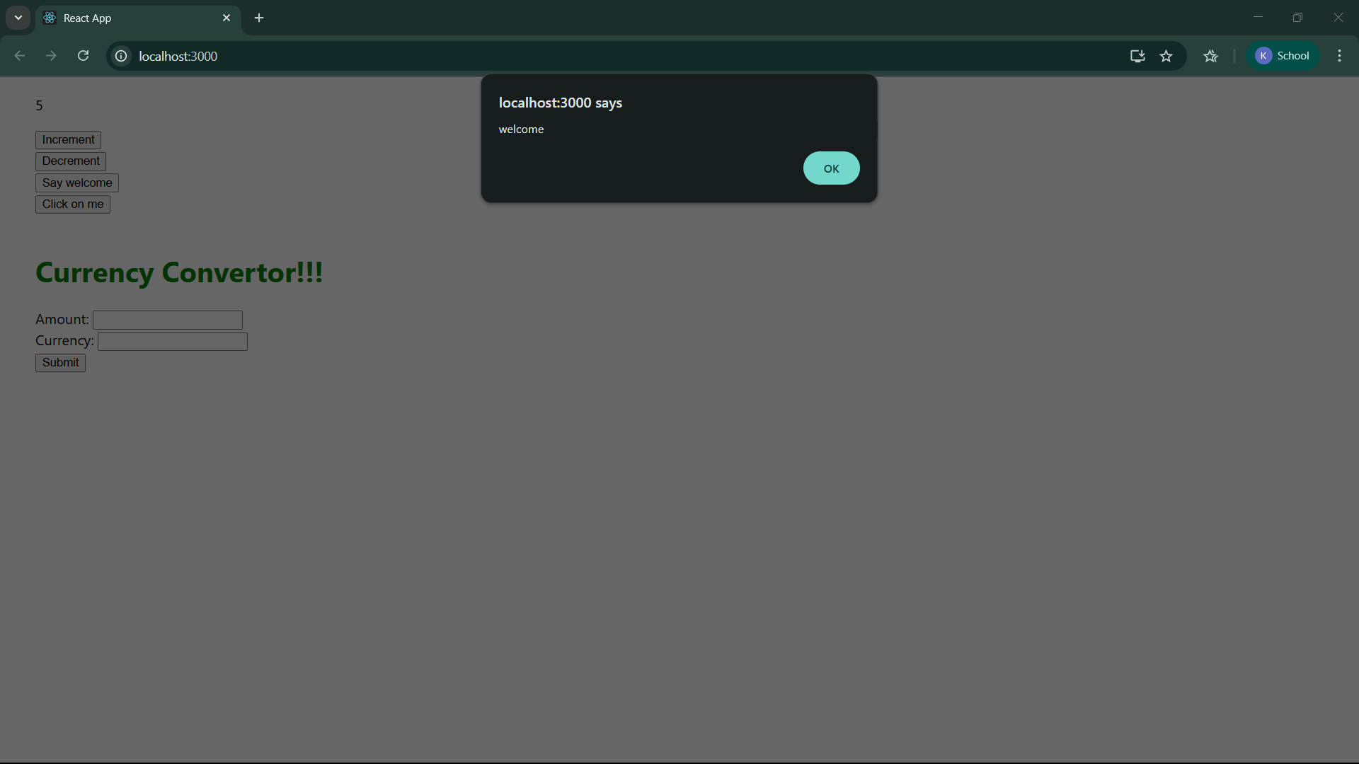

Click on me:

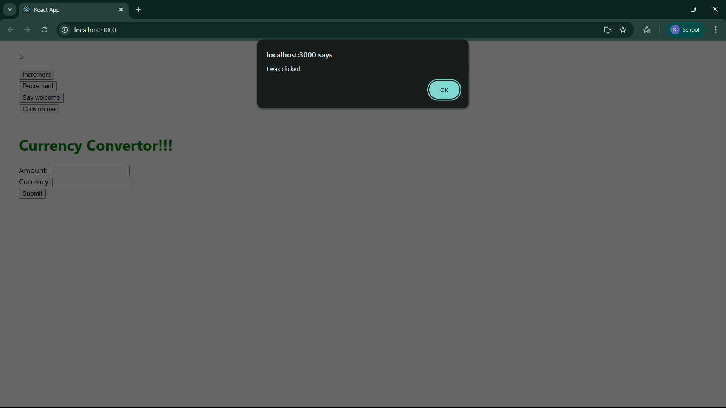

Currency Converter:

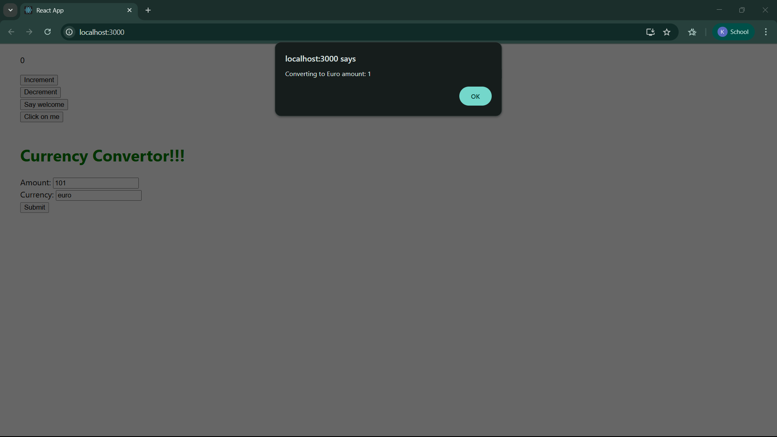

**Exercise-12: “ticketbookingapp”**

1. Create a React Application with the name of “ticketbookingapp”.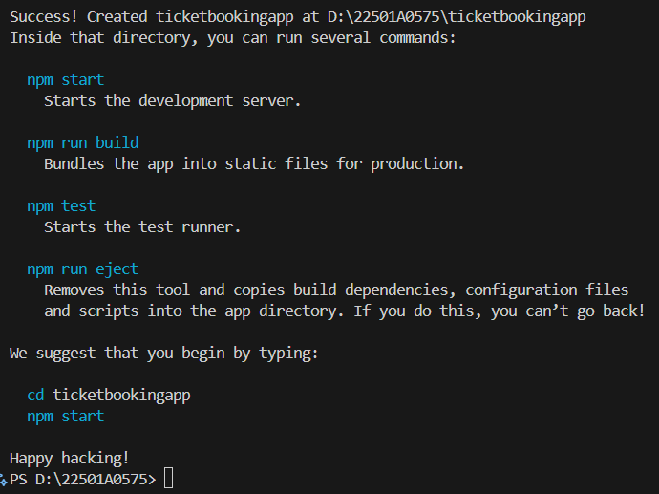

2. In the src folder create the following files:

**GuestGreeting.js:**

import React from "react";

function GuestGreeting() {

  return (

    <div>

      <h1>Please sign up.</h1>

    </div>

  );

}

export default GuestGreeting;

**UserGreeting.js:**

import React from "react";

function UserGreeting() {

  return (

    <div>

      <h1>Welcome back!</h1>

    </div>

  );

}

export default UserGreeting;

**LoginButton.js:**

import React from "react";

function LoginButton(props) {

  return <button onClick={props.onClick}>Login</button>;

}

export default LoginButton;

**LogoutButton.js:**

import React from "react";

function LogoutButton(props) {

  return <button onClick={props.onClick}>Logout</button>;

}

export default LogoutButton;

**Greeting.js:**

import React from "react";

import GuestGreeting from "./GuestGreeting";

import UserGreeting from "./UserGreeting";

function Greeting(props) {

  if (props.isLoggedIn) {

    return <UserGreeting />;

  }

  return <GuestGreeting />;

}

export default Greeting;

3. In the src folder change the following files:

**App.js:**

import React from "react";

import Greeting from "./Greeting";

import LoginButton from "./LoginButton";

import LogoutButton from "./LogoutButton";

import "./App.css";

class App extends React.Component {

  constructor(props) {

    super(props);

    this.state = {

      isLoggedIn: false,

    };

    this.handleLoginClick = this.handleLoginClick.bind(this);

    this.handleLogoutClick = this.handleLogoutClick.bind(this);

  }

  handleLoginClick() {

    this.setState({ isLoggedIn: true });

  }

  handleLogoutClick() {

    this.setState({ isLoggedIn: false });

  }

  render() {

    const isLoggedIn = this.state.isLoggedIn;

    let button;

    if (isLoggedIn) {

      button = <LogoutButton onClick={this.handleLogoutClick} />;

    } else {

      button = <LoginButton onClick={this.handleLoginClick} />;

    }

    return (

      <div className="App">

        <Greeting isLoggedIn={isLoggedIn} />

        {button}

      </div>

    );

  }

}

export default App;

**App.css:**

.App {

  padding: 100px 200px;

}

4. Run the application using “npm start” command.

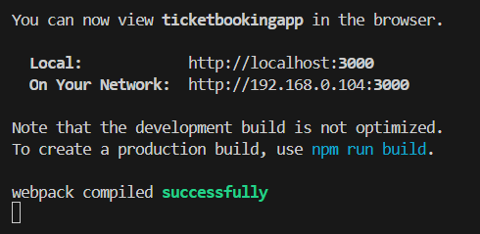

**Output:**

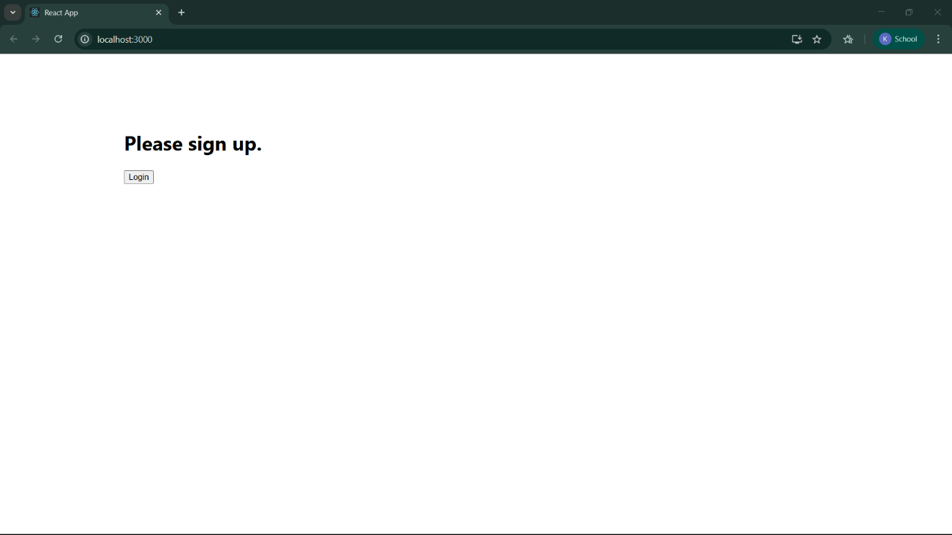

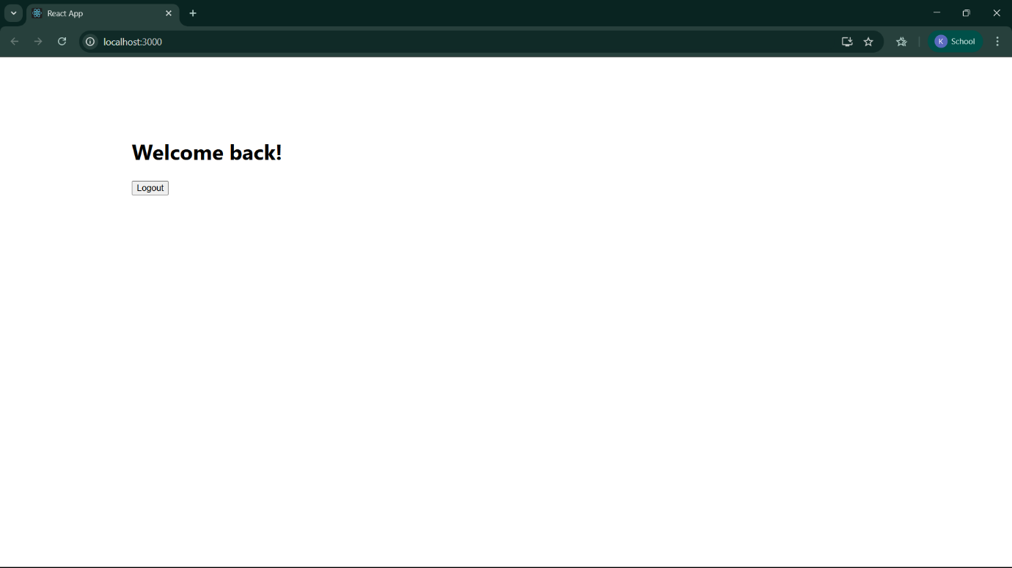

**Exercise-13: “bloggerapp”**

1. Create a React Application with the name of “bloggerapp”.

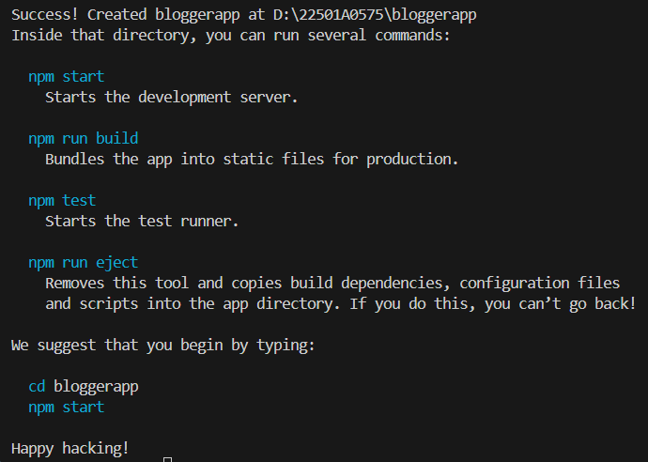

2. In the src folder create the following files:

**data.js:**

export const books = [

  { id: 101, bname: "Master React", price: 670 },

  { id: 102, bname: "Deep Dive into Angular 11", price: 800 },

  { id: 103, bname: "Mongo Essentials", price: 450 },

];

export const blogs = [

  {

    id: 1,

    title: "React Learning",

    author: 'Stephen Biz',

    content: "Welcome to learning React!",

  },

  {

    id: 2,

    title: 'Installation',

    author: 'Schezdenier',

    content: 'You can install React from npm.'

  },

];

export const courses = [

  { id: 301, cname: "Angular", date: "4/5/2021" },

  { id: 302, cname: "React Learning", date :"6/3/2021" },

];

3.In the src folder create a new folder components and in this create the following files:

**BookDetails.js:**

import React from "react";

function BookDetails({ books }) {

  return (

    <div>

      <h2>Book Details</h2>

      {books.map((book) => (

        <div key={book.id} style={{ marginBottom: "8px" }}>

          <h3>{book.bname}</h3>

          <p>Rs. {book.price}</p>

        </div>

      ))}

    </div>

  );

}

export default BookDetails;

**BlogDetails.js:**

import React from "react";

function BlogDetails({ blogs }) {

  return (

    <div>

      <h2>Blog Details</h2>

      {blogs.map((blog) => (

        <div key={blog.id}>

          <h3>{blog.title}</h3>

            {blog.author && <p><strong> {blog.author}</strong></p>}

          <p>{blog.content}</p>

        </div>

      ))}

    </div>

  );

}

export default BlogDetails;

**CourseDetails.js:**

import React from "react";

function CourseDetails({ courses }) {

  return (

    <div>

      <h2>Course Details</h2>

      {courses.map((course) => (

        <div key={course.id} style={{ marginBottom: "8px" }}>

          <h3>{course.cname}</h3>

          <p>{course.date}</p>

        </div>

      ))}

    </div>

  );

}

export default CourseDetails;

3.In the src folder change the following files:

**App.js:**

import React, { useState } from "react";

import CourseDetails from "./components/CourseDetails";

import BookDetails from "./components/BookDetails";

import BlogDetails from "./components/BlogDetails";

import { books, blogs, courses } from "./data";

import "./App.css";

function App() {

  const [show, setShow] = useState('all');

  const headings = {

    all: "Showing All Details",

    courses: "Showing Course Details",

    books: "Showing Book Details",

    blogs: "Showing Blog Details",

  };

  const renderCols = () => {

    return (

      <div className="grid-container">

        <div className="col">

          {(show === "all" || show === "courses") && <CourseDetails courses={courses} />}

        </div>

        <div className="col">

          {(show === "all" || show === "books") && <BookDetails books={books} />}

        </div>

        <div className="col">

          {(show === "all" || show === "blogs") && <BlogDetails blogs={blogs} />}

        </div>

      </div>

    );

  };

  return (

    <div>

      <div className="controls">

        <button onClick={() => setShow("all")}>Show All</button>

        <button onClick={() => setShow("courses")}>Show Courses</button>

        <button onClick={() => setShow("books")}>Show Books</button>

        <button onClick={() => setShow("blogs")}>Show Blogs</button>

      </div>

      <h1 className="center-heading">{headings[show]}</h1>

      {renderCols()}

    </div>

  );

}

export default App;

**App.css:**

.controls {

  display: flex;

  justify-content: center;

  gap: 1em;

  margin-bottom: 30px;

  margin-top: 30px;

}

.center-heading {

  text-align: center;

}

.grid-container {

  display: flex;

  justify-content: center;

  gap: 50px;

  align-items: flex-start;

}

.col {

  min-width: 200px;

  border-left: 2px solid #2c2;

  padding-left: 20px;

  min-height: 300px;

}

4. Run the application using “npm start” command.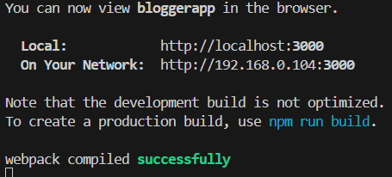

**Output:**

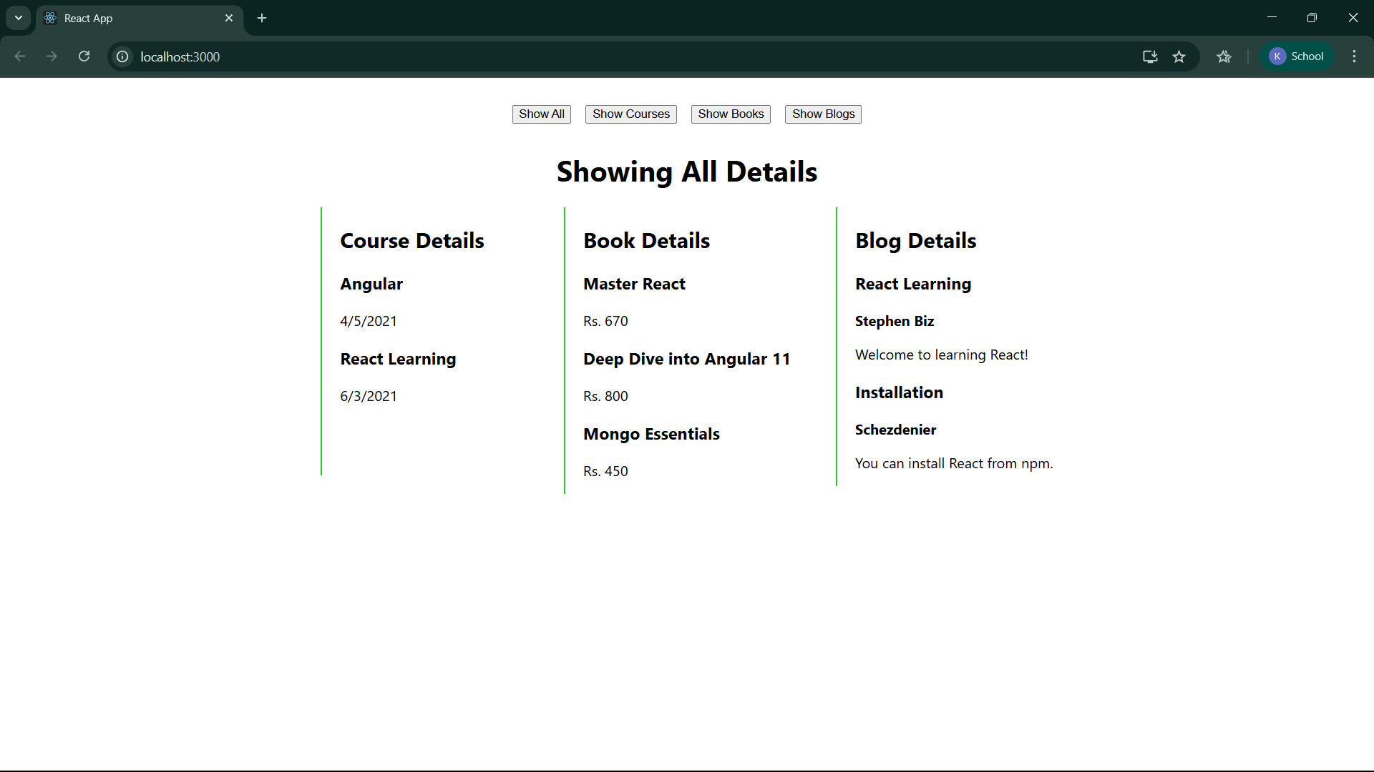

Show Courses clicked:

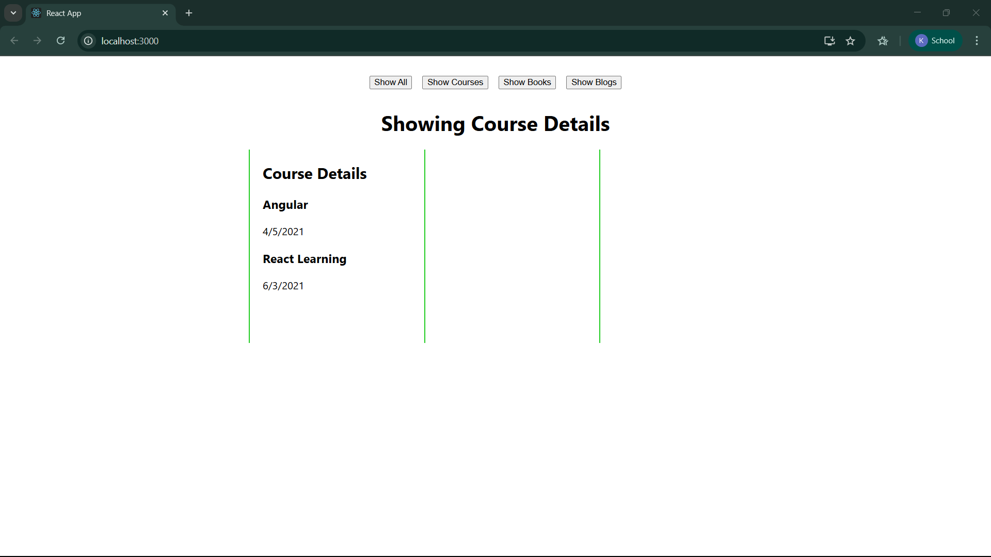

Show Books clicked:

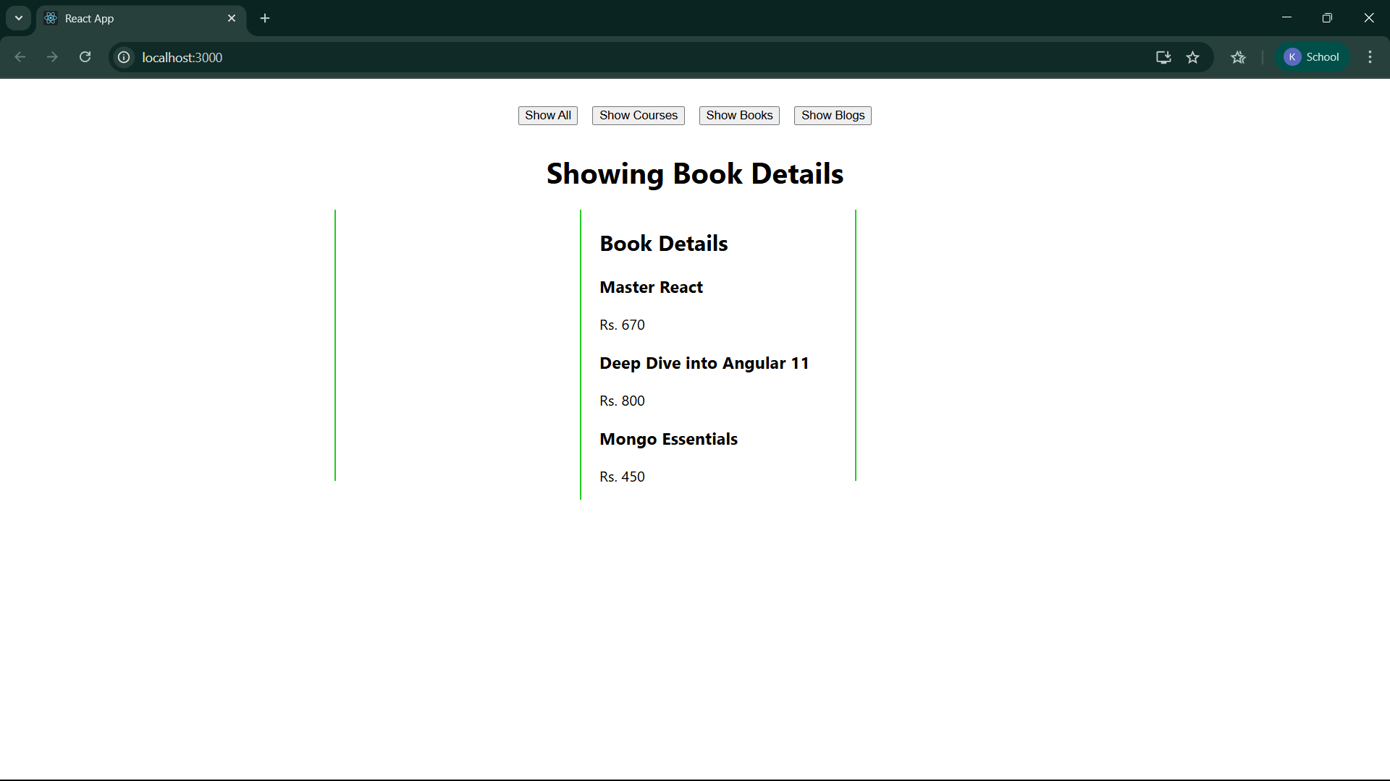

Show Blogs clicked:

