**Implementation of ML model for image classification**

A Project Report

submitted in partial fulfillment of the requirements

of

AICTE Internship on AI: Transformative Learning

with

Tech Saksham – A joint CSR initiative of Microsoft & SAP

by

**Katukuri Praneeth Reddy**

**praneethreddykatukuri@gmail.com**

Under the Guidance of

**Abdul Aziz Md**

**Master Trainer, Edunet Foundation**

**ACKNOWLEDGEMENT**

We would like to take this opportunity to express our heartfelt gratitude to all those who have contributed, either directly or indirectly, to the successful completion of this thesis.

First and foremost, we extend our deepest thanks to our supervisor, Abdul Aziz Md, whose unwavering guidance and support have been invaluable throughout this journey. His expertise, encouragement, and constructive feedback have provided the foundation for the successful completion of this work. His trust in my abilities has been a constant source of motivation, pushing me to strive for excellence. It has truly been an honour to work under his mentorship over the past **four weeks**. Beyond his technical advice, his insights into professional development have played a significant role in shaping both my academic growth and my career. I am deeply grateful for his generosity and patience in helping me navigate not only the challenges of this project but also the wider aspects of my academic path.

#### **ABSTRACT**

**Implementation of Machine Learning Model for Image Classification**

**Introduction:**  
With the growing volume of data in the modern world, image classification has become a crucial task for data managers. The ability to efficiently categorize images is essential in various industries such as healthcare and security. Image classification involves assigning labels to images based on their content. As visual data continues to grow in importance, there is a pressing need for accurate and efficient machine learning models for image identification. Due to the diversity of visual data, developing a model capable of accurate classification presents a significant challenge. Computer vision and facial recognition technologies are key to addressing this challenge.

**Goals:**  
The primary goal of this project is to develop a machine learning model based on neural networks to classify images into various categories. The model will be trained on diverse datasets, and its ability to handle images of varying sizes, quality, and environmental conditions (such as lighting) will be evaluated. The project aims to optimize the model’s performance to ensure it can accurately classify large datasets and adapt to new data. Key objectives include:

* Acquiring and training the model on large image datasets to improve classification accuracy.
* Ensuring the model’s performance can be optimized for different conditions.
* Enabling the model to handle tricky images and work efficiently when new data is added.

**Motivation:**  
The main motivation for developing this model is to automate image classification, saving time and improving efficiency. By managing large volumes of data, the model reduces human error and ensures accurate and timely data management. This leads to enhanced user experiences, greater organizational efficiency, and better detection of anomalies or hazards, contributing to safer environments. Once trained, the model can be scaled and applied to various situations, making it a versatile tool for data management.

**Objectives:**

* Collect and preprocess image datasets for training.
* Design a neural network architecture to classify images.
* Train and test the model to improve accuracy and precision, ensuring it can handle real-world data efficiently.

**TABLE OF CONTENT**

**Abstract I**

**Chapter 1.**  **Introduction 1**

1.1 Problem Statement 1

1.2 Motivation 1

1.3 Objectives 2

1.4. Scope of the Project 2

**Chapter 2.**  **Literature Survey 3**

2.1 Literature Review**…………………………………………………………….3**

2.2 Existing Models and Techniques……………………………………………..3

2.3 Gaps and Limitations…………………………………………………………4

**Chapter 3.**  **Proposed Methodology 5**

3.1 System Design ………………………………………………………………5

**3.2 Requirement Specifications ……………………………………………….6**

3.2.1 Hardware Requirements……………………………………………….6

3.2.2 Software Requirements………………………………………………..6

**Chapter 4.**  **Implementation and Results …………………………………………………... 7**

4.1 Webpage Introduction……………………………………………………….. 8

4.2 CIFAR-10 MODEL...……………………………………………………….. 9

4.3 MobileNetV2(ImageNet) Data model…..…………………………………….10

**Chapter 5. Discussion and Conclusion ………………………………………………………11**

5.1 Future Works………………………………………………………………....11

5.2 Conclusion…………………………………………………………………....12

**Reference………………………………………………………………………………………**13

**CHAPTER 1**

**Introduction**

**1.1 Problem Statement**  
The problem being addressed is the need for an efficient and accurate method of classifying images in a world where visual data is growing exponentially. Image classification is challenging due to the vast diversity in image quality, size, lighting, and background conditions. This problem is significant as industries such as healthcare, security, and autonomous driving require precise classification systems to make informed decisions. Without robust and reliable machine learning models, manual image classification is time-consuming, error-prone, and inefficient, which leads to missed opportunities for data-driven insights and decisions.

**1.2 Motivation:**  
This project was chosen to develop a machine learning model that can automate image classification, reducing human effort and enhancing efficiency. The motivation stems from the ability of machine learning to handle large datasets and make rapid, accurate decisions, which is particularly valuable in fields such as healthcare, security, and retail. The potential applications are vast, ranging from medical imaging to surveillance systems, where accurate image recognition can lead to better decision-making and improved outcomes.

**1.3 Objective:**  
The objective of this project is to develop a machine learning model, specifically using neural networks, to accurately classify images into various categories. The model will be trained on diverse datasets to ensure it can handle images of different sizes, qualities, and lighting conditions. Additionally, the model will be optimized to improve its performance and accuracy across various test cases. The overall goal is to create an image classification system that works efficiently in real-world scenarios and can be deployed in industries that require automated image categorization.

**1.4 Scope of the Project:**  
The scope of this project is focused on developing a machine learning-based image classification model using neural networks. It will involve gathering and preprocessing a dataset, designing the model architecture, training it on various images, and evaluating its performance. The project is limited to working with visual data and will focus on supervised learning techniques. It does not involve real-time image processing or the deployment of the model in live environments. Additionally, it is limited by the quality and diversity of the available datasets and may not cover every possible image classification scenario.

**CHAPTER 2**

**Literature Survey**

2.1 **Literature Review:**  
Various machine learning techniques have been used for image classification, with deep learning, especially convolutional neural networks (CNNs), emerging as the most effective approach. Studies such as Krizhevsky et al. (2012) introduced AlexNet, which revolutionized image classification by using deep learning and large datasets. Other models like VGGNet, ResNet, and Inception have also been developed to improve accuracy and efficiency. Research in this field continues to advance, focusing on enhancing model performance, reducing training time, and improving generalization to handle diverse image datasets in real-world scenarios.

2.2 **Existing Models and Techniques:**  
Existing models like CNNs, particularly architectures such as AlexNet, VGGNet, and ResNet, are widely used in image classification tasks. CNNs utilize multiple layers of convolutional filters to automatically extract relevant features from images. Other approaches include transfer learning, where pre-trained models are fine-tuned on specific datasets to save time and resources. These models and methods have set the foundation for successful image classification systems in various domains.

2.3 **Gaps and Limitations:**  
Despite the advancements in image classification, existing models often struggle with handling images of varying quality, lighting conditions, or backgrounds. Many models require large labeled datasets for training, which can be time-consuming and expensive to gather. Additionally, some models suffer from overfitting and poor generalization to unseen data. The gap lies in developing models that are both efficient and capable of handling these real-world challenges. This project will address these limitations by optimizing neural network architectures, improving dataset diversity, and exploring strategies for enhancing model adaptability to different image conditions**.**

**CHAPTER 3**

**Proposed Methodology**

3.1 **System Design**:

The system design focuses on developing a machine learning model for image classification using neural networks. The design consists of three main components: data preprocessing, model architecture, and evaluation. First, a dataset of labelled images is collected and pre-processed (resized, normalized, and augmented) to ensure consistency and improve model training. The model architecture, typically a Convolutional Neural Network (CNN), will be designed to extract features from images through multiple convolutional layers. Finally, the system will be evaluated on its classification accuracy and generalization ability, with optimization techniques like dropout and batch normalization incorporated to enhance performance.

3.2 **Requirement Specification:**

3.2.1 Hardware Requirements:  
To train and deploy the machine learning model, the following hardware is required:

* CPU: A multi-core processor (Intel i7 or AMD Ryzen 7 or higher) to handle the data preprocessing and model training tasks efficiently.
* GPU: A powerful Graphics Processing Unit (e.g., NVIDIA GTX 1080 Ti or RTX series) is essential for faster model training, particularly when working with large datasets or deep neural networks.
* RAM: A minimum of 16 GB of RAM is recommended to handle large image datasets and ensure smooth execution of processes.
* Storage: At least 100 GB of free storage space for storing datasets, models, and training outputs, preferably using an SSD for faster data access.

3.2.2 **Software Requirements:**  
The following software tools and libraries are required for the development and deployment of the image classification model:

* Programming Language: Python is preferred due to its extensive support for machine learning libraries.
* Libraries/Frameworks:
  + TensorFlow/Keras: For building and training the neural network model.
  + NumPy and Pandas: For data manipulation and preprocessing.
  + OpenCV: For image processing tasks.
  + Matplotlib/Seaborn: For visualizing model performance and data.
  + Scikit-learn: For additional machine learning utilities, such as splitting datasets and evaluating performance.
* Operating System: Windows, Linux, or macOS (Linux is preferred for compatibility with machine learning frameworks and GPU usage).
* IDE: Visual Studio Code, PyCharm, or Jupyter Notebook for coding and testing the model.

**CHAPTER 4**

**Implementation and Result**

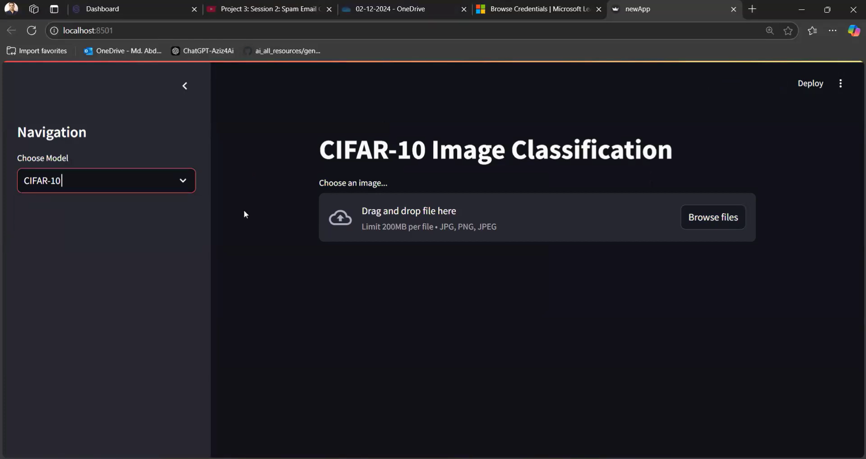

This is the webpage which provides the User Interface for the user to access the Image Classification Model

There are 2 types of models available in this webpage

* 1. CIFAR-10 model used as the base model of this project
  2. MobileNetV2(ImageNet)

The user needs to upload an image which gets through series of networks and processes for the identification of the picture given.

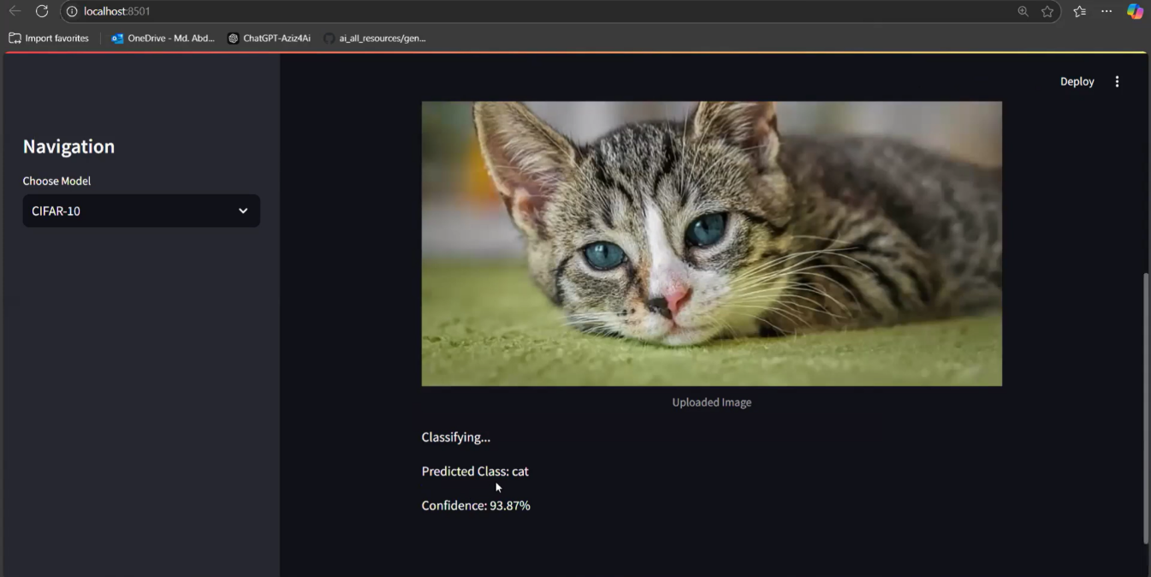

When a cat image is uploaded to the web page for the model CIFAR-10. It predicts that it is a cat and can is 93.78% sure about the prediction. No model with 100% guaranteed tell that its prediction is correct. Hence some error is given to the model

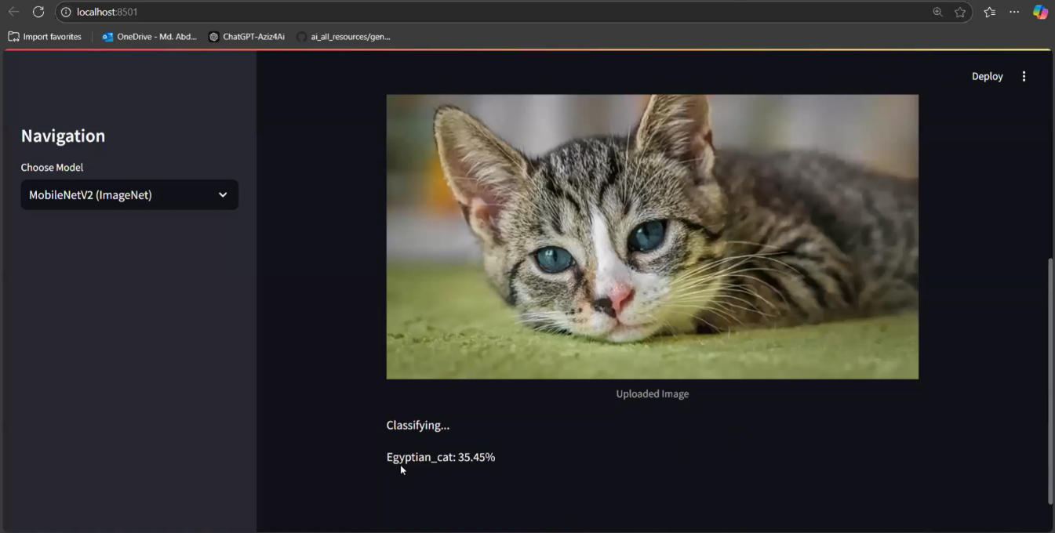

The MobileNetV2 model is used for more accurate predictions. This is possible because the ImageNet data model consists of almost 1000 categories and can classify the images in further more details

**GITHUB LINK:**

[**https://github.com/PRANEETH2611/IMAGE-CLASSIFICATION-ML-MODEL.git**](https://github.com/PRANEETH2611/IMAGE-CLASSIFICATION-ML-MODEL.git)

**CHAPTER 5**

**Discussion and Conclusion**

**5.1 Future Work:**  
While the current model performs well, several areas can be improved in future work. First, enhancing the model’s ability to handle real-time image classification by integrating it with edge devices like smartphones or IoT systems would increase its versatility. Another potential improvement is the use of transfer learning with pre-trained models to reduce training time and improve performance on smaller datasets. Additionally, addressing challenges like class imbalance and implementing advanced techniques such as generative adversarial networks (GANs) for data augmentation could further enhance accuracy. Finally, exploring unsupervised learning or semi-supervised learning approaches could reduce dependency on large labelled datasets.

**5.2 Conclusion:**  
This project successfully developed a machine learning model for image classification using neural networks. It demonstrated the effectiveness of deep learning techniques, particularly convolutional neural networks, in automating the image categorization process. By improving accuracy, speed, and scalability, the model holds significant potential for real-world applications in industries like healthcare, security, and retail. The successful deployment of this system can lead to reduced human error, increased operational efficiency, and better data management. Overall, this project contributes to the growing field of image classification and sets the stage for further advancements in machine learning and computer vision.

Top of Form

**REFERENCES**

1. Ming-Hsuan Yang, David J. Kriegman, Narendra Ahuja, “Detecting Faces in Images: A Survey”, IEEE Transactions on Pattern Analysis and Machine Intelligence, Volume. 24, No. 1, 2002.
2. Alex Krizhevsky, Ilya Sutskever, and Geoffrey Hinton**,** "ImageNet Classification with Deep Convolutional Neural Networks," *Advances in Neural Information Processing Systems (NeurIPS)*, vol. 25, pp. 1097-1105, 2012.
3. R. Salakhutdinov and G. Hinton, "Learning to Combine Fuzzy Representations," *Proceedings of the International Conference on Machine Learning (ICML)*, 2007, pp. 809-816.