Yuva Intern – Logistics Data Analyst Internship
Week 3 Task: Advanced Data Analysis and Visualization in Logistics
Student Name: K.PRANEETH RAJ
Analysis based on a hypothetical logistics dataset | Python + Pandas + Matplotlib

1. Executive Summary
This project demonstrates how exploratory data analysis (EDA) and visualization can be used to understand logistics performance. A hypothetical dataset of 500 shipments was created with variables for dates, regions, transport modes, distance, shipment volume, promised delivery time, actual delivery time, delivery delay, and transport cost. The analysis focuses on three practical questions: how quickly shipments are delivered, what drives transport cost, and where operational bottlenecks may exist.
The analysis shows that delivery time is positively related to distance and that longer shipments tend to cost more. The simulated monthly results also show a rise in average delivery time during the later months, which can be treated as a warning signal for congestion or capacity pressure. Regional comparison reveals differences in on-time performance, while transport-mode comparison shows that faster modes generally cost more. These findings are not claims about a real company; they are insights from the hypothetical dataset created specifically for this task.

2. Data Simulation
The task asks for a hypothetical logistics dataset. I created 500 shipment records using Python so that the data behaves like a realistic logistics table while remaining clearly simulated. The data covers January to June 2026 and includes the following main variables:
Variable | Type | Purpose
order_id | Text | Unique shipment identifier
order_date | Date | Shipment/order date
region | Category | North, South, East, West
transport_mode | Category | Road, Rail, Air
distance_km | Numeric | Travel distance
shipment_volume_kg | Numeric | Shipment weight/volume proxy
promised_days | Numeric | Expected delivery time
delivery_time_days | Numeric | Actual delivery time
delay_days | Numeric | Actual minus promised time
transport_cost_inr | Numeric | Estimated transport cost
on_time | Binary | 1 if delivery is on time, otherwise 0

3. Analytical Questions
- What is the typical delivery time and how spread out are delivery times?
- Is transport cost strongly related to distance and shipment volume?
- Do regions differ in on-time delivery performance?
- Does performance change across months?
- Which transport mode appears more expensive or slower?

4. Exploratory Data Analysis (EDA)

4.1 Central Tendency and Summary Statistics
Central tendency helps describe what a typical shipment looks like. Mean and median are both reported because the mean can be influenced by extreme values while the median is more resistant to them.
Metric | Mean | Median | Std. Dev. | Minimum | Maximum
Distance Km | 204.18 | 171.85 | 131.59 | 20.00 | 650.00
Shipment Volume Kg | 610.86 | 613.60 | 215.00 | 100.00 | 1,217.50
Delivery Time Days | 2.59 | 2.46 | 0.88 | 0.80 | 5.37
Delay Days | -0.75 | -0.75 | 0.43 | -2.00 | 0.40
Transport Cost Inr | 10,075.34 | 9,447.00 | 4,472.58 | 1,500.00 | 28,789.00
The average delivery time in the simulation is 2.59 days, while the median is 2.46 days. Average transport cost is ₹10,075. The mean and median being close for delivery time suggests the distribution is not dominated by a very small number of extreme values.

4.2 Distribution Analysis
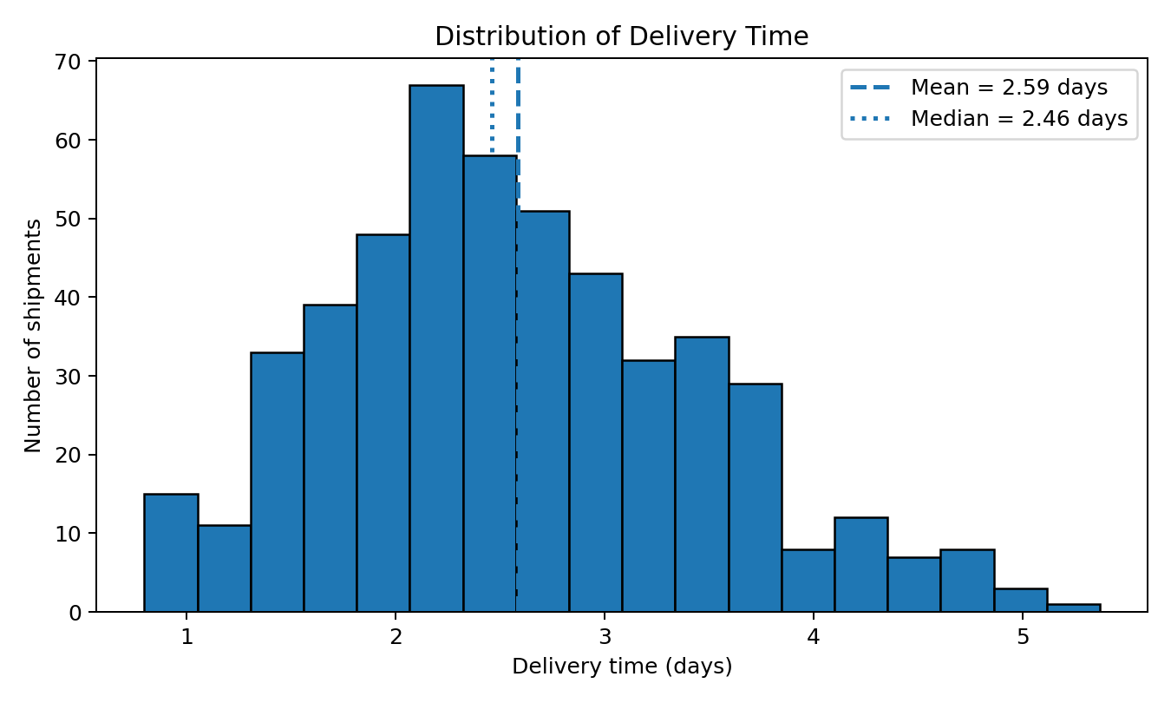
Figure 1. Distribution of simulated delivery time.
Why this chart? A histogram is useful for seeing the overall shape of a numerical variable. It shows whether delivery times are concentrated around a typical value, whether the data is spread widely, and whether there are possible extreme values. In this simulation, most deliveries fall around the middle of the observed range, with fewer shipments at the slowest end.

4.3 Time Trend Analysis
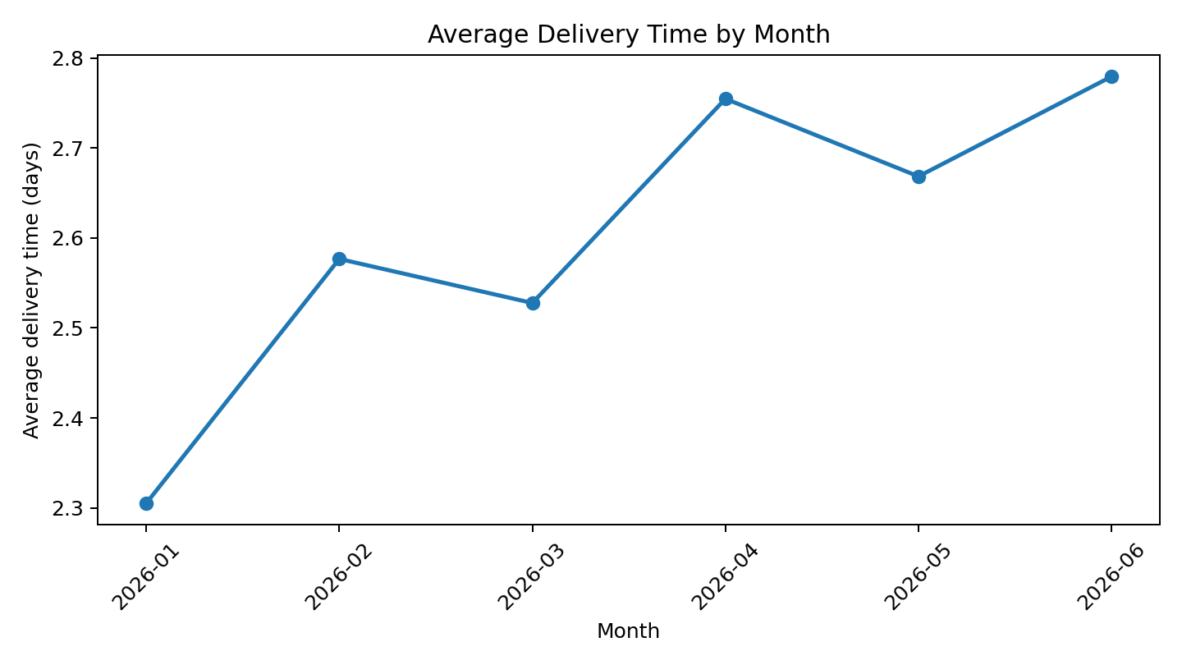
Figure 2. Monthly average delivery time across the six-month simulation.
Why this chart? A line chart is the clearest way to show movement over time. The simulated data shows a gradual increase in average delivery time in the later months, which could indicate higher demand, traffic, congestion, or capacity pressure. In a real business, this would be a point to investigate before service quality falls further.

4.4 Cost and Distance Relationship
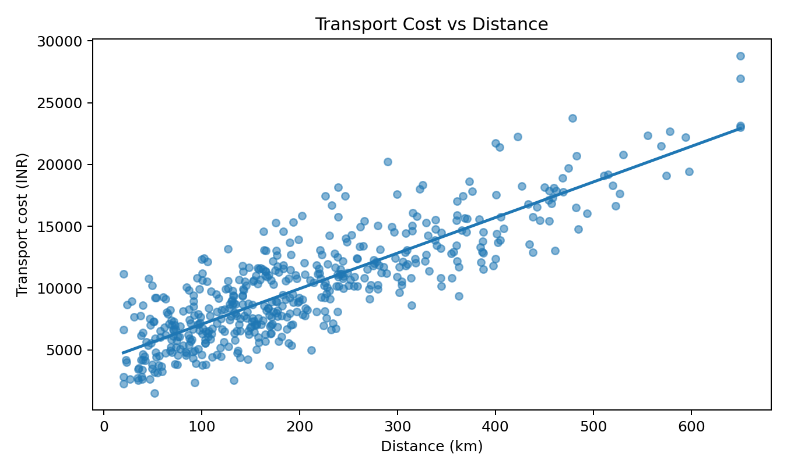
Figure 3. Relationship between distance and transport cost.
The scatter plot shows a clear positive relationship: longer routes generally cost more. The Pearson correlation between distance and transport cost in this simulation is 0.85. This is operationally sensible because fuel, driver time, handling, and vehicle usage normally increase with travel distance. The spread around the trend line also suggests that distance is not the only cost driver; shipment volume and transport mode matter too.

4.5 Regional Performance
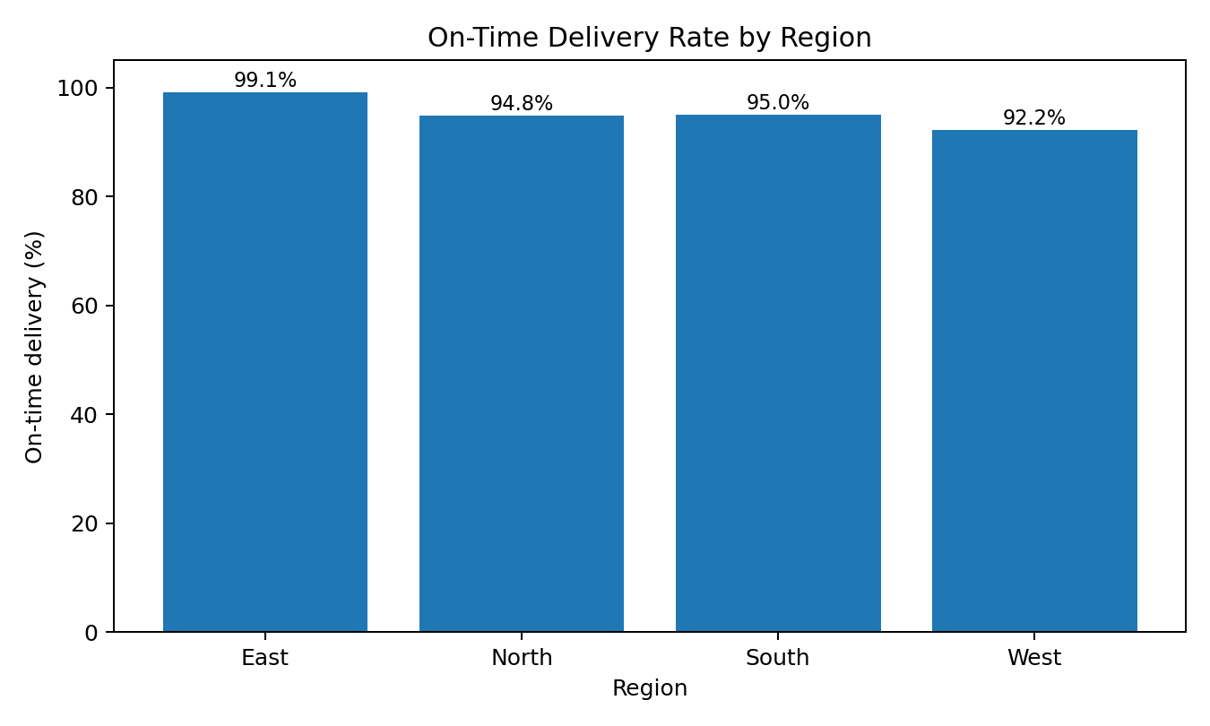
Figure 4. On-time delivery rate by region.
The regional chart helps management compare service quality. In the simulated data, East has the highest on-time rate at 99.1%, while West has the lowest at 92.2%. The difference suggests that some regions may need closer investigation of route length, traffic, carrier capacity, or operational processes.

4.6 Correlation Analysis
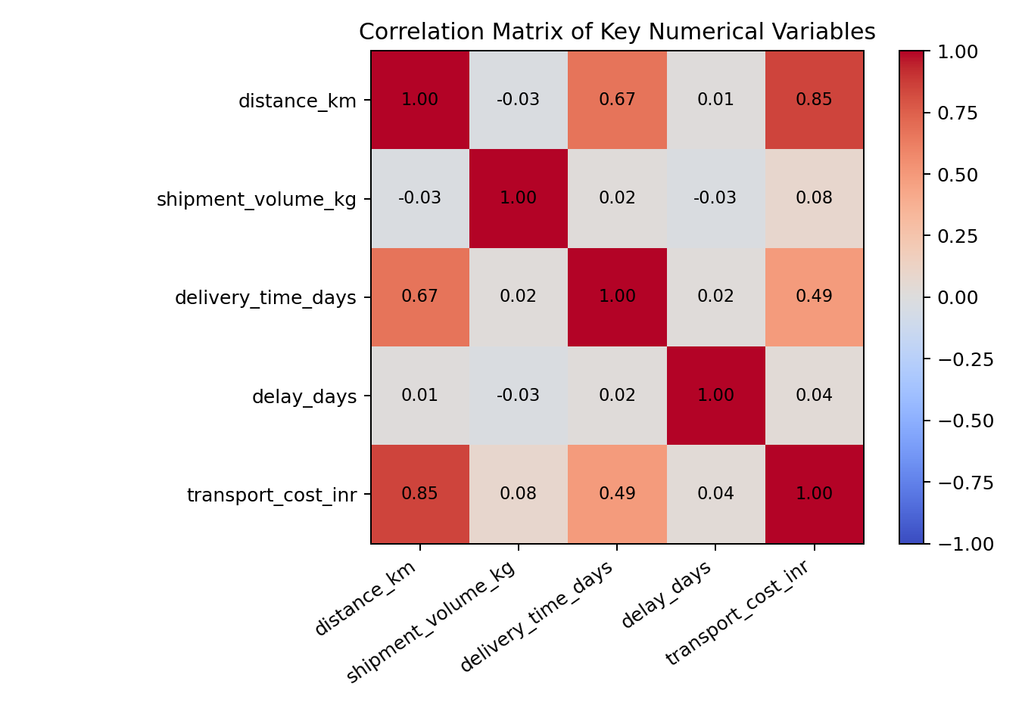
Figure 5. Correlation matrix for key numerical variables.
A correlation matrix is useful because it quickly shows which numerical variables move together. Delivery time and distance have a positive relationship in the simulated data, while transport cost is also positively related to distance and shipment volume. Correlation does not prove causation, but it is a useful starting point for deeper analysis.

4.7 Transport Mode Comparison
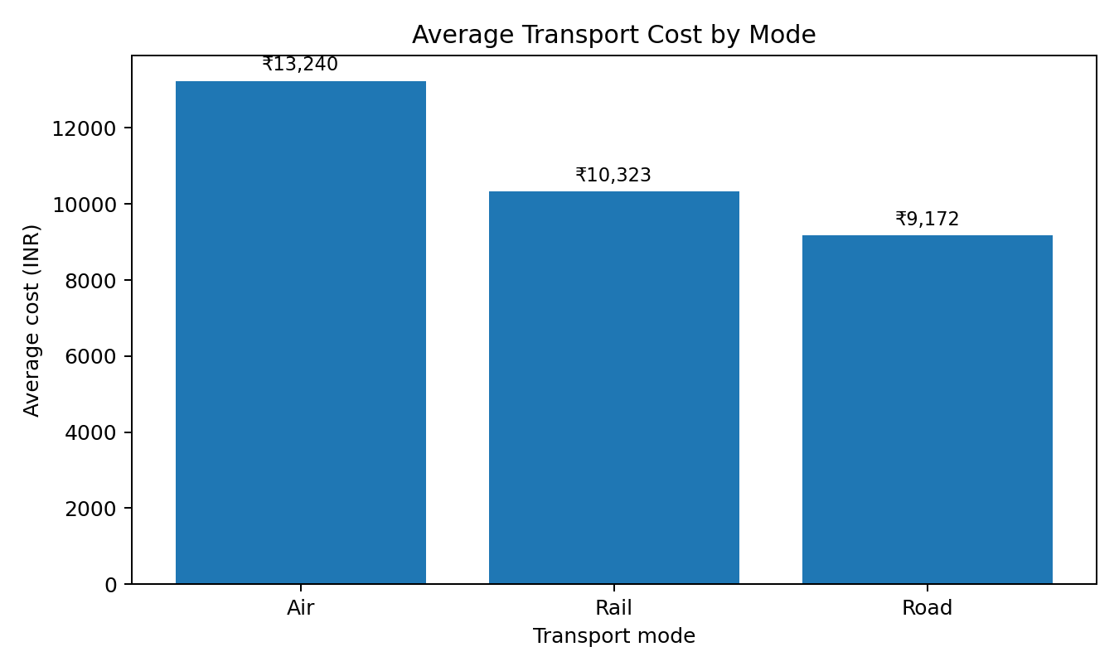
Figure 6. Average transport cost by transportation mode.
The mode comparison shows the trade-off between speed and cost. In the simulation, Air has the lowest average delivery time, while Air has the highest average cost. This highlights an important logistics decision: the fastest transport option is not always the cheapest option. Managers should select modes based on customer urgency, shipment value, distance, and budget.

5. Analytical Insights
- Distance is a major operational factor: the simulated correlation between distance and transport cost is 0.85, and the scatter plot shows an upward cost trend.
- Delivery performance changes across regions. The gap between the best and worst regional on-time rates is 6.9 percentage points.
- The monthly trend suggests increasing delivery pressure in the later part of the simulation, so seasonal planning and capacity checks would be useful.
- Transport mode creates a clear cost-versus-speed trade-off. Higher-cost modes may still be justified for urgent shipments or high-value orders.
- The cost-vs-distance scatter has visible spread around the trend line, showing that distance alone cannot explain total transport cost; shipment volume and mode also matter.

6. Possible Operational Bottlenecks
- Long-distance routes may create more delivery-time risk and higher cost.
- Regions with lower on-time rates may need route-level or carrier-level investigation.
- Later-month increases in delivery time may signal demand growth or limited transport capacity.
- Using an expensive transport mode for every shipment can increase cost without improving service where speed is not necessary.

7. Recommendations
- Set region-specific service targets and monitor on-time delivery weekly.
- Use distance and shipment volume to plan transport budgets and capacity before dispatch.
- Create a transport-mode policy: reserve faster, higher-cost modes for urgent or high-value shipments.
- Track monthly delivery trends and prepare additional capacity before expected busy periods.
- In a production project, extend the analysis with route-level, carrier-level, and customer-level data to identify the exact source of delays.

8. Python Code Illustration
import pandas as pd
import matplotlib.pyplot as plt

df = pd.read_csv("hypothetical_logistics_dataset.csv")

# Basic inspection
print(df.head())
print(df.info())
print(df.describe())

# Central tendency
print(df["delivery_time_days"].mean())
print(df["delivery_time_days"].median())

# Distribution
plt.hist(df["delivery_time_days"], bins=18, edgecolor="black")
plt.xlabel("Delivery time (days)")
plt.ylabel("Shipments")
plt.title("Delivery Time Distribution")
plt.show()

# Correlation
print(df[["distance_km", "shipment_volume_kg",
"delivery_time_days", "transport_cost_inr"]].corr())

# Regional on-time rate
region_rate = df.groupby("region")["on_time"].mean() * 100
region_rate.plot(kind="bar")
plt.ylabel("On-time delivery (%)")
plt.show()

9. Methodology: Why Each Visualization Was Chosen
Visualization | What it shows | Why it is useful
Histogram | Distribution of delivery time | Shows typical range, spread, skew, and possible extremes.
Line chart | Monthly delivery trend | Best for understanding changes over time.
Scatter plot | Distance vs cost | Shows relationship and possible trend between two numerical variables.
Bar chart | On-time rate by region | Makes category-to-category comparison easy.
Correlation heatmap | Strength/direction of numerical relationships | Gives a compact view of which variables move together.
Mode cost bar chart | Average cost by transport mode | Highlights the cost trade-off between transportation options.

10. Expected Business Value
The main value of this analysis is not the charts by themselves; it is the decisions they support. A logistics manager can use these views to decide where service problems are concentrated, whether distance or volume is driving cost, whether a region is falling behind, and whether transport choices are balanced between speed and cost. In a real organization, the same analysis could feed a dashboard and be refreshed regularly so that operational teams can act before small issues become larger service failures.

11. Limitations
- The dataset is hypothetical and was created for demonstration, so the findings do not represent a real logistics company.
- The simulated variables do not include every real-world factor such as weather, traffic incidents, carrier availability, warehouse processing time, or fuel-price changes.
- Correlation is useful for finding relationships but does not prove that one variable causes another.
- Route optimization would require actual location coordinates, vehicle constraints, and delivery time windows.

12. Conclusion
This task demonstrates how Python can be used to explore logistics data and turn raw numbers into understandable business information. The analysis covered central tendency, distributions, time trends, relationships between cost and distance, regional performance, transport-mode comparisons, and correlations. The visualizations make it easier to see operational patterns that may not be obvious from a table of numbers alone.
The main lesson is that visualization should always be connected to a business question. A good logistics chart should help a manager decide what to investigate or change. In this project, the results point to distance, regional performance, seasonal delivery pressure, and transport-mode choice as important areas for further analysis. The next step in a real project would be to use actual operational data and combine these descriptive insights with predictive and optimization models.

13. References
- Pandas documentation — https://pandas.pydata.org/docs/
- Matplotlib documentation — https://matplotlib.org/stable/
- Scikit-learn documentation — https://scikit-learn.org/stable/
- Google OR-Tools documentation — https://developers.google.com/optimization/

