Yuva Intern - Logistics Data Analyst Internship
Week 4 Task: Predictive Modeling and Optimization in Logistics Systems
Student Name: K.PRANEETH RAJ
Submission Report

1. Executive Summary
This project demonstrates how predictive modeling can be used to forecast a logistics metric and how the forecast can support operational optimization. A hypothetical dataset of 600 shipments was created with variables such as region, transport mode, priority, distance, shipment volume, traffic, weather risk, warehouse load, vehicle utilization, daily orders, and delivery time. The prediction target is Delivery_Time_days. Two models were compared: Linear Regression as a simple baseline and Random Forest Regression as a non-linear ensemble model. The Linear Regression model performed better on the test data in this simulation, so it was selected as the final model. A Random Forest was still tested as a stronger non-linear alternative and tuned with GridSearchCV for comparison. A small vehicle-allocation optimization example was also developed to show how predicted delivery risk can be converted into an operational action. The project is intentionally framed as a simulation because the Week 4 task allows a hypothetical dataset. The results should therefore be treated as demonstration results rather than claims about a real company.

2. Problem Definition and Data Simulation
Logistics managers need to know which shipments are likely to take longer than expected. If delay risk can be estimated before dispatch, vehicles and delivery capacity can be prioritized toward higher-risk regions or urgent orders. The problem is therefore defined as a supervised regression task: predict the number of days required to deliver a shipment.

2.1 Target Variable
Target: Delivery_Time_days - the simulated number of days from dispatch to delivery.

2.2 Main Features
Feature | Type | Purpose
Region | Categorical | Delivery geography
Transport_Mode | Categorical | Road, Rail, or Air
Priority | Categorical | Standard or Express
Distance_km | Numeric | Approximate travel distance
Shipment_Volume_kg | Numeric | Shipment weight/volume proxy
Traffic_Index | Numeric | Traffic severity score
Weather_Risk_Index | Numeric | Weather disruption score
Warehouse_Load_pct | Numeric | Warehouse workload level
Vehicle_Utilization_pct | Numeric | Vehicle capacity usage
Daily_Orders | Numeric | Daily order pressure

2.3 Dataset Structure
The simulated dataset contains 600 shipment records. The target was generated from a mix of operational variables plus random noise so that the modeling workflow has a realistic prediction problem without pretending that the results came from a real company.

2.4 Prediction Flow
Operational features → preprocessing → regression model → predicted delivery time → risk flag → optimization decision

3. Model Selection and Implementation
Two regression techniques were selected so the report can compare a simple, easy-to-explain model with a stronger non-linear model.

3.1 Linear Regression
Linear Regression was used as the baseline because it is simple to understand, fast to train, and provides a useful benchmark. It assumes that the relationship between the inputs and delivery time can be approximated with a linear combination of features.

3.2 Random Forest Regression
Random Forest was selected because logistics data often contains non-linear relationships. For example, the effect of traffic may become more serious when warehouse load and daily orders are already high. A forest combines many decision trees and can capture such interactions more naturally than a simple linear model.

3.3 Preprocessing
Categorical variables are one-hot encoded and numerical variables are standardized inside a scikit-learn pipeline. Keeping preprocessing inside the pipeline reduces the risk of applying different transformations to training and test data.
categorical = ["Region", "Transport_Mode", "Priority"]
numerical = [c for c in features if c not in categorical]
preprocess = ColumnTransformer([
("cat", OneHotEncoder(handle_unknown="ignore"), categorical),
("num", StandardScaler(), numerical)
])
model = Pipeline([
("pre", preprocess),
("model", RandomForestRegressor(
n_estimators=250, random_state=42, min_samples_leaf=2
))
])

4. Evaluation and Validation
The data was divided into 80% training data and 20% test data. Three evaluation metrics were used: MAE, RMSE, and R².

4.1 Evaluation Metrics
- MAE (Mean Absolute Error): average absolute prediction error in days. Lower is better.
- RMSE (Root Mean Squared Error): gives more weight to larger prediction errors. Lower is better.
- R²: shows how much variation in delivery time is explained by the model. Higher is better, with 1 being a perfect fit.
Model | MAE | RMSE | R²
Linear Regression | 1.115 | 1.420 | 0.658
Random Forest | 1.342 | 1.672 | 0.527
Tuned Random Forest | 1.342 | 1.672 | 0.527
Table 1. Test-set model performance on the simulated dataset.
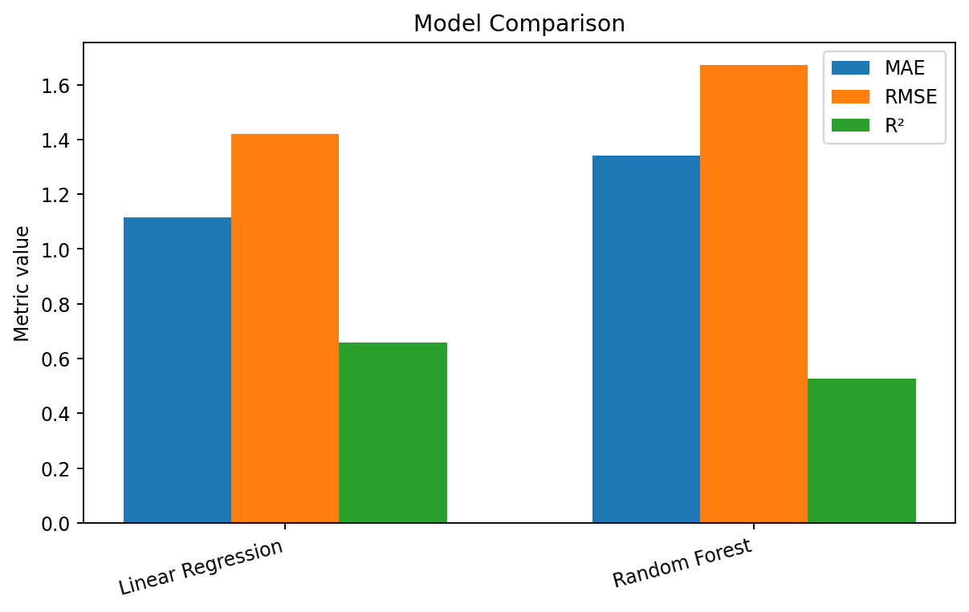
Figure 1. Comparison of the baseline models. Because MAE, RMSE, and R² use different scales, the chart is mainly a visual summary; the numeric table should be used for exact comparison.

4.2 Cross-Validation
Five-fold cross-validation was applied to the selected Linear Regression pipeline. The average cross-validation RMSE was 1.518 days with a standard deviation of 0.076 days. The average cross-validation MAE was 1.214 days. Using multiple folds gives a more stable estimate than relying on one train/test split.

4.3 Hyperparameter Tuning
A small GridSearchCV search was also tested on the Random Forest as a secondary, non-linear candidate. The best settings were: {'model__max_depth': None, 'model__min_samples_leaf': 2, 'model__n_estimators': 250}. The tuned Random Forest achieved MAE 1.342, RMSE 1.672, and R² 0.527. In this simulation, the simpler Linear Regression baseline performed better, so Linear Regression was retained as the final operational model. This is a useful reminder that a more complex model is not automatically a better model.
param_grid = {
"model__n_estimators": [150, 250],
"model__max_depth": [None, 10],
"model__min_samples_leaf": [1, 2]
}
grid = GridSearchCV(
model, param_grid, cv=3, scoring="neg_root_mean_squared_error"
)
grid.fit(X_train, y_train)

5. Analytical Findings
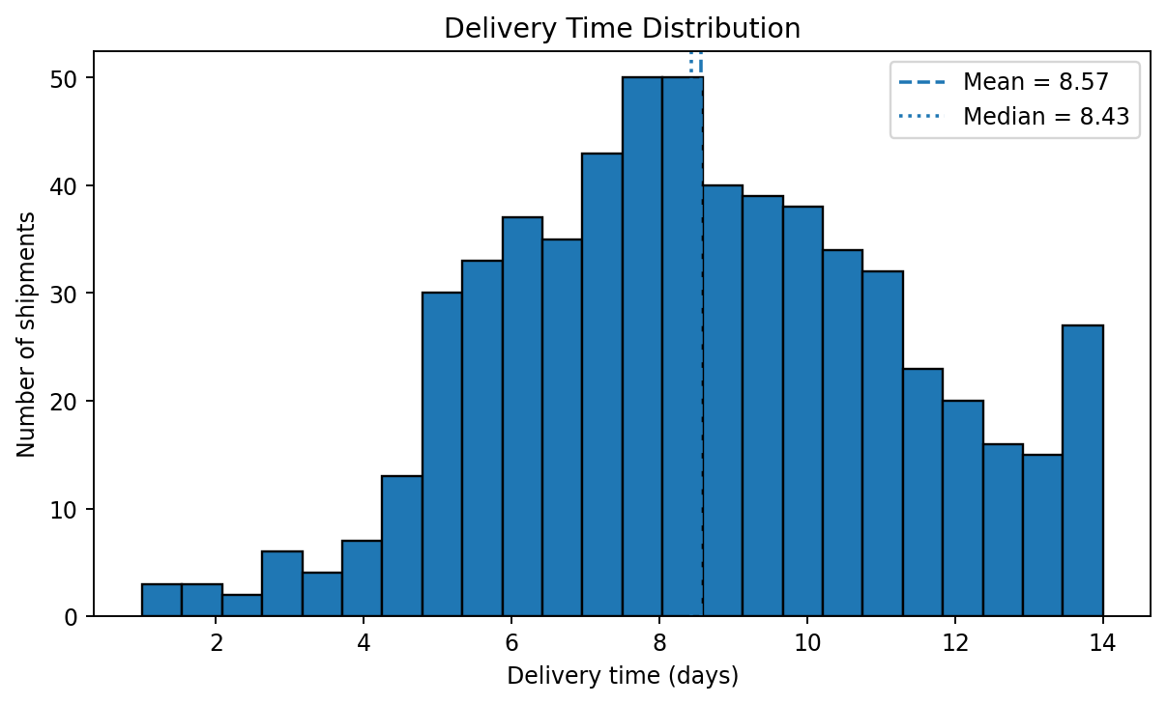
Figure 2. Distribution of simulated delivery time.
The simulated delivery time has a mean of 8.57 days and a median of 8.43 days. The distribution shows that most shipments fall in a central range, while a smaller number have longer delivery times. This type of spread is useful for prediction because the model needs to distinguish normal deliveries from higher-risk cases.

5.1 Prediction Accuracy
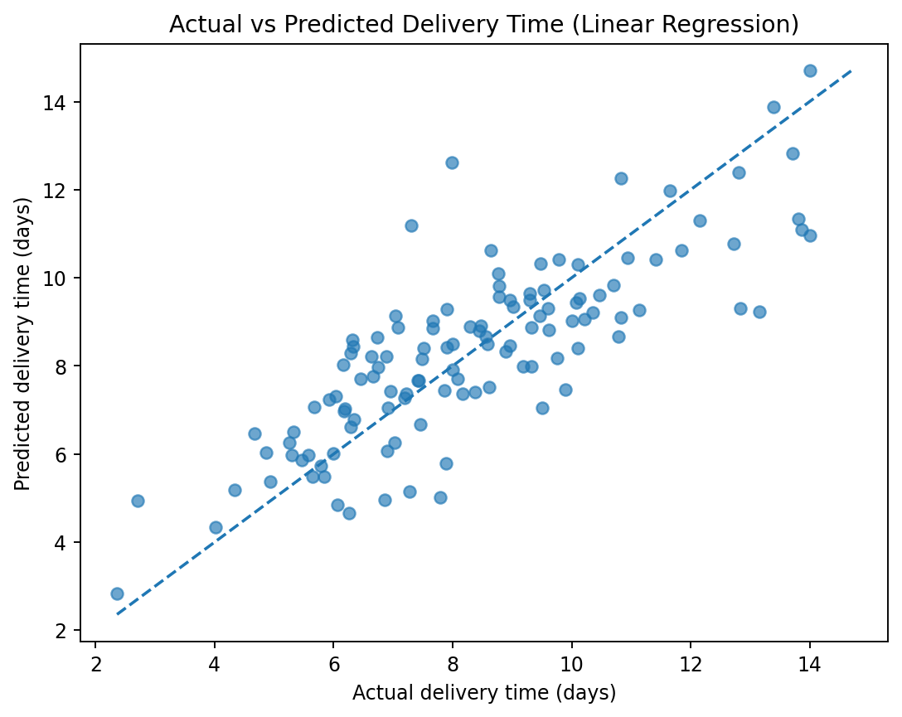
Figure 3. Actual versus predicted delivery time for the tuned model.
Points close to the diagonal line indicate predictions close to the actual delivery time. A systematic curve or wide spread would indicate model weakness. The plot is therefore a useful visual check alongside MAE, RMSE, and R².

5.2 Key Predictors
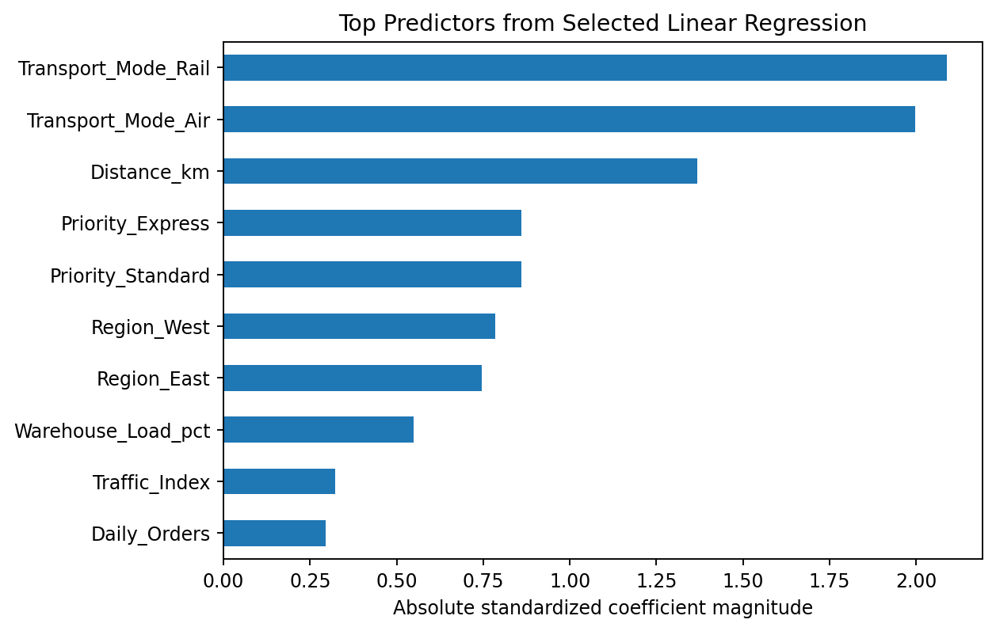
Figure 4. Largest absolute standardized coefficients from the selected Linear Regression model.
The largest absolute standardized coefficients in the selected Linear Regression model include Transport_Mode_Rail: 2.088, Transport_Mode_Air: 1.997, Distance_km: 1.369, Priority_Express: 0.860, Priority_Standard: 0.860, Region_West: 0.785. These are useful as an interpretation aid, but they should not be treated as proof of causation. They indicate which encoded inputs have the strongest linear relationship with the predicted delivery time in this simulation.

5.3 Residual Analysis
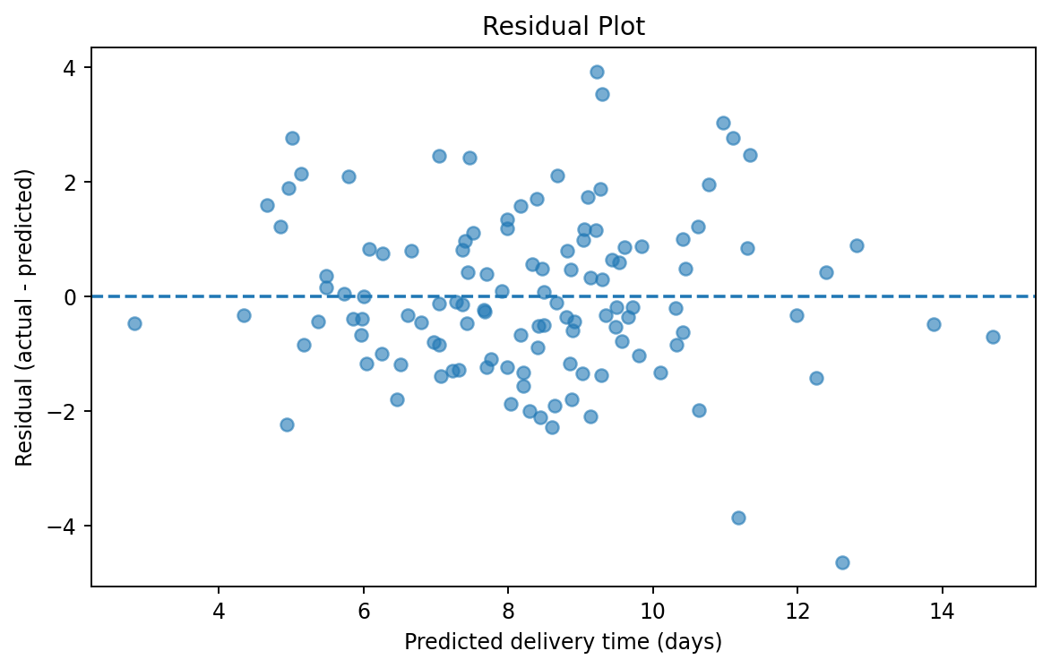
Figure 5. Residual plot for the tuned Random Forest.
A good residual plot should show errors scattered around zero without a strong pattern. Large isolated residuals can signal unusual shipments that deserve operational investigation.

6. Optimization Strategies
Prediction is useful only when it leads to an action. In this project, the model output can be converted into three practical optimization strategies.

6.1 Vehicle Resource Allocation
Allocate a limited number of vehicles to regions with the highest combination of demand and predicted delay risk. The simulated example uses 9 vehicles, 30 units of capacity per vehicle, and a relative cost factor for each region. Linear programming is used to choose a better allocation under capacity limits.
from scipy.optimize import linprog
result = linprog(
objective,
A_ub=np.array([np.ones(4)]),
b_ub=np.array([available_vehicles]),
bounds=region_bounds,
method="highs"
)
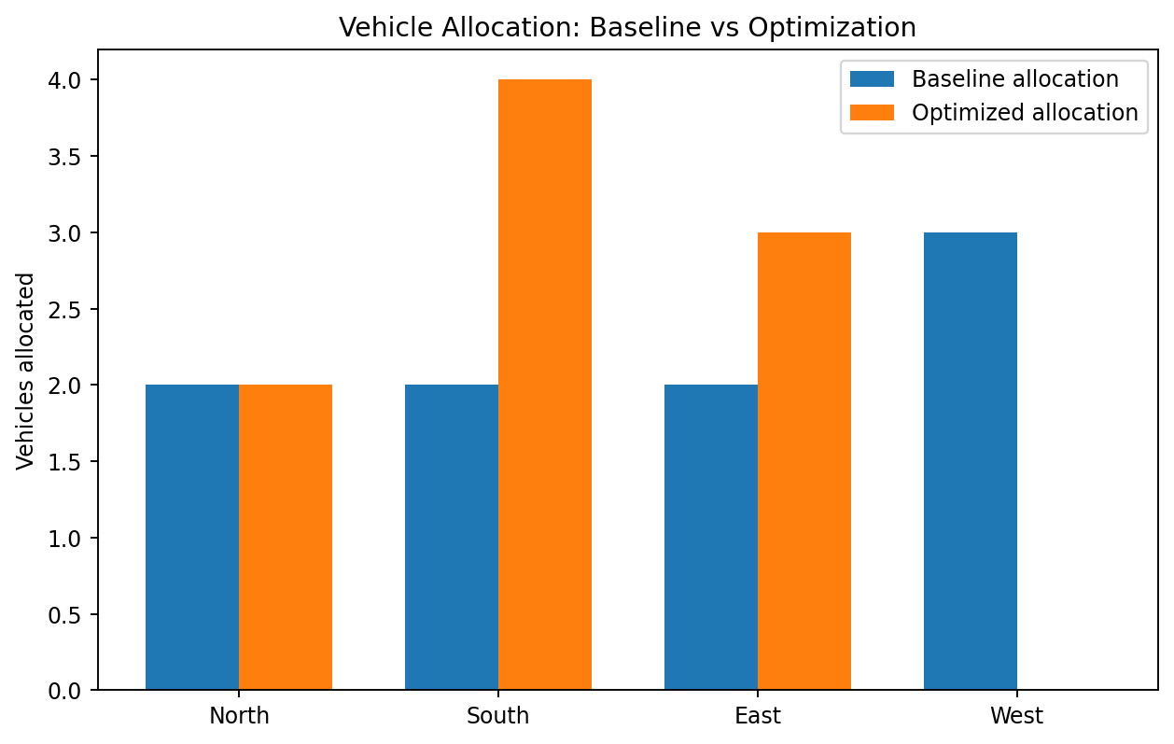
Figure 6. Simulated vehicle allocation before and after optimization.
Region | Demand | Risk | Baseline Vehicles | Optimized Vehicles
North | 82 | 0.72 | 2 | 2
South | 98 | 0.86 | 2 | 4
East | 76 | 0.91 | 2 | 3
West | 64 | 0.58 | 3 | 0
In the simulated scenario, the optimized allocation reduces the weighted shortage-risk score by approximately 16.0% relative to the baseline allocation. The relative allocation cost changes by approximately 8.0%. These are simulation outputs, not real business savings.

6.2 Route Planning
Predicted delivery time can be used to prioritize route planning. High-risk shipments can be moved to earlier delivery windows or placed on routes with more reliable travel times. A vehicle-routing model can then incorporate distance, capacity, and time-window constraints.

6.3 Cost Minimization
The business can compare the predicted cost of different transport modes and decide when a faster but more expensive mode is justified. For example, an express shipment with high predicted delay may justify premium transport while a low-risk shipment can remain on a lower-cost route.

7. End-to-End Analysis Flow
Business problem → simulate/collect data → clean and prepare data → split train/test → train baseline → train Random Forest → evaluate → cross-validate → tune hyperparameters → predict delay risk → optimize resources/routes → monitor KPIs

8. Python Implementation Summary
The complete Python script included with this submission performs data loading, feature selection, preprocessing, train/test splitting, baseline and Random Forest training, metric evaluation, 5-fold cross-validation, hyperparameter tuning, and a small linear-programming example for vehicle allocation.
# Evaluation
def evaluate(name, y_true, y_pred):
mae = mean_absolute_error(y_true, y_pred)
rmse = mean_squared_error(y_true, y_pred) ** 0.5
r2 = r2_score(y_true, y_pred)
print(f"{name}: MAE={mae:.3f}, RMSE={rmse:.3f}, R2={r2:.3f}")
# Predict
best_pred = best_model.predict(X_test)
evaluate("Tuned Random Forest", y_test, best_pred)

9. Recommendations
- Use the tuned Random Forest as a practical baseline for delivery-time prediction, but retrain and monitor it regularly when real operational data becomes available.
- Create a daily delay-risk list and prioritize shipments with high predicted delivery time or high probability of missing the promised date.
- Use predicted risk with vehicle capacity and region demand to allocate scarce vehicles where they are most valuable.
- Use route optimization for high-risk routes, especially when traffic, weather, and distance are expected to increase travel time.
- Track MAE and RMSE over time. If model error increases, investigate changes in traffic patterns, network design, or data quality.
- Validate optimization recommendations with business constraints and pilot them before large-scale deployment.

10. Limitations
- The dataset is hypothetical, so the results demonstrate methodology rather than real company performance.
- The simulation does not include all real-world factors such as driver schedules, road restrictions, exact GPS routes, holidays, or supplier lead times.
- Feature importance indicates model usage, not causal impact.
- The optimization example is intentionally small; a production system would use detailed route, capacity, and time-window constraints.

11. Conclusion
This Week 4 project shows how predictive modeling and optimization can work together in a logistics environment. The goal was to predict delivery time from operational variables and then use those predictions to guide decisions. Linear Regression provided a simple and interpretable model and produced stronger simulated test performance than the Random Forest candidate. Cross-validation was used for stability, and the Random Forest was additionally tuned to check whether more complexity improved the result. The optimization example then demonstrated how predicted risk can be translated into a resource-allocation decision. In a real logistics organization, the same approach could support earlier identification of risky shipments, better vehicle allocation, improved route planning, and lower delivery delays. The key lesson is that prediction alone is not enough: the value comes from connecting model output to a clear operational action and measuring the result over time.

12. References
- Scikit-learn User Guide - Regression and model evaluation: https://scikit-learn.org/stable/user_guide.html
- Scikit-learn LinearRegression documentation: https://scikit-learn.org/stable/modules/generated/sklearn.linear_model.LinearRegression.html
- Scikit-learn RandomForestRegressor documentation: https://scikit-learn.org/stable/modules/generated/sklearn.ensemble.RandomForestRegressor.html
- Scikit-learn model selection documentation: https://scikit-learn.org/stable/model_selection.html
- SciPy optimization documentation: https://docs.scipy.org/doc/scipy/reference/optimize.html

