YUVA INTERN - LOGISTICS DATA ANALYST
WEEK 2 TASK REPORT
Data Collection, Cleaning, and Preprocessing for Logistics Analysis
Student Name: K.PRANEETH RAJ
Project Theme: E-commerce Logistics and Supply Chain Data

1. Executive Summary
This Week 2 task focuses on the data preparation stage of a logistics analytics project. The reference dataset is the public DataCo SMART SUPPLY CHAIN FOR BIG DATA ANALYSIS dataset. The dataset provides structured supply-chain information and a separate variable-description file, and it covers activities such as provisioning, production, sales, and commercial distribution across clothing, sports, and electronic products. The dataset is published through Mendeley Data under a Creative Commons Attribution 4.0 International licence.
The main purpose of preprocessing is to make the data reliable before exploratory analysis or machine-learning work. The planned pipeline checks data types, duplicate records, missing values, extreme values, inconsistent categories, and numerical scale. Missing values will be handled according to the business meaning of each field, outliers will be reviewed using statistical rules such as the interquartile range (IQR), categorical values will be standardized, and numerical variables may be scaled when required by the selected model. The report also includes Python examples using pandas and scikit-learn.

2. Data Collection Simulation
Reference source: DataCo SMART SUPPLY CHAIN FOR BIG DATA ANALYSIS, Constante, Silva and Pereira (2019), Mendeley Data. The source provides the structured DataCoSupplyChainDataset.csv and the DescriptionDataCoSupplyChain.csv variable dictionary. A later version also includes clickstream data, but this Week 2 task will focus on the structured supply-chain file.
Item | Planned use | Reason
Structured CSV | Main preprocessing input | Suitable for pandas-based data cleaning and logistics KPI preparation
Variable description CSV | Understand field meanings | Prevents incorrect assumptions about columns
Logistics fields | Shipping, delivery, order, customer and product variables | Useful for delivery performance and operational analysis
Product domains | Clothing, sports, electronics | Supports category-level comparisons
Source note: The public dataset description states that the structured file contains supply-chain data and that a separate file describes the variables. See References: Constante, Silva & Pereira (2019), Mendeley Data, DOI 10.17632/8gx2fvg2k6.5.

3. Data Inspection and Quality Checks
Before changing any records, the first step is to inspect the dataset. This includes the number of rows and columns, data types, missing values, duplicate rows, unique category values, and basic numerical statistics.
import pandas as pd
df = pd.read_csv('DataCoSupplyChainDataset.csv', encoding='latin1')
print(df.shape)
print(df.head())
print(df.info())
print(df.isna().sum().sort_values(ascending=False).head(15))
print('Duplicate rows:', df.duplicated().sum())
print(df.describe(include='all').T.head(20))
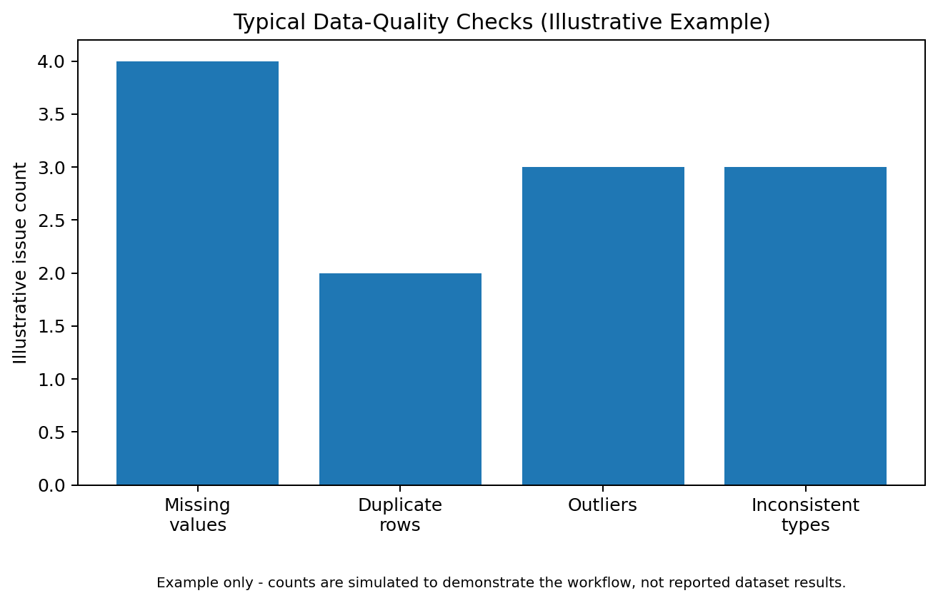
Figure 1. Illustrative quality-check categories for the planned pipeline (simulated counts).

4. Data Cleaning

4.1 Missing Values
Missing values are common in real logistics data. A blank value can appear because a field was not collected, a process step was skipped, or the source system did not contain the information. The treatment should depend on the meaning of the variable. For important numerical measures, median imputation can be safer than mean imputation when the data are skewed. For categorical fields, the most common category or an explicit label such as “Unknown” can be used when that choice makes business sense. Columns with extremely high missingness may be dropped if they provide little analytical value.
# Missing-value profile
missing_pct = df.isna().mean().mul(100).sort_values(ascending=False)
print(missing_pct.head(15))
# Example: median for a numeric feature
if 'Order Item Quantity' in df.columns:
df['Order Item Quantity'] = df['Order Item Quantity'].fillna(
df['Order Item Quantity'].median()
)
# Example: explicit category for a categorical feature
if 'Shipping Mode' in df.columns:
df['Shipping Mode'] = df['Shipping Mode'].fillna('Unknown')

4.2 Duplicate Records
Duplicate rows can make order counts, revenue totals, and delivery metrics look larger than they really are. Exact duplicate rows should normally be removed. Before dropping them, the analyst should confirm that repeated records are not legitimate repeated events.
duplicate_count = df.duplicated().sum()
df = df.drop_duplicates().copy()
print('Duplicates removed:', duplicate_count)

4.3 Outlier Detection
An outlier is a value that is unusually far from the rest of the data. In logistics, outliers can occur because of genuine long-distance deliveries, unusually large orders, data-entry errors, or system issues. The goal is not to delete every extreme value. Instead, the analyst should investigate it and decide whether it is valid. The IQR rule is a simple method for flagging possible outliers: values below Q1 - 1.5×IQR or above Q3 + 1.5×IQR are flagged for review.
# IQR-based outlier flags for a numeric column
col = 'Days for shipping (real)'
if col in df.columns:
q1 = df[col].quantile(0.25)
q3 = df[col].quantile(0.75)
iqr = q3 - q1
lower = q1 - 1.5 * iqr
upper = q3 + 1.5 * iqr
outlier_mask = (df[col] < lower) | (df[col] > upper)
print('Potential outliers:', outlier_mask.sum())
Possible actions after investigation: keep a valid extreme observation, cap/winsorize a value when justified, or remove an error when there is evidence it is incorrect. The decision should always be documented.

4.4 Inconsistent Data Types and Dates
Dates should be converted to a real datetime type before calculating delivery time, monthly trends, or day-based features. Numeric fields stored as text must also be converted before statistical analysis.
# Convert a date field when it exists
if 'shipping date (DateOrders)' in df.columns:
df['shipping date (DateOrders)'] = pd.to_datetime(
df['shipping date (DateOrders)'], errors='coerce'
)
# Convert a numeric field safely
if 'Order Item Quantity' in df.columns:
df['Order Item Quantity'] = pd.to_numeric(
df['Order Item Quantity'], errors='coerce'
)

4.5 Inconsistent Categories
Text categories can contain spelling differences, extra spaces, or inconsistent capitalization. These create duplicate categories during grouping. Standardizing text improves the reliability of counts and comparisons.
cat_col = 'Shipping Mode'
if cat_col in df.columns:
df[cat_col] = (df[cat_col].astype('string')
.str.strip()
.str.lower())

5. Normalization and Scaling
Normalization means putting numerical variables on a comparable scale. This is useful for distance-based methods such as K-Means clustering and for many machine-learning pipelines. Scaling is not automatically required for every algorithm. Tree-based models, for example, usually do not require feature scaling.
from sklearn.preprocessing import StandardScaler
features = ['Order Item Quantity', 'Days for shipping (real)']
features = [c for c in features if c in df.columns]
scaler = StandardScaler()
if features:
df[features] = scaler.fit_transform(df[features])
StandardScaler transforms a numerical feature using its mean and standard deviation. In a production workflow, the scaler should be fitted only on the training data and then applied to validation/test data to avoid data leakage.

6. End-to-End Preprocessing Workflow
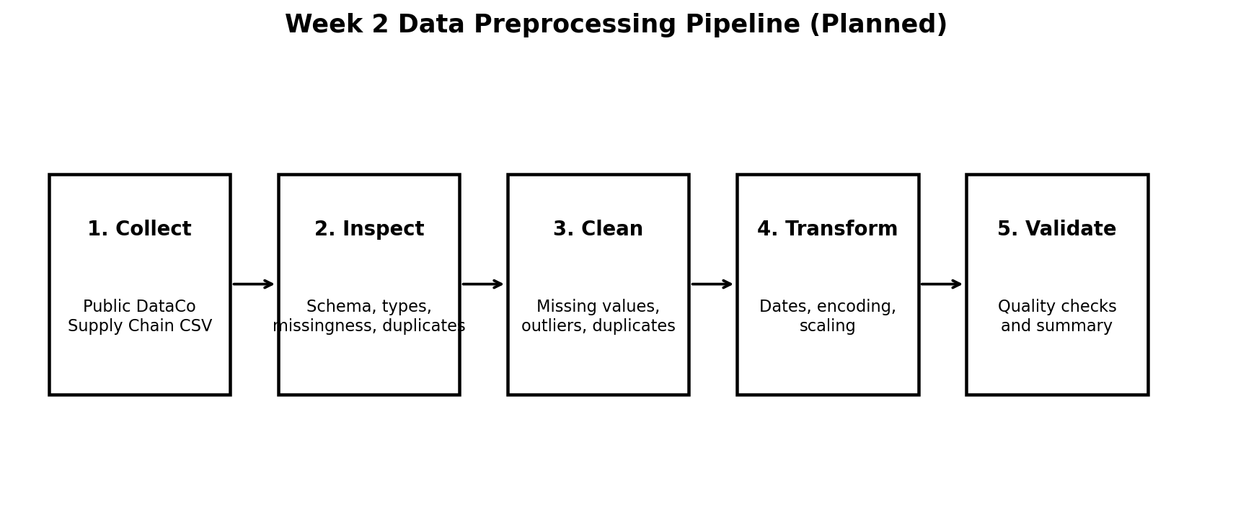
Figure 2. End-to-end Week 2 preprocessing roadmap.

7. Methodology: Why Each Step Matters
Problem | Technique | Why chosen | Impact on analysis
Missing numerical values | Median / justified imputation | Less sensitive to skew than the mean | Keeps useful records and reduces distortion
Missing categories | Unknown / mode when appropriate | Preserves rows while making missingness explicit | Improves grouping and reporting consistency
Duplicates | Drop exact duplicates after validation | Avoids double counting | Protects KPIs and aggregates
Outliers | IQR flag + business review | Simple and explainable | Prevents extreme errors from dominating models
Mixed date/type formats | pd.to_datetime / pd.to_numeric | Makes calculations reliable | Enables time features and valid statistics
Category inconsistencies | strip + lower + controlled mapping | Creates one consistent label per category | Improves grouping and encoding
Different numerical scales | StandardScaler when required | Puts features on comparable scale | Helps distance-based algorithms such as K-Means

8. Data Validation After Cleaning
Cleaning is not complete until the analyst checks the final dataset. The validation stage should confirm that the number of rows changed as expected, critical columns have acceptable missingness, dates are valid, numeric ranges are sensible, and categories contain only approved values.
print('Final shape:', df.shape)
print('Remaining duplicates:', df.duplicated().sum())
print('Remaining missing values:', int(df.isna().sum().sum()))
print(df.dtypes)
# Example range check
if 'Days for shipping (real)' in df.columns:
print(df['Days for shipping (real)'].describe())

9. Practical Impact of Data Quality on Logistics
Poor-quality data can lead to poor logistics decisions. For example, duplicate orders can inflate demand estimates, missing delivery dates can hide service problems, inconsistent shipping labels can split one category into several fake categories, and unexamined outliers can distort averages. Better data preparation gives managers more trustworthy KPIs and gives analysts a safer starting point for forecasting, clustering, and optimization.
For this reason, preprocessing is not just a technical step. It directly affects decisions such as staffing, inventory planning, route assignment, carrier comparison, and customer-service improvement.

10. Reflection
The main lesson from this task is that the quality of the input data strongly affects the quality of the final analysis. A model can be mathematically correct and still produce misleading results if the underlying data contain duplicates, missing values, incorrect dates, or inconsistent categories. In logistics, these errors can translate into wrong delivery estimates, poor resource allocation, and incorrect performance comparisons. A clear and repeatable preprocessing pipeline makes the analysis easier to explain, reproduce, and improve.

11. Conclusion
This Week 2 plan establishes a practical preprocessing pipeline for logistics analytics using Python. The process begins with a public supply-chain dataset, moves through inspection and quality checks, and then applies appropriate methods for missing values, duplicates, outliers, data types, categorical consistency, and numerical scaling. The cleaned data can then be safely used for the next stages of the internship, including exploratory analysis, visualization, predictive modeling, clustering, and optimization. The most important principle is to make every cleaning decision based on both statistical evidence and the business meaning of the data.

12. References
- Constante, F., Silva, F., & Pereira, A. (2019). DataCo SMART SUPPLY CHAIN FOR BIG DATA ANALYSIS. Mendeley Data. DOI: 10.17632/8gx2fvg2k6.5.
- Kaggle. DataCo SMART SUPPLY CHAIN FOR BIG DATA ANALYSIS dataset page.
- Pandas documentation. User guide for missing-data handling, type conversion, and duplicate removal.
- Scikit-learn documentation. StandardScaler and preprocessing utilities.
Dataset source: https://data.mendeley.com/datasets/8gx2fvg2k6/5
Note: Figure 1 uses simulated counts only to illustrate data-quality categories. No unsupported numerical cleaning results are claimed for the public dataset in this report.

