YUVA INTERN
LOGISTICS DATA ANALYST INTERN

Week 1 Task
Strategic Planning and Data Exploration in Logistics

Student Name | ____________________________
Internship | Logistics Data Analyst Intern
Task | Week 1: Strategic Planning and Data Exploration
Submission Date | 27 August 2026
Dataset | DataCo Smart Supply Chain (public dataset)

Prepared as a strategic planning report for the Week 1 internship evaluation.

1. Executive Summary
This report presents a strategic plan for a logistics data analysis project focused on delivery performance and route efficiency in an e-commerce supply chain. The proposed business scenario considers an organization that receives customer orders, processes shipments, transports goods through multiple regions, and attempts to deliver within promised timelines. The main operational challenge is to reduce delivery delays while controlling logistics cost and making better use of transport capacity. The project therefore combines descriptive analytics, exploratory data analysis (EDA), predictive modeling, customer or region segmentation, and route optimization.
The analysis will use the publicly available DataCo Smart Supply Chain dataset, which provides structured supply-chain information and a variable-description file. The dataset includes fields relevant to order status, shipping mode, delivery performance, customer and market geography, order value, and profitability. These variables make the dataset appropriate for a planning exercise centered on logistics KPIs and analytical methods. [1]
The strategic approach begins with data collection and quality checks, followed by data cleaning and feature engineering. Key performance indicators such as on-time delivery rate, average delivery delay, average delivery time, logistics cost per order, and vehicle/capacity utilization will be defined. Regression can be used as a baseline for predicting a continuous outcome such as delivery delay; clustering can help identify groups of customers or regions with similar logistics patterns; and optimization can be used to design efficient delivery routes subject to constraints such as capacity and time windows. Scikit-learn documents LinearRegression as an ordinary least-squares model, while Google OR-Tools provides vehicle-routing capabilities for constrained routing problems. [2][3]
As this is a Week 1 strategic-planning task, the report deliberately separates proposed methodology from measured results. No numerical KPI result is claimed until the public dataset is actually downloaded and analyzed. The expected outcome is a reproducible Python workflow that can later generate evidence-based findings and business recommendations.

2. Project Definition

2.1 Business Scenario
Consider an e-commerce logistics company operating across several geographic markets. Each day, the organization receives orders from customers, assigns shipping methods, prepares goods for dispatch, and transports the orders to their final destinations. Management wants to know which factors contribute to late delivery, which regions or shipping modes require attention, and how transport capacity can be allocated more efficiently. The project will use historical operational data to answer these questions.
Business flow: Order received -> warehouse processing -> shipment -> transportation -> final delivery -> KPI monitoring

2.2 Problem Statement
The proposed analytical problem is to understand and improve delivery performance. Late deliveries can increase customer dissatisfaction, create additional handling and transportation costs, and reduce the reliability of the supply chain. At the same time, inefficient routing or under-utilized capacity may increase cost without improving service. The project will therefore investigate delivery delays, demand patterns, operational segments, and routing decisions in a single analytical framework.

2.3 Project Objectives
- Identify the most important KPIs for measuring logistics and delivery performance.
- Explore the distribution of delivery times, delays, shipping modes, regions, and order characteristics.
- Identify operational patterns and possible bottlenecks using descriptive statistics and visualizations.
- Propose a baseline regression model to predict delivery delay or delivery time.
- Use clustering to identify groups of customers, regions, or orders with similar logistics behavior.
- Formulate route optimization as a constrained vehicle-routing problem for future operational improvement.
- Translate analytical findings into practical recommendations for logistics decision-making.

3. Key Performance Indicators (KPIs)
The following KPIs provide a balanced view of service quality, speed, cost, and resource utilization. The formulas below define what will be calculated during the implementation stage.
KPI | What it measures | Formula / definition | Interpretation
On-Time Delivery Rate | Service reliability | On-time orders / total orders x 100 | Higher is better
Average Delivery Delay | Delay severity | Mean(actual delivery time - promised time) | Lower is better
Average Delivery Time | Speed of fulfillment | Mean(delivery time) | Lower is generally better
Logistics Cost per Order | Cost efficiency | Total logistics cost / total orders | Lower is generally better
Capacity Utilization | Resource efficiency | Actual load / available capacity x 100 | Avoid both very low utilization and over-capacity

Example KPI logic (illustrative only):
On-Time Rate = (Number of orders delivered on or before promised date) / (Total orders) * 100
Average Delay = Mean(Actual Delivery Date - Promised Delivery Date)
Cost per Order = Total Logistics Cost / Number of Orders
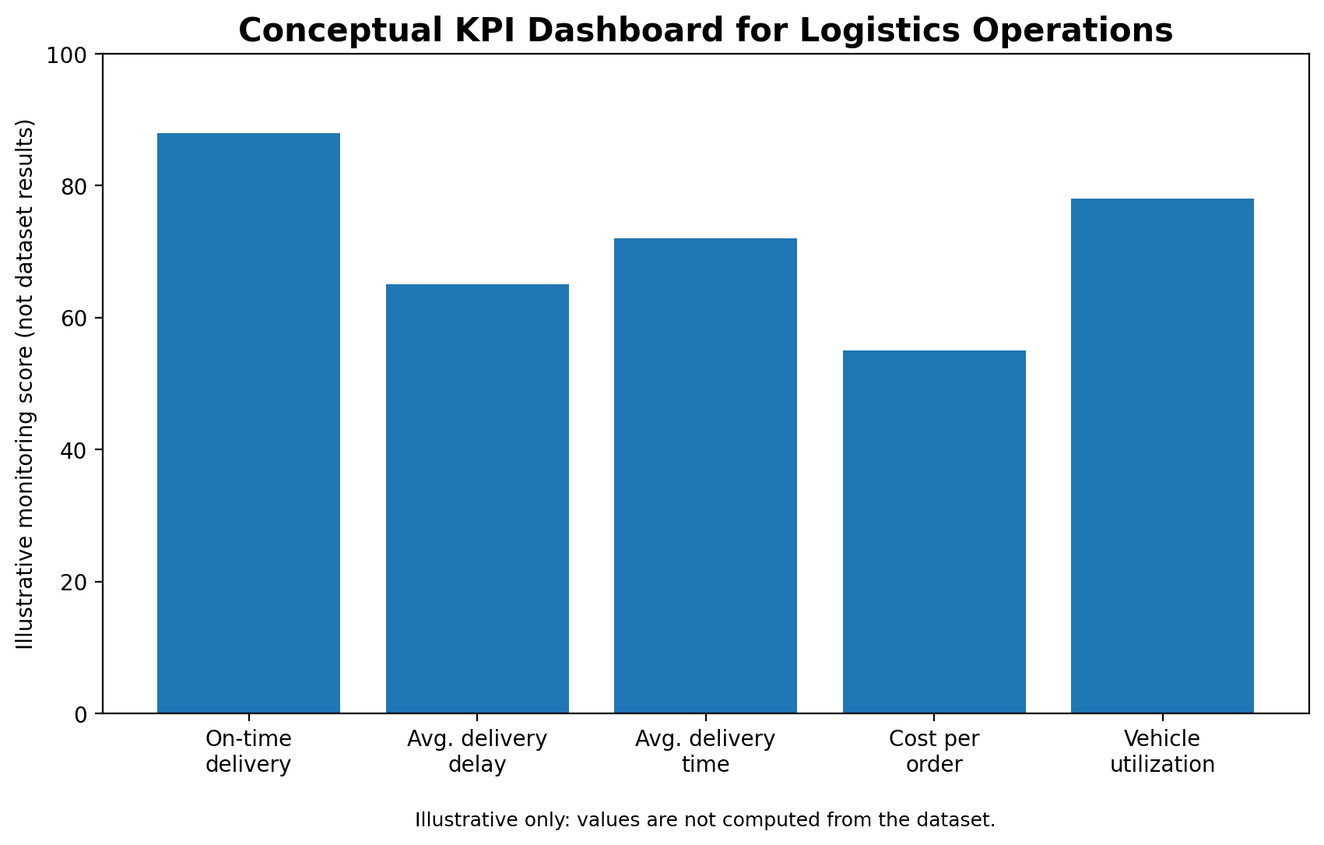
Figure 1. Conceptual KPI dashboard. The values shown are illustrative and are not dataset results.

4. Literature and Data Research

4.1 Public Dataset: DataCo Smart Supply Chain
The selected public dataset is the DataCo Smart Supply Chain dataset available through Kaggle. The public dataset description states that it contains a structured file named DataCoSupplyChainDataset.csv and a variable-description file, and that the data covers supply-chain activities such as provisioning, production, sales, and commercial distribution. The dataset description also identifies product areas including clothing, sports, and electronic supplies. [1] The original dataset is additionally indexed through Mendeley Data, where the authors are identified as Fabian Constante, Fernando Silva, and António Pereira. [4]
The dataset is well suited to this task because public examples and research have used it for delivery-risk, supply-chain performance, exploratory analysis, and machine-learning applications. A recent 2026 research article describes the same DataCo dataset as publicly available and reports its use for delivery-delay prediction and customer segmentation, reinforcing its relevance to the proposed methodology. [5]
Category | Example variables | Analytical use
Order and status fields | Order ID, Order Status | Track order lifecycle and outcomes
Shipping performance | Shipping Mode, Days for shipping (real), Days for shipment (scheduled), Delivery Status, Late_delivery_risk | Analyze service performance and delay risk
Geography | Customer City, Market, Order Region, Order State | Compare regional patterns and identify hotspots
Commercial variables | Order Item Quantity, Order Item Total, Order Profit Per Order | Connect logistics outcomes with commercial value
Time variables | Order/shipping date fields | Study seasonality and time-based patterns

4.2 Data Science Methods and Why They Fit
Method | Application | Expected benefit
Descriptive statistics | Summarize orders, delays, shipping modes and regions | Understand current operational performance
Exploratory data analysis | Histograms, bar charts, box plots, scatter plots, trend charts | Find patterns, outliers and bottlenecks
Regression | Predict a continuous outcome such as delivery delay | Estimate how input features relate to delay
Clustering | Group customers, regions or orders with similar behavior | Support differentiated operational strategies
Optimization | Minimize route distance/time under constraints | Improve route planning and resource allocation

Scikit-learn documents LinearRegression as an ordinary least-squares method that fits a linear model by minimizing residual sum of squares. This makes it a suitable baseline because it is easy to interpret and provides a simple benchmark before testing more advanced models. [2] Clustering methods such as K-Means can be used to group observations without a predefined target label. For route planning, Google OR-Tools supports vehicle-routing problems, including capacity constraints and time-window constraints; its documentation notes that larger routing problems can become computationally difficult, so practical solutions may be high-quality rather than mathematically optimal. [3][6]

5. Strategic Roadmap
The complete analytical workflow is designed as an end-to-end process. Each stage produces an output that becomes the input to the next stage.
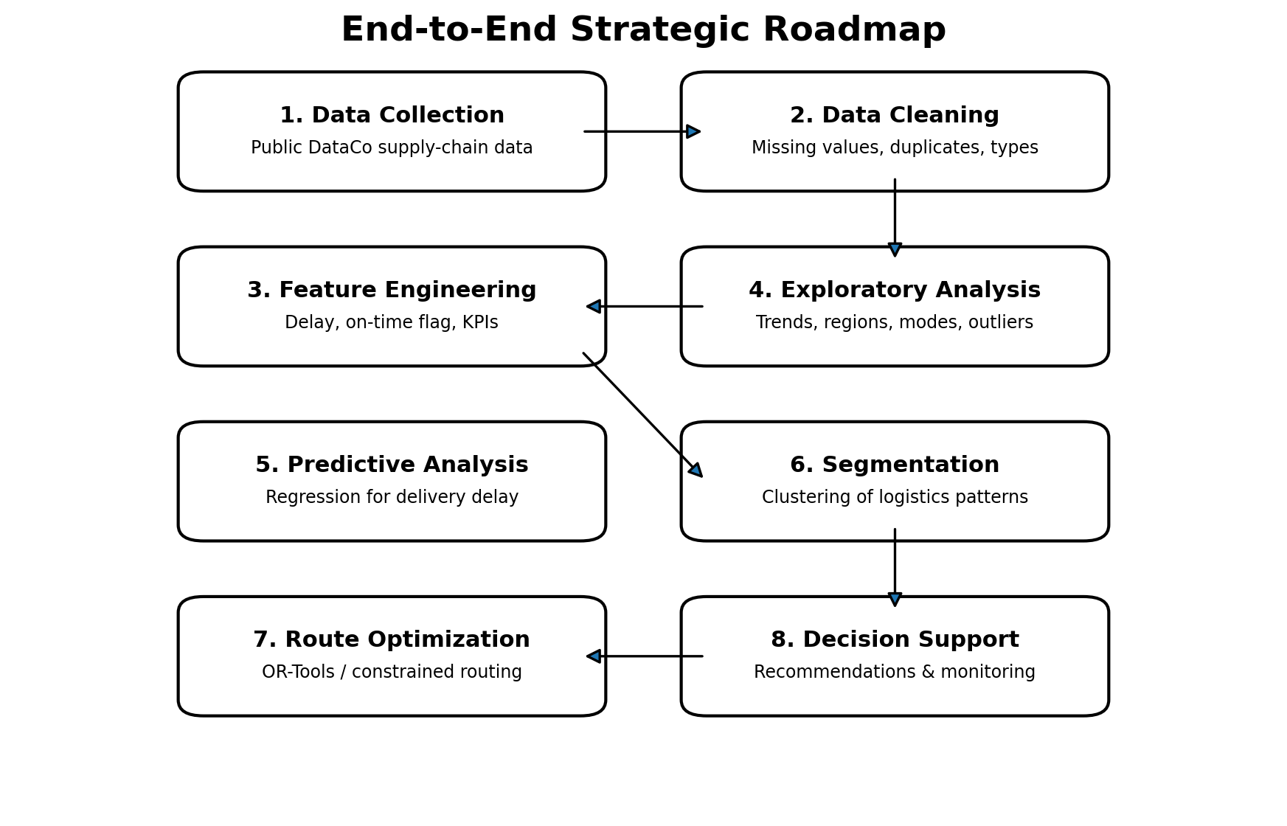
Figure 2. Proposed end-to-end strategic roadmap for the logistics analysis.

5.1 Data Collection
Download the public DataCo dataset, store the raw file without modifications, and record the source URL and version/date used. Keep a separate cleaned copy so the original data remains reproducible.

5.2 Data Cleaning
Inspect column names and data types, check missing values, identify duplicate records, parse date fields, inspect invalid or impossible values, and document every cleaning decision.

5.3 Feature Engineering
Create variables such as delivery delay, on-time delivery flag, delivery duration, order month, order region, and other derived indicators required for KPI calculations and modeling.

5.4 Exploratory Data Analysis
Calculate descriptive statistics and create visualizations to compare delays by shipping mode, region, order type, and time period. Investigate correlations and outliers before selecting predictive features.

5.5 Predictive Modeling
Create a baseline regression model for a continuous target such as delivery delay. Split the data into training and test sets and evaluate with appropriate regression metrics such as MAE, RMSE, and R-squared.

5.6 Segmentation
Standardize selected numerical variables and apply clustering to identify distinct logistics profiles, then interpret the practical meaning of each segment.

5.7 Route Optimization
For a future operational extension, formulate a vehicle-routing problem using depot, customer locations, demand, vehicle capacity, travel time/distance, and customer time windows. Use OR-Tools or another suitable solver.

5.8 Insights and Decision Support
Summarize the strongest findings, quantify improvement opportunities where possible, and translate results into actions such as route redesign, staffing, capacity reallocation, or service-level monitoring.

6. Proposed Exploratory Analysis and Visualizations
The following charts are planned for the implementation phase. They are not presented as measured findings; they are examples of the relationships that will be tested using the public dataset.
- Delivery status by shipping mode using a grouped bar chart.
- Average delivery delay by region using a horizontal bar chart.
- Monthly order volume and delay trend using a line chart.
- Distribution of delivery delay using a histogram and box plot.
- Distance/route complexity versus delivery delay using a scatter plot.
- KPI summary table showing on-time rate, average delay, delivery time, cost per order, and utilization.
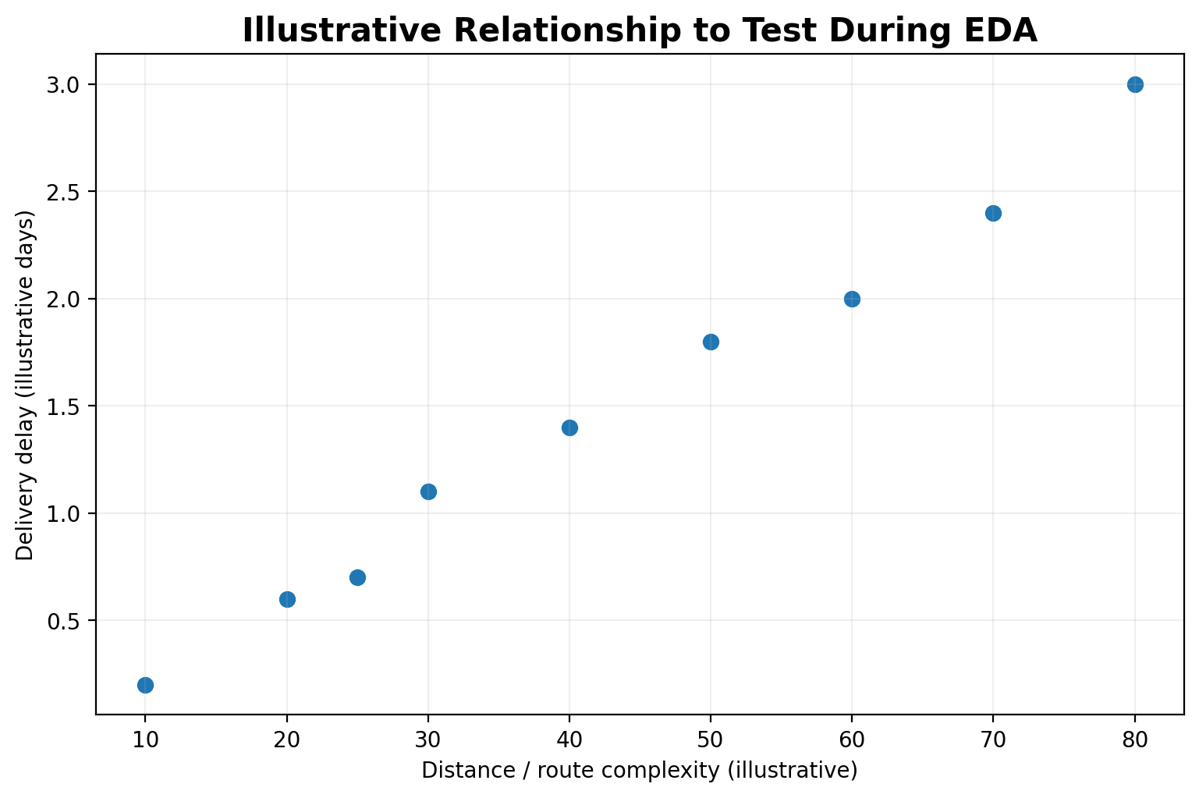
Figure 3. Illustrative scatter plot showing a relationship that could be tested during EDA. Points are hypothetical.

7. Code Illustration
The following Python snippets illustrate how the proposed analysis will be implemented. They are intentionally written as a practical baseline for Week 1 and can be expanded during later internship tasks.

7.1 Data Loading and Quality Checks
import pandas as pd
import numpy as np
# Load public dataset
df = pd.read_csv("DataCoSupplyChainDataset.csv", encoding="latin1")
# Basic inspection
print(df.shape)
print(df.head())
print(df.info())
print(df.isna().sum().sort_values(ascending=False).head(15))
# Duplicate check
print("Duplicates:", df.duplicated().sum())

7.2 Date Preparation and KPI Features
date_cols = ["shipping date (DateOrders)", "order date (DateOrders)"]
for col in date_cols:
if col in df.columns:
df[col] = pd.to_datetime(df[col], errors="coerce")
# Delivery delay based on actual vs scheduled shipping days
if {"Days for shipping (real)", "Days for shipment (scheduled)"}.issubset(df.columns):
df["delay_days"] = (
df["Days for shipping (real)"] -
df["Days for shipment (scheduled)"]
)
df["on_time"] = (df["delay_days"] <= 0).astype(int)
# Example KPI calculations
on_time_rate = df["on_time"].mean() * 100
avg_delay = df["delay_days"].mean()
print(f"On-time delivery rate: {on_time_rate:.2f}%")
print(f"Average delay: {avg_delay:.2f} days")

7.3 Exploratory Visualizations
import matplotlib.pyplot as plt
# Delay distribution
df["delay_days"].dropna().plot(kind="hist", bins=20)
plt.xlabel("Delivery delay (days)")
plt.ylabel("Number of orders")
plt.title("Distribution of Delivery Delay")
plt.show()
# Average delay by shipping mode
mode_delay = df.groupby("Shipping Mode")["delay_days"].mean().sort_values()
mode_delay.plot(kind="bar")
plt.ylabel("Average delay (days)")
plt.title("Average Delay by Shipping Mode")
plt.show()

7.4 Baseline Regression Model
from sklearn.model_selection import train_test_split
from sklearn.compose import ColumnTransformer
from sklearn.preprocessing import OneHotEncoder
from sklearn.pipeline import Pipeline
from sklearn.impute import SimpleImputer
from sklearn.linear_model import LinearRegression
from sklearn.metrics import mean_absolute_error, mean_squared_error, r2_score
import numpy as np
features = ["Days for shipment (scheduled)", "Shipping Mode", "Market", "Order Region"]
model_df = df.dropna(subset=["delay_days"])[features + ["delay_days"]].copy()
X = model_df[features]
y = model_df["delay_days"]
num_features = ["Days for shipment (scheduled)"]
cat_features = ["Shipping Mode", "Market", "Order Region"]
preprocess = ColumnTransformer([
("num", SimpleImputer(strategy="median"), num_features),
("cat", Pipeline([
("imputer", SimpleImputer(strategy="most_frequent")),
("onehot", OneHotEncoder(handle_unknown="ignore"))
]), cat_features)
])
model = Pipeline([
("preprocess", preprocess),
("regression", LinearRegression())
])
X_train, X_test, y_train, y_test = train_test_split(
X, y, test_size=0.2, random_state=42
)
model.fit(X_train, y_train)
pred = model.predict(X_test)
print("MAE:", mean_absolute_error(y_test, pred))
print("RMSE:", np.sqrt(mean_squared_error(y_test, pred)))
print("R2:", r2_score(y_test, pred))

7.5 Clustering Concept
from sklearn.preprocessing import StandardScaler
from sklearn.cluster import KMeans
cluster_features = ["Order Item Quantity", "Order Item Total", "delay_days"]
cluster_df = df[cluster_features].dropna().copy()
X_scaled = StandardScaler().fit_transform(cluster_df)
kmeans = KMeans(n_clusters=3, random_state=42, n_init="auto")
cluster_df["cluster"] = kmeans.fit_predict(X_scaled)
print(cluster_df.groupby("cluster").mean(numeric_only=True))

7.6 Route Optimization Concept
# Conceptual OR-Tools workflow
# 1. Create a distance/time matrix between depot and customers.
# 2. Define number of vehicles and vehicle capacities.
# 3. Add customer demand.
# 4. Add time-window constraints when available.
# 5. Minimize travel distance/time.
# 6. Solve and export the routes.
Google OR-Tools provides routing examples for distance minimization, capacity constraints, and vehicle routing with time windows. [3][6]

8. Expected Outcomes and Decision Impact
Outcome area | Expected analytical result | Potential decision impact
Delivery reliability | Identify where and when late deliveries are concentrated. | Prioritize corrective actions for high-risk regions or modes.
Faster fulfillment | Measure and model factors associated with longer delivery times. | Improve scheduling and reduce avoidable delays.
Better resource allocation | Identify high-demand or high-risk operational segments. | Assign capacity, vehicles, or staffing more intelligently.
Lower logistics cost | Connect service outcomes with transport and order efficiency. | Reduce unnecessary distance, under-utilization, and rework.
Better planning | Use predictive and optimization methods as decision-support tools. | Move from reactive logistics management toward proactive planning.

9. Assumptions, Limitations, and Data Quality Considerations
- The public DataCo dataset is used for a portfolio-style analytical plan; it should not be treated as a direct representation of one company's live operational system.
- Predictions will only be meaningful if the selected features are available before the delivery outcome occurs. Variables that reveal the final outcome must be excluded to avoid data leakage.
- Route optimization requires location, demand, travel-time/distance, capacity, and time-window inputs. If these are incomplete in the public dataset, the routing stage should be presented as a future extension using a prepared routing dataset or generated distance matrix.
- Cleaning and transformation decisions will be documented so that the workflow remains reproducible.
- Correlation does not automatically imply causation. Operational recommendations should be validated with business context before deployment.

10. Conclusion
This Week 1 strategic plan establishes a practical, end-to-end approach for analyzing logistics delivery performance. The proposed scenario focuses on a common business need: improving delivery reliability while controlling cost and using transport resources efficiently. Five KPIs provide a balanced measurement framework covering service quality, speed, cost, and utilization. The DataCo Smart Supply Chain dataset provides a public foundation for the analysis, while Python offers a reproducible environment for cleaning, EDA, visualization, and modeling.
The roadmap combines descriptive analytics with three complementary data-science ideas: regression for prediction, clustering for segmentation, and optimization for route planning. Regression provides a transparent baseline for estimating delivery delay; clustering can reveal groups that may need different logistics strategies; and vehicle-routing optimization can turn operational constraints into structured route decisions. The result of the later implementation should be a set of measurable insights and recommendations that managers can use to improve service levels, allocate resources, and reduce avoidable logistics inefficiencies.

11. References
[1] Kaggle. “DataCo SMART SUPPLY CHAIN FOR BIG DATA ANALYSIS.” Dataset page. https://www.kaggle.com/datasets/shashwatwork/dataco-smart-supply-chain-for-big-data-analysis
[2] scikit-learn. “LinearRegression — scikit-learn documentation.” https://scikit-learn.org/stable/modules/generated/sklearn.linear_model.LinearRegression.html
[3] Google for Developers. “Vehicle Routing.” OR-Tools documentation. https://developers.google.com/optimization/routing
[4] Mendeley Data / NIAID Data Discovery Portal. “DataCo SMART SUPPLY CHAIN FOR BIG DATA ANALYSIS.” https://data.niaid.nih.gov/resources?id=mendeley_8gx2fvg2k6
[5] ScienceDirect. “An empirical analysis of data-driven supply chain optimization in retail and logistics.” 2026. https://www.sciencedirect.com/science/article/pii/S2949863526000154
[6] Google for Developers. “Vehicle Routing Problem with Time Windows.” OR-Tools documentation. https://developers.google.com/optimization/routing/vrptw
End of Week 1 Strategic Planning Report

