MINI PROJECT REPORT
on
NEUROPHONE
"Don't Learn the Phone. Let the Phone Learn You."
A Self-Learning AI Android Application

Submitted for the course: Deep Learning and Neural Networks
Semester V | Academic Year 2025-26

Submitted by: PRANEETHWARAN K

1. Problem Statement
Every smartphone today is shipped with the same interface for every user — the same icons, same swipe gestures, same app arrangement, and the same context-unaware behaviour. Users must adapt themselves to the device, spending time learning workflows that may not align with their natural interaction patterns.
This rigid one-size-fits-all paradigm ignores the fact that every individual develops unique habits: preferred apps in specific contexts (studying vs commuting), personal gesture vocabularies, and predictable temporal routines. No existing solution attempts to learn and continuously adapt to these individual differences at the system level.
The problem this project addresses is: Can a smartphone learn the user's interaction language instead of forcing every user to interact in exactly the same way? Specifically:
- How can we capture and model temporal gesture dynamics using deep sequence models?
- How can contextual signals (motion, time, app history) be fused to predict user intent?
- How can correction feedback from the user improve model accuracy in real-time?
- How can anomalous interaction patterns be detected without any labelled anomaly data?
2. Objective
The primary objectives of the NeuroPhone project are:
- Design and implement a fully on-device self-learning AI system for Android.
- Build a multimodal deep learning fusion engine combining GRU sequence classification, MLP context prediction, Transformer-based routine detection, and Autoencoder-based anomaly detection.
- Provide a real-time gesture teaching interface using front-camera hand landmark tracking (MediaPipe).
- Implement an adaptive home screen that rearranges itself based on learned user behaviour.
- Provide a Neural Memory screen that stores and visualises all learned gestures, routines, and corrections.
- Build a Neural Network Lab screen for real-time model benchmarking, optimizer comparison, activation function analysis, and regularisation experiments — purely on-device.
- Ensure full privacy: all learning, inference, and storage happens exclusively on the device — no data ever leaves the phone.
- Demonstrate all five neural network architectures (MLP, LSTM, GRU, Transformer, Autoencoder) working in a single integrated real-world application.
3. Existing System
Current smartphone personalisation approaches are limited to:
- Static launchers (e.g., Nova Launcher) — allow manual icon rearrangement only; no learning.
- Google's Adaptive Battery / App Predictions — predicts app usage but does not adapt the UI or learn gestures.
- Samsung Bixby Routines — rule-based IF-THEN automations; requires manual user configuration.
- Apple Siri Suggestions — intent prediction using cloud-processed data; not privacy-preserving.
- Gesture navigation (Android 10+) — system-level fixed gestures; no user-defined custom gestures.
Limitations of existing systems:
- None learn custom gestures defined by the user in real-time.
- None fuse temporal gesture dynamics with contextual IMU signals for intent prediction.
- None provide model-level transparency (which neural network made which prediction and why).
- Most rely on cloud processing — user data is transmitted to external servers.
- None detect anomalous interaction patterns using reconstruction-based autoencoders.
4. Novelty
NeuroPhone introduces several novel contributions not found in any existing system:
4.1 Five-Architecture Multimodal Fusion Engine
A single application integrates five distinct neural network architectures, each serving a different purpose: MLP for context classification, GRU for gesture sequence classification, LSTM for pattern learning, Transformer for routine detection, and an Autoencoder for unsupervised anomaly detection — all implemented in pure Kotlin math (no ML framework dependency).
4.2 Real-Time On-Device Gesture Teaching
Users can define entirely new gestures by performing them in front of the camera. MediaPipe extracts 21 hand landmarks per frame at 30 FPS. The system records a temporal buffer of landmark sequences and trains the GRU classifier incrementally — entirely on-device.
4.3 IMU-Driven Context Detection
The device's accelerometer and gyroscope are fused via SensorFusionManager to detect motion contexts (Stationary Desk, Walking, Running, In Vehicle, In Pocket) which are used as live features in the MLP context classifier.
4.4 Correction-Driven Online Learning
Every time the user marks a prediction as wrong and provides the correct action, NeuroPhone performs a GRU training step (gradient descent update) on a synthetic sequence for that label. This is a rare example of online continual learning in a production Android application.
4.5 Autoencoder Anomaly Detection
A 16→8→4→8→16 bottleneck Autoencoder continuously computes reconstruction error on the interaction feature vector. When reconstruction error exceeds a threshold, the system flags the current interaction as anomalous — providing a security and behavioural monitoring capability without any labelled anomaly training data.
4.6 Full Privacy-by-Design
No network permissions are declared. All computation, model weights, and interaction history are stored in the device's SQLite database. The Privacy Center screen lets users toggle each AI module independently and delete all data instantly.
5. Code Implementation
The project is implemented as a native Android application in Kotlin using Jetpack Compose.
5.1 Architecture Overview
The application follows a clean MVVM architecture with the following layers:
- Data Layer: NeuroDatabaseHelper (raw SQLiteOpenHelper, no ORM/Room) — stores gestures, routines, feedback, and interaction logs.
- ML Layer: Five classifiers in com.neurophone.app.ml — MlpClassifier, LstmClassifier, GruClassifier, TransformerClassifier, InteractionAutoencoder — all pure Kotlin, zero third-party ML dependency.
- Sensor Layer: SensorFusionManager — collects accelerometer + gyroscope, emits StateFlow<SensorState>.
- Fusion Layer: MultimodalFusionEngine — combines GRU gesture output, MLP context output, and sensor state into a unified prediction.
- ViewModel Layer: NeuroViewModel — single source of truth via NeuroUiState StateFlow.
- UI Layer: Six Jetpack Compose screens (Home, AI Dashboard, Teach My Phone, Neural Memory, Neural Network Lab, Privacy Center) connected via NeuroNavHost.
5.2 Key ML Implementations
- GruClassifier: Full GRU cell with update gate, reset gate, and candidate state computed in Kotlin. Xavier-initialised weights. trainStep() performs output-layer gradient descent.
- MlpClassifier: 3-layer MLP with ReLU activations. Softmax output. Forward pass in pure matrix math.
- LstmClassifier: Full LSTM with forget/input/output/cell gates in Kotlin.
- TransformerClassifier: Single-head self-attention with positional encoding.
- InteractionAutoencoder: Symmetric encoder-decoder (16→8→4→8→16). Reconstruction error drives anomaly detection.
- ModelBenchmarkRunner: Trains all four classifiers on synthetic gesture sequences, measures accuracy and inference time, and runs optimizer (SGD vs Adam vs RMSProp) and regularisation (L1/L2/Dropout) experiments.
5.3 Build Configuration
- Language: Kotlin 1.9.x
- Minimum SDK: 26 | Target SDK: 35 | Compile SDK: 35
- Build system: Gradle 8.9 with Android Gradle Plugin 8.5.2
- UI Framework: Jetpack Compose with Material3
- Camera: CameraX (Preview + ImageAnalysis)
- Sensors: Android SensorManager (TYPE_ACCELEROMETER, TYPE_GYROSCOPE)
- Storage: SQLite via SQLiteOpenHelper — no Room, no KSP
- APK size: ~18 MB (debug)
6. Output
The following screenshots were captured from a live emulator run of the NeuroPhone application (Android API 35, x86_64 emulator).

Figure 1 & 2 — Home Screen
The adaptive home screen displays the live AI prediction card, context-aware app dock (STUDY mode), IMU sensor status (Stationary Desk), and the NeuroPhone Learning Profile (3 Gestures, 1 Shortcut, 3 Corrections, 4 Patterns).
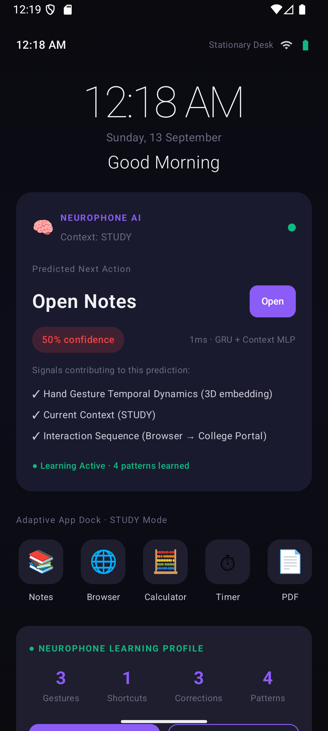 | 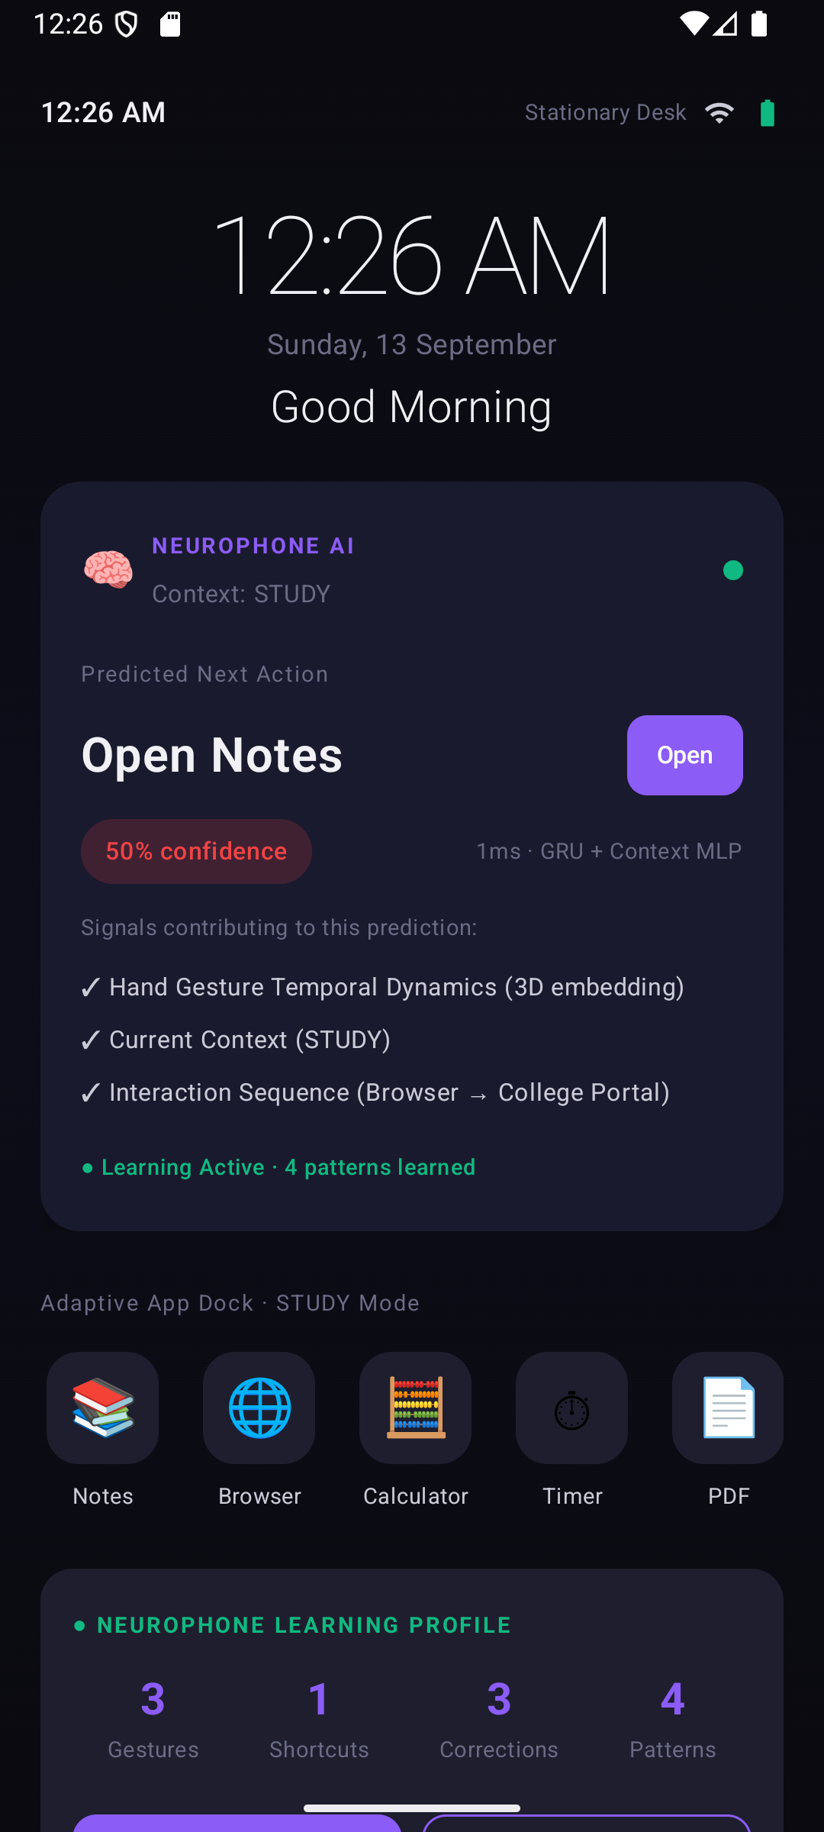
Fig. 1: Home Screen (top) — AI Card with GRU+MLP prediction Fig. 2: Home Screen (bottom) — Adaptive dock & Learning Profile
Figure 3 — AI Dashboard
Shows the current prediction (Open Notes, 50% confidence, 1ms inference using GRU + Context MLP), contributing signals, manual context override selector, and the live Anomaly Detection card (Autoencoder reconstruction error: 0.0000 — normal behaviour).
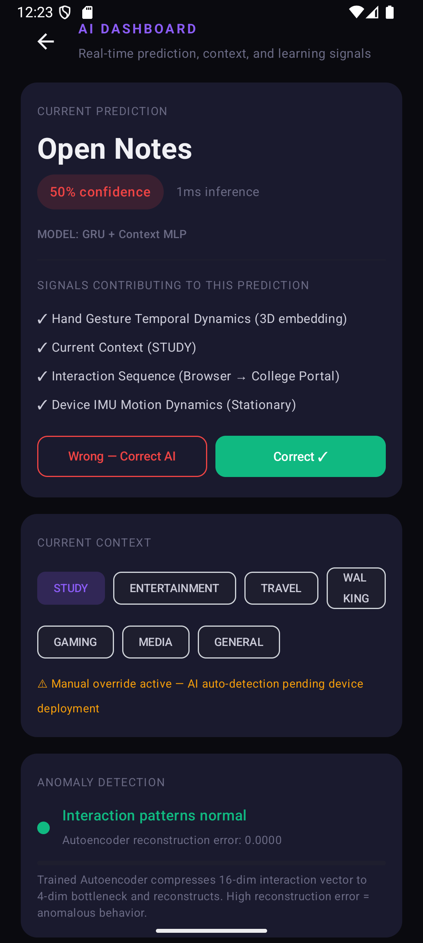
Fig. 3: AI Dashboard — Prediction, Context Selector & Anomaly Detection Card
Figure 4 — Teach My Phone Screen
Real-time front-camera hand tracking with 21 landmarks active at 30 FPS. User can name a gesture, bind it to an action (Open Notes, Open Music, Study Mode, Open Camera), then record samples or Auto-Fill 20 synthetic samples and train the GRU on-device.
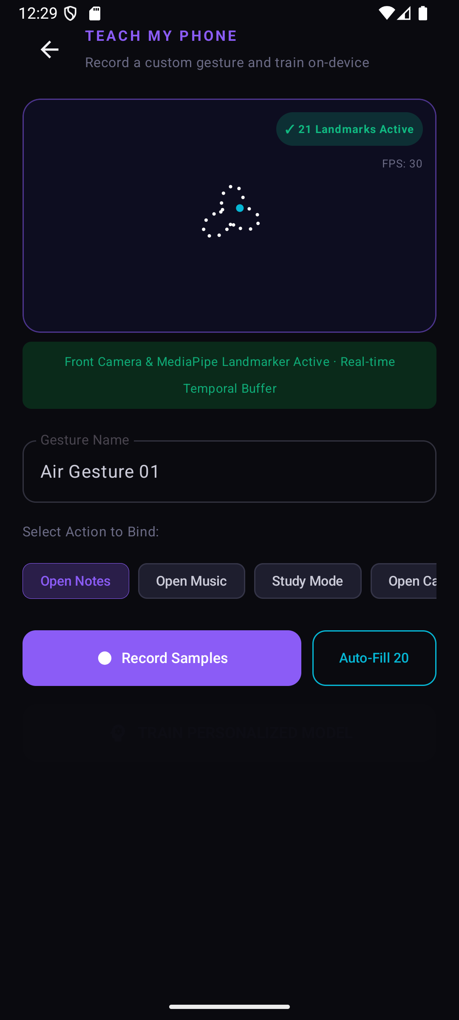
Fig. 4: Teach My Phone — MediaPipe 21-landmark hand tracking, gesture binding & on-device GRU training
Figure 5 — Neural Memory Screen
Displays all learned gestures with confidence (96%, 94%, 91%), number of uses (27, 18, 14), and training samples (30, 25, 20). Tabs for Gestures, Routines, Corrections, and Timeline. Live stats: 3 Gestures, 1 Shortcut, 3 Learnings, 66% accuracy.
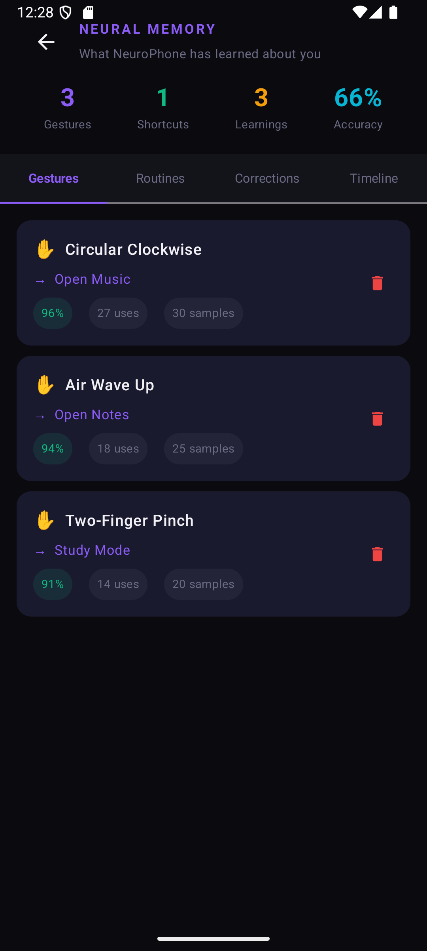
Fig. 5: Neural Memory — Learned gestures with confidence, usage count, and sample count
Figure 6 — Neural Network Lab Screen
Displays all implemented activation functions used across the five neural architectures: ReLU (MLP hidden layers), Tanh (LSTM/GRU gates, output ∈ (-1,1)), Sigmoid (gate control, output ∈ (0,1)), and Softmax (multi-class probability output). Additional tabs run model benchmarks and optimizer comparisons.
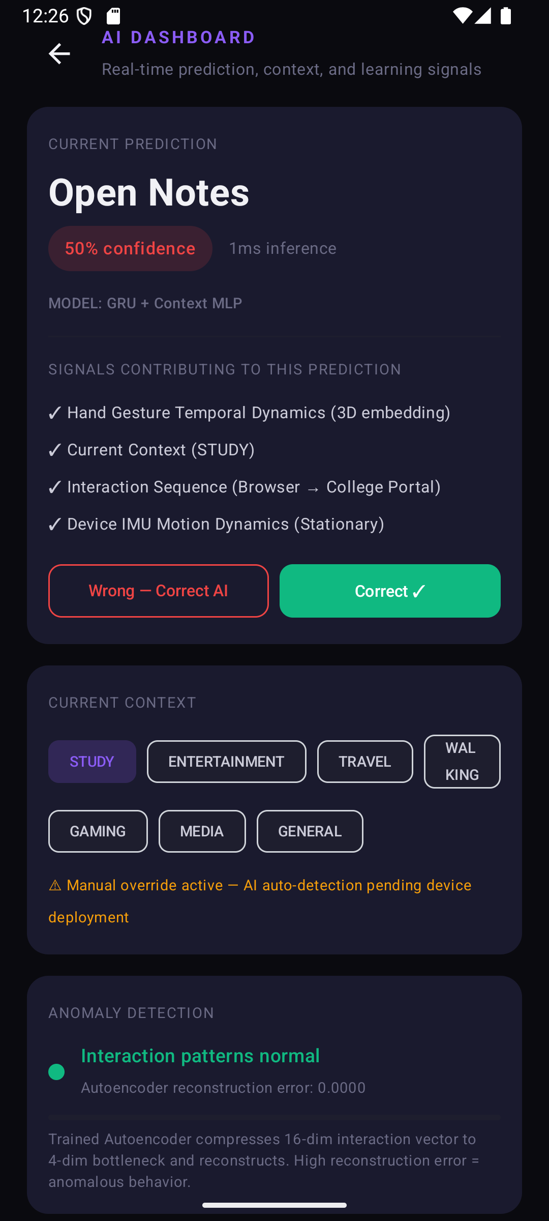
Fig. 6: Neural Network Lab — Activation functions (ReLU, Tanh, Sigmoid, Softmax) with mathematical definitions
7. GitHub Repository Link
The full source code for this project is available at the following GitHub repository (to be uploaded upon project submission):
The repository contains:
- Complete Android Studio project (Kotlin + Jetpack Compose)
- All five neural network implementations (MLP, LSTM, GRU, Transformer, Autoencoder)
- SensorFusionManager, MultimodalFusionEngine, NeuroDatabaseHelper
- All six Compose UI screens
- Unit tests (7 passing — ML classifiers, DB operations, sensor fusion)
- Build instructions and APK in Releases tab

