BlazeDemo Flight Booking Automation Framework

Prepared By: Pranshu Mishra
Framework: Selenium WebDriver + Java + TestNG + Maven + POM
Project Type: Web Automation Testing

Repository: https://github.com/PRANSHU9999/Capstone_Project

Project Overview
The BlazeDemo Flight Booking Automation Framework is designed to automate the end-to-end flight booking workflow of the BlazeDemo web application.
The framework follows the Page Object Model (POM) architecture and incorporates TestNG, Maven, Extent Reports, Data-Driven Testing, Jenkins CI/CD integration, Screenshot Capture Mechanism, and Cross-Browser Testing capabilities.
The framework aims to reduce manual testing effort, improve test coverage, ensure repeatability, and provide detailed execution reporting.

Objective of the Project:
- Automate flight booking workflow
- Validate search and booking functionality
- Implement Data-Driven Testing
- Capture screenshots automatically
- Generate detailed reports
- Execute tests through Jenkins
- Demonstrate Cross-Browser Testing
- Identify application defects
- Follow industry-standard automation practice

Technologies Used
- Java
- Selenium WebDriver
- TestNG
- Maven
- Apache POI
- Extent Reports
- Jenkins
- Git
- GitHub
- Eclipse IDE
- Firefox
- Chrome
- Edge

Framework Architecture

Base Package
Contains:
- BaseTest.java
Responsible for:
- Browser Initialization
- Browser Closure
- Test Setup

Pages Package

Contains:
- HomePage.java
- FlightSelectionPage.java
- PurchasePage.java
- ConfirmationPage.java

Purpose:
Implementation of Page Object Model.

Utilities Package

Contains:
- ConfigReader.java
- DriverFactory.java
- ExcelUtils.java
- ExtentManager.java
- ScreenshotUtil.java
- WaitUtils.java

Listeners Package

Contains:
- TestListener.java

Purpose:
- Extent Report Integration
- Screenshot Capture on Failure

DataProviders Package

Contains:
- BookingDataProvider.java

Purpose:
Data-Driven Testing through Excel.

Automated Test Cases

LaunchTest

Objective:
Verify BlazeDemo launches successfully.

Expected Result:
Home Page displayed successfully.

SearchFlightTest

Objective:
Verify user can search flights.

Expected Result:
Flight results page displayed.

EndToEndBookingTest

Objective:
Verify complete booking workflow.

Flow:
Launch Application
↓
Search Flight
↓
Select Flight
↓
Enter Passenger Details
↓
Purchase Ticket
↓
Verify Confirmation

Expected Result:
Booking confirmation generated successfully.

7. Data-Driven Testing
Excel file is used to provide multiple booking datasets.

Fields:
- Source City
- Destination City
- Passenger Name
- Address
- City
- State
- Zip Code
- Card Number
- Card Type
- Name on the card

Benefits:
- Increased coverage
- Reusable test scripts
- Faster execution

8. Cross-Browser Testing
Framework supports:

Chrome
Primary execution browser.

Firefox
Cross-browser validation.

Edge
Cross-browser validation.

9. Reporting Mechanism

TestNG Reports
Location:
test-output/index.html
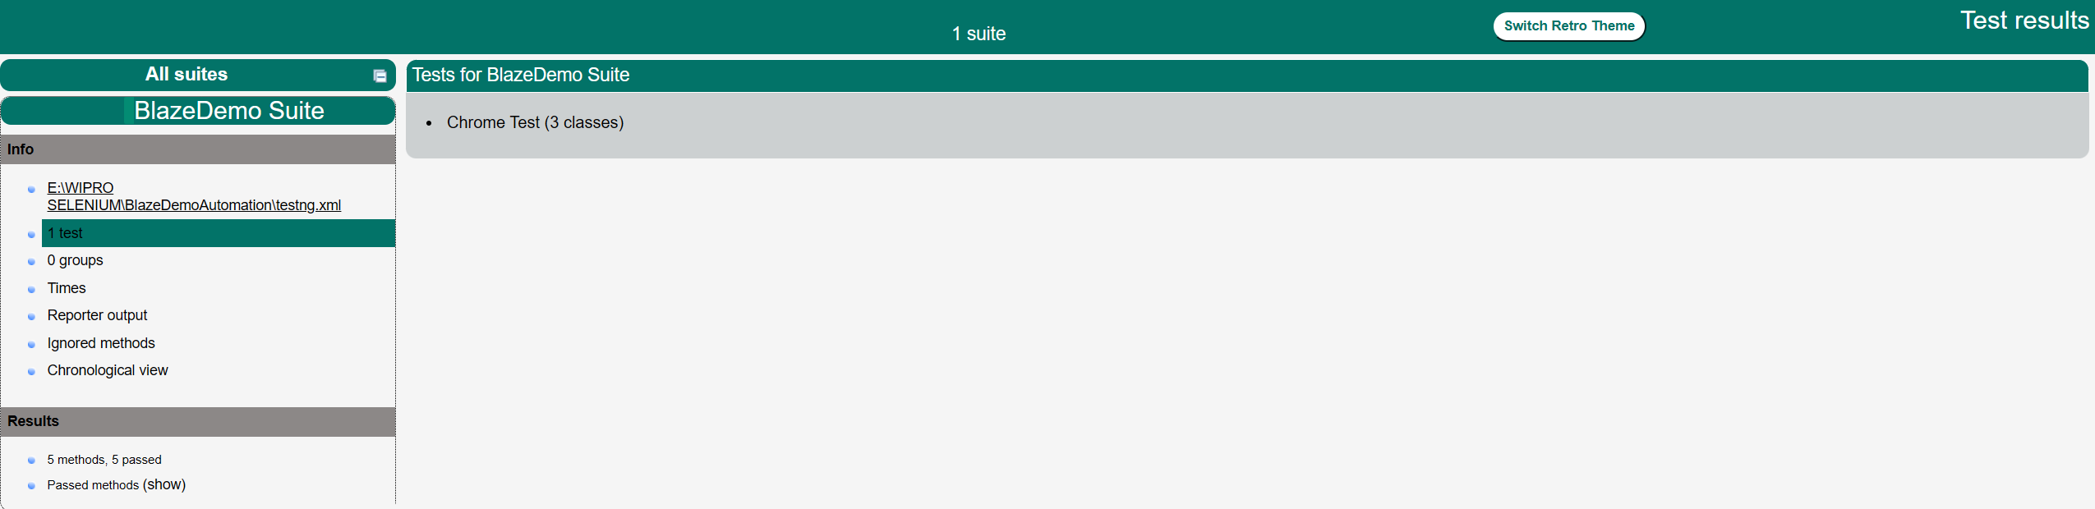
Provides:
- Passed Tests
- Failed Tests
- Skipped Tests
- Execution Summary

Extent Reports
Location:
reports/ExtentReport.html
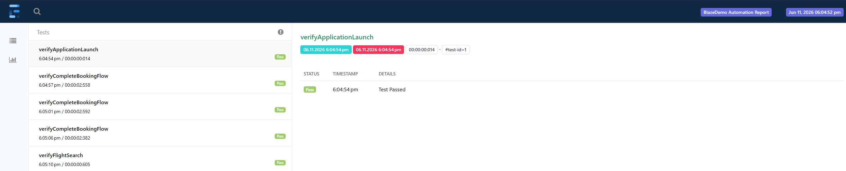
Provides:
- Interactive Dashboard
- Pass/Fail Status
- Detailed Logs
- Screenshots
- Execution Timeline

Defect Suite Reports

Location:
test-output/BlazeDemo Defect Suite/

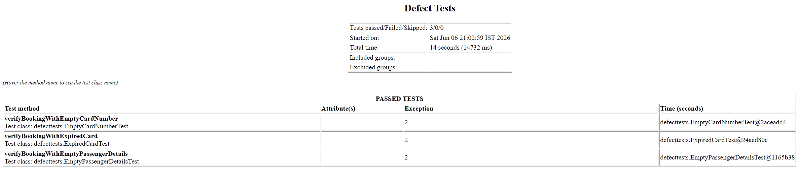
Provides:
• Defect Validation Results
• Negative Test Case Execution
• Failed Validation Tracking

Cross-Browser Execution Reports
Location:
test-output/Cross Browser Suite/
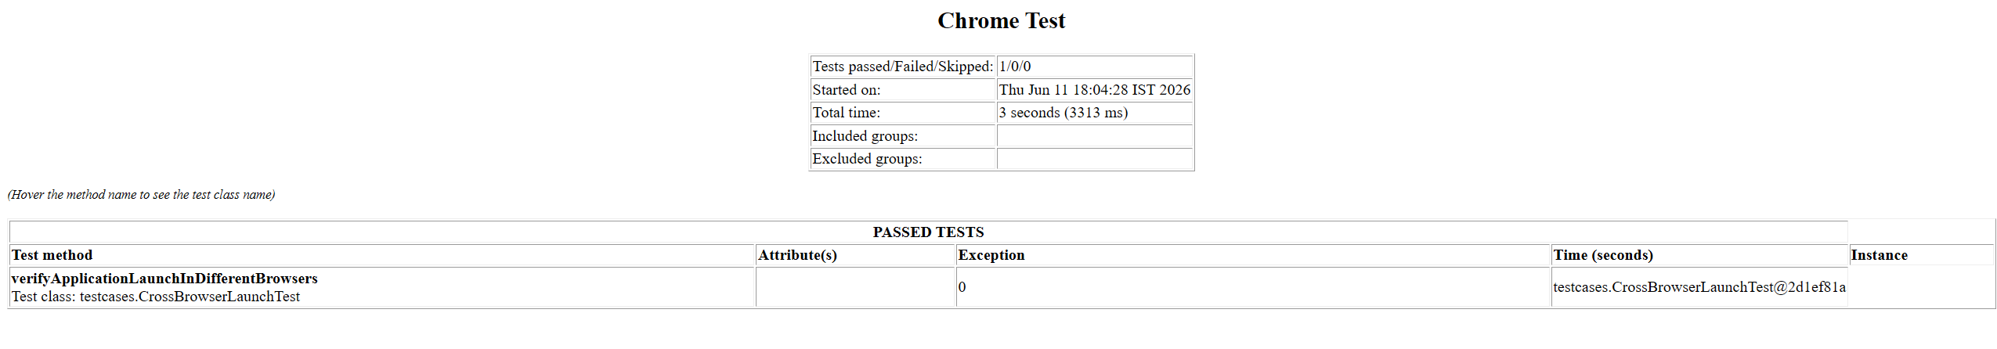

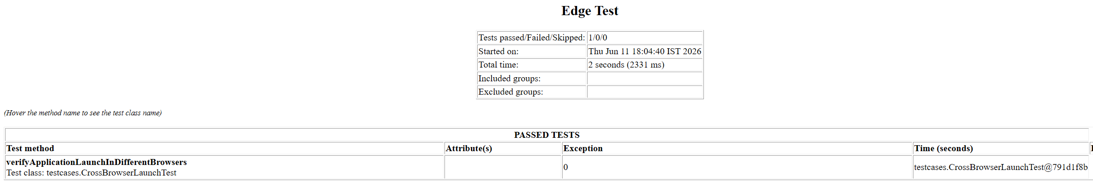

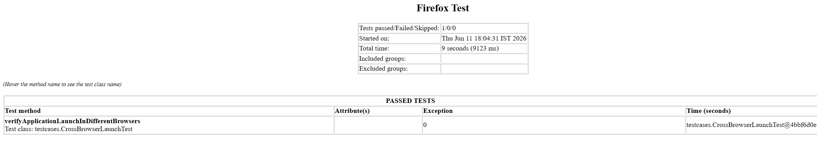
Provides:
• Chrome Execution Results
• Firefox Execution Results
• Edge Execution Results

10. Screenshot Capture
Screenshots are automatically captured:
- On Test Failure
- During Important Workflow Steps
Benefits:
- Faster debugging
- Defect evidence
- Better reporting

11. Jenkins Integration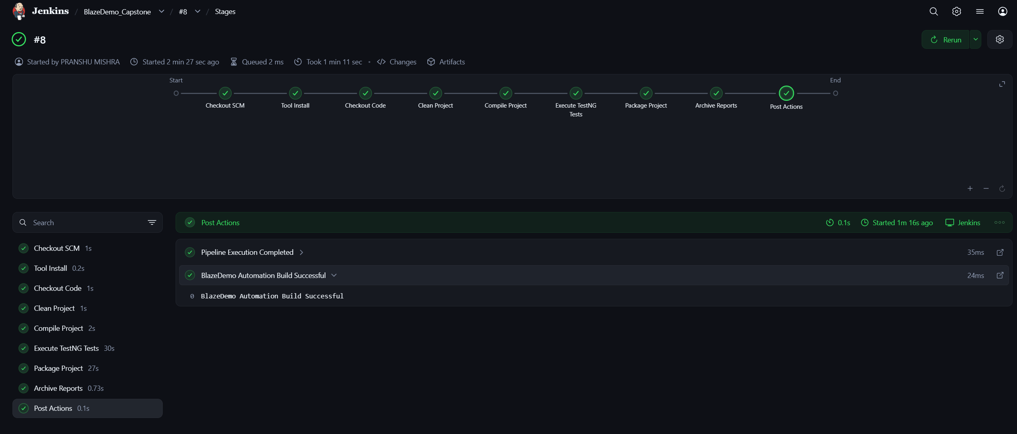
Pipeline Stages:
- Checkout Code
- Clean Project
- Compile Project
- Execute TestNG Tests
- Package Project
- Archive Reports
Benefits:
- Automated Execution
- Continuous Testing
- Build Monitoring

12. Jira Epics and User Stories

12.1 Epic – User Flight Booking Journey (CB-1)

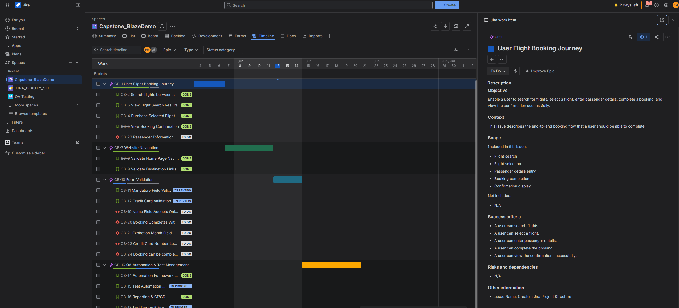

User Story – Search Flights Between Source and Destination (CB-2)
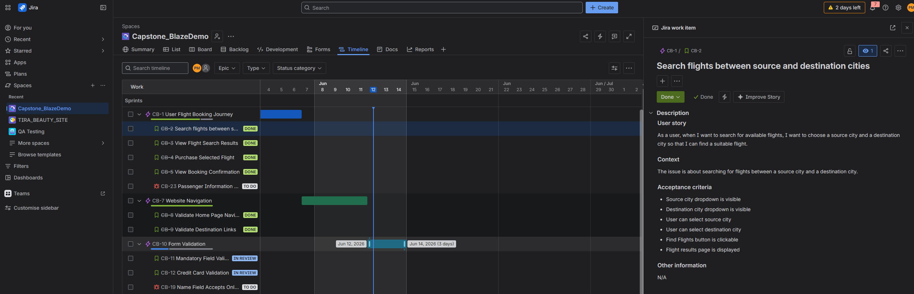

User Story – View Flight Search Results (CB-3)

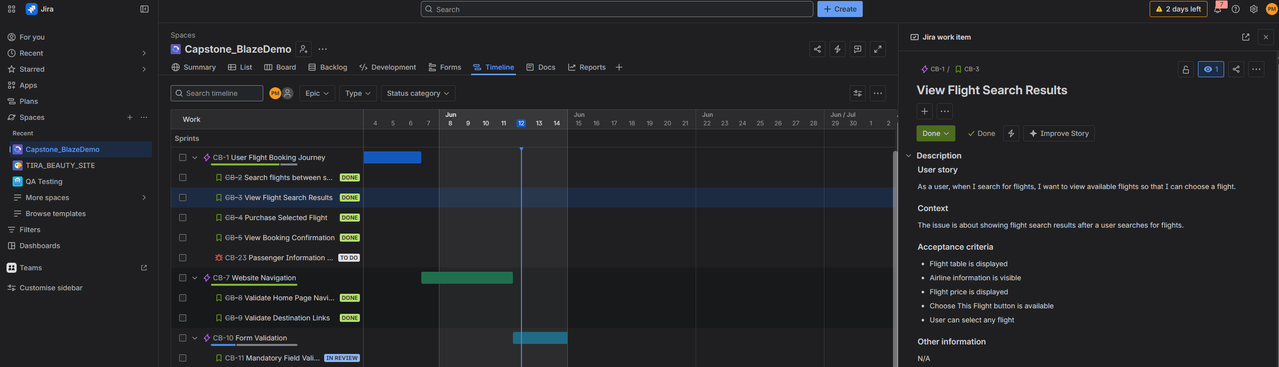User Story – Purchase Selected Flight (CB-4)
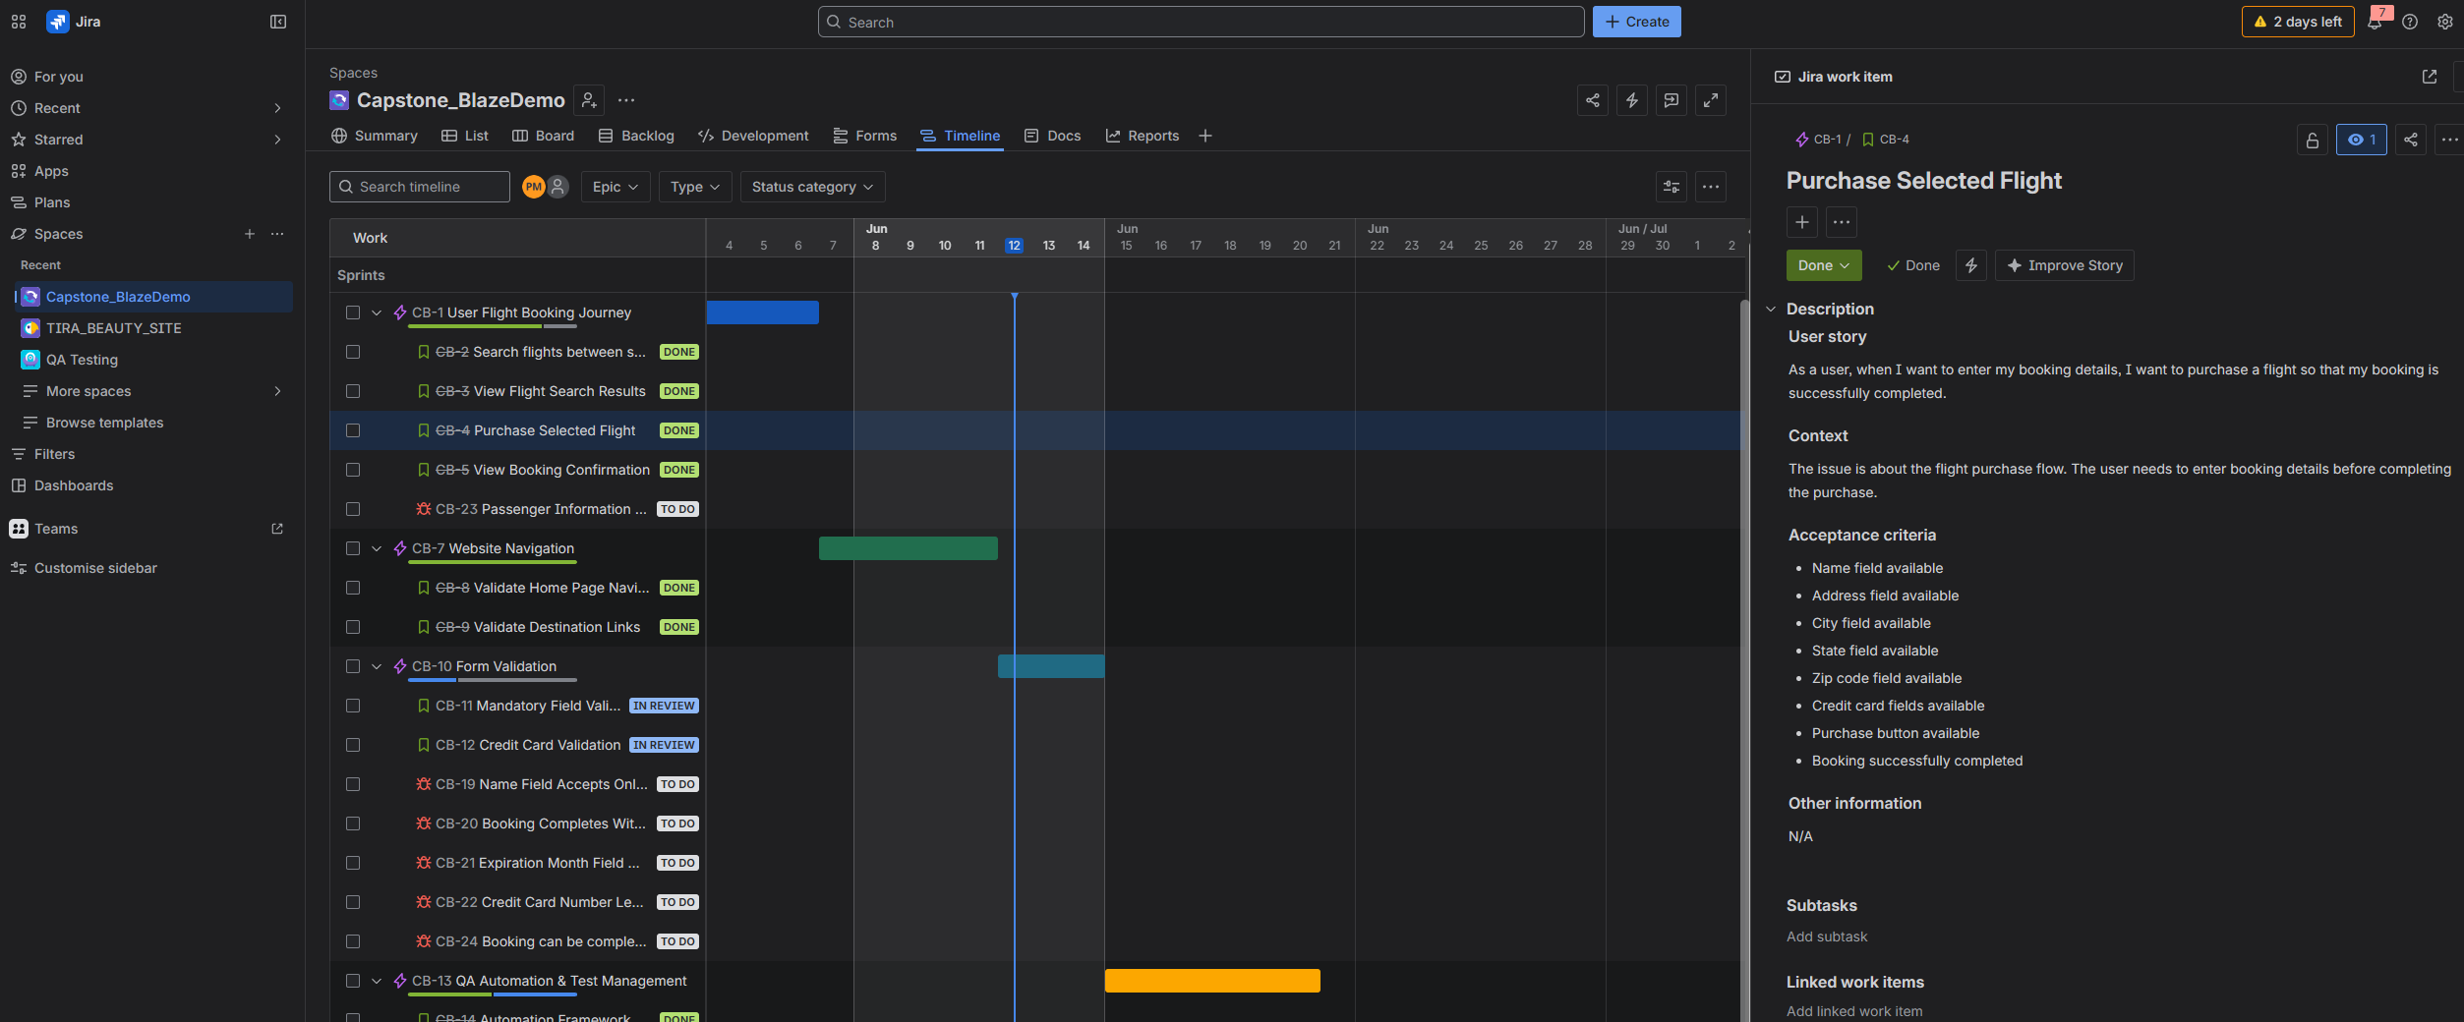

User Story – View Booking Confirmation (CB-5)
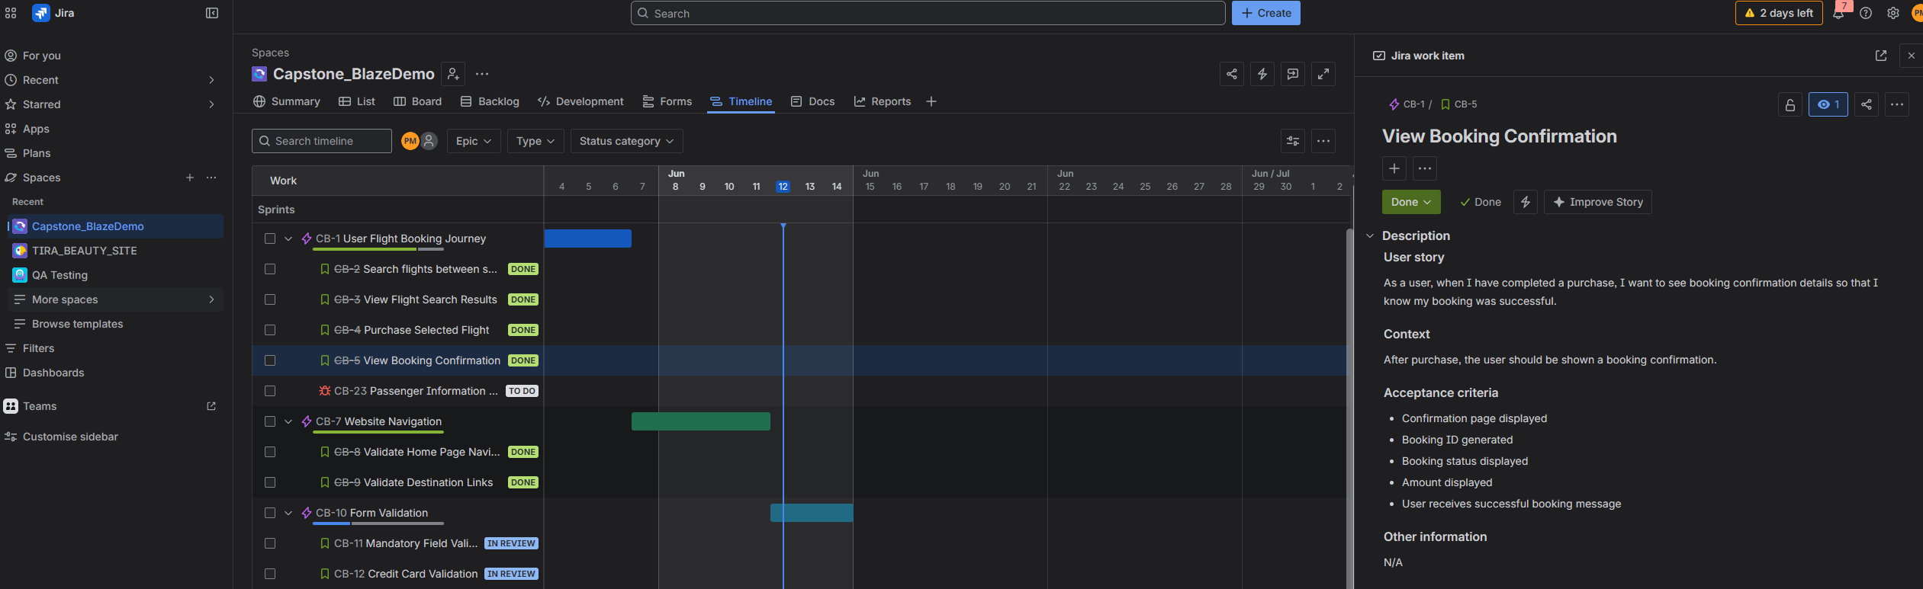

12.2 Epic – Website Navigation (CB-7)
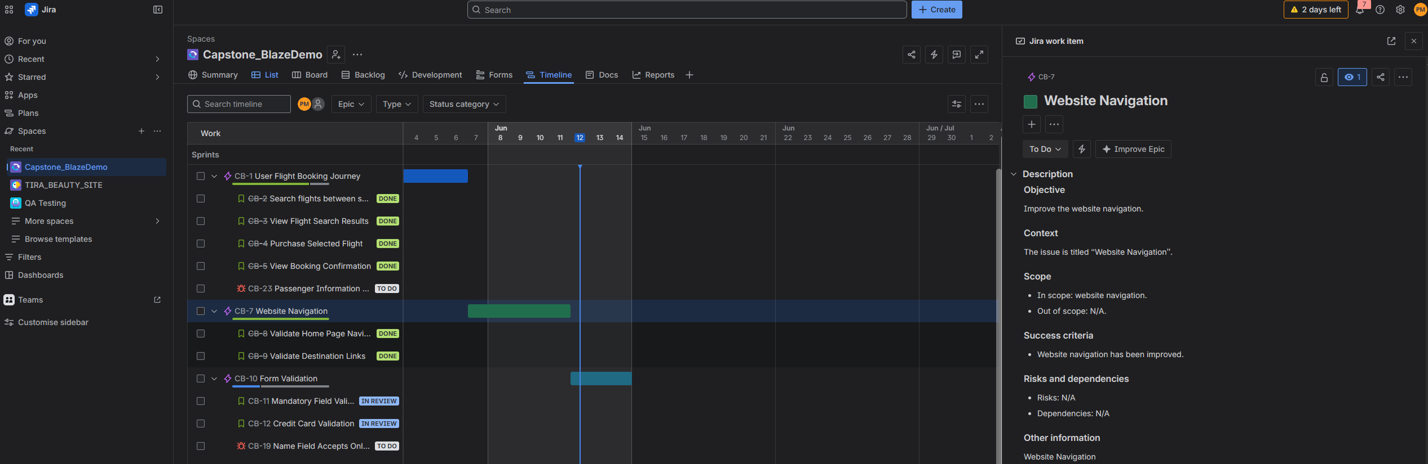

User Story – Validate Home Page Navigation (CB-8)
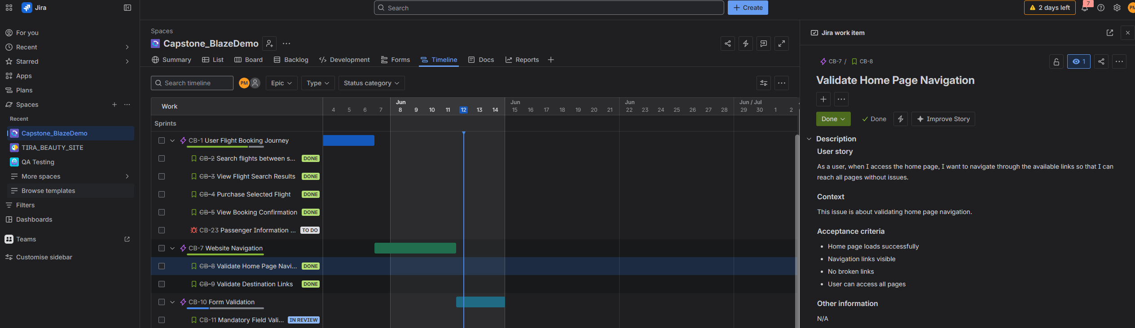

User Story – Validate Destination Links (CB-9)
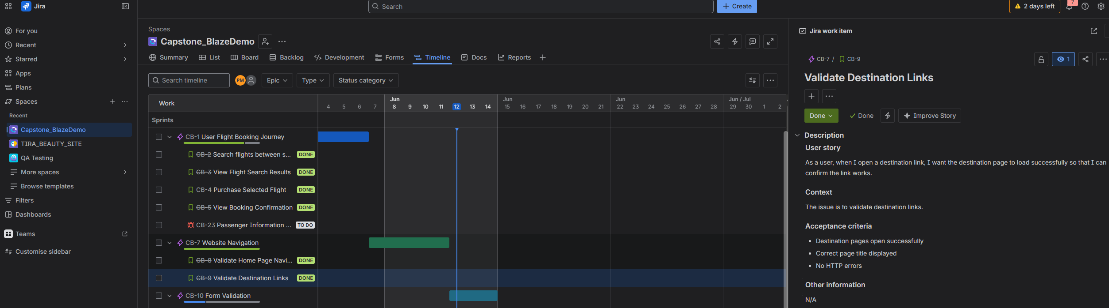

12.3 Epic – Form Validation (CB-10)
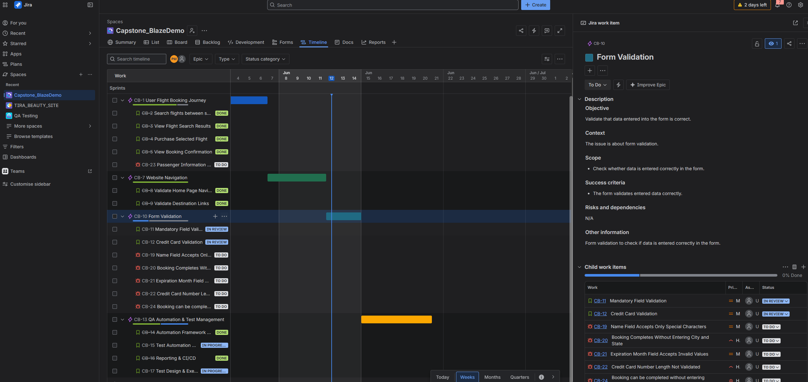

User Story – Mandatory Field Validation (CB-11)
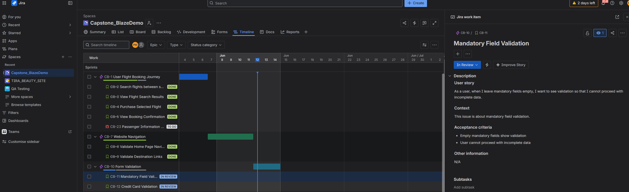

User Story – Credit Card Validation (CB-12)
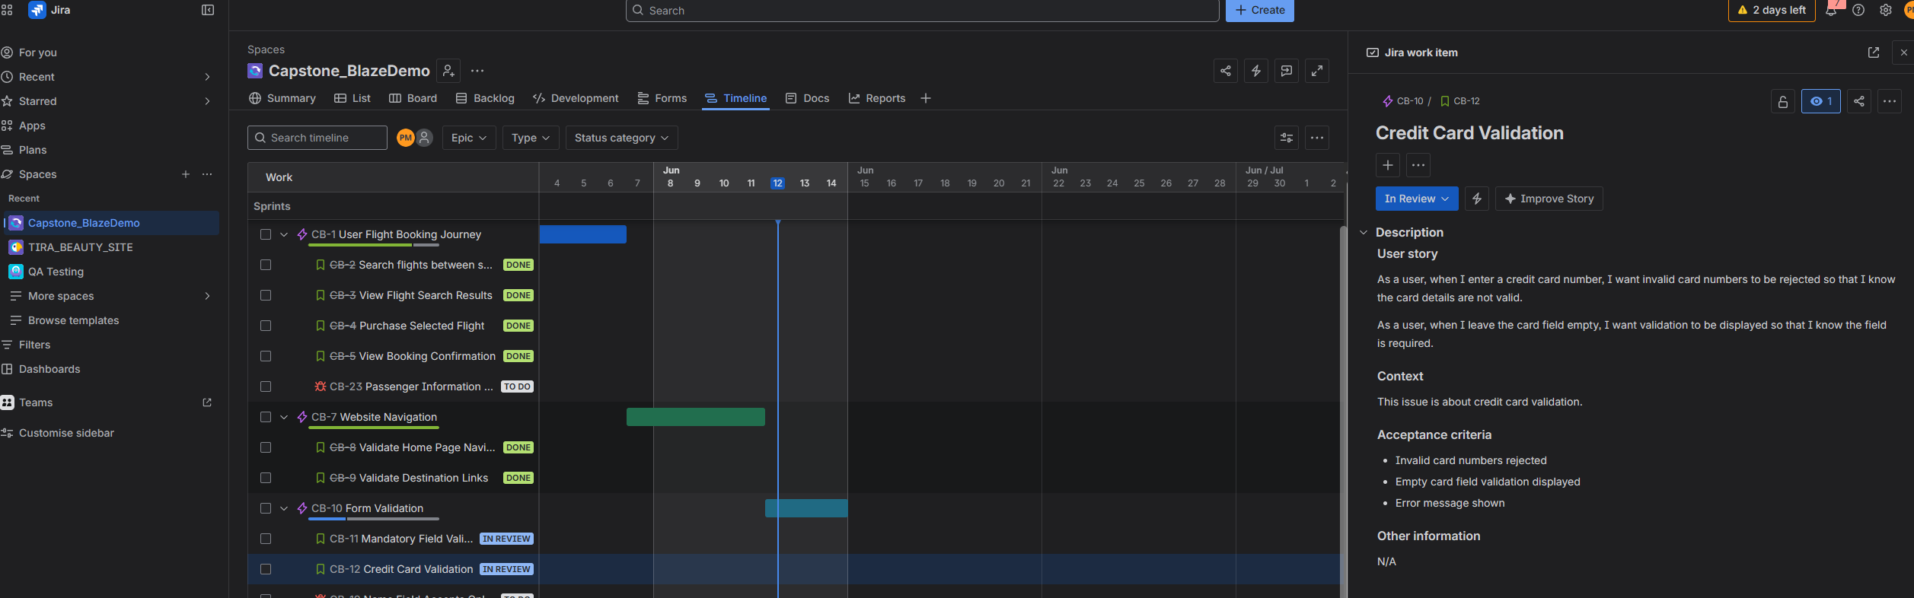

12.4 Epic – QA Automation & Test Management (CB-13)
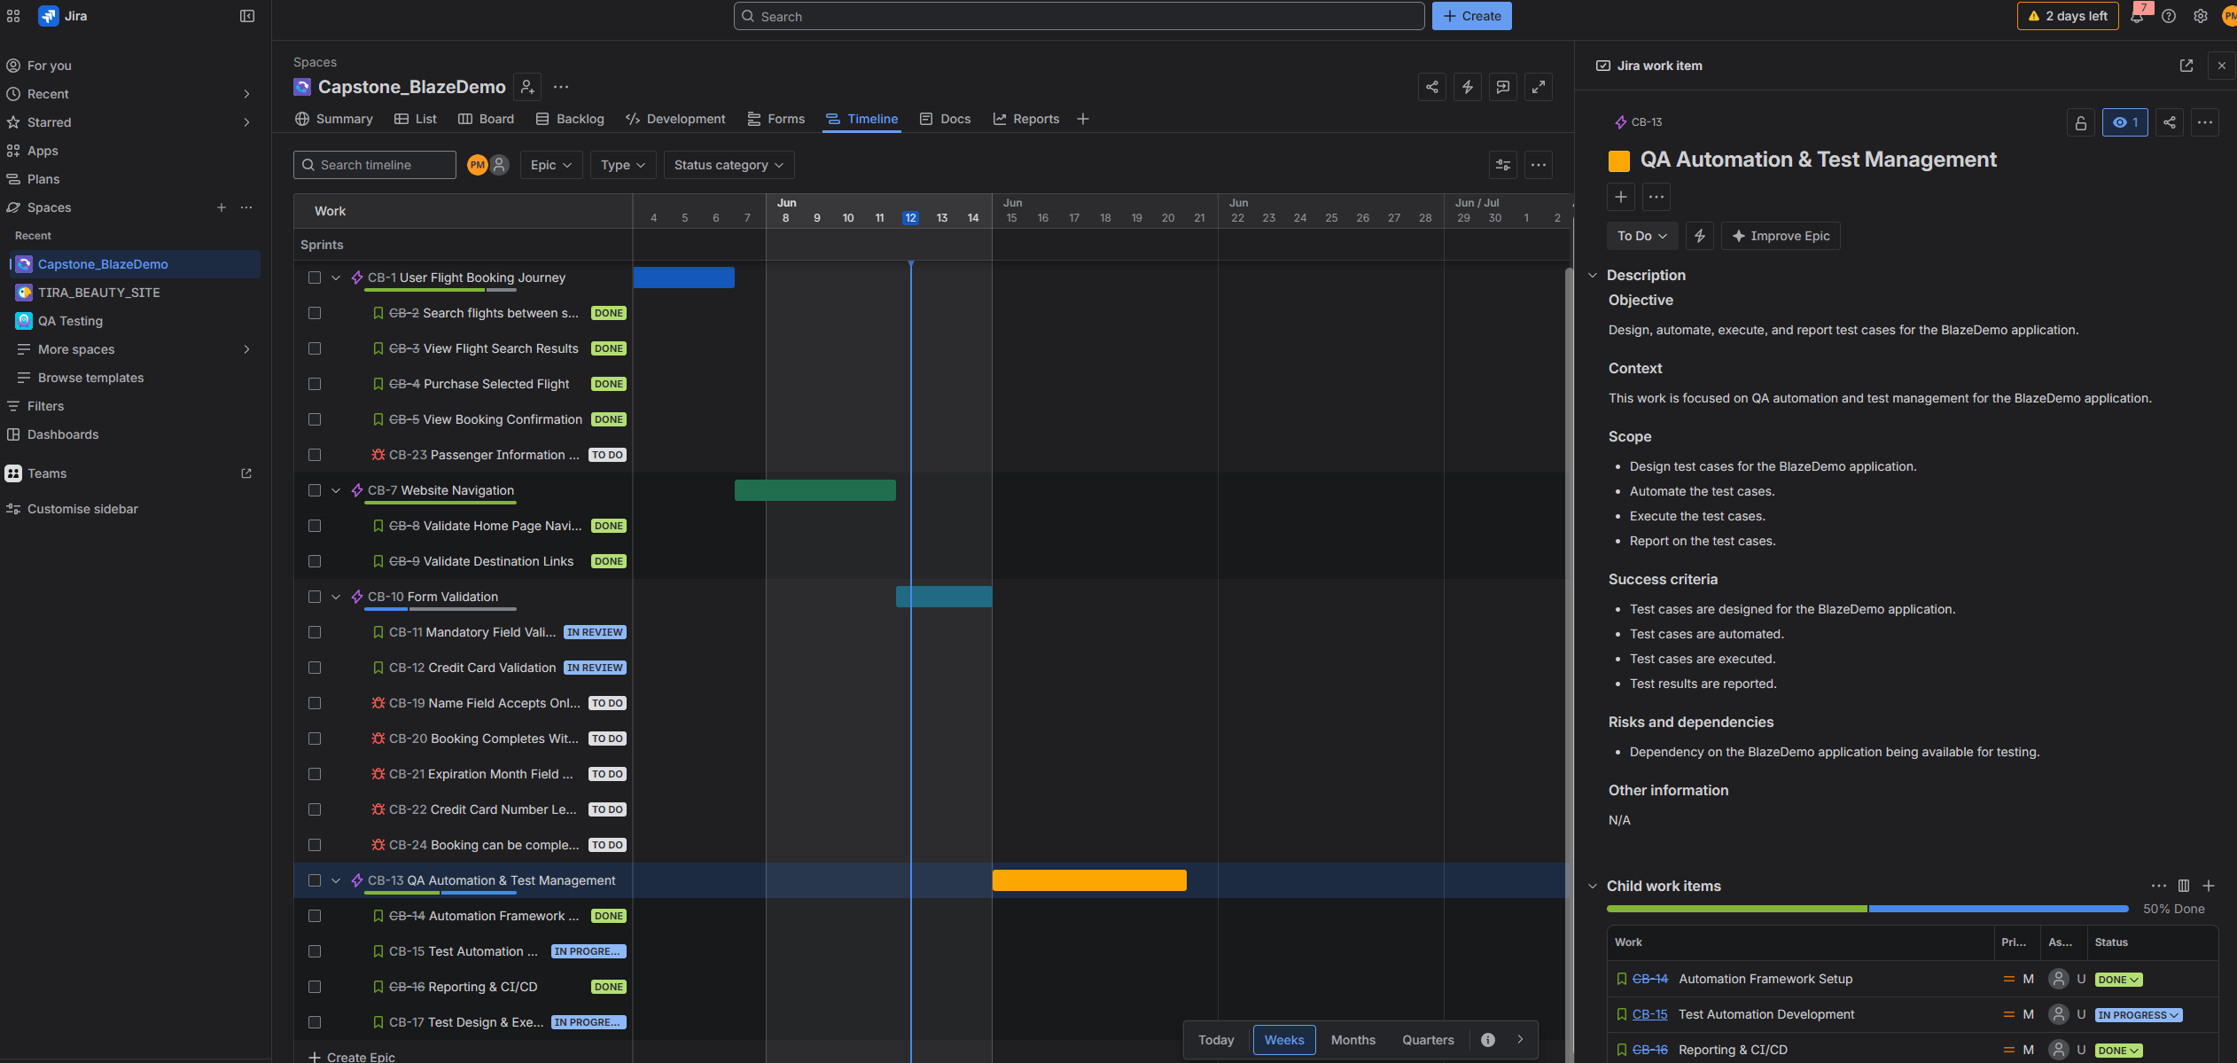

User Story – Automation Framework Setup (CB-14)
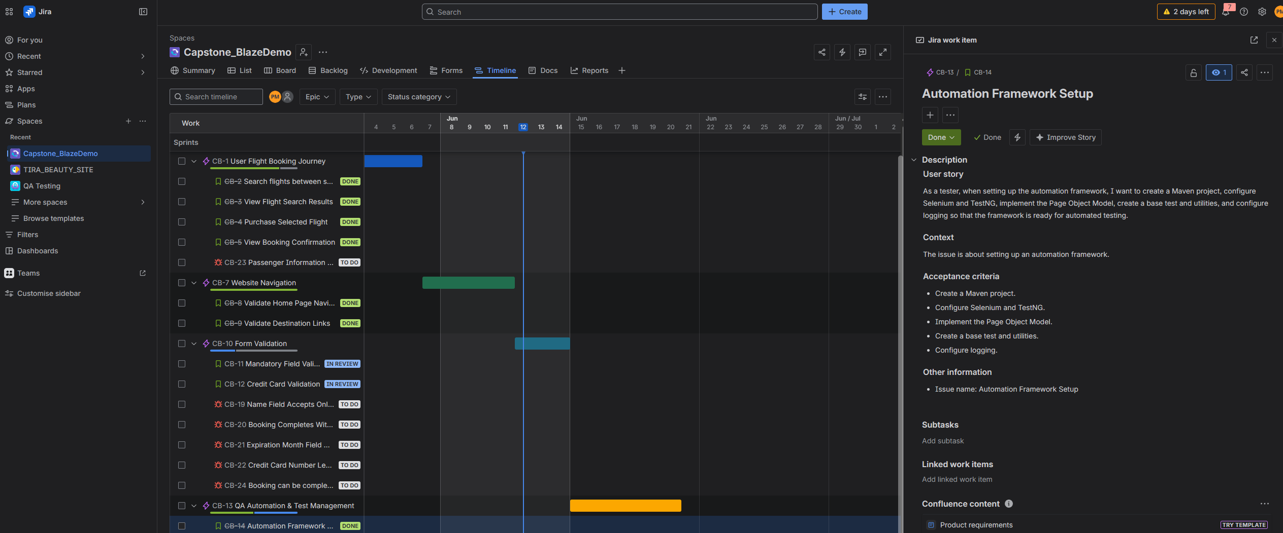

User Story – Test Automation Development (CB-15)
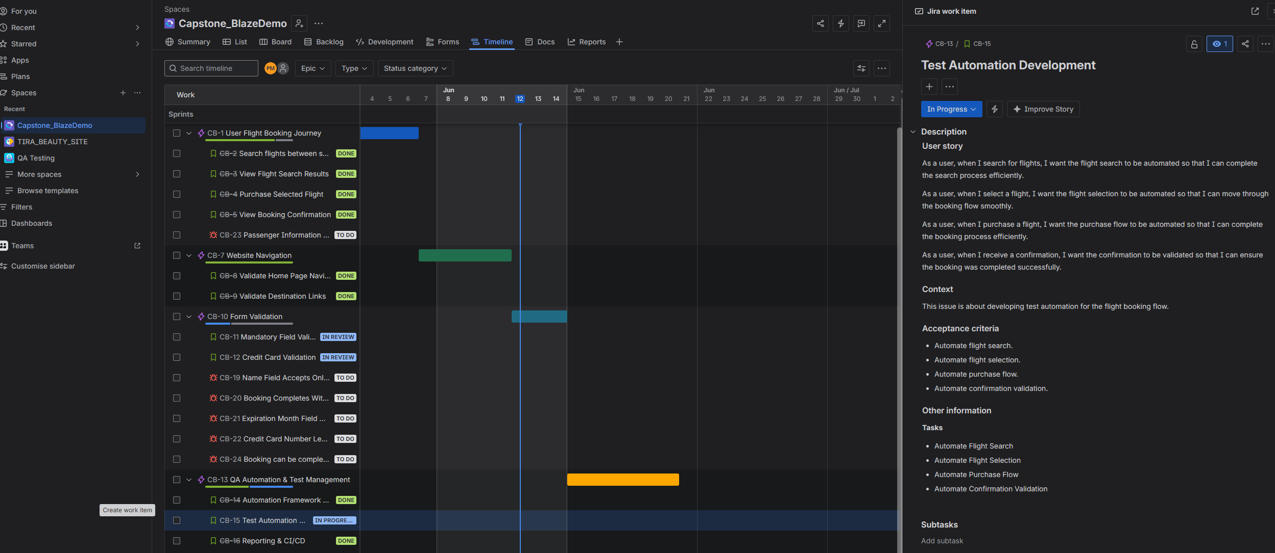

User Story – Reporting & CI/CD Integration (CB-16)
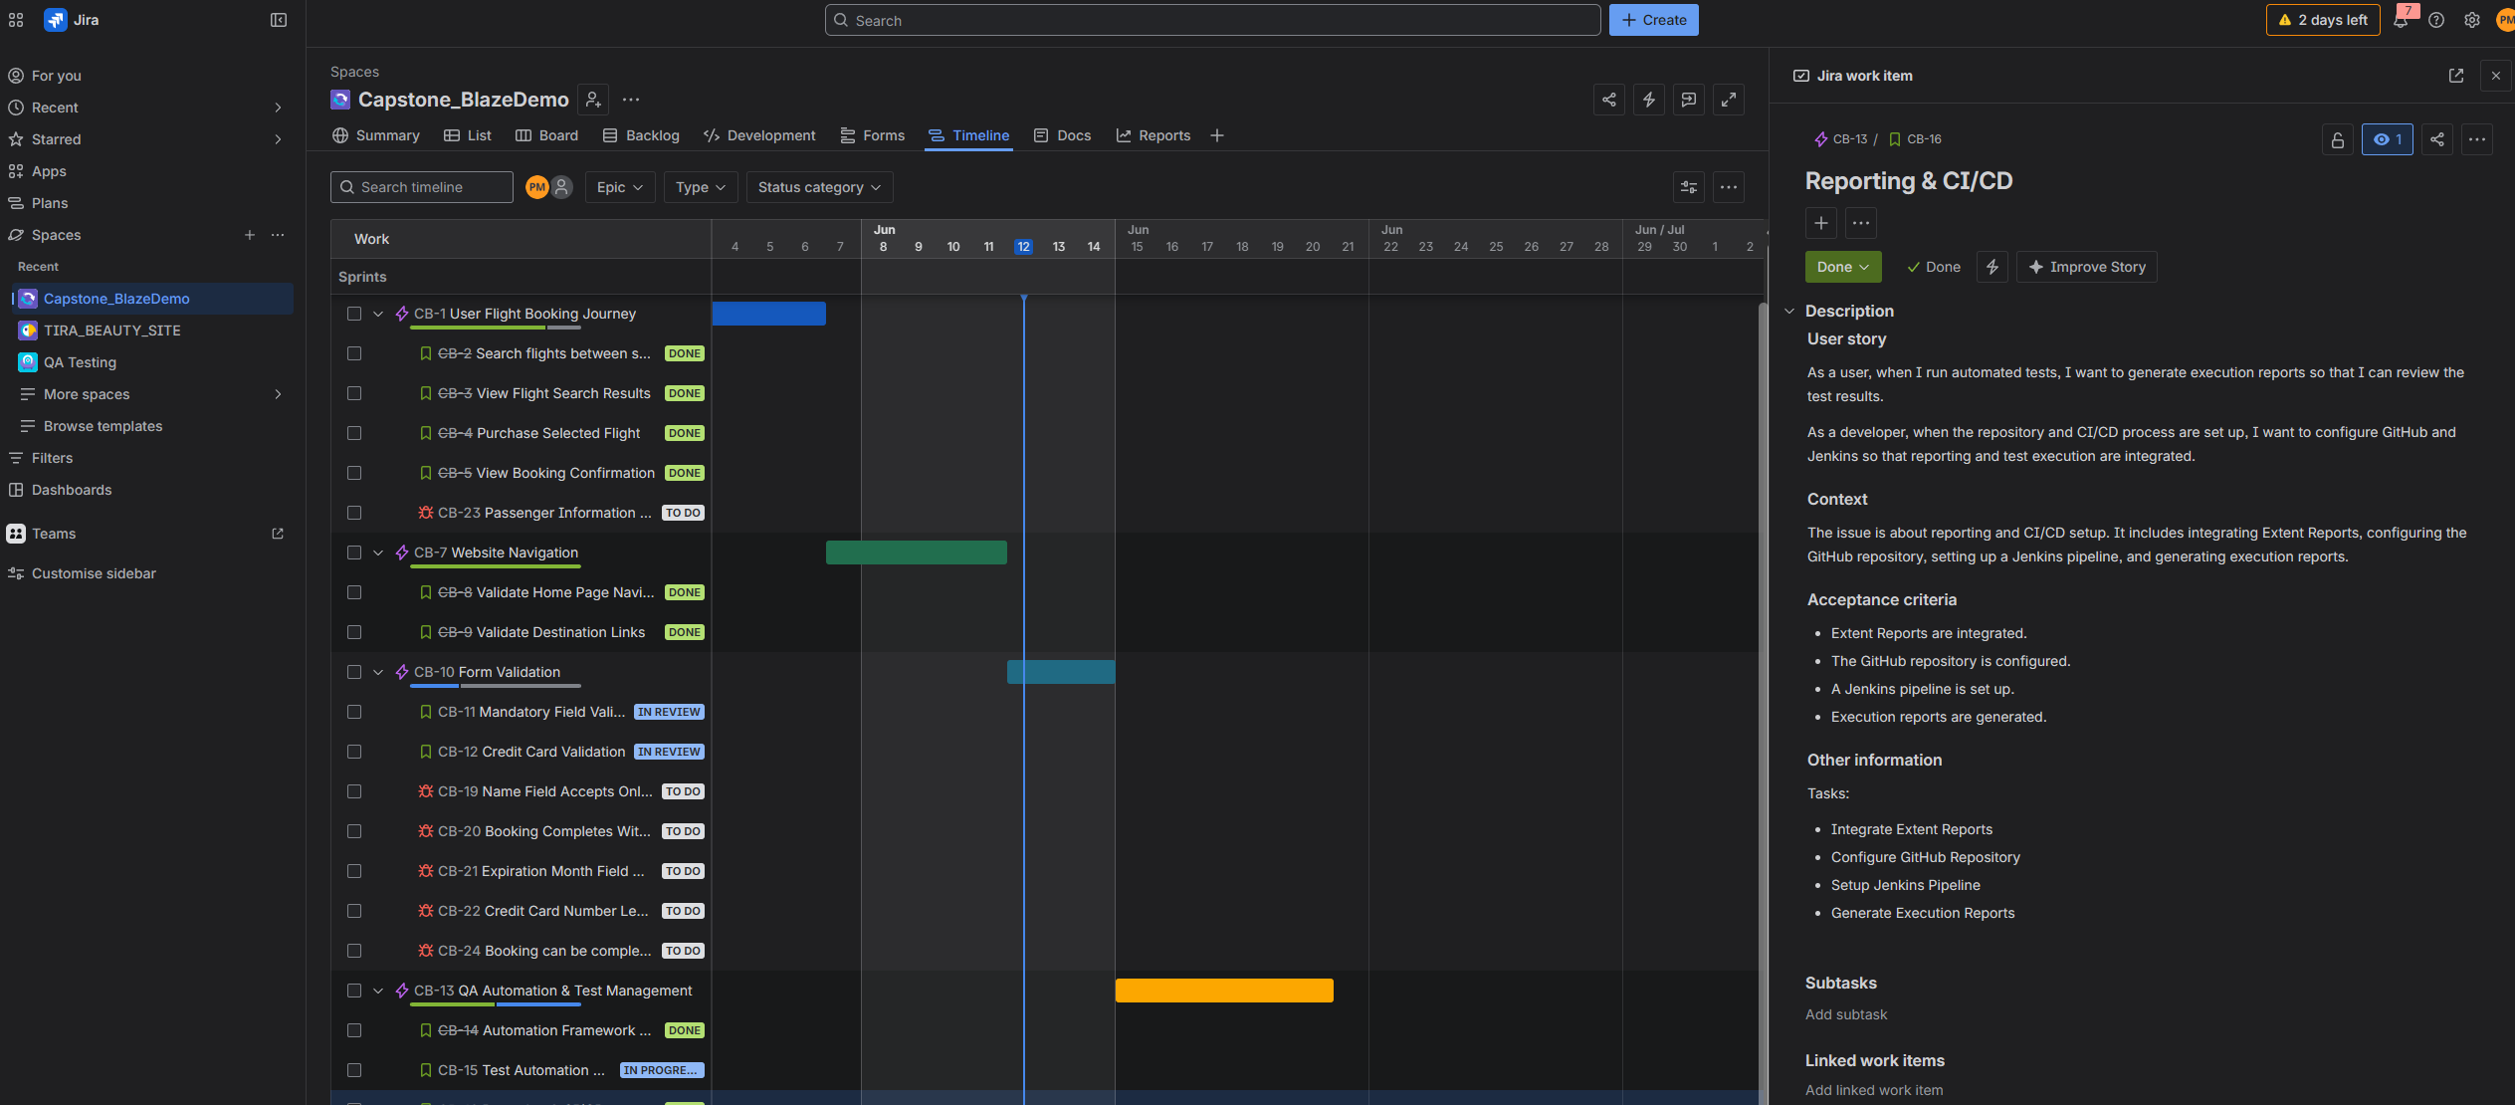

User Story – Test Design & Execution (CB-17)

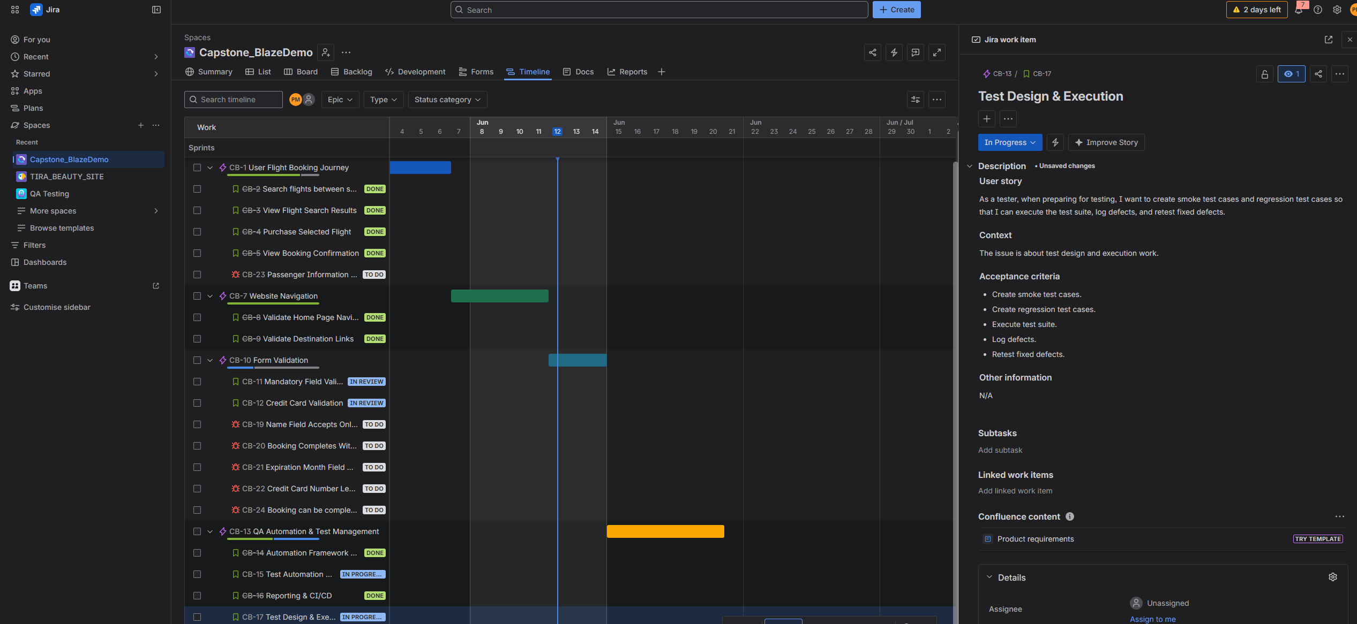

12.5 Jira Timeline Overview

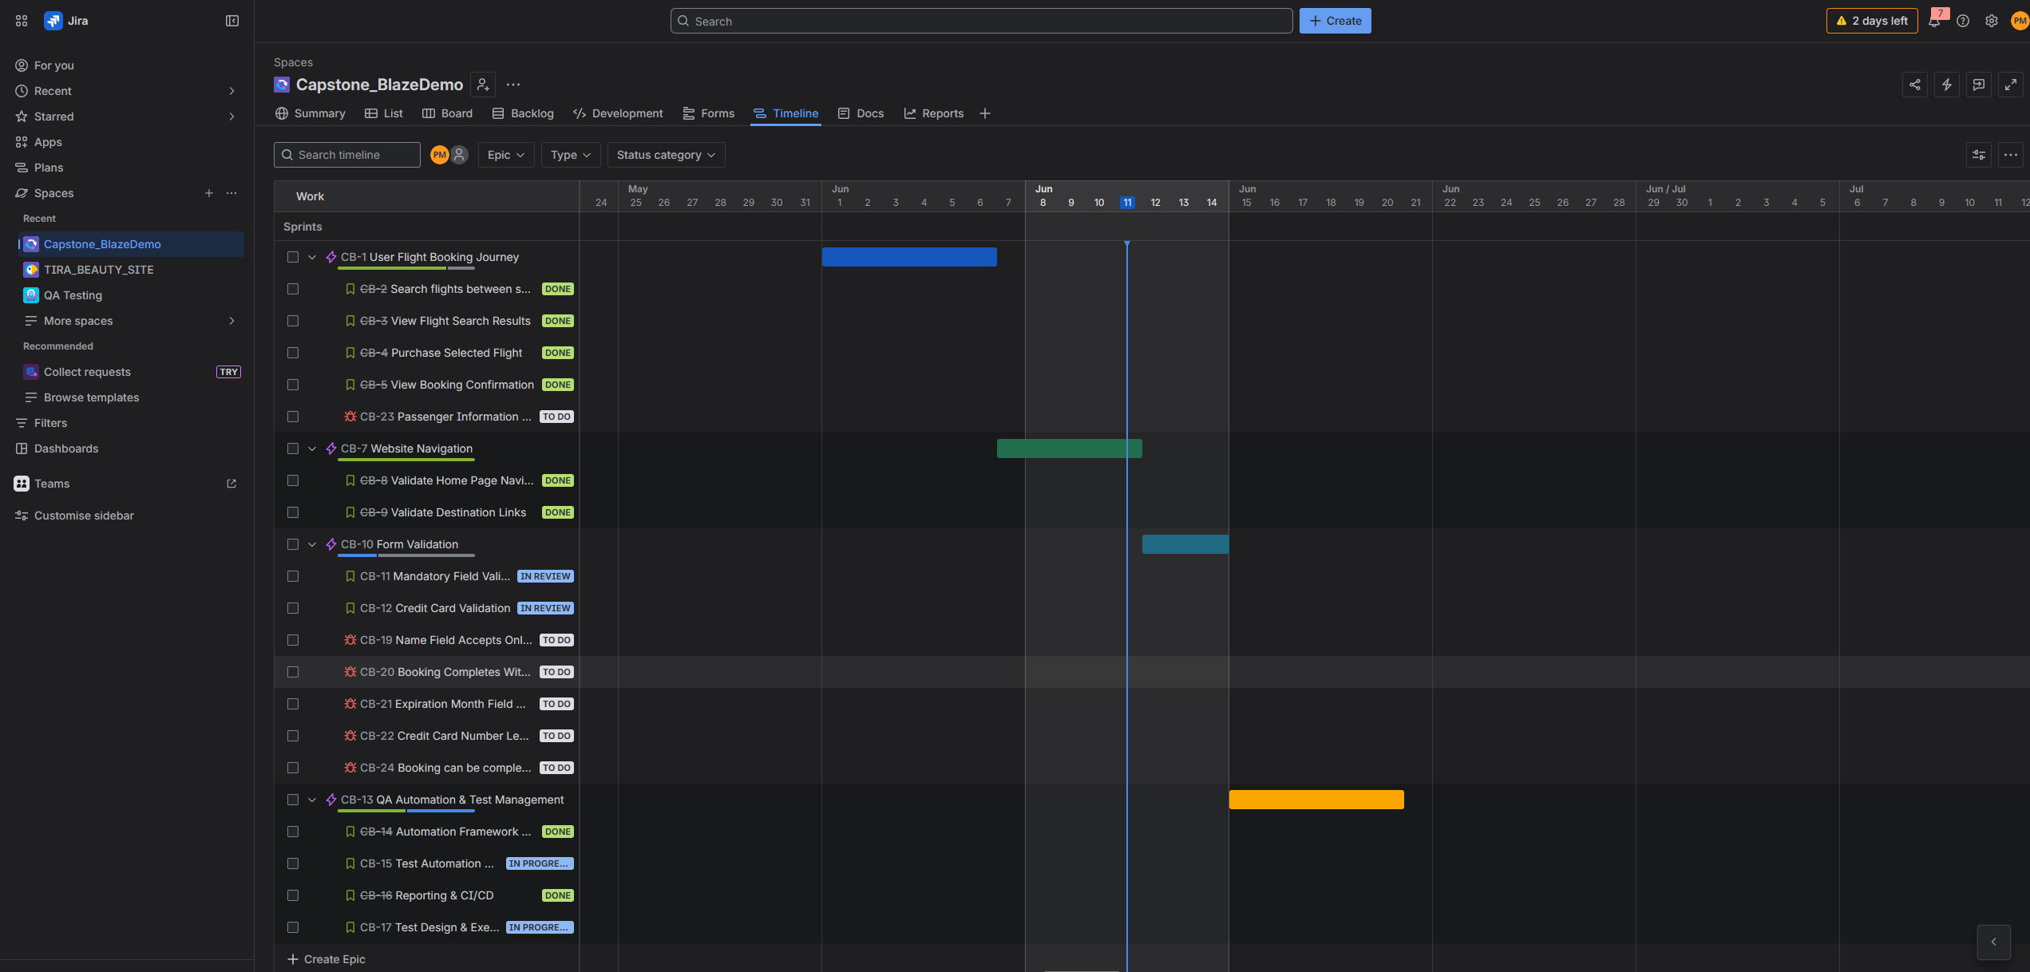

13. Defects Report

Defect 1
Name field accepts special characters.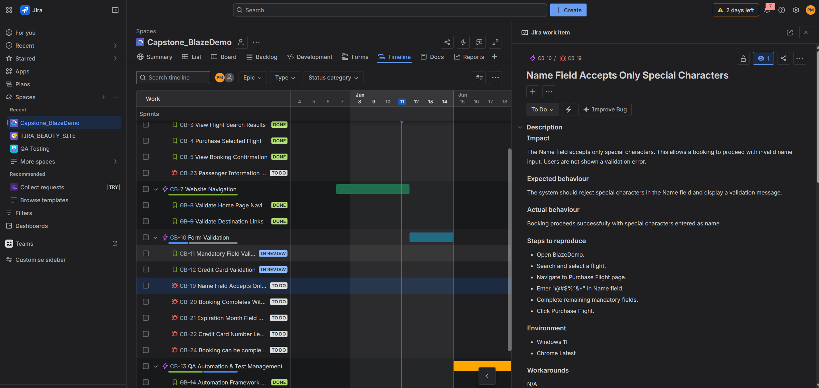

Defect 2
Booking completes without City and State.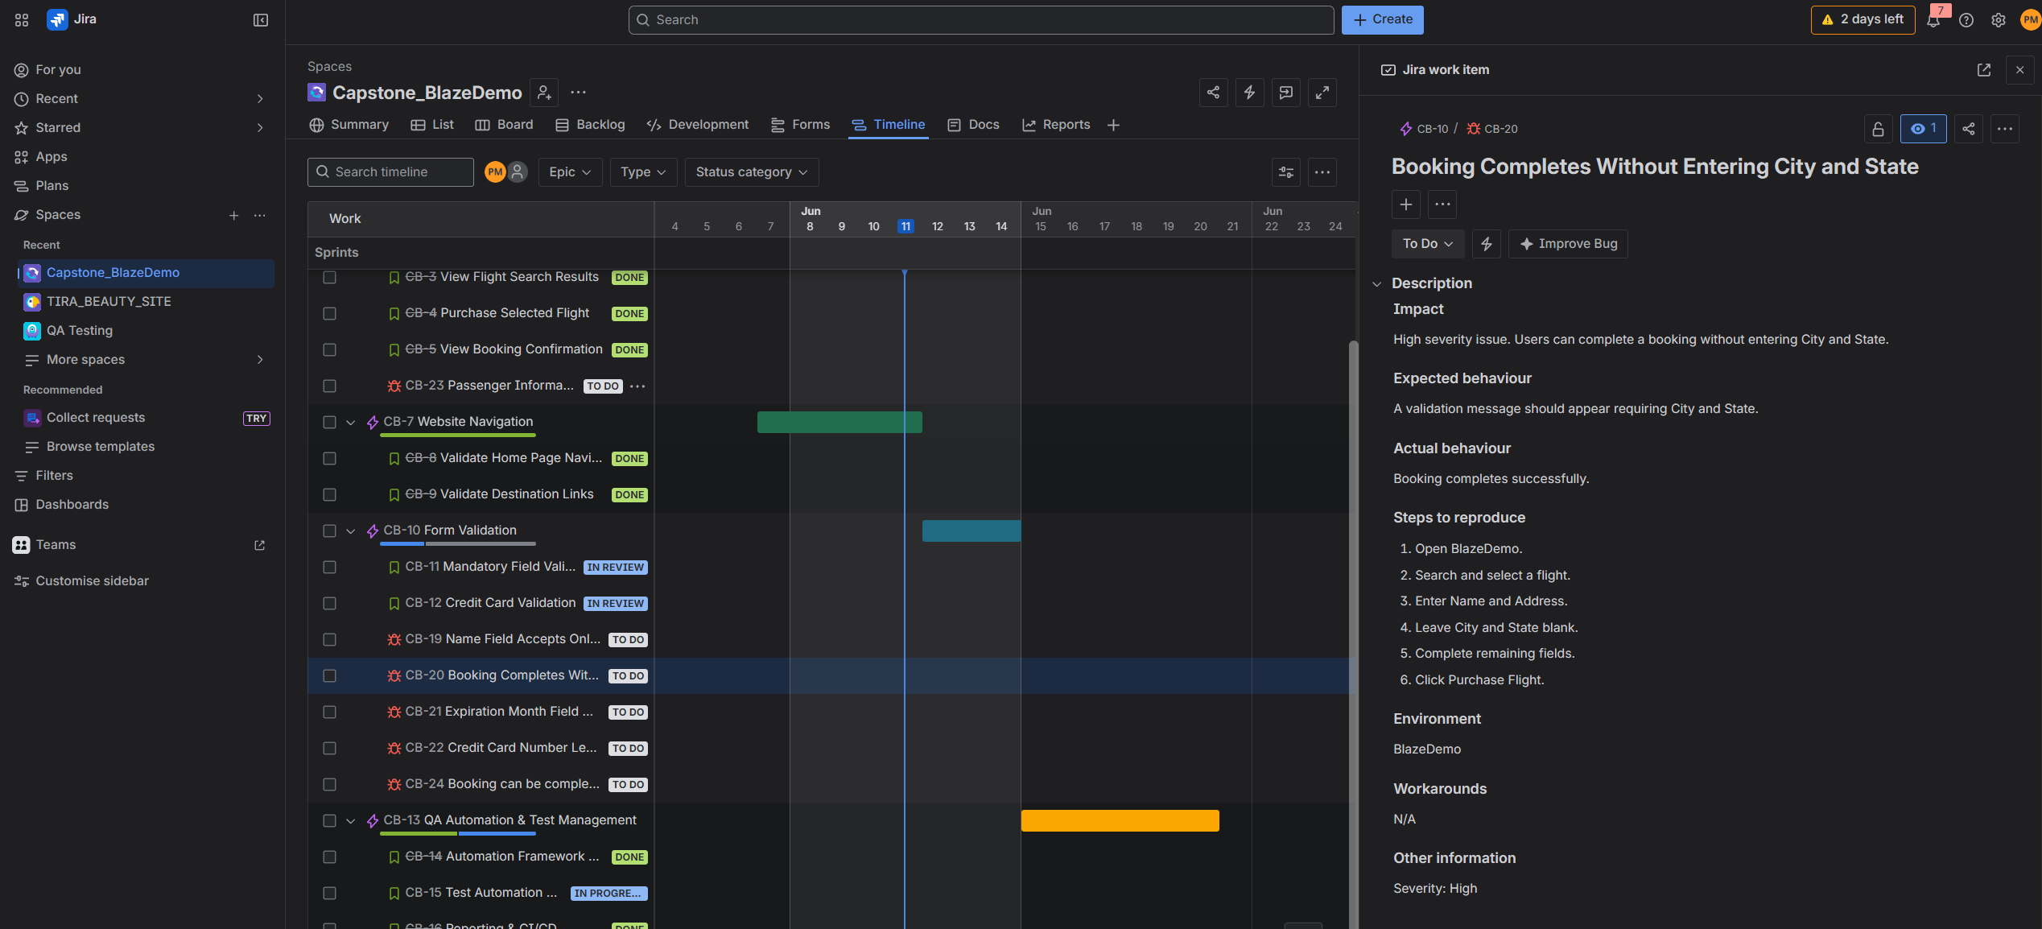

Defect 3
Invalid expiry month values accepted.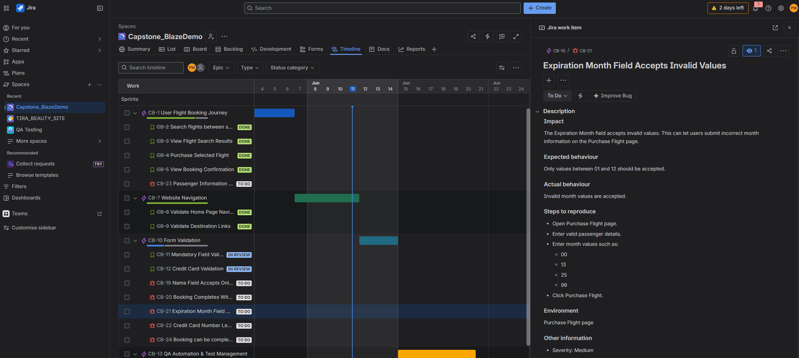

Defect 4
Credit card validation is weak. 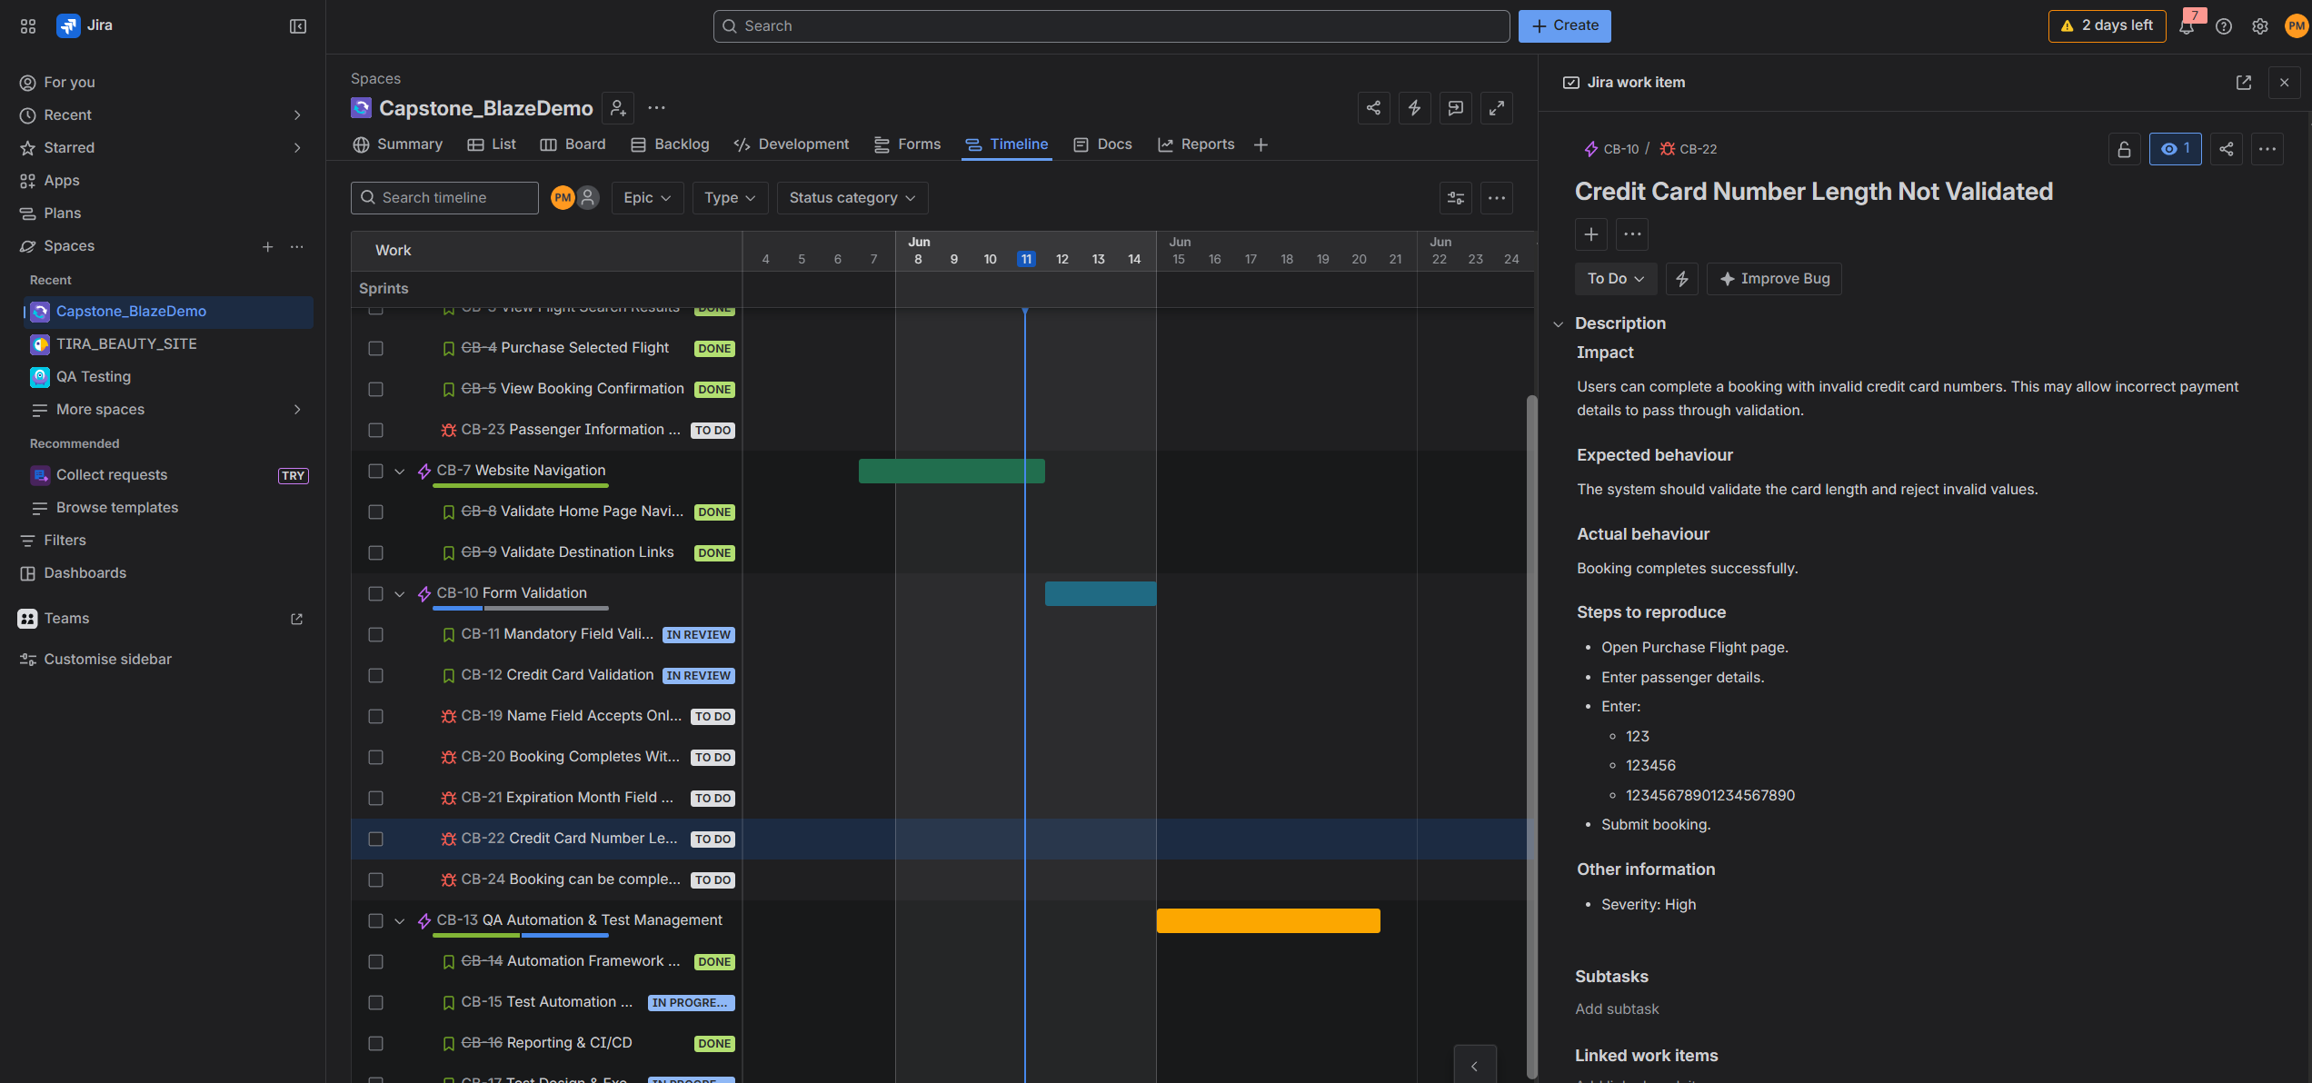

Defect 5
Passenger information mismatch on confirmation page.
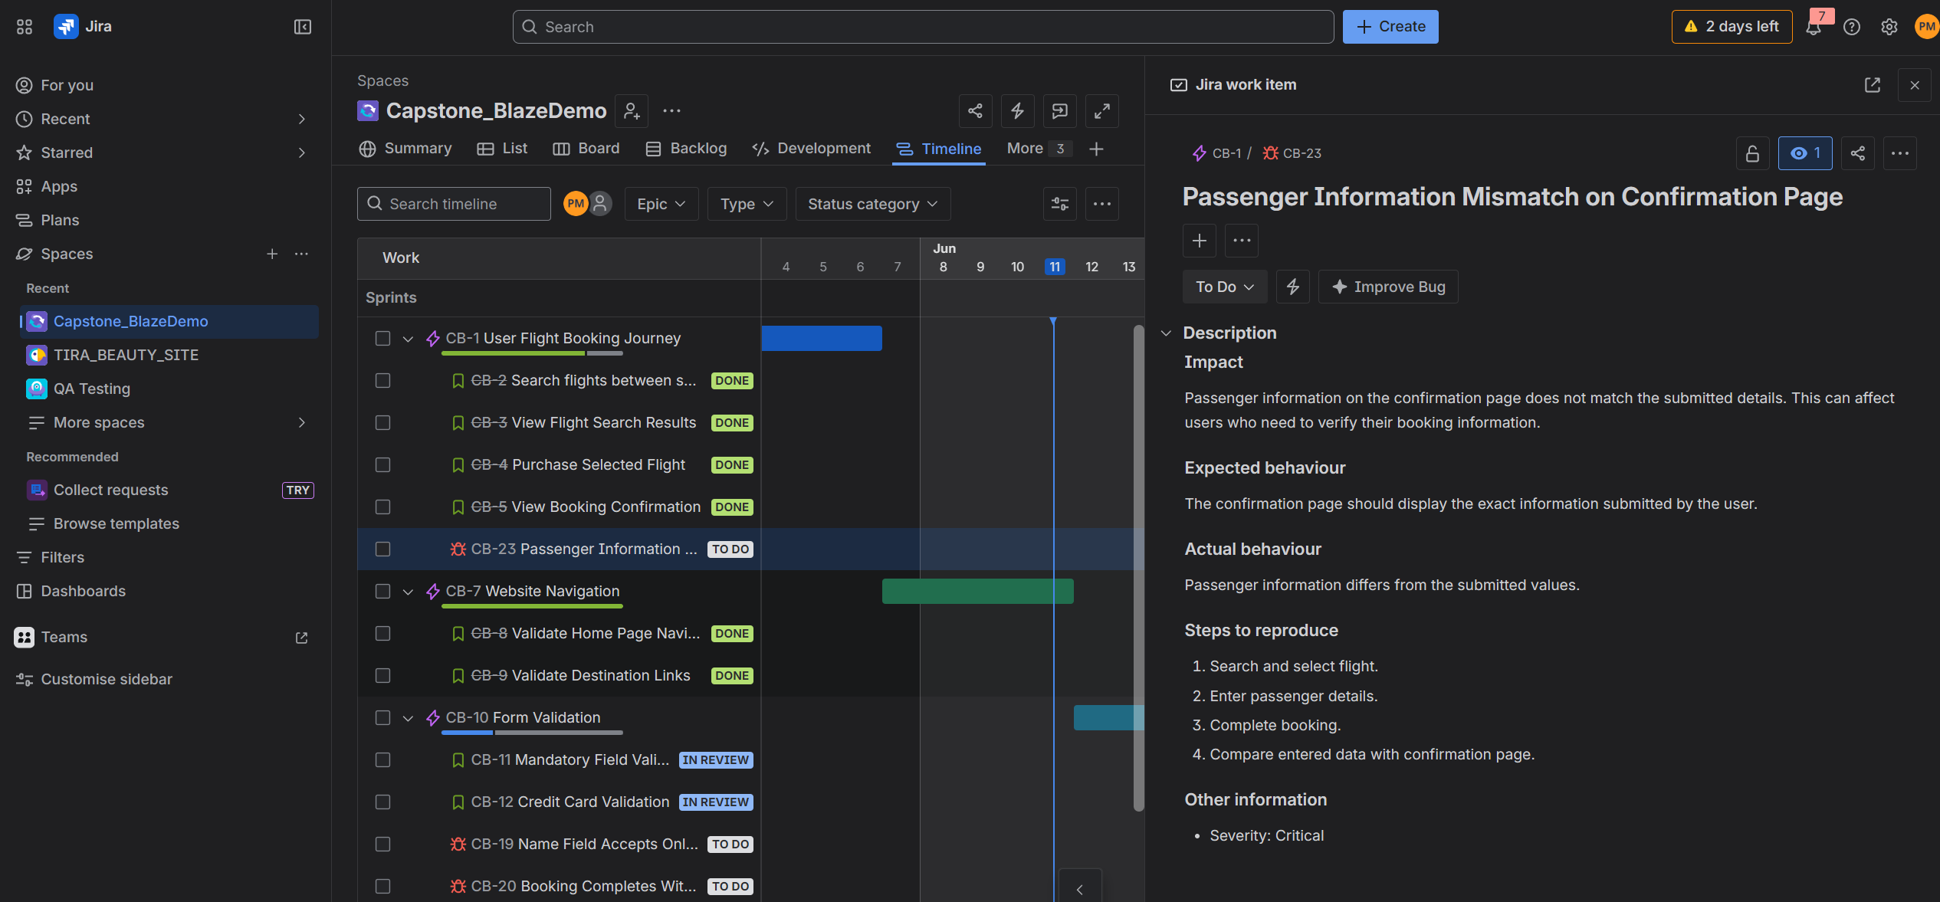

Defect 6
Booking completes without mandatory passenger details.
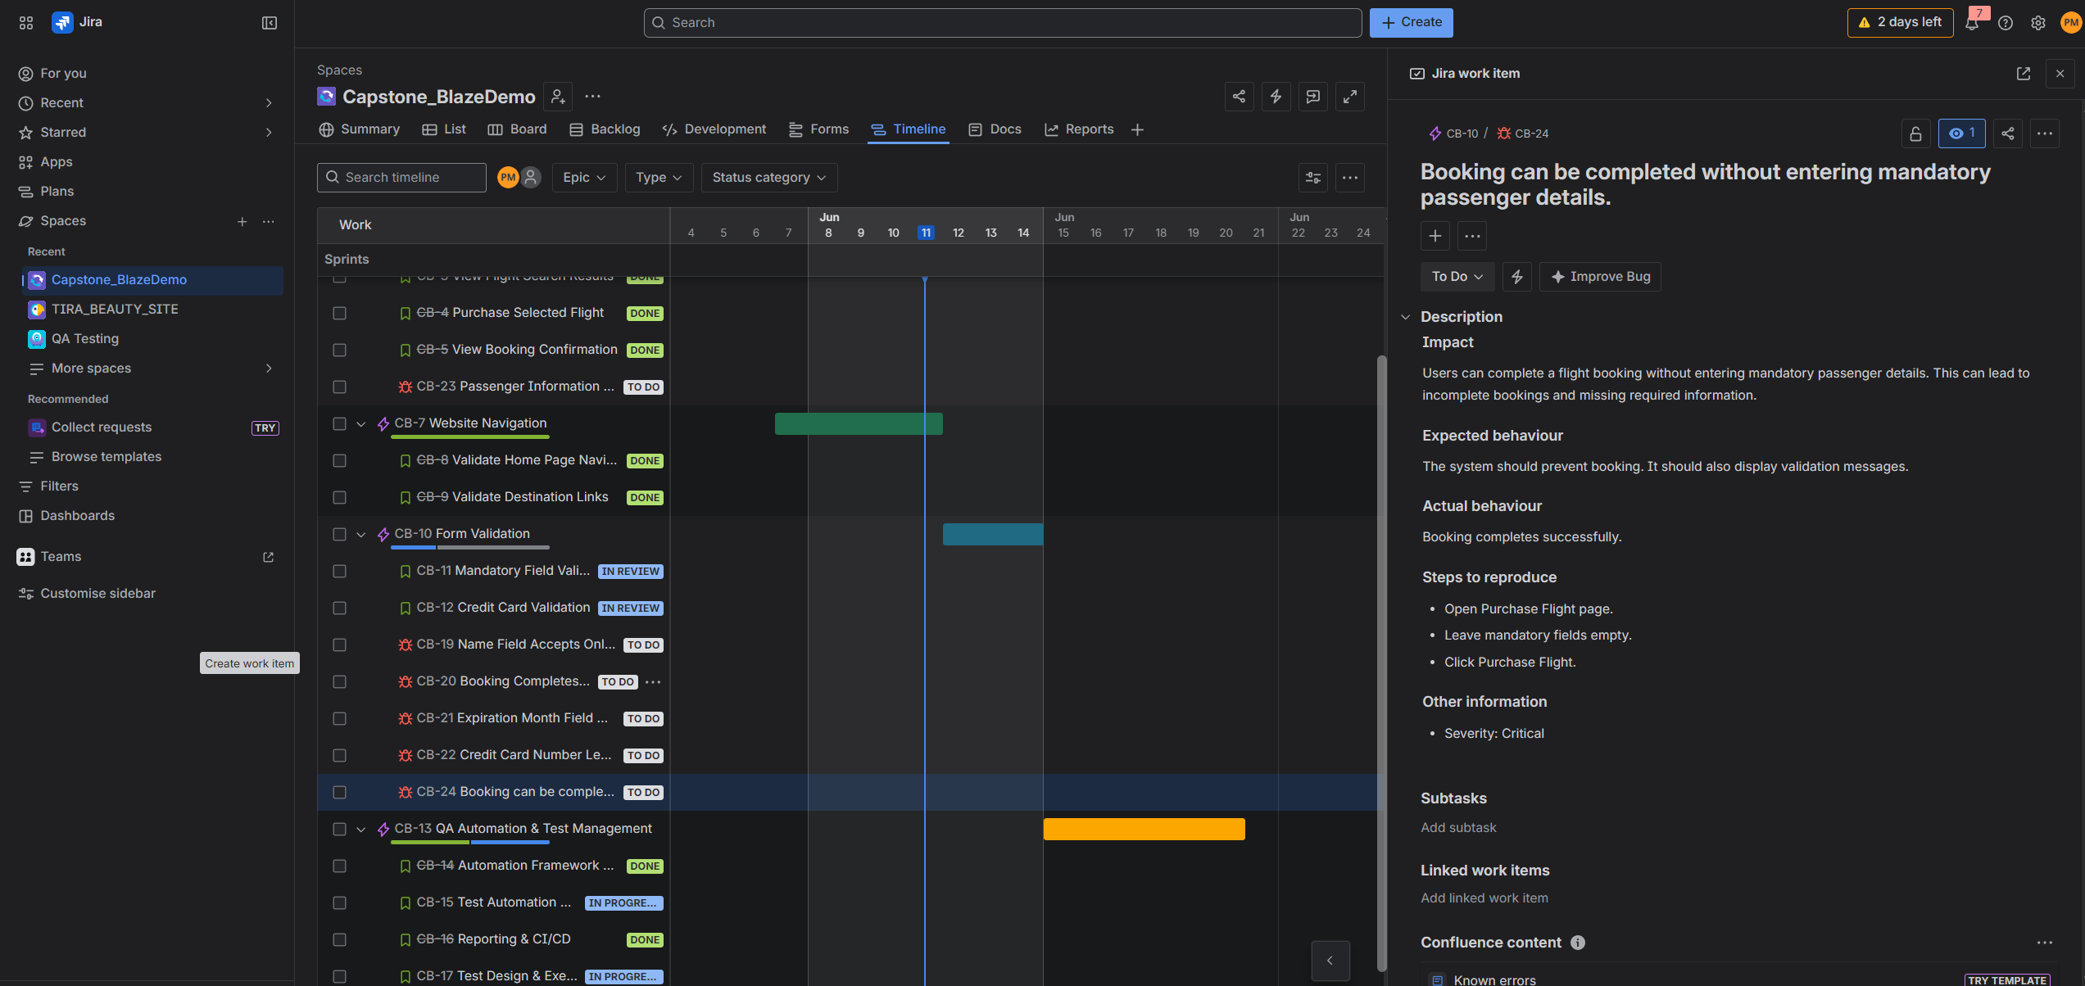

14. Challenges Faced

Challenge 1
Edge browser execution instability in Jenkins.

Solution
Configured Jenkins to execute Chrome tests while maintaining separate Cross-Browser suite.

Challenge 2
Git merge conflicts during framework updates.

Solution
Resolved Jenkinsfile and pom.xml conflicts manually.

Challenge 3
Maintaining reusable framework architecture.

Solution
Implemented Page Object Model and Utility classes.

15. Project Achievements
✓ Complete Selenium Framework Developed
✓ Page Object Model Implemented
✓ Data-Driven Testing Implemented
✓ Extent Reports Integrated
✓ Screenshot Capture Implemented
✓ Jenkins CI/CD Integrated
✓ Cross-Browser Testing Implemented
✓ GitHub Version Control Maintained
✓ Defect Validation Suite Developed

16. Conclusion
The BlazeDemo Flight Booking Automation Framework successfully automates the end-to-end flight booking process using Selenium WebDriver, Java, TestNG, and Maven. The framework follows industry-standard automation practices including Page Object Model (POM), Data-Driven Testing, Extent Reporting, Jenkins CI/CD integration, Screenshot Capture, and Cross-Browser Testing.

