OSSP (Operating Systems And Systems Programming) - 25CS2104E

- Develop a C program that demonstrates how a Linux operating system executes a command entered by a user that 1. Accept a Linux command as input. 2. Create a child process using fork(). 3. Execute the command in the child process using an appropriate exec() system call. 4. Allow the parent process to wait for the child using wait (). 5. Display the Process ID (PID) of both parent and child processes.

Using Linux terminal commands (uname, lscpu, lsblk, ps, top), investigate the relationship between hardware resources and operating system services. Prepare a report explaining how the OS abstracts CPU, memory, storage, and I/O devices.

Program:
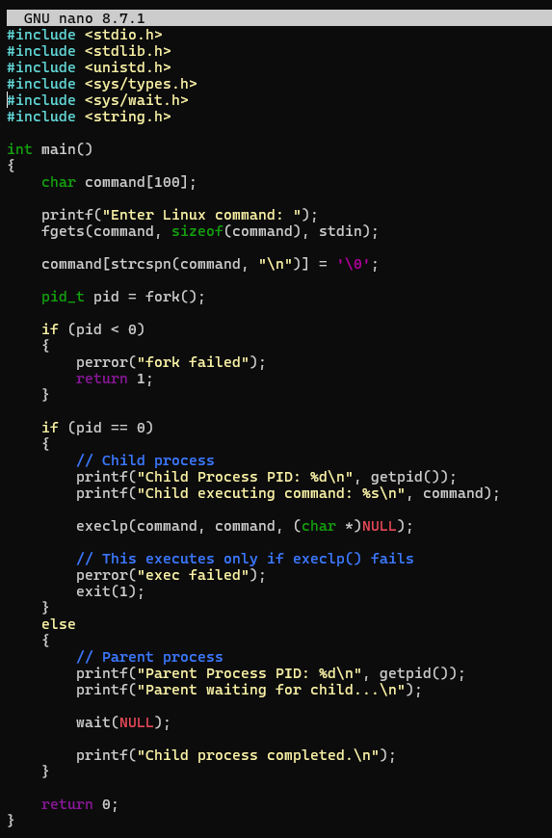

Output:
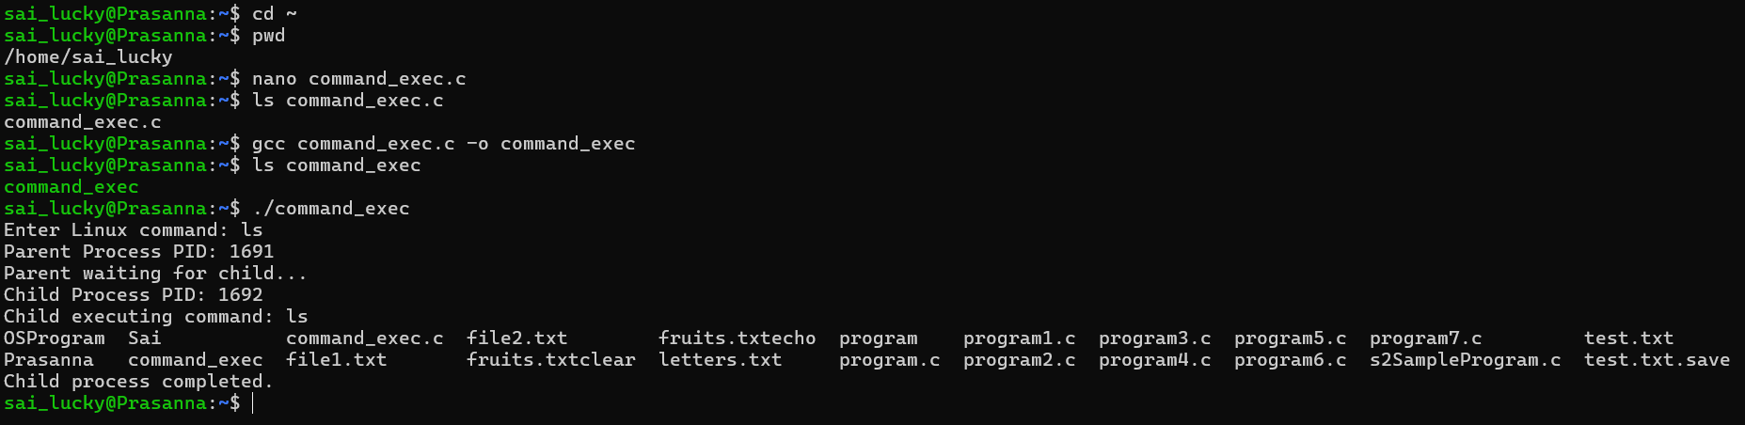
Result:
The C program successfully creates a child process using fork(), executes the specified Linux command using exec(), and allows the parent process to wait for the child using wait(). The PIDs of both parent and child processes are displayed.

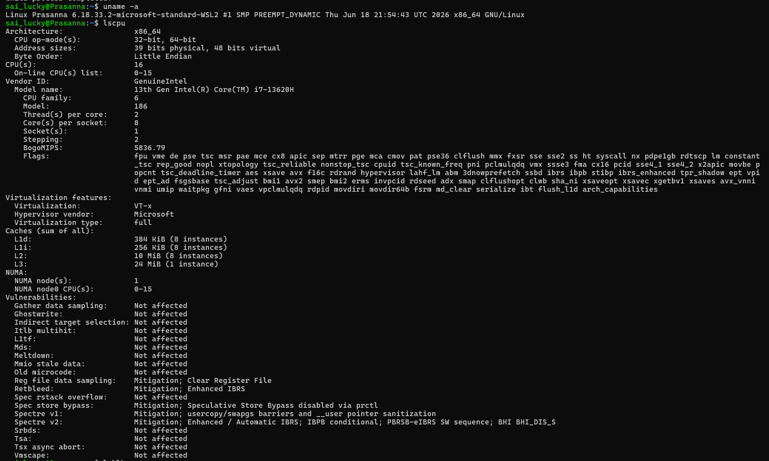
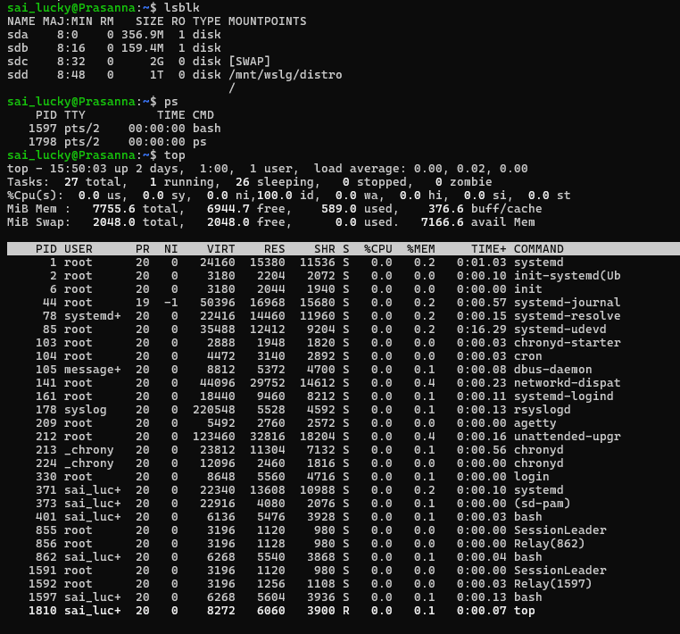

2.Develop a C program that uses the system calls open(), read(), write(), and close() to copy the contents of one file to another. Explain how control transitions between user space and kernel space during execution.
Use the strace utility to trace all system calls generated by the command cat sample.txt. Analyze the sequence of system calls and identify the kernel services involved.

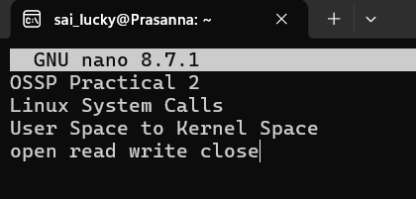

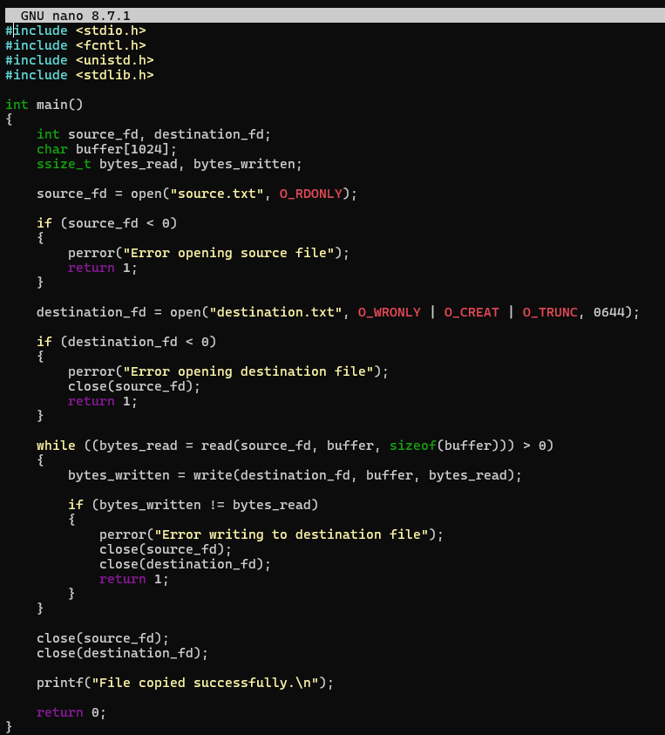
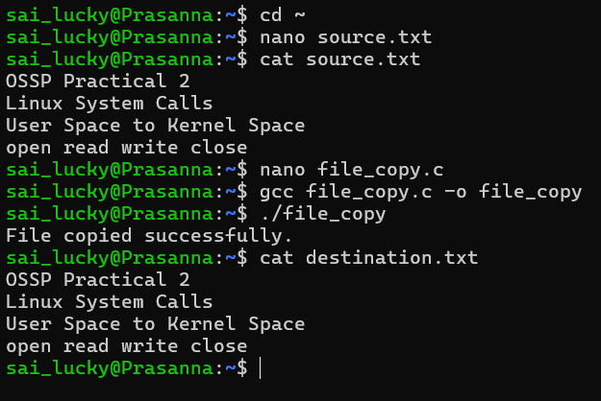
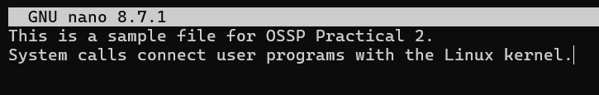
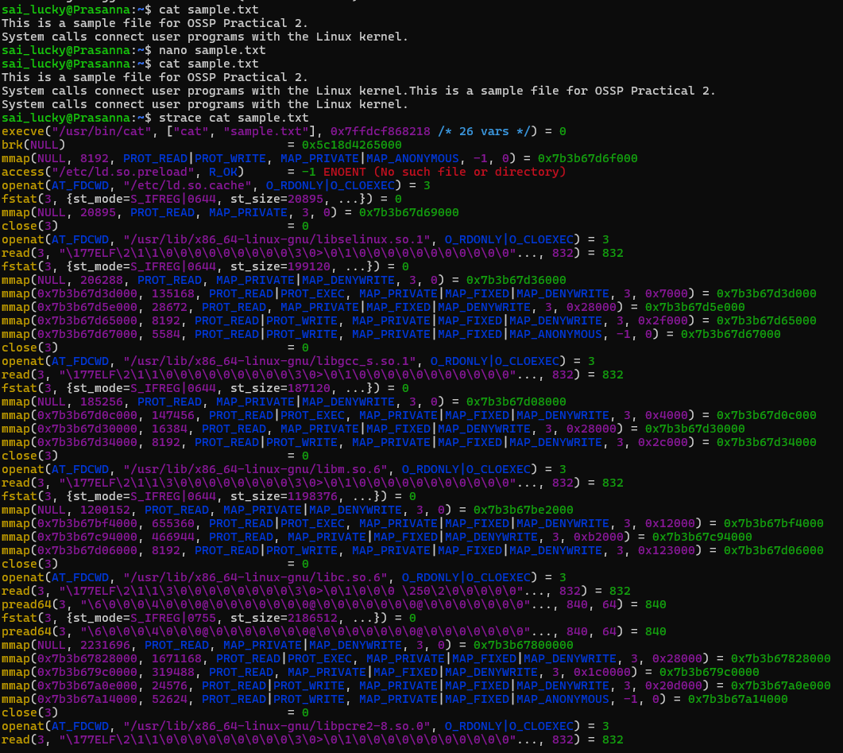
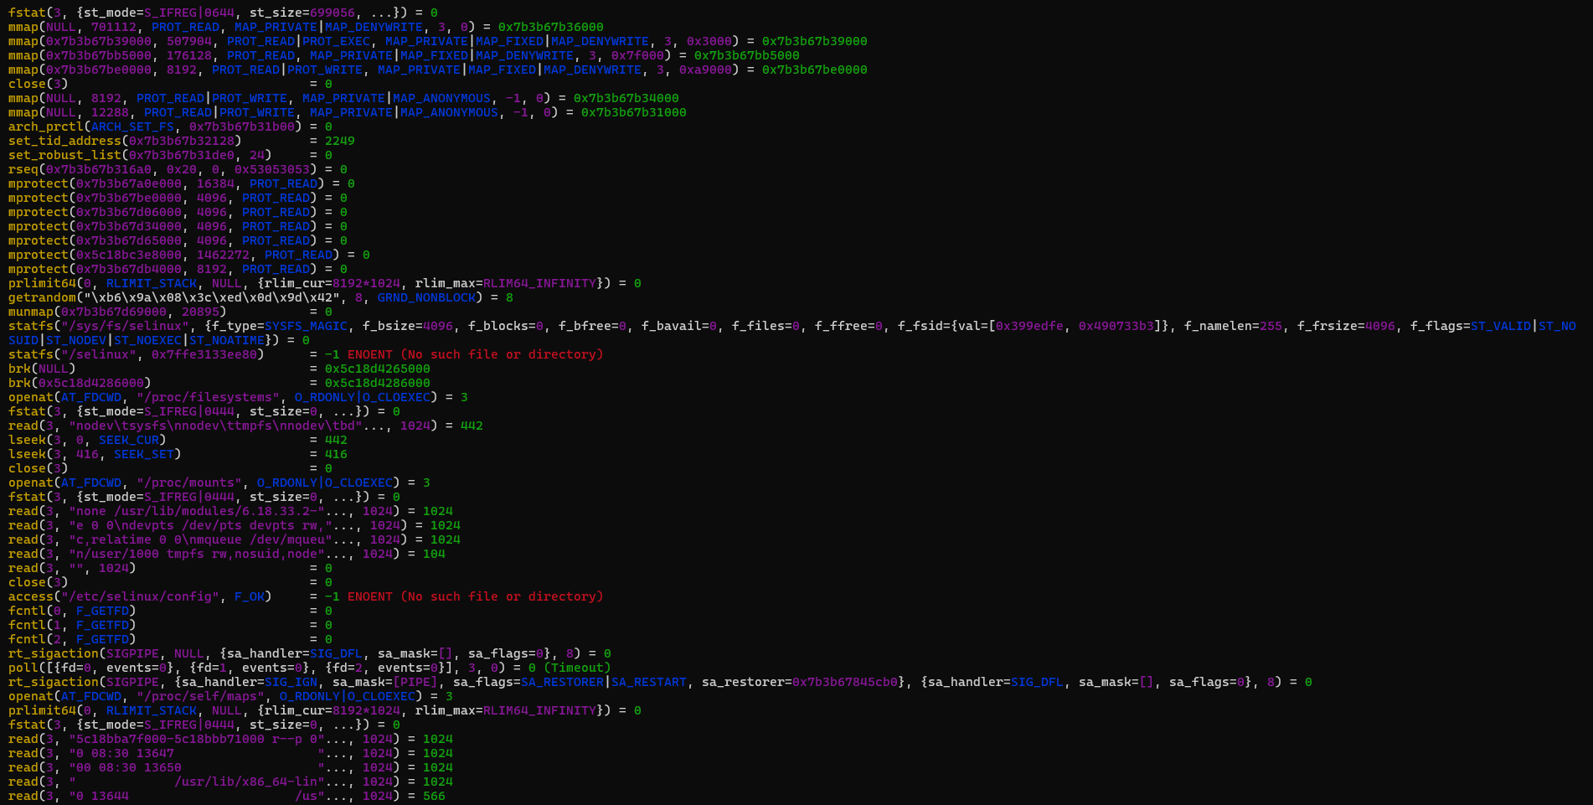
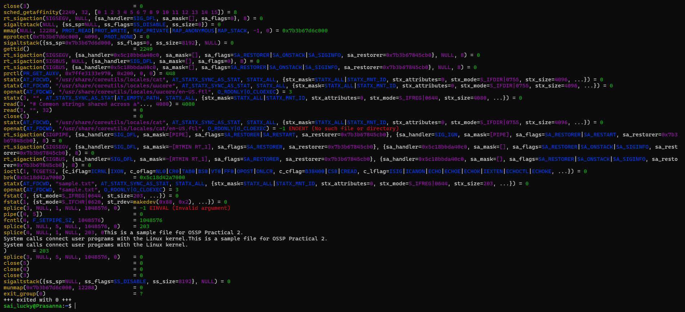

3.Develop a C program using fork() that creates a parent and child process. Display the Process ID (PID), Parent Process ID (PPID), and process states at different stages of execution.
Design an experiment to observe process state transitions (Ready, Running, Waiting, Terminated) using Linux monitoring tools such as ps, top, and /proc. Document the observations.
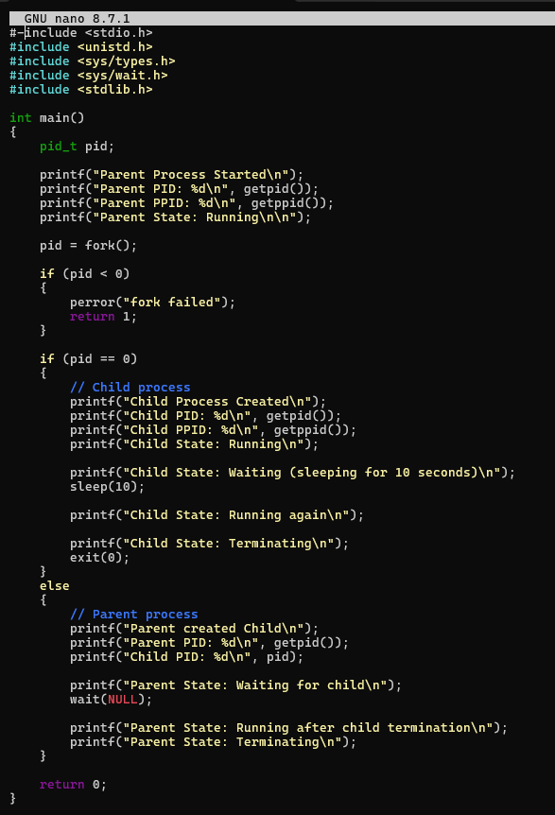
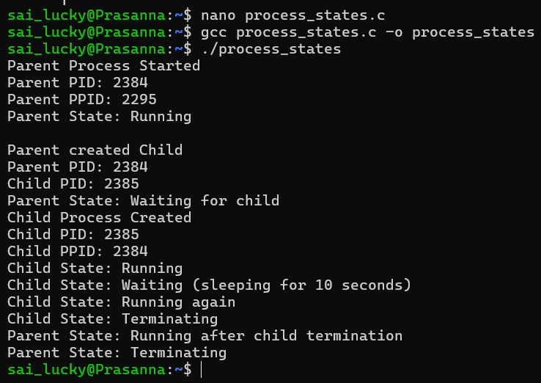
After Changing Sleep(10) to Sleep(30):
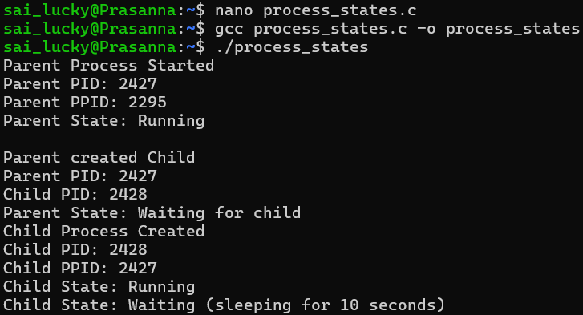
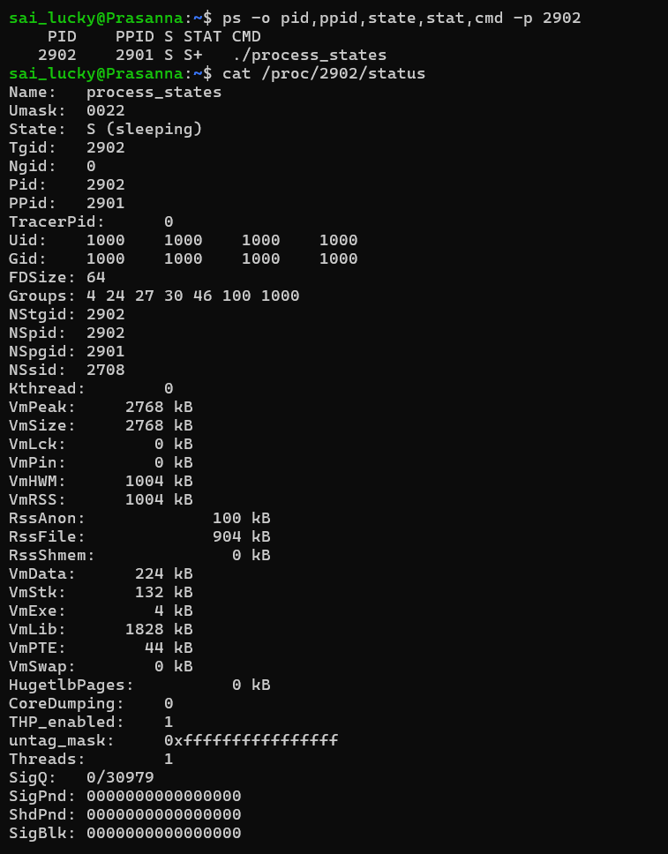
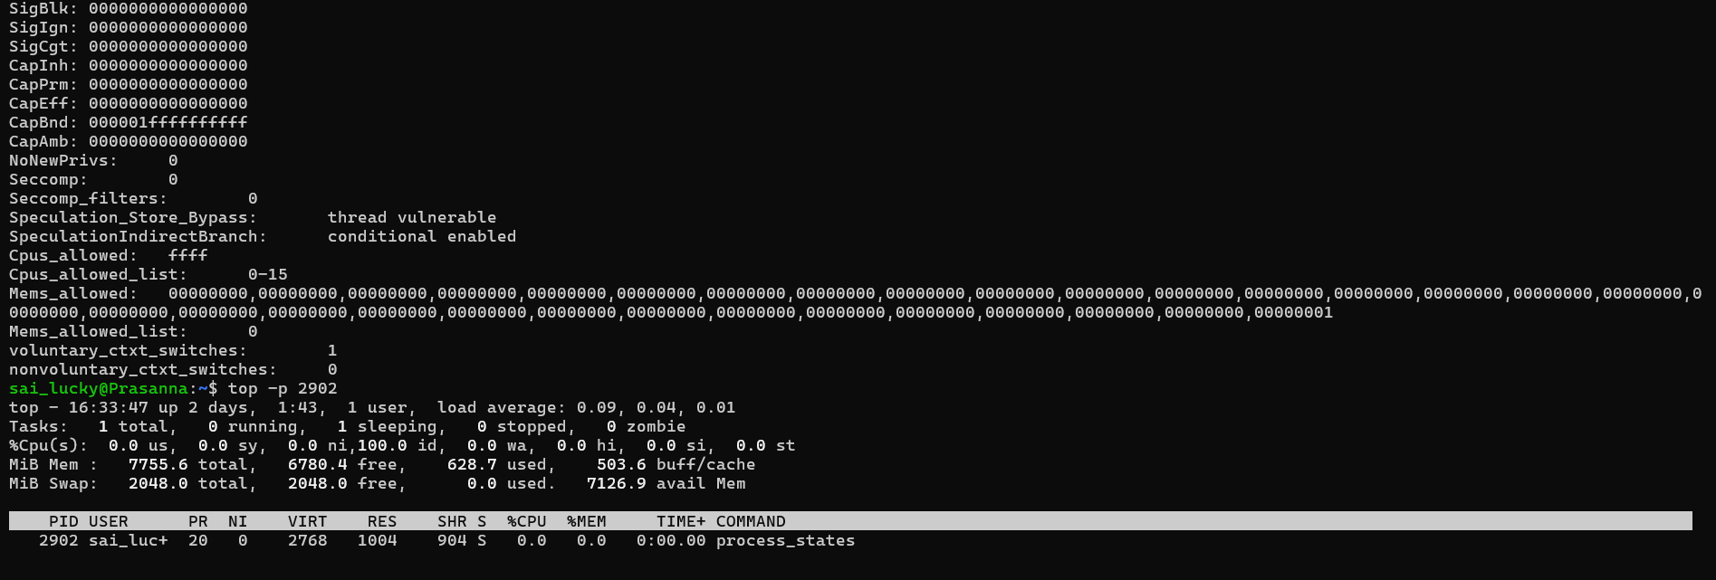
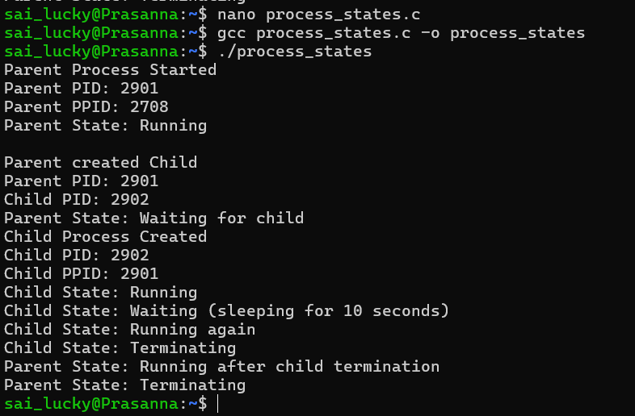
- Write a C program where a parent process creates multiple child processes and synchronizes their completion using wait() and waitpid(). Compare the behavior of both functions.

Create a scenario where a child process becomes a zombie process. Investigate the process table and then modify the program to eliminate zombie processes using proper synchronization techniques.

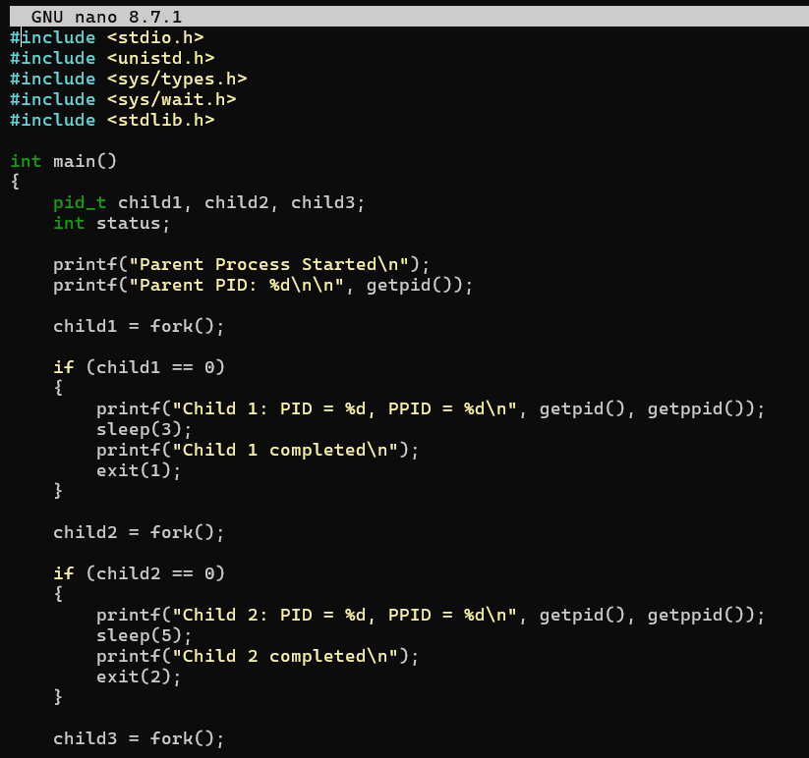
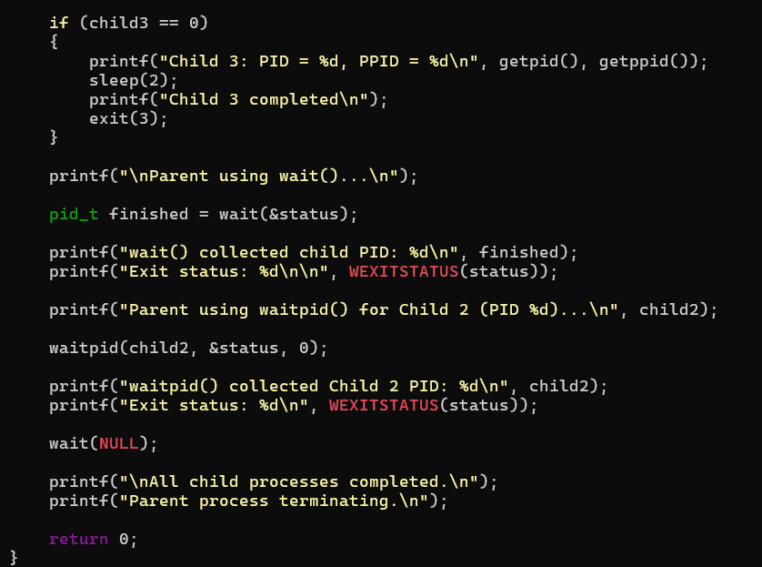
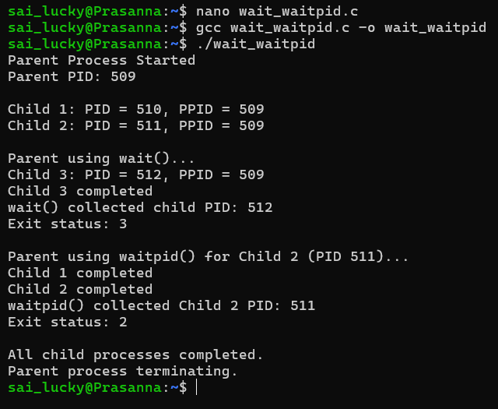
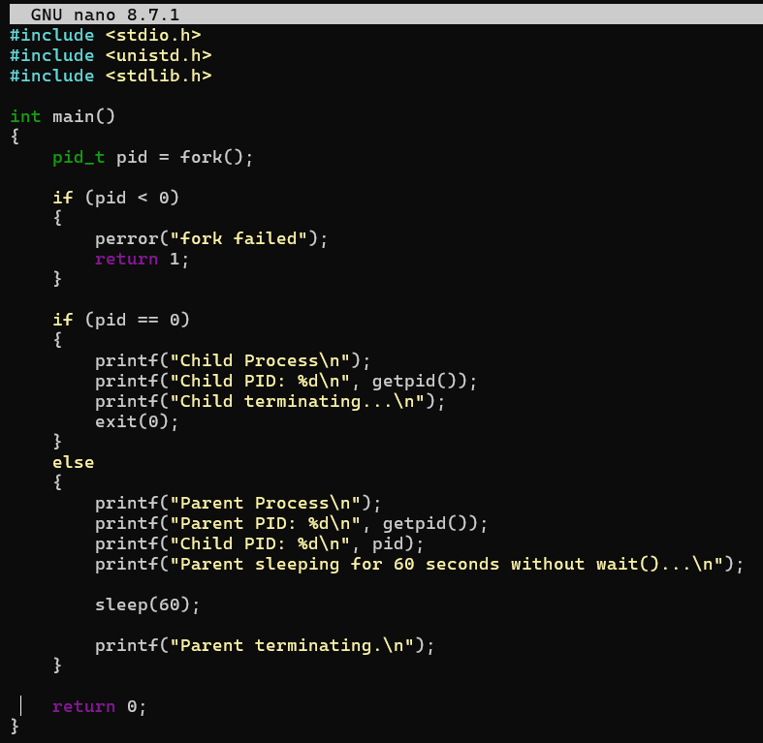
Experiment 1 — Zombie Creation
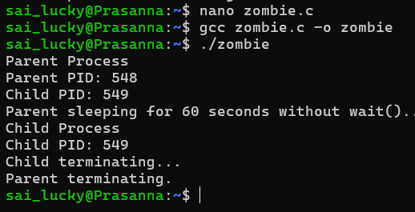
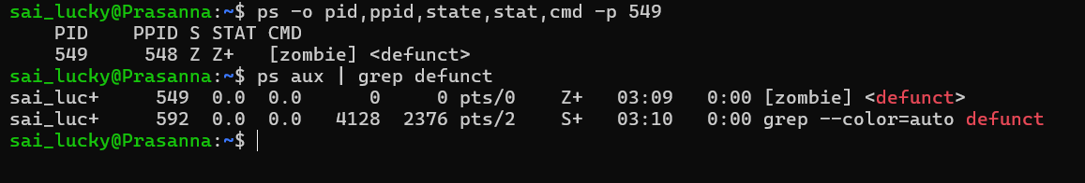

Experiment 2 — Zombie Elimination
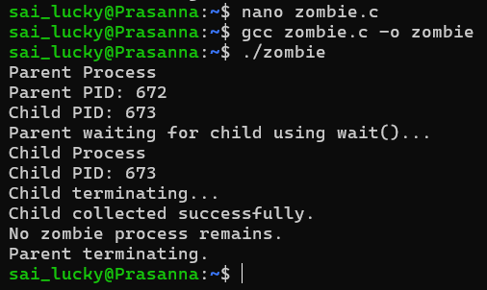

- Implement a producer-consumer communication system using anonymous pipes where the parent process generates data and the child process consumes it. Measure the communication efficiency.
Develop a program that executes the equivalent of the shell command: ls -l | grep ".c" using fork(), pipe(), dup2(), and exec() system calls.

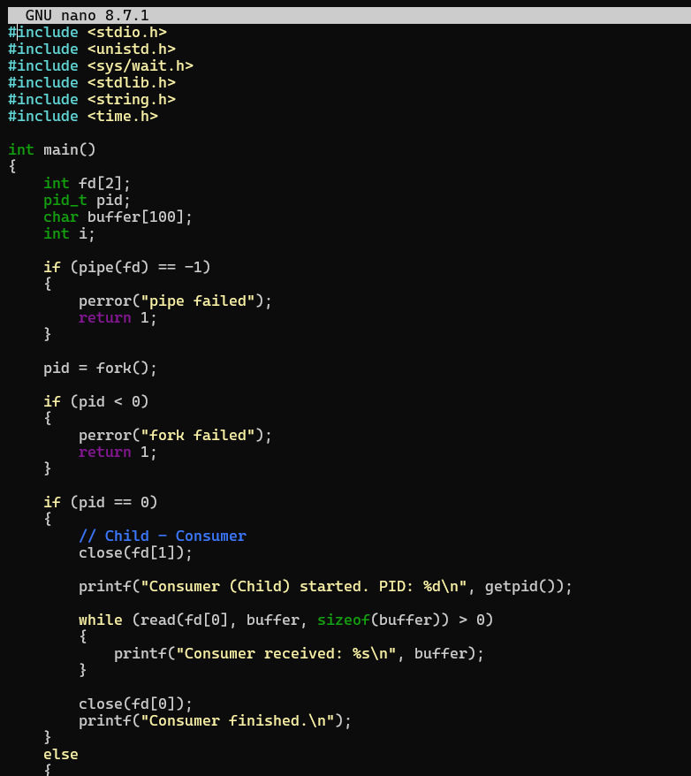

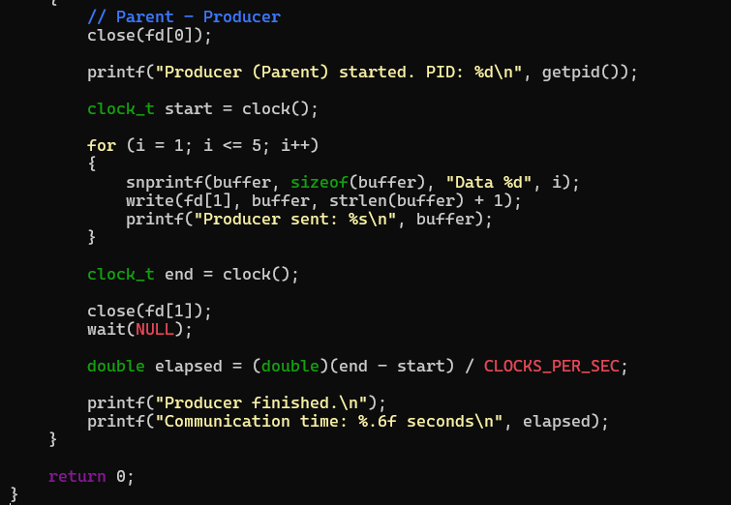

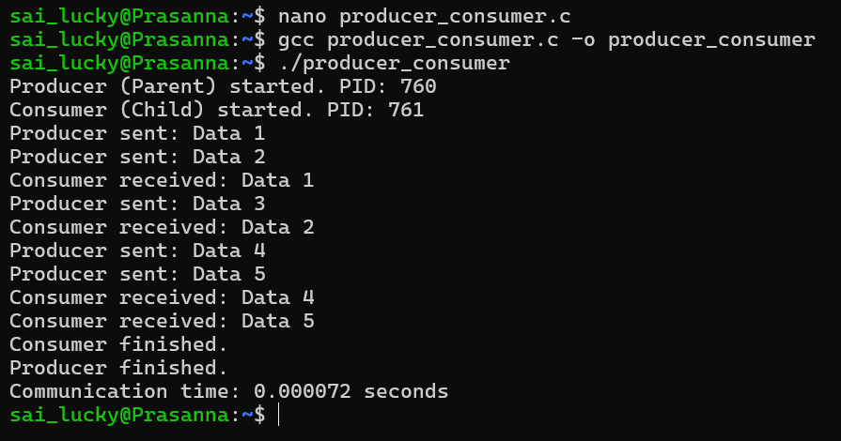
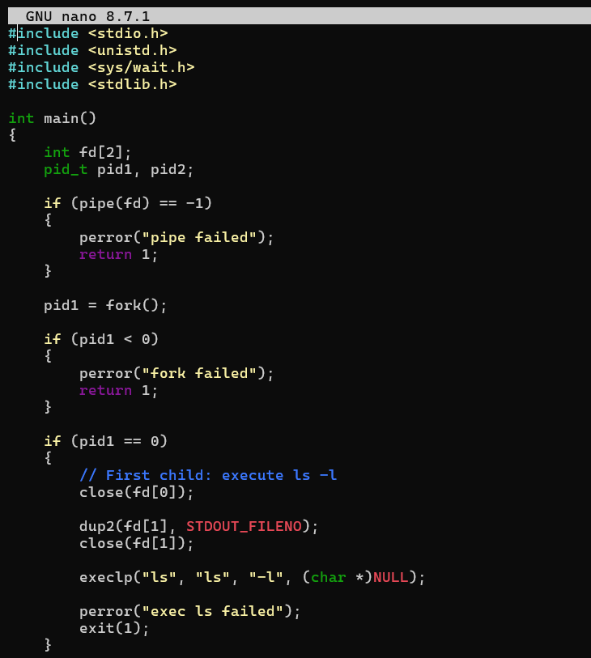
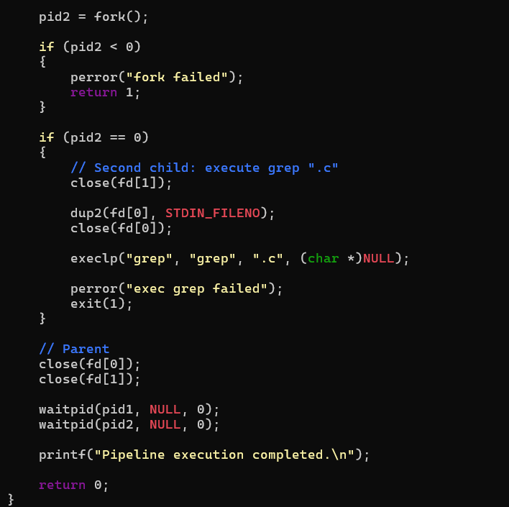
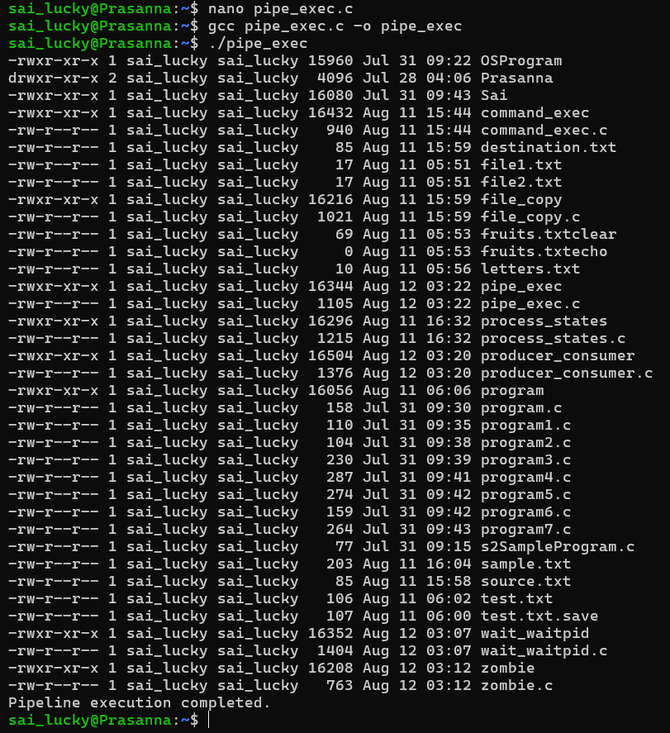

- Create a client-server application using Named Pipes (FIFOs). The client sends messages and the server processes and responds to them. Analyze FIFO behavior when multiple clients communicate simultaneously.

Create a POSIX signal handling program that captures SIGINT, SIGTERM, and SIGUSR1. Demonstrate asynchronous event handling and explain the role of signal handlers.
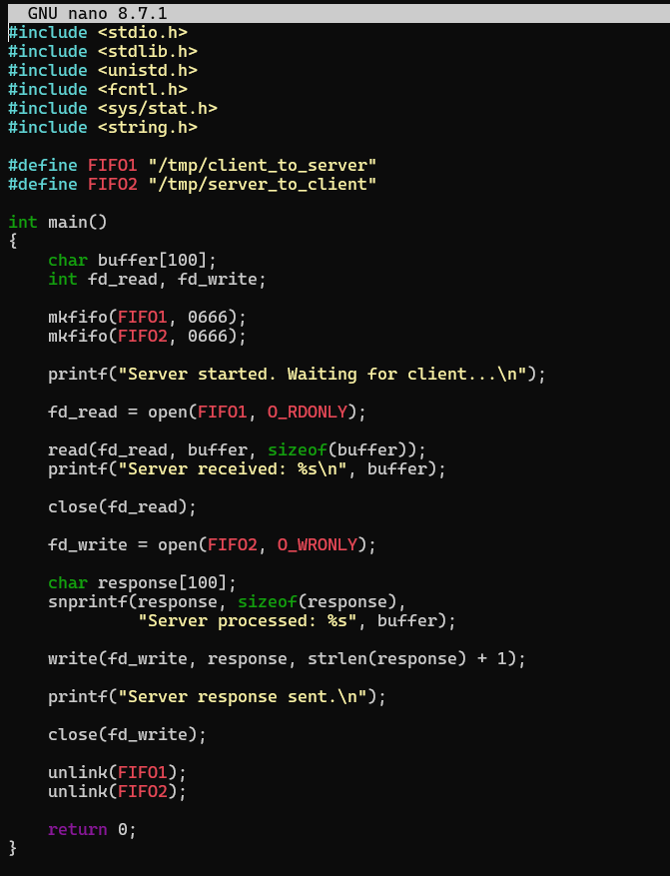

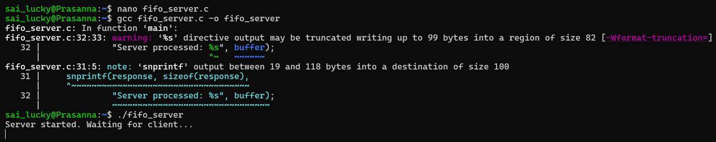
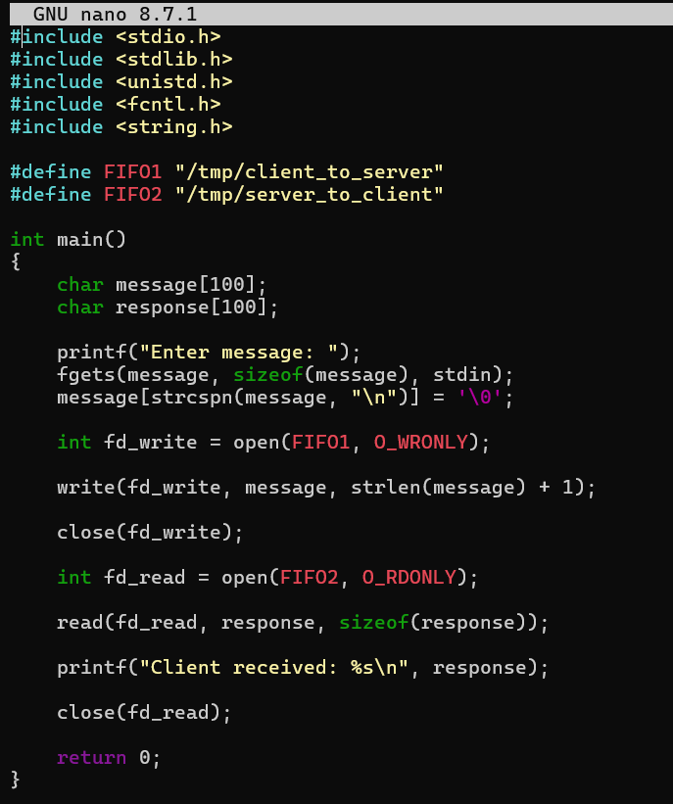
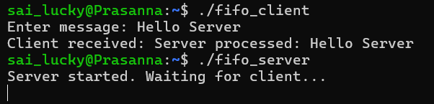

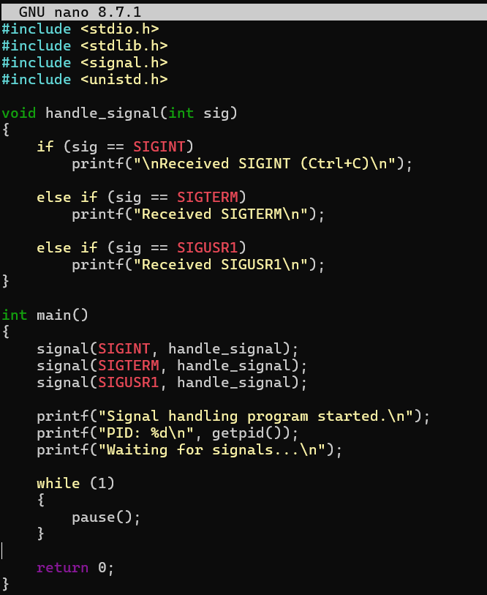
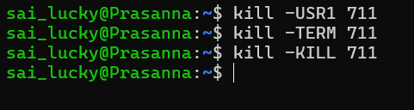
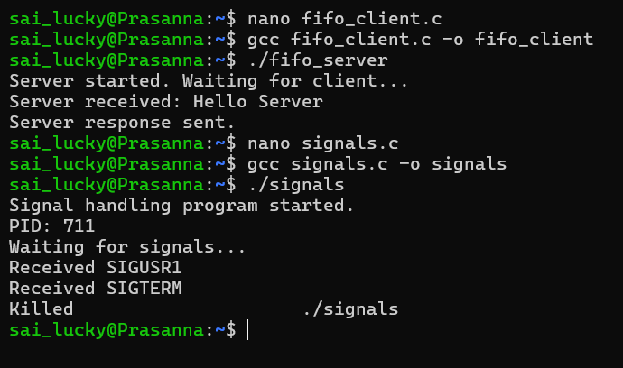

- Write a program that prints the addresses of code, global, static, heap, and stack variables. Analyze the Linux process address space layout and explain each memory segment.

Make use of the /proc//maps file and memory analysis tools to study the memory organization of a running process. Prepare a report explaining virtual memory mappings.
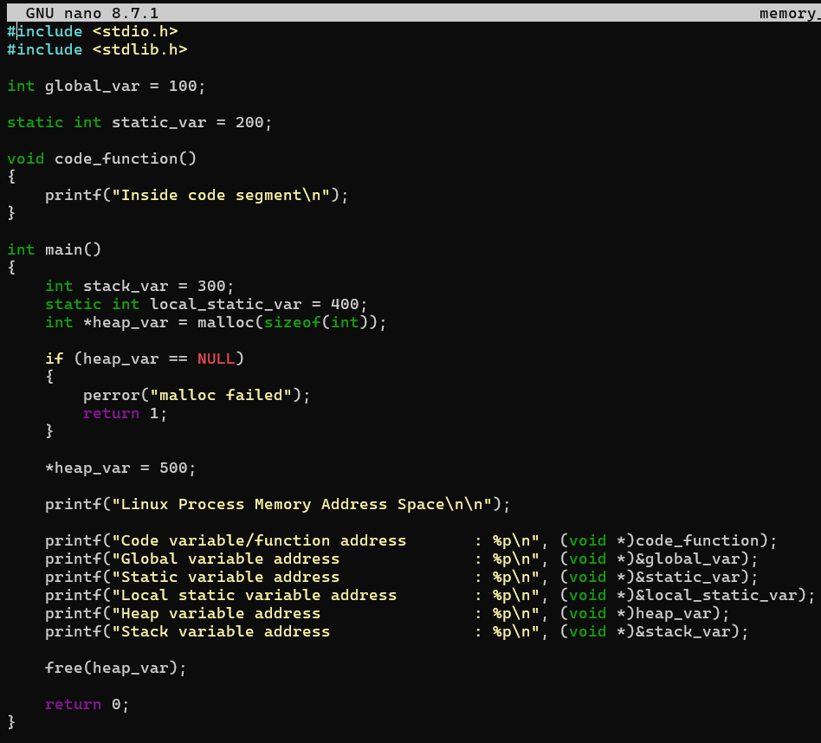
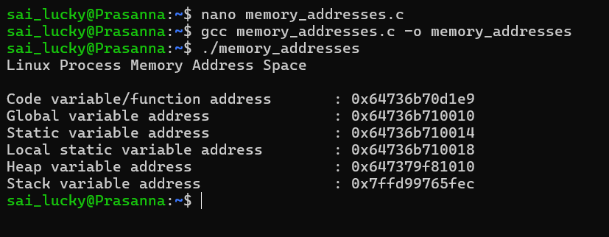
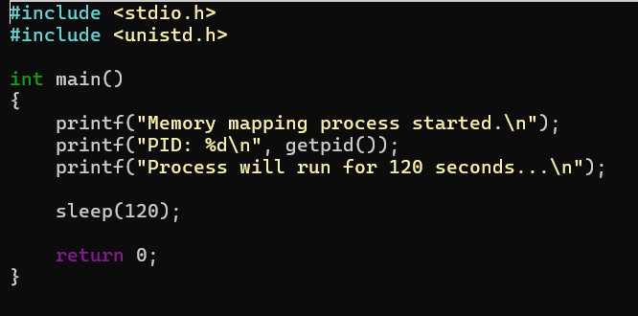
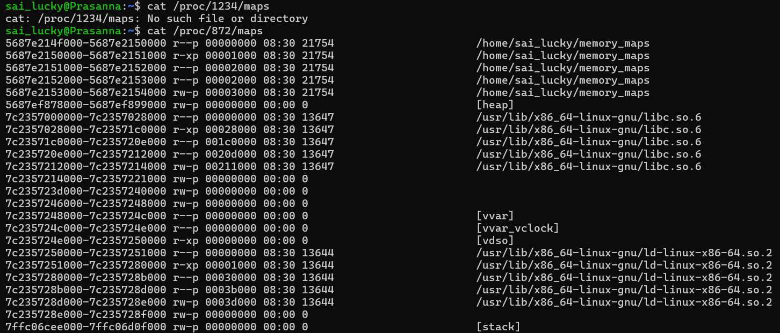
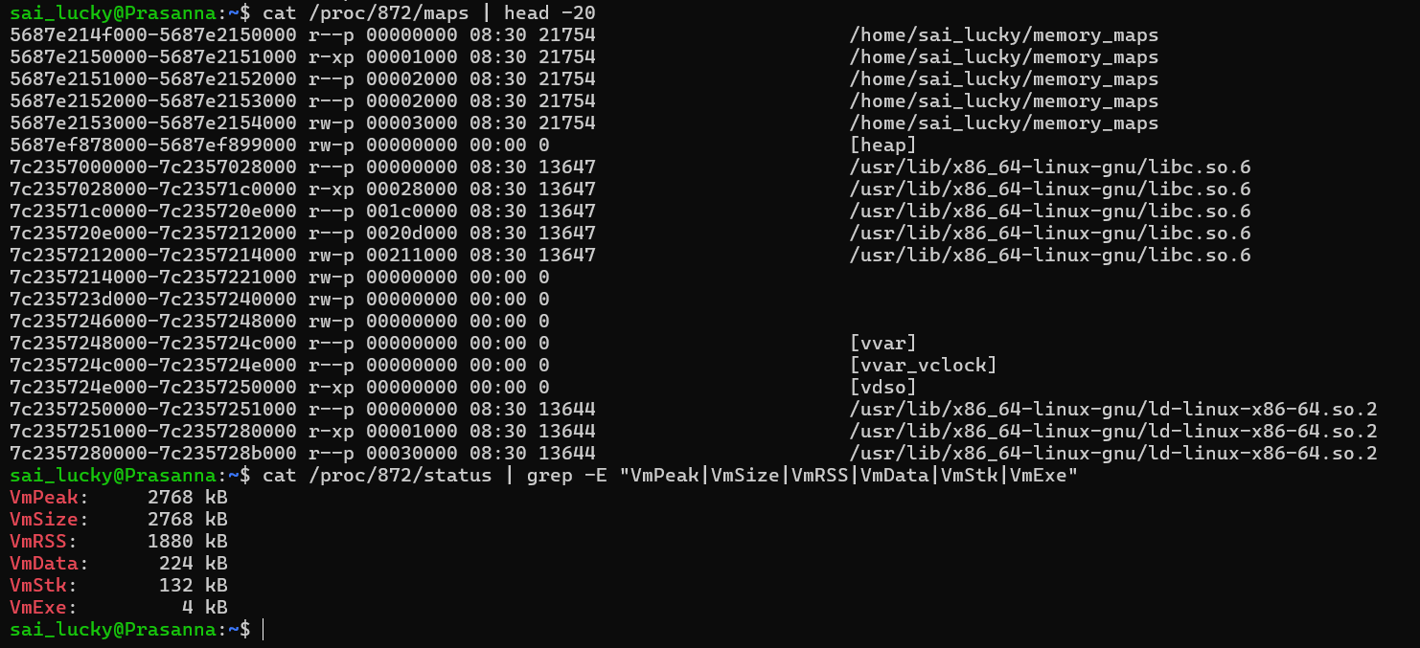
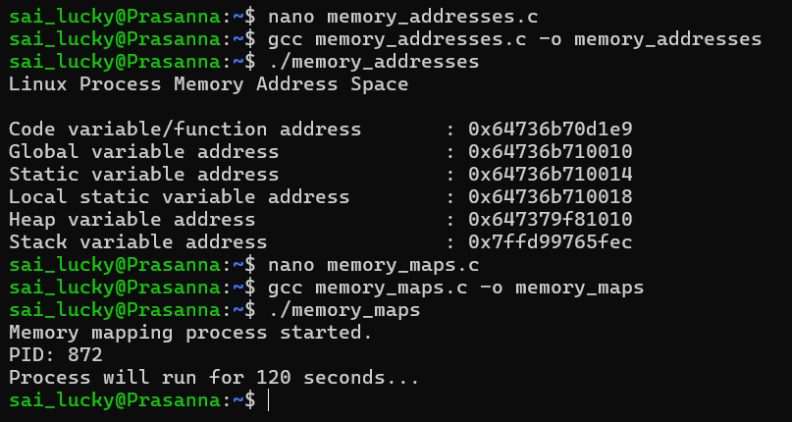
- Develop a program using malloc(), calloc(), realloc(), and free(). Monitor memory allocation behavior and identify memory leaks using Valgrind.

Develop a program that demonstrates Copy-on-Write behavior after a fork(). Analyze memory usage before and after modifying data in the child process.
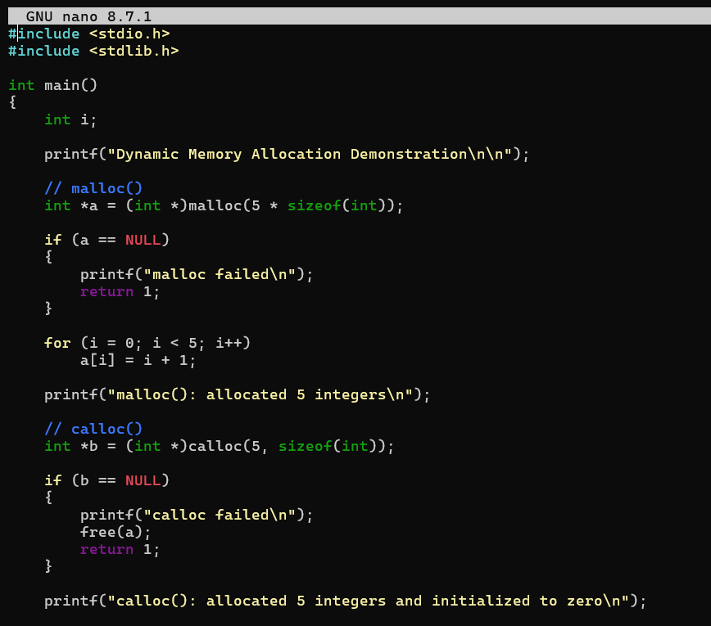
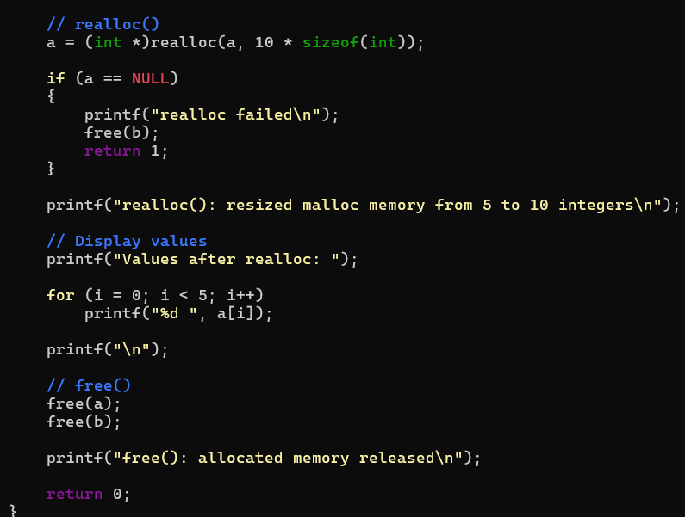

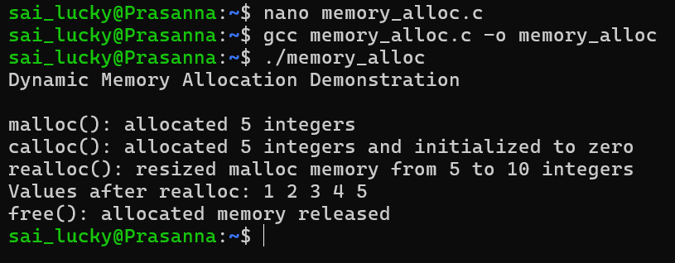

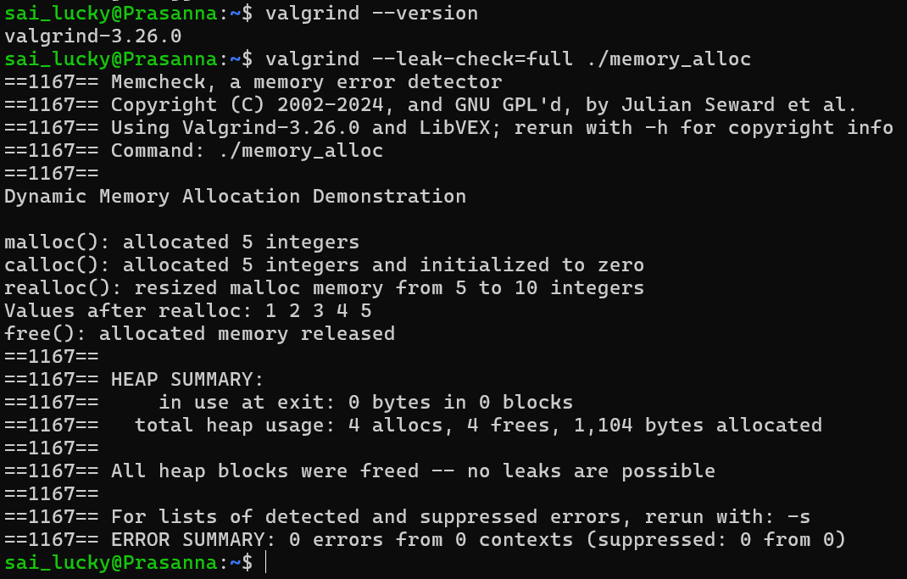
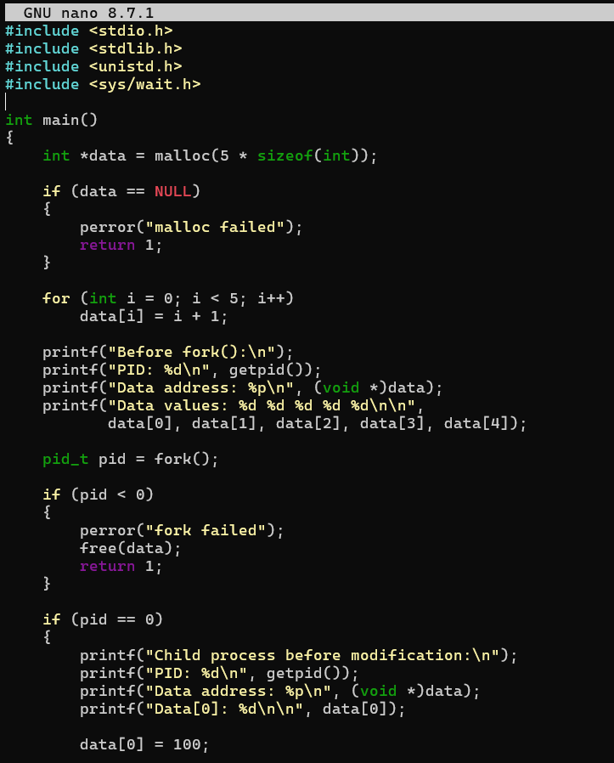
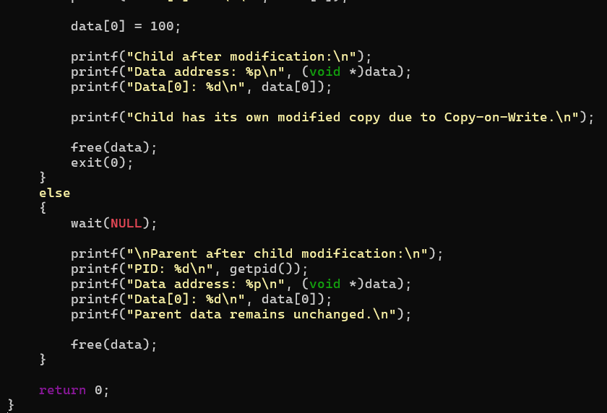
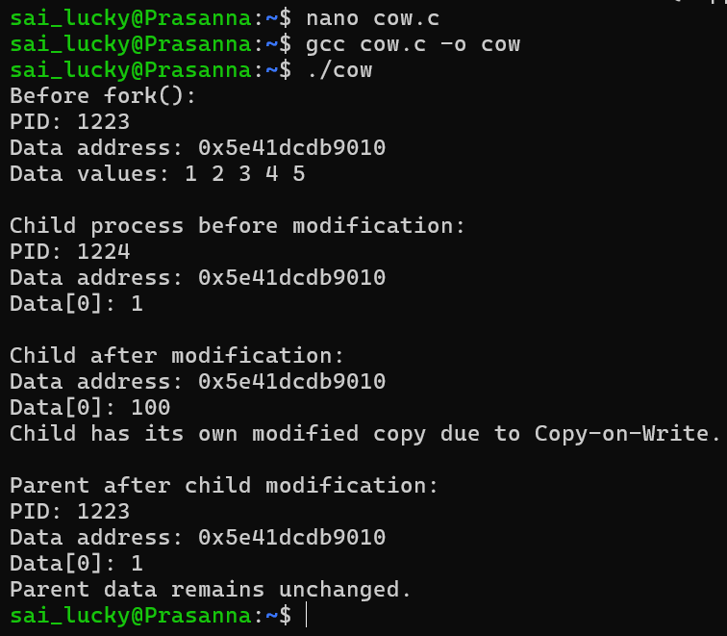
- Implement a file copy utility using low-level Linux file I/O system calls (open, read, write, lseek, close). Compare its performance with standard library functions (fopen, fread, fwrite).

Develop a program that redirects standard input and output using file descriptors and dup2(). Demonstrate how shells implement I/O redirection.

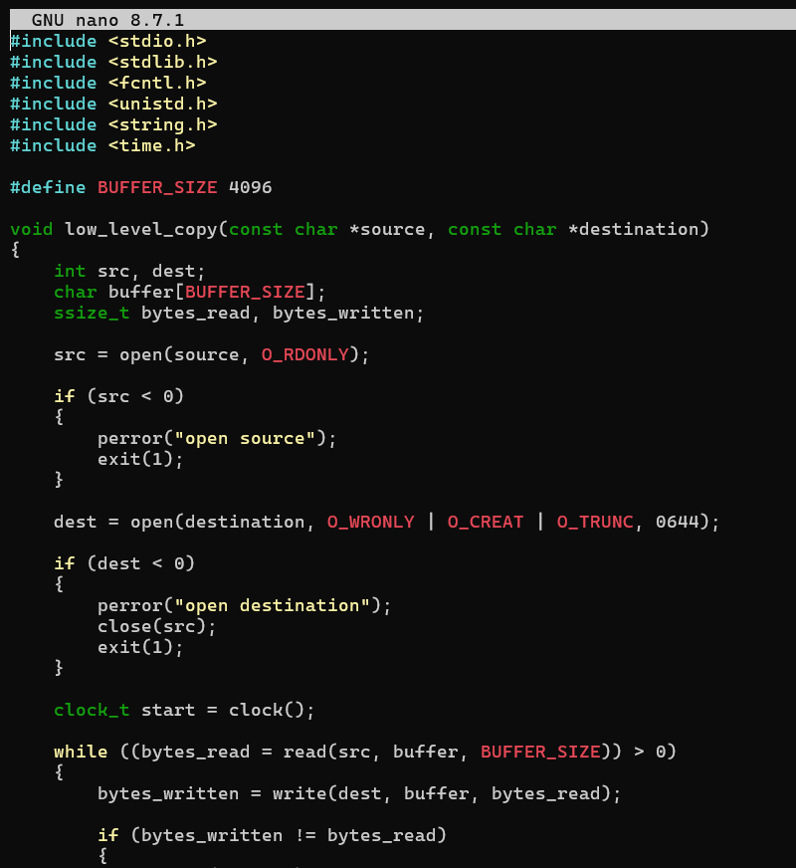
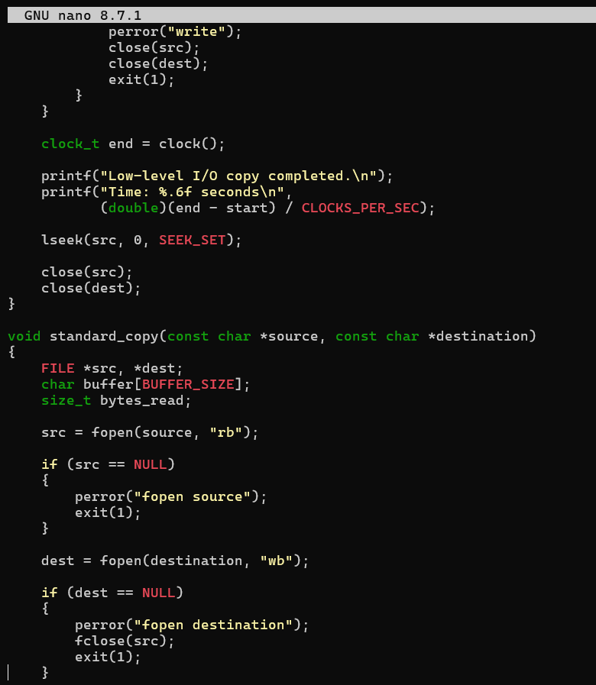
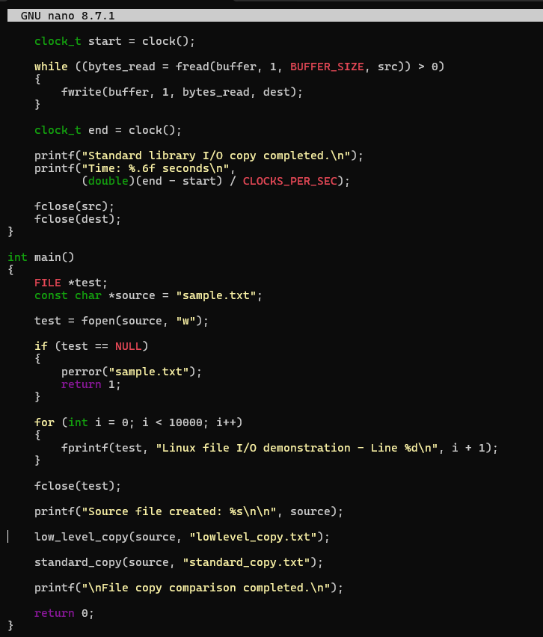
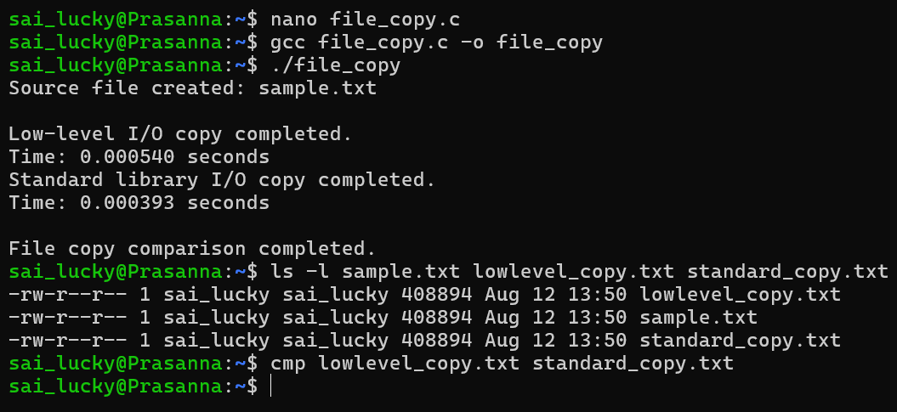
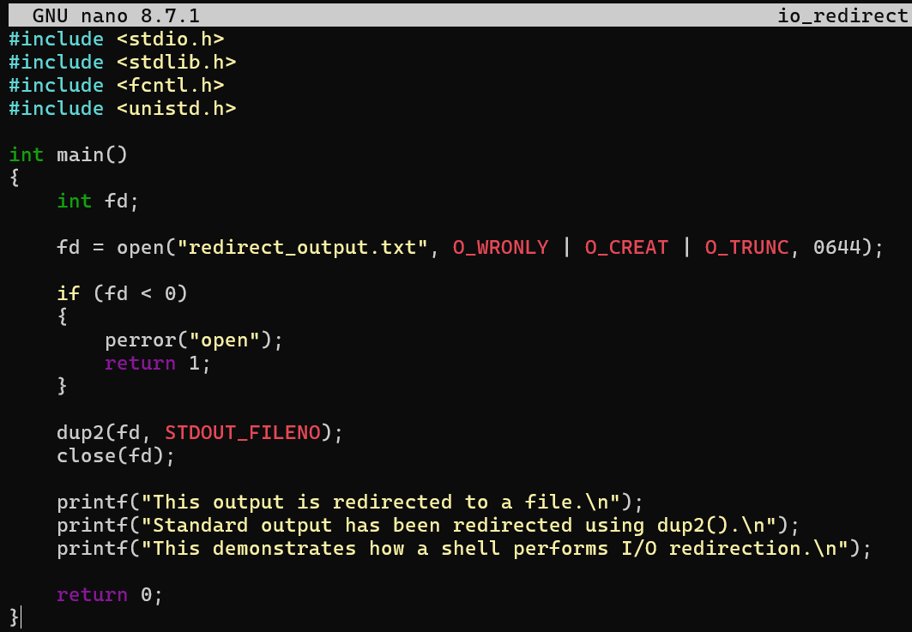
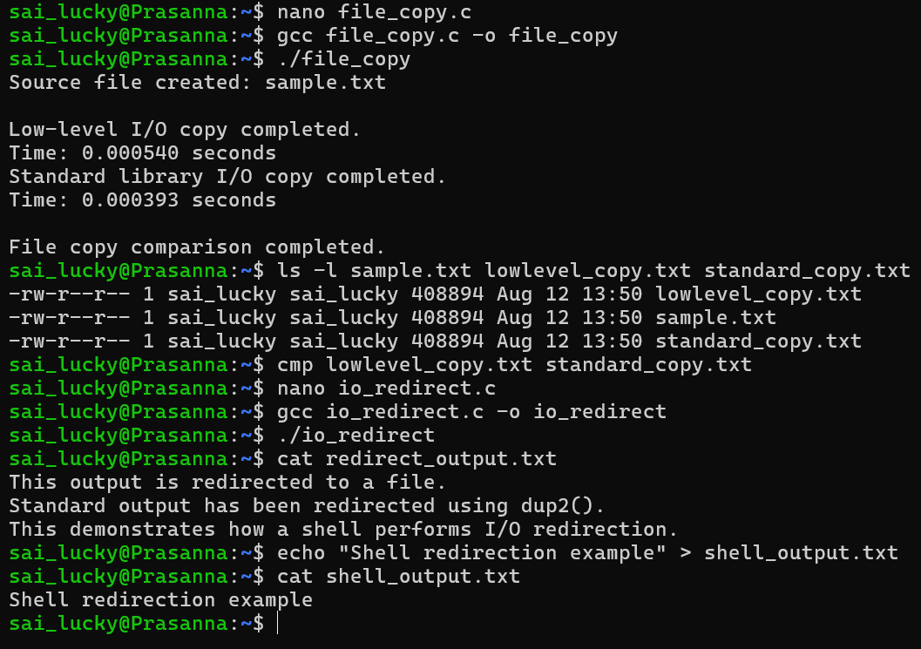
- Investigate inode structures using commands such as ls -i, stat, and find. Create hard links and symbolic links and explain their impact on inode allocation.

Design a program using mmap() to perform file reading and writing. Compare memory-mapped I/O with traditional read/write operations in terms of efficiency and implementation complexity.

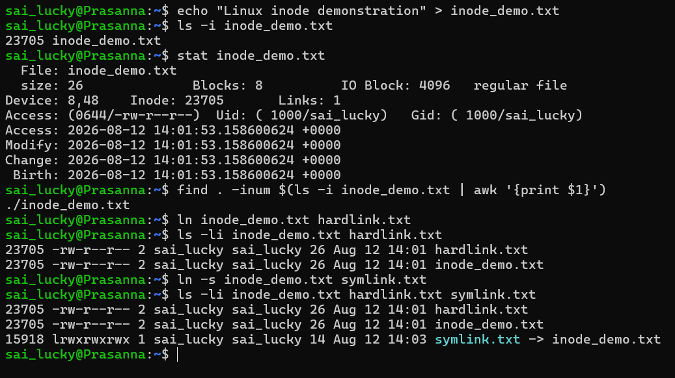
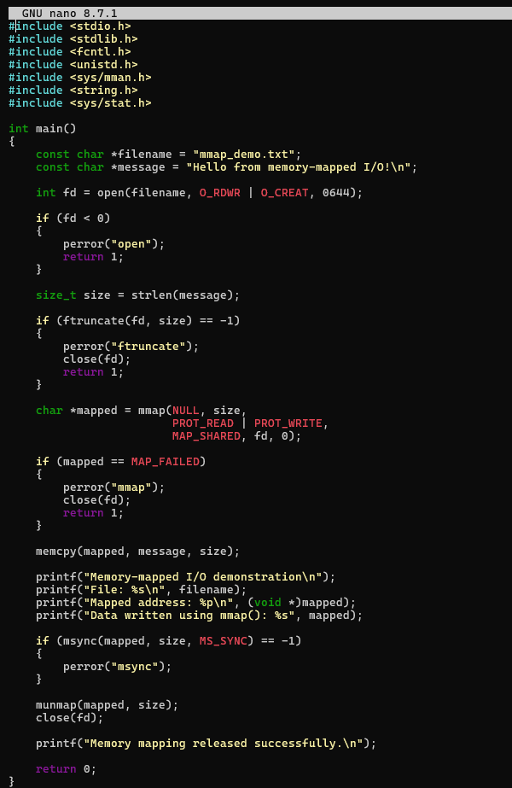

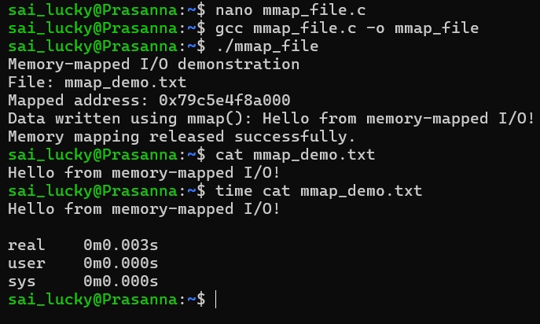

- Develop a multithreaded counter application using POSIX threads (pthread_create, pthread_join). Demonstrate race conditions by allowing multiple threads to update a shared variable concurrently.
Modify the previous program using mutex locks (pthread_mutex_lock, pthread_mutex_unlock) and compare the outputs with the race-condition version. Analyze the impact of synchronization.
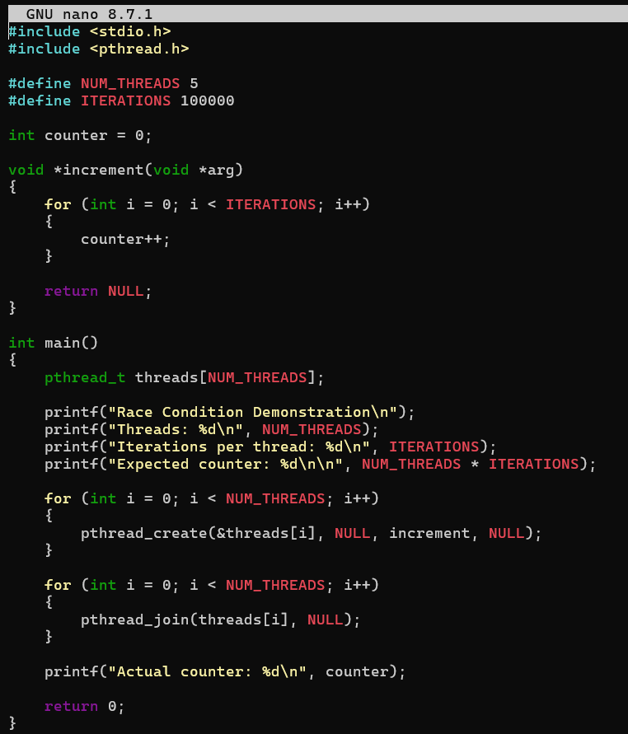
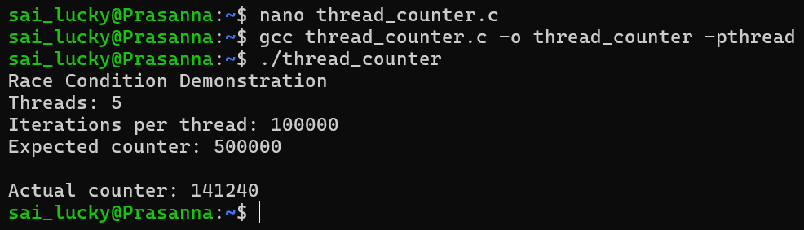
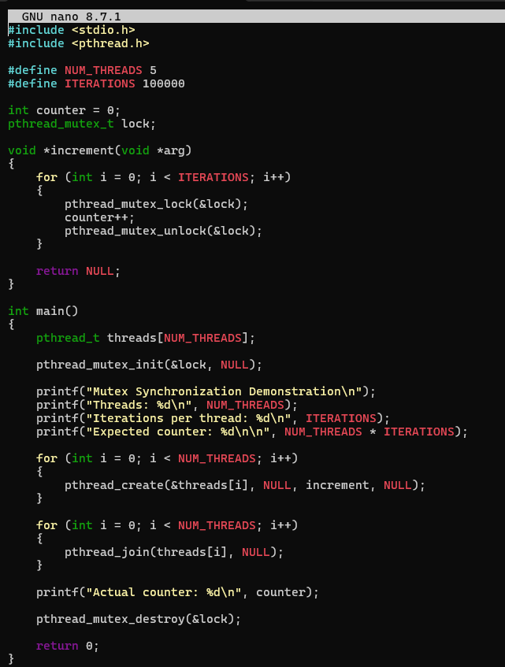
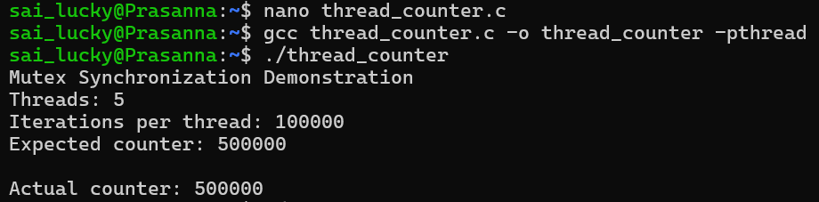
12. Implement the Producer-Consumer problem using counting semaphores and POSIX threads. Evaluate synchronization correctness and system throughput under different buffer sizes.

Design a deadlock scenario involving multiple threads competing for shared resources. Demonstrate deadlock occurrence, identify the four necessary conditions for deadlock, and implement a deadlock prevention strategy using resource ordering.
