“AeroSync: Intelligent Aviation Search & Decision Support System”
A Project Report Submitted in the partial fulfillment of the requirements for the award of the degree of
BACHELOR OF TECHNOLOGY
in
DEPARTMENT OF COMPUTER SCIENCE ENGINEERING
by
S. Harshitha | :2520030104
K.V.A. Advaitha | :2520030150
C.H. Sai Prasanna | :2520030608
Under the Guidance of
Dr. V.Sireesha
Professor
Department of Computer Science and Engineering


2026-27

DEPARTMENT OF COMPUTER SCIENCE ENGINEERING
Declaration
The Project Report entitled “AeroSync: Intelligent Aviation Search & Decision Support System” is a record of Bonafide work of S. Harshitha – 2520030104, K.V.A. Advaitha – 2520030150, C.H. Sai Prasanna – 2520030608 submitted in partial fulfillment for the award of B. Tech in Computer Science and Engineering. The results embodied in this report have not been copied from any other departments/University/Institute.

S. Harshitha – 2520030104
K.V.A. Advaitha – 2520030150
C.H. Sai Prasanna – 2520030608

DEPARTMENT OF COMPUTER SCIENCE ENGINEERING
CERTIFICATE
This is to certify that the mini project based report entitled “AeroSync: Intelligent Aviation Search & Decision Support System” is a bonafide work done and submitted by S. Harshitha – 2520030104, K.V.A. Advaitha – 2520030150, C.H. Sai Prasanna – 2520030608 in partial fulfillment of the requirements for the award of the degree of BACHELOR OF TECHNOLOGY in Department of Computer Science Engineering, during the academic year 2026-27.

Signature of the Guide Signature of the HOD
(Dr. V.Sireesha)

ACKNOWLEDGEMENT
We express our sincere gratitude to our project guide, Dr. V. Sireesha, Professor, Department of Computer Science and Engineering, for her valuable guidance, constant encouragement and timely suggestions throughout the development of our project, “AeroSync: Intelligent Aviation Search & Decision Support System”. Her insights into Data Structures and Algorithms helped us shape the project from an idea into a working system.
We are deeply thankful to Dr. P. Venkateswara Rao, Associate Professor and Head of the Department of Computer Science and Engineering, for providing the facilities, support and a motivating academic environment that enabled us to complete this work successfully. We also thank the faculty members of the department for their cooperation and the management of Koneru Lakshmaiah Education Foundation for the opportunity to carry out this project.
Finally, we thank our parents, friends and team members for their continuous support, patience and encouragement during the course of this project.

S. Harshitha – 2520030104
K.V.A. Advaitha – 2520030150
C.H. Sai Prasanna – 2520030608

Abstract
AeroSync – Intelligent Aviation Search & Decision Support System is an advanced aviation management application designed to efficiently organize, search, and manage information related to flights, airports, aircraft, crew members, passengers, gates, and operational schedules. As aviation operations involve handling large volumes of interconnected data, efficient information retrieval and decision support are essential for minimizing delays and improving resource utilization. AeroSync aims to provide a centralized platform that enables intelligent search, streamlined resource management, and operational assistance for airport and airline authorities. Throughout the project, advanced data structures and algorithmic techniques will be progressively integrated to enhance search efficiency, scheduling, resource allocation, and decision-making capabilities. The system serves as both a practical aviation management solution and a demonstration of how advanced algorithms can be applied to solve real-world operational challenges in the aviation industry.
Keywords: Aviation, Data Structures and Algorithms, KMP, Trie, Dijkstra, Bitmask TSP, SOS-DP, Decision Support, Java, React.

Table of Contents
 |  |  | Page No.
 | Acknowledgement
 | Abstract |  | i
 | Table of Contents |  | ii
 | List of Figures |  | iii
1 | Introduction | 1.1 Overview  1.2 Problem Statement  1.3 Scope of the Project  1.4 Objectives | 1-3
2 | System Requirements | 2.1 Functional Requirements  2.2 Non-Functional Requirements  2.3 Hardware and Software Requirements | 4-5
3 | System Design | 3.1 High-level Architecture Diagram  3.2 Description of each layer | 6-8
4 | Implementation | 4.1 Module-wise implementation  4.2 Front-end logic (UI rendering, state management)  4.3 API integration  4.4 DSA algorithm implementation details  4.5 Build and run instructions | 9-13
5 | Results | 5.1 Output of the modules  5.2 Complexity and performance analysis  5.3 Test scenarios | 14-19
6 | Challenges & Limitations | 6.1 Issues faced during development  6.2 Solutions applied  6.3 Limitations of the System | 20
7 | Conclusion & Future Work | 7.1 Conclusion  7.2 Future Work  7.3 Skills learned during development | 21
 | References | - Books, research papers, documentation sites used | 22

List of Figures
1.1 Overview of the AeroSync platform 1
3.1 High-level architecture of AeroSync 6
3.2 Algorithm families in the Java DSA core engine 7
3.3 Request–response data flow between UI and DSA engine 6
4.1 Mapping of front-end modules to backend algorithms 9
5.1 Dashboard overview with KPI cards and network topology 14
5.2 Global intelligent search with instant suggestions 14
5.3 Dijkstra shortest-path result for HYD to LHR 15
5.4 Bitmask TSP multi-city tour optimization 15
5.5 Runway slot scheduling using priority queue 16
5.6 Interactive gate concourse (G01–G12) 16
5.7 Resource allocation matrix using SOS-DP 17
5.8 Automated Decision Support Center 17
5.9 Algorithm Lab with live execution time 18
5.10 Growth of operation counts for the complexity classes used 18

1. INTRODUCTION

1.1 Overview
Air travel is one of the most data-intensive industries in the world. At any moment an operations centre must answer questions such as: Which flight carries this code? Which gate is free for an arriving A320? What is the shortest airway between two airports? In what order should departures use a single runway? Answering these questions quickly and correctly is fundamentally a problem of choosing the right data structure and the right algorithm.
AeroSync is an intelligent aviation operations management, search, flight scheduling, network routing and decision support platform developed as the DSA-3 project of Team 24 at KLH (Koneru Lakshmaiah Education Foundation). The system is built around a high-performance Java native DSA backend engine and a modern React + Vite + Tailwind CSS dashboard. The backend holds the aviation dataset (flights.txt) in a FlightRepository with inverted indices and runs fourteen algorithms on it, while the dashboard presents the results as tables, graphs, a gate map and automated alerts. The overall idea is shown in Fig. 1.1.
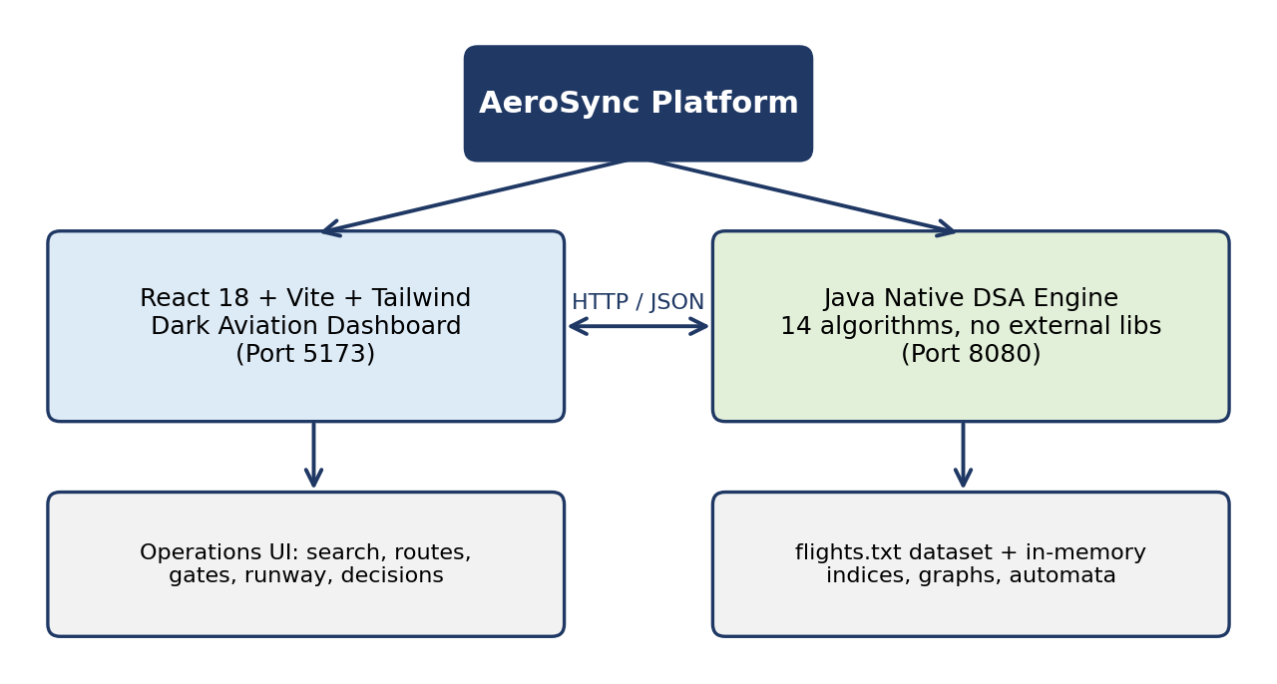
Fig. 1.1 Overview of the AeroSync platform
Aviation operations involve handling large volumes of interconnected data – flights, airports, aircraft, crew members, passengers, gates and operational schedules are all linked to one another. A change in one (for example a delayed aircraft) affects the others (the gate, the crew shift, the runway slot and the onward passengers). Efficient information retrieval and decision support are therefore essential for minimizing delays and improving resource utilization. AeroSync provides a centralized platform that brings these entities together and offers intelligent search, streamlined resource management and operational assistance for airport and airline authorities. Advanced data structures and algorithmic techniques are progressively integrated into the platform to enhance search efficiency, scheduling, resource allocation and decision-making. AeroSync is thus both a practical aviation management solution and a demonstration of how advanced algorithms solve real-world operational challenges.
Unlike a typical web application that relies on a database and third-party libraries, AeroSync deliberately implements its core algorithms natively so that the relationship between theory (time and space complexity) and application (an operational decision) is visible. For example, the search bar uses a Trie for instant autocomplete, KMP for exact pattern matching and Levenshtein distance for typo tolerance, while the route page uses Dijkstra's shortest path and the tour page uses a bitmask dynamic-programming solution to the Travelling Salesman Problem.

1.2 Problem Statement
Aviation data is large, textual and highly interrelated. Operators typically face the following problems:
- Slow and rigid search – flight codes, tail IDs, callsigns, airport names and crew names are searched with linear scans or exact matches; a single typo returns nothing.
- Manual and error-prone scheduling – runway slots, gates and crew are assigned by hand or by simple rules, causing gate conflicts, wake-turbulence violations and idle resources.
- Sub-optimal routing – choosing routes and multi-city tours without a proper shortest-path or optimization algorithm wastes fuel and time.
- Fragmented, interconnected data – information about flights, airports, aircraft, crew members, passengers, gates and schedules is spread across separate lists, so a delay or change in one place is not quickly reflected in the others, increasing delays and idle resources.
- Lack of explainability – tools that hide their logic make it difficult to trust or verify the recommendations they give.
The problem addressed by this project is therefore: to design and implement a centralized, integrated and algorithm-driven platform to organize, search and manage aviation information, minimize delays and improve resource utilization, by providing fast intelligent search, optimal routing and scheduling, resource allocation and automated decision support for aviation operations, using well-understood Data Structures and Algorithms with measurable complexity.

1.3 Scope of the Project
The scope of AeroSync includes:
- A centralized platform to organize, search and manage information on flights, airports, aircraft, crew members, passengers, gates and operational schedules, for use by airport and airline authorities.
- A Java backend engine implementing 14 DSA algorithms natively and serving results over HTTP on port 8080.
- A flight dataset (data/flights.txt) loaded into a repository with inverted indices for fast lookup.
- A React-based dark aviation dashboard (port 5173) with nine functional modules: Dashboard, Global Search, Route Graph, Tour Optimization, Runway Scheduling, Gate Management, Resource Allocation, Decision Support and Algorithm Lab.
- One-click launch (start_all.bat) and manual launch instructions for the backend and frontend.
The following are outside the current scope:
- Integration with live airline, ATC or airport systems; the project works on a static dataset.
- Passenger booking, payments, user accounts and authentication.
- Persistent database storage and multi-airport distributed deployment.

1.4 Objectives
- To provide a centralized platform for organizing, searching and managing flight, airport, aircraft, crew, passenger, gate and schedule information.
- To support minimizing delays and improving resource utilization through operational assistance and decision support for airport and airline authorities.
- To progressively integrate advanced data structures and algorithmic techniques to enhance search efficiency, scheduling, resource allocation and decision-making.
- To implement fourteen core DSA algorithms (string matching, fuzzy search, sequence alignment, tries, suffix structures, graph DP, tree DP and advanced DP) natively in Java.
- To provide instant, typo-tolerant global search over flights, airports, aircraft and crew.
- To compute shortest routes between airports and the minimum-fuel closed-loop tour across multiple cities.
- To schedule runway departures with a priority queue while respecting wake-turbulence deconfliction.
- To visualize and manage gate allocation (G01–G12) and fleet/crew/gate utilization using SOS-DP.
- To generate automated operational alerts and recommendations through a Decision Support Centre.
- To expose every algorithm in an interactive Algorithm Lab with live microsecond execution timings so that complexity can be demonstrated and compared.

2. SYSTEM REQUIREMENTS

2.1 Functional Requirements
Table 2.1 lists the functional requirements of AeroSync and the module responsible for each.
Table 2.1 Functional requirements
ID | Requirement | Module / Algorithm
FR1 | Display live aviation telemetry: KPI cards, active flights and network topology. | Dashboard
FR2 | Search flight codes (e.g., AI202), airports (HYD), aircraft (A320) and crew with instant autocomplete. | Global Search – Trie, KMP
FR3 | Tolerate typing mistakes in passenger and airport names. | Levenshtein / Damerau
FR4 | Scan text for several flight codes or keywords simultaneously and search NOTAM-style bulletins. | Aho-Corasick, Z-Algorithm, Rabin-Karp
FR5 | Compute shortest route between a chosen origin and destination with distance and waypoint breakdown. | Route Graph – Dijkstra
FR6 | Compute the minimum-fuel closed-loop tour across selected cities and check full sector coverage. | Bitmask TSP, Hamiltonian Path DP
FR7 | Schedule runway departures by priority with wake-turbulence deconfliction. | Priority Queue
FR8 | Show the terminal concourse (G01–G12) and allow real-time gate reassignment. | Gate Management
FR9 | Show fleet, crew and gate utilization and the best partition of resources. | SOS-DP
FR10 | Generate automated alerts: gate conflicts, maintenance recommendations and operational warnings. | Decision Support Centre
FR11 | Analyse hub-and-spoke route topology and passenger volume. | Tree DP
FR12 | Run each of the 14 algorithms with custom input and report live execution time in microseconds. | Algorithm Lab

2.2 Non-Functional Requirements
Table 2.2 Non-functional requirements
Attribute | Requirement
Performance | Search, routing and scheduling results must be returned almost instantly for the dataset size; algorithms are chosen for their low time complexity (e.g., O(N + M) matching, O(L) Trie lookup).
Usability | Dark aviation-themed, dashboard-style interface with clear modules, interactive controls and visual feedback so that evaluators and operators can use it without training.
Maintainability | Clear separation between the Java algorithm core, the HTTP layer and the React UI; each algorithm is an independent class that can be tested and replaced.
Portability | Runs on any machine with a JDK and Node.js; one-click launcher is provided for Windows and manual commands for other platforms.
Reliability | Algorithms are validated against a naive baseline (e.g., Naive Pattern Matcher validates KMP/Rabin-Karp results).
Scalability | Polynomial and linear algorithms scale to large data; exponential DP algorithms (TSP, Hamiltonian, SOS) are applied to small bounded inputs such as a handful of cities or resources.
Transparency | Every result can be traced to a named algorithm with a published complexity and a measured execution time.

2.3 Hardware and Software Requirements
Table 2.3 Hardware and software requirements
Component | Specification
Processor | Dual-core 2.0 GHz or higher
Memory | 4 GB RAM minimum (8 GB recommended)
Disk space | 500 MB free (includes Node.js dependencies)
Operating system | Windows 10/11 (for start_all.bat); Linux / macOS using manual launch
Backend | Java Development Kit (JDK) with javac; Java source in AeroSync/src
Frontend | Node.js and npm; React 18, Vite, Tailwind CSS
Browser | Any modern browser (Chrome, Edge, Firefox) to open http://localhost:5173
Tools | Git and GitHub for version control; VS Code / IntelliJ IDEA as editors

3. SYSTEM DESIGN

3.1 High-level Architecture Diagram
AeroSync follows a two-tier client–server architecture. The React front end (port 5173) is the presentation tier; the Java backend (port 8080) is the application and algorithm tier, and it reads its data from the flight dataset. The architecture is shown in Fig. 3.1.
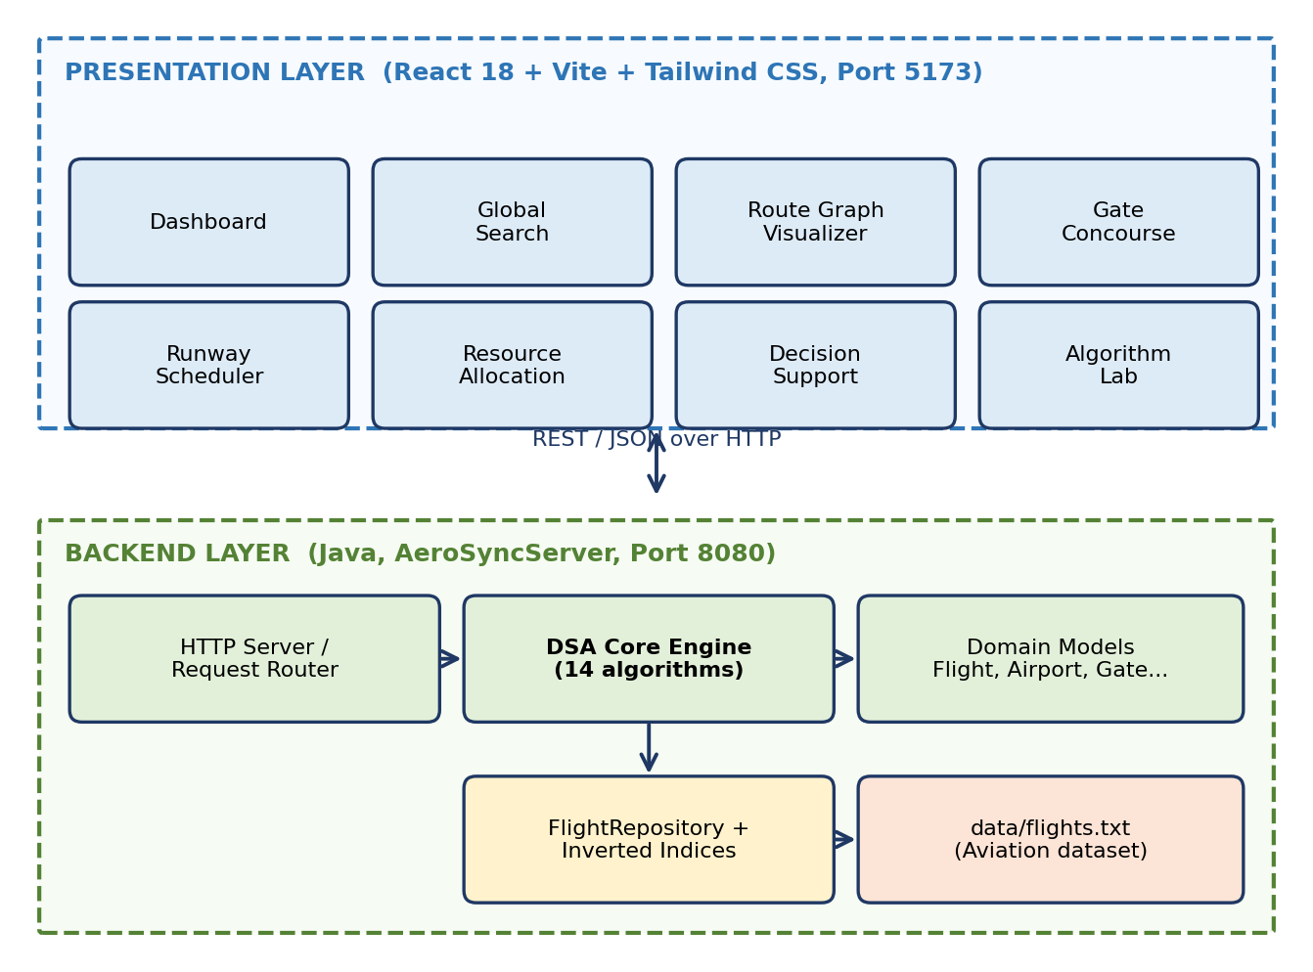
Fig. 3.1 High-level architecture of AeroSync
When the user interacts with a module, the front end sends an HTTP request carrying the input parameters; the backend selects the appropriate algorithm, runs it on the in-memory data structures, measures the execution time, and returns a JSON response that the front end renders. This request–response cycle is shown in Fig. 3.3.
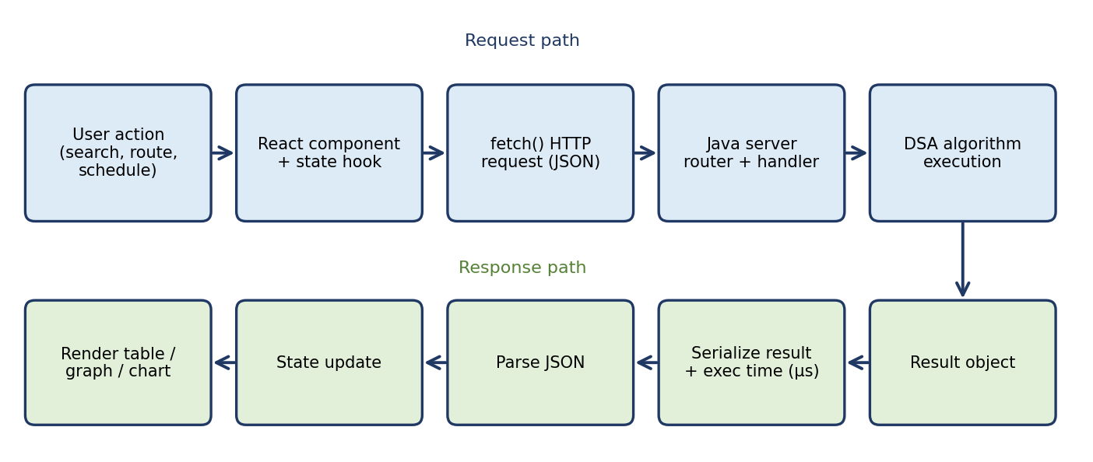
Fig. 3.3 Request–response data flow between UI and DSA engine

3.2 Description of each layer

3.2.1 Presentation layer (React 18 + Vite + Tailwind CSS)
This layer renders the dark aviation dashboard. It contains one view per module (Dashboard, Global Search, Route Graph Visualizer, Gate Concourse, Runway Scheduler, Resource Allocation, Decision Support and Algorithm Lab). React components keep their own state, call the backend, and re-render when new data arrives. Vite provides the fast development server and build tooling, and Tailwind CSS provides utility-based styling for the dark theme.

3.2.2 Communication layer
The two tiers communicate over HTTP using JSON payloads between localhost:5173 and localhost:8080. Requests carry parameters such as the search text, origin and destination, selected cities or algorithm inputs; responses carry the result together with metadata such as execution time.

3.2.3 Backend server layer (Java)
The class AeroSyncServer starts the backend on port 8080, receives requests, routes them to the correct handler and serialises the response. It is compiled with javac -d bin src/*.java and run with java -cp bin AeroSyncServer.

3.2.4 DSA core engine
This is the heart of the project. Fourteen algorithms are implemented natively in Java and are grouped into families as shown in Fig. 3.2: string matching, multi-pattern and fuzzy search, sequence alignment, trees and suffix structures, graph DP, tree DP, advanced DP, and scheduling/routing. Each algorithm has an aviation-specific use (Table 4.1).
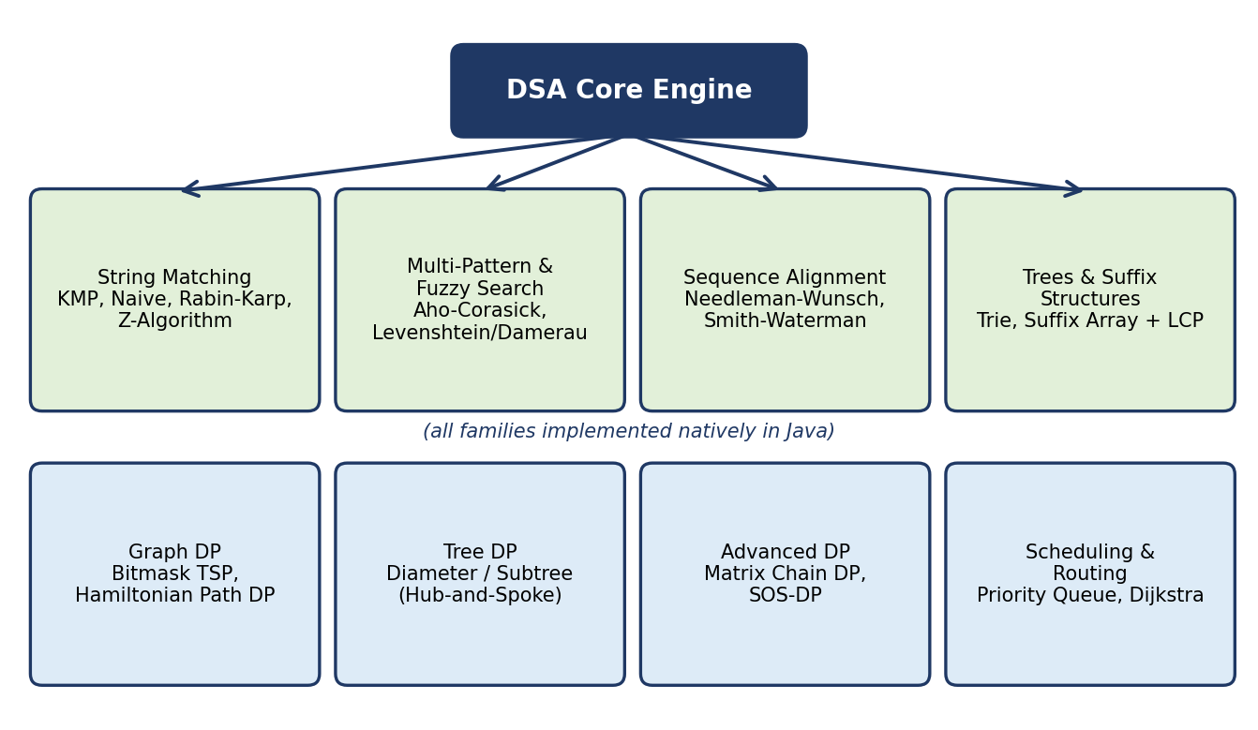
Fig. 3.2 Algorithm families in the Java DSA core engine

3.2.5 Data layer
The aviation dataset is stored in AeroSync/data/flights.txt. At start-up, the FlightRepository loads the records into memory and builds inverted indices (for example from airport code, aircraft type or flight code to the flight records), so that lookups do not require scanning every record. Keeping the data in memory makes the algorithms' measured run-times reflect their true complexity.

3.2.6 Deployment layer
The project is launched with AeroSync/start_all.bat, which starts the backend and frontend together. For manual launching, the backend is compiled and run first, followed by npm install and npm run dev for the frontend.

4. IMPLEMENTATION

4.1 Module-wise implementation
The project folder is organised as follows: AeroSync/src/ (Java algorithms and models), AeroSync/data/ (flights.txt), AeroSync/frontend/ (React application) and AeroSync/start_all.bat (launcher). Each front-end module is backed by one or more backend algorithms, as summarised in Fig. 4.1.
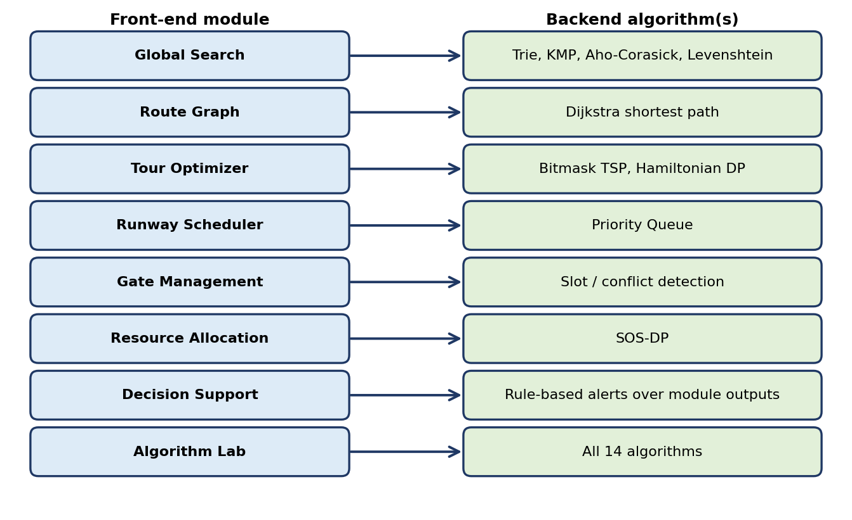
Fig. 4.1 Mapping of front-end modules to backend algorithms

4.1.1 Dashboard
The dashboard is the landing page. It shows KPI metric cards (for example number of flights, active flights and gate utilization), a live flight operations table and a graph topology view of the airport network. Data comes from the flight repository and from the results of other modules.

4.1.2 Global Intelligent Search
The search bar accepts flight codes (AI202), airports (HYD), aircraft types (A320) and crew names. Three techniques work together: (i) a Trie supplies instant autocomplete in O(L) time for a key of length L; (ii) KMP performs exact pattern matching on flight codes, tail IDs and callsigns in O(N + M); and (iii) Levenshtein/Damerau edit distance makes the search typo-tolerant. Aho-Corasick scans for many patterns in a single pass, Rabin-Karp hashes telemetry strings and barcodes, and the Z-Algorithm supports NOTAM keyword search. A Suffix Array with LCP supports indexed telemetry search and repeated-pattern anomaly detection.

4.1.3 Aviation Route Graph
Airports are modelled as vertices and flight legs as weighted edges (airway distance). When the user chooses an origin (for example HYD) and a destination (for example LHR), Dijkstra's algorithm with a priority queue returns the shortest path, total distance and a waypoint-by-waypoint breakdown. The result is drawn on the graph topology visualizer.

4.1.4 Multi-City Tour Optimization
For a set of N cities, the Bitmask TSP algorithm stores in dp[mask][i] the minimum cost of visiting the cities in mask and ending at city i, giving the minimum-fuel closed-loop tour in O(N² · 2ᴺ) time and O(N · 2ᴺ) space. Hamiltonian Path DP uses the same bitmask idea to verify complete sector coverage for aerial calibration flights. Tree DP computes the diameter and subtree passenger volumes in the hub-and-spoke topology in O(V + E).

4.1.5 Runway Slot Scheduling
Departures are kept in a priority queue ordered by priority and scheduled time. The scheduler repeatedly extracts the highest-priority flight and assigns the next free runway slot, inserting the required wake-turbulence separation between consecutive departures. Insert and extract operations are O(log N).

4.1.6 Visual Gate Management
The terminal concourse is shown as twelve gates (G01–G12). Each gate is coloured by its state, and the operator can reassign a flight to another gate in real time. The system checks the new assignment for time-overlap conflicts and raises a warning if two flights would occupy a gate simultaneously.

4.1.7 Resource Allocation Matrix
Aircraft, crew shifts and apron gates are treated as subsets of resources. Sum Over Subsets (SOS) DP computes, for every subset mask, the aggregate over all its sub-masks in O(N · 2ᴺ), which allows the best partition of resources to be found efficiently. The matrix view then shows fleet, crew and gate utilization. Matrix Chain DP (O(N³)) is used to find the cheapest multiplication order for aviation Markov scheduling state matrices.

4.1.8 Decision Support Centre
The centre consolidates the outputs of the other modules into automated, human-readable alerts: gate conflict warnings, operational alerts and aircraft maintenance recommendations. It turns raw algorithmic results into actions the operator can take.

4.1.9 Algorithm Lab
The Algorithm Lab allows all fourteen algorithms to be executed interactively with custom input parameters. For each run it displays the output together with the live execution time in microseconds, so that the practical effect of the time complexity can be observed directly (for example Naive vs. KMP matching).

4.2 Front-end logic (UI rendering, state management)
The front end is a single-page application written with React 18 function components and hooks. Vite bundles the code and serves it on port 5173 with hot module replacement during development.
- Component structure – a top-level layout (sidebar navigation and header) renders one page component per module; reusable components include KPI cards, data tables, the graph visualizer, the gate tile and alert cards.
- State management – local component state (useState) holds user input, loading flags, results and errors; side effects such as data loading use useEffect. Gate reassignments update state immediately so that the concourse view re-renders in real time.
- UI rendering – lists and tables are rendered from arrays returned by the backend; the network topology and route path are drawn as a graph, and the concourse as a grid of gate tiles.
- Styling – Tailwind CSS utility classes implement the dark aviation theme, spacing and responsive layout without separate CSS files.
- Feedback – loading indicators and execution-time badges give immediate feedback for each algorithm call.

4.3 API integration
The front end calls the Java backend with the browser fetch API. Each module sends its inputs and receives a JSON response, which is stored in component state and rendered. Because the interface (port 5173) and the server (port 8080) run on different origins, cross-origin access between the two has to be permitted. The following pattern is used for every call:
async function callBackend(url, params) {
const res = await fetch(url, {
method: 'POST',
headers: { 'Content-Type': 'application/json' },
body: JSON.stringify(params)
});
if (!res.ok) throw new Error('Backend error ' + res.status);
return await res.json(); // result + execution time (us)
}
Table 4.2 summarises the groups of API operations offered by the backend (illustrative grouping of the nine modules).
Table 4.2 API groups between the React UI and the Java backend
API group | Request input | Response
Search | Query text, search type | Matching flights / airports / crew, suggestions
Route | Origin, destination | Shortest path, distance, waypoints
Tour | List of cities | Optimal order and total fuel/cost
Runway | Departure list with priorities | Ordered slot schedule
Gates | Flight, target gate | Updated assignment, conflict warnings
Resources | Fleet / crew / gate set | Utilization matrix and best partition
Decisions | – | List of alerts and recommendations
Lab | Algorithm name, custom input | Output and execution time (µs)

4.4 DSA algorithm implementation details
Table 4.1 lists all fourteen algorithms with their category, aviation application and complexity.
Table 4.1 Algorithms implemented in the Java core
Algorithm | Category | Aviation application | Time | Space
Knuth-Morris-Pratt (KMP) | String matching | Flight code, tail ID, callsign matching | O(N + M) | O(M)
Naive Pattern Matcher | String matching | Baseline validation for manifest search | O((N−M+1)M) | O(1)
Rabin-Karp | String matching | Telemetry stream hashing, barcode filter | O(N + M) avg | O(1)
Z-Algorithm | String matching | NOTAM bulletin keyword search | O(N + M) | O(N + M)
Aho-Corasick | Multi-pattern automaton | Simultaneous multi-code scanning | O(N + ΣP) | O(Σ·P)
Levenshtein / Damerau | Fuzzy distance | Typo-tolerant passenger/airport search | O(M·N) | O(M·N)
Needleman-Wunsch / Smith-Waterman | Sequence alignment | Flight trajectory waypoint alignment | O(M·N) | O(M·N)
Prefix Tree (Trie) | Trees and tries | Autocomplete for airports/flights | O(L) | O(Σ·Keys)
Suffix Array & LCP | Suffix structures | Telemetry search, anomaly detection | O(N log² N) | O(N)
Bitmask TSP | Graph DP | Minimum-fuel closed-loop tour | O(N²·2ᴺ) | O(N·2ᴺ)
Hamiltonian Path DP | Graph DP | Complete sector coverage check | O(N²·2ᴺ) | O(N·2ᴺ)
Tree DP | Tree DP | Hub-and-spoke analysis, passenger volume | O(V + E) | O(V)
Matrix Chain DP | Dynamic programming | Markov scheduling state matrices | O(N³) | O(N²)
Sum Over Subsets (SOS-DP) | Advanced DP | Aircraft, crew, gate resource partition | O(N·2ᴺ) | O(2ᴺ)

4.4.1 String-matching family
The Naive matcher compares the pattern at every shift and is used as a correctness baseline. KMP pre-computes a failure (prefix) function so that after a mismatch the pattern shifts without re-reading text characters, giving linear time. Rabin-Karp compares rolling hash values of the pattern and each text window and verifies only on hash equality. The Z-Algorithm computes, for every position, the length of the longest substring starting there that matches a prefix of the string, enabling linear pattern search. The following illustrative pseudocode shows the KMP failure function:
computeLPS(pattern):
lps[0] = 0; len = 0; i = 1
while i < m:
if pattern[i] == pattern[len]: lps[i++] = ++len
else if len > 0: len = lps[len - 1]
else: lps[i++] = 0
return lps

4.4.2 Multi-pattern, fuzzy search and alignment
Aho-Corasick builds a trie of all patterns and adds failure links, so a text can be scanned once for all patterns. Levenshtein distance fills an M × N table where each cell is the minimum of insertion, deletion and substitution; Damerau additionally allows adjacent transposition. Needleman-Wunsch performs global alignment and Smith-Waterman local alignment using the same table idea with a scoring scheme, which is used here to align waypoint sequences of flight trajectories.

4.4.3 Trie and suffix structures
The Trie stores airport and flight keys character by character so that all keys with a given prefix can be listed quickly for autocomplete. The Suffix Array sorts all suffixes of a text and, with the LCP (longest common prefix) array, supports substring search and detection of repeated patterns in telemetry.

4.4.4 Graph, tree and DP algorithms
Dijkstra relaxes edges using a priority queue to compute shortest airway distances. Bitmask TSP and Hamiltonian Path DP represent the set of visited cities as a bit mask. Tree DP computes values such as the diameter and subtree sums in one depth-first traversal. Matrix Chain DP chooses the optimal parenthesization of matrix products, and SOS-DP iterates over each bit to aggregate subset values. The Dijkstra pseudocode is:
dijkstra(graph, source):
dist[*] = INF; dist[source] = 0
pq.add((0, source))
while pq not empty:
(d, u) = pq.poll()
if d > dist[u]: continue
for (v, w) in graph[u]:
if dist[u] + w < dist[v]:
dist[v] = dist[u] + w; parent[v] = u
pq.add((dist[v], v))
return dist, parent

4.5 Build and run instructions
Option 1 – one-click (Windows): double-click AeroSync/start_all.bat to start the backend and the frontend.
Option 2 – manual:
# 1. Start the Java backend (http://localhost:8080)
cd AeroSync
javac -d bin src/*.java
java -cp bin AeroSyncServer

# 2. Start the React frontend (http://localhost:5173)
cd AeroSync/frontend
npm install
npm run dev

5. RESULTS

5.1 Output of the modules
This section presents the output of each module following the demonstration flow of the project. Screenshots should be captured from the running application at http://localhost:5173 and inserted in the highlighted boxes.

5.1.1 Dashboard Overview
The dashboard displays live telemetry, KPI metric cards, active flights and the live network topology.

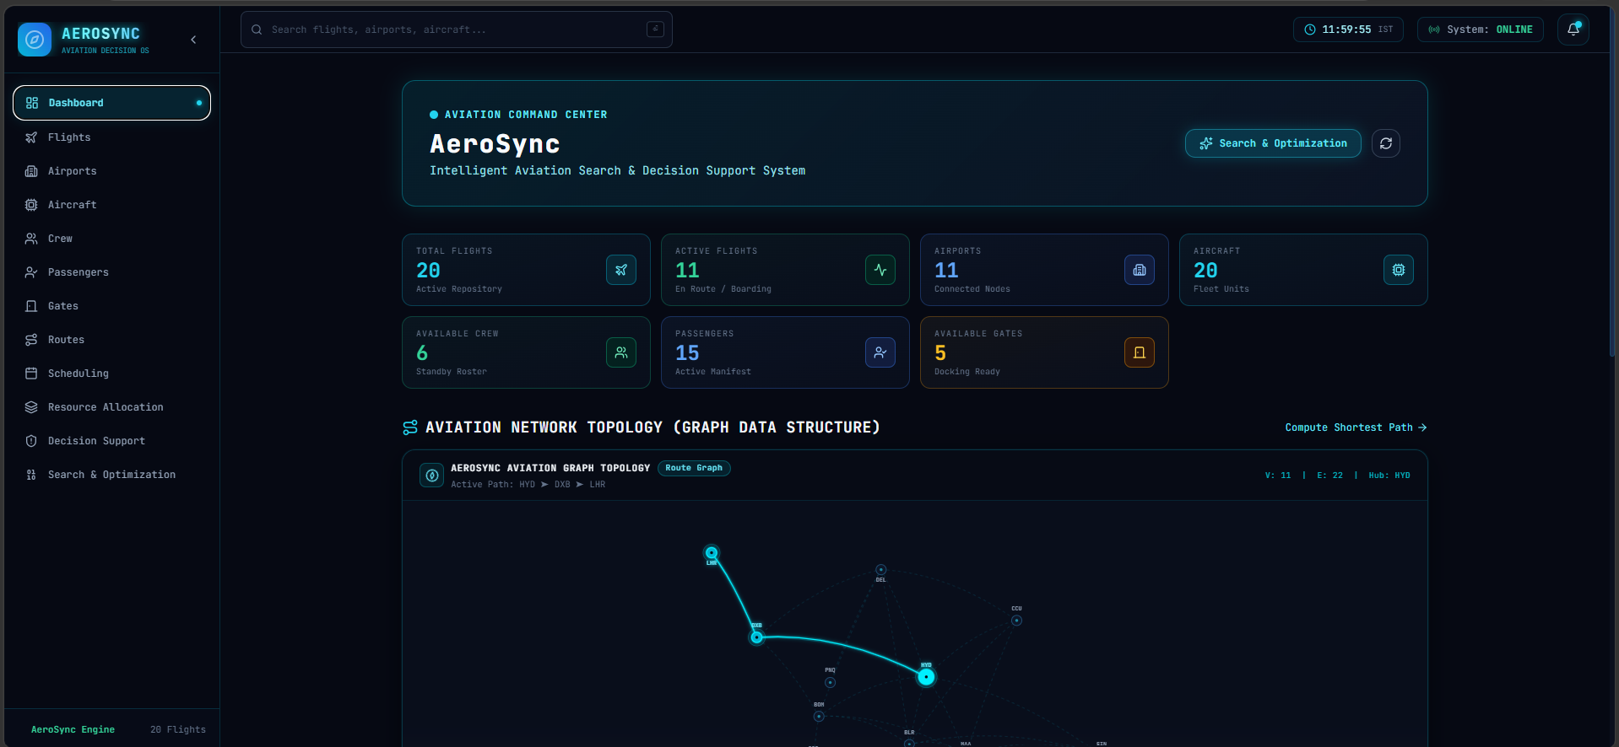
Fig. 5.1 Dashboard overview with KPI cards and network topology

5.1.2 Global Intelligent Search
Typing a flight code such as AI202, an airport such as HYD or an aircraft type such as A320 returns instant autocomplete suggestions and matching records, even with a small typing mistake.

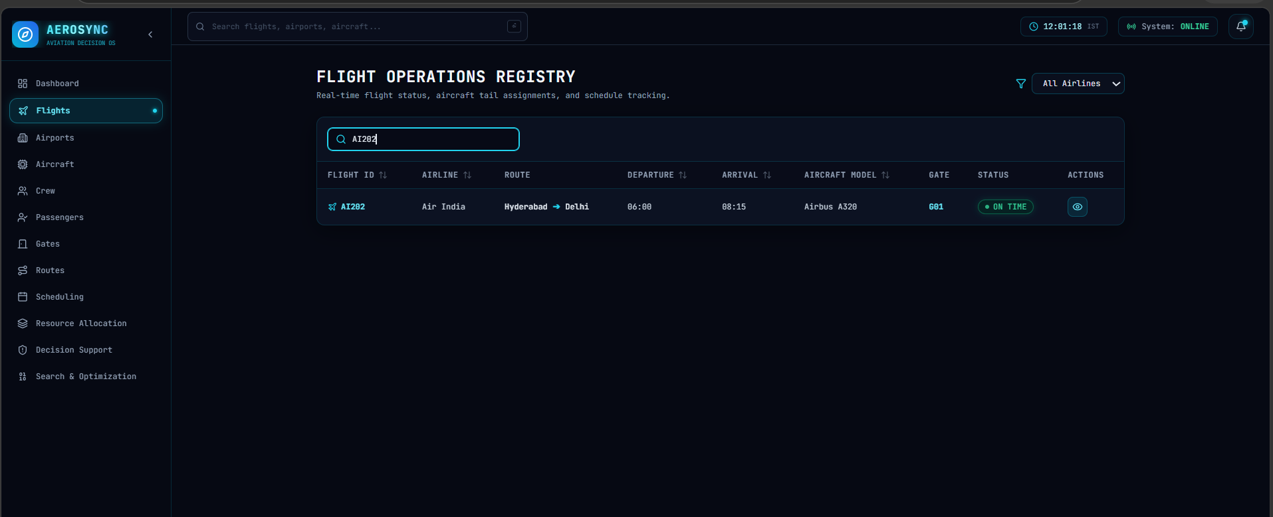
Fig. 5.2 Global intelligent search with instant suggestions

5.1.3 Aviation Route Graph
Selecting HYD as origin and LHR as destination runs Dijkstra's algorithm and shows the shortest path, total airway distance and the waypoint breakdown.

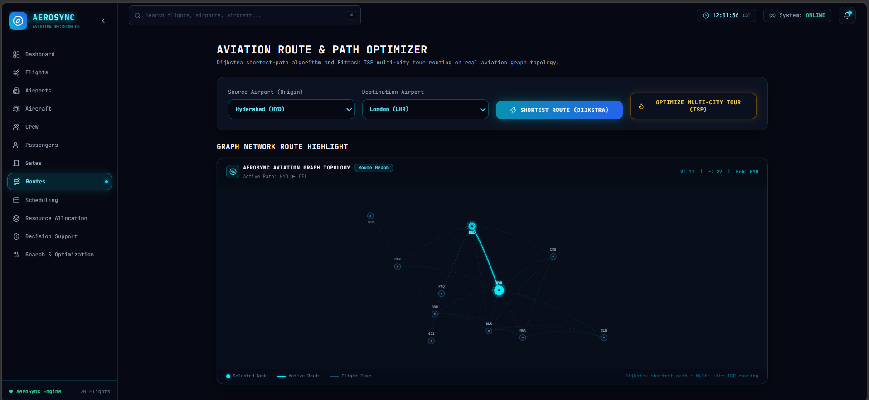
Fig. 5.3 Dijkstra shortest-path result for HYD to LHR

5.1.4 Multi-City Tour Optimization
The Bitmask TSP module outputs the visiting order that gives the minimum fuel burn for a closed-loop tour of the selected cities.

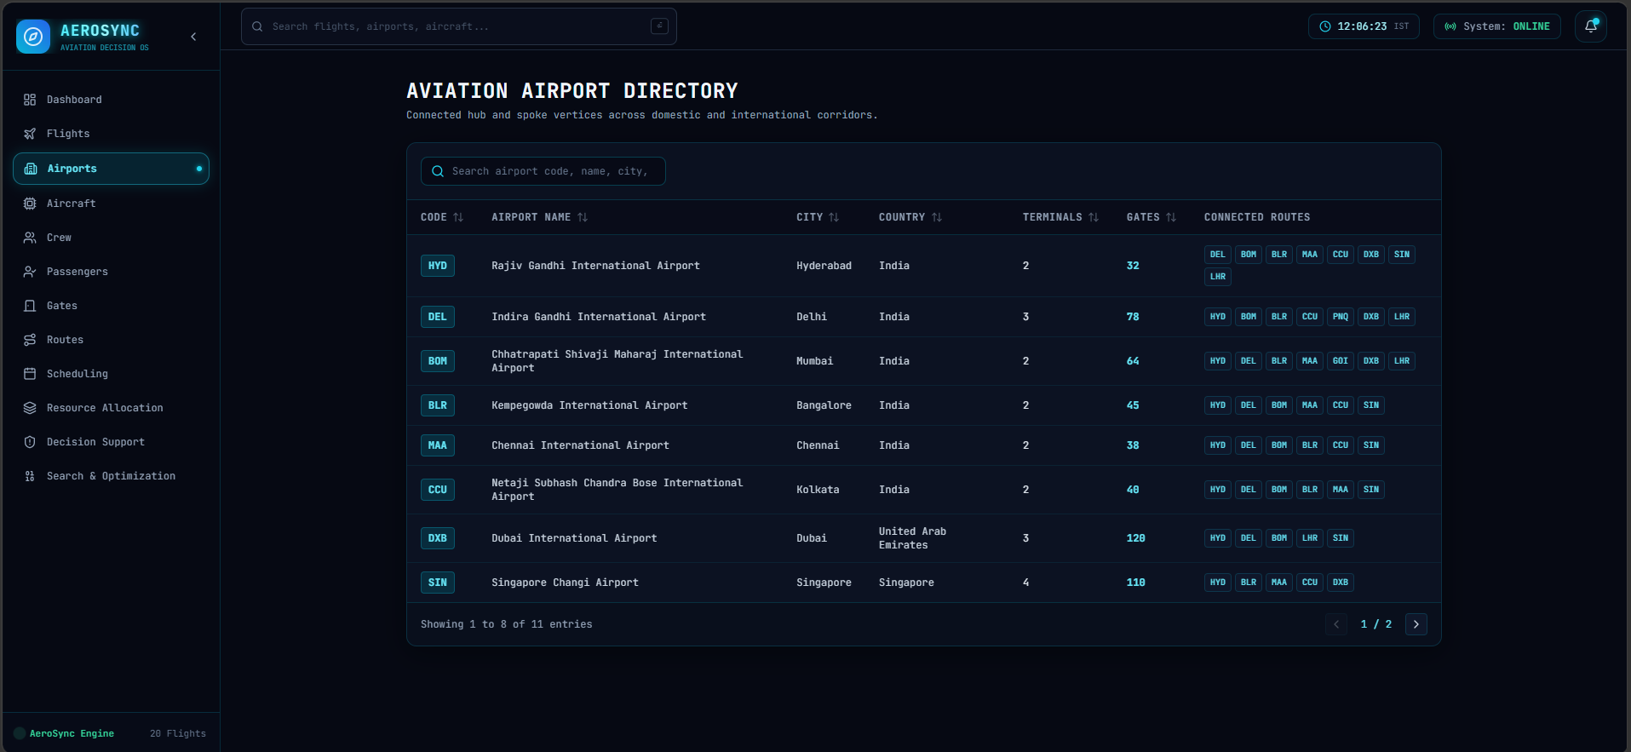
Fig. 5.4 Bitmask TSP multi-city tour optimization

5.1.5 Runway Slot Scheduling
The priority-queue scheduler orders departures by priority and inserts wake-turbulence separation between consecutive slots.

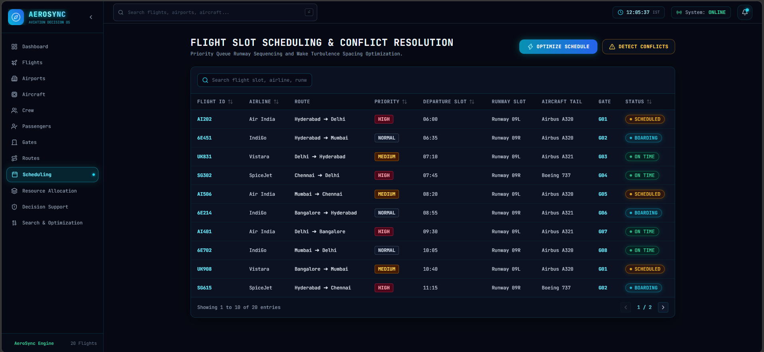
Fig. 5.5 Runway slot scheduling using priority queue

5.1.6 Visual Gate Management
The concourse shows gates G01–G12 and lets the operator reassign a flight to another gate; conflicting assignments are flagged.

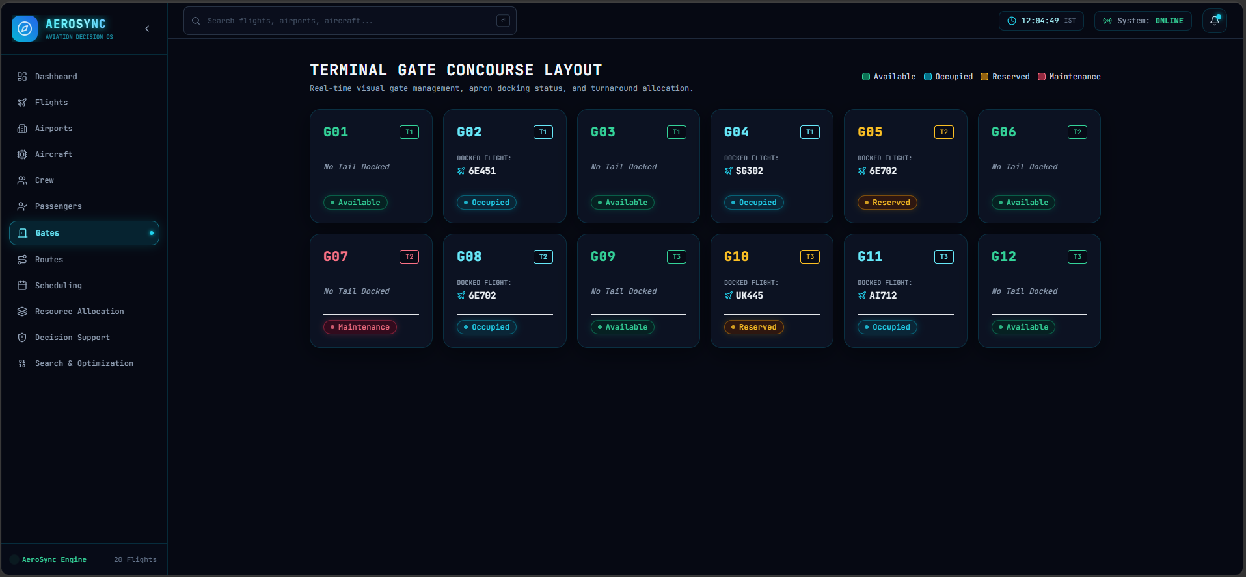
Fig. 5.6 Interactive gate concourse (G01–G12)

5.1.7 Resource Allocation Matrix
The SOS-DP matrix shows fleet, crew and gate utilization and the best resource partition.

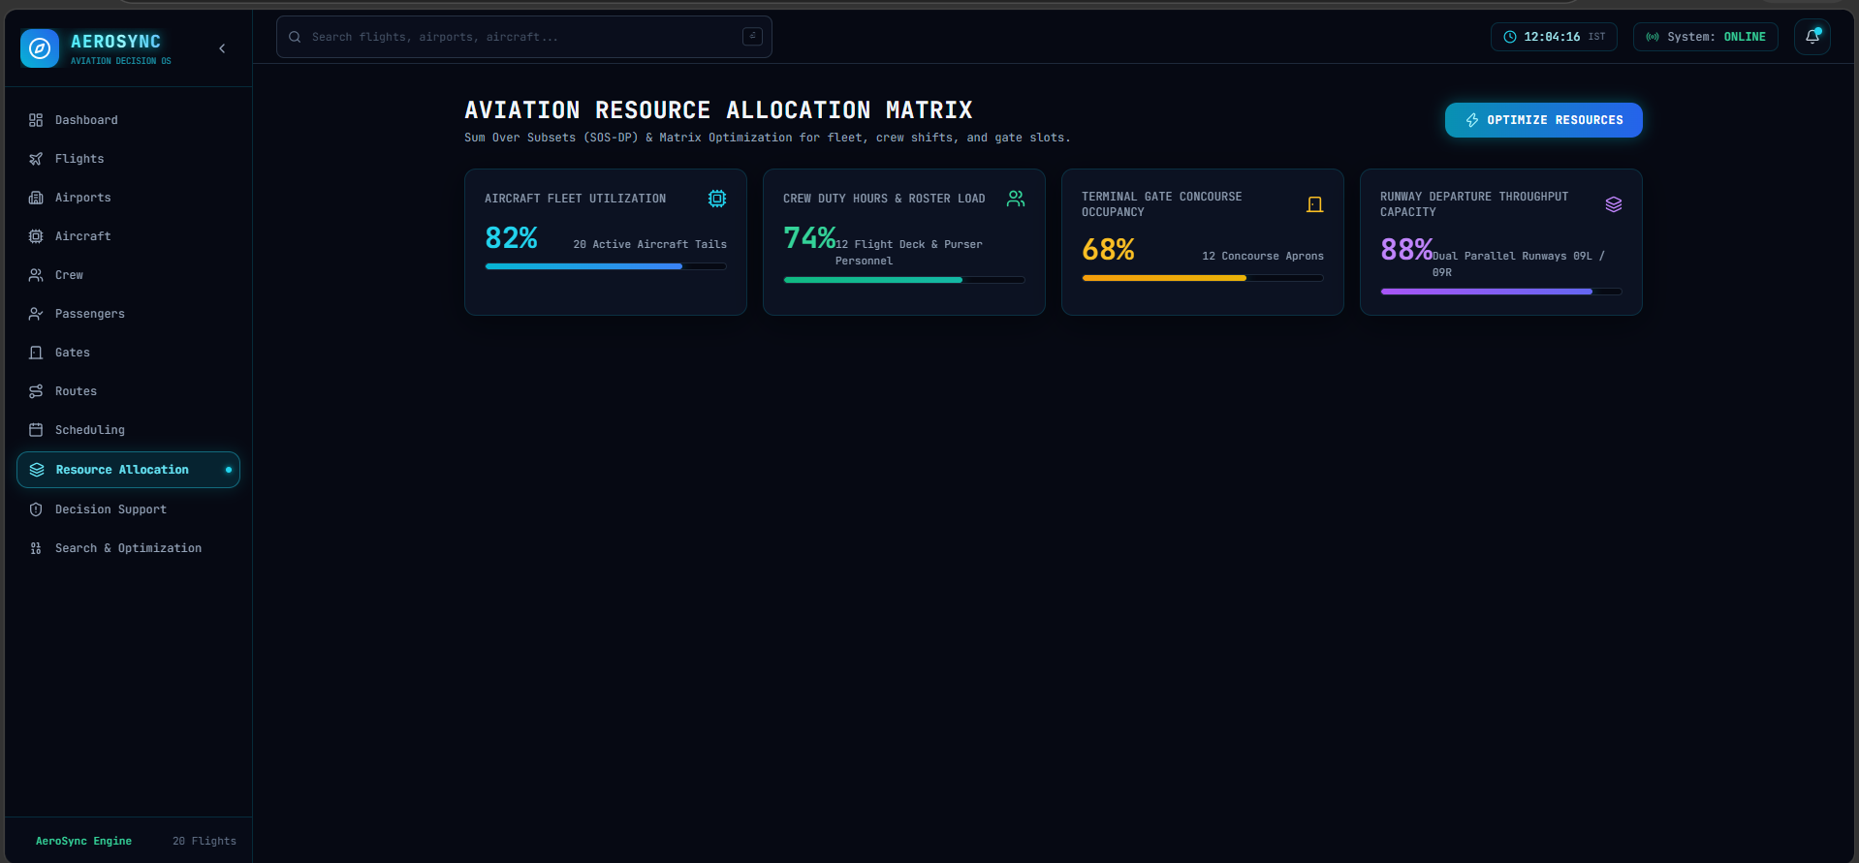
Fig. 5.7 Resource allocation matrix using SOS-DP

5.1.8 Decision Support Centre
Automated alerts summarise gate conflict warnings and aircraft maintenance recommendations.

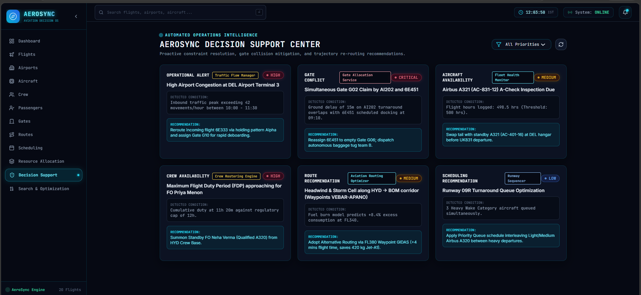
Fig. 5.8 Automated Decision Support Center

5.2 Complexity and performance analysis
The Algorithm Lab reports the live execution time of every algorithm. The theoretical growth of the complexity classes used in the project is compared in Fig. 5.10. Linear and near-linear algorithms (KMP, Z, Trie, Suffix Array) remain fast for large inputs, while the exponential bitmask DP algorithms (TSP, Hamiltonian, SOS) are practical only for small N, which is why they are applied to a limited number of cities or resource types.
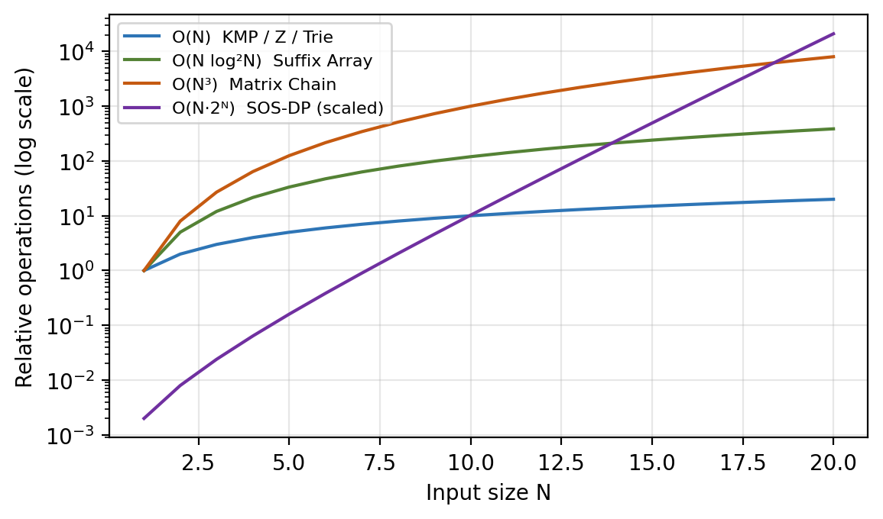
Fig. 5.10 Growth of operation counts for the complexity classes used
Observation: replacing a naive O(N·M) scan by KMP/Rabin-Karp, a linear scan by a Trie, and brute-force permutation (O(N!)) by bitmask DP (O(N²·2ᴺ)) yields substantial reductions in work, and the Algorithm Lab makes this difference visible in microseconds. Add the measured timings from your own runs in Table 5.1.
Table 5.1 Execution-time record (to be completed from Algorithm Lab)
Algorithm | Input size | Execution time (µs)
Naive Pattern Matcher | Run required | Run required
KMP | Run required | Run required
Rabin-Karp | Run required | Run required
Z-Algorithm | Run required | Run required
Bitmask TSP | Run required | Run required
SOS-DP | Run required | Run required

5.3 Test scenarios
Table 5.2 Functional test scenarios
# | Scenario | Input | Expected result
1 | Dashboard loads | Open localhost:5173 | KPI cards, flight table and topology are displayed
2 | Exact search | AI202 | Flight AI202 returned instantly
3 | Airport / aircraft search | HYD ; A320 | Matching airports/flights and autocomplete suggestions
4 | Typo-tolerant search | Slightly misspelled airport name | Closest match returned using edit distance
5 | Shortest route | Origin HYD, destination LHR | Shortest path with distance and waypoints
6 | Tour optimization | Several cities selected | Minimum-fuel closed-loop order using Bitmask TSP
7 | Runway scheduling | Departure list | Priority-ordered slots with wake-turbulence gap
8 | Gate reassignment | Move a flight to another gate (G01–G12) | Gate updated; conflict warning if overlapping
9 | Resource allocation | Open matrix | Fleet, crew and gate utilization displayed
10 | Decision support | Open centre | Gate conflicts and maintenance recommendations listed
11 | Algorithm Lab | Choose algorithm + custom input | Output with execution time in µs

6. CHALLENGES & LIMITATIONS

6.1 Issues faced during development
- Implementing algorithms natively – writing fourteen algorithms from scratch without libraries required careful handling of indexing, edge cases (empty patterns, single-node graphs) and verification against baselines.
- Exponential state space – Bitmask TSP, Hamiltonian Path DP and SOS-DP consume O(N·2ᴺ) memory, which grows quickly with N.
- Front-end/back-end integration – the React app and Java server run on separate ports, so request formats, JSON structures and cross-origin access had to be aligned.
- Typo-tolerant search speed – computing edit distance against many records can be slow if done naively.
- Consistency of gate and schedule data – gate reassignment and runway scheduling must not create overlapping slots or conflicting states.
- Visualization – drawing the network topology, route path and gate concourse in a clear and interactive way.

6.2 Solutions applied
- Every algorithm was validated against a simpler baseline (e.g., Naive matcher for KMP/Rabin-Karp) and tested with edge cases.
- Exponential algorithms are limited to small bounded inputs and use bitmasks for compact state representation.
- A fixed JSON contract was defined between the UI and the server, and cross-origin access was enabled for the front-end origin.
- Inverted indices in FlightRepository and a Trie narrow the candidate set before edit distance is applied.
- Conflict checks are executed on every gate reassignment and surfaced in the Decision Support Centre.
- React state hooks and Tailwind utilities were used to build reusable visual components.

6.3 Limitations of the System
- The system works on a static flat-file dataset (flights.txt) and not on live flight data feeds.
- Exponential DP modules (TSP, Hamiltonian Path, SOS-DP) are suitable only for small N.
- No user authentication, role-based access or persistent database.
- The one-click launcher (start_all.bat) is Windows-specific.
- Distances, fuel and wake-turbulence rules are simplified models and not certified aviation procedures.

7. CONCLUSION & FUTURE WORK

7.1 Conclusion
AeroSync successfully demonstrates how Data Structures and Algorithms can be applied to build an intelligent aviation search and decision-support platform. The Java backend implements fourteen algorithms natively, and the React dashboard turns them into nine practical modules: dashboard, intelligent search, shortest-path routing, multi-city tour optimization, runway scheduling, gate management, resource allocation, decision support and an interactive algorithm lab. Each feature is backed by an algorithm of known complexity whose run-time can be observed live.
AeroSync serves as both a practical aviation management solution and a demonstration of how advanced algorithms can be applied to real-world operational challenges: it organizes interconnected aviation data on a centralized platform, assists airport and airline authorities in reducing delays, and improves the utilization of aircraft, crew and gates.
The project met its objectives: it provides instant and typo-tolerant search, optimal routing, priority-based scheduling, visual gate control and automated alerts in a single integrated system. More importantly, it bridges the gap between classroom theory and real-world decision-making.

7.2 Future Work
- Integrate live flight data through public aviation APIs (ADS-B, airport feeds) in place of the static dataset.
- Replace the flat file with a database (SQL or graph database) and add caching.
- Use heuristics and approximation (A*, branch-and-bound, genetic algorithms) to handle larger tours than bitmask TSP allows.
- Add machine-learning models for delay prediction and demand forecasting.
- Add authentication and role-based dashboards for controllers, airline staff and ground crew.
- Provide Docker-based, cross-platform deployment and CI/CD with automated tests.
- Extend the system with a mobile application and real-time notifications via WebSockets.

7.3 Skills learned during development
- Design and analysis of algorithms: time/space complexity, dynamic programming over bitmasks, string algorithms, graph algorithms.
- Native Java programming, object-oriented design and building a lightweight HTTP server.
- Front-end development with React 18, Vite and Tailwind CSS, and REST/JSON API integration.
- Data visualization of graphs, schedules and dashboards.
- Version control with Git/GitHub, team collaboration, documentation and project presentation.

REFERENCES
- T. H. Cormen, C. E. Leiserson, R. L. Rivest and C. Stein, Introduction to Algorithms, 4th ed. Cambridge, MA, USA: MIT Press, 2022.
- R. Sedgewick and K. Wayne, Algorithms, 4th ed. Boston, MA, USA: Addison-Wesley, 2011.
- D. E. Knuth, J. H. Morris and V. R. Pratt, "Fast pattern matching in strings," SIAM Journal on Computing, vol. 6, no. 2, pp. 323–350, 1977.
- R. M. Karp and M. O. Rabin, "Efficient randomized pattern-matching algorithms," IBM Journal of Research and Development, vol. 31, no. 2, pp. 249–260, 1987.
- A. V. Aho and M. J. Corasick, "Efficient string matching: An aid to bibliographic search," Communications of the ACM, vol. 18, no. 6, pp. 333–340, 1975.
- V. I. Levenshtein, "Binary codes capable of correcting deletions, insertions, and reversals," Soviet Physics Doklady, vol. 10, no. 8, pp. 707–710, 1966.
- F. J. Damerau, "A technique for computer detection and correction of spelling errors," Communications of the ACM, vol. 7, no. 3, pp. 171–176, 1964.
- S. B. Needleman and C. D. Wunsch, "A general method applicable to the search for similarities in the amino acid sequence of two proteins," Journal of Molecular Biology, vol. 48, no. 3, pp. 443–453, 1970.
- T. F. Smith and M. S. Waterman, "Identification of common molecular subsequences," Journal of Molecular Biology, vol. 147, no. 1, pp. 195–197, 1981.
- U. Manber and G. Myers, "Suffix arrays: A new method for on-line string searches," SIAM Journal on Computing, vol. 22, no. 5, pp. 935–948, 1993.
- E. Fredkin, "Trie memory," Communications of the ACM, vol. 3, no. 9, pp. 490–499, 1960.
- E. W. Dijkstra, "A note on two problems in connexion with graphs," Numerische Mathematik, vol. 1, pp. 269–271, 1959.
- M. Held and R. M. Karp, "A dynamic programming approach to sequencing problems," Journal of the SIAM, vol. 10, no. 1, pp. 196–210, 1962.
- D. Gusfield, Algorithms on Strings, Trees, and Sequences. Cambridge, U.K.: Cambridge University Press, 1997.
- React Documentation. [Online]. Available: https://react.dev
- Vite Documentation. [Online]. Available: https://vitejs.dev
- Tailwind CSS Documentation. [Online]. Available: https://tailwindcss.com/docs
- Oracle, Java Platform, Standard Edition Documentation. [Online]. Available: https://docs.oracle.com/en/java/
- Team 24, "AeroSync: Intelligent Aviation Search & Decision Support System," GitHub repository. [Online]. Available: https://github.com/PRASANNA18-sai/KLH_CSE_2026-27_DSA3_S6_Team-24_AeroSync

