$ sudo apt-get update

$ sudo apt-get dist-upgrade

$ sudo apt-get upgrade

sudo raspi-config

The sudo is required because you will be changing files that you do not own as the pi user.

You should see a blue screen with options in a grey box in the centre, like so:

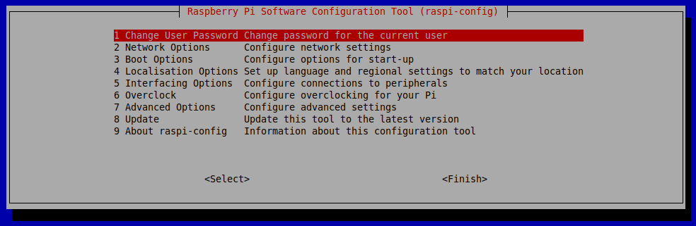

What raspi-config does

Generally speaking, raspi-config aims to provide the functionality to make the most common configuration changes. This may result in automated edits to /boot/config.txt and various standard Linux configuration files. Some options require a reboot to take effect. If you changed any of those, raspi-config will ask if you wish to reboot now when you select the <Finish> button.

## Menu options

### Change User Password

The default user on Raspbian is pi with the password raspberry. You can change that here. Read about other [users](https://www.raspberrypi.org/documentation/linux/usage/users.md).

### Network Options

From this submenu you can set the host name, your WiFi SSID, and pre-shared key, or enable/disable predictable network interface names.

#### Hostname

Set the visible name for this Pi on a network.

The password is 15

SSH is having port 40 and the VNC is http----80

Download putty for http to tcp tuneeting ----40

Download vnc having connecting to http ----8080,8081, 8005

### Boot Options

From here you can change what happens when your Pi boots. Use this option to change your boot preference to command line or desktop. You can choose whether boot-up waits for the network to be available, and whether the Plymouth splash screen is displayed at boot-up.

### Localisation Options

The localisation submenu gives you these options to choose from: keyboard layout, time zone, locale, and WiFi country code. All options on these menus default to British or GB until you change them.

#### Change locale

Select a locale, for example en_GB.UTF-8 UTF-8.

Just keep this en_US.UTF-8 UTF-8

#### Change time zone

Select your local time zone, starting with the region, e.g. Europe, then selecting a city, e.g. London. Type a letter to skip down the list to that point in the alphabet.

Put accordingly the default us time zone

#### Change keyboard layout

This option opens another menu which allows you to select your keyboard layout. It will take a long time to display while it reads all the keyboard types. Changes usually take effect immediately, but may require a reboot.

It is the related raspberry pi keyboard

#### Change WiFi Country

This option sets the country code for your WiFi network.

### Interfacing Options

In this submenu there are the following options to enable/disable: Camera, SSH, VNC, SPI, I2C, Serial, 1-wire, and Remote GPIO.

Wifi for india _+91 001 for us

SPI is Simple Peripheral Interface

SSH is Secured Socket Layer Interface

I2C is Integrated Information Circuit

Serial – Interface for Camera in raspberry pi