**Ex.No : 7**

**SubQuery& Correlated Query**

**Sub-Query and Correlated Sub-Query:**

1. Which of the student’s score is greater than the average score?

Ans)

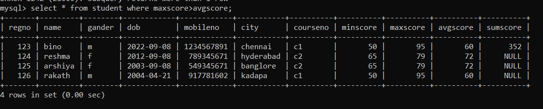

2, List the course and score of assessments that have the value more than the average score each Course

Ans)



3.) select facno from faculty where doj=(select max(doj) from faculty).

Ans)



4)select courseno from student where score>(select avg(score) from student).

Ans)

