1. Project Overview
Purpose
This Power BI project analyzes sales and profitability for the Global Superstore dataset to support executive decision-making across time, region, customer segment, and product category.

Objectives
• Build a clean visualization based on the data.
• Deliver executive, regional, customer, and product dashboards.
• Publish and share via Power BI Service.

Scope
• Dataset: https://www.kaggle.com/datasets/vivek468/superstore-dataset-final
• Time range: 2014–2017.

Tables
• Fact – Orders: transaction lines (Order ID, Product ID, Customer ID, Order Date, Sales, Profit, Quantity, Discount, Region, Segment, Category, Sub-Category, Product Name, City/State).
And I created these separated columns
• Dim_Customer: Customer_id, Customer_name, Segment, Region, Country, State, City.
• Dim_Products: Product_ID, Product_Name, Category, Sub_Category.
• Dim_Ship: Ship Mode.
• Date: continuous calendar (Date, Year, Quarter, Month, MonthNumber).
Row Counts (approx)
• Orders: ~10k rows | Customers: ~800 | Products: ~1.8k | Date: full range.

Data Quality Notes
• Locale date fix: converted DD-MM-YYYY using “Change Type using Locale”.
• Removed duplicates in dimensions (by key only).

3. Data Model (Star Schema)
Design
A star schema with Orders as the fact table. One-to-many, single-direction filters from each dimension into Orders.
Relationships
• Date[Date] 1→* Orders[Order Date] (Active)
• Dim_Customer[Customer_id] 1→* Orders[Customer ID](Active)
• Dim_Products[Product_ID] 1→* Orders[Product ID](Active)
• Dim_Ship[Ship Mode] 1→* Orders[Ship Mode](Active)

4. DAX Measures (Core)
Total_Sales = SUM(Orders[Sales])
Total_Profit = SUM(Orders[Profit])
Total_Sales_YTD = TOTALYTD([Total_Sales], 'Date table'[Date])
Total_Profit_YTD = TOTALYTD([Total_Profit], 'Date table'[Date])
Total_Sales_PY = CALCULATE([Total_Sales], SAMEPERIODLASTYEAR('Date table'[Date]))
YoY_Sales_% = DIVIDE([Total_Sales] - [Total_Sales_PY], [Total_Sales_PY])
Average_Order_Value = DIVIDE([Total_Sales], DISTINCTCOUNT(Orders[Order ID]))
Customers = DISTINCTCOUNT(Orders[Customer ID])
Orders = DISTINCTCOUNT(Orders[Order ID])
Profit_Margin_% = DIVIDE([Total_Profit], [Total_Sales])

Visuals Used

Line Chart
Axis: Date[Month]
Values: Total_Sales, Total_Profit
Shows monthly trend comparison between sales and profit. Helps identify seasonality and performance dips.

Card
Total_Sales — Displays total revenue across all transactions.
Total_Profit — Displays overall profit earned.
Average_Order_Value — Shows the average amount per customer order.
YoY_Sales_% — Highlights growth rate compared to previous year (trend indicator).

Slicers (Filters)
Fields: Year, Region, Category
Allow dynamic filtering for specific time periods, regions, or product categories.

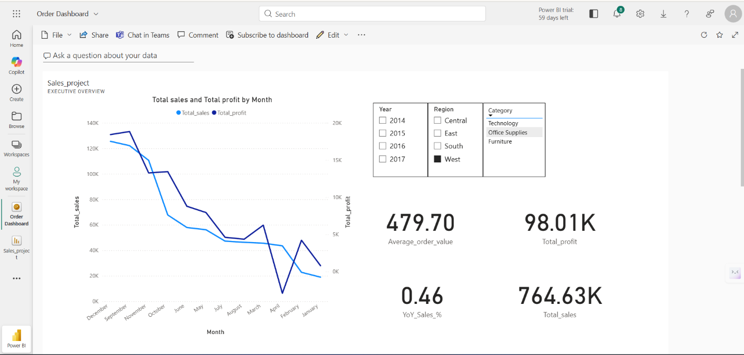

Line Chart
Axis: Date[Year]
Values: Total_Sales
Shows the overall sales trend across years (2014–2017) to visualize year-over-year growth.

Clustered Column Chart
Axis: Region
Values: Total_Sales, Total_Profit
Compares total sales and profit across all regions (West, East, Central, South) to identify the most and least profitable regions.

Clustered Column Chart
Axis: Category
Values: Total_Sales, Total_Profit
Displays total sales and profit for each product category (Technology, Furniture, Office Supplies).

Bar Chart
Axis: Sub-Category
Values: Total_Sales
Highlights total sales across product sub-categories. Helps identify top-performing products such as Chairs and Tables.

Donut Chart
Legend: Segment
Values: Total_Sales
Shows sales distribution by customer segment (Consumer, Corporate, Home Office). Useful for understanding which segment drives the most revenue.

Card
Total_Sales
Displays total revenue generated across all transactions.
Sum of Quantity
Shows the total number of items sold.

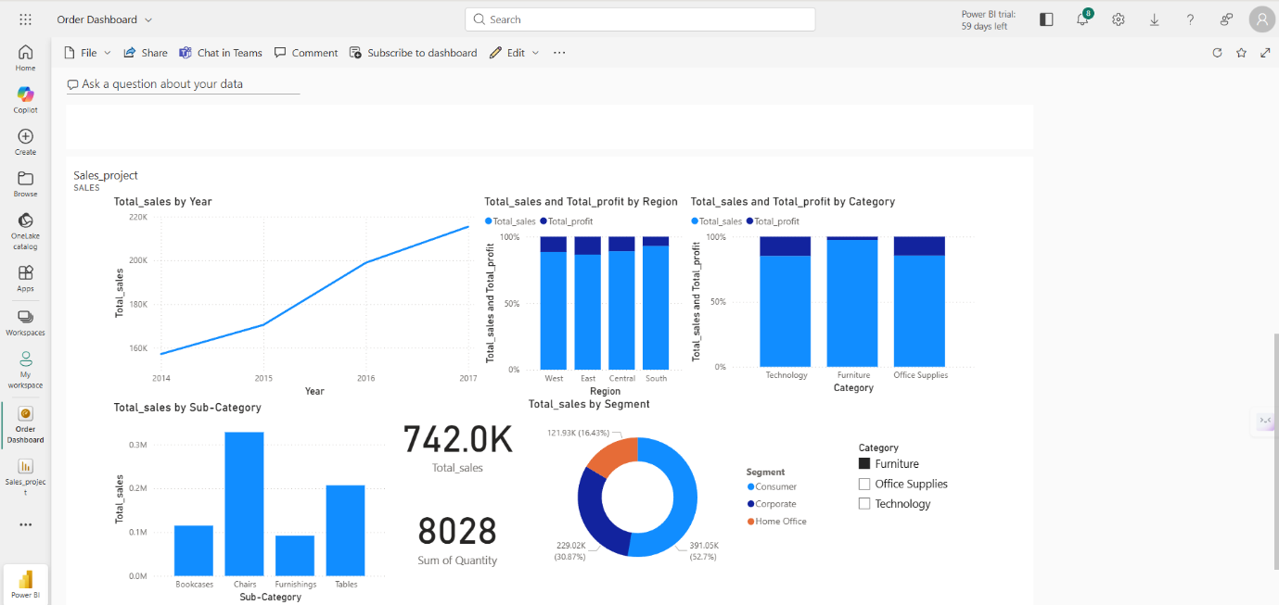

Insights

- Total Sales show a positive upward trend from 2014 to 2017, indicating consistent business expansion.
- Year-over-Year (YoY) sales growth is approximately +46%, driven primarily by Technology and Furniture categories.
- The average order value is around $480, showing moderate order size stability across years and regions
- West Region leads in both sales and profit.
- South Region lags, possibly due to high discount rates or lower volume orders.
- Consumer segment contributes ~53% of total sales.
- Corporate and Home Office segments are smaller but more consistent in profitability.
- Technology is the top-performing category — strong in both sales and profit, making it the key driver of business growth.
- Furniture contributes significantly to revenue but lags in profit due to operational costs.
- Office Supplies contributes consistent sales but requires margin improvement strategies.
- Total Sales grew from ~$160K in 2014 to ~$210K in 2017, marking continuous year-on-year growth

