- Check Computer Connectivity Using the ping Command

import java.io.*;

public class PT {
public static void main(String[] args) {
String cmd = "ping -n 4 google.com ";

try {
Process p = Runtime.getRuntime().exec(cmd);
BufferedReader r = new BufferedReader(new InputStreamReader(p.getInputStream()));
String line; boolean reachable = false;
while ((line = r.readLine()) != null) {
System.out.println(line);
if (line.contains("Reply from") || line.contains("bytes from")) reachable = true;
}
System.out.println("\nResult: Host is " + (reachable ? "reachable." : "unreachable."));
} catch (Exception e) {
System.err.println("Error: " + e.getMessage());
}
}
}

Output:
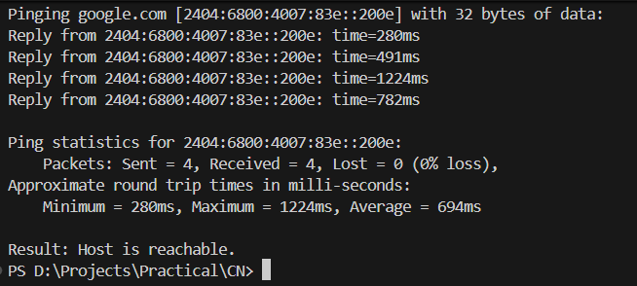

- Trace Packet Routes Using the traceroute Command

import java.io.*;
public class TracerouteSimulator {
public static void main(String[] a) throws Exception {
String host = "google.com";
System.out.println("Tracing route to " + host + "...\n");
Process p = new ProcessBuilder("tracert", host).start();
BufferedReader r = new BufferedReader(new InputStreamReader(p.getInputStream()));
String l; while ((l = r.readLine()) != null) System.out.println(l);
System.out.println("\nDone (exit " + p.waitFor() + ")");
}
}

Output:
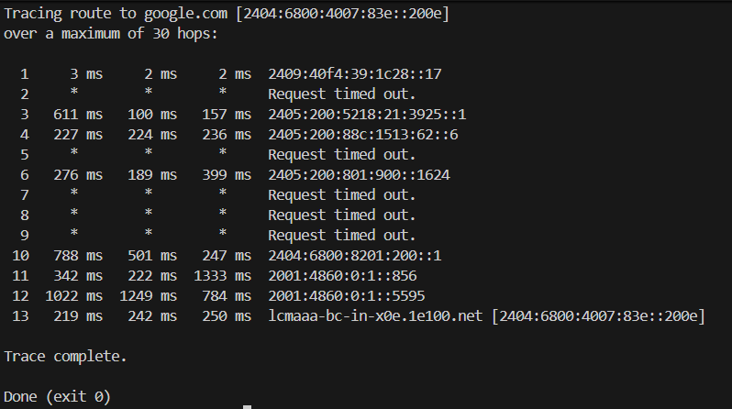

- Mounting a Remote Computer's Volume using net use Command

Server code:

import java.io.*; import java.net.*;
public class FileServer {
public static void main(String[] a) throws Exception {
ServerSocket ss = new ServerSocket(1234);
System.out.println("Waiting...");
Socket s = ss.accept();
System.out.println("Client connected.");
try (InputStream in = new FileInputStream("shared_file.txt");
OutputStream out = s.getOutputStream()) {
in.transferTo(out);
}
s.close(); ss.close();
System.out.println("File sent.");
}
}

Client code:

import java.io.*; import java.net.*;
public class FileClient {
public static void main(String[] a) throws Exception {
Socket s = new Socket("localhost", 1234);
System.out.println("Connected.");
try (InputStream in = s.getInputStream();
OutputStream out = new FileOutputStream("received_file.txt")) {
in.transferTo(out);
}
s.close();
System.out.println("File received.");
}
}

Output:
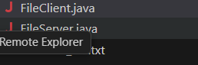

- Send Messages Between Machines Using Socket Programming

Server code:
import java.io.*; import java.net.*;
public class TCPServer {
public static void main(String[] a) throws IOException {
ServerSocket ss = new ServerSocket(1234);
System.out.println("Waiting...");
Socket s = ss.accept();
BufferedReader in = new BufferedReader(new InputStreamReader(s.getInputStream()));
PrintWriter out = new PrintWriter(s.getOutputStream(), true);
String msg = in.readLine();
System.out.println("Client: " + msg);
out.println("Server reply: " + msg);
s.close(); ss.close();
}
}

Client code:

import java.io.*; import java.net.*;
public class TCPClient {
public static void main(String[] a) throws IOException {
Socket s = new Socket("localhost", 1234);
PrintWriter out = new PrintWriter(s.getOutputStream(), true);
BufferedReader in = new BufferedReader(new InputStreamReader(s.getInputStream()));
System.out.print("Enter message: ");
String msg = new BufferedReader(new InputStreamReader(System.in)).readLine();
out.println(msg);
System.out.println(in.readLine());
s.close();
}
}

Output:
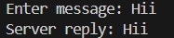

- Simulate a Chatting Application using Socket in Java
Server code:

import java.io.*;
import java.net.*;
import java.util.*;

public class ChatServer {
public static void main(String[] args) throws IOException {
ServerSocket server = new ServerSocket(1234);
System.out.println("Waiting for client...");
Socket socket = server.accept();
System.out.println("Client connected.");

BufferedReader in = new BufferedReader(new InputStreamReader(socket.getInputStream()));
PrintWriter out = new PrintWriter(socket.getOutputStream(), true);
Scanner sc = new Scanner(System.in);

// Send messages
new Thread(() -> {
while (true) {
System.out.print("Enter your message: ");
String msg = sc.nextLine();
out.println(msg);
if (msg.equalsIgnoreCase("exit")) System.exit(0);
}
}).start();

// Receive messages
String msg;
while ((msg = in.readLine()) != null) {
System.out.println("\nClient: " + msg);
if (msg.equalsIgnoreCase("exit")) System.exit(0);
}
}
}

Client code:

import java.io.*;
import java.net.*;
import java.util.*;

public class ChatClient {
public static void main(String[] args) throws IOException {
Socket socket = new Socket("localhost", 1234);
System.out.println("Connected to server.");

BufferedReader in = new BufferedReader(new InputStreamReader(socket.getInputStream()));
PrintWriter out = new PrintWriter(socket.getOutputStream(), true);
Scanner sc = new Scanner(System.in);

// Send messages
new Thread(() -> {
while (true) {
System.out.print("Enter your message: ");
String msg = sc.nextLine();
out.println(msg);
if (msg.equalsIgnoreCase("exit")) System.exit(0);
}
}).start();

// Receive messages
String msg;
while ((msg = in.readLine()) != null) {
System.out.println("\nServer: " + msg);
if (msg.equalsIgnoreCase("exit")) System.exit(0);
}
}
}

Output:
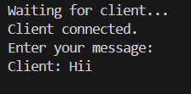
- Implementation of File Transfer Protocol (FTP) in Java

FTP Server code

import java.io.*; import java.net.*;
public class FTPServer {
public static void main(String[] args) throws IOException {
ServerSocket server = new ServerSocket(5000);
System.out.println("FTP Server started on port 5000...");
while(true){
Socket s = server.accept();
System.out.println("Client connected: " + s.getInetAddress());
DataInputStream dis = new DataInputStream(s.getInputStream());
DataOutputStream dos = new DataOutputStream(s.getOutputStream());
String cmd = dis.readUTF();
if(cmd.equalsIgnoreCase("UPLOAD")){
String f = dis.readUTF();
try(FileOutputStream fos=new FileOutputStream(f)){
byte[] buf=new byte[4096]; int n;
while((n=dis.read(buf))!=-1) fos.write(buf,0,n);
}
System.out.println("File received: "+f);
} else if(cmd.equalsIgnoreCase("DOWNLOAD")){
String f = dis.readUTF(); File file = new File(f);
if(file.exists()){
dos.writeUTF("FILE_EXISTS");
try(FileInputStream fis=new FileInputStream(file)){
byte[] buf=new byte[4096]; int n;
while((n=fis.read(buf))!=-1) dos.write(buf,0,n);
}
System.out.println("File sent: "+f);
} else dos.writeUTF("FILE_NOT_FOUND");
}
s.close();
}
}
}

FTP Client code
import java.io.*; import java.net.*;
public class FTPClient {
public static void main(String[] args) throws IOException {
Socket s = new Socket("localhost",5000);
DataInputStream dis = new DataInputStream(s.getInputStream());
DataOutputStream dos = new DataOutputStream(s.getOutputStream());
BufferedReader br = new BufferedReader(new InputStreamReader(System.in));
System.out.print("Enter command (UPLOAD/DOWNLOAD): "); String cmd=br.readLine();
dos.writeUTF(cmd);
if(cmd.equalsIgnoreCase("UPLOAD")){
System.out.print("Enter file path: "); String path=br.readLine();
File file=new File(path);
if(file.exists()){
dos.writeUTF(file.getName());
try(FileInputStream fis=new FileInputStream(file)){
byte[] buf=new byte[4096]; int n;
while((n=fis.read(buf))!=-1) dos.write(buf,0,n);
}
System.out.println("File uploaded!");
} else System.out.println("File not found!");
} else if(cmd.equalsIgnoreCase("DOWNLOAD")){
System.out.print("Enter filename: "); String f=br.readLine();
dos.writeUTF(f);
if(dis.readUTF().equals("FILE_EXISTS")){
try(FileOutputStream fos=new FileOutputStream("downloaded_"+f)){
byte[] buf=new byte[4096]; int n;
while((n=dis.read(buf))!=-1) fos.write(buf,0,n);
}
System.out.println("File downloaded!");
} else System.out.println("File not found on server!");
}
s.close();
}
}

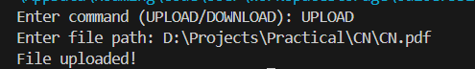
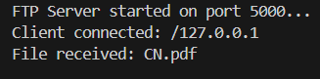

- Implementation of CRC and Hamming Code for Error Handling in Java
import java.util.Scanner;

public class CRC {
public static void main(String[] args) {
Scanner sc = new Scanner(System.in);

// Input data bits and generator polynomial
System.out.print("Enter data bits: ");
String data = sc.next();
System.out.print("Enter generator polynomial: ");
String generator = sc.next();

// Calculate CRC and display transmitted data
String transmittedData = calculateCRC(data, generator);
System.out.println("Transmitted Data: " + transmittedData);

// Input received data and check for errors
System.out.print("Enter received data: ");
String receivedData = sc.next();
if (checkError(receivedData, generator)) {
System.out.println("No error detected.");
} else {
System.out.println("Error detected in received data!");
}

sc.close();
}

// Method to calculate CRC and append to data
public static String calculateCRC(String data, String generator) {
int genLength = generator.length();
StringBuilder paddedData = new StringBuilder(data);

// Append zeros to match generator length
for (int i = 0; i < genLength - 1; i++) {
paddedData.append('0');
}

// Perform XOR division
for (int i = 0; i <= paddedData.length() - genLength;) {
for (int j = 0; j < genLength; j++) {
paddedData.setCharAt(i + j, paddedData.charAt(i + j) == generator.charAt(j) ? '0' : '1');
}
while (i < paddedData.length() && paddedData.charAt(i) == '0') {
i++;
}
}

// Extract remainder and append to original data
String crc = paddedData.substring(paddedData.length() - genLength + 1);
return data + crc;
}

// Method to check for errors in received data
public static boolean checkError(String receivedData, String generator) {
int genLength = generator.length();
StringBuilder temp = new StringBuilder(receivedData);

// Perform XOR division
for (int i = 0; i <= temp.length() - genLength;) {
for (int j = 0; j < genLength; j++) {
temp.setCharAt(i + j, temp.charAt(i + j) == generator.charAt(j) ? '0' : '1');
}
while (i < temp.length() && temp.charAt(i) == '0') {
i++;
}
}

// Check if remainder is all zeros
for (int i = temp.length() - genLength + 1; i < temp.length(); i++) {
if (temp.charAt(i) != '0') {
return false;
}
}
return true;
}
}

Output:
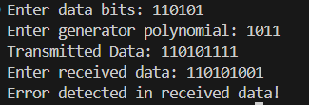

- Hamming Code (Error Correction)

import java.util.Scanner;

public class HammingCode {
public static void main(String[] args) {
Scanner sc = new Scanner(System.in);
System.out.print("Enter 4-bit data: ");
String data = sc.next();
int[] code = encodeHamming(data);
System.out.print("Transmitted Code: ");
for (int b : code) System.out.print(b);

System.out.print("\nEnter received 7-bit code: ");
String r = sc.next();
int err = detectError(r);
System.out.println(err == 0 ? "No error detected." : "Error at position: " + err);
sc.close();
}

static int[] encodeHamming(String d) {
int[] c = new int[7];
c[2]=d.charAt(0)-'0'; c[4]=d.charAt(1)-'0'; c[5]=d.charAt(2)-'0'; c[6]=d.charAt(3)-'0';
c[0]=c[2]^c[4]^c[6]; c[1]=c[2]^c[5]^c[6]; c[3]=c[4]^c[5]^c[6];
return c;
}

static int detectError(String r) {
int p1=r.charAt(0)-'0'^r.charAt(2)-'0'^r.charAt(4)-'0'^r.charAt(6)-'0';
int p2=r.charAt(1)-'0'^r.charAt(2)-'0'^r.charAt(5)-'0'^r.charAt(6)-'0';
int p4=r.charAt(3)-'0'^r.charAt(4)-'0'^r.charAt(5)-'0'^r.charAt(6)-'0';
return p1 + p2*2 + p4*4;
}
}

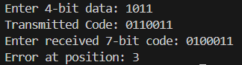
- Client-Server Program using TCP and UDP Sockets in Java
Server code:

import java.io.*; import java.net.*;

public class TCPServer {
public static void main(String[] args) throws IOException {
ServerSocket server = new ServerSocket(6789);
System.out.println("TCP Server running...");
while (true) {
Socket s = server.accept();
System.out.println("Client connected: " + s.getInetAddress());
BufferedReader in = new BufferedReader(new InputStreamReader(s.getInputStream()));
PrintWriter out = new PrintWriter(s.getOutputStream(), true);
String msg = in.readLine();
System.out.println("Received: " + msg);
out.println("Server Reply: " + msg.toUpperCase());
s.close();
}
}
}

Client code:

import java.io.*; import java.net.*;

public class TCPClient {
public static void main(String[] args) throws IOException {
Socket s = new Socket("localhost", 6789);
System.out.println("Connected to server...");
PrintWriter out = new PrintWriter(s.getOutputStream(), true);
BufferedReader in = new BufferedReader(new InputStreamReader(s.getInputStream()));
out.println("Hello from TCP Client!");
System.out.println("Server Response: " + in.readLine());
s.close();
}
}

Output:
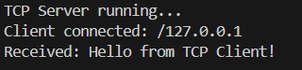

- UDP Socket Communication (Connectionless)
UDP Server:
import java.net.*;

public class UDPServer {
public static void main(String[] args) throws Exception {
DatagramSocket server = new DatagramSocket(9876);
System.out.println("UDP Server running...");
byte[] buf = new byte[1024];

while (true) {
DatagramPacket recv = new DatagramPacket(buf, buf.length);
server.receive(recv);
String msg = new String(recv.getData(), 0, recv.getLength());
System.out.println("Received: " + msg);

String reply = "Server Reply: " + msg.toUpperCase();
byte[] sendData = reply.getBytes();
DatagramPacket send = new DatagramPacket(sendData, sendData.length,
recv.getAddress(), recv.getPort());
server.send(send);
}
}
}

UDP Client:
import java.net.*;
import java.util.Scanner;

public class UDPClient {
public static void main(String[] args) throws Exception {
DatagramSocket client = new DatagramSocket();
InetAddress serverIP = InetAddress.getByName("localhost");
Scanner sc = new Scanner(System.in);

System.out.print("Enter message: ");
String msg = sc.nextLine();
byte[] sendData = msg.getBytes();
client.send(new DatagramPacket(sendData, sendData.length, serverIP, 9876));

byte[] recvData = new byte[1024];
DatagramPacket recv = new DatagramPacket(recvData, recvData.length);
client.receive(recv);
System.out.println("Server Response: " + new String(recv.getData(), 0, recv.getLength()));

client.close();
sc.close();
}
}

Output:
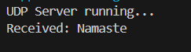

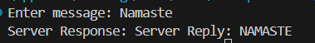

- ARP to RARP

import java.util.*;
public class ARP_RARP_Simulation{
static Map<String,String> a=new HashMap<>(),r=new HashMap<>();
public static void main(String[] x){
a.put("192.168.1.1","00:1A:2B:3C:4D:5E");
a.put("192.168.1.2","00:2B:3C:4D:5E:6F");
r.put("00:1A:2B:3C:4D:5E","192.168.1.1");
r.put("00:2B:3C:4D:5E:6F","192.168.1.2");
Scanner s=new Scanner(System.in);
System.out.print("1.ARP 2.RARP> ");
int c=s.nextInt();
s.nextLine();
System.out.println(c==1?"MAC:"+a.getOrDefault(s.nextLine(),"Not Found"):
c==2?"IP:"+r.getOrDefault(s.nextLine(),"Not Found"):"Invalid!");
}
}

Output:
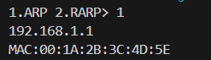

- Socket Programming: Echo, Ping, and Talk Commands in Java
Server code:

import java.io.*; import java.net.*;

public class EchoServer {
public static void main(String[] args) throws IOException {
ServerSocket server = new ServerSocket(5000);
System.out.println("Echo Server started...");
Socket s = server.accept();
System.out.println("Client connected.");

BufferedReader in = new BufferedReader(new InputStreamReader(s.getInputStream()));
PrintWriter out = new PrintWriter(s.getOutputStream(), true);

String msg;
while ((msg = in.readLine()) != null) {
System.out.println("Received: " + msg);
out.println("Server echoes: " + msg);
}

s.close();
server.close();
}
}

Client code:

import java.io.*; import java.net.*; import java.util.Scanner;

public class EchoClient {
public static void main(String[] args) throws IOException {
Socket s = new Socket("localhost", 5000);
System.out.println("Connected to Echo Server.");

PrintWriter out = new PrintWriter(s.getOutputStream(), true);
BufferedReader in = new BufferedReader(new InputStreamReader(s.getInputStream()));
Scanner sc = new Scanner(System.in);

System.out.print("Enter message: ");
String msg = sc.nextLine();
out.println(msg);
System.out.println("Server response: " + in.readLine());

s.close();
sc.close();
}
}

Output:
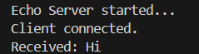
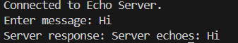

- PING

Server code:

import java.io.*; import java.net.*;

public class PingServer {
public static void main(String[] args) throws IOException {
ServerSocket server = new ServerSocket(6000);
System.out.println("Ping Server started...");
Socket s = server.accept();
System.out.println("Client connected.");

BufferedReader in = new BufferedReader(new InputStreamReader(s.getInputStream()));
PrintWriter out = new PrintWriter(s.getOutputStream(), true);
String msg;
while ((msg = in.readLine()) != null) {
if (msg.equalsIgnoreCase("ping")) {
out.println("pong");
System.out.println("Ping received. Sent pong.");
}
}

s.close();
server.close();
}
}

Client code:

import java.io.*; import java.net.*;

public class PingClient {
public static void main(String[] args) throws IOException {
Socket s = new Socket("localhost", 6000);
System.out.println("Connected to Ping Server.");

PrintWriter out = new PrintWriter(s.getOutputStream(), true);
BufferedReader in = new BufferedReader(new InputStreamReader(s.getInputStream()));

long start = System.currentTimeMillis();
out.println("ping");
if (in.readLine().equals("pong")) {
long rtt = System.currentTimeMillis() - start;
System.out.println("Ping successful. RTT: " + rtt + " ms");
}

s.close();
}
}

Output:
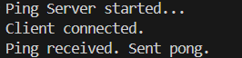
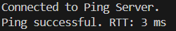

- TALK
Server code:

import java.io.*; import java.net.*;

public class TalkServer {
public static void main(String[] args) throws IOException {
ServerSocket server = new ServerSocket(7000);
System.out.println("Talk Server started...");
Socket s = server.accept();
System.out.println("Client connected.");

BufferedReader in = new BufferedReader(new InputStreamReader(s.getInputStream()));
PrintWriter out = new PrintWriter(s.getOutputStream(), true);
BufferedReader serverInput = new BufferedReader(new InputStreamReader(System.in));

String clientMsg, serverMsg;
while (true) {
clientMsg = in.readLine();
System.out.println("Client says: " + clientMsg);
System.out.print("Server reply: ");
serverMsg = serverInput.readLine();
out.println(serverMsg);
}
}
}

Client code:

import java.io.*; import java.net.*; import java.util.Scanner;

public class TalkClient {
public static void main(String[] args) throws IOException {
Socket s = new Socket("localhost", 7000);
System.out.println("Connected to Talk Server.");

PrintWriter out = new PrintWriter(s.getOutputStream(), true);
BufferedReader in = new BufferedReader(new InputStreamReader(s.getInputStream()));
Scanner sc = new Scanner(System.in);

String userMsg, serverResp;
while (true) {
System.out.print("Client: ");
userMsg = sc.nextLine();
out.println(userMsg);
serverResp = in.readLine();
System.out.println("Server says: " + serverResp);
}
}
}

Output:
