**THRIVE QUOTIENT – AN MOBILE APP TO LEARN WHAT YOU REALLY WANT.**

**PART-1: IKIGAI – THE PURPOSE OF LIFE**

**Thrive Quotient:**

**An Personal AI Assistant (Mobile app) to find one’s Ikigai to learn and work for the real passion, love, and market needs alignment.**

**Feasibility factors:**

* **Data input** – User still need to log activities, moods, and energy levels daily; the app can’t know without your input unless it’s integrated with wearables.
* **Automation** – Wearables (smartwatches, fitness trackers) can provide activity, sleep, and stress data. AI can analyse patterns faster.
* **Pattern recognition** – AI can detect correlations between activities and users energy/mood trends, then highlight possible Ikigai zones.
* **Personalisation** – The best results come when the app adapts over time to the users unique behavioural patterns.

**Challenges:**

* Needs consistent and honest self-reporting of users at first.
* Emotional fulfilment is subjective, so algorithm interpretation can’t be perfect.
* Privacy concerns if storing personal behaviour data in the cloud.

**Bottom line:**  
 It’s **practical** and can speed up discovery, but it works best when combined with **human reflection**. Apps can suggest the “where” to look, but users still decide the “what” and “why.”

**1. Core Features**

**a. Daily Behaviour Tracking**

* **Manual inputs**: Activity, mood, energy level, joy rating, flow state.
* **Automatic inputs**: Wearable data (heart rate, steps, sleep quality, stress levels).

**b. Four-Dimension Analysis**

* **What you love** – Tags activities with high joy & frequent repetition.
* **What you’re good at** – Identifies activities with consistently high performance.
* **What the world needs** – Tracks volunteering/helping behaviours and cause-driven tasks.
* **What you can be paid for** – Links logged skills to market demand databases.

**c. Pattern Detection**

* Weekly & monthly analytics showing overlaps of high joy, skill, demand, and social impact.
* Visualised as a **4-circle Ikigai diagram** with data heatmaps.

**2. Supporting Features**

* **Gamification** – Streaks for consistent tracking, badges for self-discovery milestones.
* **AI Recommendations** – Suggests roles, hobbies, or career moves based on the users top overlaps.
* **Mood Correlation Charts** – See how different activities affect emotional states.
* **Journaling Prompts** – AI asks reflective questions to deepen insights.
* **Exportable Reports** – PDF or spreadsheet summaries for personal review.

**3. Technical Requirements**

* **Frontend**: React Native / Flutter (cross-platform for iOS & Android).
* **Backend**: Node.js / Python with cloud database (Firebase, AWS).
* **AI Layer**: Python ML models for pattern recognition & recommendation(**Model type: Neural Network with Shared Embedding Layer, Framework:** PyTorch or TensorFlow/Keras**).**
* **Integration APIs**: Google Fit, Apple Health, Fitbit, LinkedIn (for skill-market matching).

**4. Privacy & Ethics**

* On-device processing for sensitive data when possible.
* Clear consent for any cloud storage or AI analysis.
* Option to anonymise data for aggregated research.

Here’s a **Sample screen flow** for an Ikigai-finding app:

**1. Onboarding Screens**

* **Screen 1:** Welcome + brief intro to Ikigai concept.
* **Screen 2:** Quick self-assessment (passions, skills, causes you care about, paid work).
* **Screen 3:** Connect wearables (optional) for automatic tracking.

**2. Daily Log Screen**

* **Top Section:** Date & mood slider (1–10 scale).
* **Activity Entry:**
  + Activity name (autocomplete + custom tags).
  + Energy level (1–10).
  + Joy rating (1–10).
  + Flow state toggle (Yes/No).
  + Skill used (dropdown from user skills list).
  + Monetizable? (Yes/No).
* **Save & Continue** button.

**3. Analytics Dashboard**

* **Today’s Summary:** Mood, energy, and activity count.
* **Ikigai Radar Chart:** Shows strength in each of the 4 Ikigai dimensions.
* **Trend Graphs:** Joy vs. energy, flow moments per week, skill usage frequency.
* **Top Activities:** Sorted by highest Ikigai potential.

**4. Insights & Recommendations**

* **AI Insight Card:**  
  *“Over the last 3 weeks, activities involving ‘mentoring’ scored highest for joy, skill, and social impact. Consider exploring teaching roles.”*
* Suggested roles, hobbies, or projects with matching patterns.
* Link to market data for **monetizable skills.**

**5. Ikigai Map**

* Interactive 4-circle Venn diagram.
* Click a section to see the activities contributing to that dimension.
* **Highlighted overlap zone = your current *Ikigai candidates***.

**6. Reflection & Growth**

* Weekly journaling prompt.
* Goal setting for next week (e.g., “Increase time spent on high-joy, high-skill tasks”).
* Progress tracking streaks.

**3-step framework to turn your life patterns into a personal purpose statement:**

**Step 1 Self-Discovery Audit**

Look at the **last 5–10 years** of your life and list:

* **Peak joy moments** → Times you felt truly alive.
* **Natural strengths** → Skills you use with ease.
* **Meaningful contributions** → Ways you’ve helped or impacted others.
* **Core values** → Non-negotiables you live by.

**Step 2: Pattern Mapping**

From your list, highlight recurring themes.  
Example:

* Joy moments → *Helping people learn, solving problems*
* Strengths → *Explaining complex ideas simply*
* Contributions → *Mentoring colleagues, teaching workshops*
* Values → *Growth, empathy, knowledge-sharing*

These give you your **life ingredients**.

**Step 3: Craft Your Purpose Statement**

Use this template:

“My purpose is to **[core contribution]**, using my strength in **[key skills]**, to create **[impact or benefit]** for **[who you serve]**, while living by **[core values]**.”

Example:

“My purpose is to guide and inspire others to learn and grow, using my ability to simplify complex ideas, to help people gain confidence and clarity, while living by empathy, curiosity, and integrity.”

**Sample prediction of my ikigai by using ChatGPT:**

Great — let’s run through a **short purpose-finding interview**.  
Answer these questions as honestly and briefly as you can:

**1. Joy Moments**

* Think of 3–5 moments in your life when you felt deeply fulfilled, happy, or “in flow.”  
  What were you doing? Who were you with?

**2. Strengths**

* What are 3 things you do exceptionally well, where others often seek your help?

**3. Contributions**

* When have you made a difference in someone’s life or work that you’re proud of?

**4. Values**

* What are 3 principles you’d never compromise on, even if it was inconvenient?

**5. Audience / Who You Serve**

* If you could dedicate your life to helping one type of person or group, who would it be?

Once you give me these, I’ll turn them into a **clear, personal purpose statement** for you.

here’s your **personal purpose statement** built from your answers:

**"My purpose is to help people grow and solve real-world problems through technology and knowledge-sharing, using my strengths in software development, problem-solving, and research, to empower individuals to find clarity, develop skills, and improve their lives — while living by respect, integrity, and a commitment to quality."**

* This reflects:
* **What you love:** Learning, building, problem-solving.
* **What you’re good at:** Tech troubleshooting, development, logical thinking.
* **Your contribution style:** Teaching, creating solutions, inspiring upskilling.
* **Your values:** Respect, quality service, ethical boundaries.
* **Your audience:** People seeking skills, clarity, and purpose.

If you want, I can now **map this statement into an Ikigai diagram** so you see visually how it connects your passions, strengths, market value, and social impact. That would make it easier to act on.

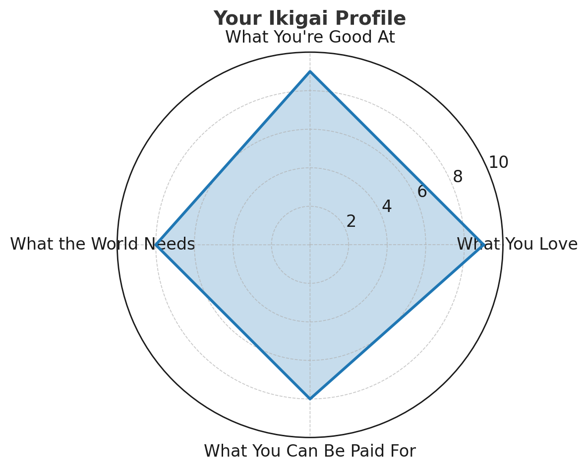

Here’s your **Ikigai profile radar chart** — it visually shows your high alignment in passion, skill, market value, and social need, meaning you’re already close to operating in your Ikigai zone.

**Frameworks for finding purpose of life:**

***Ikigai* is just one of several frameworks for finding purpose and alignment in life.  
Here are some other well-known ones:**

**1. Hedgehog Concept** *(Jim Collins, Good to Great)*

* Intersection of:
  + What you’re deeply passionate about
  + What you can be the best in the world at
  + What drives your economic engine

**2. Golden Circle** *(Simon Sinek)*

* **Why** → Your purpose, cause, or belief
* **How** → The process/values you follow
* **What** → The tangible results or output

**3. Dharma / Swadharma** *(Indian philosophy)*

* Your duty or true calling, aligned with your nature and societal role.
* Often framed as “living in accordance with your unique purpose.”

**4. Sweet Spot Model**

* Overlap of:
  + Talents
  + Passions
  + Market opportunities

**5. Flow Model** *(Mihaly Csikszentmihalyi)*

* Purpose found in activities where skill level and challenge are both high, leading to “flow” states.

**6. Purpose Venn Diagram Variants**

* Many life coaching models adapt *Ikigai* into 3-circle or 5-circle diagrams to emphasize different factors (values, lifestyle goals, legacy, etc.).

