

Contents

Installation and Setup Steps for DNIF: 2

1. VirtualBox – Ubuntu installation 2

2. Docker Installation on Ubuntu 3

3. Making your Ubuntu IP Static: 3

4. Configuration File: All in One File – Named as A10 4

5. Final Step: Visit the Web Console 5

NOTES 5

The DNIF Installation Guide

**Note:** Windows also supports DNIF Installation since it would be running a container. The environment in the container is just fine. There are certain settings that would need to be done in Windows (Host) to make the setup tick.

# Installation and Setup Steps for DNIF:

## VirtualBox – Ubuntu installation

* Download Ubuntu ISO file. (<https://www.ubuntu.com/download/desktop>)
* Create the virtual machine with following things in mind - Set minimum 4GB RAM for Ubuntu VM and more than 50GB hard drive space.
* Boot it once. Check the image is running fine. Check network connectivity.
* Before the next boot, GO to NETWORK and select BRIDGE NETWORK.

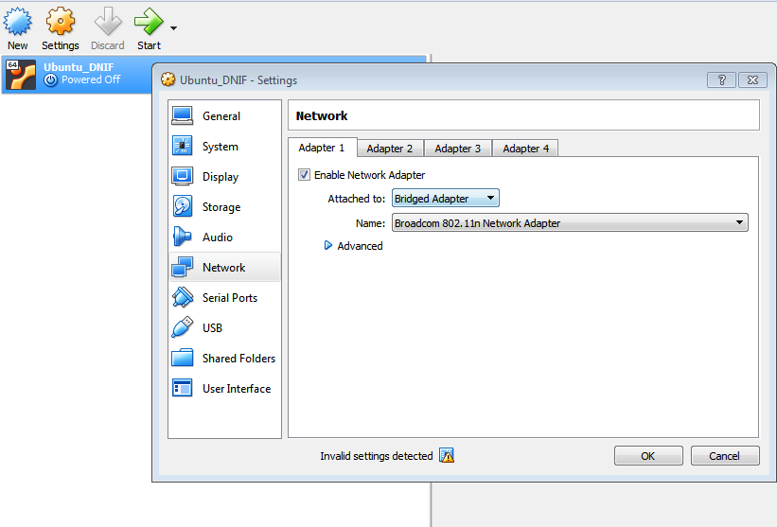

## Docker Installation on Ubuntu

* Now, next is setting up the Docker environment. Open the terminal and carry out SUDO commands as listed below in order:

1. sudo apt-get update
2. sudo apt-get install \ apt-transport-https \ ca-certificates \ curl \ software-properties-common
3. curl -fsSL https://download.docker.com/linux/ubuntu/gpg | sudo apt-key add -
4. sudo add-apt-repository \ "deb [arch=amd64] https://download.docker.com/linux/ubuntu \ $(lsb_release -cs) \ stable"
5. sudo apt-get update
6. sudo apt-get install docker-ce=17.06.2~ce-0~ubuntu
7. sudo docker run hello-world
8. sudo apt-get install python-pip
9. sudo pip install docker-compose

**Note:** If facing any difficulties with the above commands, please visit the Docker website where these steps are mentioned. Visit that webpage, and copy the command (that isn’t working from this list) and paste it as it is.

<https://docs.docker.com/install/linux/docker-ce/ubuntu/#prerequisites>

## Making your Ubuntu IP Static:

Here are few links of how you can make your IP static in Ubuntu:

1. <https://www.swiftstack.com/docs/install/configure_networking.html>
2. <https://www.tecmint.com/set-static-ip-address-in-ubuntu-15-10-server/>

## Configuration File: All in One File – Named as A10

* A10 configuration file has all the three components as mentioned on the website – Adapter, Datastore, & Correlator.

1. Download configuration file from DNIF website

<https://dnif.it/docs/guides/getting-started/installing-dnif.html>

1. Create folder on desktop (a10 folder)
2. Do the necessary changes in configuration file. (Refer the video on website as to what has to be changed in the configuration file.

**CRIP:** The IP address of Ubuntu – which is as same as the network address space. Also the IP address should be static (Follow instructions from Ubuntu Community as to how to make IP static)

**Key:** Provided in mail, titled = DNIF – Getting Started

**Volumes:** The path where the setup folder will be extracted. (Refer the video on website as to how it has to be done.

Example: /home/newttwo/Desktop:/dnif

1. Open the terminal in A10 folder (right click and open terminal), where the configuration file exists and run the following command:

sudo docker-compose up

1. Once the folder is created in the path specified in Volumes field, **download license** and **signature.bin files** attached in mail ( Title =DNIF - Getting Started)

* Move both files in "your deployment key"/LICENSE (the folder which got created in the Volumes path specified)
* (if not able to move file open new terminal and write this command sudo chown -R $USER: $HOME)

## Final Step: Visit the Web Console

* Add Google Authenticator to the chrome browser as an extension
* Once the GAuth is added (the bar code icon besides omnibox’s right),

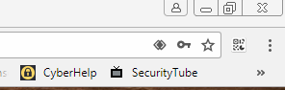

Click on it, add an account manually and provide the following details:

**Account Name:** DNIF

**Key:** Provided in mail. Named as GAuth Key

**DropDown:** Time Phased

* Visit <https://go.dnif.it/>
* Login with credentials when first registered. And provide the GAuth key generated.
* Once logged in, **Go to Management Tab -> Connection - > Change Source Address Field** (same as the one provided in CRIP. This is the Ubuntu IP address)
* Save & Update field and test the connection.

## NOTES

**sudo apt-get install \ apt-transport-https \ ca-certificates \ curl \ software-properties-common**

* get packages via httpS protocol and prevent any kind of tampering by an attacker during download.
* Ca-certificates helps in two way encryption. It is a certificate which helps a client browser to trust DNIF server ecosystem. (Learn more about ca-certicates ONLINE)
* Software-properties-common is to MANAGE package repositories seamlessly.

**curl -fsSL https://download.docker.com/linux/ubuntu/gpg | sudo apt-key add –**

* similar to Wget. Used to download files, images, web pages.

**sudo apt-get update**

* This command checks for updates for the currently installed packages.

It does not upgrade or install newer version of packages