Spring REST using Spring Boot 3
Name: Prashant Rai
Registration No.: 23BAI11124
In this experiment, I created a Spring Boot project using IntelliJ IDEA. After creating the project, I added a simple REST controller and checked the output by running the application in the browser..

1. Project Structure
The following screenshot shows the project structure created in IntelliJ IDEA. It contains the Maven project, source folders, resources, and the Java classes required for the first hands-on exercise. 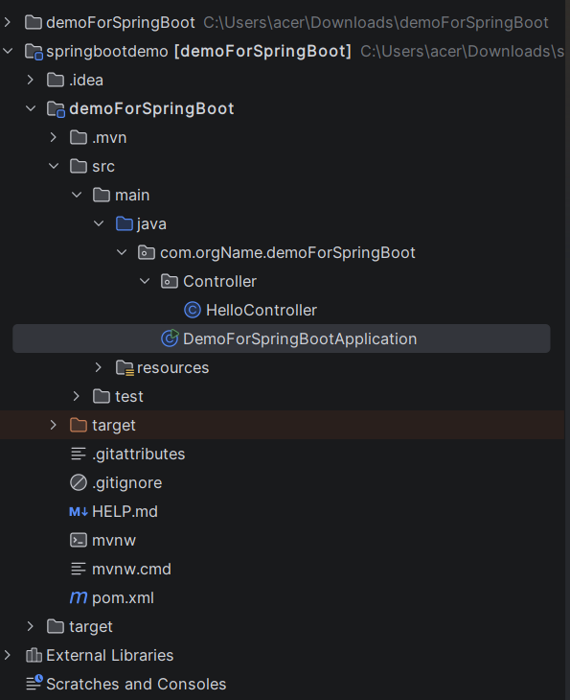
2. Spring Boot Main Application
The main application class is annotated with @SpringBootApplication. It acts as the entry point of the Spring Boot application and starts the embedded server.
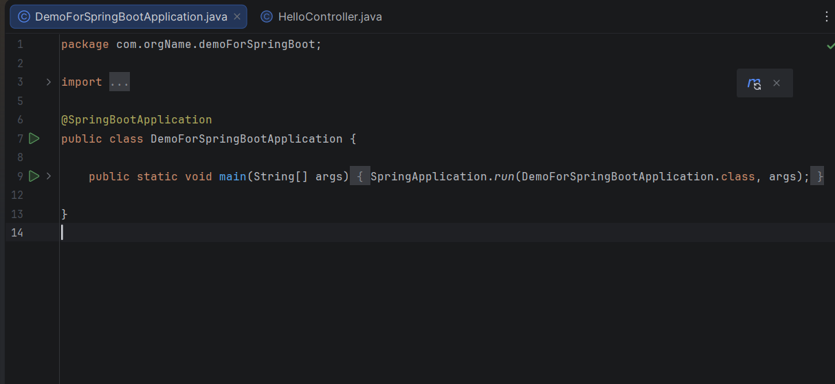

3. HelloController.java
The HelloController class is annotated with @RestController and exposes the '/hello' endpoint. When accessed, it returns a simple greeting message demonstrating a basic REST API.
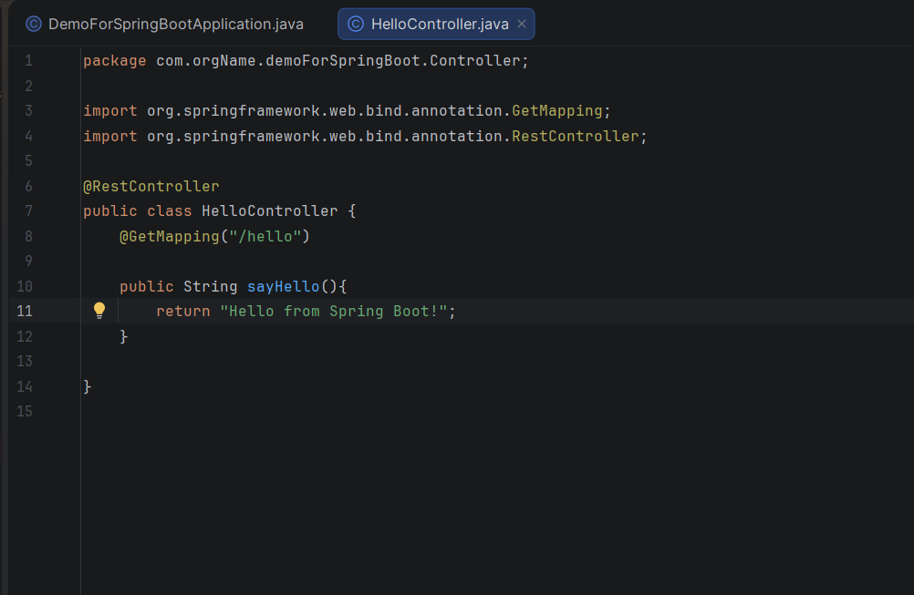

4. Browser Output
The application was executed successfully. Accessing the '/hello' endpoint from the browser returns the expected response.
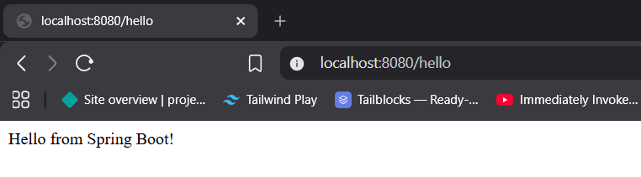

Conclusion
The Spring Boot application was created successfully using IntelliJ IDEA. The REST endpoint was tested through a web browser and produced the expected output, confirming that the application is functioning correctly.

