CONTAINERIZED EVENT SPONSORSHIP TRACKER
A DevOps-Based CI/CD and Deployment Architecture

Technical White Paper

Student Name: Prashi Rawal
Roll Number: 23102C0067
Course: DevOps
Guide Name: Dr. Snehal Andhare
GitHub Repository: https://github.com/PRASHIRAWAL/event-sponsorship-tracker

Abstract
The Event Sponsorship Tracker is a web application intended to manage event information, sponsors, sponsorship amounts, payment status, and related records. This white paper proposes a DevOps workflow to improve build reliability, testing, deployment consistency, and maintainability. The proposed solution combines Git and GitHub for version control, Jenkins for continuous integration and continuous delivery (CI/CD), Maven for building the Java application, Selenium for browser-based testing, Docker for containerization, Nginx as a reverse proxy, and Ansible for deployment automation. MySQL stores application data, while Spring Boot Actuator can provide health information. The design aims to reduce manual deployment effort, detect defects earlier, and support repeatable releases.

1. Introduction
DevOps combines development and operations practices to improve collaboration, automate repetitive tasks, and deliver software reliably. Traditional delivery may rely on manual compilation, testing, environment configuration, and deployment. These activities can introduce human error and differences between development and production environments.
The Event Sponsorship Tracker supports the management of event and sponsorship records. A structured DevOps workflow can make updates easier to build, test, package, and deploy. This paper proposes an automated delivery process based on version control, pipeline automation, containerization, configuration management, and health verification.

2. Problem Statement
- Inconsistent environments: Differences in runtime versions, dependencies, and configuration may cause deployment failures.
- Manual testing: Repeated verification of event creation, sponsor management, search, and payment status takes time.
- Deployment complexity: Application and database setup must be performed consistently.
- Limited failure visibility: Without build logs and health checks, diagnosing problems is harder.
- Release risk: Untested changes may introduce defects into a working application.
The objective is to design a workflow that builds, tests, packages, and deploys validated application versions while providing basic operational health checks.

3. Existing Approaches, Tools and Limitations
A traditional workflow may involve local compilation, manual browser testing, and direct deployment to a server. These methods can be adequate for a small prototype, but become difficult to reproduce as the application evolves.
Tool / Approach | Purpose | Limitations
Manual build and deployment | Compile and release software | Repetitive, difficult to reproduce, error-prone
Git and GitHub | Version control and collaboration | Automation requires additional workflow configuration
Maven | Build and dependency management | Depends on correct project configuration
Jenkins | Automates pipeline stages | Requires maintenance and secure credentials
Selenium | Browser-based functional tests | UI changes can require test maintenance
Docker | Packages application runtime | Images, networks, volumes, and security need management
Nginx | Reverse proxy and request routing | Requires correct routing and server configuration
Ansible | Automates host configuration and deployment | Inventories and playbooks must be maintained
Git provides change tracking [2], Maven standardizes build phases [3], and Jenkins Pipeline supports delivery workflows as code [1]. Selenium automates browser interactions [4], while Docker packages applications into containers [5]. Nginx can forward requests to an application server [6], and Ansible automates infrastructure configuration [7].

Evaluation
The proposed toolchain separates responsibilities: GitHub manages source history, Jenkins coordinates the pipeline, Maven builds the application, Selenium validates key user journeys, Docker standardizes packaging, and Ansible supports repeatable deployment. These tools complement one another rather than replacing all development and operational judgment.

4. Proposed Technical Solution and Architecture
The proposed pipeline starts when a developer pushes code or merges a reviewed change to GitHub. Jenkins checks out the repository, runs a Maven build and tests, and proceeds to create a Docker image only when the required checks pass. The validated image is deployed to a target host. Nginx routes incoming requests to the Spring Boot application, which uses MySQL for persistent data.

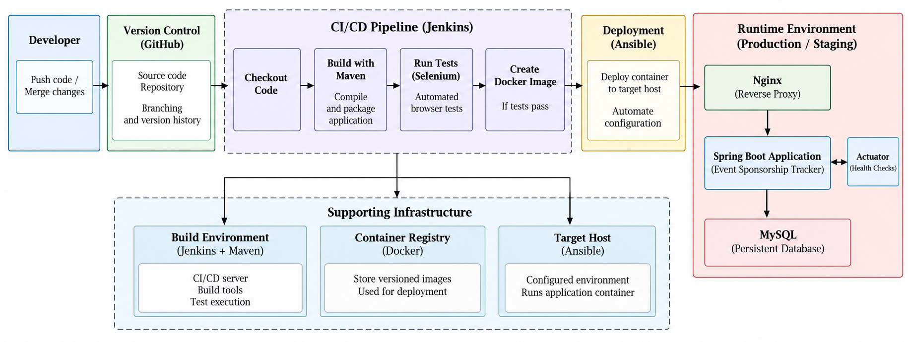
Figure 1. Proposed DevOps architecture for the Event Sponsorship Tracker.

Component Responsibilities
- Git and GitHub: Maintain source code, version history, and reviewed changes.
- Jenkins and Maven: Orchestrate the build, execute configured tests, and package the application.
- Selenium: Verify browser workflows such as adding events, searching sponsors, and updating payment status.
- Docker and Ansible: Create a versioned container image and automate deployment configuration.
- Nginx, Spring Boot, and MySQL: Route web requests, execute application logic, and persist data.
- Spring Boot Actuator: Expose a health endpoint for operational checks [8].
The database should use persistent storage. Credentials should be supplied through protected configuration rather than committed to source control. CI/CD permissions should follow the principle of least privilege [9], and secrets should be managed securely [10].

5. Implementation Steps
- Version control: Maintain the application in GitHub. Use commits and reviewed changes to track development and trigger pipeline execution.
- Build automation: Configure Jenkins to check out the repository and run `mvn clean verify`. Stop the pipeline if compilation or tests fail.
- Automated testing: Add unit and integration tests, then Selenium tests for important browser workflows such as creating an event and updating sponsorship status.
- Containerization: Create a Dockerfile and build a versioned image containing the packaged Spring Boot application. Run MySQL separately and preserve its data in persistent storage.
- Deployment automation: Use Ansible to configure the target host and deploy the validated image. Keep environment-specific configuration outside the image.
- Request routing: Configure Nginx to forward web traffic to the running application container.
- Health verification: Enable Spring Boot Actuator and check `/actuator/health`. Confirm that the application responds as expected after deployment.
- Security and recovery: Store secrets securely, restrict deployment permissions, retain logs, and document rollback to a previously validated image.

Pipeline Quality Gates
The pipeline should fail fast when the build or required tests fail. Only validated images should be deployed. A production release may include a manual approval stage. Build logs, test reports, image tags, and deployment results should be retained to support traceability and troubleshooting.

Implementation Scope
The architecture is a proposed target workflow. Each tool should be described as implemented only after it has been configured and tested in the project environment. The initial implementation can begin with version control and Maven tests, followed by Docker packaging, Jenkins automation, deployment automation, and health checks.

6. Expected Output, Benefits and Conclusion

Expected Output
The intended output is a repeatable pipeline that builds and tests the application, generates a Docker image, deploys it to a configured environment, and verifies application health. Evidence of successful implementation includes a passing Jenkins build, test reports, a running container, working application pages, database persistence after restart, and a successful health-check response.

Benefits
- Reduces manual effort: Reduces repetitive manual build and deployment work.
- Environment consistency: Improves consistency between environments.
- Early defect detection: Detects defects earlier through automated testing.
- Reliable deployment: Supports repeatable deployments and easier recovery.
- Improved traceability: Improves traceability through source history, build logs, and versioned images.
- Operational visibility: Provides operational visibility through health checks.
- Enhanced security: Strengthens security through controlled credentials and deployment permissions.]

Conclusion
A DevOps-based architecture can improve the reliability and maintainability of the Event Sponsorship Tracker by integrating version control, automated builds, testing, containerization, and deployment automation. Jenkins and Maven provide the core build pipeline, Selenium supports functional verification, Docker standardizes packaging, and Ansible supports repeatable deployment. Nginx and Spring Boot Actuator provide request routing and health verification. The design offers a practical foundation for continuous delivery while allowing each stage to be implemented and validated incrementally.

References
[1] Jenkins, “Pipeline.” https://www.jenkins.io/doc/book/pipeline/
[2] Git, “Pro Git Book: About Version Control.” https://git-scm.com/book/en/v2/Getting-Started-About-Version-Control
[3] Apache Maven, “Introduction to the Build Lifecycle.” https://maven.apache.org/guides/introduction/introduction-to-the-lifecycle.html
[4] Selenium, “Selenium Documentation.” https://www.selenium.dev/documentation/
[5] Docker, “Java Language-Specific Guide.” https://docs.docker.com/guides/java/run-tests/
[6] NGINX, “NGINX Reverse Proxy.” https://docs.nginx.com/nginx/admin-guide/web-server/reverse-proxy/
[7] Ansible, “Introduction to Ansible.” https://docs.ansible.com/projects/ansible/latest/getting_started/introduction.html
[8] Spring, “Spring Boot Actuator Monitoring.” https://docs.spring.io/spring-boot/reference/actuator/monitoring.html
[9] OWASP, “CI/CD Security Cheat Sheet.” https://cheatsheetseries.owasp.org/cheatsheets/CI_CD_Security_Cheat_Sheet.html
[10] OWASP, “Secrets Management Cheat Sheet.” https://cheatsheetseries.owasp.org/cheatsheets/Secrets_Management_Cheat_Sheet.html

