



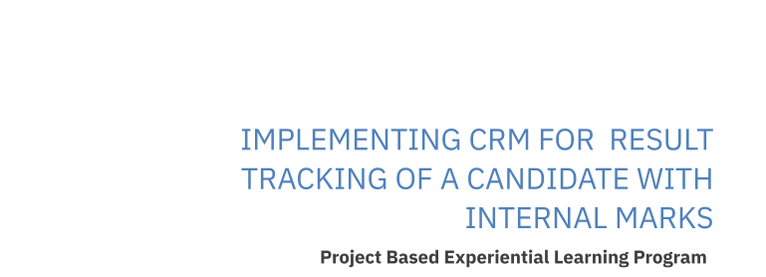

**Implementing CRM for Result tracking of a candidate with internal marks.**

INTRODUCTION

* 1. Overview

A brief description about your project

**Description:**

Administrator should be able to create all base data including Semester, Candidate, Course and Lecturer ,Lecturer should have the ability to create Internal Results,Dean, who is one of the Lecturer, should be the only one with ability to update Internal Results,Re-evaluation Can be initialised by Candidate for all Internal Results.Now only dean can update the marks after re- evaluation

**Milestone 1:Creation Salesforce Org:**

Purpose

The use of this project. What can be achieved using this.

# Introduction

Are you new to Salesforce? Not sure exactly what it is, or how to use it? Don’t know where you should start on your learning journey? If you’ve answered yes to any of these questions, then you’re in the right place. This module is for you.

Welcome to Salesforce! Salesforce is game-changing technology, with a host of productivity-boosting features, that will help you sell smarter and faster. As you work toward your badge for this module, we’ll take you through these features and answer the question, “What is Salesforce, anyway?”

**What Is Salesforce?**

Salesforce is your customer success platform, designed to help you sell, service, market, analyze, and connect with your customers.

Salesforce has everything you need to run your business from anywhere. Using standard products and features, you can manage relationships with prospects and customers, collaborate and engage with employees and partners, and store your data securely in the cloud.

So what does that really mean? Well, before Salesforce, your contacts, emails, follow-up tasks, and prospective deals might have been organized something like this: <https://youtu.be/r9EX3lGde5k>

**Activity 1:**

**Creating Developer Account**

Creating a developer org in salesforce.

1. Go to [developers.salesforce.com/](https://developer.salesforce.com/) 2. Click on sign up.

3. On the sign up form, enter the following details :

a. First name & Last name

1. Email
2. Role : Developer
3. Company : College Name
4. County : India
5. Postal Code : pin code
6. Username : should be a combination of your name and company

This need not be an actual email id, you can give anything in the format :

username@organization.com

Click on sign up after filling these.

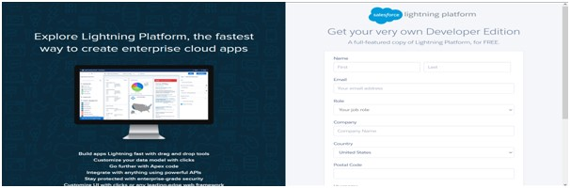

# Account Activation

Go to the inbox of the email that you used while signing up. Click on the verify account to activate your account. The email may take 5-10mins, as

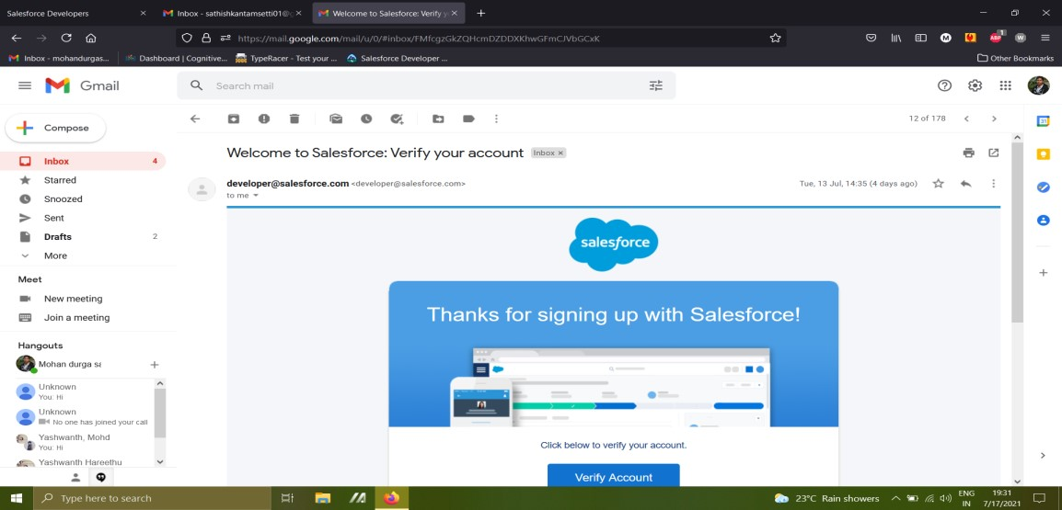

# Login To Your Salesforce Account

1.Go to salesforce.com and click on login.

2.Enter the username and password that you just created.

3.After login this is the home page which you will see.

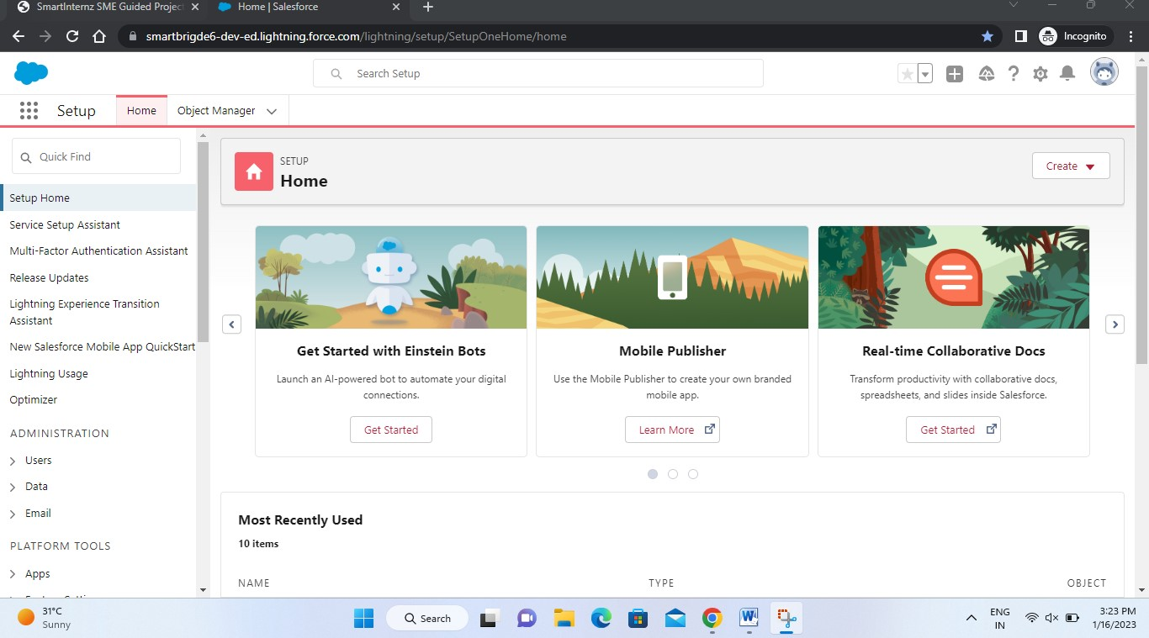

*Salesforce Login* htttps://login.salesforce.com

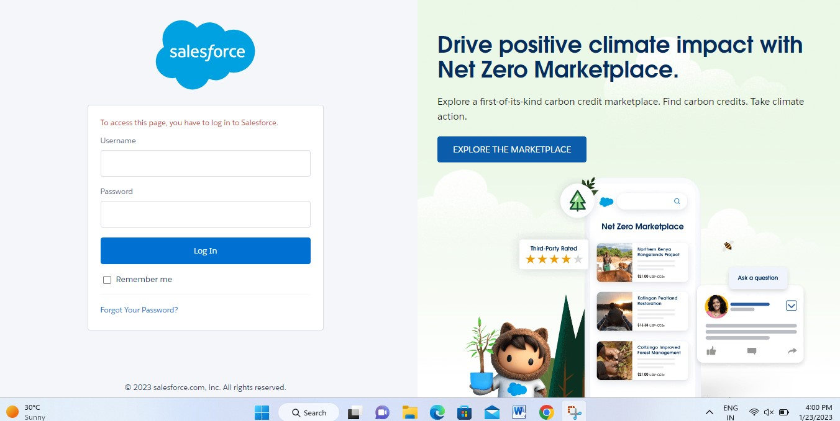

## Milestone-2:Object

Salesforce objects are database tables that permit you to store data that is specific to an organisation. Salesforce objects are of two types: Standard Objects: Standard objects are the kind of objects that are provided by salesforce.com such as users, contracts, reports, dashboards, etc.

**Custom objects:**

1.Semester

2.Candidate

3.Course Details

4.Lecturer Details

5.Internal results

**Activity-1:**

**To Create an object**:

Creation of Objects for Candidate Internal Result Card, For this Candidate Internal Result Card we need to create 5 objects i.e Semester,Candidate,Course Details,Lecturer Details,Internal Results.

The below steps will assist you in creating those objects.

* Click on the gear icon and then select Setup.
* Click on the object manager tab just beside the home tab.
* After the above steps, have a look on the extreme right you will find a Create Dropdown click on that and select Custom Object.

On the Custom Object Definition page, create the object as follows:

* Label: Semester
* Plural Label: Semesters
* Record Name: Semester Name
* Check the Allow Reports checkbox ● Check the Allow Search checkbox ● Click Save.
* Now create a custom tab. Click the Home tab, enter Tabs in Quick Find and select Tabs.
* Under Custom Object Tabs, click New.
* For Object, select Semester.
* For Tab Style, select any icon.
* Leave all defaults as is. Click Next, Next, and Save.

To Navigate to Setup page:

Click on gear icon → click setup.

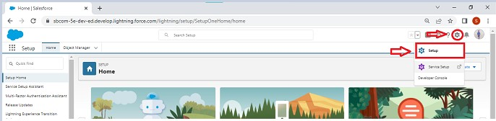

To create an object:

From the setup page → Click on Object Manager → Click on Create → Click on Custom Object.

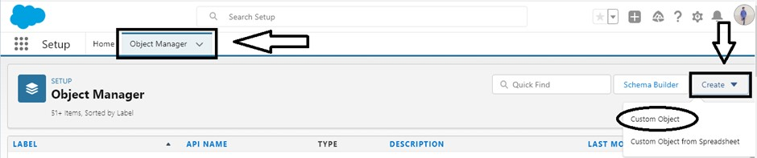

On Custom object defining page:

Enter the label name, plural label name, click on Allow reports, Allow search → Save.

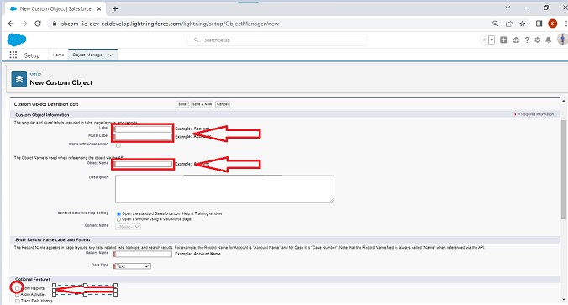

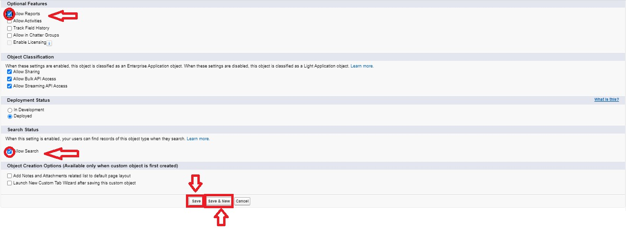

**Activity-2:**Follow Similar steps to create Candidate,Course Details,Lecturer Details,Internal results Objects.

### Milestone -2:Fields and Relationship

An object relationship in Salesforce is a two-way association between two objects.

Relationships are created by creating custom relationship fields on an object. This is done so that when users view records, they can also see and access related data.

**Activity-1:**

**Creation of fields:**

* Click the gear icon and select Setup. This launches Setup in a new tab.
* Click the Object Manager tab next to Home.
* Select Semester.
* Select Fields & Relationships from the left navigation, and click New Now ready to make a custom field. Let's do this!
* Select the Text as the Data Type, then click Next.
* For Field Label, Enter Semester Name.
* Click Next, Next, then Save

To create fields in an object:

Go to setup → click on Object Manager → type object name in search bar → click on the object.

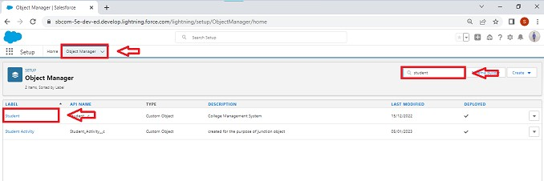

Now click on “Fields & Relationships” → New

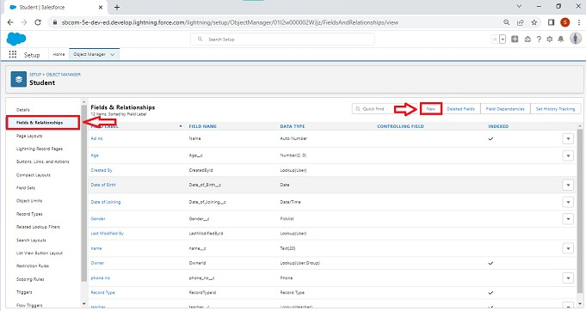

Fill the field label name → Next → Next → Save.

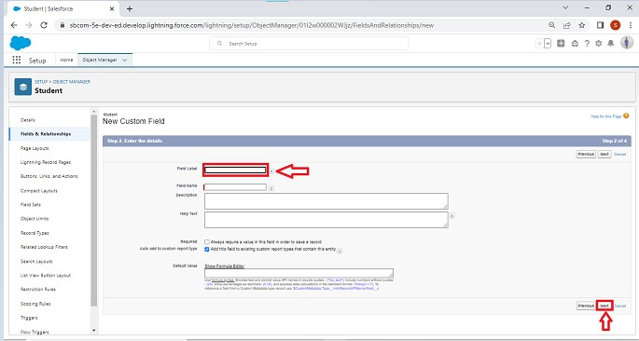

**Activity-2:**Similarly Create Following Fields according to the objects.

|  |  |  |  |  |
| --- | --- | --- | --- | --- |
| Semester: | Candidate: | Course  Details: | Lecturer Details: | Internal results |
| Semester Name | Candidate  Name | Course Name | Lecturer Role | Candidate  ID |
| Course(lookup) | Candidate Id | Course ID | Lecturer Name | Course ID |
|  | Semester  Name |  | Course ID | Marks |
|  | Internal results(lookup) |  | Course(lookup) |  |

### Milestone-3:Lightning App

Apps in Salesforce are a group of tabs that help the application function by working together as a unit. It has a name, a logo, and a particular set of tabs. The simplest app usually has just two tabs.

**Activity-1:**

**Create the Candidate Internal Result Card app:**

* From Setup, enter App Manager in the Quick Find and select App Manager.
* Click New Lightning App. Enter Candidate Internal Result Card as the App Name, then click Next
* Under App Options, leave the default selections and click Next.
* Under Utility Items, leave as is and click Next.
* From Available Items, select Semester,Candidate,Course

Details,LecturerDetails,InternalResults and move them to Selected Items. Click Next.

* From Available Profiles, select System Administrator and move it to Selected Profiles. Click Save & Finish.
* To verify your changes, click the App Launcher, type Candidate Internal Result Card and select the Candidate Internal Result Card app.

To create a lightning app page:

Go to setup page → search “app manager” in quick find → select “app manager” → click on New lightning App.

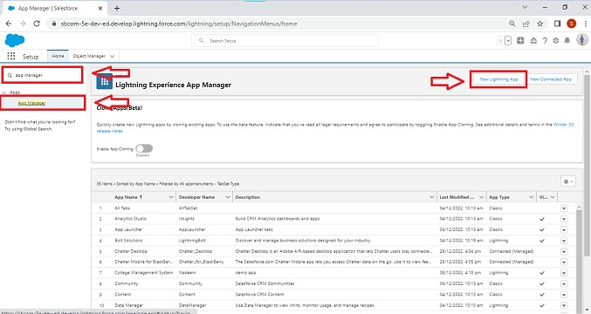

Fill the app name in app details and branding →Next → (App option page) keep it as default → Next → (Utility Items) keep it as default → Next → (Add Navigation Items) → Next → (Add User Profile) Add System Administrator → Next.

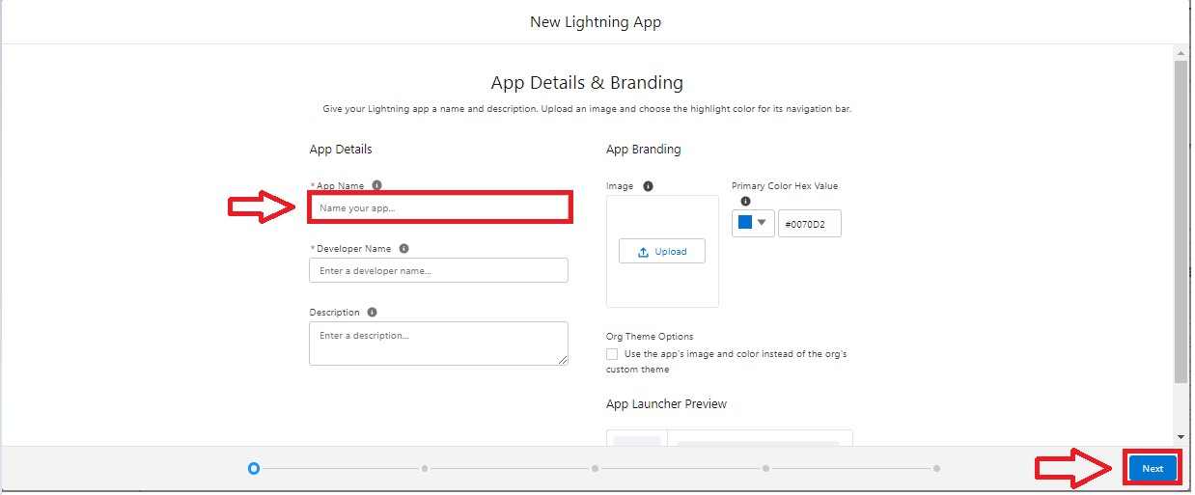

To Add Navigation Items:

Select the items from the search bar and move it using the arrow button → Next.

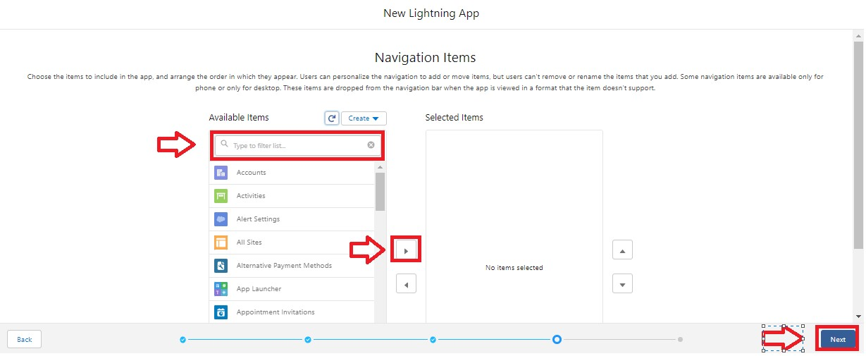

To Add User Profiles:

Search profiles in search bar → click on the arrow button → save & finish.

## Milestone-4: Users

A user is anyone who logs in to Salesforce. Users are employees at your company, such as sales reps, managers, and IT specialists, who need access to the company's records. Every user in Salesforce has a user account.

**Activity 1:**

**Creating a Users:**

1. From Setup, in the Quick Find box, enter Users, and then select Users.
2. Click New User.
3. Enter the user’s name John Martin and (Your) email address and a unique username in the form of an email address. By default, the username is the same as the email address.
4. Select a **Role**(none)
5. Select a User Licence As salesforce.
6. Select a profile as Salesforce User.
7. Check Generate new password and notify the user immediately to have the user’s login name and a temporary password emailed to your email.

### Milestone-5:Reports

A report is a list of records that meet the criteria you define. It's displayed in Salesforce in rows and columns, and can be filtered, grouped, or displayed in a graphical chart. Every report is stored in a folder. Folders can be public, hidden, or shared, and can be set to read-only or read/write.

**Activity 1:**

**Reports and dashboards:**

1. From the Reports tab, click New Report.
2. Select the report type as Candidate with candidate Marks for the report, and click Create.
3. Customise your report, then save or run it.

To create a report:

Go to the app → click on the reports tab

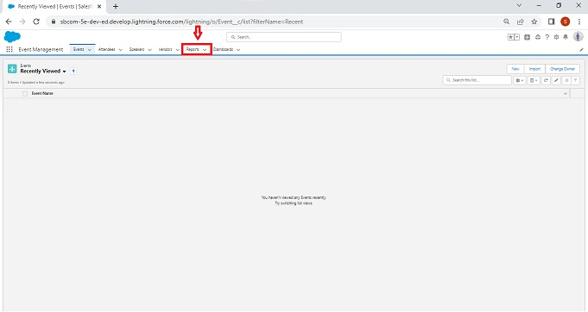

Click New Report

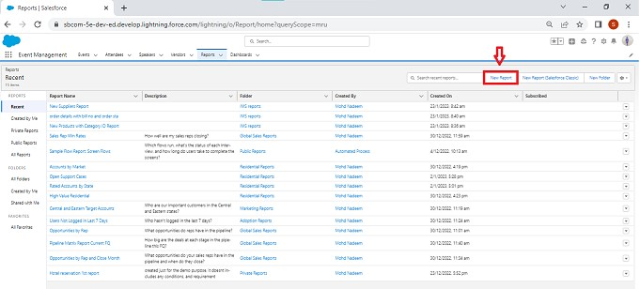

Select report type from category or from report type panel or from search panel → click on start report.

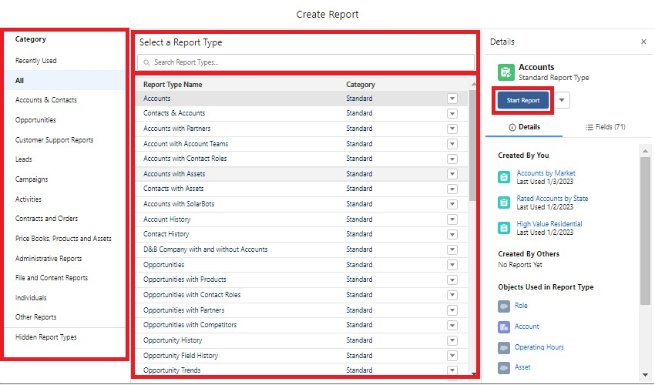

Customize your report, then save or run it.

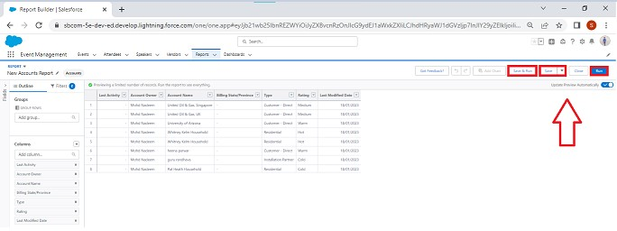

**Milestone-6:Dashboards:**

Dashboards let you curate data from reports using charts, tables, and metrics. If your colleagues need more information, then they're able to view your dashboard's data-supplying reports. Dashboard filters make it easy for users to apply different data perspectives to a single dashboard.

**Activity 1:**

**Create a Dashboard:**

1. Click the Dashboards tab.
2. Click New Dashboard.
3. Name your dashboard Candidate Board . Leave all other fields as is and click Create.
4. Click + Component.
5. For Report, select Candidate Marksby Stage. Click Select. ...
6. For Display As, select Vertical Bar Chart and click Add.
7. Click Save.
8. Click Done
9. **Problem Definition & Design Thinking**
   1. Empathy Map

Paste the empathy map screenshot

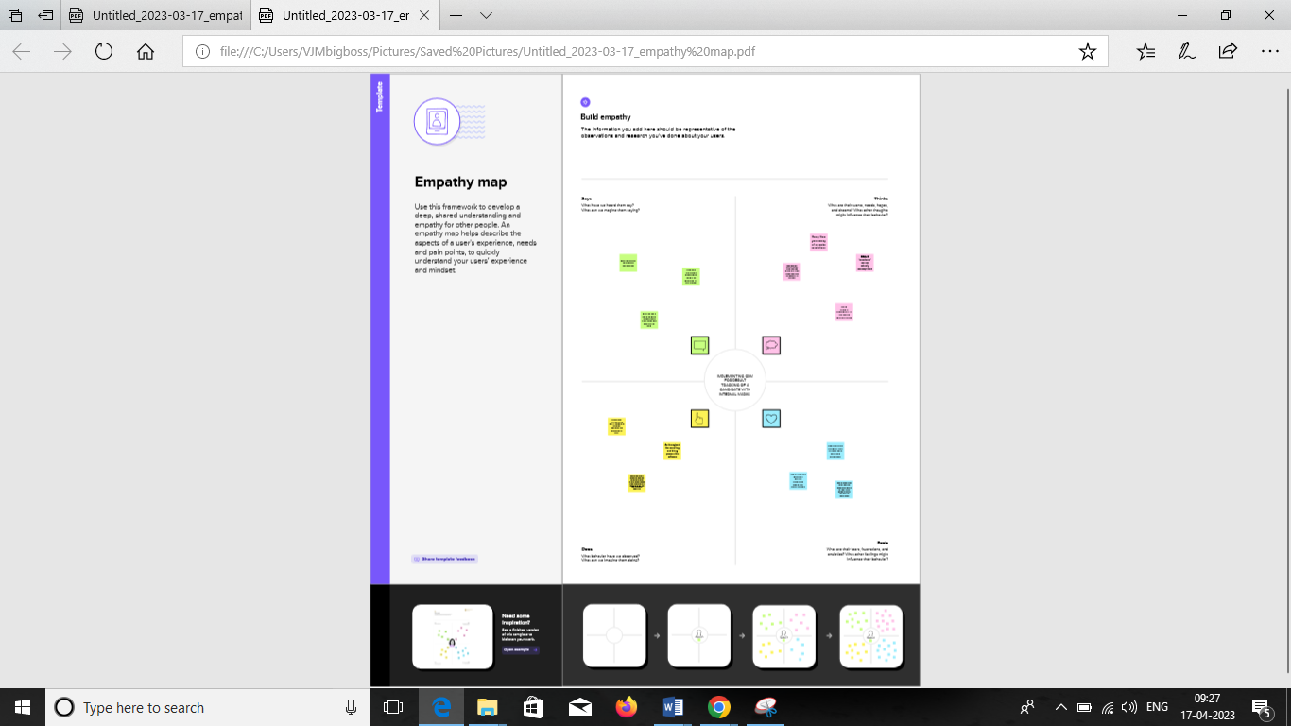

* 1. Ideation & Brainstorming Map

Paste the Ideation & brainstorming map screenshot



# activity & Screenshot

Attach the screenshots of your project activity along with the description.

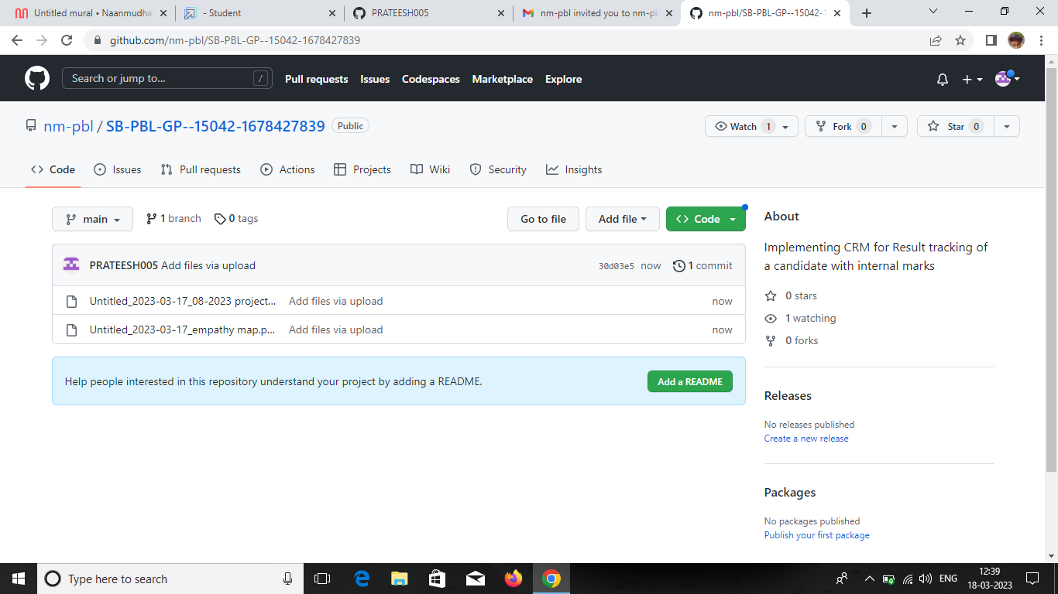

# Trailhead Profile Public URL

Team Lead - https://trailblazer.me/id/mp005 Team Member 1 - **https://trailblazer.me/id/hgahlo05**

Team Member 2 -https://trailblazer.me/id/mp005 Team Member 3 –

**https://trailblazer.me/id/hgahlot00**