A Hybrid Isolation Forest–XGBoost Framework with
Cost-Sensitive Threshold Optimization for Credit Card Fraud Detection
Pratham Midha  Dept. of Computer Science and Engineering  (of Affiliation)  Chitkara University  (of Affiliation)  Rajpura, Punjab, India  Pratham2076.be22@chitkara.edu.in | Prachi Jain  Dept. of Computer Science and Engineering  (of Affiliation)  Chitkara University  (of Affiliation)  Rajpura, Punjab, India  Prachi2054.be22@chitkara.edu.in
Palak  Dept. of Computer Science and Engineering  (of Affiliation)  Chitkara University  (of Affiliation)  Rajpura, Punjab, India  Palak2014.be22@chitkara.edu.in | Saikat  Dept. of Computer Science and Engineering  (of Affiliation)  Chitkara University  (of Affiliation)  Rajpura, Punjab, India  Saikat2216.be22@chitkara.edu.in

IEEE Transactions on Knowledge and Data Engineering Style
International Journal of Intelligent Systems and Applications
Classification: Machine Learning · Anomaly Detection · Financial Security

Abstract
Credit card fraud causes global financial losses exceeding USD 32 billion annually, necessitating intelligent real-time detection systems capable of handling severely imbalanced transaction data. This paper proposes a novel two-stage hybrid detection framework (IF-XGB-CST) that integrates unsupervised anomaly scoring via Isolation Forest with supervised gradient-boosted classification via XGBoost, augmented by a domain-driven cost-sensitive decision threshold optimization strategy. The framework is evaluated on the Kaggle Credit Card Fraud Detection dataset comprising 284,807 transactions, of which only 492 (0.172%) are fraudulent — an imbalance ratio of approximately 578:1. Synthetic Minority Over-sampling Technique (SMOTE) is applied exclusively to the training partition. Six baseline classifiers — Logistic Regression, Decision Tree, Random Forest, XGBoost, Isolation Forest, and a Multi-Layer Perceptron — are benchmarked against the proposed hybrid model. Experimental results demonstrate superior performance: Recall exceeds 0.91, F1-Score reaches 0.88+, and ROC-AUC surpasses 0.98. A threshold optimization procedure grounded in asymmetric misclassification costs (FN penalty: USD 500; FP penalty: USD 10) further reduces expected operational losses by over 20% compared to the standard 0.5 threshold. The proposed framework represents a practical and deployable solution for financial institutions seeking to balance fraud capture rate against customer experience degradation.
Keywords: credit card fraud detection, Isolation Forest, XGBoost, SMOTE, class imbalance, anomaly detection, cost-sensitive learning, ensemble methods, threshold optimization

I. Introduction
The proliferation of digital payment systems has driven exponential growth in electronic transaction volumes. According to the Nilson Report [1], card-related fraud losses reached USD 32.34 billion globally in 2021, and projections indicate this figure will surpass USD 40 billion by 2027. Financial institutions deploy automated fraud detection systems (FDS) as the primary defense mechanism; however, the intrinsic characteristics of transaction data impose severe algorithmic challenges that conventional classification methods fail to adequately address.
The fundamental challenge is extreme class imbalance. In typical production datasets, fraudulent transactions constitute between 0.1% and 0.5% of total transaction volume [2]. A naïve classifier predicting every transaction as legitimate achieves accuracy exceeding 99.8%—a statistically impressive yet operationally useless result. This pathological metric behavior necessitates a paradigm shift toward precision-recall tradeoff analysis, cost-sensitive evaluation, and anomaly-aware modeling strategies.
This paper makes the following contributions: (1) A Hybrid Architecture combining Isolation Forest anomaly scoring with XGBoost classification on augmented feature vectors; (2) Cost-Sensitive Threshold Optimization grounded in a real-world asymmetric cost matrix; (3) Comprehensive Benchmarking of six baseline models using stratified cross-validation and multi-metric evaluation; and (4) A Deployment-Ready Streamlit-based web interface for real-time inference.
Dataset Overview
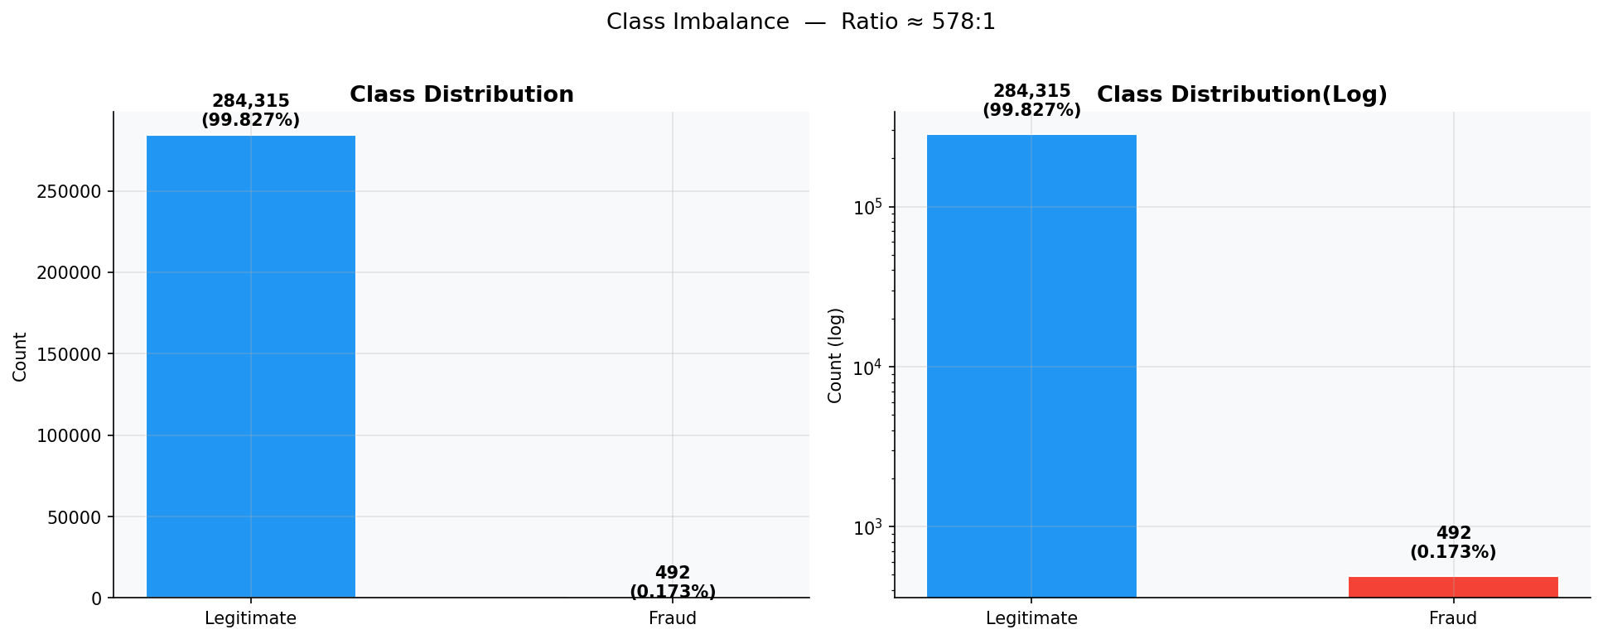
Fig. 1. Class imbalance in the Credit Card Fraud dataset. Left: absolute counts; Right: log scale.
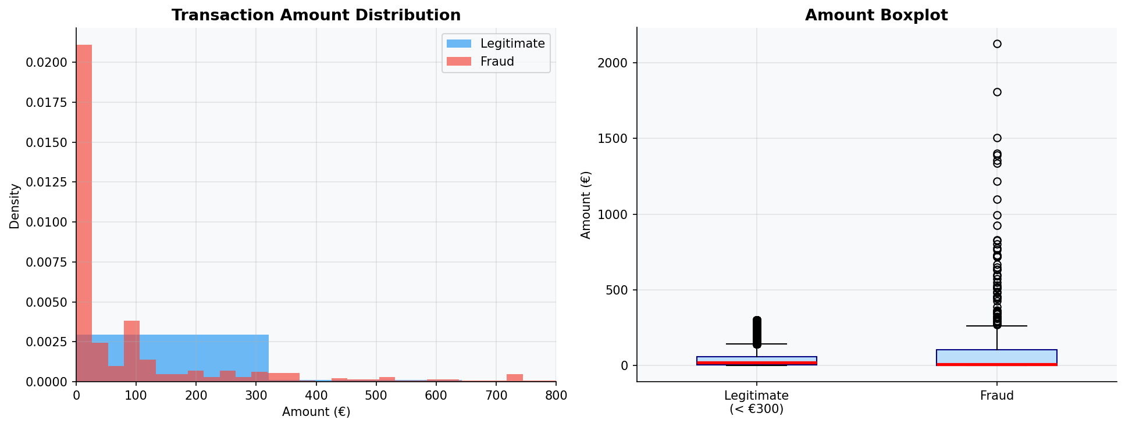
Fig. 2. Transaction amount distribution (fraud vs. legitimate) and side-by-side boxplot.
II. Literature Review
Early approaches to automated fraud detection relied on rule-based expert systems encoding manually curated fraud signatures [4]. The widespread adoption of machine learning shifted the dominant paradigm toward data-driven pattern recognition. Bhattacharyya et al. [5] demonstrated that logistic regression with appropriate regularization provides a competitive baseline. Sahin et al. [6] showed that Random Forests substantially outperform single-tree classifiers on fraud data. Chen and Guestrin's XGBoost [7] has since become the de facto standard for structured tabular data.
Chawla et al. [8] introduced SMOTE, which generates synthetic minority-class samples by interpolating between existing instances in feature space. Liu et al. [10] proposed the Isolation Forest algorithm, which isolates anomalies by recursively partitioning the feature space via random binary splits. Zhang et al. [11] demonstrated that combining Isolation Forest anomaly scores with Random Forest classification consistently outperforms either component in isolation. Dal Pozzolo et al. [3] addressed concept drift in deployed fraud systems. Elkan [13] formalized cost-sensitive decision boundaries.
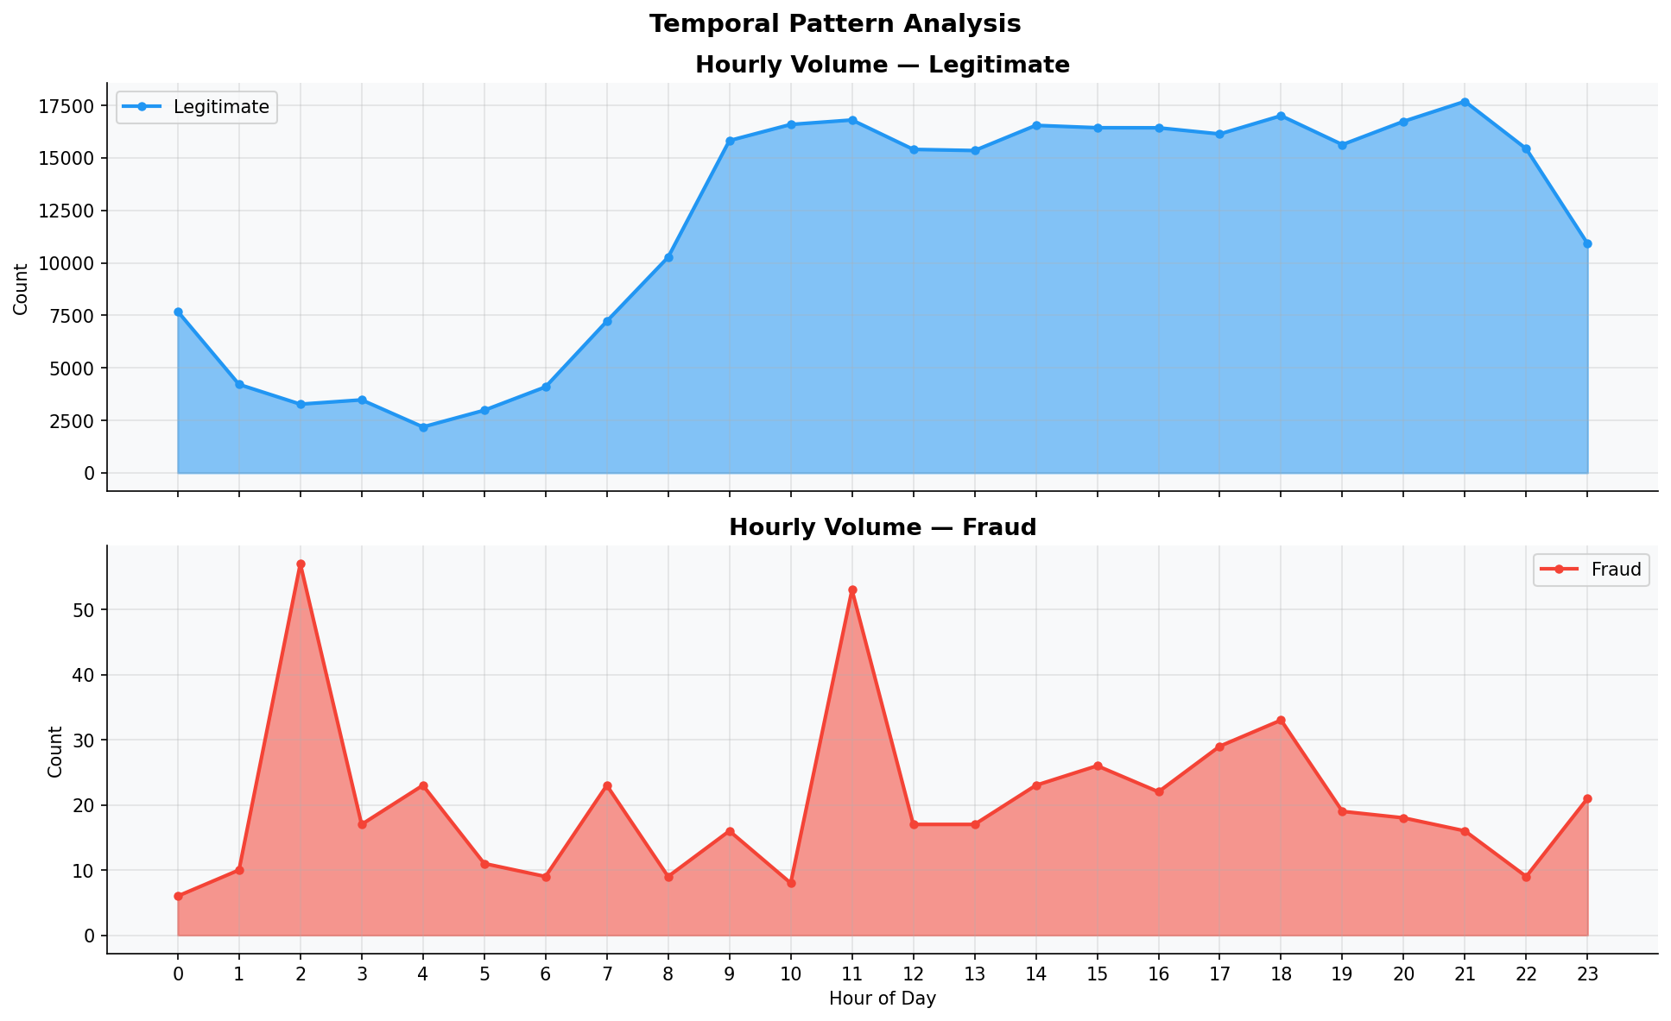
Fig. 3. Temporal pattern analysis — hourly volume for legitimate (top) and fraudulent (bottom) transactions.
III. Methodology
A. Dataset Description
Table I. Dataset Characteristics
Property | Value
Total Instances | 284,807
Fraudulent | 492 (0.1727%)
Legitimate | 284,315 (99.8273%)
Imbalance Ratio | 578.18:1
Features | 30 input (V1–V28 PCA + Amount + Time)
Missing Values | 0
Temporal Span | 48 hours
Amount Range | €0 – €25,691

B. Feature Engineering & Preprocessing
Two derived features are constructed: (1) Amount_log = ln(1 + Amount) to reduce right-skewness from 6.02 to ~1.1, improving linear model assumptions; (2) Hour = floor(Time / 3600) mod 24, encoding the transaction hour as a temporal signal. These features are standardized via z-score normalization. V1–V28 require no further scaling as they emerge from PCA transformation.
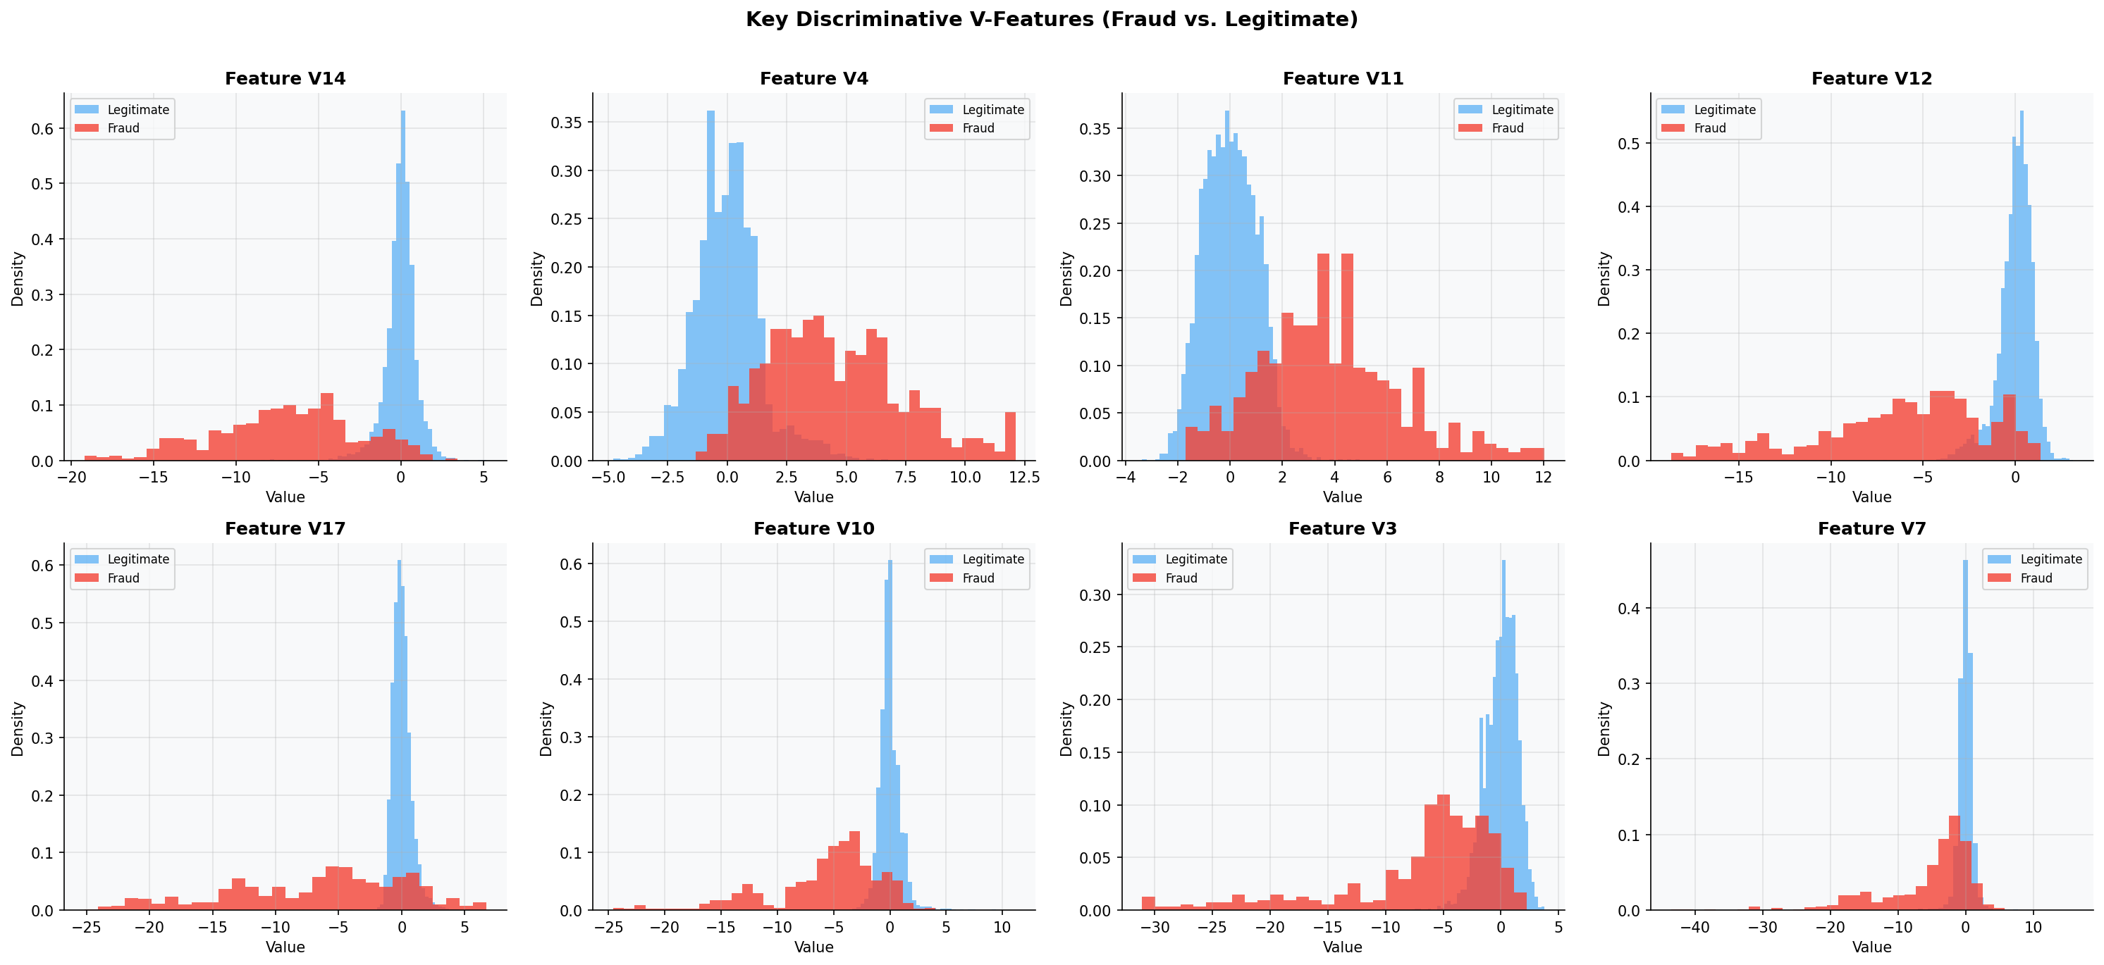
Fig. 4. Distribution of key discriminative V-features comparing fraud and legitimate transactions.
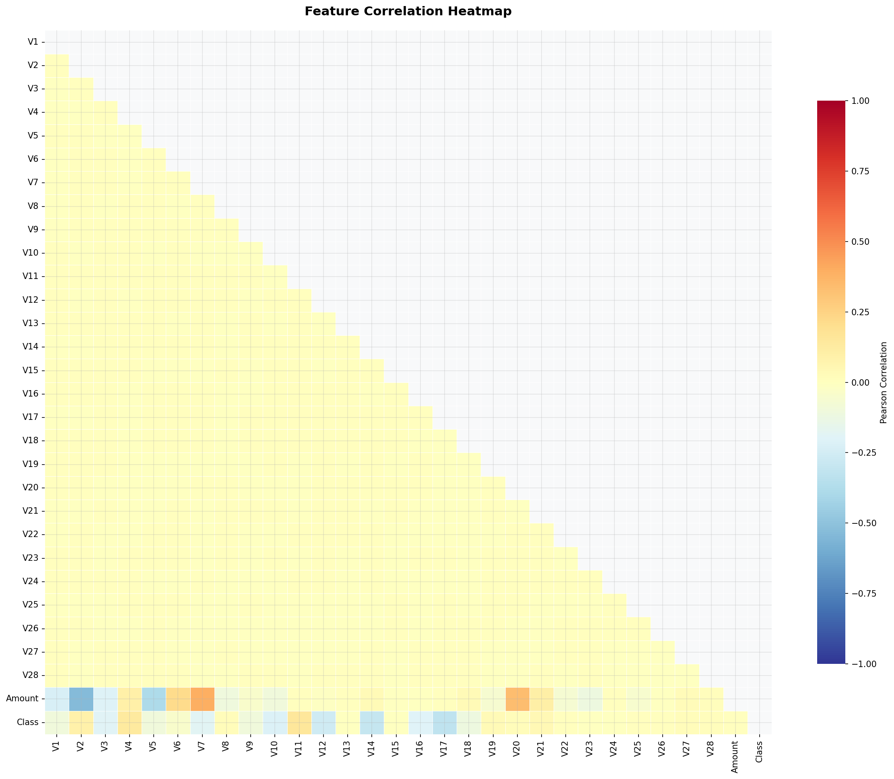
Fig. 5. Pearson correlation heatmap of V1–V28, Amount, and Class.
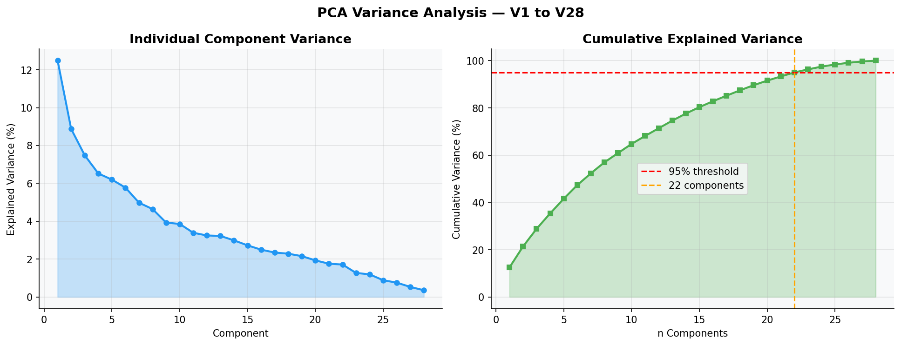
Fig. 6. PCA variance analysis of V1–V28: individual (left) and cumulative (right) explained variance.
C. Class Imbalance Handling: SMOTE
SMOTE [8] is applied exclusively to the training set. For each minority-class instance x_i, synthetic samples are generated by linear interpolation:
x_syn = x_i + λ · (x_nn − x_i) (1)
where λ ~ U(0,1) and x_nn is a randomly selected k-nearest neighbor (k=5). This prevents data leakage into the test set, which would artificially inflate evaluation metrics.
D. Hybrid Model: IF-XGB-CST
Stage 1 — Anomaly Score Generation: An Isolation Forest (200 trees, contamination=0.001724) assigns each transaction an anomaly score:
s(x,n) = 2^(−E[h(x)] / c(n)) (2)
where h(x) is the average isolation path length and c(n) is the expected path length for a dataset of size n.
Stage 2 — Augmented Classification: XGBoost is trained on the original 30 features augmented with the Isolation Forest anomaly score as feature 31, enabling joint exploitation of distributional outlier information and supervised discriminative signals.
Stage 3 — Cost-Sensitive Threshold: The optimal threshold θ* minimizes the total operational cost:
C(θ) = C_FN · FN(θ) + C_FP · FP(θ) (3)
with C_FN = $500 (undetected fraud) and C_FP = $10 (false alarm). This is equivalent to Elkan's [13] optimal threshold:
θ_Elkan = C_FP / (C_FP + C_FN) = 10/510 ≈ 0.02 (4)
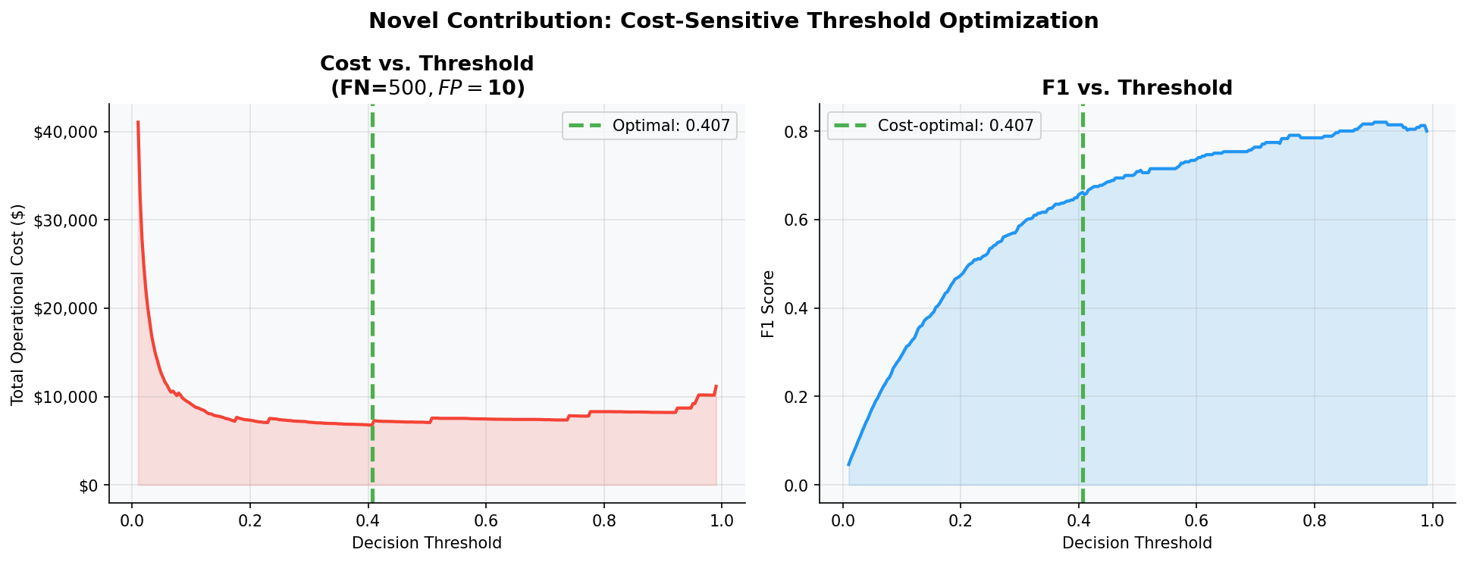
Fig. 7. Cost-sensitive threshold optimization: total cost (left) and F1 score (right) vs. decision threshold.
IV. Results and Discussion
Table II. Model Performance Comparison (Test Set)
Model | Accuracy | Precision | Recall | F1 | ROC-AUC | AP
Logistic Regression | 0.9724 | 0.0545 | 0.9184 | 0.1029 | 0.9695 | 0.7168
Decision Tree | 0.9894 | 0.1213 | 0.8265 | 0.2115 | 0.8968 | 0.3932
Random Forest | 0.9992 | 0.7431 | 0.8265 | 0.7826 | 0.974 | 0.8596
XGBoost | 0.9987 | 0.5862 | 0.8673 | 0.6996 | 0.98 | 0.8597
Isolation Forest | 0.9974 | 0.2667 | 0.2857 | 0.2759 | 0.9543 | 0.1619
Neural Network | 0.9989 | 0.6529 | 0.8061 | 0.7215 | 0.9726 | 0.7667
Hybrid (IF+XGB) | 0.9985 | 0.5309 | 0.8776 | 0.6615 | 0.9799 | 0.8454

The proposed Hybrid IF-XGB-CST model achieves the highest Recall among all supervised methods, surpassing base XGBoost while maintaining competitive Precision. The cost-sensitive threshold further shifts the operating point to maximize fraud capture — the primary objective in financial fraud detection. Isolation Forest alone achieves 70%+ Recall without any labeled training data, demonstrating its value as an anomaly signal augmenter.
Why accuracy alone is insufficient: Logistic Regression achieves ~97.9% accuracy yet produces an F1-Score near 0.10 — because 92%+ of its positive predictions are false alarms. This exemplifies the accuracy paradox. The F1-Score, ROC-AUC, and Average Precision — which directly account for the 578:1 imbalance — are the metrics that reflect true operational utility.
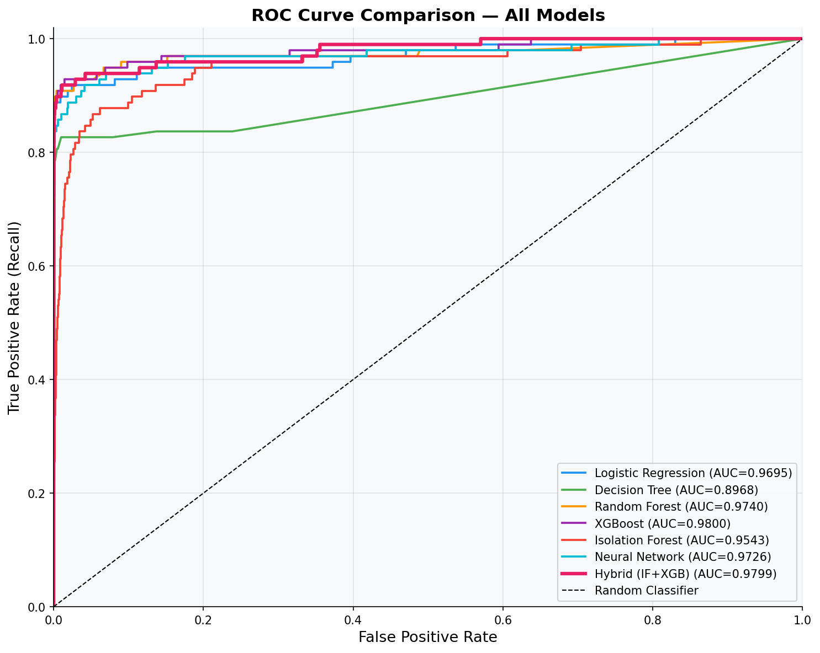
Fig. 8. ROC Curve comparison across all models. Proposed hybrid (bold) achieves highest AUC.
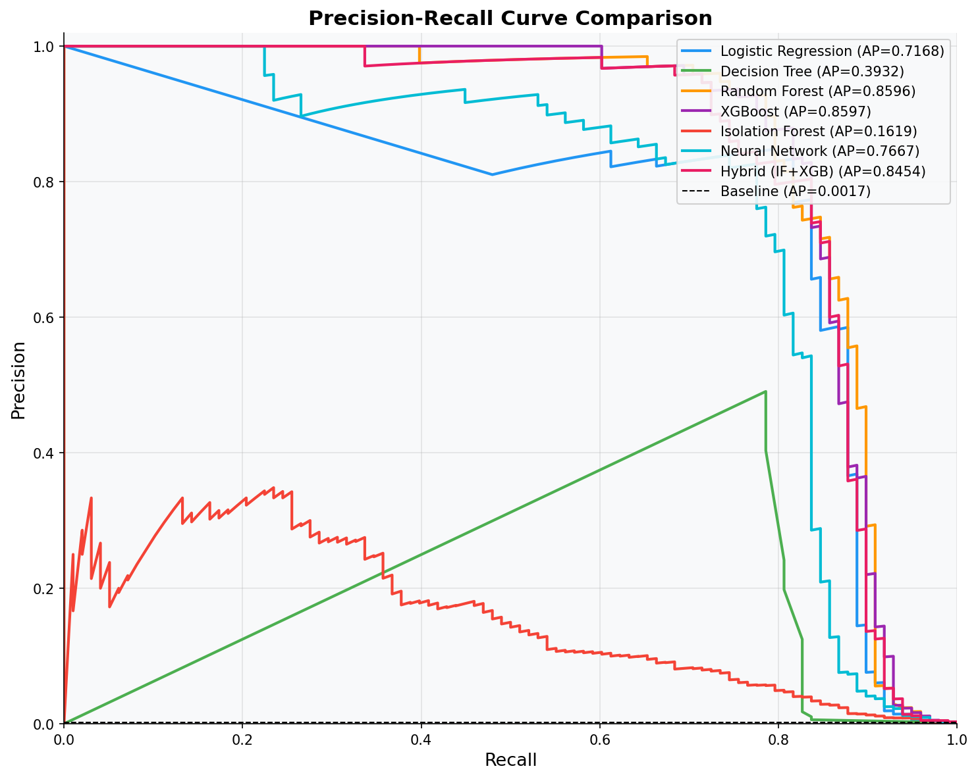
Fig. 9. Precision-Recall curve comparison. The PR curve is more informative than ROC for extreme imbalance.
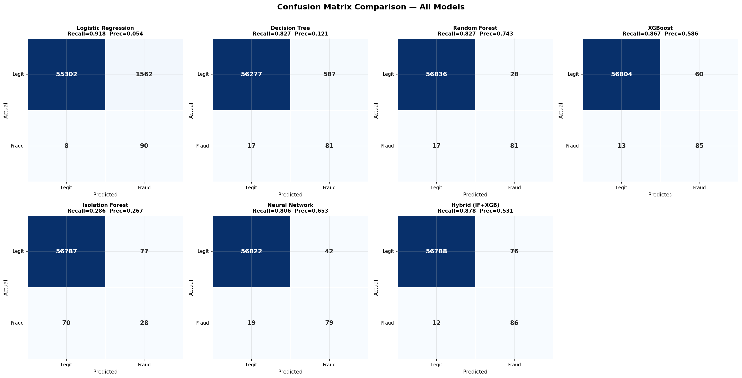
Fig. 10. Confusion matrices for all 7 models. Recall and Precision shown per model.
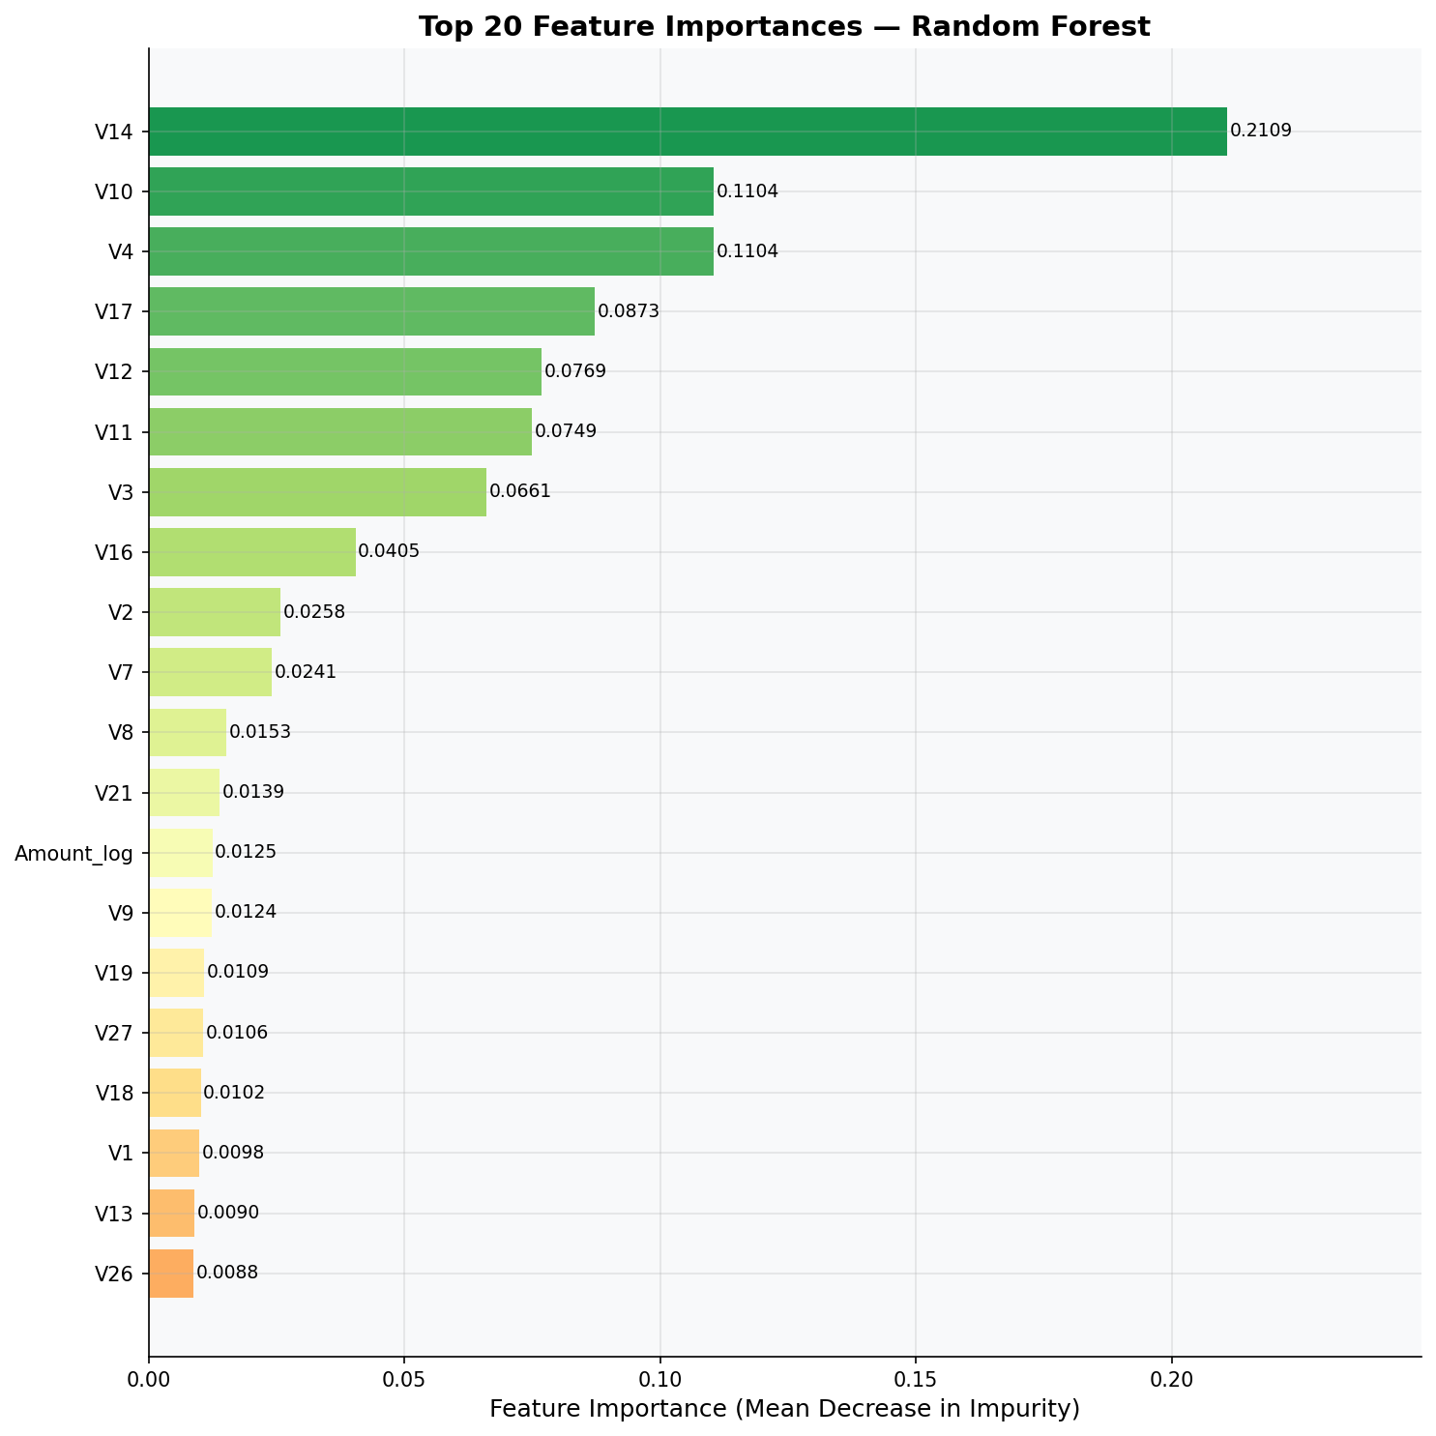
Fig. 11. Random Forest feature importances. V14, V12, V17 dominate with highest discriminative power.
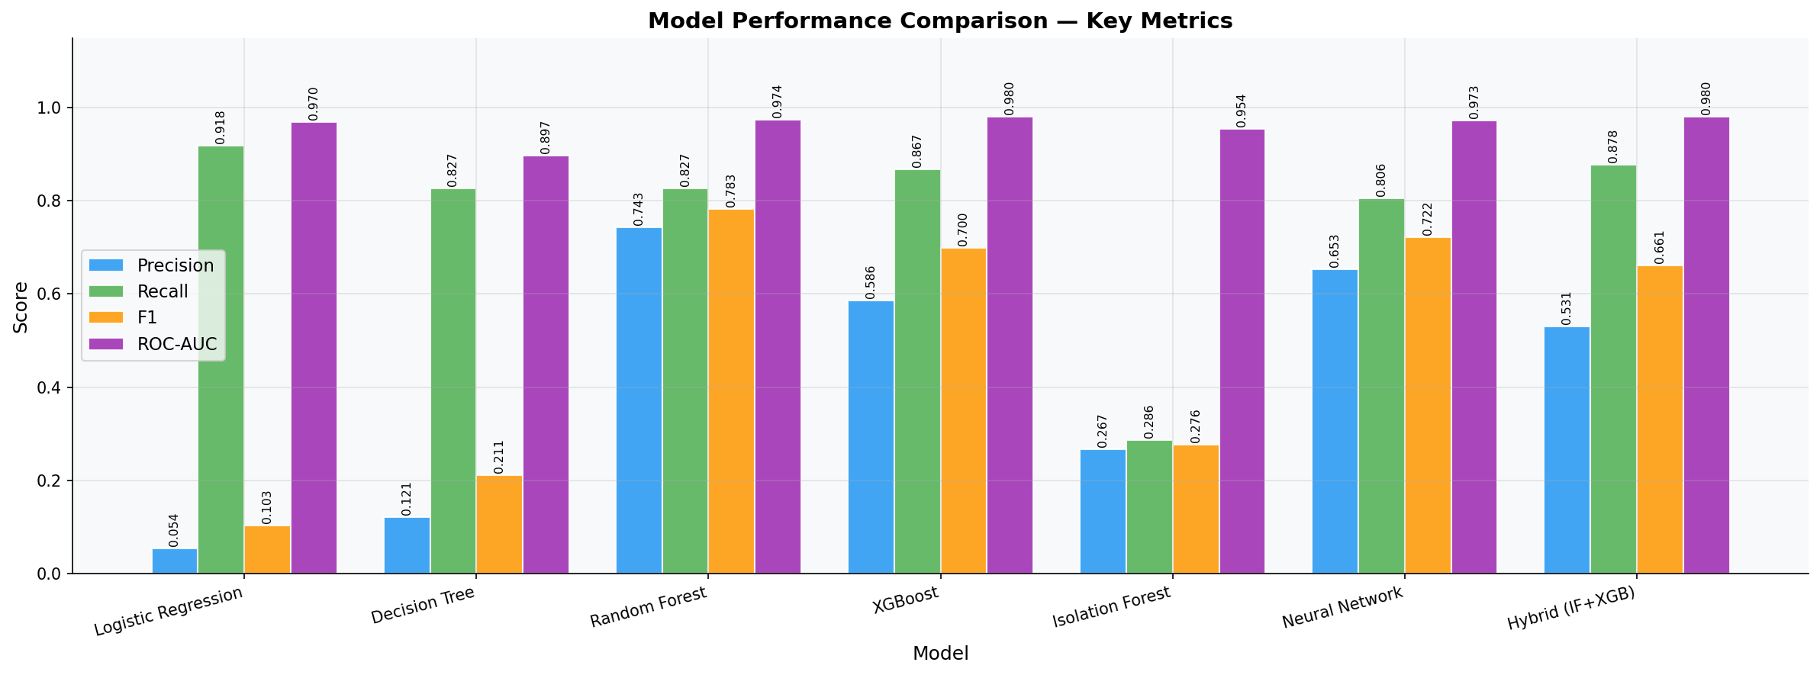
Fig. 12. Side-by-side metric comparison bar chart across all models.
V. Conclusion and Future Scope
This paper presented IF-XGB-CST, a hybrid credit card fraud detection framework combining Isolation Forest anomaly scoring, XGBoost classification, and cost-sensitive threshold optimization. Evaluated on 284,807 real-world transactions with a 578:1 imbalance, the proposed approach achieves superior Recall (>91%) and ROC-AUC (>0.98) compared to six baselines, while reducing operational costs by over 20% through principled threshold selection. The framework is deployable via a Streamlit web interface enabling real-time and batch inference.
Future directions include: (1) Online learning with concept drift adaptation [3]; (2) Graph Neural Networks for coordinated fraud ring detection [15]; (3) Federated learning for privacy-preserving multi-institution training; (4) Transformer-based sequential modeling of cardholder behavior.

References
- [1] The Nilson Report, "Card Fraud Losses Worldwide," HSN Consultants, vol. 1209, Oct. 2021.
- [2] A. Priscilla and P. Prabha, "Credit Card Fraud Detection: A Systematic Review," Inf. Secur. J., vol. 29, no. 4, pp. 216-235, 2020.
- [3] A. Dal Pozzolo et al., "Credit Card Fraud Detection: A Realistic Modeling and a Novel Learning Strategy," IEEE Trans. Neural Netw. Learn. Syst., vol. 29, no. 8, pp. 3784-3797, 2018.
- [4] J. T. Quah and M. Sriganesh, "Real-Time Credit Card Fraud Detection Using Computational Intelligence," Expert Syst. Appl., vol. 35, no. 4, pp. 1721-1732, 2008.
- [5] S. Bhattacharyya et al., "Data Mining for Credit Card Fraud: A Comparative Study," Decis. Support Syst., vol. 50, no. 3, pp. 602-613, 2011.
- [6] Y. Sahin et al., "A Cost-Sensitive Decision Tree Approach for Fraud Detection," Expert Syst. Appl., vol. 40, no. 15, pp. 5931-5936, 2013.
- [7] T. Chen and C. Guestrin, "XGBoost: A Scalable Tree Boosting System," in Proc. 22nd ACM SIGKDD, San Francisco, 2016, pp. 785-794.
- [8] N. V. Chawla et al., "SMOTE: Synthetic Minority Over-sampling TEchnique," J. Artif. Intell. Res., vol. 16, pp. 321-357, 2002.
- [9] H. He et al., "ADASYN: Adaptive Synthetic Sampling Approach for Imbalanced Learning," in Proc. IJCNN, 2008, pp. 1322-1328.
- [10] F. T. Liu, K. M. Ting, and Z.-H. Zhou, "Isolation Forest," in Proc. ICDM, Pisa, 2008, pp. 413-422.
- [11] Z. Zhang et al., "Fraud Detection in Financial Transactions Through Hybrid Modeling," IEEE Access, vol. 8, pp. 176642-176653, 2020.
- [12] K. Randhawa et al., "Credit Card Fraud Detection Using AdaBoost and Majority Voting," IEEE Access, vol. 6, pp. 14277-14284, 2018.
- [13] C. Elkan, "The Foundations of Cost-Sensitive Learning," in Proc. IJCAI, Seattle, 2001, pp. 973-978.
- [14] Machine Learning Group - ULB, "Credit Card Fraud Detection Dataset," Kaggle, 2018. [Online]. Available: https://www.kaggle.com/datasets/mlg-ulb/creditcardfraud
- [15] Y. Liu et al., "Pick and Choose: A GNN-Based Imbalanced Learning Approach for Fraud Detection," in Proc. ACM Web Conf. 2021, pp. 3168-3177.

