# NAME: PRTHAPJ

# TOPIC: Retail Sales Dashboard Report

## **Introduction**

**This document provides an overview of a Python-based retail sales analysis dashboard. The program processes sales data, generates visualizations, and automates PowerPoint generation. This approach helps businesses analyze sales trends and category performance efficiently.**

Functions & Their Roles:

* **load_sales_data():** Loads and preprocesses the sales data.
* **aggregate_sales_data()**: Computes sales trends by month and category.
* **create_sales_figures():** Generates visualizations using Plotly.
* **save_figures()**: Saves the generated images.

Benefits:

* Code Readability: Well-structured functions improve readability.
* Reusability: The functions can be reused in different projects
* Maintainability: Changes can be made easily without affecting other parts of the code.

## Advantages

1. Automates sales data analysis and visualization.

2. Generates PowerPoint slides with insights automatically.

3. Uses Python for data processing and visualization.

4. Provides interactive graphs and insights.

## Solution Explanation

The solution is divided into the following modules:  
1. Data Processing: Cleans and aggregates sales data.  
2. Visualization: Generates charts using Plotly.  
3. Report Generation: Saves visualizations and creates a PowerPoint file.

**CODE IMPLEMENTATION**

import pandas as pd

import plotly.express as px

import dash

from dash import dcc, html

from dash.dependencies import Input, Output

# Load Sales Data

df = pd.read_csv('/home/asu/sales_data1.csv')

# Strip spaces from column names

df.columns = df.columns.str.strip()

# Convert Date column to datetime

df['Date'] = pd.to_datetime(df['Date'])

# Group sales by month

sales_trend = df.groupby(df['Date'].dt.to_period('M')).agg({'Total_Sales': 'sum'}).reset_index()

sales_trend['Date'] = sales_trend['Date'].astype(str) # Convert period to string

# Group sales by category

category_sales = df.groupby('Category').agg({'Total_Sales': 'sum'}).reset_index()

# Initialize Dash app

app = dash.Dash(__name__)

# App Layout

app.layout = html.Div([

html.Div([

html.H2("Retail Sales Dashboard", style={'textAlign': 'center', 'color': 'white'}),

html.Hr(),

html.Label("Select Month:", style={'fontWeight': 'bold', 'color': 'white'}),

dcc.Dropdown(

id='month-dropdown',

options=[{'label': month, 'value': month} for month in sales_trend['Date']],

value=sales_trend['Date'].iloc[-1], # Default to latest month

clearable=False,

style={'width': '90%', 'margin': 'auto'}

),

], style={'width': '20%', 'backgroundColor': '#003366', 'padding': '20px', 'position': 'fixed', 'height': '100vh', 'color': 'black'}),

html.Div([

html.Div([

html.H3("Sales Trend Over Time", style={'color': '#006699'}),

dcc.Graph(id='sales-trend')

], style={'backgroundColor': '#f8f9fa', 'padding': '20px', 'borderRadius': '10px', 'marginBottom': '20px'}),

html.Div([

html.H3("Sales by Product Category", style={'color': '#006699'}),

dcc.Graph(id='category-sales')

], style={'backgroundColor': '#f8f9fa', 'padding': '20px', 'borderRadius': '10px'}),

], style={'marginLeft': '22%', 'padding': '20px'})

], style={'fontFamily': 'Arial', 'backgroundColor': '#e9ecef'})

# Callbacks to update charts

@app.callback(

Output('sales-trend', 'figure'),

Output('category-sales', 'figure'),

Input('month-dropdown', 'value')

)

def update_graphs(selected_month):

filtered_df = df[df['Date'].dt.to_period('M').astype(str) == selected_month]

sales_trend_filtered = filtered_df.groupby(filtered_df['Date'].dt.date).agg({'Total_Sales': 'sum'}).reset_index()

sales_trend_filtered['Date'] = sales_trend_filtered['Date'].astype(str) # Convert date to string

trend_fig = px.line(

sales_trend_filtered,

x='Date', y='Total_Sales',

title=f"Sales Trend for {selected_month}",

markers=True,

color_discrete_sequence=['#FF5733']

)

category_sales_filtered = filtered_df.groupby('Category').agg({'Total_Sales': 'sum'}).reset_index()

category_fig = px.bar(

category_sales_filtered, x='Category', y='Total_Sales',

title=f"Product Sales by Category for {selected_month}",

color='Category',

color_discrete_sequence=px.colors.qualitative.Pastel

)

return trend_fig, category_fig

# Run server

if __name__ == '__main__':

app.run(debug=True)

## OUTPUT:

## Generated Visualizations

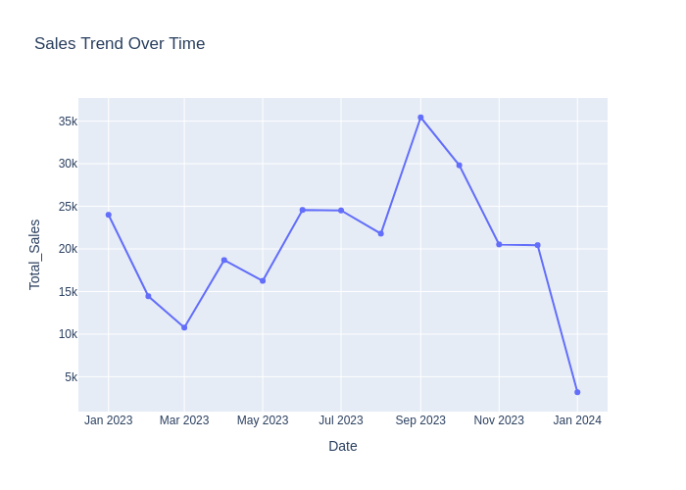

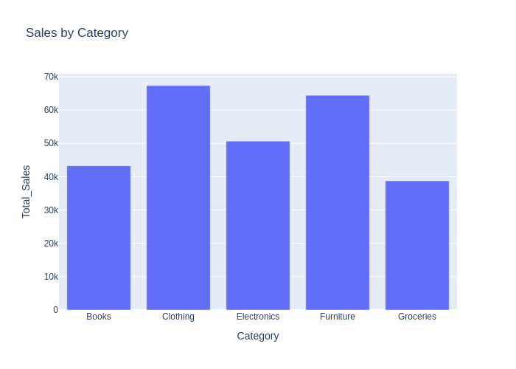

**CATEGORY_SALES**



