AIM: To perform Add Two Numbers of BCD Data in 8086.
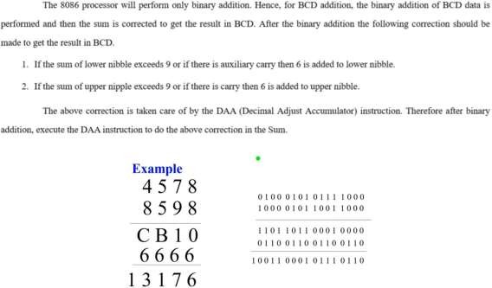

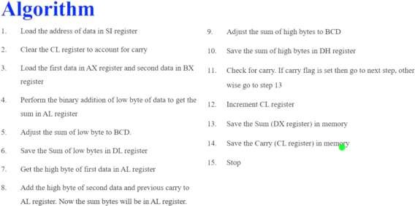

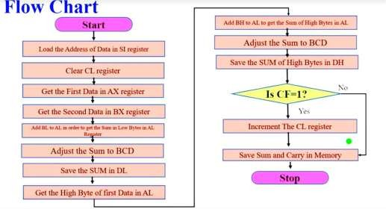
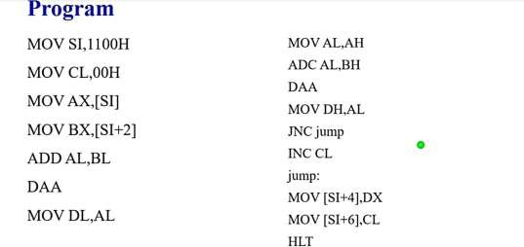

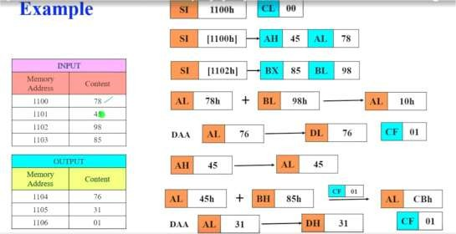
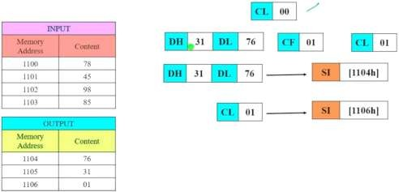

Program :

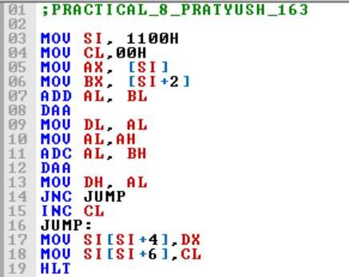
Update memory and provide data :
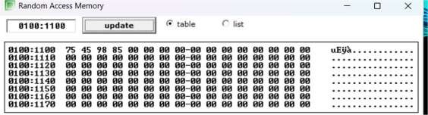

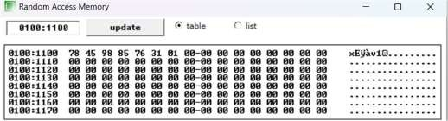
Check the output and Flag :
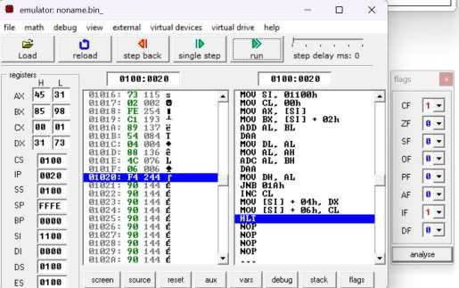

Program 2 :Write a program in 8086 microprocessor to find out the addition of two 8- bit BCD numbers, where numbers are stored from starting memory address 2000 : 500 and store the result into memory address 2000 : 600 and carry at 2000 : 601.

Example –
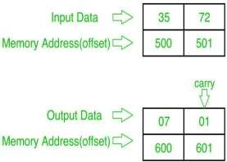

Algorithm –

- Load data from offset 500 to register AL (first number)
- Load data from offset 501 to register BL (second number)
- Add these two numbers (contents of register AL and register BL)
- Apply DAA instruction (decimal adjust)
- Store the result (content of register AL) to offset 600
- Set register AL to 00
- Add contents of register AL to itself with carry
- Store the result (content of register AL) to offset 601
- Stop

Program –

MEMORY ADDRESS | MNEMONICS | COMMENT
400 | MOV AL, [500] | AL<-[500]
404 | MOV BL, [501] | BL<-[501]
408 | ADD AL, BL | AL<-AL+BL
40A | DAA | DECIMAL ADJUST AL
40B | MOV [600], AL | AL->[600]
40F | MOV AL, 00 | AL<-00
411 | ADC AL, AL | AL<-AL+AL+cy(prev)
413 | MOV [601], AL | AL->[601]
417 | HLT | END

Explanation –

- MOV AL, [500]: load data from offset 500 to register AL
- MOV BL, [501]: load data from offset 501 to register BL
- ADD AL, BL: ADD contents of registers AL AND BL
- DAA: decimal adjust AL
- MOV [600], AL: store data from register AL to offset 600
- MOV AL, 00: set value of register AL to 00
- ADC AL, AL: add contents of register AL to AL with carry
- MOV [601], AL: store data from register AL to offset 601
- HLT: stop

Program :
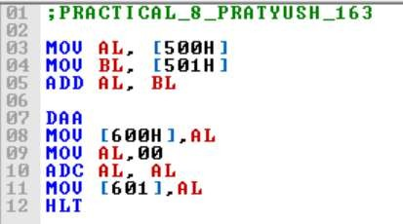
Execution :
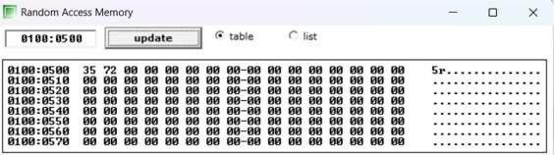
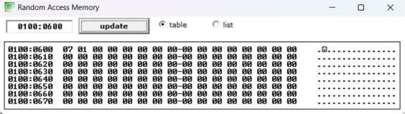

Conclusion :

