1. Add this unit as dg/ml 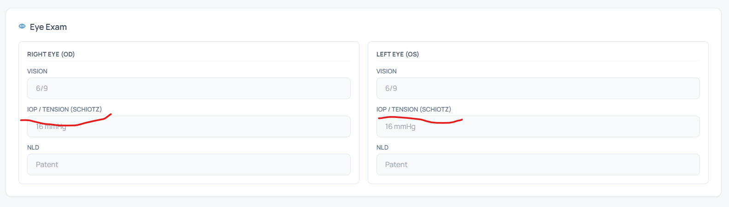
2.Add dg/ml near blood sugar and when it is printed the value should be printed with units
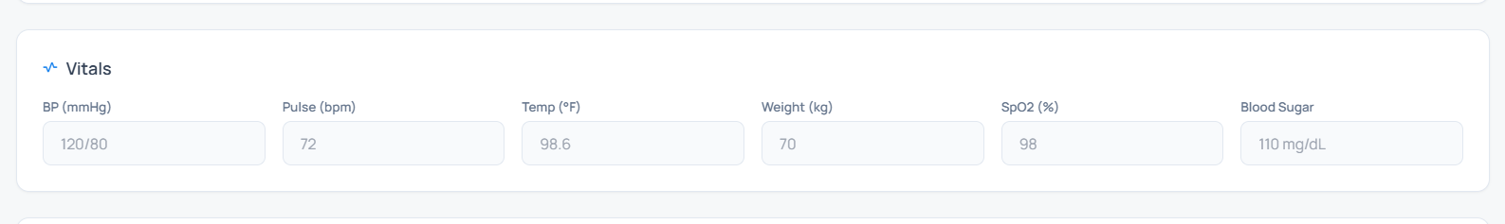
3.Check both the pictures the completed and handled counts are missing but the completed count is correct. I want the correct count to be reflected in both places
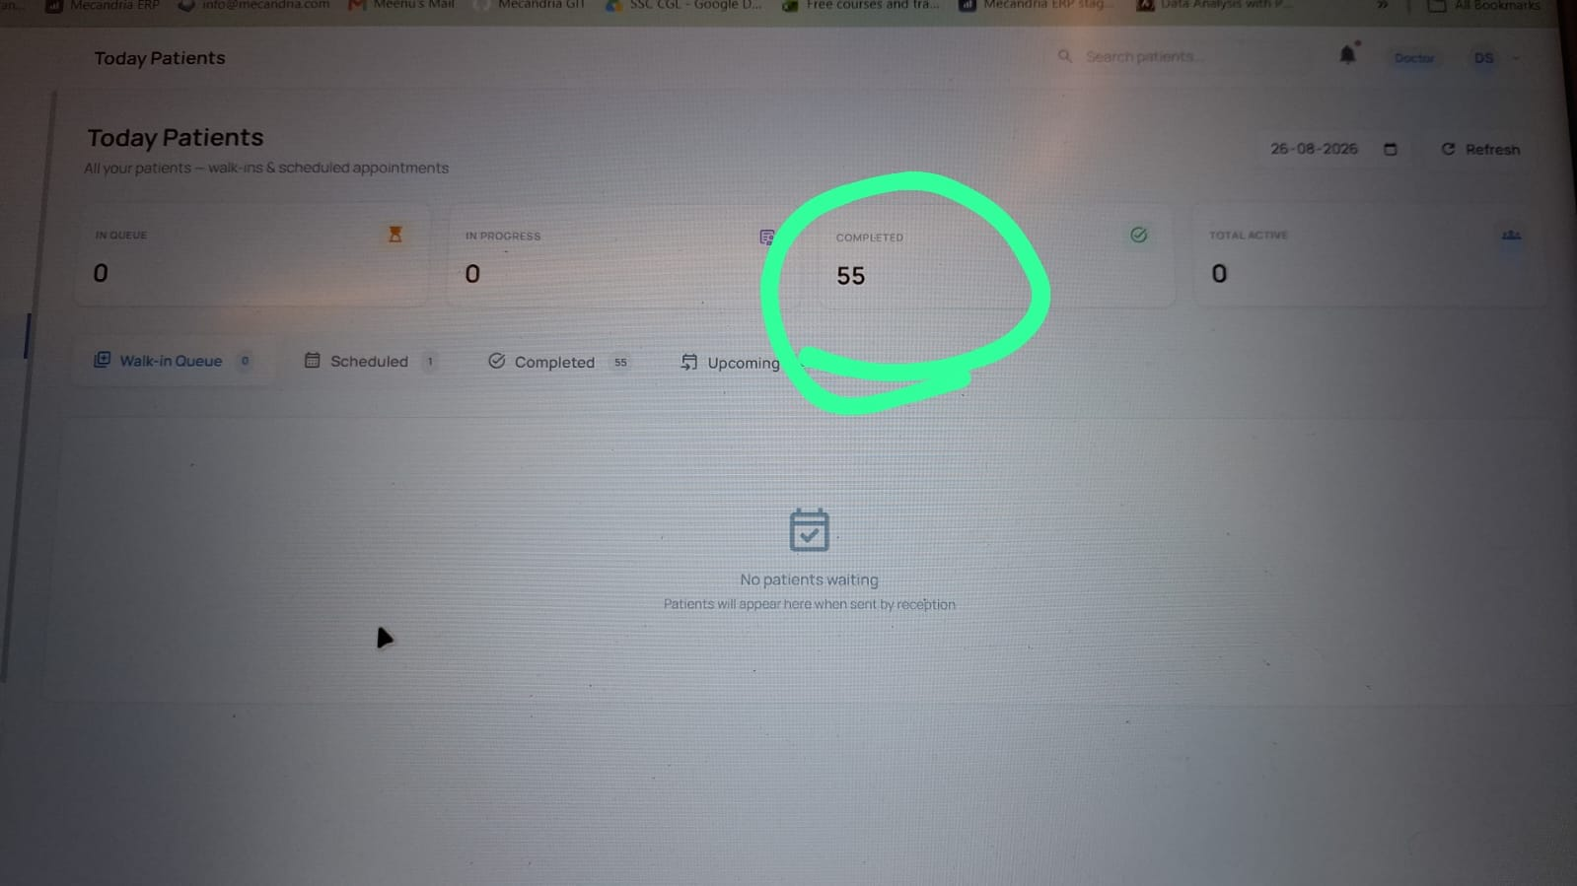

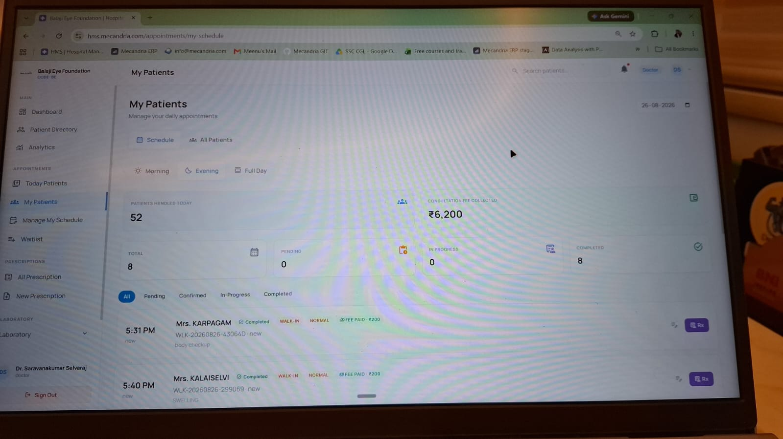

4. Lap reports are not coming for the patients with optical entry..

