Boot camp

Q3. Raj wants to know the age of the youngest friend among his 10 close friends.   
Wrie a c program to print the age of Raj's youngest friend.

Program:

#include <stdio.h>

int main()

{

int array[100], minimum, size, c;

printf("Enter number of elements in array\n");

scanf("%d", &size);

printf("enter the ages");

for (c = 0; c < size; c++)

scanf("%d", &array[c]);

minimum = array[0];

for (c = 1; c < size; c++)

{

while (array[c] < minimum)

{

minimum = array[c];

}

}

printf("Rajs youngest friend ageis %d\n", minimum);

return 0;

}

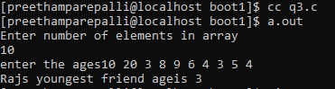Output:

Q9. Write a c program to check whether the number is a prime number. If it is a prime number, display the number along with the alphabet ‘p’ appended to it.

Program:

#include <stdio.h>

int main()

{

int n, i, flag = 0;

printf("Enter a positive integer: ");

scanf("%d", &n);

for(i = 2; i <= n/2; ++i)

{

if(n%i == 0)

{

flag = 1;

break;

}

}

{

if (flag == 0)

printf("%dp", n);

}

return 0;

}

Output:

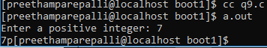

5. Write a c program based on the following info to calculate the tax.  
Tax slabs for general   
0 to 1,80,000 No tax  
1,80,001 to 5,00,000 10%  
5,00,001 to 8,00,000 20%  
Above 8,00,000 30%  
Write if statements to achieve this.  
Make sure that you indent the code well so that it is readable.

Program: #include<stdio.h>

int main()

{

float income,intrest=0;

char name[20];

printf("enter the name of payee");

scanf("%s",name);

printf("income:");

scanf("%f",&income);

if(income>=0&&income<=180000)

printf("no tax");

else if(income>=180001&&income<=500000)

printf("intrest is %f",intrest=income*0.01);

else if(income>=500001&&income<=800000)

printf("intrest is %f",intrest=income*0.02);

else if(income>=800000)

printf("intrest is %f",intrest=income*0.03);

}

Output: 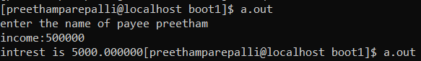

Q12. Print the carzy factorial of a given number.

Program:

#include<stdio.h>

int main()

{

int n, i;

unsigned long long factorial = 1;

printf("Enter an integer: ");

scanf("%d",&n);

if (n < 0)

printf("Error! Factorial of a negative number doesn't exist.");

else

{

for(i=1; i<=n; ++i)

{

factorial *= i;

}

printf("Crazy Factorial = %llu", n, factorial);

}

return 0;

}

OUTPUT:

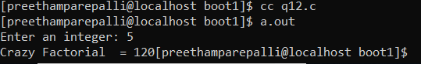

10.

Program:

#include<stdio.h>

int main()

{ int phy,chem,bio,mat,com,id;

float avg;

char name[20];

printf("enter the name, id");

scanf("%s %d",name,&id);

printf("enter the marks");

scanf("%d %d %d %d %d",&phy,&chem,&bio,&mat,&com);

avg=(phy+chem+bio+mat+com)/5.0;

printf("\n%s %d \n",name,id);

if(avg>=90)

printf("Grade A");

else if(avg>=80)

printf("Grade B");

else if(avg>=70)

printf("Grade C");

else if(avg>=60)

printf("Grade D");

else if(avg>=40)

printf("Grade E");

else

printf("Grade F");

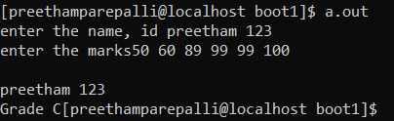} **output:**

**11.**

**Program:** #include<stdio.h>

int main()

{ int i,j;

for(i=0;i<5;i++)

{

for(j=0;j<i;j++)

printf(" ");

for(j=0;j<(2*i+1);j++)

{

printf("*");

}

printf("\n");

}

}

Output:

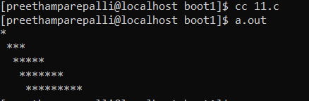

8.

Program:

#include<stdio.h>

int main()

 {

        int n;

        int g,d;

        printf("Enter number of orange:");

        scanf("%d",&n);

        g=n/144;

        n=n%144;

        d=n/12;

        n=n%12;

        printf("%d Gross,%d Dozen and %d",g,d,n);

}

Output: 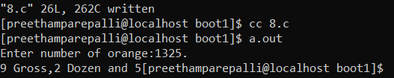

**13.**

#include <stdio.h>

void drawCircle(int r)

{

    int N = 2*r+1;

    int x, y;

    for (int i = 0; i < N; i++)

    {

        for (int j = 0; j < N; j++)

        {

                        x = i-r;

            y = j-r;

            if (x*x + y*y <= r*r+1 )

                printf(".");

            else

            printf(" ");

        }

        printf("\n");

    }

}

int  main()

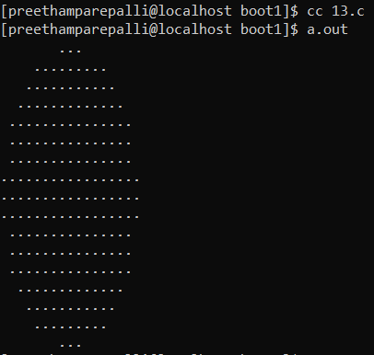{

    drawCircle(8);

    return 0;

}

**Output:**

14.

Program:

#include <stdio.h>

int f();

int main()

{

int a = 0;

f();

printf("%d\n",a);

return 0;

}

int f()

{ int a=5;

printf("%d",a);

}

Output: 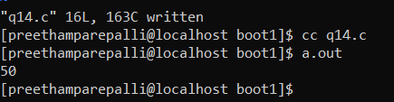

6. #include <stdio.h>

int main()

{

int n, reversedInteger = 0, remainder, originalInteger;

y: printf("Enter an integer: ");

scanf("%d", &n);

if(n>32767) goto y;

originalInteger = n;

while( n!=0 )

{

remainder = n%10;

reversedInteger = reversedInteger*10 + remainder;

n /= 10;

}

if (originalInteger == reversedInteger)

printf("%d is a palindrome.", originalInteger);

else

printf("%d is not a palindrome.", originalInteger);

return 0;

}

Output: 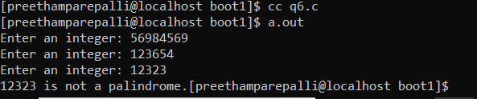

7.

Program:

#include<stdio.h>  
int main()  
{  
int product;  
int quantity;  
float s1,s2,s3;  
float p1,p2,p3;  
p1=22.5;  
p2=44.5;  
p3=9.99;  
float total;  
printf("enter product number:");  
scanf("%d",&product);  
printf("enter the quantity:");  
scanf("%d",&quantity);  
switch(product)  
{  
case 1:s1=(float)quantity*p1;  
        break;  
case 2:s2=(float)quantity*p2;  
        break;  
case 3:s3=(float)quantity*p3;  
        break;  
default:printf("Invalid input\n");  
break;  
}  
total=(float)s1+s2+s3;  
printf("Total sales:%.2f\n",total);  
return 0;  
}

Output: 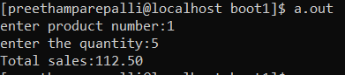

Q1. Write a c program to clear the nth bit of a number input by the user.

**Program:**

#include <stdio.h>

int main()

{

int num, n, newNum;

printf("Enter any number: ");

scanf("%d", &num);

printf("Enter nth bit to clear (0-31): ");

scanf("%d", &n);

newNum = num & (~(1 << n));

if(n>31)

printf(“sorry wrong bit number\n”);

else

printf("Bit cleared successfully.\n\n");

return 0;

}

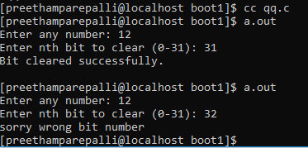**Output:**

Q2. Write a c program to swap two number using bitwise operator.

**Program:**

#include <stdio.h>

void swap(int*, int *);

void main()

{

int num1, num2;

printf("\nInput two numbers:");

scanf("%d %d", &num1, &num2);

printf(" numbers before swap %d %d", num1, num2);

swap(&num1, &num2);

printf("\n numbers after swap %d %d\n", num1, num2);

}

void swap(int *x, int *y)

{

*x = *x ^ *y;

*y = *x ^ *y;

*x = *x ^ *y;

}

**OUTPUT:**

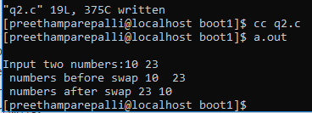

Q4. Print the following out-put:

1

1 2

1 2 3

1 2 3 4

1 2 3 4 5

Output:

