Program:1

**package** bootcamp2;

**import** java.util.Scanner;

**public** **class** Oranges {

**public** **static** **void** main(String[] args) {

Scanner sc=**new** Scanner(System.***in***);

**int** org;

**int** gross=0;

**int** abovegross;

**int** dozens;

**int** extras;

System.***out***.print("Enter number of oranges: ");

org = sc.nextInt();

**if**(org!=0) {

gross = org / 144;

abovegross = org % 144;

dozens = abovegross / 12;

extras = abovegross % 12;

System.***out***.println("Your number of oranges is "+gross+" gross,"+dozens+" dozen, and "+extras+".");

}

}

}

Output:1

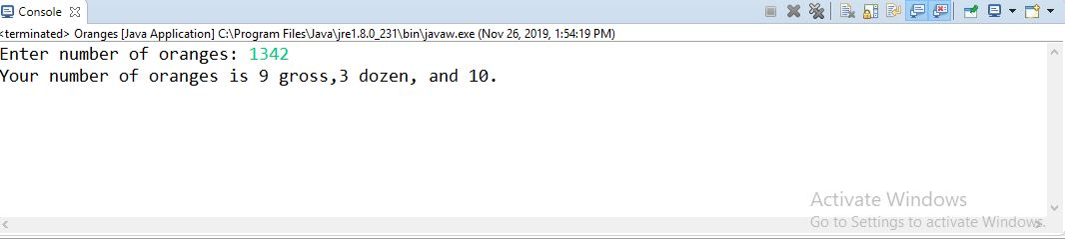

Program:2

**package** bootcamp2;

**import** java.util.Scanner;

**public** **class** Primenumber {

**public** **static** **void** main(String args[])

{

**int** num, j, count=0;

Scanner sc = **new** Scanner(System.***in***);

System.***out***.print("Input any integer: ");

num = sc.nextInt();

**for**(j=2; j<num; j++)

{

**if**(num%j == 0)

{

count++;

**break**;

}

}

**if**(count == 0)

{

System.***out***.print(num+"p");

}

**else**

{

System.***out***.print(num+"np");

}

}

}

Output:2

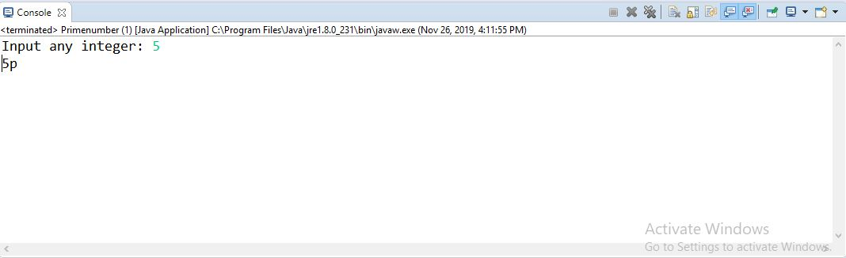

Output:5

**package** bootcamp2;

**import** java.util.Arrays;

**import** java.util.HashSet;

**public** **class** Intersection {

**public** **static** **void** main(String[] args)

{

Integer[] a = {10,4,5,8,6};

Integer[] b = {9,5,4,7,11};

Integer[] c;

HashSet<Integer> set = **new** HashSet<>();

set.addAll(Arrays.*asList*(a));

set.retainAll(Arrays.*asList*(b));

//System.out.println(set);

//convert to array

Integer[] intersection = {};

intersection = set.toArray(intersection);

System.***out***.println("c="+Arrays.*toString*(intersection));

}

}

Output:5

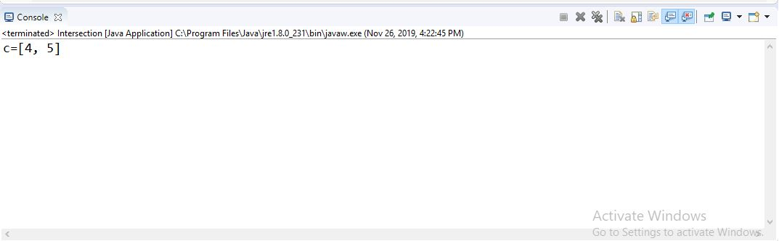

Program:6

**package** bootcamp2;

**public** **class** Selectionsort {

**void** sort(**int** array[])

{

**int** n = array.length;

**for** (**int** i = 0; i < n-1; i++)

{

**int** min_idx = i;

**for** (**int** j = i+1; j < n; j++)

**if** (array[j] < array[min_idx])

min_idx = j;

**int** temp = array[min_idx];

array[min_idx] = array[i];

array[i] = temp;

}

}

**void** printArray(**int** array[])

{

**int** n = array.length;

**for** (**int** i=0; i<n; ++i)

System.***out***.print(array[i]+" ");

System.***out***.println();

}

// Driver code to test above

**public** **static** **void** main(String args[])

{

Selectionsort ob = **new** Selectionsort();

**int** array[] = {4,8,1,3,45,12};

ob.sort(array);

System.***out***.println("Array elements after sorting:");

ob.printArray(array);

}

}

Output:6

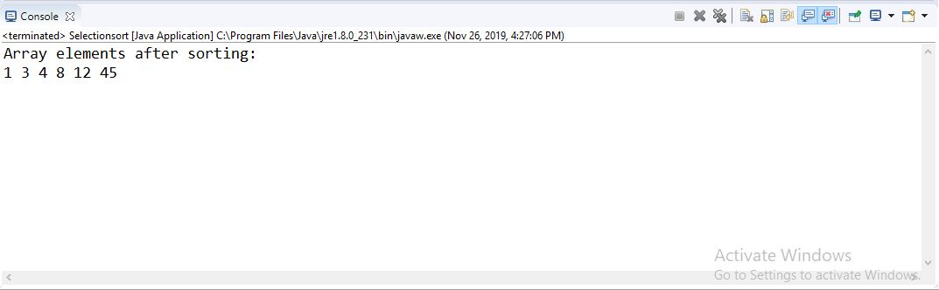

Program:7

**package** bootcamp2;

**import** java.util.Arrays;

**public** **class** Removeduplicates {

**public** **static** **int** removeDuplicateElements(**int** arr[], **int** n){

**if** (n==0 || n==1){

**return** n;

}

**int**[] temp = **new** **int**[n];

**int** j = 0;

**for** (**int** i=0; i<n-1; i++){

**if** (arr[i] != arr[i+1]){

temp[j++] = arr[i];

}

}

temp[j++] = arr[n-1];

// Changing original array

**for** (**int** i=0; i<j; i++){

arr[i] = temp[i];

}

**return** j;

}

**public** **static** **void** main (String[] args) {

**int** arr[] = {10, 4, 5, 4, 8, 10};//unsorted array

Arrays.*sort*(arr);//sorting array

**int** length = arr.length;

length = r*emoveDuplicateElemen*ts(arr, length);

//printing array elements

**for** (**int** i=0; i<length; i++)

System.***out***.print(arr[i]+" ");

}

}

Output:7

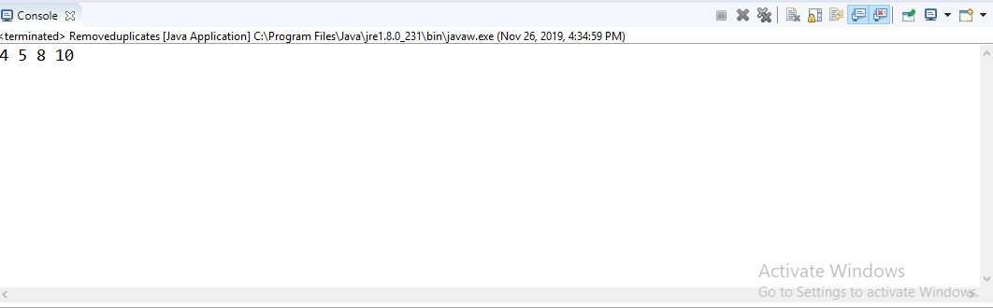

Program:8

**package** bootcamp2;

**public** **class** MaxandMin {

**public** **static** **void** main(String args[]){

**int** array[] = **new** **int**[]{10, 4, 5, 4, 8, 10};

**int** max = *getMax*(array);

**int** min = *getMin*(array);

System.***out***.print("Max = "+max+ " & Min = "+min);

}

**public** **static** **int** getMax(**int**[] inputArray){

**int** maxValue = inputArray[0];

**for**(**int** i=1;i < inputArray.length;i++){

**if**(inputArray[i] > maxValue){

maxValue = inputArray[i];

}

}

**return** maxValue;

}

**public** **static** **int** getMin(**int**[] inputArray){

**int** minValue = inputArray[0];

**for**(**int** i=1;i<inputArray.length;i++){

**if**(inputArray[i] < minValue){

minValue = inputArray[i];

}

}

**return** minValue;

}

}

Output:8

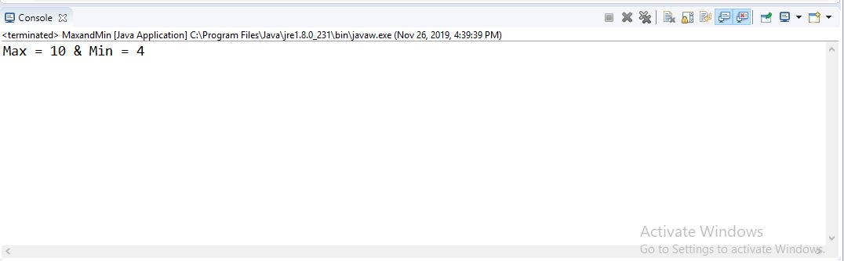

Program:9

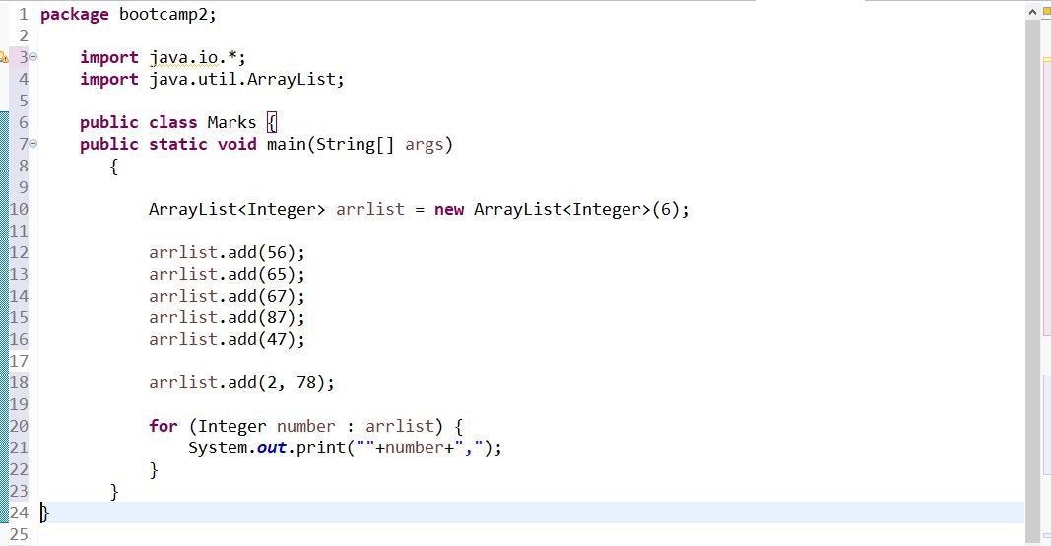

Output:9

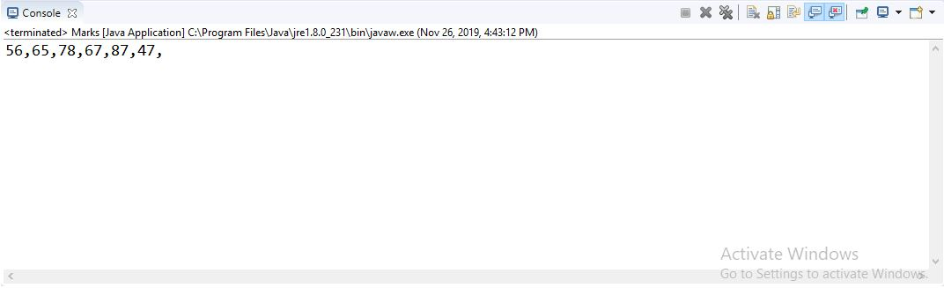

Program:10

**package** bootcamp2;

**import** java.io.*;

**import** java.util.*;

**public** **class** Arraysofintegers {

**public** **static** **boolean** areEqual(**int** arr1[], **int** arr2[])

{

**int** m = arr1.length;

**int** n = arr2.length;

**if** (m != n)

**return** **false**;

Arrays.*sort*(arr1);

Arrays.*sort*(arr2);

**for** (**int** j = 0; j < m; j++)

**if** (arr1[j] != arr2[j])

**return** **false**;

**return** **true**;

}

**public** **static** **void** main(String[] args)

{

**int** arr1[] = { 2, 5, 7, 1, 2 };

**int** arr2[] = { 7, 1, 9, 8, 4 };

**if** (*areEqual*(arr1, arr2))

System.***out***.println("Equal.");

**else**

System.***out***.println("Not equal.");

}

}

Output:10

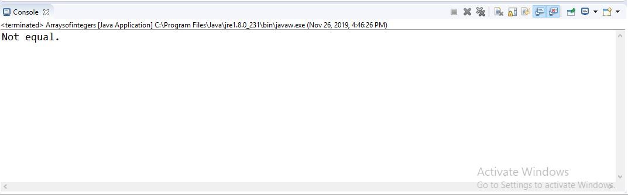

Program:11

**package** bootcamp2;

**import** java.util.Scanner;

**public** **class** Crazyfactorial {

**public** **static** **void** main(String args[])

{

**int** n,n1,n2,n3,fac=-1,fac1=1,fac2=1,fac3=-1,i;

Scanner sc = **new** Scanner(System.***in***);

n = sc.nextInt();

n1 = sc.nextInt();

n2 = sc.nextInt();

n3 = sc.nextInt();

**for**(i=1;i<=n;i++)

fac*=i;

**for**(i=1;i<=n1;i++)

fac1*=i;

**for**(i=1;i<=n2;i++)

fac2*=i;

**for**(i=1;i<=n3;i++)

fac3*=i;

System.***out***.println(fac);

System.***out***.println(fac1);

System.***out***.println(fac2);

System.***out***.println(fac3);

}

}

Output:11

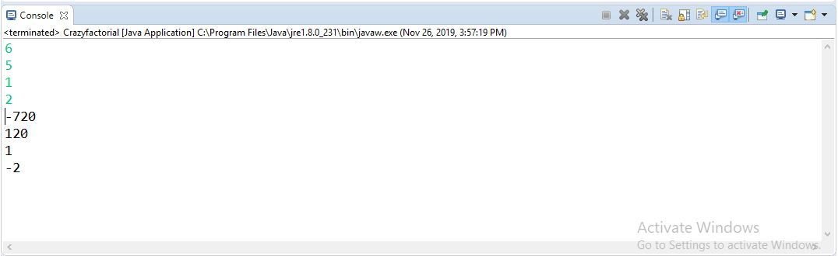

Program:12

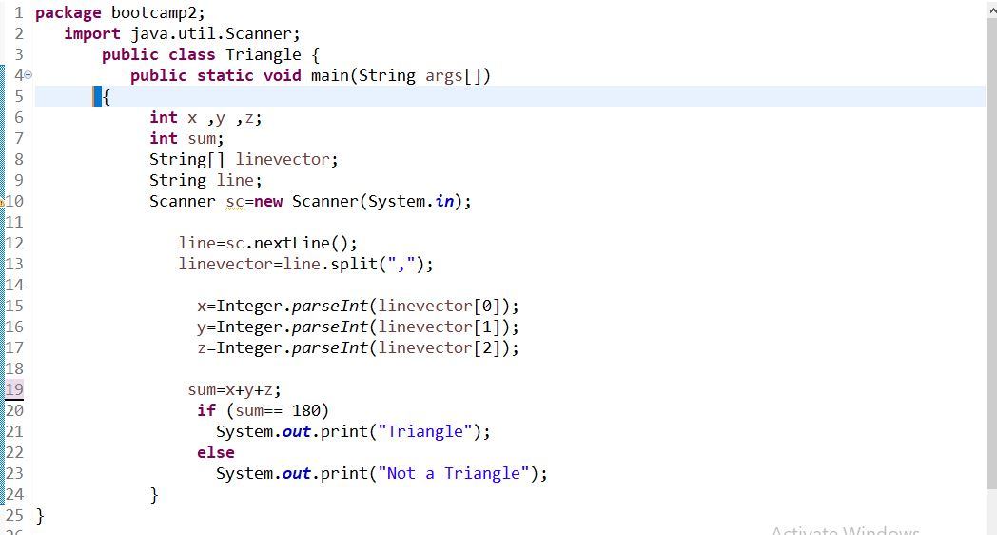

Output:12

