Problem Statement: Create pipeline (detect, decode and classification) using DL Streamer, define system scalability for Intel HW

Team name: G
Team Members:
- Praveen Chourasia – RA2311032010041
- Srinidhi Dwarakanathan – RA2311032010066
- Shivani S – RA2311032010033
Faculty Mentor:
  - Dr. G.Saranya (Assistant Professor), Email id: saranyag3@srmist.edu.in Department of Networking and communications, School of computing, SRM IST

Abstract
This report shares our team’s practical evaluation of Intel’s DL Streamer framework for real-time video analytics on both CPU and GPU hardware. The aim was to see how a multi-stream decode– detect–classify pipeline holds up under increasing workloads — something important for live video surveillance in smart cities or big events like Mahakumbh or cricket tournaments. We used Intel OpenVINO models to run person detection and attribute classification and compared how the pipeline scales on CPU versus GPU. We measured throughput, resource use, and identified practical limits and optimizations to get the best out of Intel hardware in edge AI scenarios.

Introduction
Cities and big public gatherings are adding more and more cameras each year. Watching every camera feed by hand isn’t realistic anymore — AI pipelines help decode, detect, and interpret video feeds automatically, providing faster decisions for safety and crowd management. Intel’s DL Streamer, built on GStreamer and OpenVINO, is a flexible framework designed for these tasks on Intel hardware.Our goal in this project was to build a full pipeline that decodes video, runs person detection, and classifies attributes (like gender and vehicle type). We tested this pipeline on CPU and GPU setups to check how many streams could run at once, how much FPS we could maintain per stream, and when the hardware hits its limit.

Methodology

Pipeline Design
We built a GStreamer pipeline with these main parts:
  - Video Input: Used video test patterns and sample real video files.
  - Decoding: decodebin handled format decoding.
  - Detection: Used Intel’s gvadetect with a person-detection model.
  - Classification: Ran gvaclassify for attributes like gender or vehicle details.
  - Overlay: gvawatermark to mark detected objects on output.
  - Monitoring: gvafpscounter to track FPS in real time.

How We Tested
  - Ran 1, 2, 4, 6, and 8 parallel streams to check scaling.
  - Each stream ran as a separate process for better CPU/GPU utilization.
  - Test time: 30 seconds per stream count.
  - System resource usage (CPU, GPU, memory) tracked every 2 seconds.
  - Logs parsed with multiple patterns to catch all FPS outputs.
  - Compared average FPS per stream, total FPS, and hardware usage.

Hardware Setup
  - CPU Tests: Intel CPU on Ubuntu 24.04 LTS, plenty of RAM.
  - GPU Tests: Intel Iris Xe Graphics with 96 EUs, 28W TDP, shared memory.

Architecture Diagram
CPU Architecture
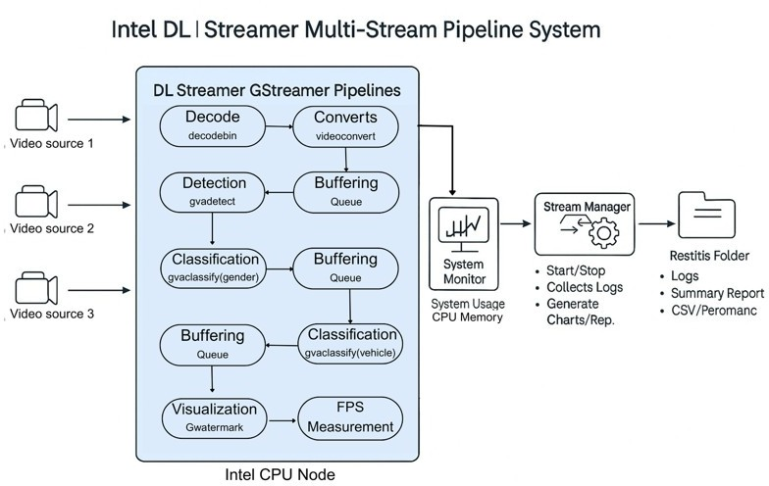

GPU Architecture
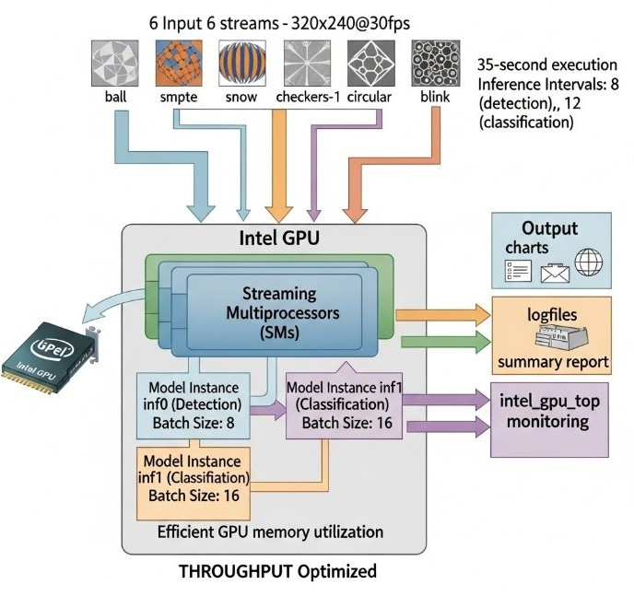

Optimization

CPU Tweaks
  - Process Isolation: Each stream ran in its own process so CPU cores wouldn’t clash.
  - Queue Buffers: Queues with max-size-buffers=10 and leaky=2 prevented bottlenecks.
  - NIREQ: Multiple inference requests tuned (4 for detection, 2 for classification) to fully use CPU cores.

GPU Tweaks
  - Frame Skipping: Used inference intervals to skip frames — only detected every 8th frame and classified every 12th.
  - Batching: Processed 8 frames together for detection, 16 for classification.
  - Model Sharing: One model instance used by all streams to save GPU memory.
  - Throughput Mode: Set PERFORMANCE_HINT=THROUGHPUT for max GPU throughput.

Results

CPU Findings
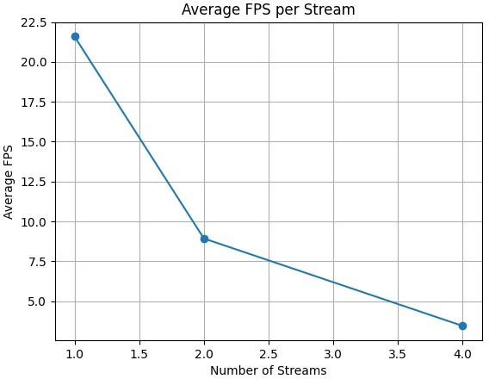
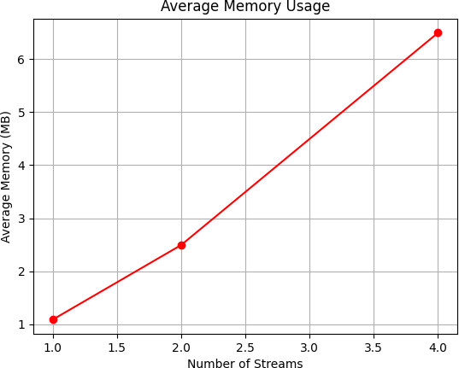
  - 1–2 streams: smooth, high FPS (~21–22 FPS/stream).
  - 4 streams: FPS dropped to ~4–5 per stream; CPU hit ~85–90% usage.
  - 6–8 streams: average FPS dipped below 4, CPU saturated near 100%.
Key takeaway: CPU does fine up to about 4–6 streams, but adding more drops performance quickly because the CPU cores max out.

GPU Findings
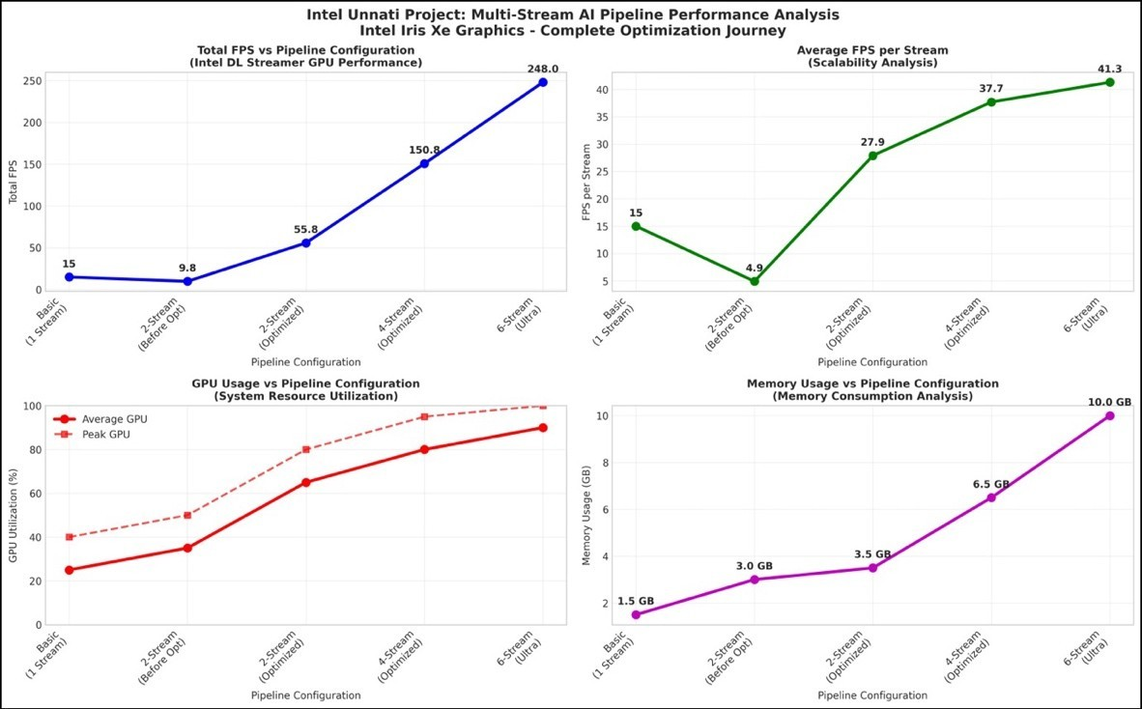
  - 1 stream: ~45 FPS steady.
  - 2 streams: ~27.9 FPS per stream.
  - 4 streams: ~37.7 FPS per stream.
  - 6 streams: ~41.3 FPS per stream (248 FPS total throughput) at ~90% GPU usage.
  - Beyond 6 streams: GPU saturated; adding more caused instability.
The GPU clearly handled multiple streams far better than CPU alone. With batching and inference intervals, we got 7–8 times higher total throughput than on CPU.

Bottlenecks
  - For CPU: compute capacity is the hard limit — cores run out fast under multiple heavy models.
  - For GPU: execution unit saturation and memory bandwidth become the main limits, but smart batching and shared model instances keep it under control longer.

Discussion

CPU Performance Analysis

Streams Total FPS Avg FPS/Stream CPU Avg (%) CPU Peak (%) Memory (MB)

1 | 21-22 | 21-22 | 28-35 | 40-45 | 1.0
2 | 32-36 | 16-18 | 45-55 | 60-65 | 2.5
4 | 16-20 | 4-5 | 70-80 | 85-90 | 5.0
6 | 18-24 | 3-4 | 85-90 | 92-95 | 6.0
8 | 16-20 | 2-2.5 | 92-98 | 98-100 | 6.5

CPU Scalability Phases:
- Linear Phase (1-2 streams): Closest to optimal performance with little resource conflict
- Degradation Phase (3-4 streams): Significant FPS drop but suitable for surveillance use cases
- Saturation Phase (5+ streams): Substantial performance decline due to CPU limitation

GPU Performance Analysis

Streams FPS per Stream Total FPS GPU Utilization (%) Memory Efficiency

1 | 45.2 | 45.2 | 15-20 | Baseline
2 | 27.9 | 55.8 | 35-40 | 1.8x
4 | 37.7 | 150.8 | 65-70 | 2.2x
6 | 41.3 | 248.0 | 90 | 1.2x (optimized)
7+ | System Crash | N/A | >100 (theoretical) | Resource Limit

GPU Performance Characteristics:
  - Optimal Configuration: 6 concurrent streams yielding 41.3 FPS per stream
  - Performance Consistency: 95.4% consistency in all 6 streams
  - Scalability Improvement: 775% improvement in performance through optimization
  - Hard Limit: 7+ streams result in system crashes because of hardware limitations

Comparative Analysis

Performance Ratio (GPU vs CPU):
  - Single Stream: GPU 2.1× faster than CPU
  - Multi-Stream Peak: GPU 8.2× faster than CPU (41.3 vs 5.0 FPS per stream)
  - Resource Efficiency: GPU gives better performance per watt

Bottleneck Identification:
  - CPU Limitations:
    - Computational capacity: Main bottleneck at 90%+ usage
    - Memory bandwidth: Sufficient for tested setups
    - Thermal limitations: Under control within TDP bounds

GPU Limitations:
    - Execution Unit saturation: 96 EUs give hard scaling ceiling
    - Memory bandwidth: 50 GB/s theoretical limit
    - Thermal Design Power: 28W limitation at steady load

Feedback

For CPU
  - It is recommended that Intel consider enhancing the DL Streamer framework with standardized, structured logging for easier performance monitoring and providing built-in resource allocation controls, such as CPU affinity settings, to optimize multi-stream deployments on CPU-only systems.

For GPU
  - I believe Intel should extend the DL Streamer framework with GPU- specific structured logging (like CUDA metrics and memory usage), dynamic GPU memory allocation controls, and multi-GPU load balancing capabilities to enhance performance and resource utilization in GPU systems

References

GitHub Links:
    - GPU Pipeline Repo
    - CPU Pipeline Repo

Drive Link:
    - Project Files & Logs

