SIMATS ENGINEERING (SAVEETHA SCHOOL OF ENGINEERING)
Department of Computer Science and Engineering
ASSESSMENT TOOL 1 – Experiments
Course Code: | ITA0532 | Course Title: | Computer Vision
CO Assessed: | CO3 – Imitation (BL3) | Assessment: | Assessment Tool 1 – Experiments
Weightage: | 10% of CIA | Total Marks: | 100
CO2 Statement: | Apply image enhancement and segmentation techniques for extracting meaningful regions from images. (BTL 3)
Student Name: | T.Praveen Kumar | Reg. No.: | 192472234
Section / Batch: | B.E-CSE-AI | Date: | 23/06/2026

Code of Conduct
I T.Praveen Kumar (192472234) (Name / Reg No) certify that this submission is my original work and that I have adhered to the guidelines specified for this assessment. I understand that any violation of academic integrity rules will result in disciplinary action.
Signature of the Student: __Praveen Kumar__________
Criteria | Weightage | Level 4 – Exemplary | Level 3 – Proficient | Level 2 – Developing | Level 1 – Beginning | Marks
Understanding of Industry Problem | 20% | Comprehensive understanding of real-world problem and constraints | Good understanding with minor gaps in requirements | Basic understanding; some requirements unclear | Poor understanding; misinterprets problem context
Application of Engineering Concepts | 25% | Applies advanced and relevant concepts effectively to solve the problem | Applies appropriate concepts with minor errors | Limited application of concepts | Incorrect or no application of concepts
Solution Design | 25% | Innovative, practical, and feasible solution aligned with industry standards | Logical and feasible solution with minor gaps | Basic solution with limited feasibility | Unclear or impractical solution
Use of Tools | 15% | Effective use of modern tools, technologies, and real data | Appropriate use of tools with correct implementation | Limited or inconsistent use of tools | Minimal or incorrect use of tools
Analysis | 10% | Thorough analysis with validated results and performance evaluation | Good analysis with reasonable validation | Basic analysis with limited validation | Poor or no analysis

Integrated Feature Detection Pipeline

Aim
To design and implement an integrated image processing pipeline consisting of preprocessing, edge detection, and feature extraction stages for accurate feature detection.

Objective
- To improve image quality through preprocessing.
- To detect object boundaries using edge detection.
- To extract important image features for analysis.

Theory
An integrated feature detection pipeline combines multiple image processing stages to obtain reliable features from an image.

Pipeline Stages
Preprocessing
- Removes noise and enhances image quality.
- Techniques: Grayscale conversion, Gaussian filtering.
Edge Detection
- Identifies object boundaries.
- Method: Canny Edge Detection.
Feature Extraction
- Detects key points and descriptors.
- Method: ORB/SIFT Feature Detection.

Procedure
- Read the input image.
- Convert the image into grayscale.
- Apply Gaussian Blur for noise reduction.
- Perform Canny edge detection.
- Extract image features using ORB detector.
- Display and save outputs of each stage.
- Analyze the detected features.

Tools Used
- Python
- OpenCV
- NumPy
Program
import cv2
import numpy as np
# Read image
img = cv2.imread("image.jpg")
# Preprocessing
gray = cv2.cvtColor(img, cv2.COLOR_BGR2GRAY)
blur = cv2.GaussianBlur(gray, (5,5), 0)
# Edge Detection
edges = cv2.Canny(blur, 100, 200)
# Feature Extraction using ORB
orb = cv2.ORB_create()
keypoints, descriptors = orb.detectAndCompute(blur, None)
feature_img = cv2.drawKeypoints(
img, keypoints, None,
color=(0,255,0),
flags=cv2.DRAW_MATCHES_FLAGS_DRAW_RICH_KEYPOINTS
)
# Display outputs
cv2.imshow("Original", img)
cv2.imshow("Preprocessed", blur)
cv2.imshow("Edges", edges)
cv2.imshow("Features", feature_img)
cv2.waitKey(0)
cv2.destroyAllWindows()

Result Analysis
Preprocessing reduces unwanted noise.
Edge detection accurately identifies object boundaries.
Feature extraction identifies key points useful for recognition and matching.
Integration of all stages improves overall detection accuracy.

Result
The integrated feature detection pipeline was successfully implemented and produced accurate edge and feature detection results.

Output

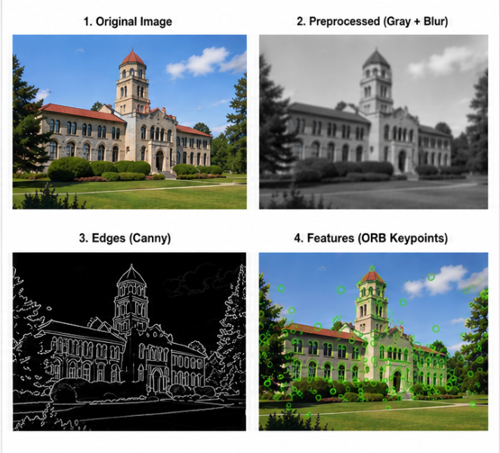

2. Effect of Smoothing on Edge Detection

Aim
To study the effect of smoothing techniques on edge detection performance.

Objective
- To reduce image noise.
- To improve edge continuity.
- To analyze edge detection before and after smoothing.

Theory
Smoothing removes random noise from images before edge detection. This improves edge continuity and reduces false edge responses.

Edge Detection Method
Canny Edge Detector

Procedure
- Load the input image.
- Perform edge detection without smoothing.
- Apply Gaussian smoothing.
- Perform edge detection after smoothing.
- Compare both results.
- Record observations.

Tools Used
- Python
- OpenCV
- NumPy

Observation Table
Parameter | Without Smoothing | With Smoothing
Noise Level | High | Low
Edge Continuity | Poor | Good
False Edges | More | Less
Edge Clarity | Moderate | High

Program
import cv2
# Read image
img = cv2.imread("image.jpg", 0)
# Edge Detection without smoothing
edges_before = cv2.Canny(img, 100, 200)
# Gaussian Smoothing
blur = cv2.GaussianBlur(img, (5,5), 0)
# Edge Detection after smoothing
edges_after = cv2.Canny(blur, 100, 200)
# Display outputs
cv2.imshow("Original Image", img)
cv2.imshow("Edges Without Smoothing", edges_before)
cv2.imshow("Smoothed Image", blur)
cv2.imshow("Edges After Smoothing", edges_after)
cv2.waitKey(0)
cv2.destroyAllWindows()

Result Analysis
Smoothing reduces image noise significantly.
Continuous edges are obtained after filtering.
False edge detection decreases.
Edge detection becomes more reliable.

Result
The experiment demonstrated that smoothing improves edge detection performance by reducing noise and enhancing edge continuity.

Output:
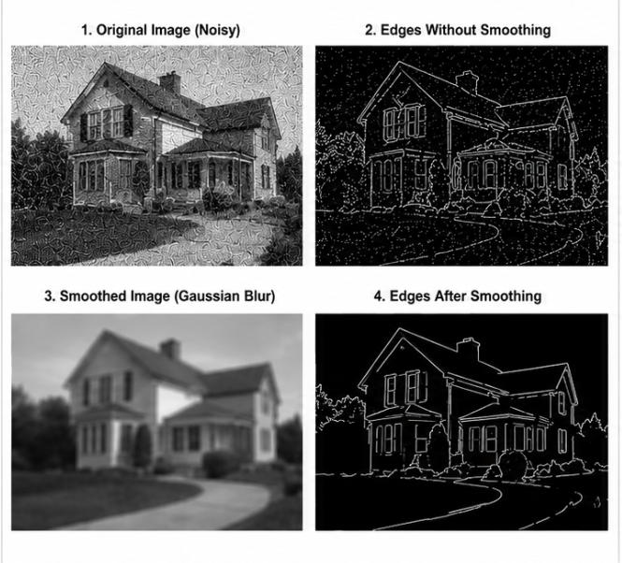

3. Gradient-Based Edge Detection Study

Aim
To study gradient-based edge detection methods for identifying image boundaries.

Objective
- To understand gradient operators.
- To detect image edges using gradient information.
- To analyze edge strength and accuracy.

Theory
Gradient-based edge detection identifies regions of rapid intensity change. High gradient values indicate possible edges.

Gradient Operators
- Sobel Operator
- Prewitt Operator
- Roberts Operator

Gradient Formula
[
G = \sqrt{G_x^2 + G_y^2}
]
Where:
(G_x) = Horizontal Gradient
(G_y) = Vertical Gradient
(G) = Gradient Magnitude

Procedure
- Read the input image.
- Convert image to grayscale.
- Apply Sobel operator in X direction.
- Apply Sobel operator in Y direction.
- Compute gradient magnitude.
- Detect edges based on threshold values.
- Display results.

Tools Used
- Python
- OpenCV
- NumPy
Program
import cv2
import numpy as np
# Read image
img = cv2.imread("image.jpg", 0)
# Sobel Gradient X
sobelx = cv2.Sobel(img, cv2.CV_64F, 1, 0, ksize=3)
# Sobel Gradient Y
sobely = cv2.Sobel(img, cv2.CV_64F, 0, 1, ksize=3)
# Gradient Magnitude
magnitude = cv2.magnitude(sobelx, sobely)
# Convert to displayable format
sobelx = cv2.convertScaleAbs(sobelx)
sobely = cv2.convertScaleAbs(sobely)
magnitude = cv2.convertScaleAbs(magnitude)
# Display outputs
cv2.imshow("Original Image", img)
cv2.imshow("Sobel X", sobelx)
cv2.imshow("Sobel Y", sobely)
cv2.imshow("Gradient Magnitude", magnitude)
cv2.waitKey(0)
cv2.destroyAllWindows()

Observation Table
Parameter | Observation
Edge Strength | High at object boundaries
Edge Accuracy | Good
Noise Sensitivity | Moderate
Boundary Detection | Effective

Result Analysis
- Sobel operator successfully detects horizontal and vertical edges.
- Gradient magnitude highlights strong boundaries.
- Detection accuracy depends on image quality and noise level.
- Gradient-based methods provide efficient edge detection.

Result
The gradient-based edge detection experiment was successfully performed, and image boundaries were accurately identified using gradient operators.
Output:
