SIMATS ENGINEERING (SAVEETHA SCHOOL OF ENGINEERING)
Department of Artificial Intelligence and Data Science
ASSESSMENT TOOL 1 – APPLICATION BASED QUESTIONS

Course Code: | DSA03 | Course Title: | Natural Language Processing
CO Assessed: | CO1 – Imitation (L1) | Assessment: | Assessment Tool 2 – Coding Challenge
Weightage: | 30% of CIA
CO1 Statement: | Analyse NLP models, regular expression patterns, finite state automata, morphological processing techniques and to interpret language processing. (BL-3)
Student Name: | T.Praveen Kumar | Reg. No.: | 192472234
Section / Batch: | B.E-CSE-AI | Date: | 16-07-2026

Code of Conduct
I T.Praveen Kumar (192472234) (Name / Reg No) certify that this submission is my original work and that I have adhered to the guidelines specified for this assessment. I understand that any violation of academic integrity rules will result in disciplinary action.
Signature of the Student: T.Praveen Kumar

Instructions
- Develop a modular and efficient Python program that satisfies all the functional requirements specified in the problem statement.
- Demonstrate the correctness of the implementation using suitable test cases and justify the output obtained.
- Follow good programming practices, including meaningful variable names, proper code indentation, comments, and error handling wherever applicable.
- Duration: 30 minutes.

Section / Topic | Focus | Q Nos
Information Extraction | Regex-Based Information Extraction | 1
Pattern Matching | Regex Pattern Matching | 2
Regular Expression Patterns | Regex-Based Input Validation | 3

Annexure A – Coding Challenge


Section 1: Intelligent Email and Password Validator using Regular Expressions
1. Problem Statement:
A software company is developing a user registration system. Before creating an account, the system must validate user credentials based on predefined security policies.
Develop a Python application that validates:
Email Address Password Mobile Number
using Regular Expressions.
Validation Rules
Email
Must start with an alphabet.
May contain letters, digits, '.', '_' before '@'. Domain should contain only alphabets.
Valid extensions: .com, .org, .edu, .net, .in
Password
Minimum 8 characters
At least one uppercase letter At least one lowercase letter At least one digit
At least one special character (@,#,$,%,&,!)
Mobile Number
Must contain exactly 10 digits. First digit should be between 6–9. Expected Output
Display:
Valid Email / Invalid Email
Strong Password / Weak Password
Valid Mobile Number / Invalid Mobile Number

Section 2: Design a Finite State Automata (FSA) Simulator
- Problem Statement
Develop a Python-based Deterministic Finite Automata (DFA) simulator.
The program should:
  - Accept the DFA description
    - States
    - Input alphabet
    - Transition table
    - Initial state
    - Final state(s)
  - Accept multiple input strings.
  - Simulate state transitions.
  - Display whether the string is Accepted or Rejected.
Example
Language:
Strings ending with "ab"

Input
abaab

Output
Transition Path:
q0 → q1 → q0 → q1 → q2 Accepted

Section 3: Smart Pattern Matching Engine using Regular Expressions
3. Problem Statement

Develop a Python-based text search engine that performs pattern matching using Regular Expressions.
The system should support:
Word Search Prefix Search Suffix Search Date Search
Phone Number Search Hashtag Search
Mention (@username) Search

Example Input Meeting on 12/09/2026 Call 9876543210 #NLP
@OpenAI
natural language processing

User Menu
- Search Date
- Search Phone Number
- Search Hashtag
- Search Mention
- Search Prefix
- Search Suffix

Expected Output
Display all matching patterns based on user selection.

Rubrics for Calculation

Criteria | Weightag e | Level 4 – Exemplary | Level 3 – Proficient | Level 2 – Developing | Level 1 – Beginning
Problem Understanding | 20% | Clearly understands problem constraints, edge cases, and competitive requirements | Understands problem with minor gaps in constraints | Partial understanding; misses key constraints | Misinterprets problem or constraints
Algorithm | 25% | Selects optimal algorithm with best time and space complexity for  competitive constraints | Uses efficient algorithm with minor scope for improvement | Uses basic/inefficient approach | No clear algorithmic approach
Code Implementation | 20% | Writes correct, efficient, and clean code that passes all constraints | Code works with minor errors or inefficiencies | Partially correct code; fails for some cases | Code does not execute or gives incorrect results
Competitive Performance | 20% | Solves problem within time limits  and handles large inputs effectively | Solves within acceptable time with minor delays | Struggles with time limits or larger inputs | Unable to solve within time constraints
Test Case Handling | 15% | Handles all test cases including edge and hidden cases | Handles most test cases | Misses important edge cases | Fails on multiple test cases

Q. No. / Criteria | Problem Understandi ng | Algorithm | Code Implementat ion | Competitive Performance | Test Case Handling | Sub. Total | Total  %
1
2
3

Faculty In-charge | Course Coordinator | Program Director
Signature: | Signature: | Signature:
Date: | Date: | Date:

Section 1: Intelligent Email and Password Validator using Regular Expressions CODE:
import re
# Input
email = input("Enter Email: ") password = input("Enter Password: ")
mobile = input("Enter Mobile Number: ")
# Email Validation
email_pattern = r'^[A-Za-z][A-Za-z0-9._]*@[A-Za-z]+\.(com|org|edu|net|in)$'
if re.match(email_pattern, email): print("Valid Email")
else:
print("Invalid Email")
# Password Validation
password_pattern = r'^(?=.*[A-Z])(?=.*[a-z])(?=.*\d)(?=.*[@#$%&!]).{8,}$'
if re.match(password_pattern, password): print("Strong Password")
else:
print("Weak Password")
# Mobile Number Validation mobile_pattern = r'^[6-9]\d{9}$'
if re.match(mobile_pattern, mobile): print("Valid Mobile Number")
else:
print("Invalid Mobile Number")

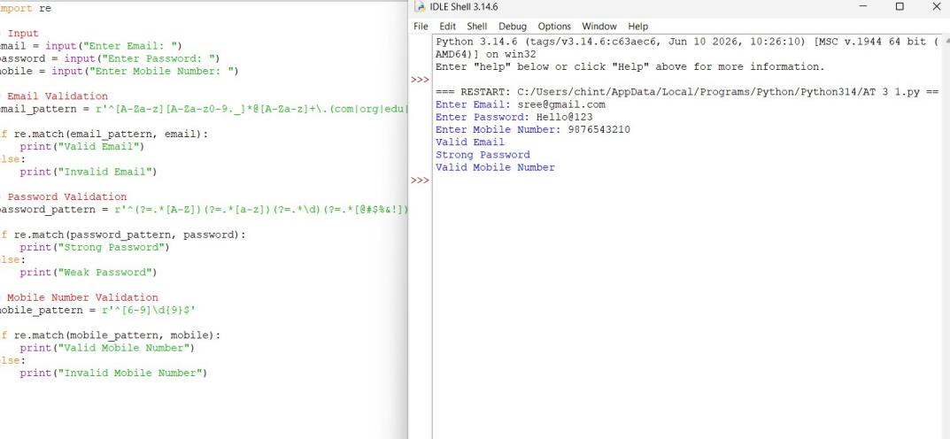

OUTPUT:
Enter Email: sree123@gmail.com
Enter Password: Hello@123
Enter Mobile Number: 9876543210
Valid Email
Strong Password Valid Mobile Number

Section 2: Design a Finite State Automata (FSA) Simul CODE:
# DFA for strings ending with "ab"

# Transition table transitions = {
'q0': {'a': 'q1', 'b': 'q0'},
'q1': {'a': 'q1', 'b': 'q2'},
'q2': {'a': 'q1', 'b': 'q0'}
}

initial_state = 'q0' final_state = 'q2'

# Input string
string = input("Enter input string: ")

state = initial_state path = [state]

# Simulate DFA for ch in string:
if ch not in ['a', 'b']: print("Invalid Input") exit()
state = transitions[state][ch] path.append(state)

# Display transition path print("Transition Path:")

print(" -> ".join(path))

# Check acceptance if state == final_state:
print("Accepted") else:
print("Rejected")

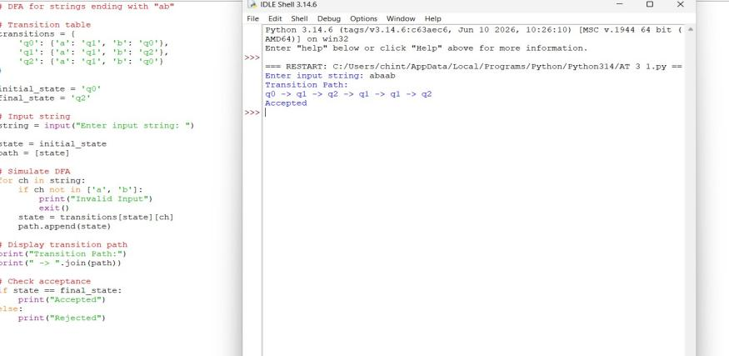

OUTPUT:
Enter input string: abaab

Transition Path:
q0 -> q1 -> q2 -> q1 -> q1 -> q2
Accepted

Section 3: Smart Pattern Matching Engine using Regular Expressions CODE:
import re

text = """
Meeting on 12/09/2026 Call 9876543210 #NLP
@OpenAI
natural language processing """

print("1. Search Date")
print("2. Search Phone Number")

print("3. Search Hashtag") print("4. Search Mention") print("5. Search Prefix") print("6. Search Suffix")
choice = int(input("Enter your choice: ")) if choice == 1:
print(re.findall(r'\b\d{2}/\d{2}/\d{4}\b', text))

elif choice == 2:
print(re.findall(r'\b[6-9]\d{9}\b', text))

elif choice == 3: print(re.findall(r'#\w+', text))

elif choice == 4: print(re.findall(r'@\w+', text))

elif choice == 5:
prefix = input("Enter prefix: ") print(re.findall(r'\b' + prefix + r'\w*', text))

elif choice == 6:
suffix = input("Enter suffix: ") print(re.findall(r'\b\w*' + suffix + r'\b', text))

else:
print("Invalid Choice")

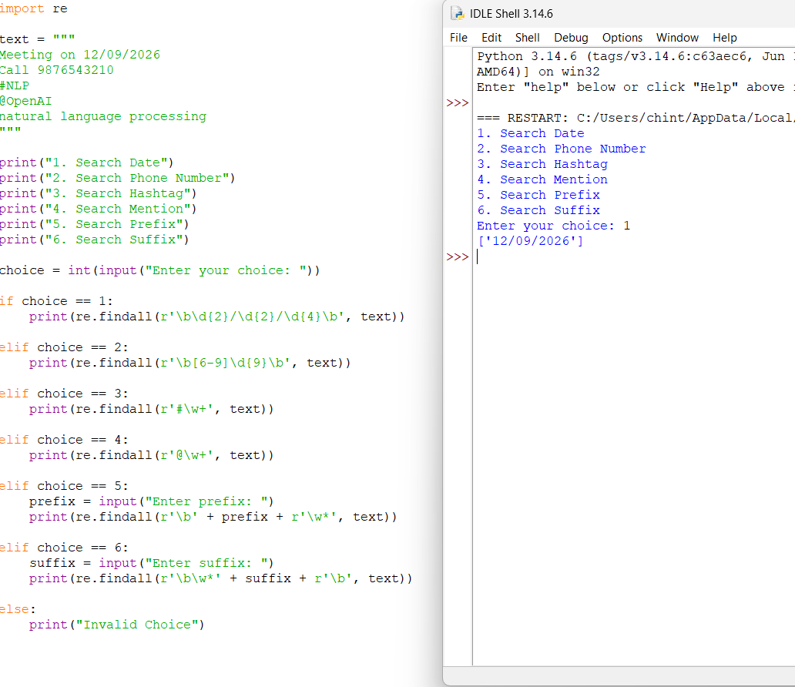

OUTPUT:

- Search Date
- Search Phone Number
- Search Hashtag
- Search Mention
- Search Prefix
- Search Suffix Enter your choice: 1 ['12/09/2026']

